Convert MySQL database to PostgreSQL

Step-1

To install mysql2psql (under ubuntu 11.10): No need to get from github, just:
# gem install mysql pg mysql2psql

if there is no gem install it first,

# apt-get update && apt-get -y upgrade && apt-get install -y apache2 php5 libapache2-mod-php5 php5-mysql libapache2-mod-perl2 libcurl4-openssl-dev libssl-dev apache2-prefork-dev libapr1-dev libaprutil1-dev libmysqlclient-dev libmagickcore-dev libmagickwand-dev curl git-core gitolite patch build-essential bison zlib1g-dev libssl-dev libxml2-dev libxml2-dev sqlite3 libsqlite3-dev autotools-dev libxslt1-dev libyaml-0-2 autoconf automake libreadline6-dev libyaml-dev libtool imagemagick apache2-utils ssh zip libicu-dev libssh2-1 libssh2-1-dev cmake libgpg-error-dev subversion libapache2-svn nano

# apt-get -y install software-properties-common

# add-apt-repository ppa:brightbox/ruby-ng

# apt-get update

# apt-get -y install ruby2.1 ruby-switch ruby2.1-dev ri2.1 libruby2.1 libssl-dev zlib1g-dev

# ruby-switch --set ruby2.1

# gem update

# gem install mysql pg mysql2psql

Step-2
To get info about the mysql socket:(run this on mysql server)

# netstat -l | grep mysql
or
# netstat -ln | grep -o -m 1 -E '\S*mysqld?\.sock'

Step-3
creates a .yml template
# mysql2psql

now it shows some error and a “mysql2psql.yml” file for make our work more easy

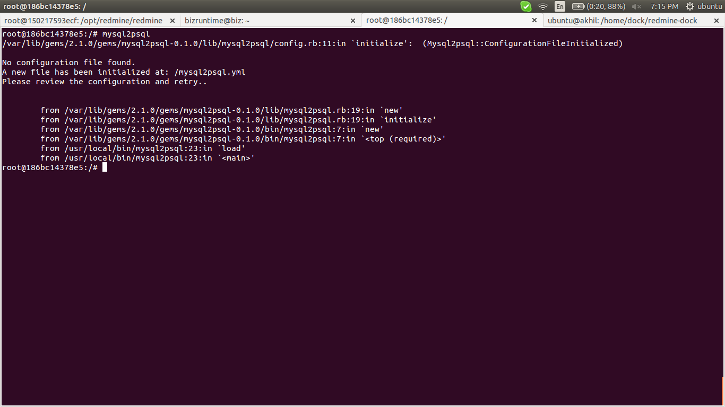

Step-4
edit the template
# nano mysql2psql.yml
edit the mysql and postgresql section

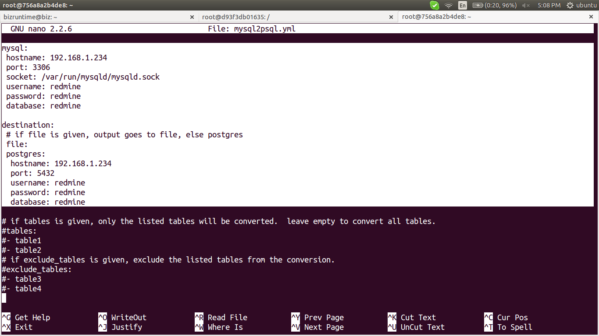

Step-5
connects to mysql database and write into postgres database
# mysql2psql
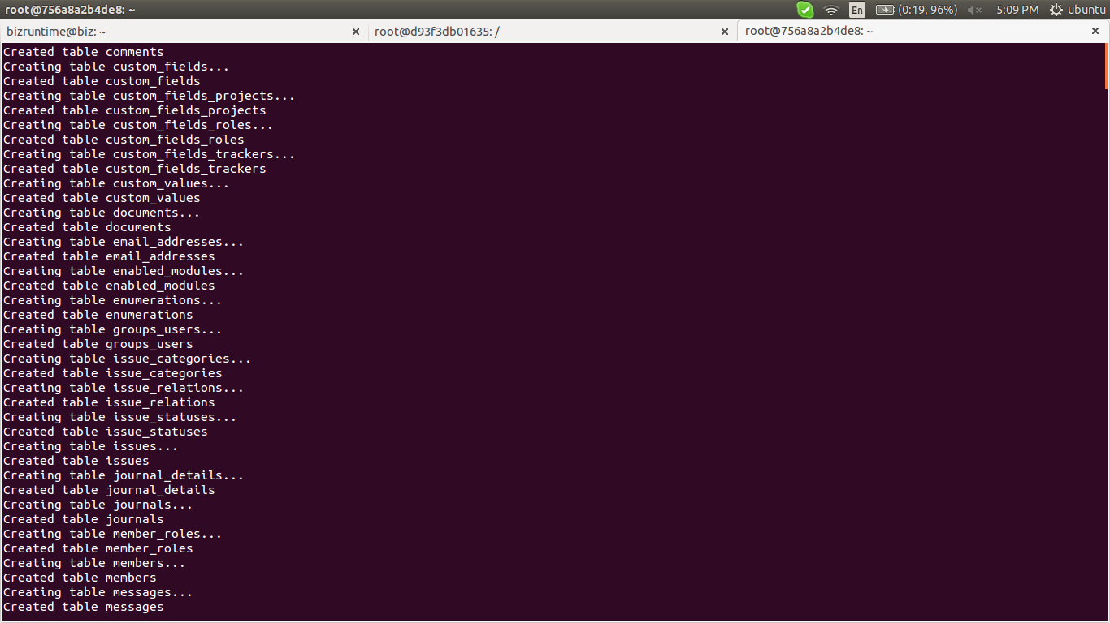
links: http://nicolas-brousse.github.io/ubuntu-install-and-tips/pages/others/mysql-to-postgresql/

%%%%%%%%%%%%%%%%%%%%%%%%%%%%%%%%%%%%%%%%%%%%%%%%

here is an example for converting mysql to psql database for redmine
after step 5 we need to reconfigure the redmine database.yml file

Step-6

# {redmine home}/config/database.yml
mysql db configuration show below

production:
adapter: mysql2
database: redmine
host: 192.168.1.234
username: redmine
password: redmine
encoding: utf8

change this to postgresql db configuration

production:
adapter: postgresql
database: redmine
host: 192.168.1.234
username: redmine
password: redmine
encoding: utf8
schema_search_path: public

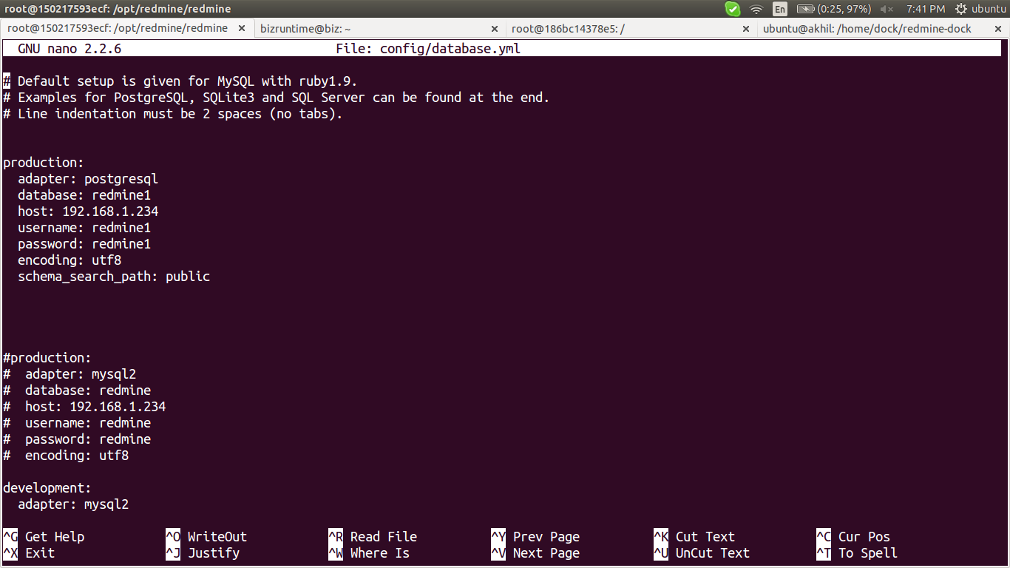
Step-7

whenever made a changes in config files of redmine need to use this command for activate

# bundle install --without development test postgresql sqlite

links : http://www.redmine.org/projects/redmine/wiki/redmineinstall

Step-8

after migration try to create a new tickets to check whether it is working properly or not

