Setup SSH for Auto Login without a Password
Server-side:

# cd .ssh/
# ssh-keygen -t rsa

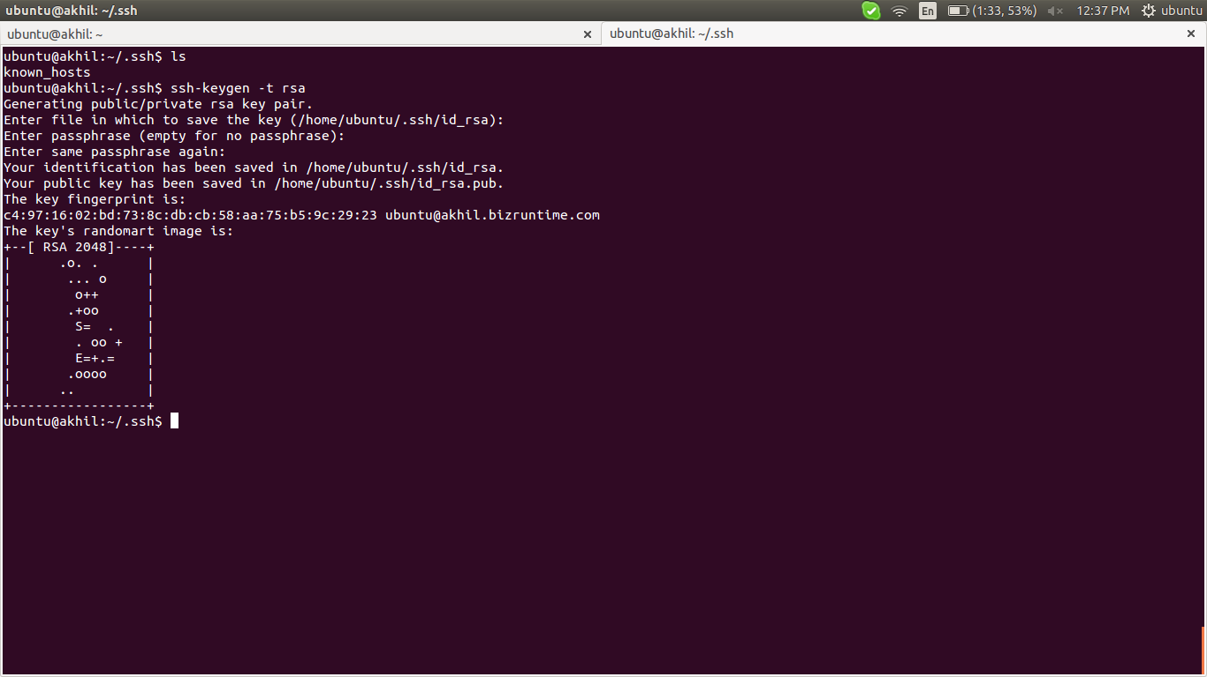
# mv id_rsa.pub authorized_keys
# sudo chmod 600 authorized_keys

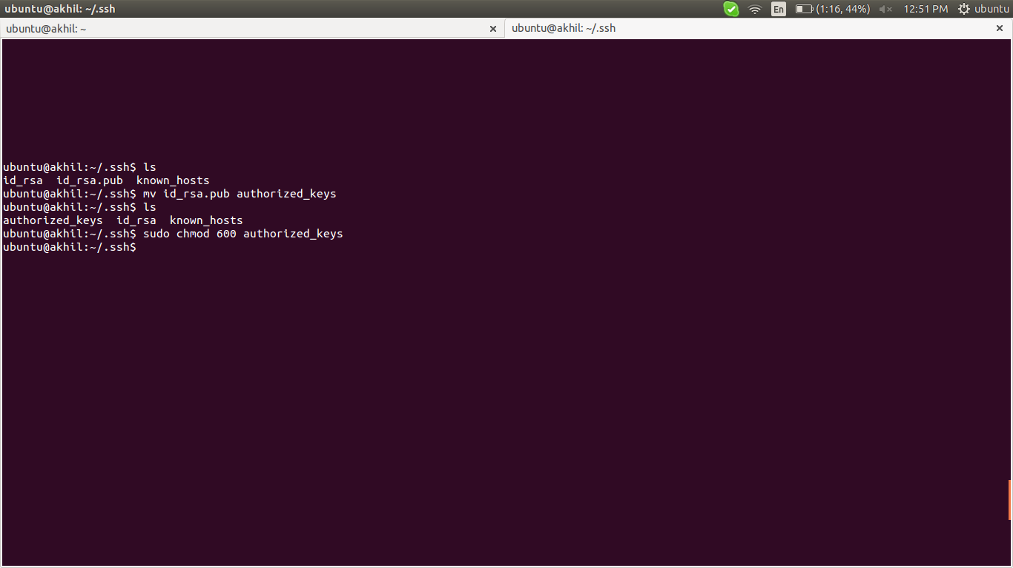

# scp authorized_keys ubuntu@192.168.1.42:/home/ubuntu/.ssh/

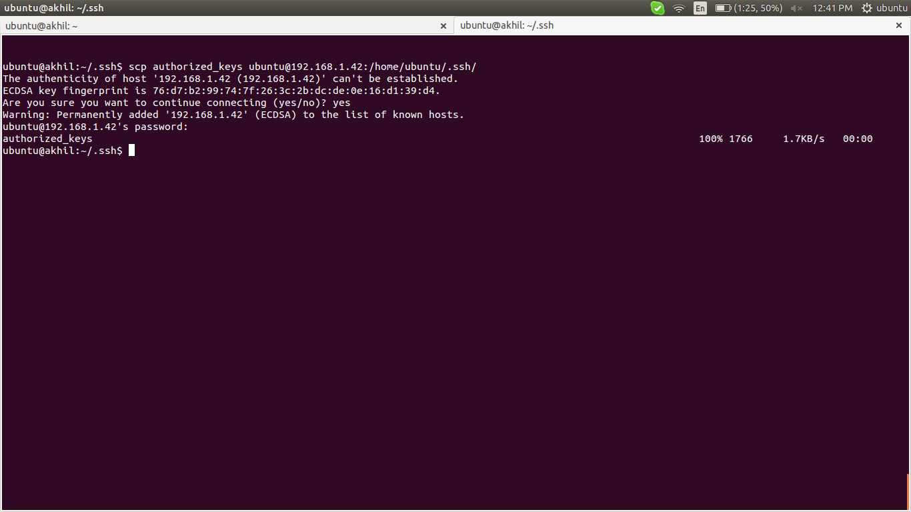

if provide passphase while create key using ssh-keygen, it will ask while copy the authorized_keys to remote machine.

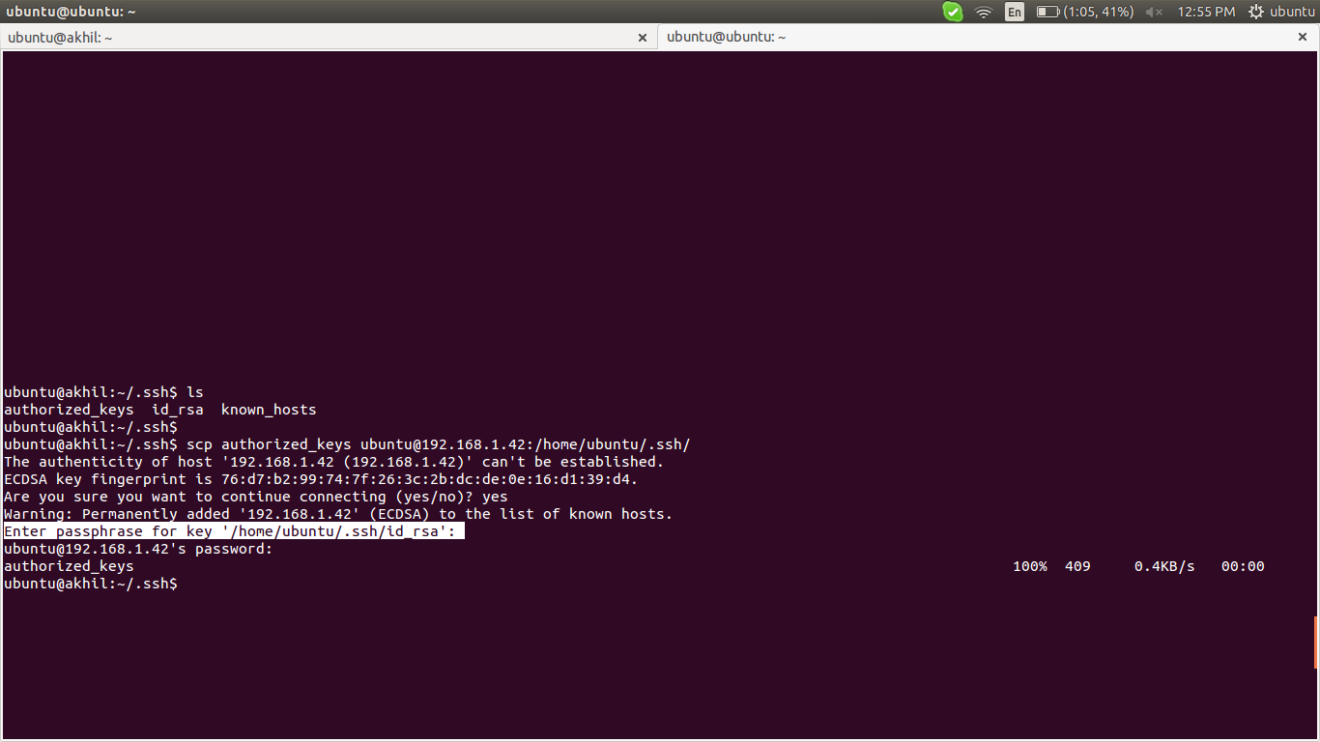

client-side:
check whether the authorized_keys under the particular user's .ssh directory

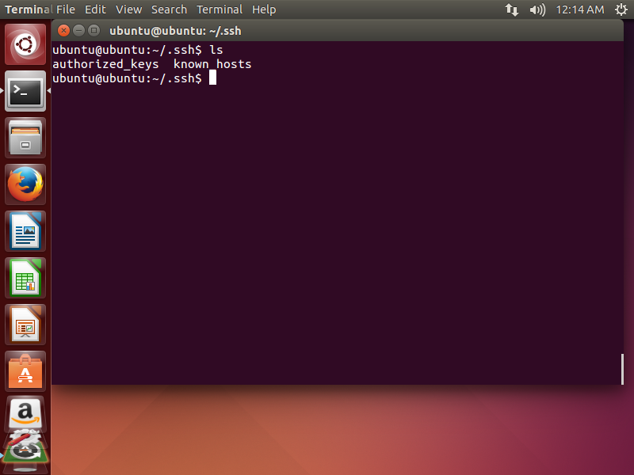
try to access from server to that remote machine
# ssh ubuntu@192.168.1.42

if provide passphase while create key using ssh-keygen, it will ask while copy the authorized_keys to remote machine. But no password,
passphase for more security purpose,
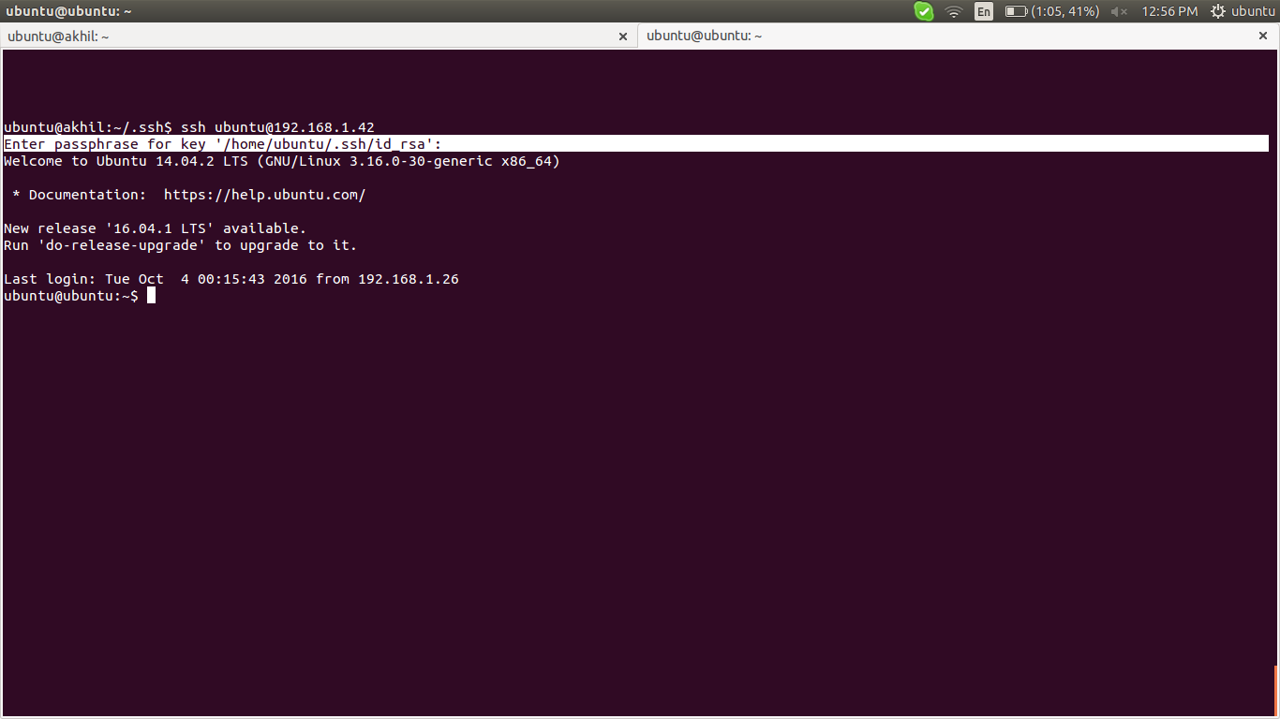
links: http://www.rebol.com/docs/ssh-auto-login.html

Convert Amazon .pem key to Putty .ppk key Linux

1) install wine in linux for installing .exe file (windows software)
2) download puttygen.exe from http://www.chiark.greenend.org.uk/~sgtatham/putty/download.html
3) open with wine
4) file > load private key

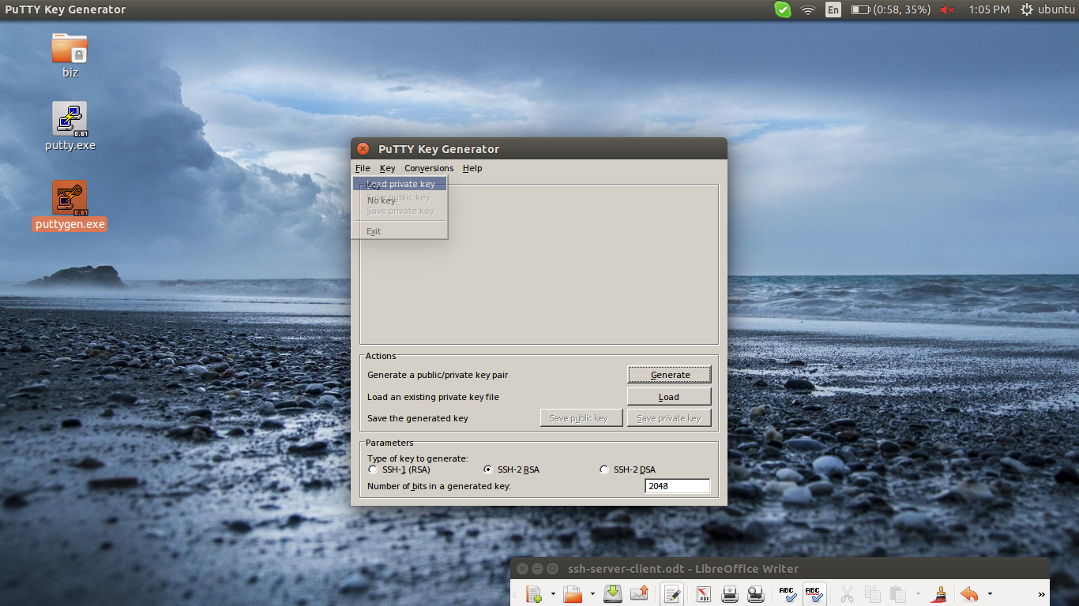
5) take any perm file to create ppk file

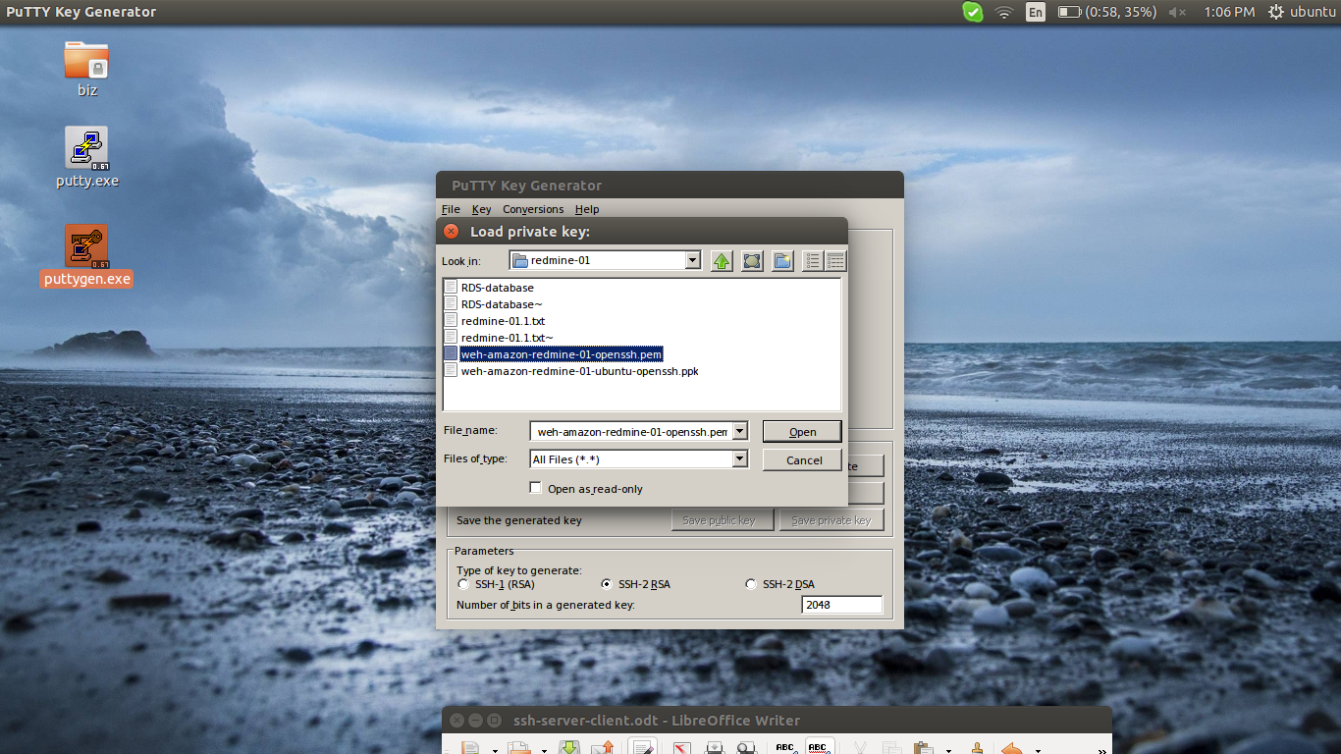

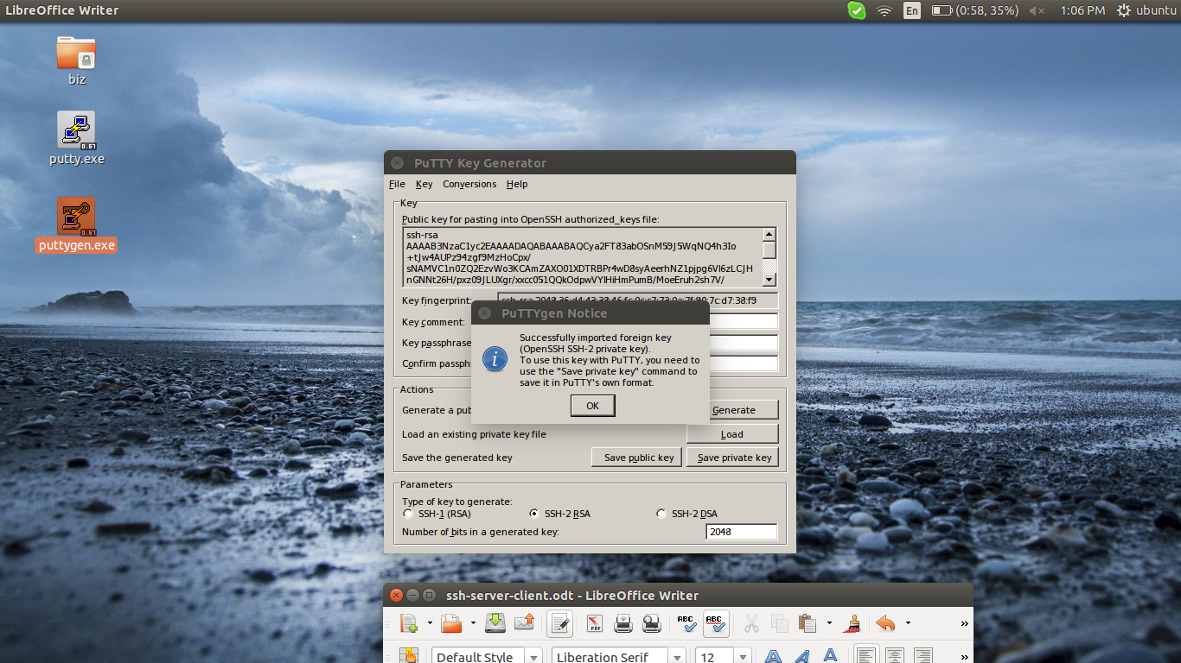

6) provide the passphase if needed, and click on save private key

then give the destination path and name for that ppk file > save

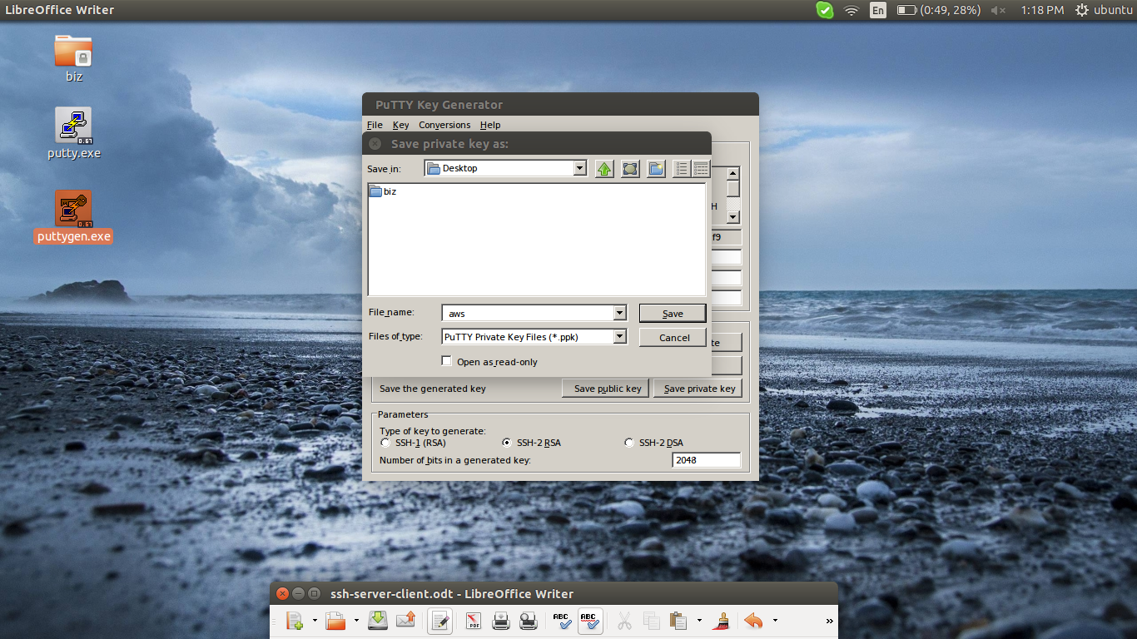

7) now ppk file created, in this senario “aws.ppk”

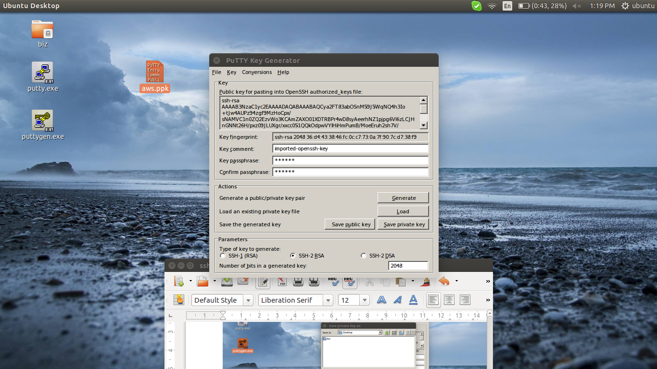

links: http://unix.stackexchange.com/questions/116303/convert-amazon-pem-key-to-putty-ppk-key-linux

