**Mesos and Marathon Cluster**

**Requirments :**

1. Three virtual machines -

a. mesos-master

b. mesos-slave 1

c. mesos-slave 2

**Installation and Configuration Mesos,marathon,zookeeper :**

Step 1. Install Zookeper , Mesos , Marathon on Master Instance.

sudo apt-get update -y

sudo DEBIAN_FRONTEND=noninteractive apt-get install -y python-software-properties software-properties-common

sudo apt-key adv --keyserver keyserver.ubuntu.com --recv E56151BF

DISTRO=$(lsb_release -is | tr '[:upper:]' '[:lower:]')

CODENAME=$(lsb_release -cs)

echo "deb http://repos.mesosphere.io/${DISTRO} ${CODENAME} main" | sudo tee /etc/apt/sources.list.d/mesosphere.list

# Install Java 8 from Oracle's PPA

sudo add-apt-repository ppa:webupd8team/java

sudo apt-get update -y

sudo apt-get install -y oracle-java8-installer oracle-java8-set-default

sudo apt-get -y install mesosphere (this will install zookeeper, mesos, marathon)

**Setup Zookeeper Cluster on Master Instances**

sudo vi /etc/zookeeper/conf/myid

1 (This value should be unique for each master node)

# Specify all zookeeper servers in zoo.cfg

sudo vi /etc/zookeeper/conf/zoo.cfg

server.1=<MASTER_NODE1_IP>:2888:3888

**Setup zookeeper connection info for Mesos on all Master Instance**

sudo vi /etc/mesos/zk

zk://<MASTER_NODE1_IP>:2181/mesos

**Configure Mesos Master on all Master Instances**

sudo vi /etc/mesos-master/quorum

1 //quorumm size depends on no. Of master instance , here in our case we have 1 master instance . If 3 masters quorum should 2

echo <MASTER_NODE_IP> | sudo tee /etc/mesos-master/ip

sudo cp /etc/mesos-master/ip /etc/mesos-master/hostname

**Configure Marathon on all Master Instances**

sudo mkdir -p /etc/marathon/conf

sudo cp /etc/mesos-master/hostname /etc/marathon/conf

sudo cp /etc/mesos/zk /etc/marathon/conf/master (To connect marathon to Mesos)

sudo cp /etc/marathon/conf/master /etc/marathon/conf/zk (Marathon own configuration)

sudo vi /etc/marathon/conf/zk (replace mesos w marathon)

echo http_callback | sudo tee /etc/marathon/conf/event_subscriber

**We don't want to run mesos-slave on master instances, execute the following command to prevent running mesos-slave on master instances.**

sudo stop mesos-slave

echo manual | sudo tee /etc/init/mesos-slave.override

**Start Zookeeper, mesos-master and Marathon on all master instances**

sudo restart zookeeper

sudo start mesos-master

sudo start marathon

**Install Mesos on all Slave Instances**

# Add Mesosphere repository

sudo apt-key adv --keyserver keyserver.ubuntu.com --recv E56151BF

DISTRO=$(lsb_release -is | tr '[:upper:]' '[:lower:]')

CODENAME=$(lsb_release -cs)

echo "deb http://repos.mesosphere.io/${DISTRO} ${CODENAME} main" | sudo tee /etc/apt/sources.list.d/mesosphere.list

# Install mesos

sudo apt-get -y update

sudo apt-get -y install mesos

**Setup zookeeper connection info for Mesos on all Slave Instance**

sudo vi /etc/mesos/zk

zk://<MASTER_NODE1_IP>:2181/mesos

**We don't want to run zookeeper and mesos-master on slave instances, execute the following command to prevent running zookeeper and mesos-master on slave instances**

sudo stop zookeeper

echo manual | sudo tee /etc/init/zookeeper.override

echo manual | sudo tee /etc/init/mesos-master.override

sudo stop mesos-master

**Configure Mesos Slave on all Slave Instances**

echo <SLAVE_NODE_IP> | sudo tee /etc/mesos-slave/ip

sudo cp /etc/mesos-slave/ip /etc/mesos-slave/hostname

echo 'docker,mesos' | sudo tee -a /etc/mesos-slave/containerizers >/dev/null

echo '5mins' | sudo tee -a /etc/mesos-slave/executor_registration_timeout >/dev/null

echo 'ports(*):[4000-5000, 8000-9000, 31000-32000]' | sudo tee -a /etc/mesos-slave/resources >/dev/null

**Install docker on all slave instances**

curl -sSL https://get.docker.**com**/ | **sh**

**Start mesos-slave on all slave instances**

sudo start mesos-slave

At this point your cluster should be up and running.  
  
**If you hit any <MASTER_NODE_IP>:5050, you should see Mesos UI. Check out the Slaves Tab**

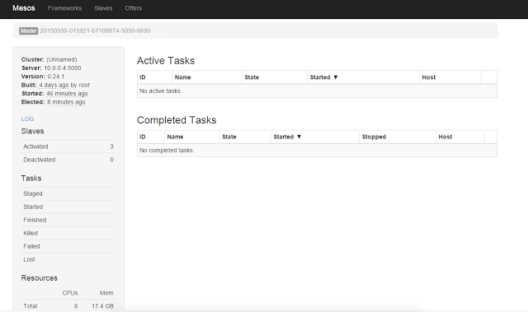

**If you hit any<MASTER_NODE_IP>:8080,you should see Marathon UI**

