LDAP-AUTH-ODOO AND SMTP MAIL SERVICE

Install ldap module in server

search ldap in app in gui of odoo and install it

Configure Odoo
Odoo should be at least configured, and basic modules installed.
- Log into Odoo as an Administrator
- From the Odoo homepage, select the Settings menu item.
- Clear the filter in the searchbox, and perform a search for LDAP
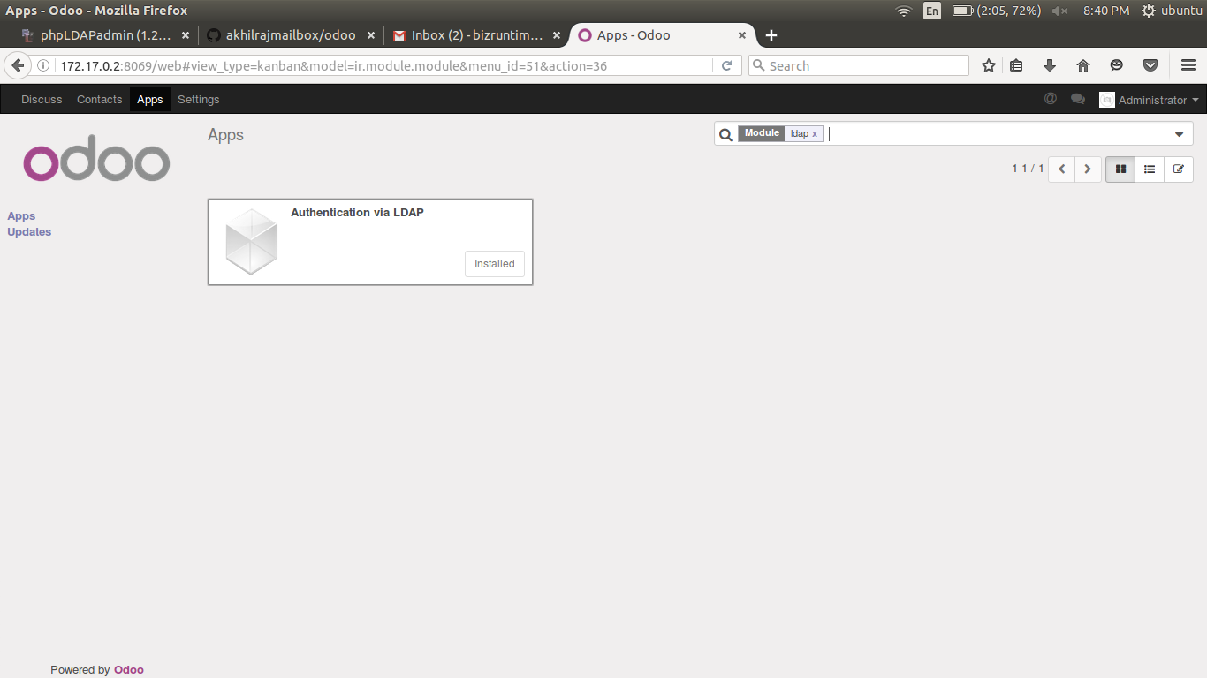
no need for creation of a user in odoo,,,,, it will automatiocally created at the first time login of ldap user

- Install the module.

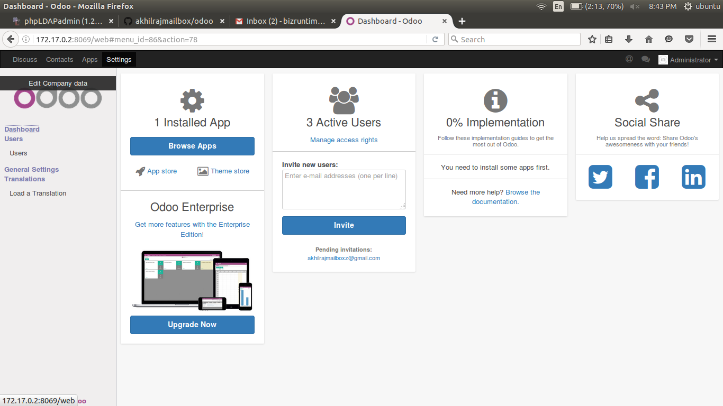
- When complete, on the Settings page select “edit company data” from the side menu.
- select the configuration tab and select Edit.
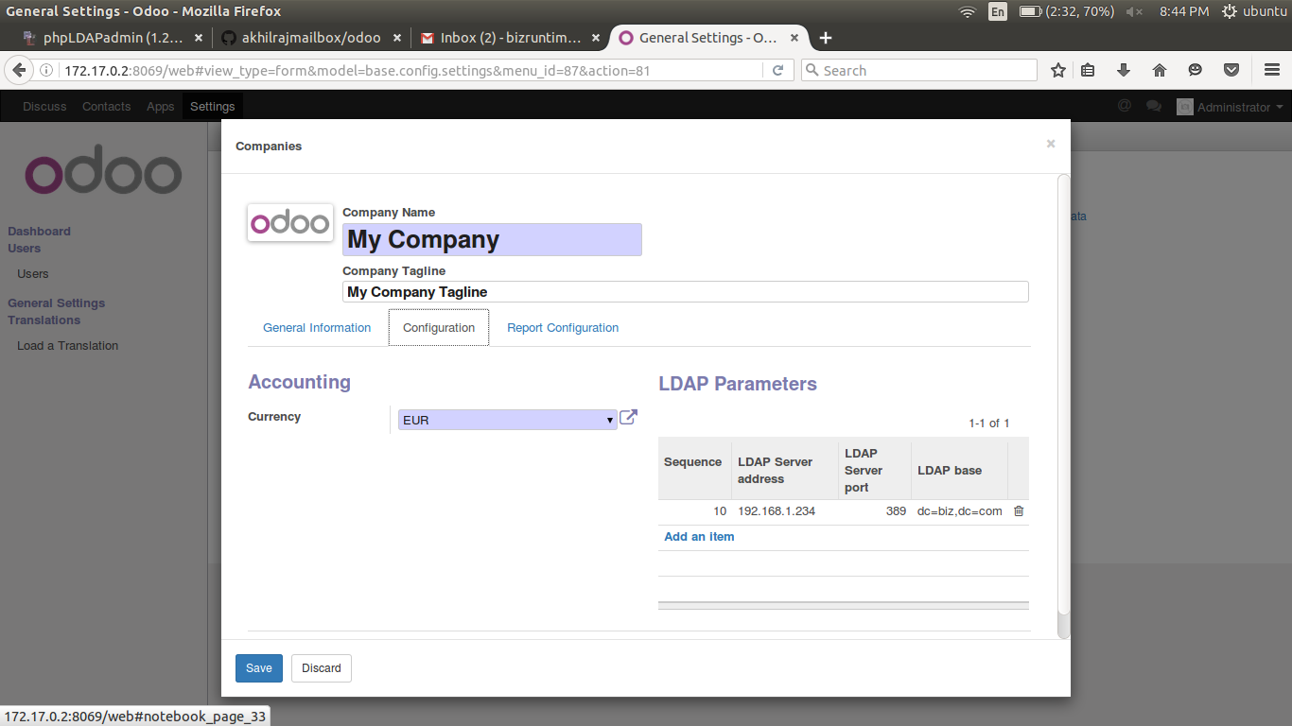
- After selecting Edit, click Add an item in the LDAP Parameters section.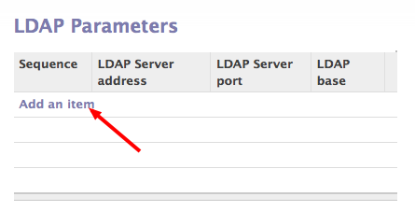
- On the Create: LDAP Parameters add the following:
  - LDAP Server Address (ldap server name or IP)
  - LDAP Server Port (389)
  - LDAP binddn – The user that was set up in Zentyal to connect to the LDAP to search for valid users. The value will be in the form of: username@domain For example: if the created user is admin and the base DN is cn=admin,dc=biz,dc=com then the binddn value would be cn=admin,dc=biz,dc=com (mail admin agent)
  - LDAP Password – Password for LDAP binddn user
  - LDAP base – The value from the LDAP setting screen in phpadmin ldap gui
eg : dc=biz,dc=com
  - LDAP filter uid=%s
  - The other settings can be left alone.

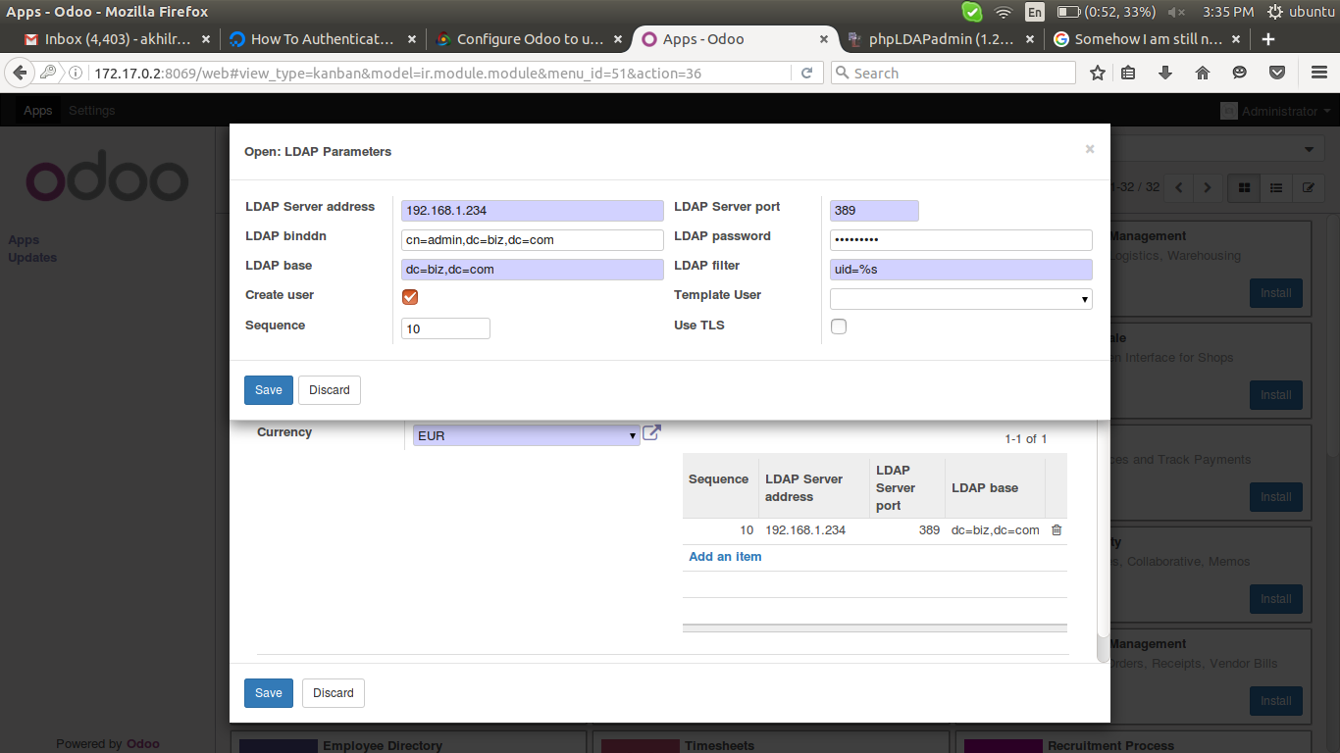
- Click Save & Close, then click Save on the Companies Screen.
- The entry should be visible under LDAP Parameters
- Test the entry by logging out of the Administrator user, and performing a login using the test user set up in the LDAP. This user currently does not exist in Odoo.
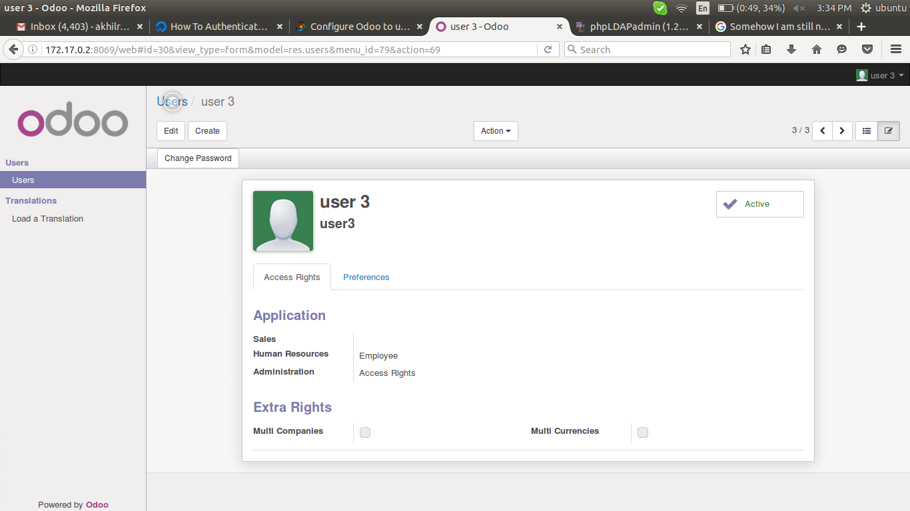
- After logging as the test user the permissions should be equivalent to those set in user_template.

- Logging back into the Administrator user, the newly created user can be seen in Users on the Setting Page. This user has been allowed access by the lookup done to the LDAP.
And give right access for access the odoo webpage by that user

- 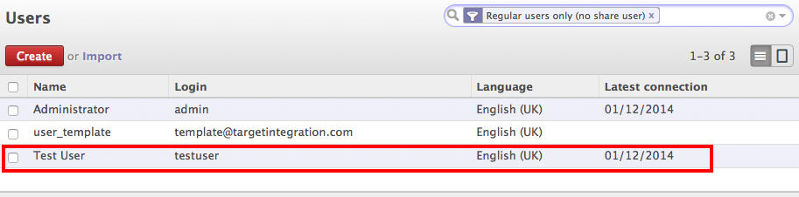
Short URL: http://j.mp/1emZAQ4

SSMTP MAIL

install ssmtp in odoo server first

In odoo, install fetchmail and configure the incoming and outgoing mail servers

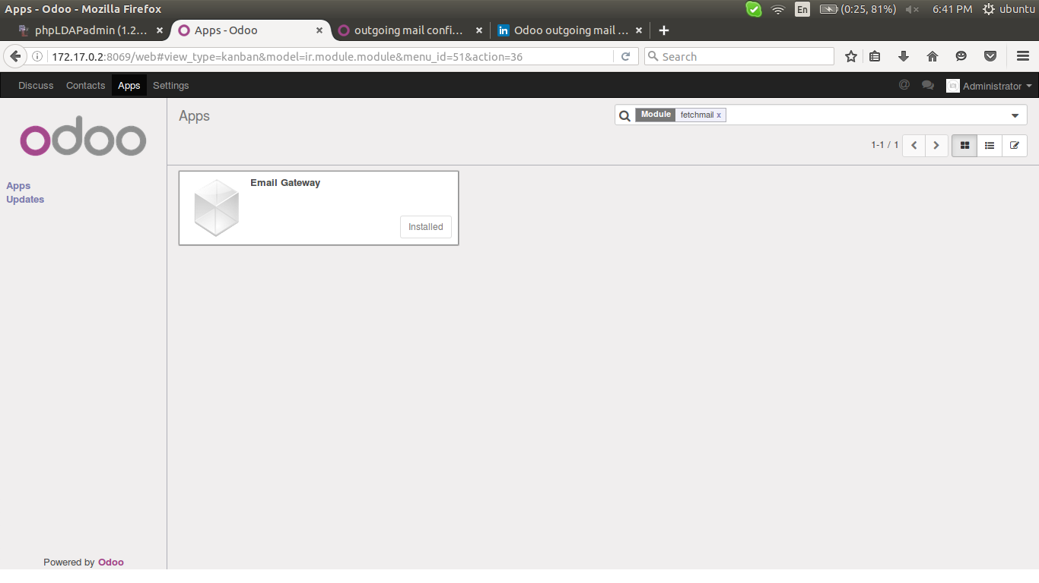
choose general settings from the menu

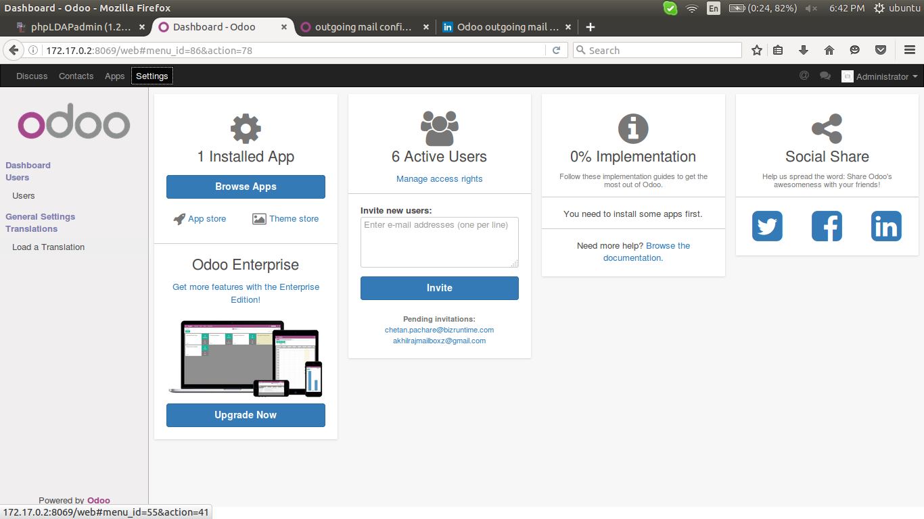
First go to Settings > general settings > Outgoing Mail servers and click on Create.
You will get a new window looking like this:

Let’s go over the fields:
- Description: A description for the outgoing mail server.
- Priority: The priority of your mail server. The lower the number the higher the priority. This will mean that the e-mailserver with the lowest number will be used the most.
- SMTP server: The pointer to the SMTP of your server, for example smtp.gmail.com.
- SMTP port: The port of your SMTP server, for example port 465 for Gmail.
- Connection security: The type of security. You should choose SSL/TLS for Gmail. The data is then send over HTTPS.
- Username: Your e-mail account, in this example youremail@gmail.com
- Password: The password of your e-mail account.
For Gmail it will look like this:

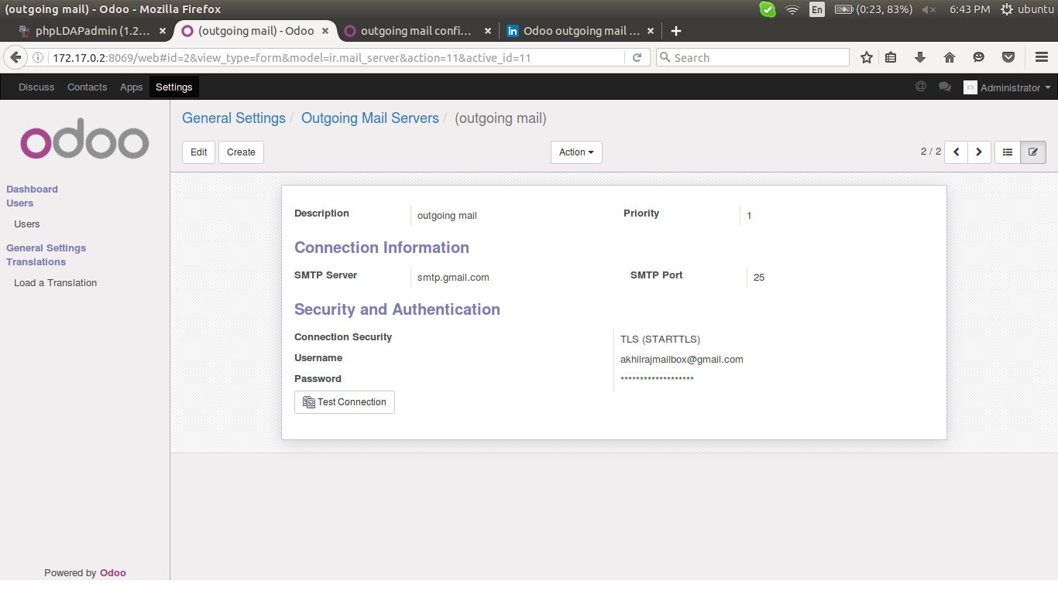
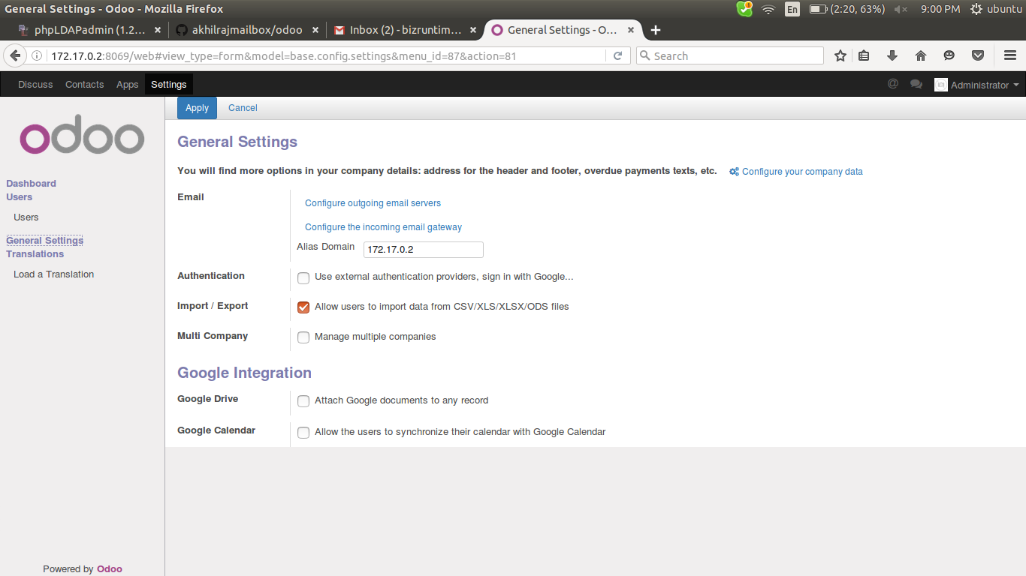

go to configure outgoing email servers then configure it as mentioned below
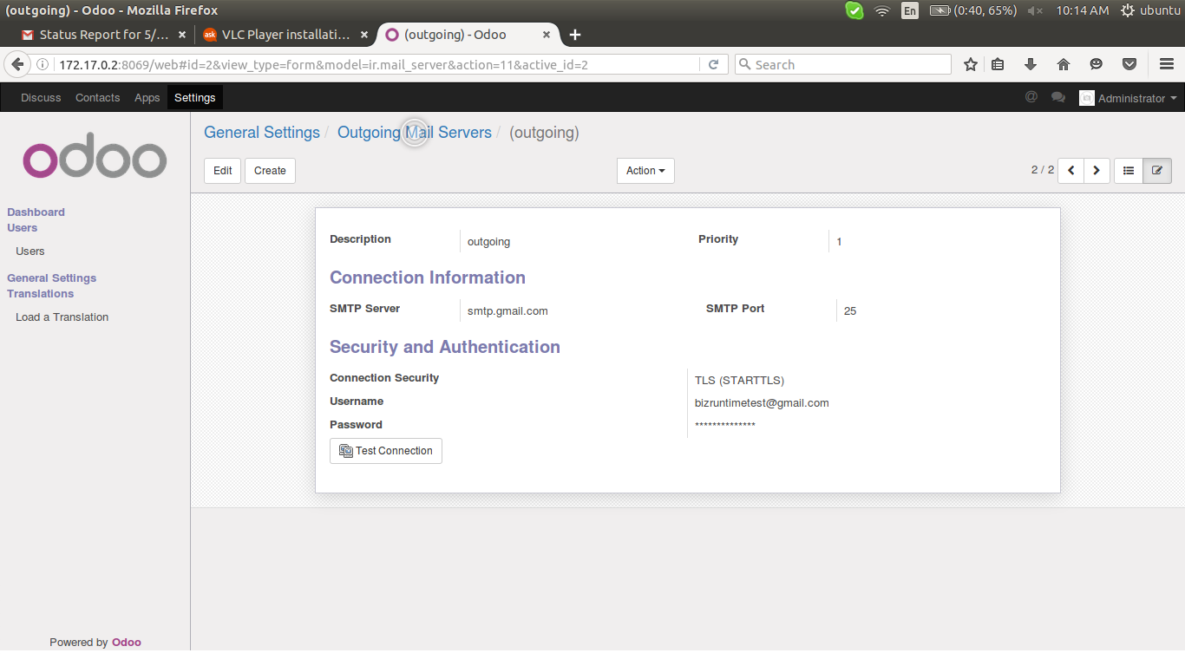
provide priority always high, means 1,
test connection. Click on that

Log into your google email account and then go to this link: https://www.google.com/settings/security/lesssecureapps and set "Access for less secure apps" to ON. Test to see if your issue is resolved. If it isn't resolved, as it wasn't for me, continue to Step #2.
- Go to https://support.google.com/accounts/answer/6009563 (Titled: "Password incorrect error"). This page says "There are several reasons why you might see a “Password incorrect” error (aka 534-5.7.14) when signing in to Google using third-party apps. In some cases even if you type your password correctly." This page gives 4 suggestions of things to try.
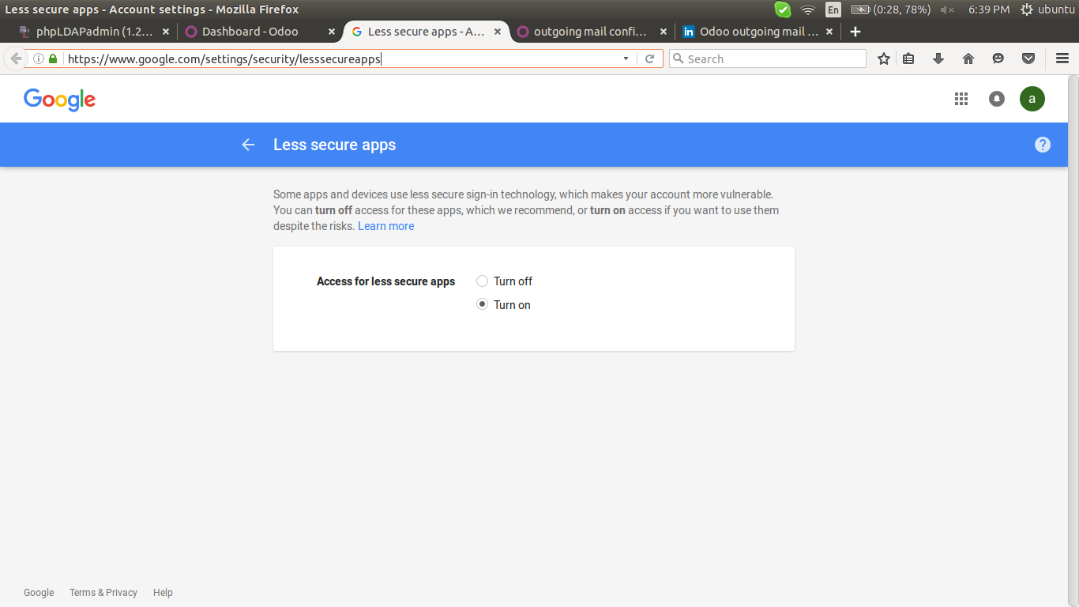

Further face error ...lets go for ...............

http://www.slideshare.net/engmohamans/outgoing-mail-servers-configuration

try to send an invitation if all configurations are fine. Then it look like this,,,,,,,,

