SSMTP-CONFIGURATION AND LDAP-CONFIGURATION

Do the configuration in server

in configuration.yml

production:
delivery_method: :smtp
smtp_settings:
tls: true
address: "smtp.gmail.com"
port: '465'
domain: "smtp.gmail.com"
authentication: :plain
user_name: "gmail"
password: "passwd"

My account >> give email

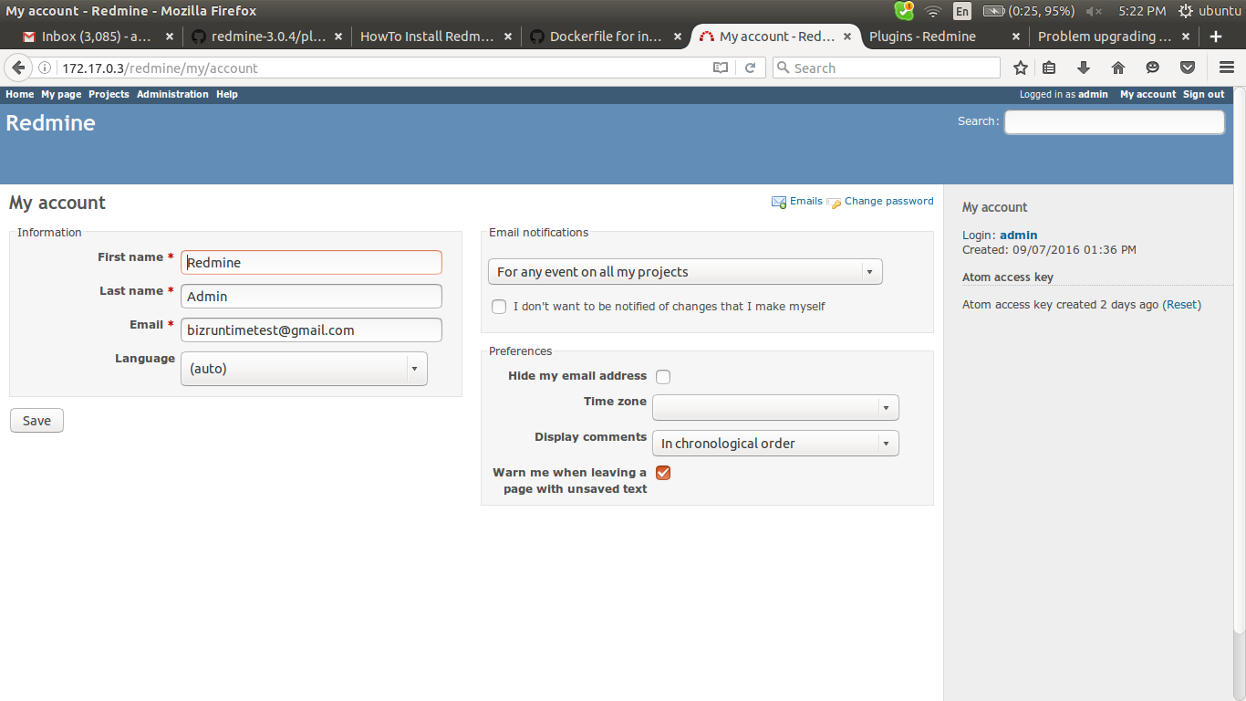

create project

project > create new project (this is for testing mail service)

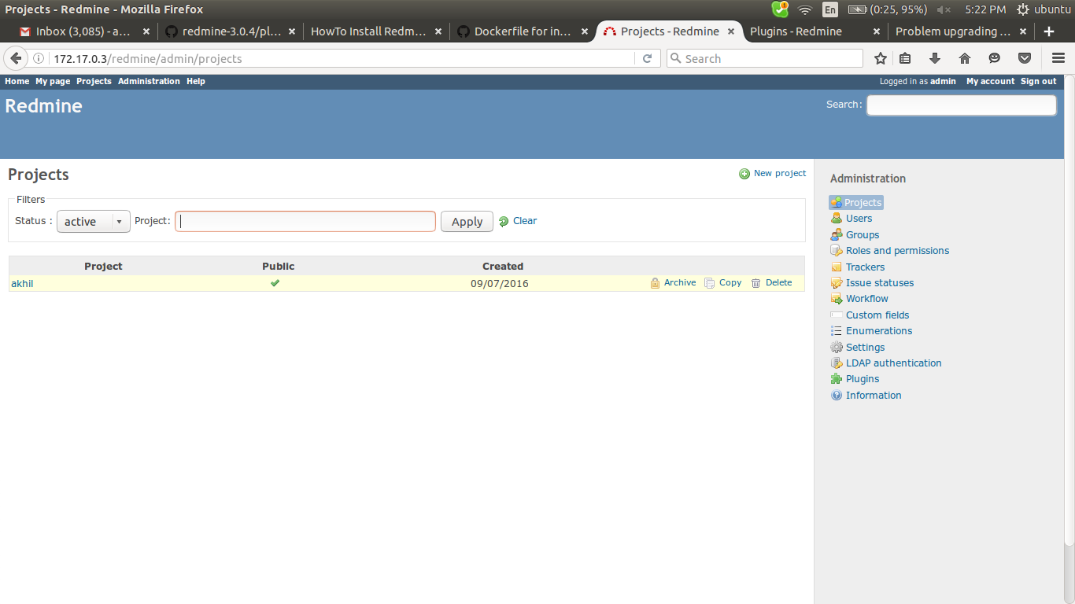

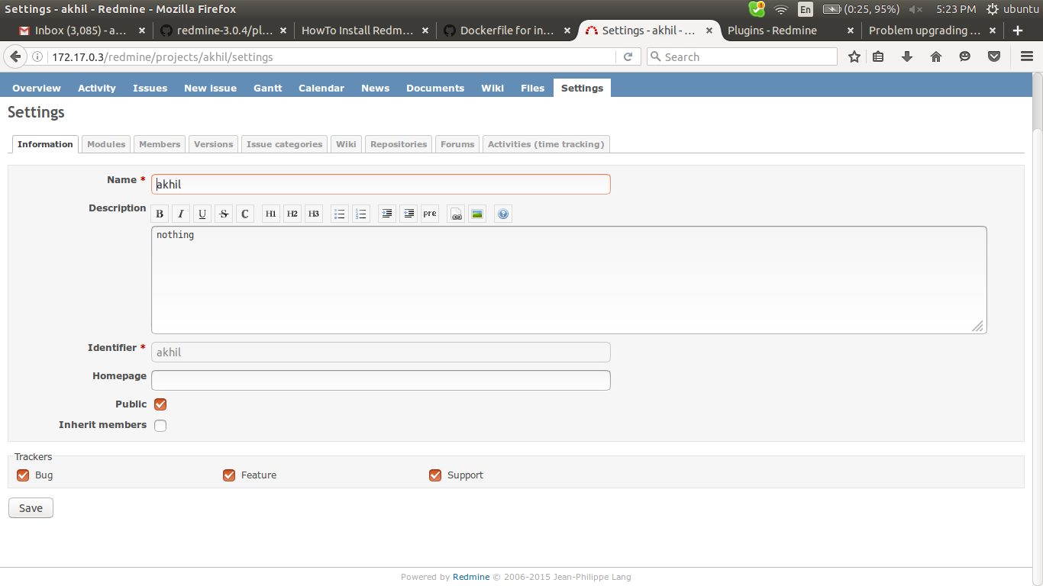

administration > settings > email notification

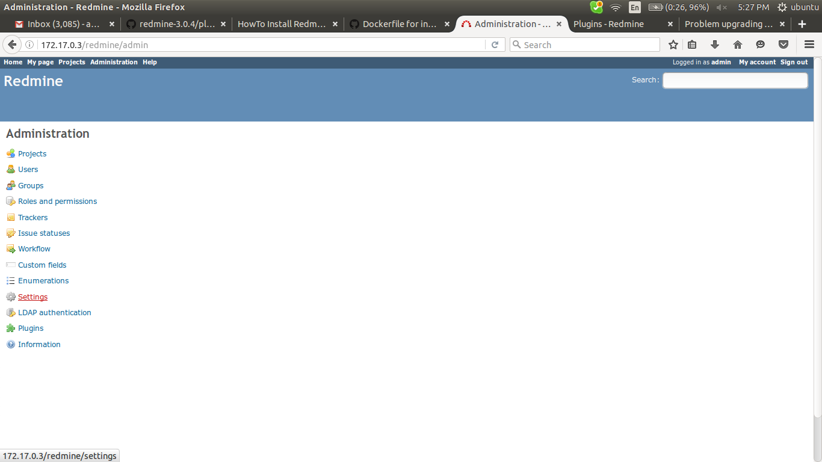

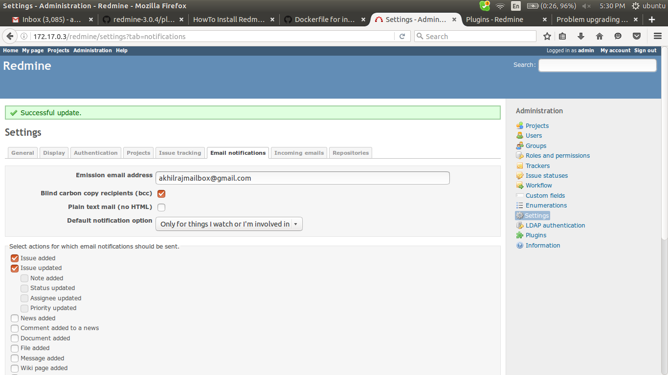

emission email address is the address in which the client seems that the mail send by that domain

send a test message > for sending an message to admin mail for checking

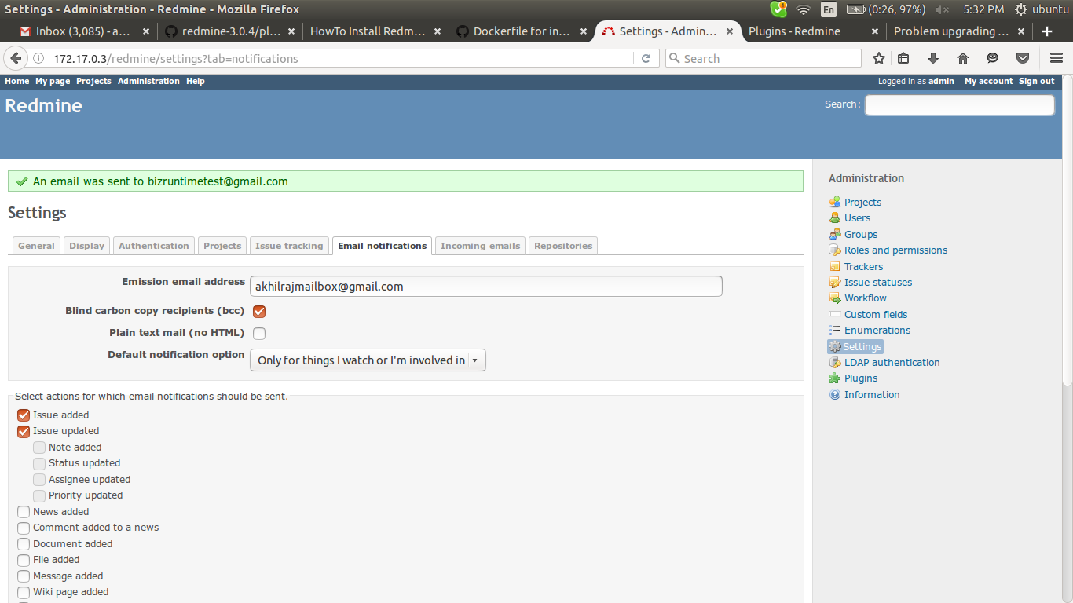

check mail

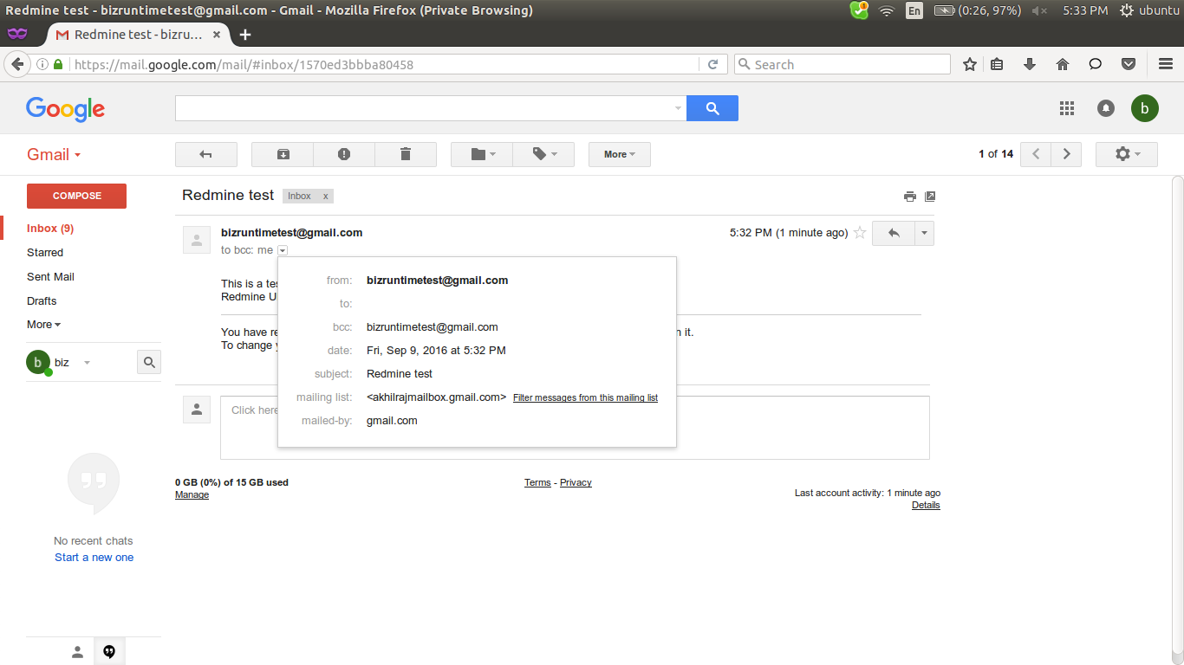

go to project > create a new issue > check admin mail

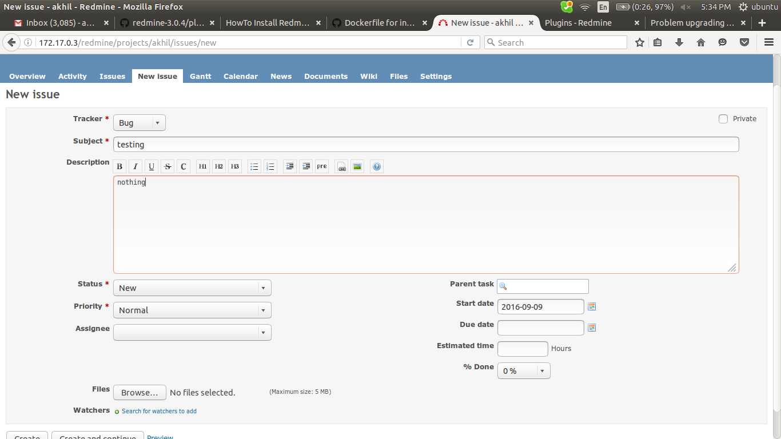

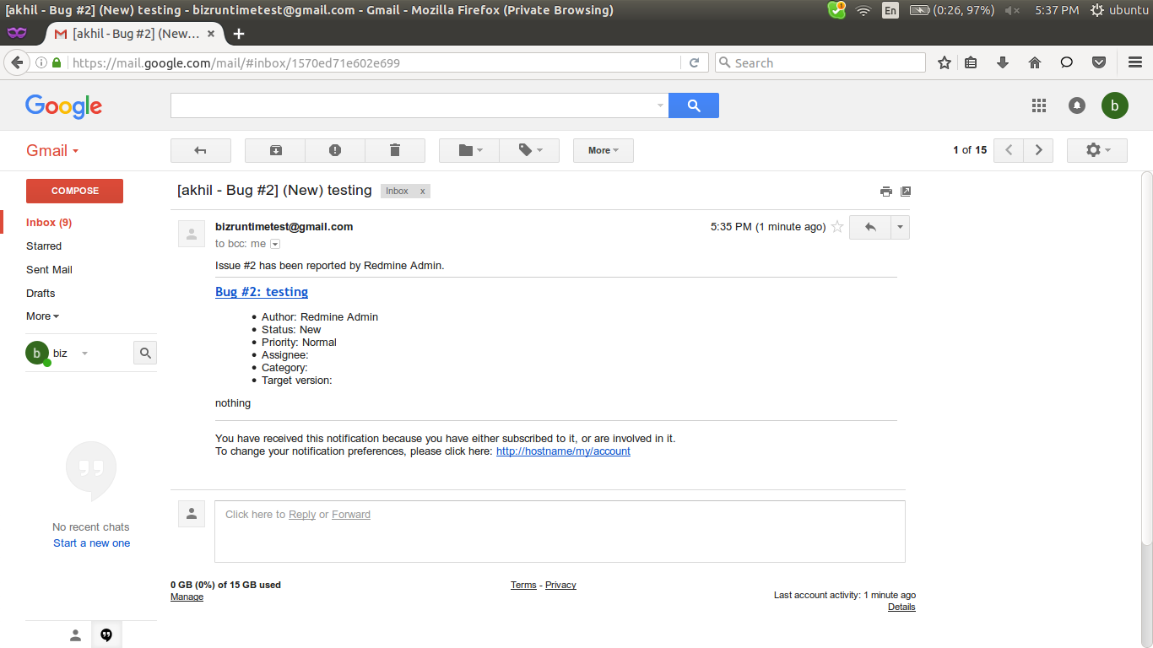

ldap configurations

login as admin > administration > LDAP authentication

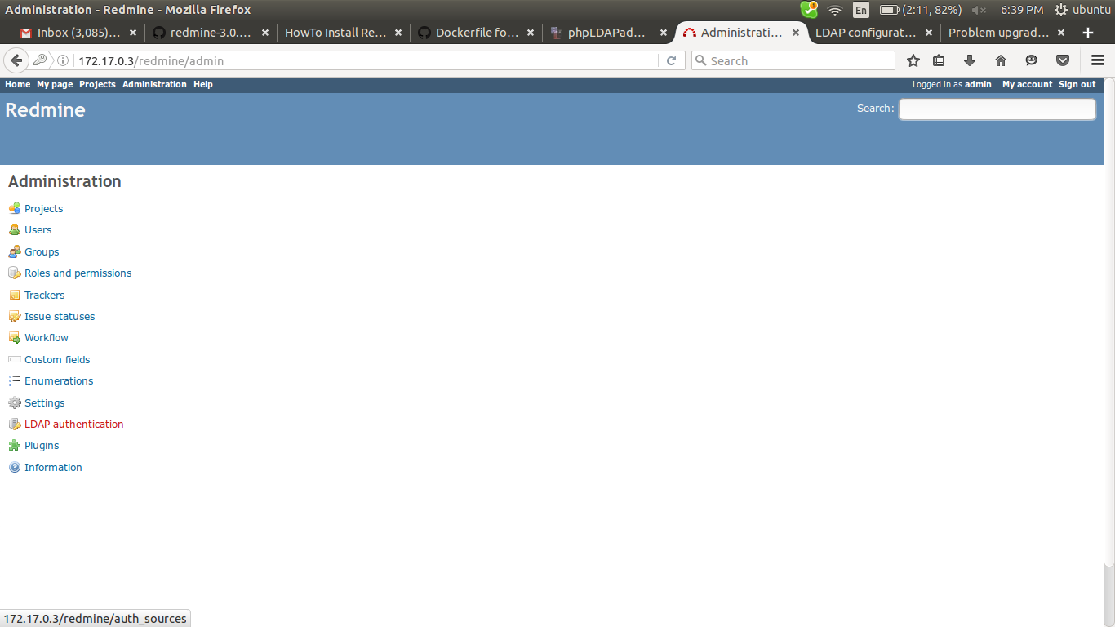

configure it with your ldap server identity

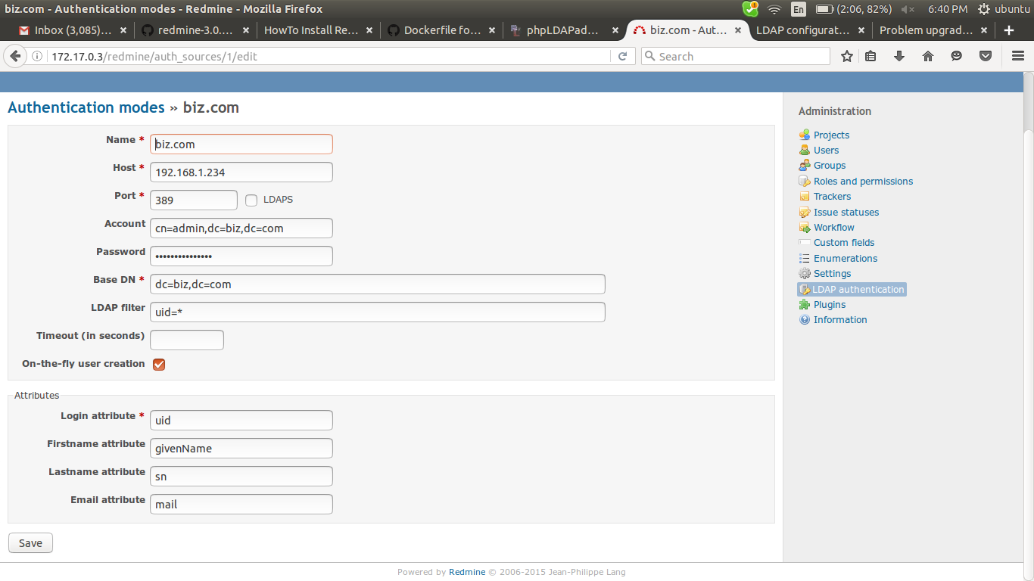

Name: an arbitrary name for the directory
Host: the LDAP host name
Port: the LDAP port (default is 389)
LDAPS: check this if you want or need to use LDAPS to access the directory
Account: enter a username that has read access to the LDAP , otherwise leave this field empty if your LDAP can be read anonymously (ldap admin)
Password: password for the account (ldap admin passwd)
Base DN: the top level DN of your LDAP directory tree
Login attribute: enter the name of the LDAP attribute that will be used as the Redmine username
if provide attributes same as in ldap then directly get into redmine, otherwise need to enter some values.

Try to login as user in ldap

after that again login as admin then,

to see the users in redmine, administration > users

