Using Scripts to Automate Tasks

Set Explanation

[b–f] Denotes any characters in the set b , c , d , e , f
[1–4,7–9] Denotes any two numbers, the first of which must be 1 , 2 , 3 , or
4 and the second of which must be 7 , 8 , or 9
[aeiou] Denotes any character that is a vowel
[b,aeiou] Denotes any character that is either b or a vowel
[aeiou][a–z] Denotes any vowel followed by any lowercase character
between and including a and z

eg :

$ ls [b-c]*
basename bash2
bash
bsh
cat
chgrp
chmod
chown
consolechars
cp
cpio
csh
cut

The resulting set consists of any file name beginning with b or c.

$ ls [b-d,f]?
cp dd df

BASH SPECIAL CHARACTERS

Character Description

* Multicharacter wildcard
? Single-character wildcard
< Redirect input
> Redirect output
>> Append output
| Pipe
{ Start command block
} End command block
( Start subshell
) End subshell
` Command substitution
$ Variable expression
‘ Strong quote
“ Weak quote
\ Interpret the next character literally
& Execute command in background
; Command separator
~ Home directory
# Comment

You should already be familiar with redirecting input and output and using
pipes, but you will see examples of all three operations later in the chapter. Input
and output redirection should be familiar to you. Commands in a block, that is,
delimited by { and } elicit different behavior from Bash than commands executed
in a subshell, that is, commands delimited by ( and ) .

PREDEFINED VARIABLES

Variable Name Description
PPID Stores the process ID of the Bash’s parent process.
PWD Contains the current working directory (as set by the cd
command).
OLDPWD Stores the most previous working directory (as set by the next
most recent cd command).
UID Contains the user ID of the current user as set when the shell
started.
BASH_VERSION Stores the version string of the current Bash instance.
RANDOM Returns a random number between 0 and 32,767 each time it is
referenced.
OPTARG Contains the last command line argument read using the
getopts built-in command.
OPTIND Points to the array index of the next argument to be processed
using the getopts built-in command.
HOSTNAME Stores the name of the current host system.
SHELLOPTS Contains a colon-separated string of the currently enabled shell
options (as set using the set -o shell built-in command).
IFS Stores the value of the Internal Field Separator, used to define
word boundaries. The default value is a space, a tab, or a new line.
HOME The home directory of the current user.
PS1 Defines the primary command prompt. The default value is
“\s-\v\$ “ .
PS2 Defines the secondary command prompt, used to indicate that
additional input is required to complete a command.
HISTSIZE The number of commands retained in Bash’s command history.
The default value is 500.
HISTFILE The name of the file in which Bash stores the command history.
The default value is $HOME/.bash_history .

Eg :

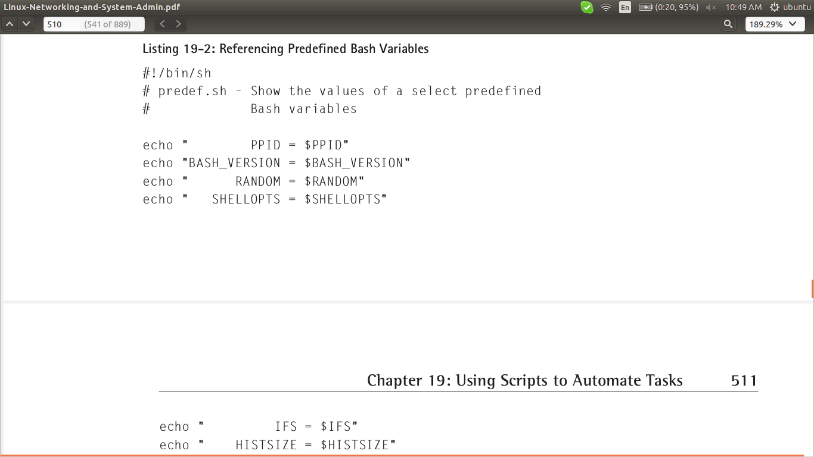
output :

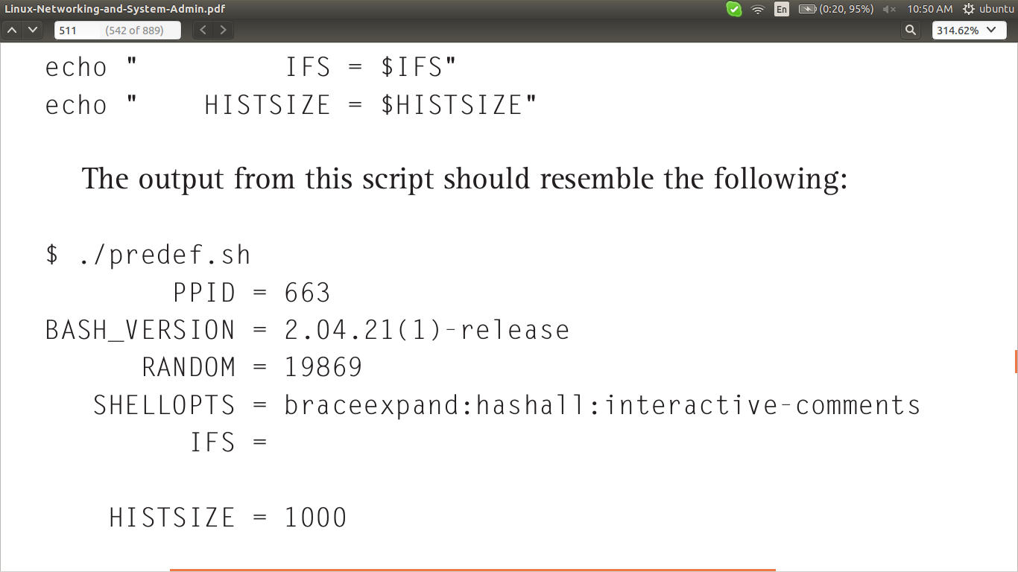

BASH STRING COMPARISON OPERATORS

Operator Expression True if...
= str1 = str2 str1 matches str2
== str1 == str2 str1 matches str2
!= str1 != str2 str1 does not match str2
< str1 < str2 str1 is less than str2
> str1 > str2 str1 is greater than str2
-n -n str str ’s length is nonzero
-z -z str str ’s length is zero

BASH NUMERIC COMPARISON OPERATORS

Operator Expression True if...
-eq val1 -eq val2 val1 equals val2
-ne val1 -ne val2 val1 is not equal val2
-ge val1 -ge val2 val1 is greater than or equal to val2
-gt val1 -gt val2 val1 is greater than val2
-le val1 -le val2 val1 is less than or equal to val2
-lt val1 -lt val2 val1 is less than val2

When comparing strings, keep in mind that A–Z come before a–z in the ASCII
character set, so A is “less than” a and foo is “greater than” bar

eg : Using Bash String Comparison Operators

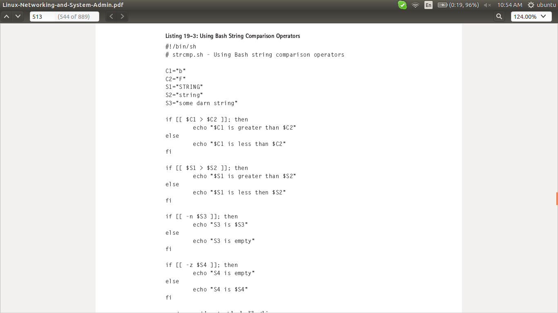

output :

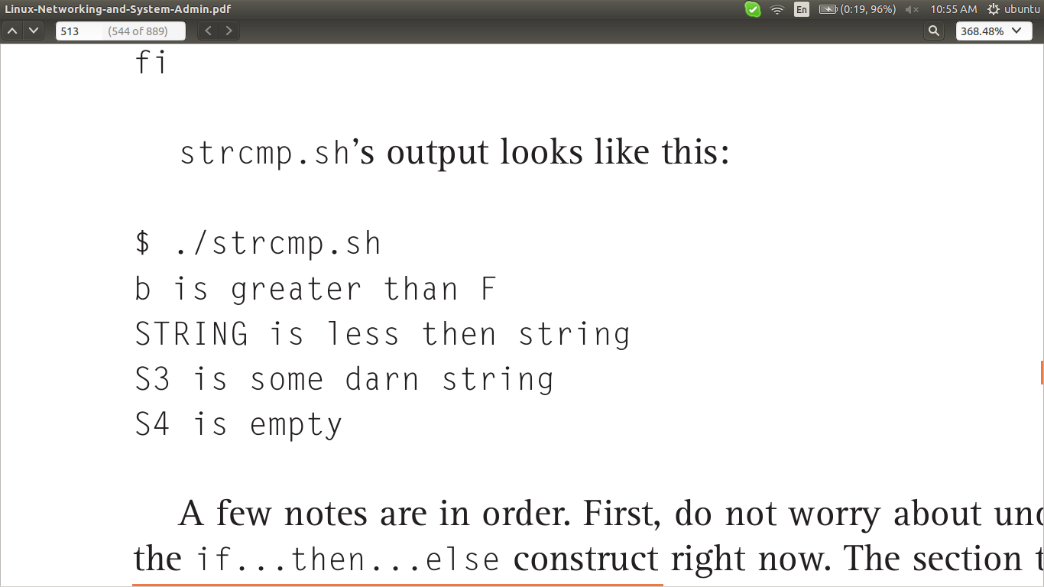

eg : Using Bash Numeric Comparison Operators

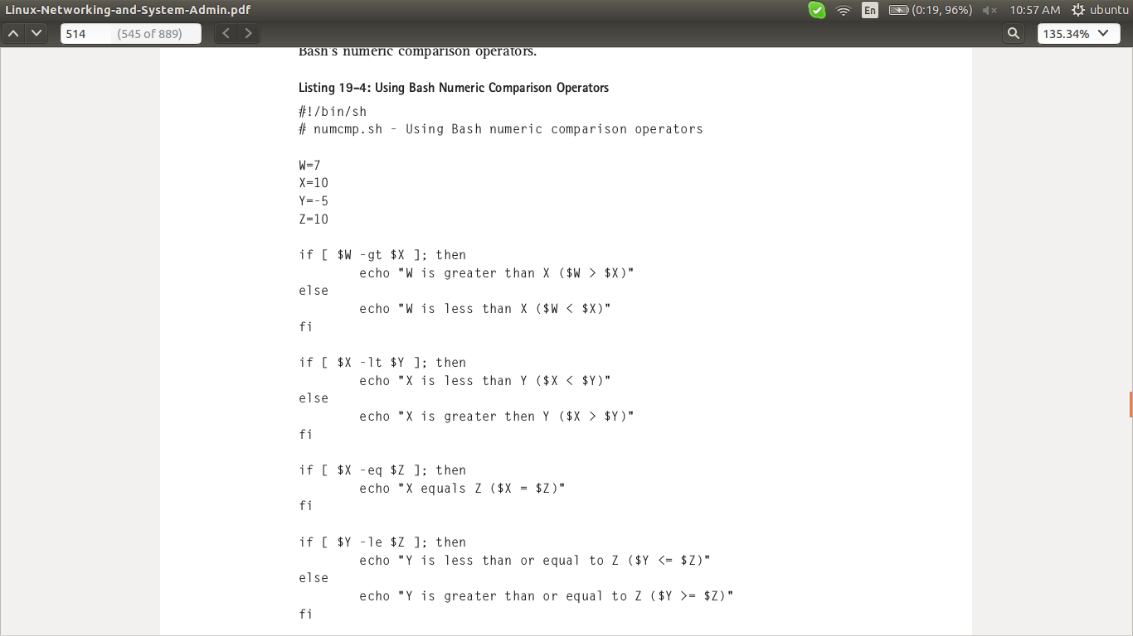
output :

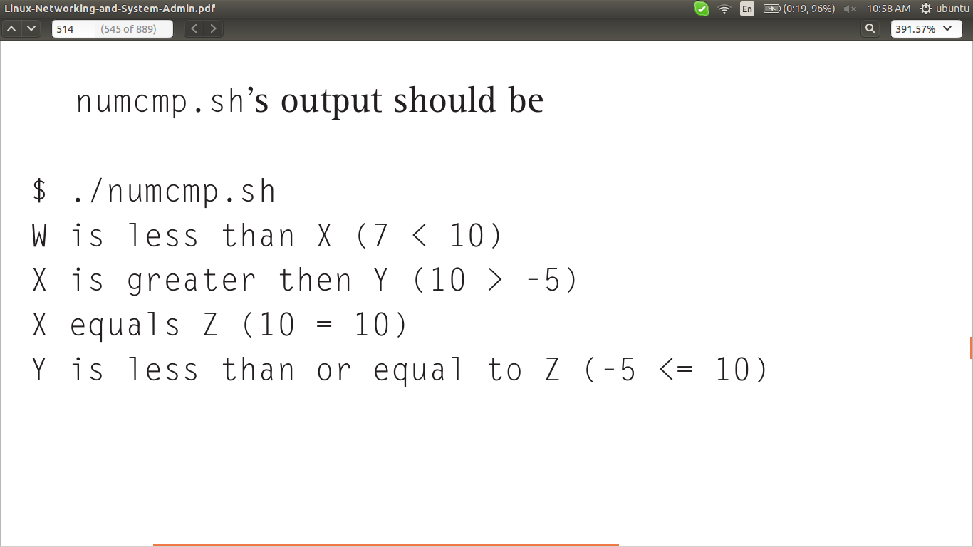

ARITHMETIC OPERATORS
If Bash allows you to compare numeric values and variables, it follows that Bash
allows you to perform arithmetic on numeric values and variables. In addition to
the comparison operators discussed in the previous section, Bash uses the operators
listed in Table 19-6 to perform arithmetic operations in shell scripts.

ARITHMETIC OPERATORS

Operator Expression Description
++ var++ Increments var after obtaining its value
++ ++var Increments var before obtaining its value
-- var-- Decrements var after obtaining its value
-- --var Decrements var before obtaining its value
+ var1 + var2 Adds var1 and var2
- var1 - var2 Subtracts var2 from var1
* var1 * var2 Multiplies var1 by var2
/ var1 / var2 Divides var1 by var2
% var1 % var2 Calculates the remainder of dividing var1
by var2
= var = op Assigns result of an arithmetic operation op
to var

FILE TEST OPERATORS

Many common administrative tasks involve working with files and directories.
Bash makes it easy to perform these tasks because it has a rich set of operators that
perform a variety of tests. You can, for example, determine if a file exists at all or
if it exists but is empty, if a file is a directory, and what the file’s permissions are.
Table 19-9 lists commonly used file test operators.

BASH FILE TEST OPERATORS
Operator Description

-d file file exists and is a directory.
-e file file exists.
-f file file exists and is a regular file (not a directory or special
file).
-g file file exists and is SGID (set group ID).
-r file You have read permission on file.
-s file file exists and is not empty.
-u file file exists and is SUID (set user ID).
-w file You have write permission on file.
-x file You have execute permission on file or, if file is a
directory, you have search permission on it.
-O file You own file.
-G file file ’s group ownership matches one of your group
memberships.
file1 -nt file2 file1 is newer than file2.
file1 -ot file2 file1 is older than file2 .

Eg : File Test Operators

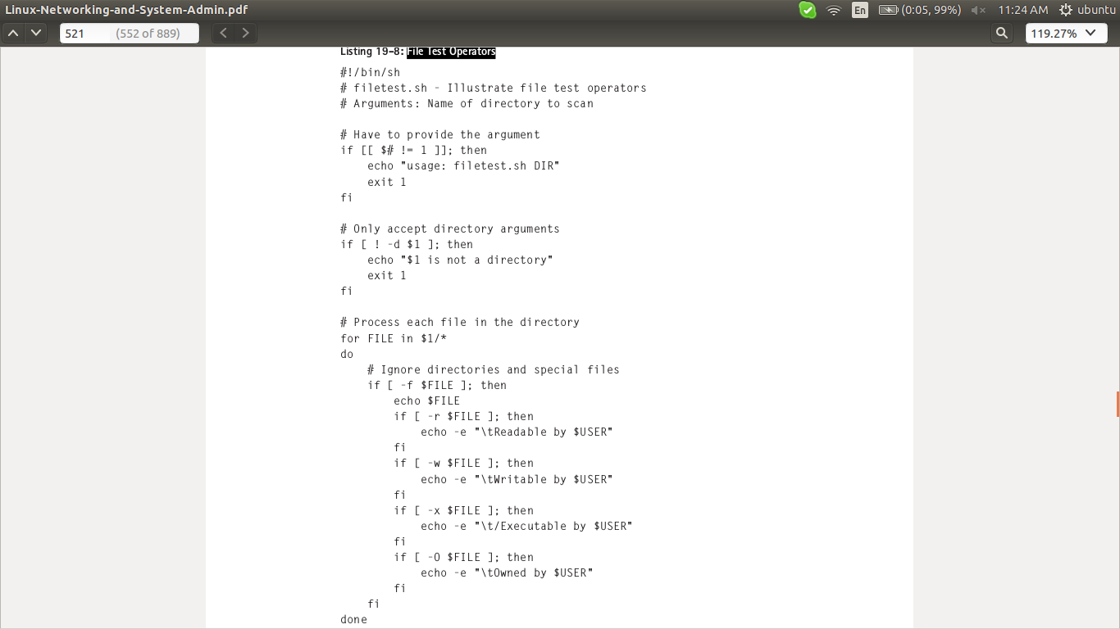

output :

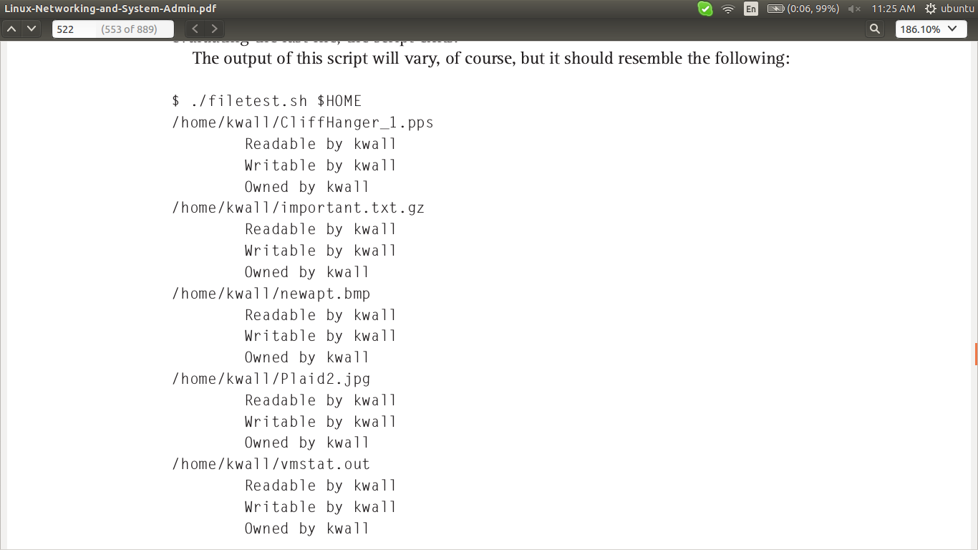

BASH FLOW CONTROL STATEMENTS

Statement Type Description
if Conditional Executes code if a condition is true or false
for Looping Executes code a fixed number of times
while Looping Executes code while a condition is true or false
until Looping Executes code until a condition becomes true or false
case Branching Executes code specific to the value of a variable
select Branching Executes code specific to an option selected by a user

CONDITIONAL EXECUTION USING IF

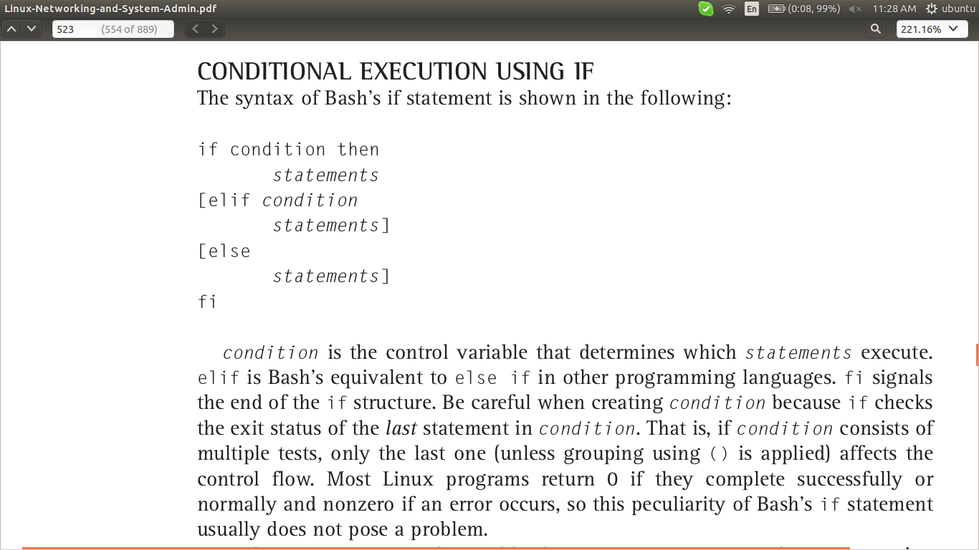

DETERMINATE LOOPS USING FOR
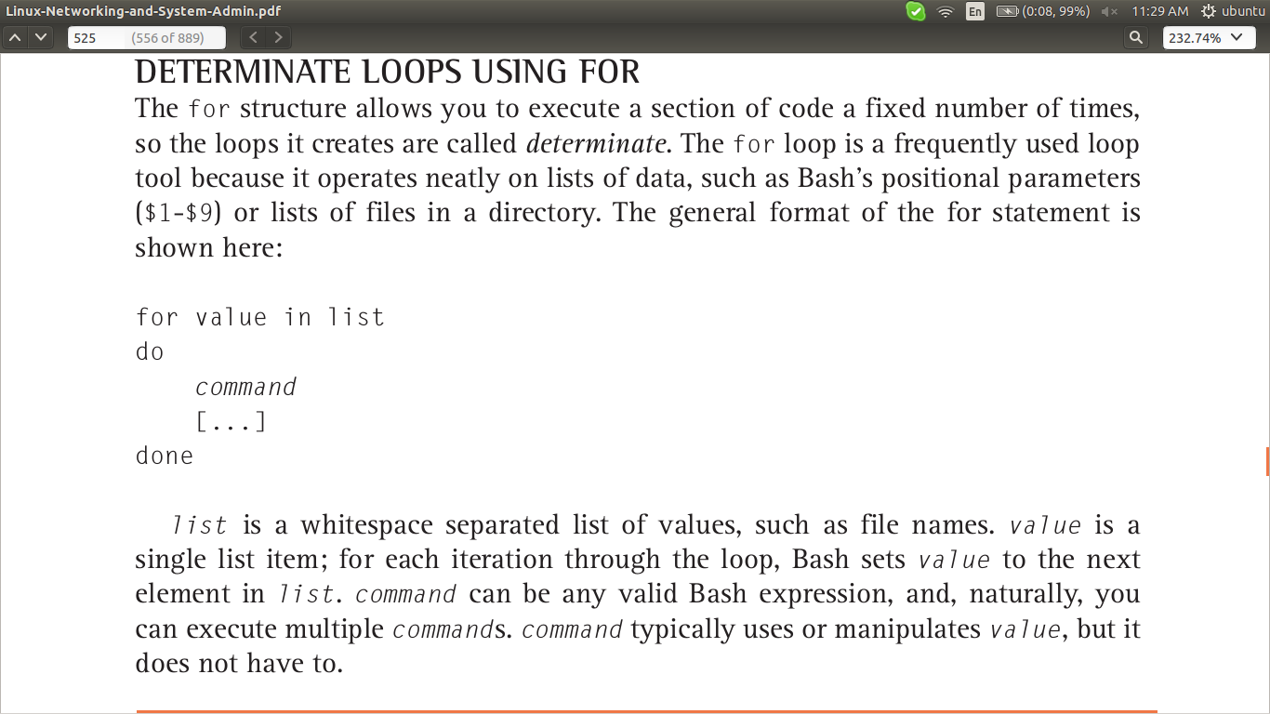

INDETERMINATE LOOPS USING WHILE AND UNTIL

The for loop is ideal when you know in advance, or can determine before entering
the loop, how many times a given section of code must execute. If you do not know
in advance or cannot determine at runtime how many times to execute a code
block, you need to use one of Bash’s indeterminate loop structures, while and
until . while and until constructs cause continued code execution as long as or
until a particular condition is met. The key here is that your code must ensure that
the condition in question is eventually met, or you will get stuck in an infinite loop.

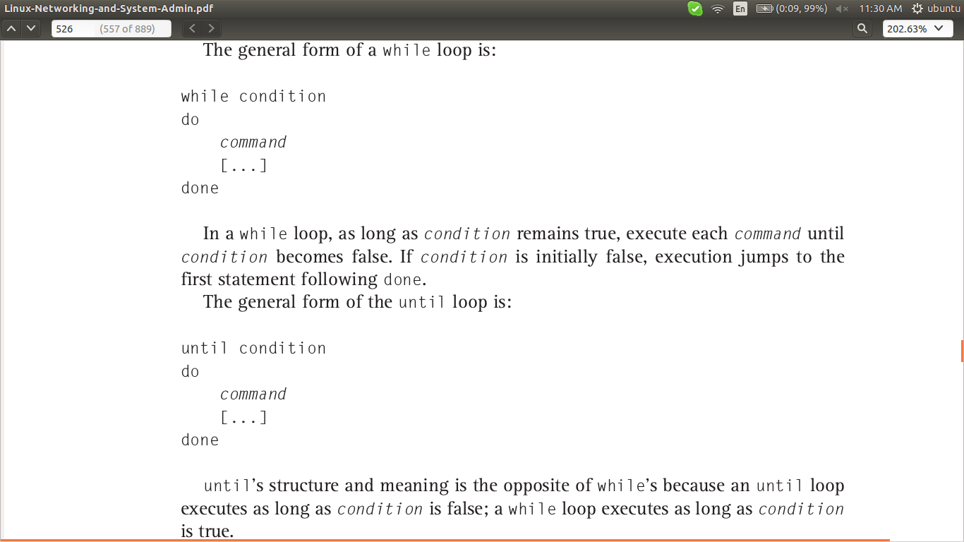

Eg : Bash while Loops

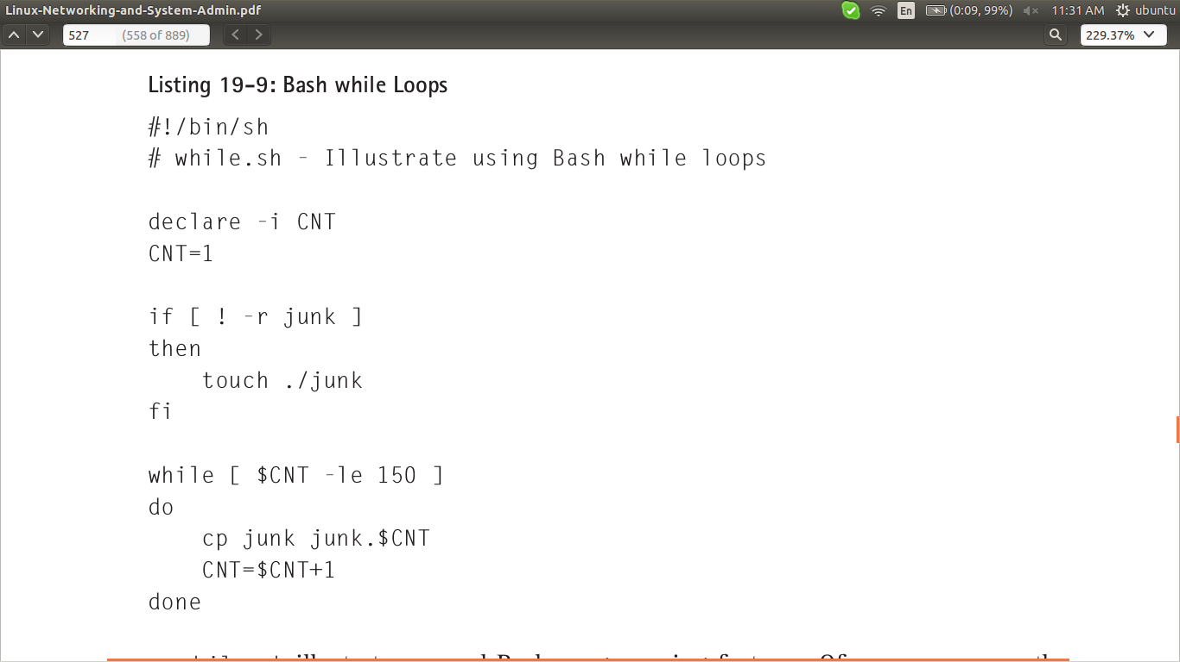

Eg : Bash until Loops

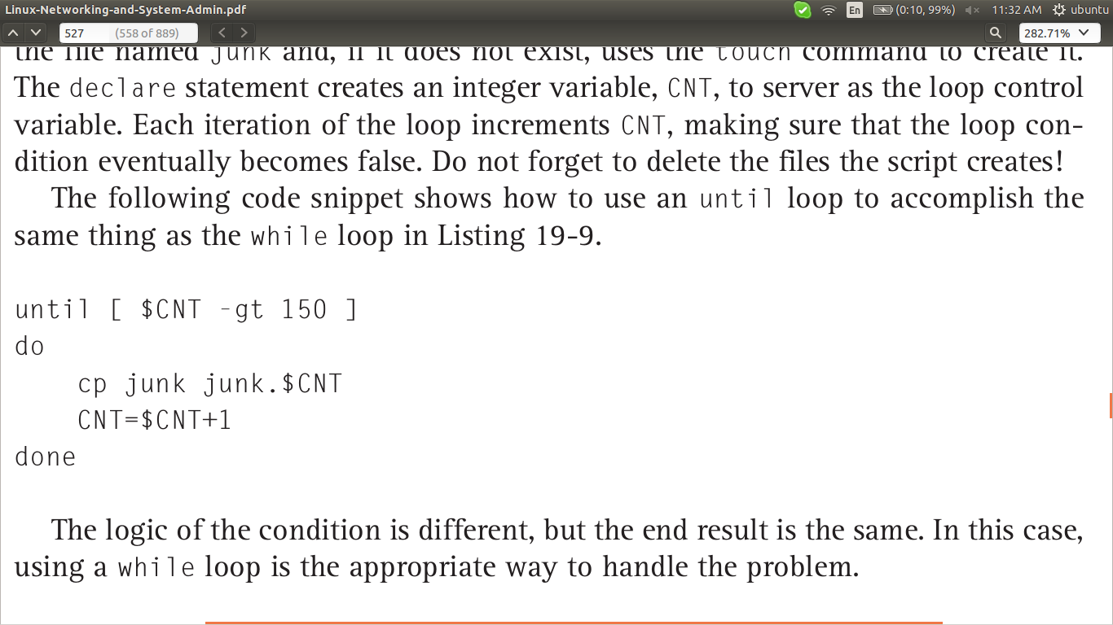

THE CASE STATEMENT

The case structure, approximately comparable to C’s
switch keyword, is best suited for situations in which a variable or expression can
have numerous values and as a replacement for long if blocks. The complete syntax
for case is as follows:

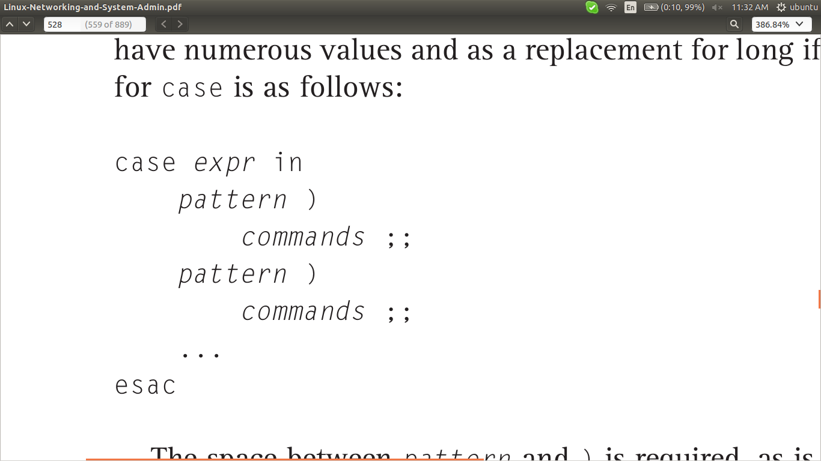

eg : Using the case Statement

