Wiki-confluence configuration in gui after installation

1) set confluence > next

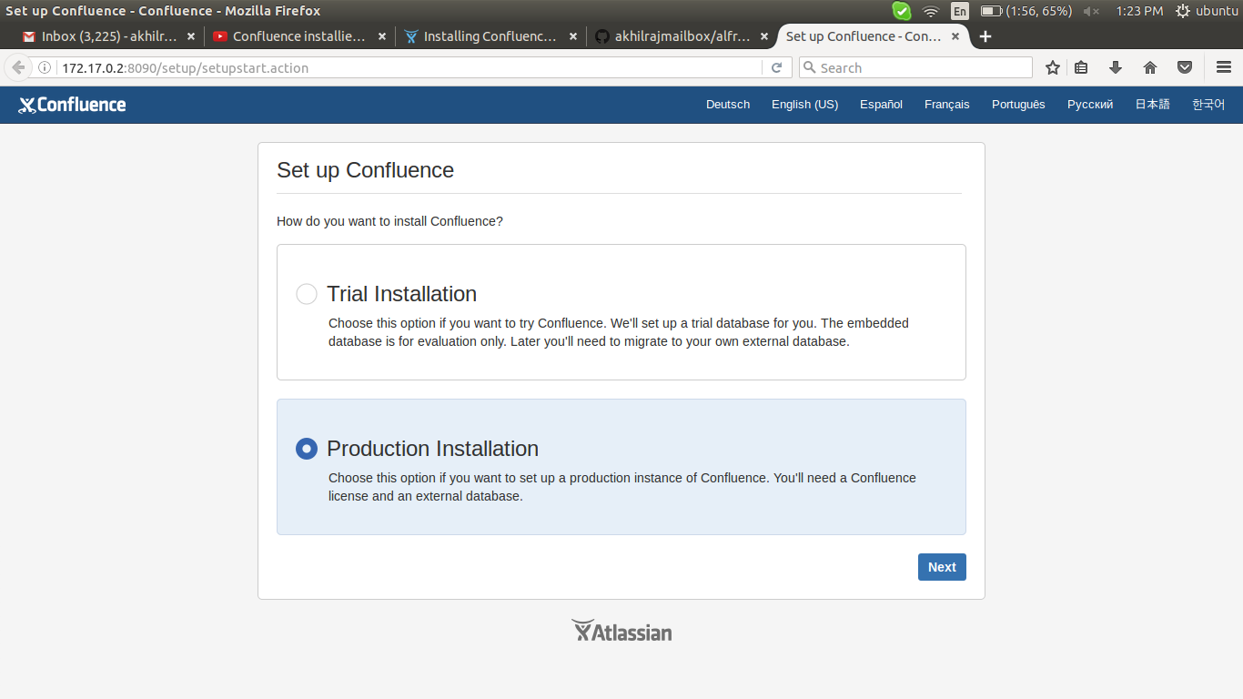

2) Get add-ons > next
(in here i didnt select anything)

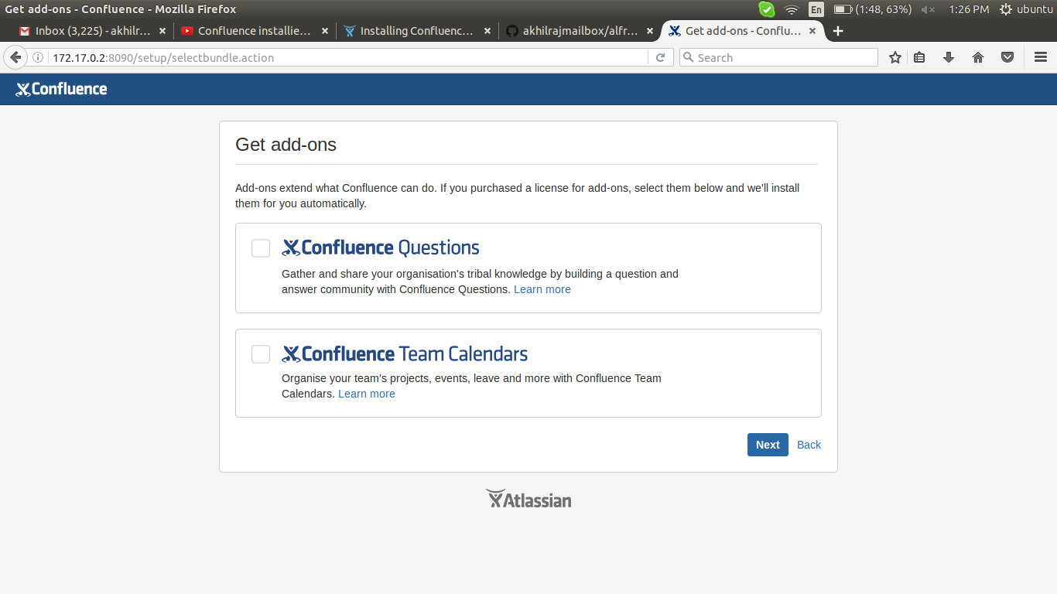

3) License key
Get an evaluation license > sing up > create a new account

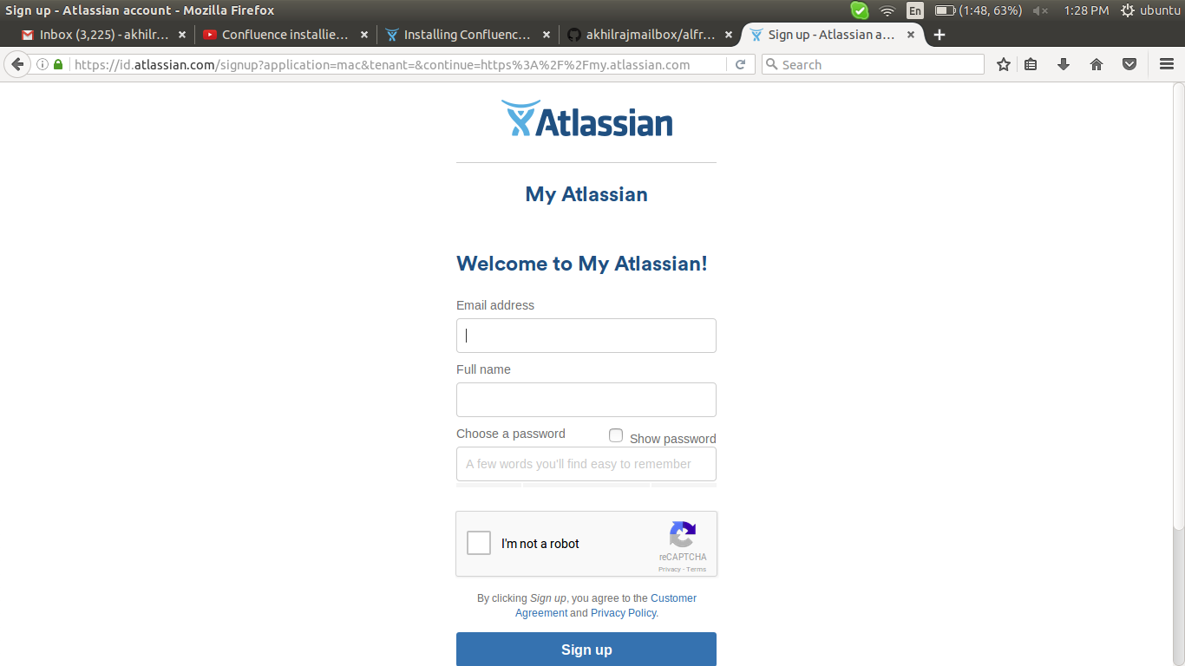

4) check email

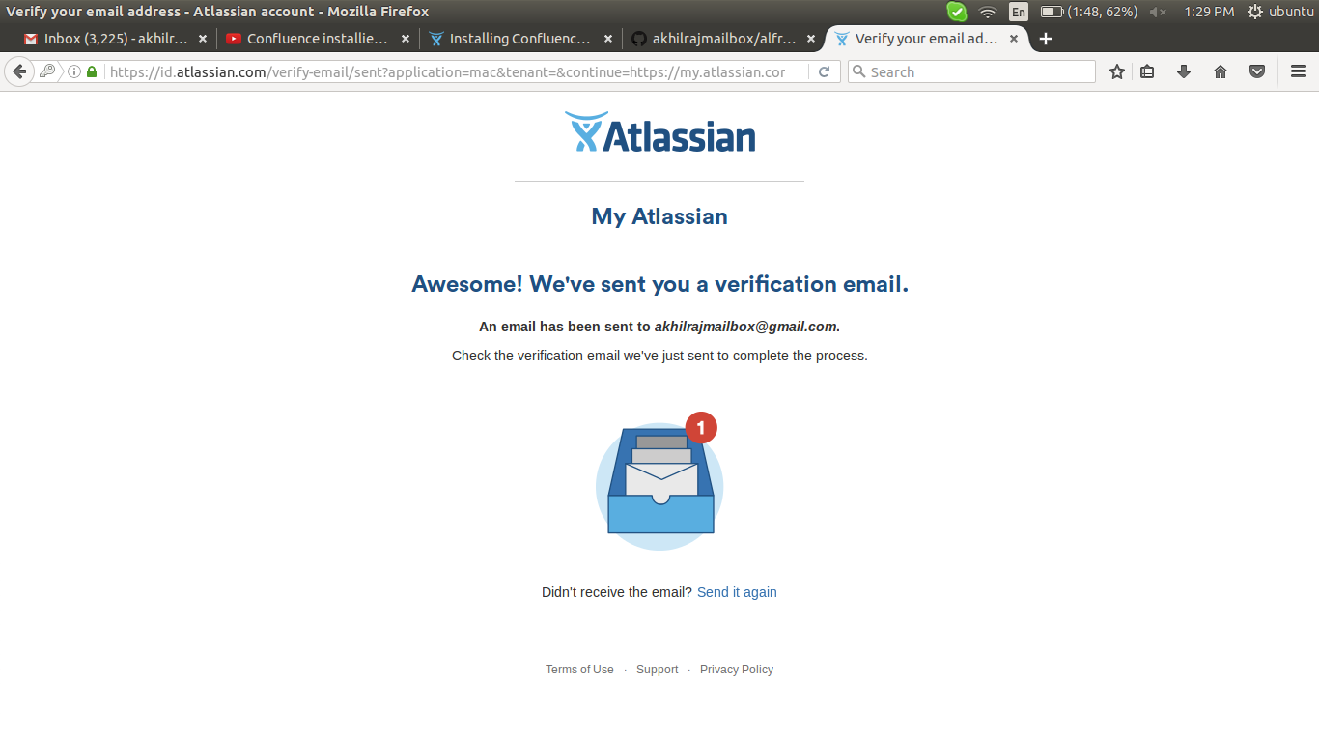

5) in mail > reset it

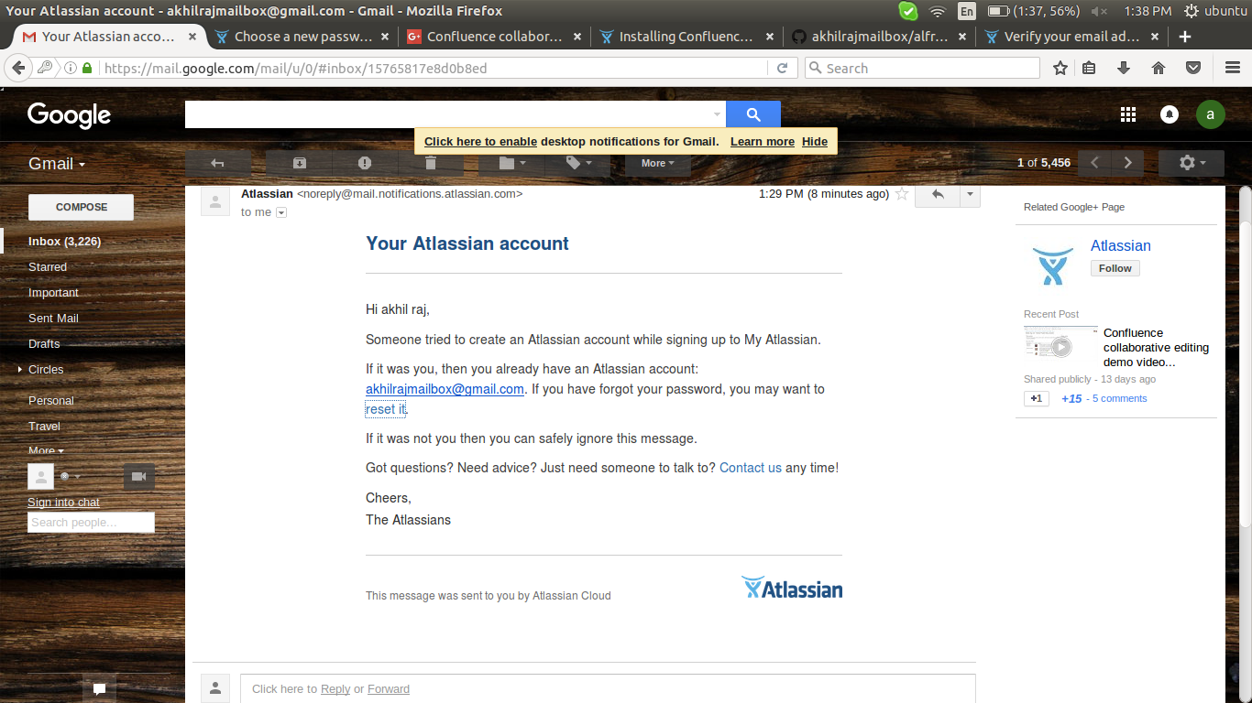

6) type passwd

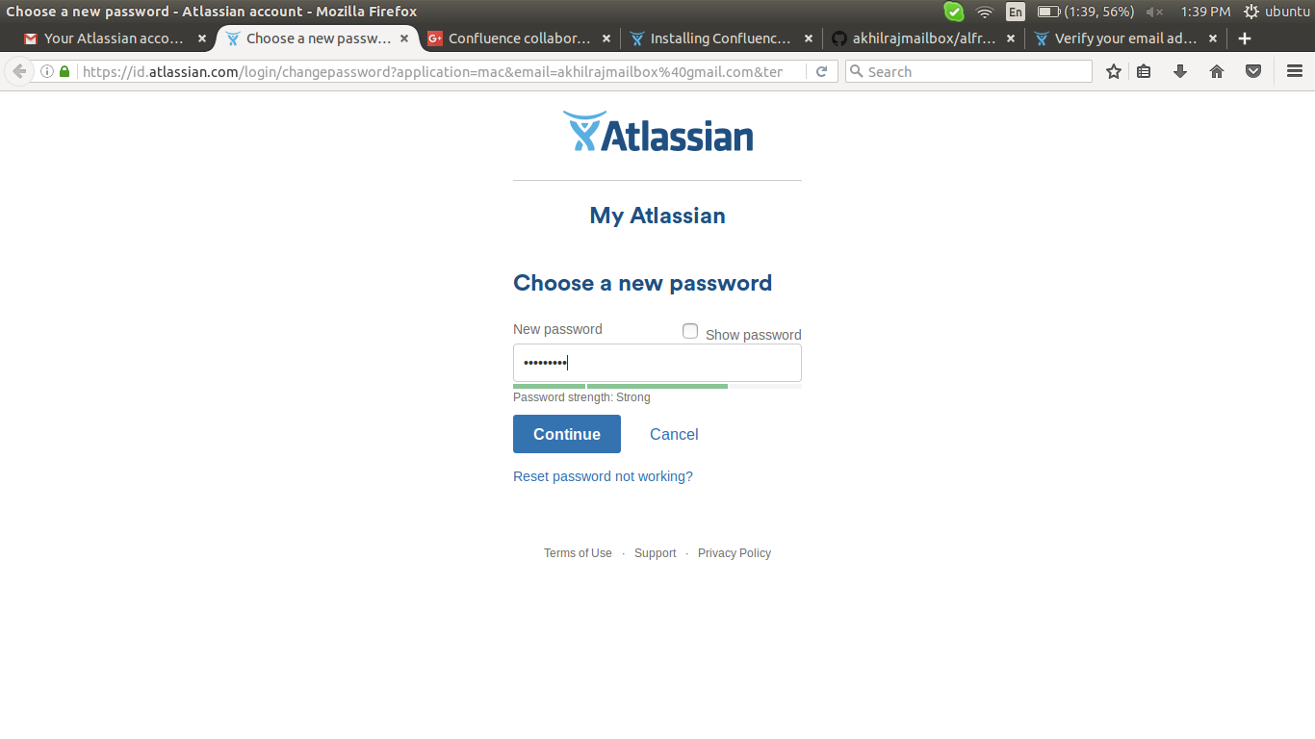

7) generate license

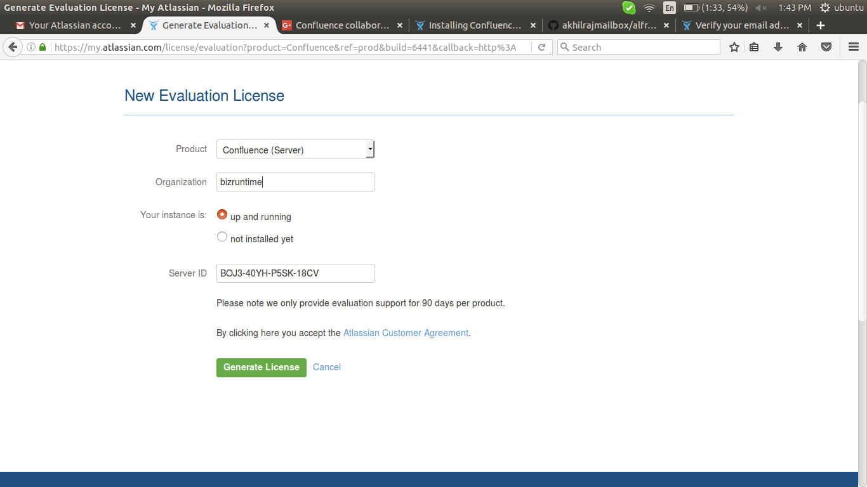

8) submit > yes > continue (shown up your server ip)

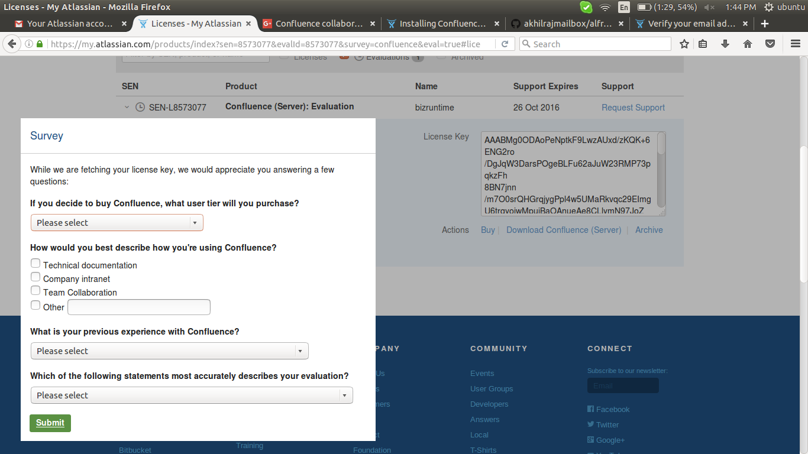

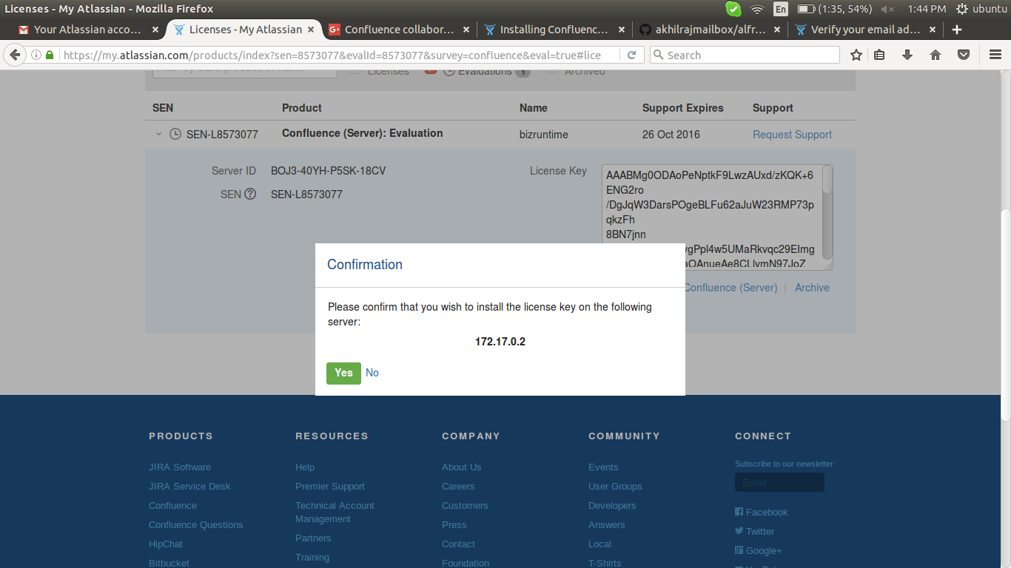

9) now there is a license in that field > next

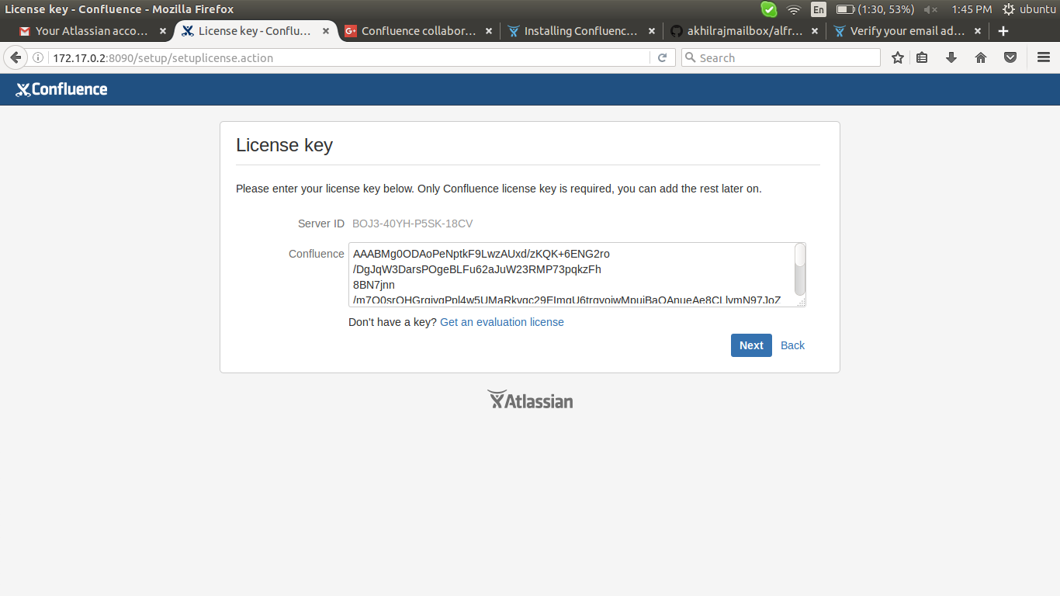

9) take mysql or postgresql connection > direct jdbc
for mysql connecton jdbc connector for mysql need to be download and put in
/opt/atlassian/confluence/confluence/WEB-INF/lib directory

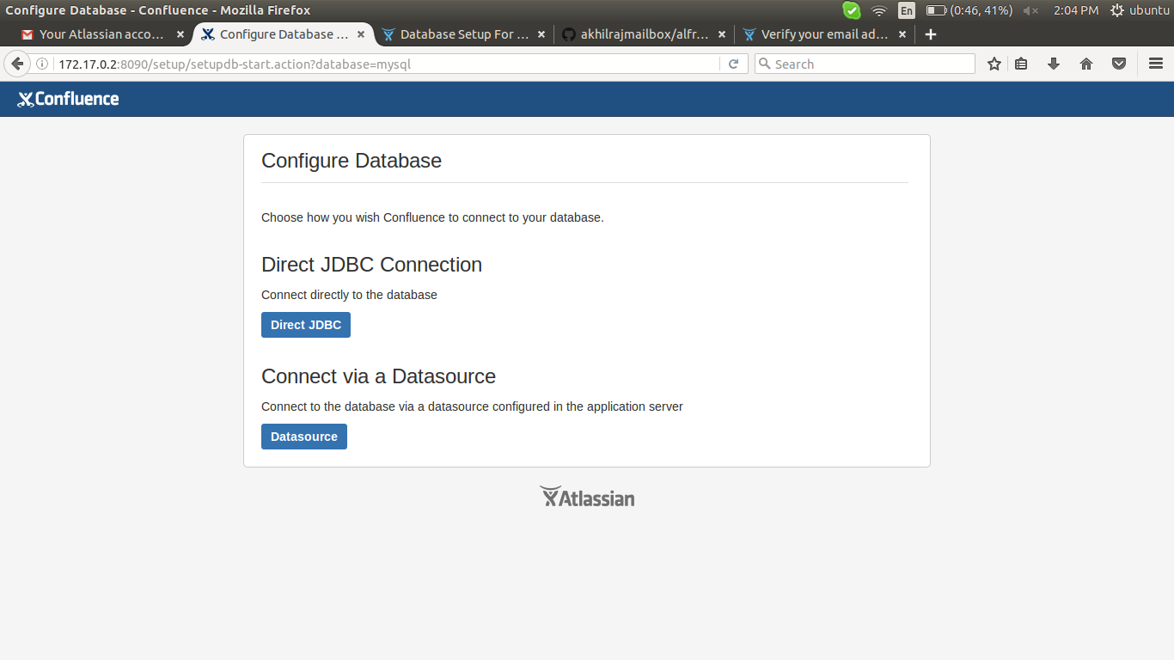

10) read the information carefully to configure mysql database, create a user, database, and give privileges to that user before go to this step

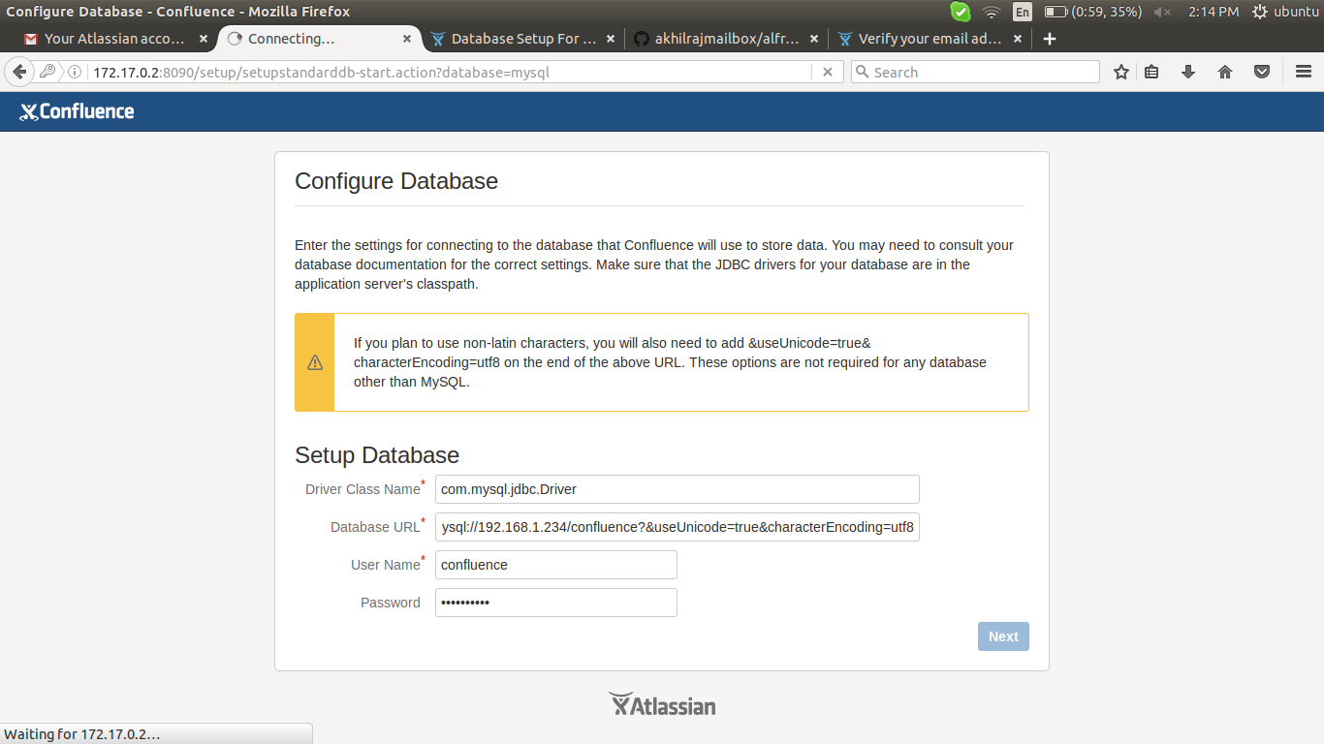

11) click on example site

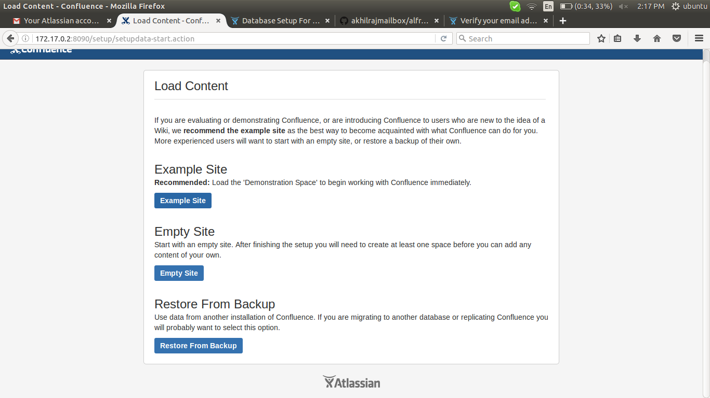

12) user management > manage users and groups within confluence

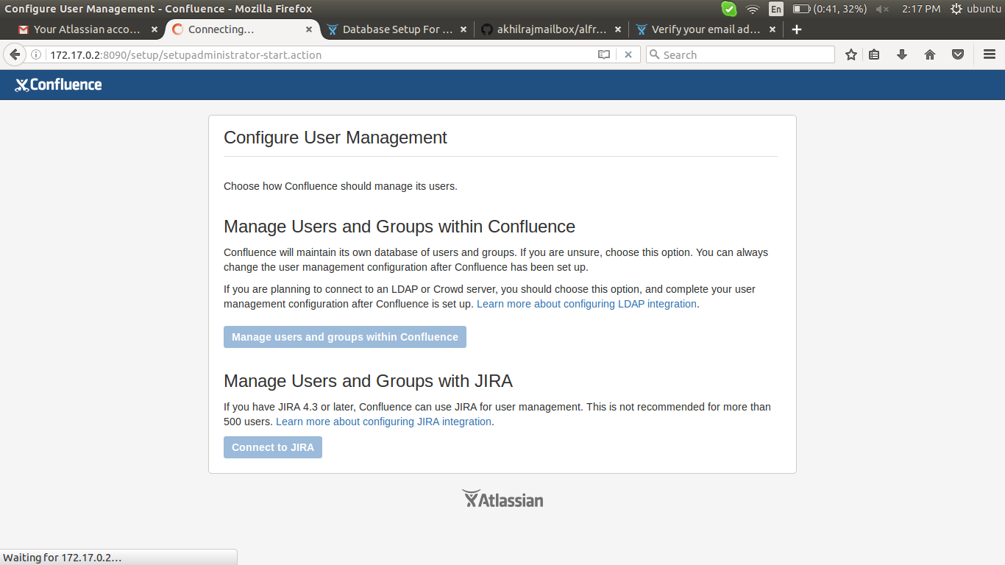

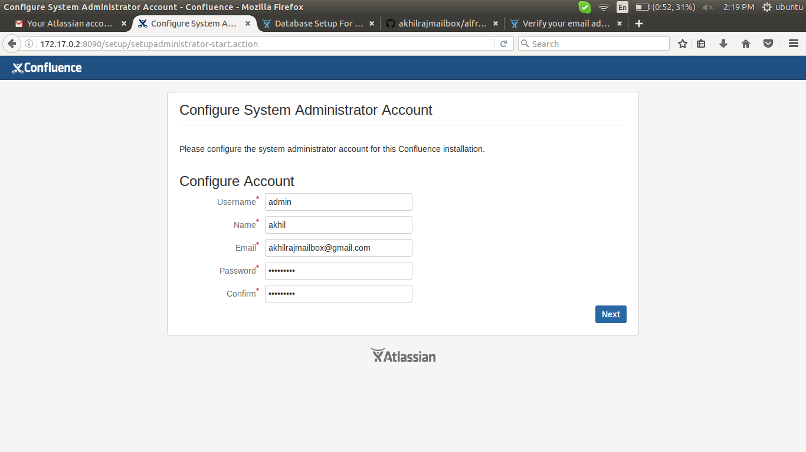

13) start the wiki

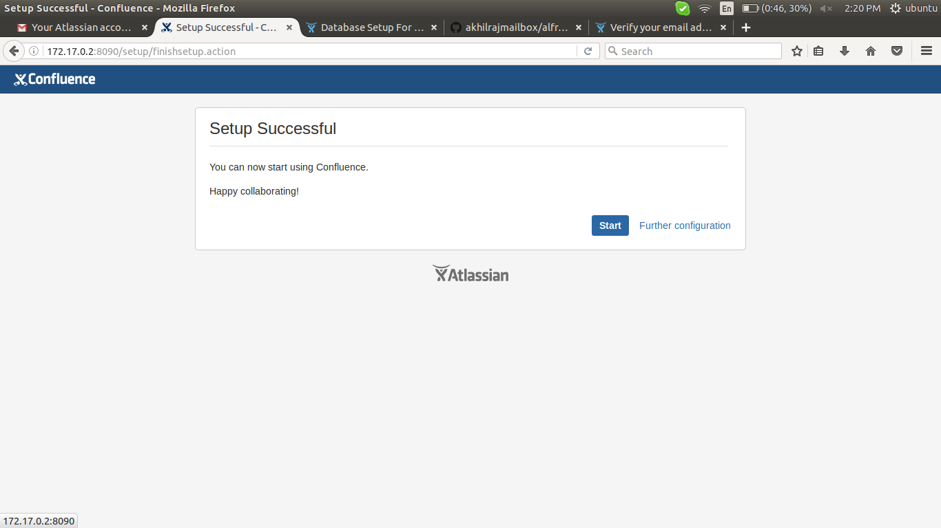

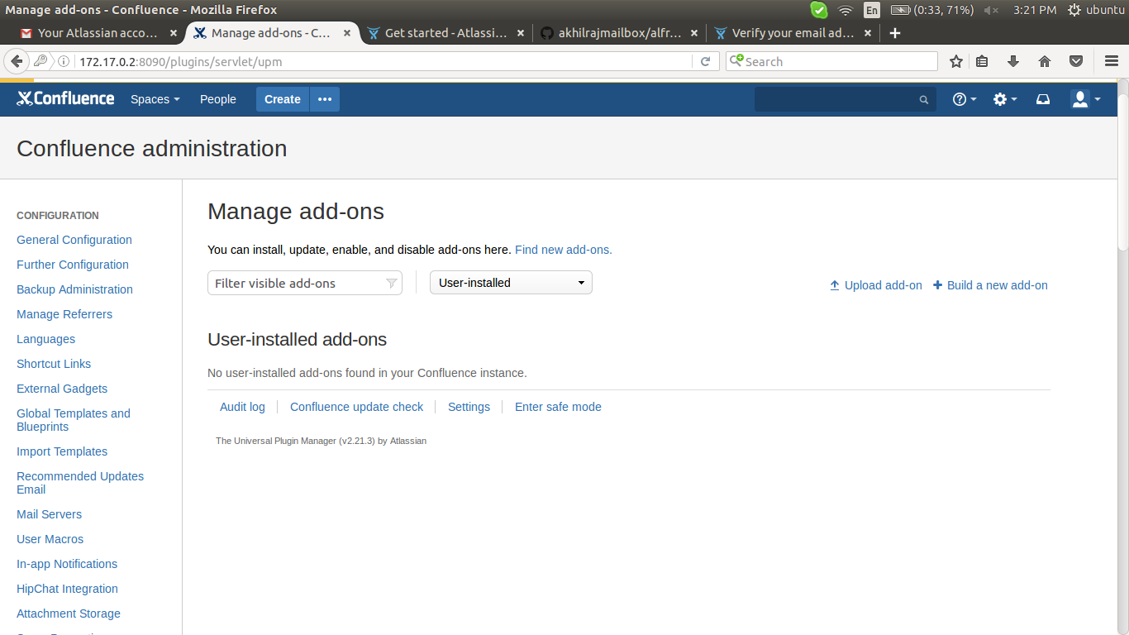

ldap configuration in wiki-confluence

1) home > general configuration

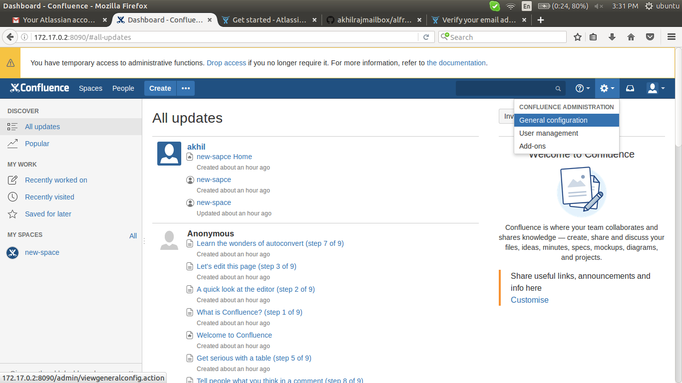

in configuration options (left side) > Users & Security > users directory > ldap > add directory

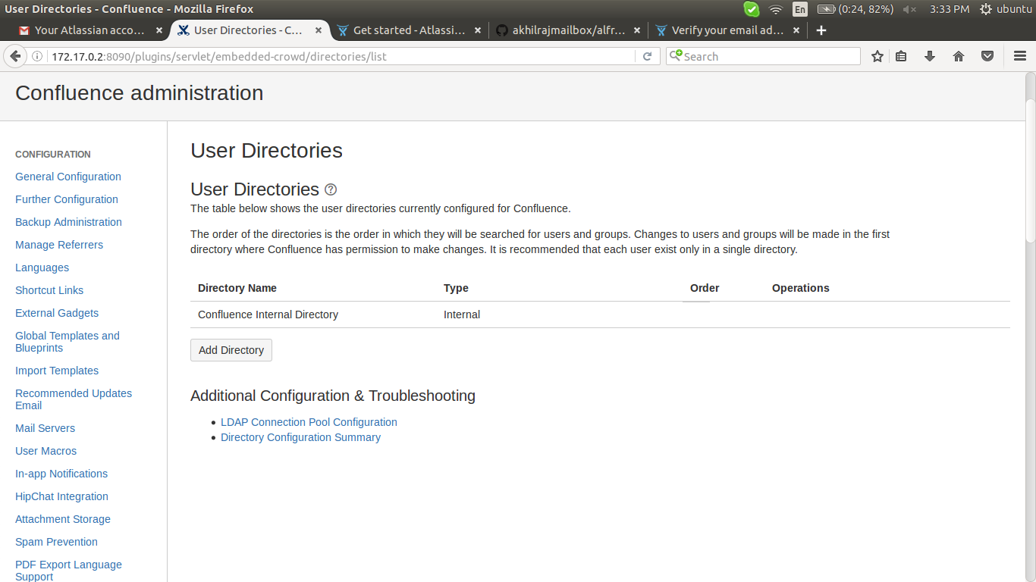

2) configure as following

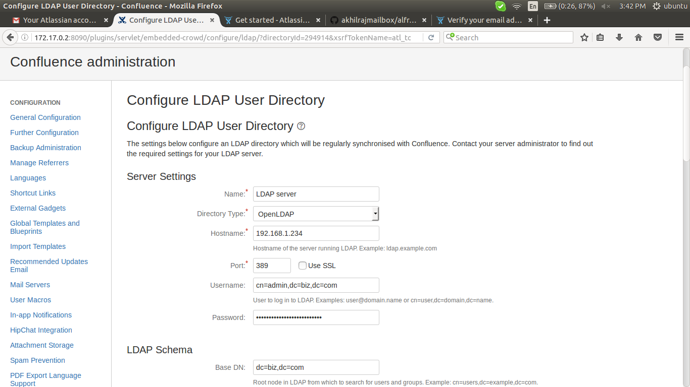

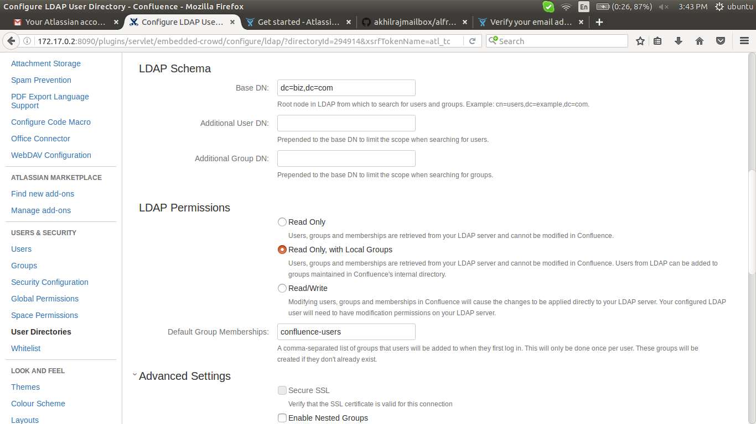

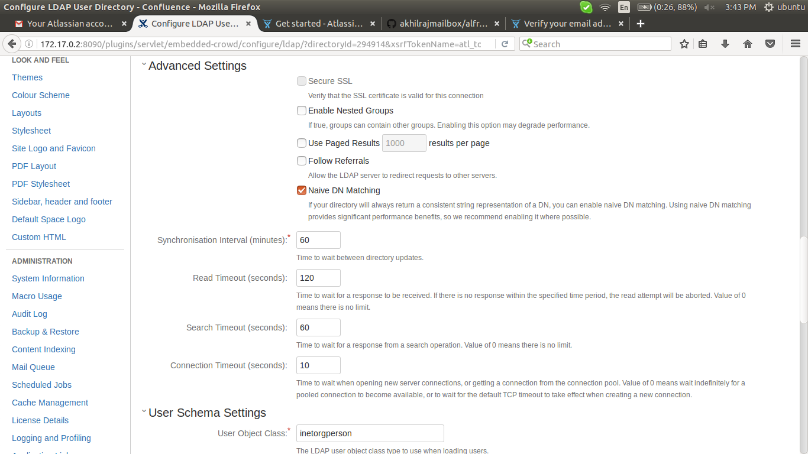

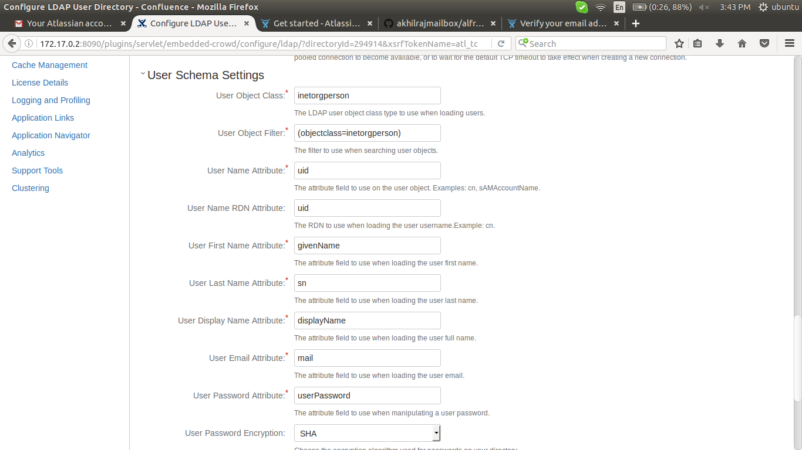

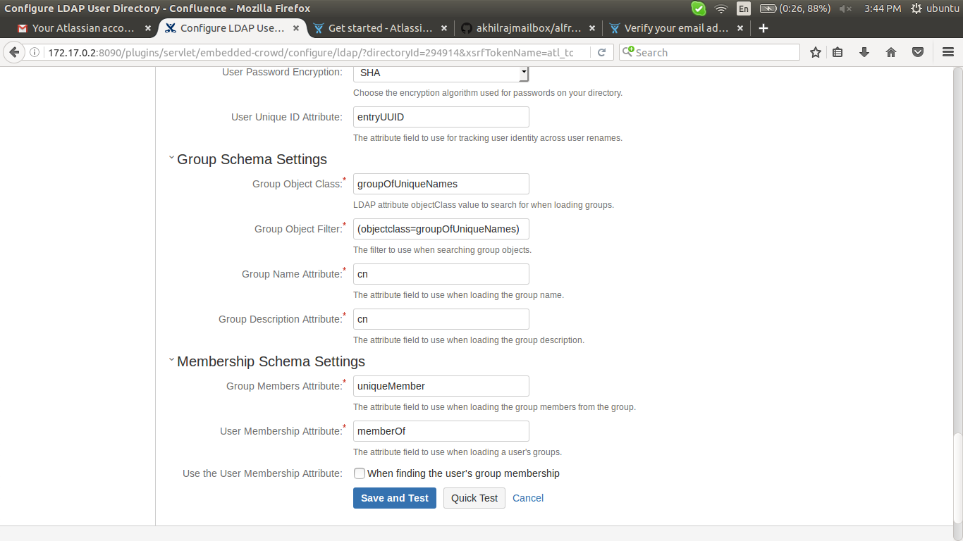

3) after configuration as per your ldap users information, click on save and test,

give username and passwd of ldap user in bottom of this page

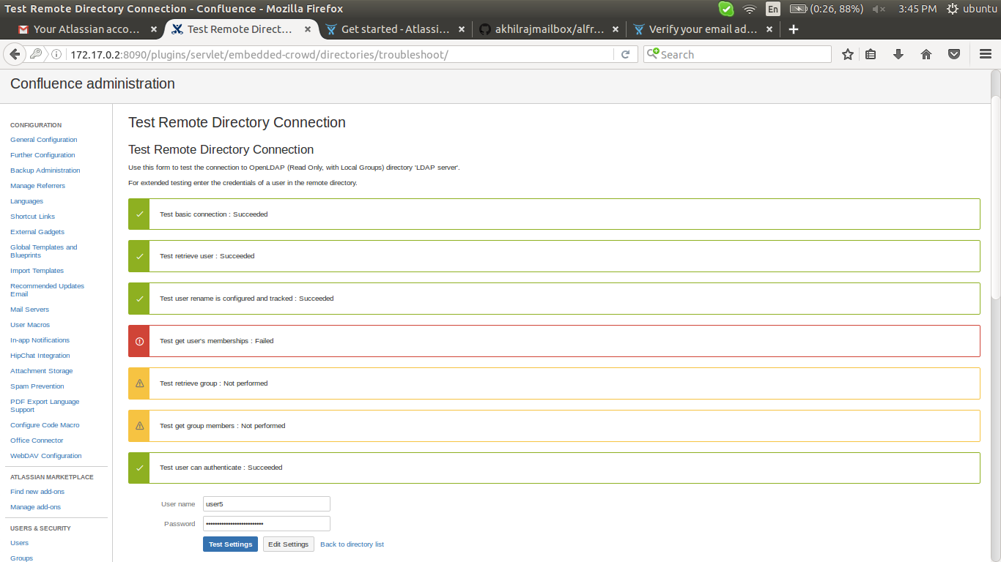

4) try to access with ldap user

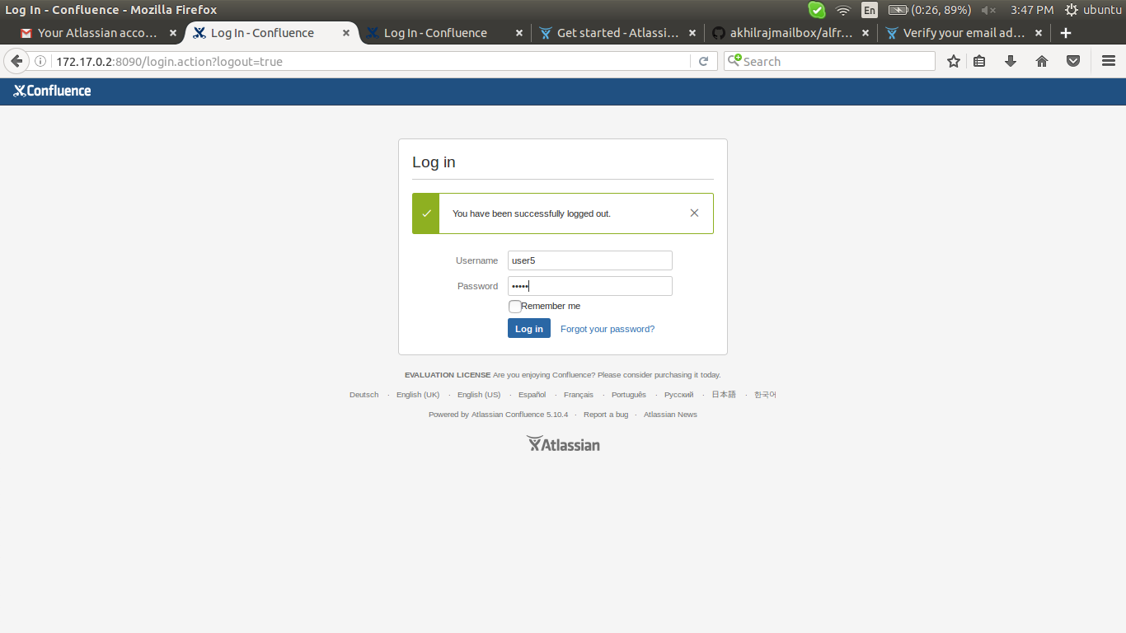

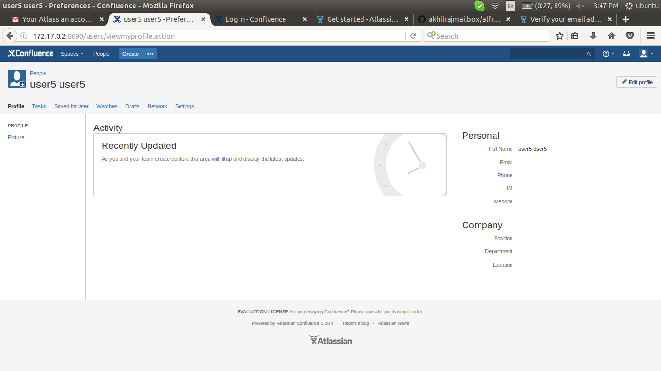

ssmtp configuration

1) general configuration > mail server > add a new smtp mail server

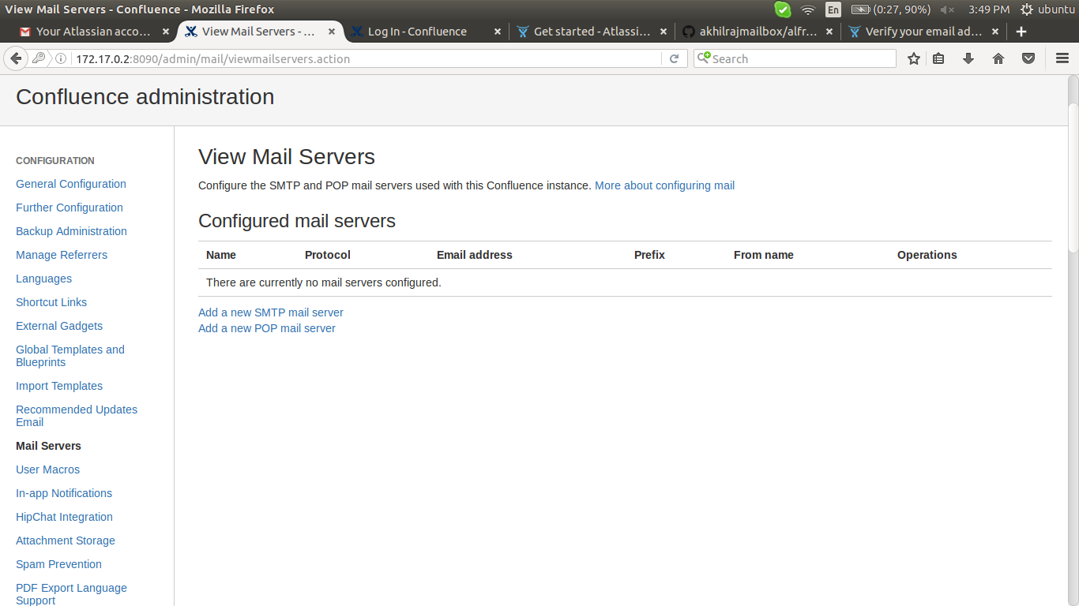

2) give the informations of the mail

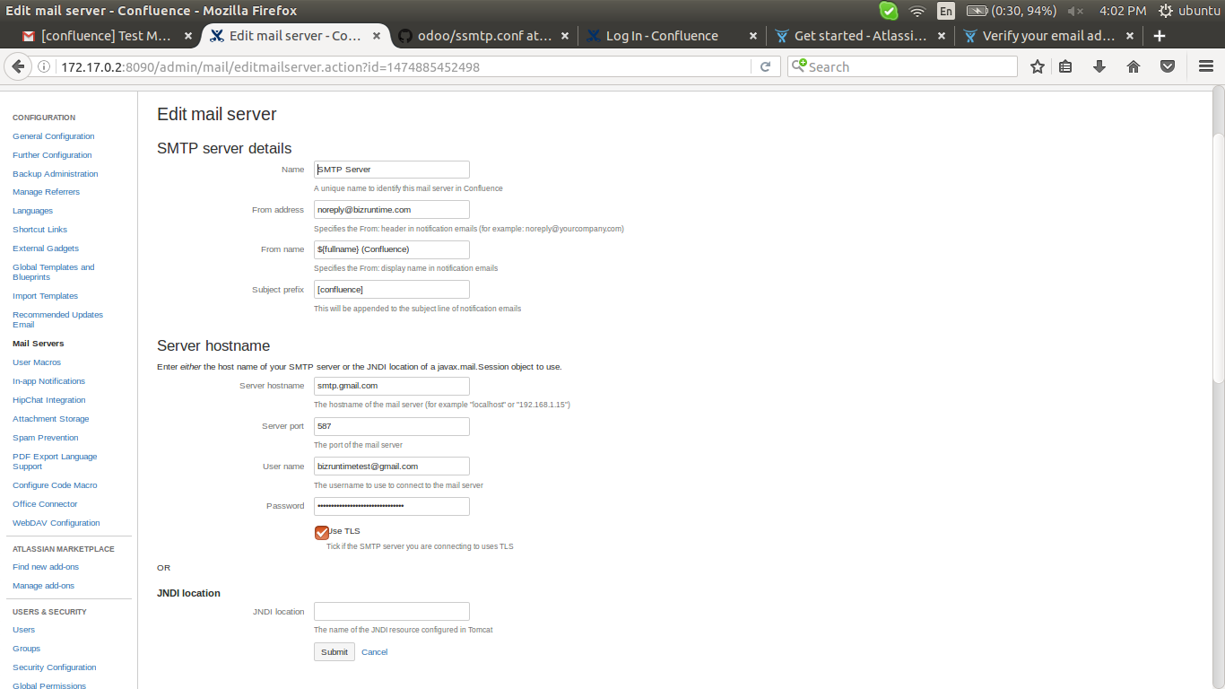

3) submit > send a test message

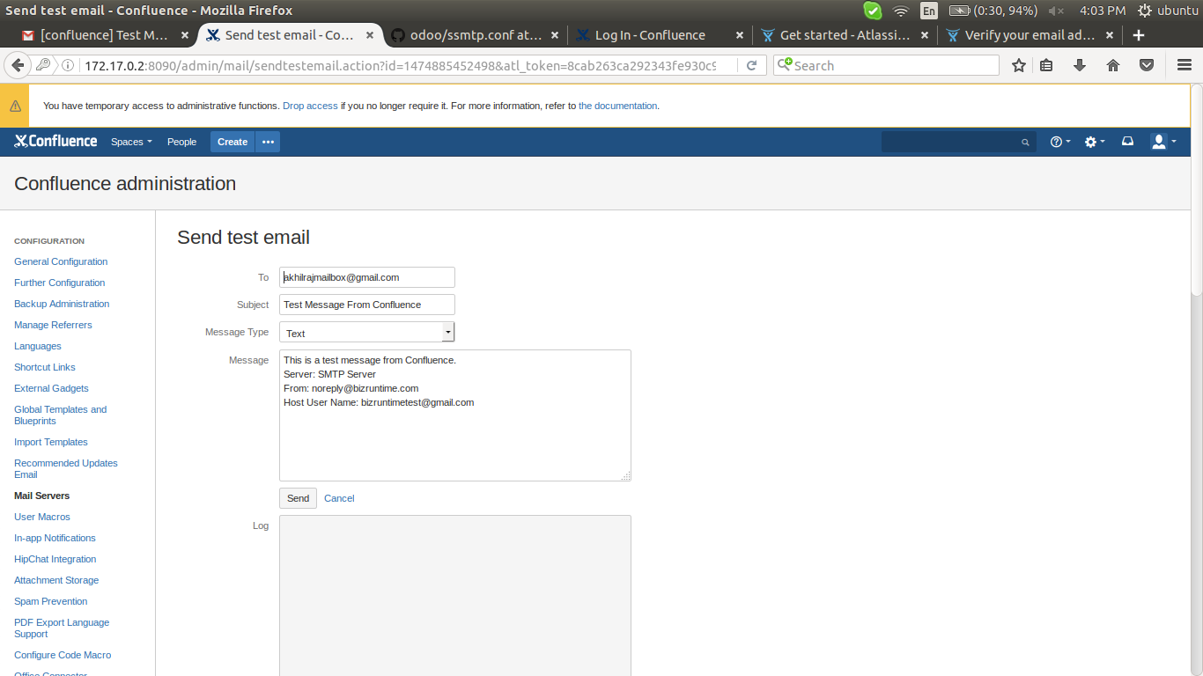

4) check on reciever mail



