Title: To solve the space junk problem, address economic incentives
Authors: Akhil Rao¹*, Matthew G. Burgess^{1,2,3}, Daniel Kaffine¹
Affiliations:
¹Department of Economics, University of Colorado Boulder
²Cooperative Institute for Research in Environmental Sciences, University of Colorado Boulder
³Environmental Studies Program, University of Colorado Boulder
*Correspondence to: akhil.rao@colorado.edu.
One Sentence Summary: Policies to reduce space junk should address incentives to overuse the space commons.
Main Text:
The Tragedy of the Commons (1) has reached the final frontier: space. As the global rate of satellite launches rapidly increases, each launched satellite contributes to—and risks damage from—a growing buildup of space debris (2). Without intervention, the industry may soon reach a tipping point at which the debris field becomes self-sustaining (3). Technological solutions are being explored (2), but these will not solve the underlying incentive problem driving the debris buildup. We argue that internationally coordinated economic incentives such as satellite taxes are needed, in addition to technological solutions. Existing international incentive systems could serve as a model for building necessary institutions. Using a simple model of commercial launches and debris accumulation in low-Earth orbit, we project that economically optimal incentives could quadruple the net present value of the satellite industry in 2020. The cost of continued inaction would escalate substantially each decade.
In 2017, 466 new satellites were launched—more than double the previous year’s launches, and more than 20% of all active satellites in orbit in 2017 (Fig. 1). These satellites risk colliding with space debris, currently including over 15,000 objects in low-Earth orbit (2). Satellites can also collide with each other, creating additional debris. If the debris buildup continues unabated, it could reach a tipping point, known as Kessler Syndrome, whereby debris growth becomes self-sustaining due to collisions between debris objects (3). Kessler Syndrome could make some low-Earth orbits unusable, and may also make higher orbits costlier or impossible to access.
As space debris accumulates and collision risk intensifies, much of the solutions focus (4) has been technological: How can we better map, clean up, and steer satellites away from existing debris? These solutions include end-of-life deorbit guidelines and “keep-out” zones for active satellites, and nets, harpoons and lasers to deorbit debris (5). However, due to open access to orbits, reducing the risk of satellite collisions will incentivize additional satellite launches. For instance, if firms were willing to tolerate a 0.1% risk of satellite loss before the technological improvement, they will be willing to launch more satellites until the risk of satellite loss once again becomes 0.1%.
As such, the core of the space debris problem is not technological; it is a problem of incentives. Firms and governments deciding how many satellites to launch are not adequately accounting for the adverse effects of increasing collision risk on other entities’ satellites. This is a classic Tragedy of the Commons problem (1, 2, 6), which can be addressed in an economically efficient manner via incentive-based solutions. For instance, governments of space-faring countries could coordinate harmonized satellite taxes, or a tradable permit systems for orbital slots, analogous to using carbon taxes or cap-and-trade to limit carbon pollution.
While the potential Tragedy of the Space Commons has been recognized (8-11), to our knowledge we are the first to quantify the economic benefits of correcting it. We use a simple dynamic model of space-industry economics and debris buildup to compare the economic value of optimally managed orbits against a business-as-usual (BAU), open-access scenario (Fig. 2) [see Supplementary Materials (SM)]. We first calibrate the model by fitting a model of open access to industry data and launch trends. Using the fitted model and projections of future growth of the space economy through 2040 (12), we project future launch rates under this BAU scenario. For comparison, we project launch rates which would maximize society’s economic benefit from satellite services, measured as the long-run value of the entire fleet of satellites in orbit, accounting for both the financial costs of replacing satellites due to natural retirement and collisions as well as the opportunity cost of investing funds in satellites rather than capital markets (net present value, or NPV). By comparing the open-access launch rates to the optimal launch rates, we are able to calculate the economic gains from shifting to optimal orbital management in a particular year.
We project that shifting from open access to optimal orbit management in 2020 would increase the NPV of the satellite industry by approximately $2 trillion in 2020, and by over $4 trillion in 2040. These gains can be achieved by imposing an annual tax on orbiting satellites, starting at around $40,000 per satellite per year in 2020 and escalating at ~5.2% per year to around $1 million per satellite per year in 2040. Rising optimal tax paths are common in environmental pricing such as carbon taxes.
The cost of inaction in 2040—measured as forgone long-run economic value of the satellite industry in 2040 due to suboptimal management under BAU—escalates from around $1 trillion if optimal management begins in 2020 to $4.6 trillion if optimal management begins in 2035. The costs of institutional inaction even when active debris removal is available remain substantial. At best, debris removal can recover up to 55% of the value lost under open access. At worst, it can exacerbate orbital congestion in a rebound-type effect, causing additional losses on the order of 15% of the value already lost from open access due to the costs of launching until risk is once again equated with return (see SM).
Escalating costs of inaction through time is a common feature of the Tragedy of the Commons. In other sectors, addressing the Tragedy of the Commons has often been a game of catch-up, with substantial social costs (13). For example, tens of billions of dollars in net benefits are lost annually from open-access or poorly-managed fisheries (14). Similarly, open access to oil fields at the turn of the century drove recovery rates down to 20-25% at competitively drilled sites, compared to 85-90% potential recovery under optimal management (15). Open access to roadways—somewhat analogous to orbits—is estimated to create traffic congestion costs in excess of $120 billion a year in the U.S. alone (16). In contrast, with the space industry still in its infancy, there is a rare opportunity to get out ahead of the Tragedy of the Commons, if the right incentives can be put in place.
The international natures of orbit users and the satellite industry pose challenges to implementing satellite pricing systems, but these challenges need not be insurmountable.
Theory suggests that countries could each collect and spend tax revenues domestically, without losing economic efficiency as long as the tax level was internationally harmonized (7). One example of such a system is the Vessel Day Scheme (VDS) used by the Parties to the Nauru Agreement (PNA) to manage tuna fisheries (17). Under the VDS, PNA countries lease fishing rights within their waters, using a common price floor, but each retains the lease revenue domestically (17). This system has been politically popular within the PNA, and has generated significant revenue for its constituent countries (17).
There is also precedent for internationally coordinated tradable permit systems. The European Union, for instance, has a carbon cap-and-trade system (the Emissions Trading System, ETS) coordinated across its member countries. Since 2005, capped emissions under ETS have fallen by 21%. California and Quebec have cap-and-trade systems that are linked. Both the Kyoto Protocol and Paris Agreement have provisions allowing countries to trade emission rights.
Each of these internationally coordinated pricing programs is built on a pre-existing governance institution or bilateral relationship—the Nauru Agreement, the E.U., the UN, the close bilateral relationship between Canada and the U.S. Similarly, a satellite tax could be built within existing governance of the orbital commons. For example, Article VI of the Outer Space Treaty states that countries supervise their space industries. This article could thus provide a framework for nation-based enforcement of a satellite tax. Further, Article IX of the Outer Space Treaty establishes that treaty members have a duty to engage in international consultation when activities by one country may cause “potential harmful interference” to another. Such “potential harmful interference” could be defined to include collision risk in excess of the socially optimal level as determined by state-of-the-art science.
Of course, orbits are useful for more than just commercial purposes. In December of 2018, satellites from all nations with acknowledged military users accounted for 430 of the 1957 satellites in orbit. The US military is a particularly large user of orbits, accounting for approximately 134 satellites in orbit—just over 6% of all satellites, and over 30% of all satellites with military users. In addition to acknowledged national security satellites, some ostensibly-commercial satellites may also fill national security needs. Further, governments may provide satellite-based public goods to their citizens, such as remote sensing and GIS. In practice, any international satellite management policy should account for these interests. Antarctica and the Arctic Circle offer two models of internationally managed regions in which commercial interests interact with geopolitical interests.
Our projection that technical or managerial solutions to the space debris problem are unlikely to be effective, by failing to address the underlying incentives problem, mirrors the experience in other resource contexts. For instance, in fisheries, attempts to restrict entry have led to “capital stuffing,” where existing vessels heavily invest in harvest capacity. Similarly, catch limits led to the “race to fish” phenomena, whereby fishermen exert extreme effort to harvest as much as possible before the catch limit is reached. Attempts to build new highway capacity to reduce traffic congestion have been frustrated because new capacity induces new demand for travel (18). By contrast, policies such as individual tradable quotas (19) and congestion charges (20) directly target the underlying incentive issue and have proven more successful, though are not without some controversy due to distributional effects (21).
The Tragedy of the Space Commons is an incentives problem, and therefore needs solutions that address incentives. While technology fixes are promising, relying on them alone is likely to have escalating and unnecessary costs. Successful international incentive programs, such as the EU Emissions Trading System and the PNA’s Vessel Day Scheme, offer potential models for success.

References and Notes:
- G. Hardin, The tragedy of the commons. Science 162, 1243-1248 (1968).
- A. Witze, The quest to conquer Earth's space junk problem. Nature 561, 24-26 (2018).
- D.J. Kessler, B.G. Cour-Palais, Collision frequency of artificial satellites: The creation of a debris belt. Journal of Geophysical Research 83, 2637-2646 (1978).
- J. Morin, Four steps to global management of space traffic. Nature 567, 25-27 (2019).
- J. Pearson, J. Carroll, E. Levin, Active Debris Removal: EDDE, the ElectroDynamic Debris Eliminator. Space Manufacturing 14 (2010)
- H.S. Gordon, The economic theory of a common-property resource: The fishery. Journal of Political Economy 62, 124-142 (1954).
- M. L. Weitzman, Can negotiating a uniform carbon price help to internalize the global warming externality? Journal of the Association of Environmental and Resource Economists 1, 29-49 (2014).
- M. Weinzierl, Space, the final economic frontier. Journal of Economic Perspectives 32, 173-192 (2018).
- C. Muñoz-Patchen, Regulating the space commons: Treating space debris as abandoned property in violation of the Outer Space Treaty. Chi. J. Int'l L. 19, 233 (2018).
- N. Adilov, P. J. Alexander, B. M. Cunningham, Earth orbit debris: An economic model, Environmental and Resource Economics 60, 81-98 (2015).
- N. Adilov, P.J. Alexander, B.M. Cunningham, An economic “Kessler Syndrome”: A dynamic model of earth orbit debris. Economics Letters 166, 79-82 (2018).
- A. Jonas et al., “Space: Investment Implications of the Final Frontier.” (Morgan Stanley, 2017). Accessed January 2019. Available from: https://fa.morganstanley.com/griffithwheelwrightgroup/mediahandler/media/106686/Space_%20Investment%20Implications%20of%20the%20Final%20Frontier.pdf.
- G.D. Libecap, Contracting for property rights. Property rights: Cooperation, conflict, and law (2003).
- K. Kelleher, R. Willmann, R. Arnason, The sunken billions: the economic justification for fisheries reform. (The World Bank, 2009).
- G.D. Libecap, S.N. Wiggins, Contractual responses to the common pool: Prorationing of crude oil production. American Economic Review 74, 87-98 (1984).
- D. Schrank, T. Lomax, B. Eisele. Urban Mobility Report. Texas Transportation Institute, College Station, TX (2012).
- E. Havice, Rights-based management in the Western and Central Pacific Ocean tuna fishery: economic and environmental change under the Vessel Day Scheme. Marine Policy 42, 259-267 (2013).
- G. Duranton, M.A. Turner, The fundamental law of road congestion: Evidence from US cities. American Economic Review 101, 2616-52 (2011).
- C. Costello, S.D. Gaines, J Lynham, Can catch shares prevent fisheries collapse? Science 321, 1678-1681 (2008).
- J. Leape, The London congestion charge. Journal of Economic Perspectives 20, 157-176 (2006).
- N. C. Ban, I.R. Caldwell, T.L. Green, S.K. Morgan, K. O'Donnell, J.C. Selgrath, Diverse fisheries require diverse solutions. Science 323, 338-339 (2009).
Acknowledgments: Data presented in the paper, and the R code used to run the analysis, are available from [link]. The authors acknowledge funding from the University of Colorado Boulder. We thank [names] for comments on previous drafts of the manuscript, and Dr. Francesca Letizia of the European Space Agency for data on debris fragments and collision risk in low-Earth orbit.

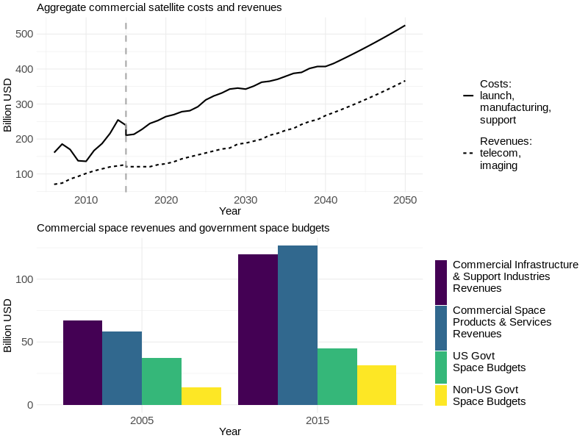
Fig. 1. State of the industry. (A) Projected growth of satellite industry costs and revenues. (B) Observed growth in commercial space sector revenues and government space budgets.

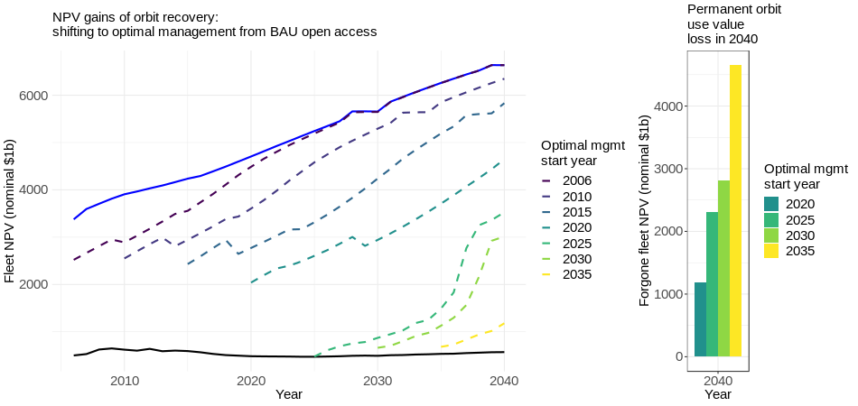
Fig. 2. Projected gains from optimal management. Left panel: NPV gains of orbit recovery, with optimal management beginning in different years. Right panel: Gap in permanent orbit use value from delaying optimal management, relative to 2015 optimal management start.
Supplementary Materials:
Materials and Methods
Figures S1-S#
Tables S1-S#
References (##-##)

