Title: To solve the space junk problem, address economic incentives
Authors: Akhil Rao¹*, Matthew G. Burgess^{1,2,3}, Daniel Kaffine¹
Affiliations:
¹Department of Economics, University of Colorado Boulder
²Cooperative Institute for Research in Environmental Sciences, University of Colorado Boulder
³Environmental Studies Program, University of Colorado Boulder
*Correspondence to: akhil.rao@colorado.edu.
One Sentence Summary: Policies aimed at reducing space junk should address underlying incentives to overuse the space commons.
Main Text:
The Tragedy of the Commons (1) has reached the final frontier: space. The global rate of satellite launches is rapidly increasing, with each launch contributing to—and risking damage from—a growing buildup of space debris (2). Without intervention, the industry may soon reach a tipping point at which the debris field becomes self-sustaining (3). Several promising technological solutions are being explored (2), but these will not solve the underlying incentive problem driving the debris buildup. We argue that internationally coordinated economic incentives such as satellite taxes are needed in addition to technological solutions. Existing international economic incentives systems could serve as a model for building necessary institutions. Using a simple model of commercial launches and debris accumulation in low-Earth orbit, we project that economically optimal incentives could increase the value of the space industry by XX%, and that the cost of continued inaction would escalate substantially each decade.
Over 400 new satellites were launched in 2017—more than double the previous year’s total, and 20% of all active satellites in orbit in 2017(Fig. 1). These satellites are at risk of colliding with each other and may create additional space debris. They can also collide with existing space debris, including over 15,000 objects currently in low-Earth orbit (2). If the amount of debris continues to increase, it could eventually reach a tipping point, known as Kessler Syndrome, whereby debris growth becomes self-sustaining due to collisions between debris objects (3). If this occurs, ceasing future launches and deorbiting active satellites may be insufficient to prevent these orbits from becoming unusable due to space debris. This may also make higher orbits costlier or impossible to access.
As this risk intensifies, much of the solutions focus has been technological: How can we better map, clean up, and steer satellites away from existing debris? These solutions include end-of-life deorbit guidelines and “keep-out” zones for active satellites, and nets, harpoons and lasers to deorbit debris [18]. However, due to open access to orbits, reducing the risk of satellite collisions will induce additional satellite launches. For instance, if firms were willing to tolerate a 0.1% risk of satellite loss before the technological improvement, they will be willing to launch more satellites until the risk of satellite loss once again becomes 0.1%.
As such, the core of the space debris problem is not technological; it is a problem of incentives. Firms and governments deciding how many satellites to launch are not adequately accounting for the adverse effects of increased collision risk on other entities’ satellites. This is a classic Tragedy of the Commons problem (1, 2, Gordon), which can be addressed in an economically efficient manner via incentive-based solutions. For instance, governments of space-faring countries could coordinate harmonized satellite taxes, analogous to using carbon taxes to limit carbon pollution. As with carbon taxes, satellite taxes could be administered at national levels and still be economically efficient, as long as they were internationally harmonized (cite Weitzman 2014 JAERE).
While the potential Tragedy of the Space Commons has been recognized (cite ERE, JEP, law article, Economic Letters etc), to our knowledge we are the first to quantify the societal benefits of correcting it. We use a simple dynamic model of space-industry economics and debris buildup to compare the societal value of optimally-managed orbits against a business-as-usual, open-access scenario (Fig. 2). We first calibrate the model to existing data and launch trends by determining the parameter values under which open access institutions best explain the observed data. Then, using these parameter values, we project future launch rates under this business-as-usual scenario, and calculate the counterfactual launch rates which would maximize society’s benefit from satellite services. By comparing the open access launch rates to the optimal launch rates, we are able to calculate the gains from shifting to optimal orbit management. We describe this approach in more detail in the online supplement [CITE]. [2-4 SENTENCES SUMMARIZING MODEL METHODS, WITH REFERENCES TO THE ONLINE SUPPLEMENT AND/OR AKHIL’S OTHER PAPERS FOR DETAILS.]
[PARAGRAPH SUMMARIZING RESULTS FROM MODEL. DESCRIBE, IN THIS ORDER: (1) THE PROJECTED GAINS FROM FIRST-BEST VS. BAU; (2) HOW BIG THE SATELITTE TAX NEEDS TO BE FOR FIRST BEST; (3) HOW THE COST OF INACTION ESCALATES THROUGH TIME (4) WHAT ARE THE EFFECTS OF TECHNOLOGICAL SOLUTIONS]
There are four main results we wish to highlight. First, shifting to optimal orbit management in 2020 creates societal gains on the order of $XX in 2020. Second, these gains can be achieved by imposing a satellite tax on the order of $YY in 2020. Third, the cost of inaction – measured as the amount of social benefit forgone due to suboptimal management – escalates from $XX in 2020 to $ZZ in 2040. Finally, technological solutions such as active debris removal can reduce the amount of debris in orbit, but the costs of institutional inaction under technological solutions remain substantial - $xx in 2020 and $zz in 2040, or aa% and bb% of the costs of institutional and technological inaction.
Our projection that the costs of inaction will escalate through time is a common feature of the Tragedy of the Commons. Indeed, when the Tragedy of the Commons has been addressed in other sectors, it has often been a game of catch-up, typically with substantial social costs (cite Libecap, 2003). For example, tens of billions of dollars in net benefits are estimated to be lost annually from open-access or poorly-managed fisheries [CITE SUNKEN BILLIONS]. Similarly, open access to oil fields at the turn of the century drove recovery rates down to 20-25 percent at competitively drilled sites, compared to 85-90 percent potential recovery if those sites has been optimally managed [CITE Libecap and Wiggins 1984]. A less obvious but equally instructive example is roadway congestion, where open access to roads is estimated to create traffic congestion costs in excess of $120 billion a year in the U.S. alone [CITE Schrank 2012]. In contrast, with the space industry still in its infancy, there is a rare opportunity to get out ahead of the Tragedy of the Commons, if the right incentives can be put in place.
Our analysis suggests that, starting in 2020, a price of ~$X/year on each orbiting satellite would provide the economically efficient incentive. This price would need to rise at an average rate of cc% per year to account for the growth in value of satellite services over time. Such rising optimal tax paths are characteristic of environmental problems with growth in value of the underlying externality-creating activities, e.g. rising optimal carbon taxes [CITE?]. Such a price could be imposed through a satellite tax or a tradable permit system for satellites, analogous to other types of pollution pricing. The international nature of the space industry poses challenges to implementing such pricing systems, but these challenges need not be insurmountable.
Theory (cite Weitzman 2014 JAERE) suggests that countries could each collect and spend tax revenues domestically, without losing economic efficiency as long as the tax level was internationally harmonized. One example of such a system is the Vessel-Day Scheme (VDS) used by the Parties to the Nauru Agreement (PNA) to manage tuna fisheries (cite Havice 2013 Marine Policy). Under the VDS, PNA countries lease fishing rights within their waters, using a common price floor, but each retains the lease revenue domestically (cite Havice 2013 Marine Policy). This system has been politically popular within the PNA, and has generated significant revenue for its constituent countries (cite Havice 2013 Marine Policy).
There is also precedent for internationally coordinated tradable permit systems. The European Union, for instance, has a carbon cap-and-trade system (the Emissions Trading System, ETS) coordinated across its member countries. Since 2005, capped emissions under ETS have fallen by 21%. California and Quebec have cap-and-trade systems that are linked. Both the Kyoto Protocol and Paris Agreement have provisions allowing countries to trade emission rights.
Each of these internationally coordinated pricing programs is built on a pre-existing governance institution or bilateral relationship—the Nauru Agreement, the E.U., the UN, the close bilateral relationship between Canada and the U.S. Similarly, a satellite tax could be built within existing governance of the orbital commons. For example, Article VI of the Outer Space Treaty states that “the activities of non-governmental entities in outer space...shall require authorization and continuing supervision by the appropriate State Party to the Treaty.” In a scenario with optimal orbital management, nation states party to the Outer Space Treaty could enforce commercial entities’ compliance with the optimal satellite tax. To go one step further, Article IX of the Outer Space Treaty establishes that nation states party to the Treaty have the right to “international consultation” if they believe that activities by its nationals in outer space may cause “potential harmful interference” with other entities in space. Such “potential harmful interference” could be defined to include collision risk in excess of the socially optimal level as determined by state-of-the-art science, and such “international consultation” could be defined to include compliance with an internationally harmonized satellite tax schedule. [AKHIL, PLEASE ADD 1-2 SENTENCES DESCRIBING SYNERGISTIC SPACE GOVERNANCE- OUTER SPACE TREATY].
To be clear, orbits are useful for more than just commercial purposes. Acknowledged national security satellites of various nations account for XX of the YY satellites in orbit. The US military is a particularly large national security user of orbits, with ZZ acknowledged national security satellites in orbit. In addition to acknowledged national security satellites, ostensibly-commercial satellites may fill national security needs. More generally, national security applications may involve complex game theoretic calculations, with the benefits one nation derives from satellites depending on the number and nature of such satellites fielded by their adversaries. Further, governments may provide satellite-based public goods to their citizens, such as remote sensing services. Antarctica and the Arctic Circle offer two models of regions in which commercial interests interact with geopolitical ones.
[NATIONAL SECURITY & OTHER CONSIDERATIONS PARAGRAPH] [ACKNOWLEDGE THAT IT’S NOT JUST COMMERICAL INTERESTS PLAYING IN THIS SPACE. 1) NATIONAL SECURITY 2) OTHER GOVERNMENT USES – REMOTE SENSING. MAYBE MENTION ANTARCTICA HERE, AS AN EXAMPLE OF A REGION WHERE NATIONAL SECURITY/GEOPOLITICAL CONCERNS INTERACT WITH ECONOMIC ONES]
Our model projects that technical or managerial attempts to control space debris that fail to address the underlying incentives problem are unlikely to be as effective as hoped. This mirrors the experience in other resource contexts. For example, in fisheries, attempts to restrict entry have led to “capital stuffing,” where existing vessels heavily invest in harvest capacity. Similarly, catch limits led to the “race to fish” phenomena, whereby fishermen exert extreme effort to harvest as much as possible before the catch limit is reached. Attempts to build new highway capacity to reduce traffic congestion have been frustrated because new capacity induces new demand for travel (Duranton and Turner 2011). By contrast, policies such as individual tradable quotas (Costello et al 2008) and congestion charges (Leape 2006) directly target the underlying incentive issue and have proven more successful, though are not without some controversy due to distributional effects (Ban et al 2008).
The Tragedy of the Space Commons is an incentives problem, and therefore needs solutions that address incentives. While technology fixes are promising, relying on them alone is likely to have escalating and unnecessary costs. Successful international incentive programs, such as the EU Emissions Trading System and the PNA’s vessel-day scheme, offer potential models for success.

VERSION 4 TO-DO LIST
1. Model summary and results paragraphs
2. National security paragraph
3. 1-2 sentences on Synergistic Space Governance (page 3)
4. Figures
5. Harpoons and fricken lasers citation (para 3)

References and Notes: [15 is guideline, let’s keep it under 20]
- G. Hardin, The tragedy of the commons. Science 162, 1243-1248 (1968).
- A. Witze, The quest to conquer Earth's space junk problem. Nature 561, 24-26 (2018).
- D.J. Kessler, B.G. Cour-Palais, Collision frequency of artificial satellites: The creation of a debris belt. Journal of Geophysical Research 83, 2637-2646 (1978).
- M. L. Weitzman, Can negotiating a uniform carbon price help to internalize the global warming externality? Journal of the Association of Environmental and Resource Economists 1, 29-49 (2014).
- M. Weinzierl. 2018. Space, the final economic frontier. Journal of Economic Perspectives 32, 173-192 (2018).
- C. Costello, S.D. Gaines, J Lynham, Can catch shares prevent fisheries collapse? Science, 321, 1678-1681 (2008).
- K. Kelleher, R. Willmann, R. Arnason, The sunken billions: the economic justification for fisheries reform. (The World Bank, 2009).
- H.S. Gordon, The economic theory of a common-property resource: The fishery. Journal of Political Economy 62, 124-142 (1954).
- G.D. Libecap, S.N. Wiggins, Contractual responses to the common pool: prorationing of crude oil production. American Economic Review 74, 87-98 (1984).
- G.D. Libecap, Contracting for property rights. Property rights: Cooperation, conflict, and law (2003).
- C. Muñoz-Patchen, Regulating the space commons: Treating space debris as abandoned property in violation of the Outer Space Treaty. Chi. J. Int'l L. 19, 233 (2018).
- N. Adilov, P. J. Alexander, B. M. Cunningham, Earth orbit debris: An economic model," Environmental and Resource Economics 60, 81-98 (2015).
- D. Schrank, T. Lomax, B. Eisele. Urban Mobility Report. Texas Transportation Institute, College Station, TX, (2012).
- G. Duranton, M.A. Turner, The fundamental law of road congestion: Evidence from US cities. American Economic Review 101, 2616-52 (2011).
- N. C. Ban, I.R. Caldwell, T.L. Green, S.K. Morgan, K. O'Donnell, J.C. Selgrath, Diverse fisheries require diverse solutions. Science, 323(5912), 338-339 (2009).
- J. Leape, The London congestion charge. Journal of Economic Perspectives, 20(4), 157-176 (2006).
- E. Havice, E. Rights-based management in the Western and Central Pacific Ocean tuna fishery: economic and environmental change under the Vessel Day Scheme. Marine Policy, 42, 259-267 (2013).
- J. Pearson, J. Carroll, E. Levin, Active Debris Removal: EDDE, the ElectroDynamic Debris Eliminator. Space Manufacturing 14 (2010)

Acknowledgments: [Science instructions: The acknowledgments should include a statement about where the data reported in the paper are presented, archived, or available (for example, in the Supplementary Materials or in a community archive). If in an archive, include the accession number or a placeholder for it. Please also include relevant funding information such as grant numbers and funding agencies. You can also include a statement of author contributions here or in the Supplementary Materials.]
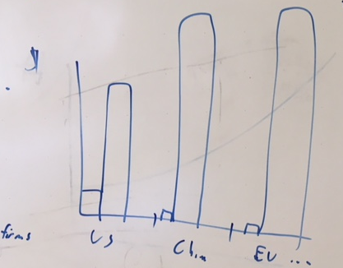
Fig. 1. [Caption.] [Science instructions: The figure caption should begin with an overall descriptive statement of the figure followed by additional text. They should be immediately after each figure. Figure parts are indicated with capital letters (A). If you prefer, you can place both the actual figures and captions logically through the text near where they are cited rather than at the end of the file (but not both). If a paragraph in the main text begins with the name of a figure, write out “Figure” in full (e.g., <para>“Figure 1 shows….”)]

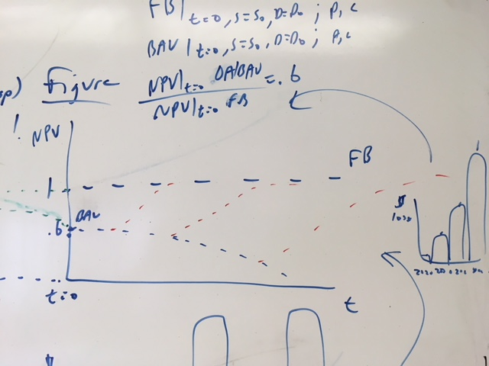or 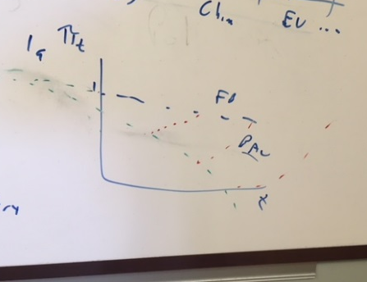
Fig. 2. [Caption.]
Supplementary Materials:
Materials and Methods
Figures S1-S#
Tables S1-S#
Movies S1-S#
Audio Files S1-S#
External Databases S1-S#
References (##-##)

Supplementary Materials:
[Science instructions: This section includes the actual text of the Supplementary Materials, which can include any or all of the preceding items, and figure captions and tables that can easily be incorporated into one supplementary material file. Please edit the list above as appropriate and include it at the end of your main paper. If there are additional files that cannot be easily accommodates (e.g., movies or large tables), please include captions here.]
Materials and Methods: [Science instructions: Can include the Materials and Methods here. Additional references should be cited here and included in the main reference list.]
Any Additional Author notes: [Science instructions: For example, author contributions or a list of group authors.]

