Title: The space junk problem needs economic solutions
Authors: Akhil Rao¹*, Matthew G. Burgess^{1,2,3}, Daniel Kaffine¹
Affiliations:
¹Department of Economics, University of Colorado Boulder
²Cooperative Institute for Research in Environmental Sciences, University of Colorado Boulder
³Environmental Studies Program, University of Colorado Boulder
*Correspondence to: akhil.rao@colorado.edu.
One Sentence Summary: Policies aimed at reducing space junk should address underlying incentives to pollute.
Main Text:
The Tragedy of the Commons (1) has reached the final frontier: space. The global rate of satellite launches is rapidly increasing, with each launch contributing to—and risking damage from—a growing buildup of space debris (2). Without intervention, the industry may soon reach a tipping point at which the debris field becomes self-sustaining and very difficult to clean up (3). Several promising technological solutions are being explored (2), but these will not solve the underlying incentive problem. We argue that internationally coordinated economic incentives such as satellite taxes are needed in addition, and that successful governance systems for managing Antarctic resources could serve as a model for building necessary institutions. Using a simple model of commercial launches and debris accumulation in low-Earth orbit, we project that improved incentives could increase the value of the space industry by XX%, and that the cost of continued inaction would escalate substantially each decade.
Over 400 new satellites were launched in 2017—more than double the previous year’s total, and X% of all active satellites in orbit (Fig. 1). These satellites are at risk of colliding with—and they also create—space debris, currently including over 15,000 objects in low-Earth orbit (2). If the amount of debris continues to increase, it could eventually reach a tipping point, whereby [EXPLAIN KESSLER SYNDROME CONCISELY]) (3).
As this risk intensifies, much of the solutions focus has been technological: How can we better map, clean up, and steer satellites away from existing debris? [ONE OR TWO SENTENCES SUMMARIZING/ACKNOWLEDGING LEADING TECH SOLUTIONS]
However, the core of the space debris problem is not technological; it is a problem of incentives. Firms and governments deciding how many satellites to launch are not adequately accounting for the adverse effects of space debris buildup on other firms or countries. Reducing the risk of satellite collisions will induce additional satellite launches – that is, if firms were willing to tolerate an X% risk of satellite loss before the technological improvement, they will be willing to launch more satellites until the risk of satellite once again becomes X%. This is a classic Tragedy of the Commons problem (1, 2), which can be addressed in an economically efficient manner via incentive-based solutions. For instance, governments of space-faring countries could coordinate harmonized satellite taxes, analogously to using carbon taxes to limit carbon pollution. As with carbon taxes, satellite taxes could be administered at national levels and still be economically efficient, as long as they were internationally harmonized (cite Weitzman 2014 JAERE).
We use a simple model of space-industry economics and debris buildup to project the impacts of such a policy, in comparison to a business as usual scenario in the current incentives remain (Fig. 2). [2-4 SENTENCES SUMMARIZING MODEL METHODS, WITH REFERENCES TO THE ONLINE SUPPLEMENT AND/OR AKHIL’S OTHER PAPERS FOR DETAILS.]
[PARAGRAPH SUMMARIZING RESULTS FROM MODEL. DESCRIBE, IN THIS ORDER: (1) THE PROJECTED GAINS FROM FIRST-BEST VS. BAU; (2) HOW BIG THE SATELITTE TAX NEEDS TO BE FOR FIRST BEST; (3) HOW THE COST OF INACTION ESCALATES THROUGH TIME]
Our projection that the costs of inaction will escalate through time is a common feature of the Tragedy of the Commons. Indeed, when the Tragedy of the Commons has been addressed in other sectors, it has often been a game of catch up. [BRIEFLY DESCRIBE TWO POIGNANT EXAMPLES OF CATCH-UP, WITH NUMBERS AND REFERENCES, E.G. ‘THE SUNKEN BILLIONS’ IN FISHERIES – I THINK PETROLEUM AND FISHERIES MIGHT BE GOOD EXAMPLES – SEE COMMENTS TRANSPORATION ALSO? External costs from traffic congestion in the US exceed $120 billion per year (Schrank,Lomax, and Eisele 2012).]. In contrast, with the space industry is still in its infancy, there is a rare opportunity to get out ahead of the Tragedy of the Commons, if the right incentives can be put in place.
[POLICY PARAGRAPH 1]
[POLICY PARAGRAPH 2]
[SHORT PARAGRAPH ON WHY TECH FIXES, WITHOUT INCENTIVE FIXES, COULD BACKFIRE, DRAWING ON EXAMPLES FROM OTHER SECTORS]Technical or managerial attempts to control space debris that fail to address the underlying incentives problem are unlikely to be as effective as hoped. For example, in fisheries, attempts to restrict entry have led to “capital stuffing” while restrictions on season lengths led to the “race to fish”. Similarly, attempts to build new highway capacity to reduce traffic congestion have been frustrated by the fact that new capacity induces new demand for travel. By contrast, policies such as individual tradable quotas (Costello et al 2008) and congestion charges (London congestion charge?) directly target the underlying incentive issue and have proven more successful, though are not without some controversy due to distributional effects.
[NATIONAL SECURITY & OTHER CONSIDERATIONS PARAGRAPH]
[CONCLUDING PARAGRAPH – 2-3 SENTENCES MAX]Institutional failures require institutional solutions.

References and Notes:
- G. Hardin, The tragedy of the commons. Science 162, 1243-1248 (1968).
- A. Witze, The quest to conquer Earth's space junk problem. Nature 561, 24-26 (2018).
- D.J. Kessler, B.G. Cour-Palais, Collision frequency of artificial satellites: The creation of a debris belt. Journal of Geophysical Research 83, 2637-2646 (1978).
- M. L. Weitzman, Can negotiating a uniform carbon price help to internalize the global warming externality? Journal of the Association of Environmental and Resource Economists 1, 29-49 (2014).
- M. Weinzierl. 2018. Space, the final economic frontier. Journal of Economic Perspectives 32, 173-192 (2018).
- C. Costello, S.D. Gaines, J Lynham, Can catch shares prevent fisheries collapse? Science, 321, 1678-1681 (2008).
- K. Kelleher, R. Willmann, R. Arnason, The sunken billions: the economic justification for fisheries reform. (The World Bank, 2009).
- A. Scott, The fishery: The objectives of sole ownership. Journal of Political Economy 63, 116-124 (1955).
- H.S. Gordon, The economic theory of a common-property resource: The fishery. Journal of Political Economy 62, 124-142 (1954).
- G.D. Libecap, S.N. Wiggins, Contractual responses to the common pool: prorationing of crude oil production. American Economic Review 74, 87-98 (1984).
- G.D. Libecap, Contracting for property rights. Property rights: Cooperation, conflict, and law (2003).
- C. Muñoz-Patchen, Regulating the space commons: Treating space debris as abandoned property in violation of the Outer Space Treaty. Chi. J. Int'l L. 19, 233 (2018).
- N. Adilov, P. J. Alexander, B. M. Cunningham, Earth orbit debris: An economic model," Environmental and Resource Economics 60, 81-98 (2015).
- D. Schrank, T. Lomax, B. Eisele. Urban Mobility Report. (Texas Transportation Institute, College Station, TX, 2012).
- G. Duranton, M.A. Turner, The fundamental law of road congestion: Evidence from US cities. American Economic Review 101, 2616-52 (2011).

Acknowledgments: [Science instructions: The acknowledgments should include a statement about where the data reported in the paper are presented, archived, or available (for example, in the Supplementary Materials or in a community archive). If in an archive, include the accession number or a placeholder for it. Please also include relevant funding information such as grant numbers and funding agencies. You can also include a statement of author contributions here or in the Supplementary Materials.]
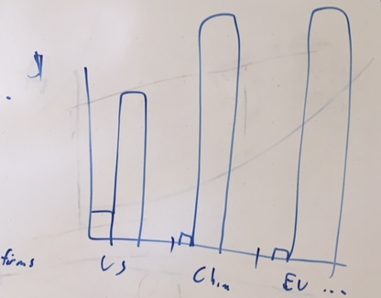

Fig. 1. [Caption.] [Science instructions: The figure caption should begin with an overall descriptive statement of the figure followed by additional text. They should be immediately after each figure. Figure parts are indicated with capital letters (A). If you prefer, you can place both the actual figures and captions logically through the text near where they are cited rather than at the end of the file (but not both). If a paragraph in the main text begins with the name of a figure, write out “Figure” in full (e.g., <para>“Figure 1 shows….”)]

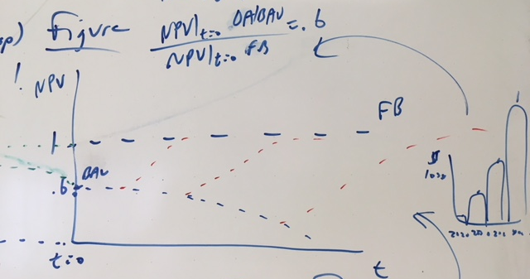or 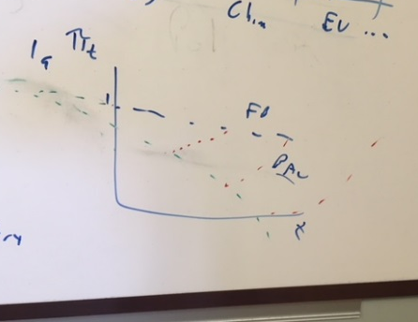

Fig. 2. [Caption.]

Supplementary Materials:
Materials and Methods
Figures S1-S#
Tables S1-S#
Movies S1-S#
Audio Files S1-S#
External Databases S1-S#
References (##-##)

Supplementary Materials:
[Science instructions: This section includes the actual text of the Supplementary Materials, which can include any or all of the preceding items, and figure captions and tables that can easily be incorporated into one supplementary material file. Please edit the list above as appropriate and include it at the end of your main paper. If there are additional files that cannot be easily accommodates (e.g., movies or large tables), please include captions here.]
Materials and Methods: [Science instructions: Can include the Materials and Methods here. Additional references should be cited here and included in the main reference list.]
Any Additional Author notes: [Science instructions: For example, author contributions or a list of group authors.]

