Title: Orbital-use fees could more than quadruple the value of the space industry
Authors: Akhil Rao¹*, Matthew G. Burgess^{2,3,4}, Daniel Kaffine⁴
Affiliations:
¹Department of Economics, Middlebury College
²Cooperative Institute for Research in Environmental Sciences, University of Colorado Boulder
³Environmental Studies Program, University of Colorado Boulder
⁴Department of Economics, University of Colorado Boulder
*Email: akhilr@middlebury.edu.
The space industry’s rapid recent growth represents the latest example of the Tragedy of the Commons^{1,2}. Satellites launched into orbit contribute to—and risk damage from—a growing buildup of space debris and other satellites. Collision risk from this orbital congestion is costly to satellite operators¹. Technological and managerial solutions—such as active debris removal or end-of-life satellite deorbit guidelines—are currently being explored by space regulatory authorities^{3,4}. However, none of these approaches address the underlying incentive problem: satellite operators do not account for the costs they impose on each other via collision risk. Here, we show that an internationally harmonized orbital-use fee can correct these incentives and substantially increase the value of the space industry. We construct and analyze a model of commercial launches and debris accumulation in low-Earth orbit. Our model projects that the economically optimal fee starts at roughly $13,500 dollars per satellite per year in 2020, and gradually increases thereafter, similar to carbon taxes. The long-run value of the satellite industry would more than quadruple by 2040—increasing from around $600 billion under business-as-usual to around $3 trillion. In contrast, we project that purely technological solutions, such as debris removal, are unlikely to fully address the problem of orbital congestion. In some cases, our model finds that debris removal worsens economic damages from congestion by increasing launch incentives. In other sectors, addressing the Tragedy of the Commons has often been a game of catch-up, with substantial social costs⁵. In the infant space industry, there is a rare opportunity to get out ahead, if the right incentives can be put in place.

In 2017, 466 new satellites were launched—more than double the previous year’s launches, and more than 20% of all active satellites in orbit in 2017^{6,7}. Rapid space industry growth is projected to continue, driven largely by commercial satellites (Fig. 1). This growth is driving buildup of debris in low-Earth orbit, currently including over 15,000 objects¹. Collision risk from debris is costly; collisions damage or destroy expensive capital assets that are difficult or impossible to repair. Debris buildup could eventually make some low-Earth orbits economically unviable and other orbits difficult or impossible to access⁸. In the worst case—though uncertain and occurring over long time horizons—debris growth could become self-sustaining due to collisions between debris objects, a tipping point called Kessler Syndrome^{8,9}.

Proposed solutions have so far largely been technological and managerial, aimed at mapping, avoiding, and removing debris^{3,4}. These include end-of-life deorbit guidelines and “keep-out” zones for active satellites, and nets, harpoons and lasers to deorbit debris⁴. However, with open access to orbits, reducing debris and collision risk incentivizes additional satellite launches, which eventually restores the debris and risk. For instance, if firms were willing to tolerate a 0.1% annual risk of satellite loss before a technological improvement in debris removal, they will be willing to launch more satellites until the 0.1% annual risk of satellite loss is restored.

Thus, the core of the space debris problem is incentives, not technology. Since satellite operators are unable to secure exclusive property rights to their orbital paths or recover collision-related costs imposed by others, prospective operators face a choice between launching profitable satellites, thereby imposing current and future collision risk on others, or not launching and leaving those profits to competitors. This is a classic Tragedy of the Commons problem, as others have noted^{1,6,10,11}. It can be economically efficiently addressed via incentive-based solutions, such as fees or tradable permits for time in orbit, analogous to carbon taxes or cap-and-trade¹². Incentives should target objects in orbit—rather than launches—because orbiting objects are what directly impose collision risk on other satellites¹³. We provide the first analysis, to our knowledge, quantifying the economic benefits of implementing such incentives.

We use a model combining rich physical dynamics with satellite economics to quantify the benefits of an internationally harmonized ‘orbital-use fee’ (OUF) relative to a business-as-usual (BAU) open-access scenario, and a scenario with active debris removal, while accounting for the effects of each scenario on satellite launch decisions (see Methods and Supplementary Methods). While we focus on an orbital-use fee for analytical convenience, it is conceptually equivalent to other mechanisms for pricing orbits, such as tradable permits.

Our physical model of satellite and debris evolution in orbit obeys the relevant accounting identities and utilizes reduced-form approximations of physical processes validated in other works^{14,15}. We fit and calibrate the model using data on collision risk and orbital debris produced by the European Space Agency (ESA)¹⁶, and data on active satellites from the Union of Concerned Scientists (UCS)⁷ (see Methods and Supplementary Methods), with the ESA dataset covering 1958-2017 and the UCS dataset covering 1957-2017. By assumption, runaway debris growth (Kessler Syndrome) cannot occur in our physical model, which likely makes it understate the benefits of OUFs (see Methods). Our economic model assumes satellites are launched and operated to maximize per-satellite private profits, net of any fees, subject to collision risk. We calibrate the model by fitting the BAU scenario (no fees or debris removal) to historical industry data and launch trends^{6,7} (see Methods and Supplementary Methods).

We project future launch rates to 2040 under the BAU scenario using our fitted model and published projections of future growth of the space economy¹⁷. We then calculate launch rates that would maximize the long-run value of the industry, and we calculate the time series of OUFs that would incentivize these optimal launch rates. The industry value is measured as net present value (NPV)—the long-run value of the entire fleet of satellites in orbit, accounting for both the financial costs of replacing satellites due to natural retirement and collisions, as well as the opportunity cost of investing funds in satellites rather than capital markets. For instance, an NPV of $1 trillion in 2020 means that the sum total of the stream of net benefits, looking into the future from 2020 and accounting for the timing of the net benefits, is $1 trillion.

Though our models are deliberately simplified for tractability, they are based on previously-validated approaches to orbital object modeling^{14,15}, and our calibrations allow us to reproduce observed trends and magnitudes in the growth of orbital debris and satellite stocks, as well as the calculated collision risk (see Extended Data Fig. 2). Nonetheless, our projections should be interpreted as order-of-magnitude approximations that can be refined as needed by more detailed models. In these respects, our approach mirrors integrated assessment modeling approaches that have been useful in developing solutions to other natural resource management problems (e.g., ref 18).

We project that shifting from open access to the optimal series of OUFs in 2020 would increase the NPV of the satellite industry from around $600 billion under business-as-usual to around $3 trillion—a more than four-fold increase (Fig. 2) (4.68 to 6.54 times in 95% of parameter sets randomly drawn from their calibrated distributions; see Extended Data figure 10b and Supplementary Methods). Assuming a 5% market rate of return, an increase of $2.5 trillion in NPV would be equivalent to annual benefits of approximately $120 billion in perpetuity. Based on our calculations (see Methods), the optimal OUF starts at roughly $13,500 per satellite per year in 2020 and escalates at ~14.8% per year to around $244,000 per satellite per year in 2040. Rising optimal price paths are common in environmental pricing such as carbon taxes¹². The rising price path in this case partly reflects the rising value of safer orbits (resulting in rising industry NPV; see Fig. 2a) created by the OUF.

Forgone NPV from the satellite industry in 2040—the cost of inaction under BAU—escalates from around $300 billion if optimal management begins in 2025 to around $750 billion if optimal management begins in 2035. Without OUFs, losses remain substantial even when active debris removal is available. In a best-case analysis where we assume debris removal is costless (i.e., it is provided for free, and requires no additional satellites to implement), debris removal can only recover up to 8.6% of the value lost under open access. At worst, debris-removal can exacerbate orbital congestion via a rebound-type effect, causing additional losses on the order of 1.8% of the value already lost from open access (see Extended Data Fig. 5 and Supplementary Discussion). The inability of debris removal to induce efficient orbit use is driven by open-access launching behavior and underscores the importance of policies to correct economic incentives to launch satellites.

Escalating costs of inaction is a common feature of the Tragedy of the Commons, evident in several other sectors in which it went unaddressed for long periods of time⁵. For example, tens of billions of dollars in net benefits are lost annually from open-access or poorly-managed fisheries around the globe¹⁹. Similarly, open access to oil fields in U.S. at the turn of the century drove recovery rates down to 20-25% at competitively drilled sites, compared to 85-90% potential recovery under optimal management²⁰. Open access to roadways—somewhat analogous to orbits—is estimated to create traffic congestion costs in excess of $120 billion a year in the U.S. alone²¹. In contrast, there is a rare opportunity to get out ahead of the Tragedy of the Commons in the young space industry.

The international and geopolitically complex nature of the space sector poses challenges to implementing orbital-use pricing systems, which need not be insurmountable. Theory suggests countries could each collect and spend orbital-use fee revenues domestically, without losing economic efficiency, as long as the fee’s magnitude was internationally harmonized²². An example of such a system is the Vessel Day Scheme (VDS) used by the Parties to the Nauru Agreement (PNA) to manage tuna fisheries. Under the VDS, PNA countries each lease fishing rights within their waters, using a common price floor²³. The European Union’s (E.U.) Emissions Trading System (ETS) provides an example of an internationally coordinated tradable permit system²⁴. Notably, each of these pricing programs is built on a pre-existing international governance institution (the Nauru Agreement and the E.U.).

An OUF could also be built within existing space governance institutions, such as the Outer Space Treaty²⁵. For example, Article VI states that countries supervise their space industries, which provides a framework for orbital-use fees to be administered nationally. Article II prohibits national appropriation of outer space, but it does not prohibit private property rights, thus potentially allowing for tradable orbital permitting.

Military and other non-commercial uses of satellites are also important to consider in designing any incentive-based orbital management policy. In December of 2018, 430 of 1957 satellites in orbit had acknowledged military users⁷. Some ostensibly-commercial satellites may also fill national security needs. Further, governments provide satellite-based public goods to their citizens, such as remote sensing and GIS. In addition to collision risk, satellite and debris buildup may impose costly interference on ground-based space observation systems. OUFs targeting the commercial sector should account for these interests and monitor, as best possible, any "leakage" (see ref 26) from the commercial sector to the government sector. Antarctica and the Arctic Circle offer two models of internationally managed regions in which commercial interests, environmental interests, and geopolitical interests interact (e.g., ref 27).

Despite the simplifying assumptions of our model, its key qualitative results may be robust to geopolitical and other complexities. Experience in other resource contexts supports our projection that technological or managerial solutions to the space debris problem are unlikely to be as effective as incentive-based solutions. For instance, in fisheries, attempts to restrict entry have led to “capital stuffing,” where existing vessels heavily invest in harvest capacity²⁸. Similarly, catch limits led to the “race to fish” phenomena²⁹, whereby fishermen exert extreme effort to harvest as much as possible before the catch limit is reached. Attempts to build new highway capacity to reduce traffic congestion have been frustrated because new capacity induces new demand for travel³⁰. By contrast, policies such as individual tradable quotas³¹ and congestion charges³² directly target the underlying incentive issue and have proven more successful, though are not without some controversy due to distributional effects³³.

The Tragedy of the Space Commons is an international incentives problem and therefore needs an internationally coordinated incentive-based solution. Our analysis suggests such solutions could add trillions in value to the industry. Programs such as the EU Emissions Trading System and the PNA’s Vessel Day Scheme offer potential models for success.

- Witze, A. The quest to conquer Earth's space junk problem. Nature 561, 24-26 (2018).
- Hardin, G. The tragedy of the commons. Science 162, 1243-1248 (1968).
- Morin, J. Four steps to global management of space traffic. Nature 567, 25-27 (2019).
- Pearson, J., Carroll, J. & Levin, E. Active Debris Removal: EDDE, the ElectroDynamic Debris Eliminator. Space Manufacturing 14 (2010).
- Libecap, G. D. Contracting for property rights. Property rights: Cooperation, conflict, and law (2003).
- Weinzierl, M. Space, the final economic frontier. Journal of Economic Perspectives 32, 173-192 (2018).
- Union of Concerned Scientists, “UCS Satellite Database”, 2018. Accessed April 2019. Available from UCS at https://www.ucsusa.org/nuclear-weapons/space-weapons/satellite.database
- Kessler, D. J. & Cour-Palais, B. G. Collision frequency of artificial satellites: The creation of a debris belt. Journal of Geophysical Research 83, 2637-2646 (1978).
- Liou, J.-C. & Johnson, N.L. Instability of the present LEO satellite populations. Advances in Space Research 41, 1046-1053 (2008).
- Muñoz-Patchen, C. Regulating the space commons: Treating space debris as abandoned property in violation of the Outer Space Treaty. Chi. J. Int'l L. 19, 233 (2018).
- Adilov, N., Alexander, P. J. & Cunningham, B. M. Earth orbit debris: An economic model, Environmental and Resource Economics 60, 81-98 (2015).
- Nordhaus, W. D. To tax or not to tax: Alternative approaches to slowing global warming. Review of Environmental Economics and Policy 1, 26-44 (2007).
- Rao, Akhil. The Economics of Orbit Use: Theory, Policy, and Measurement. Diss. University of Colorado at Boulder (2019).
- Letizia, Francesca, et al. Extending the ECOB space debris index with fragmentation risk estimation. (2017).
- Bradley, A. M. & Wein, L.M. Space debris: Assessing risk and responsibility. Advances in Space Research 43, 1372-1390 (2009)
- European Space Agency, “DISCOS (Database and Information System Characterising Objects in Space)”. Accessed September 2018. Available from ESA at https://discosweb.esoc.esa.int/web/guest/home
- Jonas, A., et al., “Space: Investment Implications of the Final Frontier.” (Morgan Stanley, 2017). Accessed January 2019. Available from: https://fa.morganstanley.com/griffithwheelwrightgroup/mediahandler/media/106686/Space_%20Investment%20Implications%20of%20the%20Final%20Frontier.pdf.
- Rogelj, J., et al. Scenarios towards limiting global mean temperature increase below 1.5 C. Nature Climate Change 8, 325-332 (2018).
- Kelleher, K., Willmann, R. & Arnason, R. The sunken billions: the economic justification for fisheries reform. (The World Bank, 2009).
- Libecap, G. D. & Wiggins, S. N. Contractual responses to the common pool: Prorationing of crude oil production. American Economic Review 74, 87-98 (1984).
- Schrank, D., Lomax, T. & Eisele, B. Urban Mobility Report. Texas Transportation Institute, College Station, TX (2012).
- Weitzman, M. L. Can negotiating a uniform carbon price help to internalize the global warming externality? Journal of the Association of Environmental and Resource Economists 1, 29-49 (2014).
- Havice, E. Rights-based management in the Western and Central Pacific Ocean tuna fishery: economic and environmental change under the Vessel Day Scheme. Marine Policy 42, 259-267 (2013).
- EU Commission. “EU ETS Handbook.” DG Climate Action (2015). Accessed June 26, 2019. Available from: https://ec.europa.eu/clima/sites/clima/files/docs/ets_handbook_en.pdf
- United Nations Office for Disarmament Affairs. “Treaty on Principles Governing the Activities of States in the Exploration and Use of Outer Space, including the Moon and Other Celestial Bodies” (UNODA, 1967). Accessed June 26, 2019. Available from: http://disarmament.un.org/treaties/t/outer_space
- Felder, S. & Rutherford, T. F. Unilateral CO2 reductions and carbon leakage: the consequences of international trade in oil and basic materials. Journal of Environmental Economics and Management 25, 162-176 (1993).
- Brooks, C. M. Competing values on the Antarctic high seas: CCAMLR and the challenge of marine-protected areas. The Polar Journal 3, 277-300 (2013).
- Townsend, R. E. On "capital-stuffing" in regulated fisheries. Land Economics 61, 195-197 (1985).
- Birkenbach, A. M., Kaczan, D. J. & Smith, M. D. Catch shares slow the race to fish. Nature 544, 223-226 (2017).
- Duranton, G. & Turner, M. A. The fundamental law of road congestion: Evidence from US cities. American Economic Review 101, 2616-52 (2011).
- Costello, C., Gaines, S. D. & Lynham, J. Can catch shares prevent fisheries collapse? Science 321, 1678-1681 (2008).
- Leape, J. The London congestion charge. Journal of Economic Perspectives 20, 157-176 (2006).
- Ban, N. C., Caldwell, I. R., Green, T. L., Morgan, S. K., O'Donnell, K. & Selgrath, J. C. Diverse fisheries require diverse solutions. Science 323, 338-339 (2009).

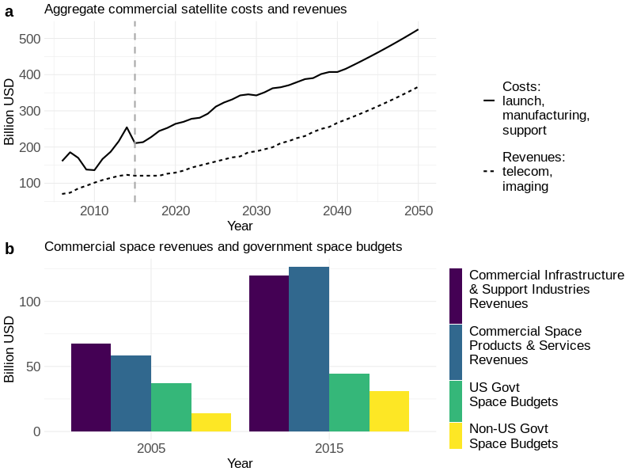
Fig. 1. State of the industry (data from refs. 6, 7, 17). a: Projected growth of satellite industry costs and revenues. Revenues and costs are yearly flows. Costs are not annuitized over the satellite lifetime. b: Observed growth in commercial space sector revenues and government space budgets.

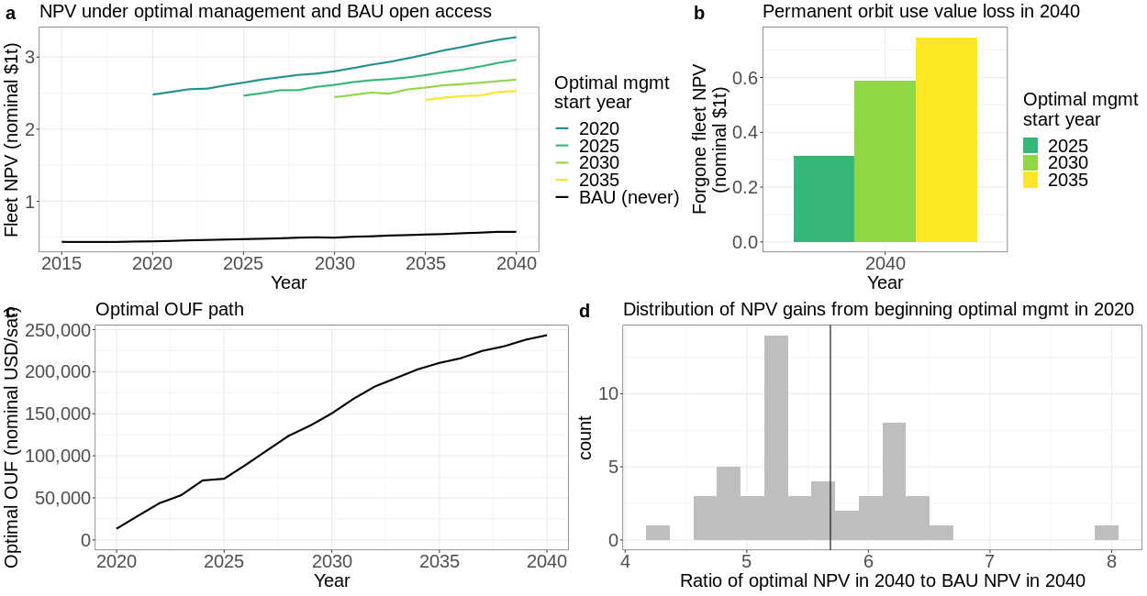

Fig. 2. Projected gains from optimal management via orbital-use fees. a: NPV of orbit recovery, with optimal management beginning in different years. BAU is shown in black. The NPV gain is the difference between optimal management and BAU. b: Loss in permanent orbit use value from delaying optimal management, relative to 2020 optimal management start. c: Time path of the optimal OUF. d: Distribution of the ratio of optimal NPV in 2040 (assuming optimal management begins in 2020) to BAU NPV in 2040 using 50 draws of alternate parameter sets. The distribution is calculated via a residual-bootstrap resampling procedure which illustrates the effect of calibration uncertainty. We describe the bootstrap in more detail in section 1.4 of the Supplementary Methods.

Methods

Here we describe the data sources, calibration procedures, and dynamic optimization model used to quantify the economic benefits of orbits under BAU and under optimal management via an OUF.

Data. We use data on collision risk, orbital debris counts, and satellite counts provided by the European Space Agency (ESA)¹⁶ and the Union of Concerned Scientists (UCS)⁷ to calibrate our physical models of aggregate active satellite and debris evolution. We calibrate our economic model of open access launching using historical aggregate returns and costs for the space industry obtained from ref. 6 and launch data calculated from ref. 7. Our physical data cover 1957–2017, while our historical economic data cover 2005–2015.

For each year, the ESA data provides counts of the number of debris objects in orbit within a specified 50 km. altitude band (average orbital altitude) beginning at 100 km. above mean sea level and extending to 2000 km. above sea level, as well as the estimated probability that a collision occurs in the same bands. Each observation in the ESA data corresponds to a year, and each column corresponds to an altitude band. The UCS data describe all known active satellites currently in orbit, including variables for stated purpose, date of launch, and date of deorbit (if applicable). Each observation in this dataset corresponds to an active satellite, with corresponding variables describing that satellite. This dataset is spread over a series of files, released at roughly quarterly to semi-annually frequencies between 2005–2018, from which we reconstruct yearly counts of the number of active satellites in the 100-2000 km. range from 1957–2015.

The economic dataset we use comes from refs. 6 and 17, with data from ref. 6 representing historical data. An observation in the original dataset represents a year, with variables for dollars spent on different space sector activities, e.g. satellite construction and launch services, ground observation services, government spending by different national governments, etc. We classify these entries into yearly revenues flowing to satellite owners, and yearly costs of building, launching, and operating satellites (which we refer to as “launch costs” for brevity). We merge these data with the estimated collision probability data from the ESA dataset¹⁶.

An observation in the final, merged dataset we use for physical model calibration represents a year in 1957–2015, which includes variables for active satellite count, debris count, estimated collision probability, and estimated returns to and costs of launching a satellite in the 100-2000 km. range. An observation in the final, merged dataset we use for economic model calibration represents a year in 2005–2015, with variables for aggregate satellite sector revenues and costs, the yearly gross rate of return on a satellite, the year-over-year change in launch costs, and the estimated collision probability. We describe our data and variable construction procedures in greater detail in Supplementary Methods.

Calibrating the physical model. We construct the laws of motion for aggregate active satellite and debris stocks from accounting relationships. We assume that a) a constant fraction (3.3%) of undestroyed active satellites naturally deorbit each period (without creating additional debris), b) a constant fraction (49%) of debris deorbits each period, and c) new fragment creation occurs due to launch debris, anti-satellite missile tests, and collisions between orbital objects. We parameterize the probability that an active satellite is destroyed in a collision using an approximate form validated in other works^{14,15}, and from that functional form derive an expression for the number of new fragments created in collisions. The parameters in these functions are calibrated separately. Specific formulas are presented in Supplementary Methods.

We first calibrate the collision probability function by fitting it to data on the estimated probability of a collision between 100-2000 km provided by ESA, using constrained nonlinear least squares. We constrain the parameter estimates to be positive, which is consistent with the physical interpretation of the collision probability parameters as combinations of positive values: the magnitude of velocity differences between colliding objects, the total cross-sectional area of the collision, and scaling values that relate object counts to object densities.

We then calibrate the debris law of motion, using the estimated collision probability parameters, by constrained ridge regression. We use ridge regression to improve the debris model fit, given that we have relatively few observations for the number of parameters. We constrain the parameters to comply with their physical interpretations: parameters representing numbers of fragments created in collisions must be positive, while the debris decay rate must be between 0 and 1. Given the uncertainties involved in modeling and calibrating the potential for Kessler Syndrome, we disallow the possibility of debris objects colliding with each other. This likely makes our conclusions conservative, as it likely understates the growth in collision risk over time due to debris-debris collisions. Consequently, the estimated optimal OUF is likely less than what a model with debris-debris collisions would predict, as are our estimated benefits of implementing the OUF.

Finally, we calibrate the fraction of active satellites that naturally deorbit by fitting the active satellite law of motion using ordinary least squares. This yields an estimated average lifespan of approximately 30 years (the 3.3% deorbit rate mentioned above), which is consistent with an average mission length of 5 years followed by compliance with the IADC’s 25-year deorbit guideline³⁴. We assume full compliance with the guideline to be conservative in our estimates of debris production. We describe our physical calibration procedures in greater detail in Supplementary Methods. We show sensitivity analyses of our calibrations in Extended Data Fig. 7, and of our model projections in Extended Data Figs. 8-10. We describe our sensitivity analysis procedure in Supplementary Methods.

Calibrating the economic model. Economic theory predicts that the collision probability will be determined by the excess rate of return on an active satellite¹³. However, the excess rate of return includes the internal rate of return on a satellite asset, which we do not observe, as well as factors relating to the economic structure of the various satellite-using industries involved, which we do not model. To account for these issues, we model the excess rate of return using observed aggregate revenues and costs for the satellite industry, and then include the various unknown and unmodeled factors as parameters to estimate. We then fit this model to the estimated collision probability data using ordinary least squares. Since the signs of the parameters representing the unknown and unmodeled factors are ambiguous, we do not constrain the estimates. The estimated parameters are incorporated into the economic model and used to adjust for unmodeled economic factors. The adjustment produces estimated “implied aggregate costs”, shown in Extended Data Table 3. We describe this adjustment procedure in Supplementary Methods and discuss the relevant unmodeled factors in Supplementary Discussion. We assume a market discount rate of 5 percent³⁵. The economic gains from an OUF would be even larger in magnitude at lower social discount rates.

Projecting open access and optimal launch rates. To project the launch rates under BAU and optimal management via an OUF, we solve the dynamic optimization problems associated with launching new satellites. Under open access BAU, each firm wishes to maximize their own lifetime satellite profits, and the optimization problem determines each firm’s decision of whether to launch or not, which in turn determines the total launch rate across all firms. This involves calculating whether the expected lifetime revenues from another satellite exceed the cost of launching it and aggregating up from the individual decisions to the total launch rate. Under optimal management, the optimization problem directly determines the total launch rate which maximizes the NPV of the satellite fleet. This involves calculating whether the expected lifetime revenues from another satellite exceed the total industry-wide costs of launching it, including the expected costs of replacing other satellites lost due to collision risk created by the new satellite and its associated debris.

Solving these dynamic optimization problems yields “launch policy functions”, which map the possible orbital states – satellite and debris counts, given current revenues and costs – into an annual launch rate. As the launch policy functions encode behavioral and institutional assumptions, the launch rates they generate are more realistic approximations of orbit management behavior than simple sensitivity analyses over all possible launch rates. That is, the launch decisions are consistent with, and respond to changes in, economic and orbital conditions. By using the launch policy functions along with the laws of motion for the satellite and debris stocks and an initial condition, we can project the number of satellites and debris in orbit each year under a specified type of management institution. We describe the computation of the launch policy functions in more detail in Algorithms 1-3 in Supplementary Methods.

Calculating the optimal orbital-use fee and its benefits. To calculate the optimal OUF for each year t, we compare the expected cost of satellite-destroying collisions in year t+1 under BAU and under optimal management (see Equation 18 in Supplementary Methods). The OUF is positive whenever the optimal management solution maintains a lower collision probability than what would occur under open access BAU. The OUF is simply the marginal external cost of another satellite launch, which is the additional industry-wide cost of another satellite in orbit (additional collision risk and debris production now and in the future) that is not internalized by individual firms under BAU. By charging firms the marginal external cost of their satellite launch through an OUF, each firm’s incentives and thus their launch rates are aligned with those under industry-wide, NPV-maximizing optimal management.

To calculate the benefits of imposing the OUF, we use the launch policy functions described above to compute the NPV of the entire satellite fleet under BAU and optimal management. These NPVs reflect the value of the entire satellite fleet, in perpetuity, assuming society stays on the BAU or optimal management path. The difference between the NPVs yields the gains from implementing the optimal OUF and moving from BAU to the optimal management path.

Although we abstract from many of the economic and physical complications in modeling orbit use, we consider how those factors would affect our analysis in the Supplementary Methods and Supplementary Discussion. In particular, Supplementary Methods details our sensitivity analyses with respect to physical parameter uncertainty, and Supplementary Discussion considers how these concerns may impact our conclusions. Our conclusions are likely robust to the complications we abstract from, with our calculated optimal OUF and the NPV benefits of implementing it providing the correct order of magnitude with the correct qualitative features. Future research will improve our estimates and provide more detailed guidance to policymakers.

- IADC. IADC Space Debris Mitigation Guidelines. Tech. Rep. IADC-02-01 (2007).
- Goulder, L. H., & Stavins, R. N. Discounting: an eye on the future. Nature 419, 673-674 (2002).

Data availability. All source data from UCS, ESA, and refs. 6, 7, and 17 are available from the Github repository for this paper, https://github.com/akhilrao/tragedy-space-commons/data, along with code to reconstruct the data series used for computation from the source data.
Acknowledgements
We acknowledge funding from the University of Colorado Boulder. We thank Francesca Letizia of the European Space Agency for data on debris fragments and collision risk in low-Earth orbit, and Teri Grimwood of the Union of Concerned Scientists for the full catalog of UCS active satellite data. We thank Waleed Abdalati for helpful comments on a previous draft, and attendees of a European Space Agency Space Debris Office seminar for providing helpful feedback on our results.
Author contributions
A.R. and D.K. conceived the project; A.R. performed the analysis, with input from M.G.B. and D.K.; A.R., M.G.B., and D.K. wrote the paper.
Competing Interests
The authors have no competing interests.
Additional Information
Supplementary information is available for this paper at https://doi.org/xxx.
Correspondence and requests for materials should be addressed to A.R.
Reprints and permissions information is available at http://www.nature.com/reprints.

Extended Data

Extended Data Table 1 | Summary statistics of calibration and projection data
Variable | Sample period | Mean | St. Dev. | Min | Max
Active satellite count | 1957–2014 | 1057.9 | 720.3 | 4 | 2271
Launch successes | 1957–2014 | 89.9 | 47.1 | 5 | 334
Launch failures | 1957–2014 | 13.8 | 9.8 | 1 | 42
Payloads decayed | 1957–2014 | 50.8 | 24.1 | 3 | 90
Anti-satellite missile tests | 1957–2014 | 0.2 | 0.5 | 0 | 3
Active debris count | 1957–2014 | 3375.6 | 2681.3 | 0 | 9662
Expected collision rate | 1957–2014 | 2.6 | 1.8 | 0 | 6
Historical satellite industry revenues  (billion nominal USD) | 2006–2014 | 101.7 | 20.4 | 70.4 | 126.6
Historical satellite industry costs  (billion nominal USD) | 2006–2014 | 185.4 | 40.1 | 136.2 | 254.4
Projected satellite industry revenues  (billion nominal USD) | 2015–2040 | 217.9 | 76.5 | 120.8 | 366.6
Projected satellite industry costs  (billion nominal USD) | 2015–2040 | 362.2 | 87 | 210.7 | 525.1

Summary statistics for the data we use to calibrate our physical and economic models and to project open access and optimal launch rates.

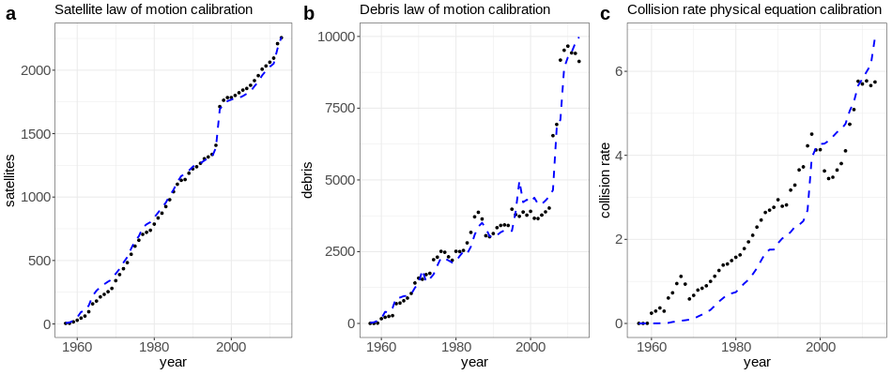
Extended Data Fig. 2 | Calibrated physical model fits to historical data. The black dots show historical data points (1957–2014) for debris counts, active satellite counts, and estimated collision rate. The blue dashed lines show the fits of the calibrated models. We describe our data construction procedures in section 1.1 of the Supplementary Methods, and the calibration procedures in section 1.3 of Supplementary Methods.

Extended Data Table 3 | Aggregate launch costs implied by open access and observed aggregate costs
Year | Observed aggregate cost | Implied aggregate cost
2006 | 161.02 | 194.26
2007 | 185.5 | 178.88
2008 | 170 | 154.86
2009 | 137.81 | 131.47
2010 | 136.16 | 140.48
2011 | 166.99 | 149.09
2012 | 186.88 | 165.69
2013 | 215.9 | 170.79
2014 | 254.39 | 170.68

Launch costs (inclusive of satellite construction, integration, and maintenance) implied by open access and observed revenues and costs. Since aggregate launch costs do not reflect the various unmodeled frictions (changing shadow price of the launch constraint, economies of scale in satellite launching, and the share of satellites which are in LEO), we calibrate the economic costs to the collision probability as per equation (15) in section 1.3.2 of the Supplementary Methods, and use the calibration to back out implied costs that reflect these frictions as per equation (17) in section 1.3.2 of Supplementary Methods. All values are given in billions of nominal US dollars per year.
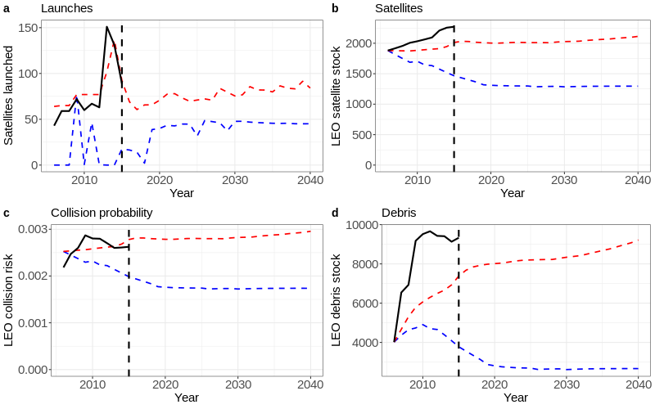
Extended Data Fig. 4 | Historical and future model simulations. Panels a-d show the time paths of satellites launched, the satellite stock, collision risk, and the debris stock over time in both open access and optimal management simulations. The solid black lines show the observed data from 2006–2015. The red dashed lines show the fit of the open access model simulation, and the blue dashed lines show the fit of the optimal model simulation. The dashed black line shows the end of the historical sample in 2015. While the simulation begins from the initial condition of observed satellite and debris levels in 2006, the initial projected collision probabilities don’t match the data exactly because of calibration error in the collision rate function (shown in Extended Data figures 2c and 7a). Simulation paths beginning from 2006 emphasize the fact that the open-access model resembles the observed data. We describe the simulation procedures in section 1.3 of Supplementary Methods.

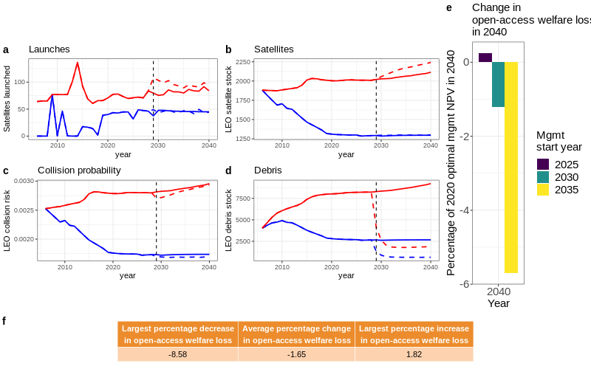
Extended Data Fig. 5 | Model simulations with debris removal. Panels a-d show the time paths of launches, satellites, debris, and collision risk with 50% debris removal beginning in 2029. The red lines show open access paths, while the blue lines show optimal management paths. The dashed lines show time paths with debris removal. The vertical dashed black line marks 2029, when removal begins in the simulation. Panel e shows the change in fleet NPV in 2040 with debris removal and open access, relative to a baseline of switching to optimal management in 2020 with debris removal beginning in 2029. Panel f shows summary statistics for changes in open-access welfare loss 50% debris removal for free beginning in each year from 2021–2034. Positive values in panels e and f indicate increased losses due to open access (debris removal makes open access worse), and negative values indicate reduced losses due to open access (debris removal makes open access better). We discuss the intuition for the results in the Supplementary Discussion.

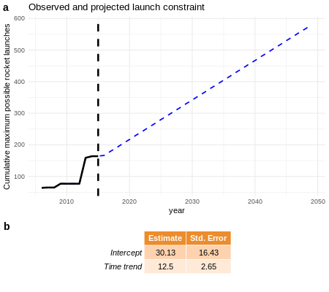

Extended Data Fig. 6 | Projected launch constraint model. To represent the various factors constraining the number of rocket launches possible each year – e.g. limited rocket availability, weather-induced launch cancellations, limited launch slots – we model the aggregate launch constraint as a linear time trend based on observed launch behavior from 2006–2015. We use this constraint in our open access and optimal management model simulations to avoid implausibly large launch rates in any given year. Panel a shows the observed and projected launch constraint. The solid black line from 2006–2015 indicates the observed cumulative maximum number of rocket launches in any given year, the dashed blue line from 2016–2050 shows the projected maximum number of rocket launches possible in each year, and the vertical dashed black line marks the end of the in-sample period (2006–2015). Panel b shows the estimated intercept and time trend with standard errors.

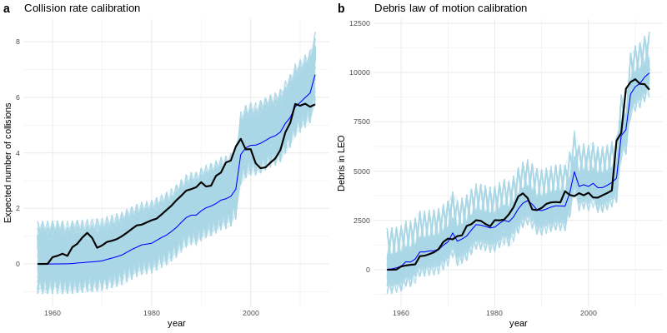

Extended Data Fig. 7 | Sensitivity of physical model calibration to parameter uncertainty. Panels a-b show a sensitivity analysis of the model calibrations for the collision rate function and debris law of motion. The black lines show the underlying collision rate and debris count data from ESA, 1957–2017. The thin darker blue lines show the fit of the models calibrated to the black lines (the same model fits shown in Extended Data figure 4). The light blue lines show model fits from residual bootstrap-resampled data, indicating the effects of uncertainty in the model calibration. The same procedure was used to generate Fig. 2d. We describe the residual bootstrap resampling procedure in more detail in section 1.4 of the Supplementary Methods.

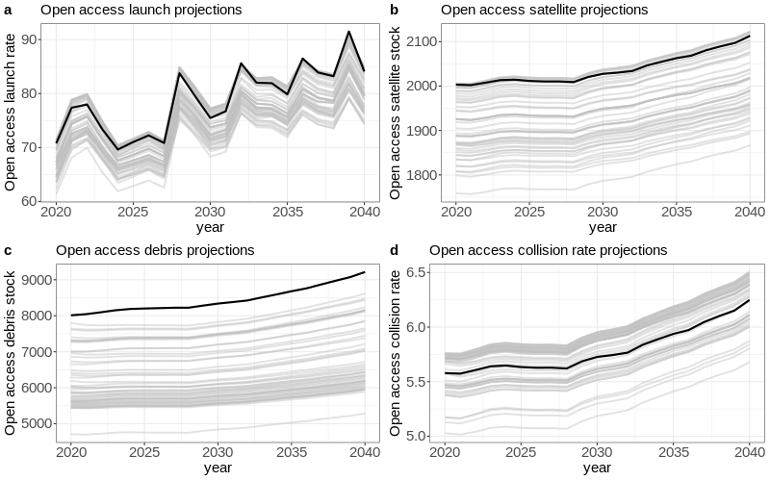
Extended Data Fig. 8 | Sensitivity of open-access paths to physical parameter uncertainty. Panels a-d show a sensitivity analysis of open-access model projections beginning in 2020 to uncertainty in the physical parameters. The thick black lines show the projection from the main model estimated on the full 1957–2017 time series of object counts and collision rate estimates. The gray lines show projections using alternate sets of parameter estimates generated from 50 draws of the residual bootstrap-resampling procedure used in Fig. 2d.
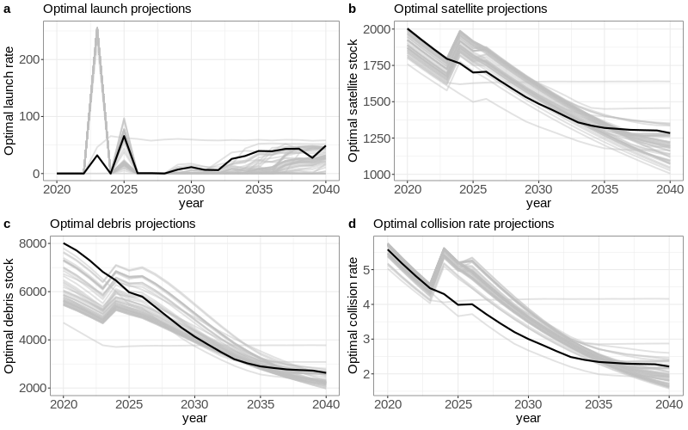
Extended Data Fig. 9 | Sensitivity of optimal paths to physical parameter uncertainty. Panels a-d show a sensitivity analysis of optimal model projections beginning in 2020 to uncertainty in the physical parameters. The thick black lines show the projection from the main model, where the physical parameters were estimated on the 1957–2017 calibration time series constructed from ESA and UCS count data. The gray lines show projections using alternate sets of parameter estimates generated from 50 draws of the residual bootstrap-resampling procedure used in Fig. 2d.

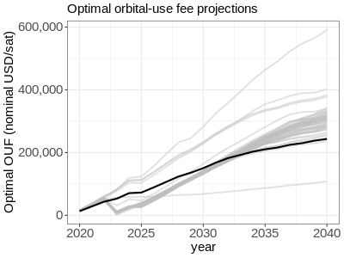

Extended Data Fig 10 | Sensitivity of optimal OUF to physical parameter uncertainty. The thick black line shows the projection from the main model, where the physical parameters were estimated on the 1957–2017 calibration time series constructed from ESA and UCS count data. The gray lines show projections using alternate sets of parameter estimates, generated from 50 draws of the residual bootstrap-resampling procedure used in Fig. 2d.

