# **1.INTRODUCTION**

The Crime Report System ensures that, the person who committed the crime is more likely to be arrested and kept from doing the same thing to someone else. All crime is serious, and your safety is important.When you report a crime to police you will be listened to and they can tell you about options that can help make you safer.

It does not matter what happened or when it happened, all crime is serious.This is where this project plays an important role.Usually,many tends not to report a crime because of they think that it is not much important and serious.Some also tends not to report because of the hustle and bustle to report a crime in police station.

This project helps the people to report crimes through a website application instantly without any hustle.So each and every crimes can be recorded and investigated.

## **1.1 OBJECTIVE OF THE PROJECT**

The main aim for this project is to provide all crime management solutions which are easily accessible by everyone. The system starts with every people who want to login a complaint through the internet so that it is very useful for police department and social worker to find out the problem in the society without making people to come to police station every time.

The main purpose of the system is to provide solution for public to give complaint through website application. This project provides lot of features to manage all the data in well manner. The system has been developed to override the problems prevailing in the manual system. The project is supported to eliminate and reduce the hardships faced by the existing system. This system is designed for particular need to carry out operations in a smooth and effective manner. The application is reduced as much as possible to avoid errors while entering the data and it also provide error message while entering invalid data.

No formal knowledge is needed for the user to use this system and hence it proves it is user friendly. Online crime reporting system can lead to error free, secure, reliable and fast management system and it can assist the user to concentrate on the other activities rather than to concentrate on the record keeping.

The purpose of the project is to automate the existing manual system with the help of computerized equipments and to fulfill the requirements so that the data can be stored for long period with easy accessing and manipulation.

## **2.SYSTEM ANALYSIS**

This project provides lot of features to manage all the data in well manner. The system has been developed to override the problems prevailing in the manual system. The project is supported to eliminate and reduce the hardships faced by the existing system. This system is designed for particular need to carry out operations in a smooth and effective manner. The application is reduced as much as possible to avoid errors while entering the data and it also provide error message while entering invalid data.

The victims can file the FIR through the website under various sections. In this system, user’s information will be kept confidential and only users complain will be forwarded to the nearest Admin. Users complaint number are forwarded from the server side automatically.The users will be notified if the Admin have filed the approved their complaint. This project is cop friendly too.

## **2.1 EXISTING SYSTEM**

User need to visit Police station for reporting the complaint and it would take time.Also a lot of paper word are to be completed for reporting a single Crime.This slow procedure also leads to slow investigation of reported Complaint.

### DRAWBACKS

* Time Consuming
* No mobile based system available.
* Data entry is very difficult
* Data entries are done in register book which doesn’t provide any security
* Cannot check the latest updates.

## **2.2 PROPOSED SYSTEM**

In the proposed system, there are various controls to provide user friendliness. Details can be accessed over the internet, and huge amount of data, records and information can be stored. It provides high level of security and there is no risk of data mismanagement. The overall result processing system is easier, flexible and requires less time.

### ADVANTAGES

* Less time consuming.
* This system makes crime reporting easier and efficient.
* User friendly
* Data entry is very easy
* Even small crimes will get reported

## **2.3 SYSTEM REQUIREMENT SPECIFICATION**

A System Requirements Specifications (SRS) is a comprehensive description of the intended purpose and environment for system under development. The SRS fully describes what the system will do and how it will be expected to perform. An SRS minimizes the time and effort required by developers to achieve desired goals and also minimizes the development cost. A good SRS will interact with system hardware, other programs and human users in a wide variety of real-worked situations.

### Customer Requirements

* The system should be fast
* User friendly
* Maintaining security of data
* Efficiency in data retrieval and management.

**What the developer needs to know?**

* Must know the existing system and its drawbacks
* Must know what will be needed in the proposed system

### Business Requirements

The system should be feasible both the developer and client. It should be effective and should be able to complete in time. Developer should be responsible for developing the system, install the software and update the software whenever necessary, conducting any user training that may be needed for using the system.

### User Requirements

The user requirement(s) specification is a document usually that specifies the requirements the user expects from software to be conducted in a software project.

* Administrator has overall control in the system.
* Admin can view and edit user details and complaints.
* Faster processing

### Functional Requirements

Functional requirements define what a system is supposed to do. The system should perform the following functionalities.

**Admin**

* Login of admin
* Admin can view user details and remove users if want
* Admin can view reported complaints
* Admin can approve/reject the complaints
* Admin can logout

**User**

* Login of user
* User can register themselves
* User can report crimes
* User can view the complaint status
* User can Update their Details
* User can Logout

#### **2.3.1 Hardware Specifications**

|  |  |
| --- | --- |
| Processor | :Intel Premium 4 or higher processor |
| Speed | :1.5GHz or higher |
| System bus | :32 bits |
| Memory | :1GB RAM or Higher |
| Hard disk | :40GB or Higher |
| Monitor | :14”LCD Monitor |
| Keyboard | :104 keys |
| Pointing Device | :two or three button Mouse |

#### **2.3.2 Software Specifications**

Operating System :Windows 10

Front End :PHP,HTML,CSS

Scripting Language :JavaScript

Back End :SQL Server Web Server WAMP 2.0

Browser :Google Chrome

#### **2.3.3 Front End**

##### **PHP**

PHP is a server-side scripting language designed for web development but also used as a general-purpose programming language. Originally created by Rasmus Lerdorf_ in 1994. The PHP reference implementation is now produced by The PHP Group. PHP originally stood for Personal Home Page. But it now stands for the recursive backronym PHP: Hypertext Pre-processors.

PHP code may be embedded into HTML code or it can be used in combination with various web template systems, web content management system and web frameworks. PHP code is usually processed by a PHP interpreter implemented as a module in the web server or as a Common Gateway Interface (CGI) executable. The web server combines the results of the interpreted and executed PHP code, which may be any type of data, including images with the generated web page. PHP code may also be executed with a Command-Line Interface (CLI) and can be used to implement standalone graphical applications.

##### **CSS**

Cascading Style Sheet (CSS) is a style sheet language used for describing the presentation of a document written in a mark-up language. Although most often used to set the visual style of web pages and user interfaces written in HTML and XTML. The language can be applied to any XML document, including plain XML, SVG and XUL and is applicable to rendering in speech or in other media.

Along with HTML and JavaScript, CSS is a cornerstone technology used by most websites to create visually engaging webpages, user interfaces for web applications, and user interfaces for any mobile applications.

CSS is designed primarily to enable the separation of document content from document presentation, including aspects such as layout, colours and fonts. This separation can improve content accessibility, provide more flexibility and control in the specification or presentation characteristics, enable multiple HTML pages to share formatting by specifying on all platforms except Windows. MySQL ships with no GUI tools to administrate MySQL databases or manage data contained within the databases. Users may use the included command line tools or install MySQL Workbench via a separate download. Many third party GUI tools are also available.

##### **HTML**

The HyperText Markup Language or HTML is the standard [markup language](https://en.wikipedia.org/wiki/Markup_language) for documents designed to be displayed in a [web browser](https://en.wikipedia.org/wiki/Web_browser). It can be assisted by technologies such as [Cascading Style Sheets](https://en.wikipedia.org/wiki/Cascading_Style_Sheets) (CSS) and [scripting languages](https://en.wikipedia.org/wiki/Scripting_language) such as [JavaScript](https://en.wikipedia.org/wiki/JavaScript).

[Web browsers](https://en.wikipedia.org/wiki/Web_browser) receive HTML documents from a [web server](https://en.wikipedia.org/wiki/Web_server) or from local storage and [render](https://en.wikipedia.org/wiki/Browser_engine) the documents into multimedia web pages. HTML describes the structure of a [web page](https://en.wikipedia.org/wiki/Web_page) [semantically](https://en.wikipedia.org/wiki/Semantic_Web) and originally included cues for the appearance of the document.

[HTML elements](https://en.wikipedia.org/wiki/HTML_element) are the building blocks of HTML pages. With HTML constructs, [images](https://en.wikipedia.org/wiki/HTML_element#Images_and_objects) and other objects such as [interactive forms](https://en.wikipedia.org/wiki/Fieldset) may be embedded into the rendered page. HTML provides a means to create [structured documents](https://en.wikipedia.org/wiki/Structured_document) by denoting structural [semantics](https://en.wikipedia.org/wiki/Semantics) for text such as headings, paragraphs, lists, [links](https://en.wikipedia.org/wiki/Hyperlink), quotes, and other items. HTML elements are delineated by tags, written using [angle brackets](https://en.wikipedia.org/wiki/Bracket#Angle_brackets). Tags such as <img /> and <input /> directly introduce content into the page. Other tags such as <p> surround and provide information about document text and may include other tags as sub-elements. Browsers do not display the HTML tags but use them to interpret the content of the page.

HTML can embed programs written in a [scripting language](https://en.wikipedia.org/wiki/Scripting_language) such as [JavaScript](https://en.wikipedia.org/wiki/JavaScript), which affects the behavior and content of web pages. The inclusion of CSS defines the look and layout of content. The [World Wide Web Consortium](https://en.wikipedia.org/wiki/World_Wide_Web_Consortium) (W3C), former maintainer of the HTML and current maintainer of the CSS standards, has encouraged the use of CSS over explicit presentational HTML since 1997. A form of HTML, known as [HTML5](https://en.wikipedia.org/wiki/HTML5), is used to display video and audio, primarily using the <canvas> element, in collaboration with javascript.

**2.3.4 Back End**

##### **MySQL**

MySQL server is powerful and it requires limited programs and used as back end. It supports GUI and more application is developed by this server. Collection of tables which holds the data is called database. A beginner can create their own database by clicking home page. Users may use the included command line tools or install MySQL Workbench via a separate download. Many third party GUI tools are also available.

##### **JavaScript**

JavaScript often abbreviated as JS, is a [programming language](https://en.wikipedia.org/wiki/Programming_language) that is one of the core technologies of the [World Wide Web](https://en.wikipedia.org/wiki/World_Wide_Web), alongside [HTML](https://en.wikipedia.org/wiki/HTML) and [CSS](https://en.wikipedia.org/wiki/CSS). As of 2022, 98% of [websites](https://en.wikipedia.org/wiki/Website) use JavaScript on the [client](https://en.wikipedia.org/wiki/Client_(computing)) side for [webpage](https://en.wikipedia.org/wiki/Web_page) behavior, often incorporating third-party [libraries](https://en.wikipedia.org/wiki/Library_(computing)). All major [web browsers](https://en.wikipedia.org/wiki/Web_browser) have a dedicated [JavaScript engine](https://en.wikipedia.org/wiki/JavaScript_engine) to execute the [code](https://en.wikipedia.org/wiki/Source_code) on [users](https://en.wikipedia.org/wiki/User_(computing))' devices.

JavaScript is a [high-level](https://en.wikipedia.org/wiki/High-level_programming_language), often [just-in-time compiled](https://en.wikipedia.org/wiki/Just-in-time_compilation) language that conforms to the [ECMAScript](https://en.wikipedia.org/wiki/ECMAScript) standard. It has [dynamic typing](https://en.wikipedia.org/wiki/Dynamic_typing), [prototype-based](https://en.wikipedia.org/wiki/Prototype-based_programming) [object-orientation](https://en.wikipedia.org/wiki/Object-oriented_programming), and [first-class functions](https://en.wikipedia.org/wiki/First-class_function). It is [multi-paradigm](https://en.wikipedia.org/wiki/Programming_paradigm), supporting [event-driven](https://en.wikipedia.org/wiki/Event-driven_programming), [functional](https://en.wikipedia.org/wiki/Functional_programming), and [imperative](https://en.wikipedia.org/wiki/Imperative_programming) [programming styles](https://en.wikipedia.org/wiki/Programming_paradigm). It has [application programming interfaces](https://en.wikipedia.org/wiki/Application_programming_interface) (APIs) for working with text, dates, [regular expressions](https://en.wikipedia.org/wiki/Regular_expression), standard [data structures](https://en.wikipedia.org/wiki/Data_structure), and the [Document Object Model](https://en.wikipedia.org/wiki/Document_Object_Model) (DOM).

##### **WAMP**

Stands for "Windows, Apache, MySQL, and PHP." WAMP is a variation of [LAMP](https://techterms.com/definition/lamp) for Windows systems and is often installed as a [software](https://techterms.com/definition/software) bundle (Apache, MySQL, and PHP). It is often used for [web development](https://techterms.com/definition/web_development) and internal testing, but may also be used to serve live websites.

The most important part of the WAMP package is [Apache](https://techterms.com/definition/apache) (or "Apache HTTP Server") which is used run the [web server](https://techterms.com/definition/web_server) within Windows. By running a local Apache web server on a Windows machine, a web developer can test [webpages](https://techterms.com/definition/webpage) in a [web browser](https://techterms.com/definition/web_browser) without publishing them live on the Internet.

WAMP also includes [MySQL](https://techterms.com/definition/mysql) and [PHP](https://techterms.com/definition/php), which are two of the most common technologies used for creating [dynamic websites](https://techterms.com/definition/dynamicwebsite). MySQL is a high-speed database, while PHP is a scripting language that can be used to access data from the database. By installing these two components locally, a developer can build and test a dynamic website before publishing it to a public web server.

While Apache, MySQL, and PHP are open source components that can be installed individually, they are usually installed together. One popular package is called "WampServer," which provides a user-friendly way to install and configure the "AMP" components on Windows.

## **2.4 FEASIBILTY ANALYSIS**

A feasibility study is an evaluation and analysis of the potential of the proposed project which is based on extensive investigation and research to give full comfort to the decision makers. Feasibility studies aim to objectively and rationally uncover the strength and weakness of existing business of proposed venture, opportunities and threads as presented by the environment, the resources required to carry through, and ultimately the process for success. In its simplest terms, the two criteria to judge feasibility are cost required and value to attain. As such, a well-designed feasibility are cost required and value to attain. As such, a well-designed feasibility study should provide a historical background of the business or project, description of the product or service, accounting statements, details of the operations and management, marketing research and policies, financial data, legal requirements and tax obligations.

The four aspects in the feasibility study are:

* Technical feasibility
* Economic feasibility
* Operational feasibility
* Behavioural feasibility

### ü Technical Feasibility

The technical feasibility centres on the existing system and what extend it can support the proposed addition. The technical feasibility assessment is focused on gaining an understanding of the present technical resources of the organization and their applicability to the expected needs of the proposed system. The minimum requirements of the system are met by average user. The developer system has a modest technical requirement as only minimal or null changes are required for implementing system.

Normally associated with the technical feasibility includes:

* Development risk
* Resource availability
* Technology

The proposed system can work without any additional hardware or software support other than the computer system and networks. So, I analysed that the proposed system is much more technically feasible than other systems when comparing with the benefits of the new system.

### ü Economic Feasibility

Economic feasibility analysis is also known as cost/benefit analysis. The purpose of the economic feasibility assessment is to determine the positive economic benefits to the organization that the proposed system will provide. The proposed system reduces the operating cost in terms of time by automating the process. This system is economically feasible

### ü Operational Feasibility

Operational feasibility is a measure of how well a proposed system solves the problems, and takes advantage of the opportunities identified during space definition and how it satisfies the requirements identified in the requirements analysis phase of system development.

### ü Behavioural Feasibility

People are inherently resistant to changes and computer is known for facilitating the chances. An estimate should be made to how strongly the users react towards the development of the system. The proposed system consumes less time. Thus, the people are made to engage in some other important work.

## **2.5 DATA FLOW DIAGRAM (DFD)**

## 

### 2.5.1 Introduction of data flow diagram

A Data Flow Diagram (DFD) is a graphical representation of the “flow” of data through an information system. It differs from the flowchart as it shows the data flow instead of the control flow of the program. A data flow diagram can also be used for the visualization of data processing (structured design).

Data Flow Diagrams were invented by Larry Constantine, the original developer of structured design based on Martin and Estrin’s “Data Flow Graph” model of computation.

Data Flow Diagrams (DFD) are one of the three essential perspectives of Structured System Analysis and Design Method SSADM. The sponsor of a project and the end users will need to be briefed and consulted throughout all stages of a system’s evolution. With a dataflow diagram, users are able to visualize how the system will operate, what the system will accomplish and how the system will be implemented. The old system’s data flow diagram can be drawn up and compared with the new system’s data flow diagram can be drawn comparisons to implement a more efficient system. Data flow diagrams can be used to provide the end user with physical idea of where the data they input ultimately has an effect upon the structure of the whole system from order to dispatch to report. How many system is developed can be determined through a data flow diagram.

Developing a data flow diagram helps in identifying the transaction data in the data model. There are different notations to draw data flow diagrams, defining different visual representation for process, data stores, data flow and external entities. The first step is to draw a Data Flow Diagram (DFD) also known as “bubble chart” has the purpose of clarifying system requirements and identifying major transformation that will become program in system design. So, it is starting point of the design phase that functionally decompose the requirements specification down to the lowest level of details. DFD consists of series of bubbles joined by lines. The bubbles represent data transformation and the lines represent data flow in the system.

### DFD Symbols

* Square – Defines source or destination of system

* Data flow – Identifies data flow circle

* Circle – Represents a process that transforms incoming data to outgoing data

* Open Rectangle – Data store

**LEVEL 0**

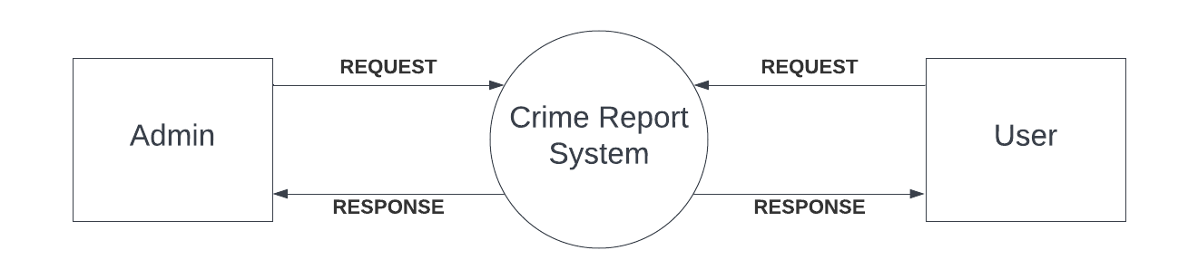**LEVEL 1**

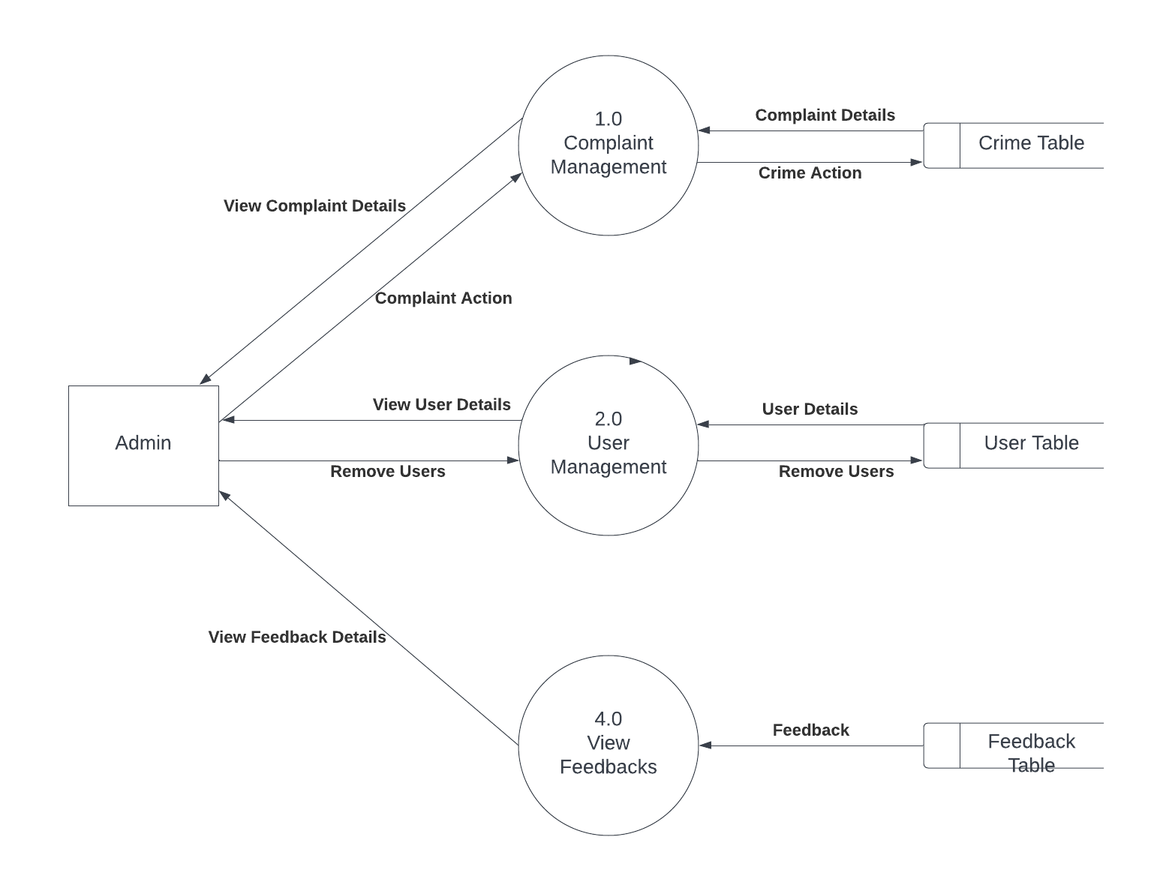

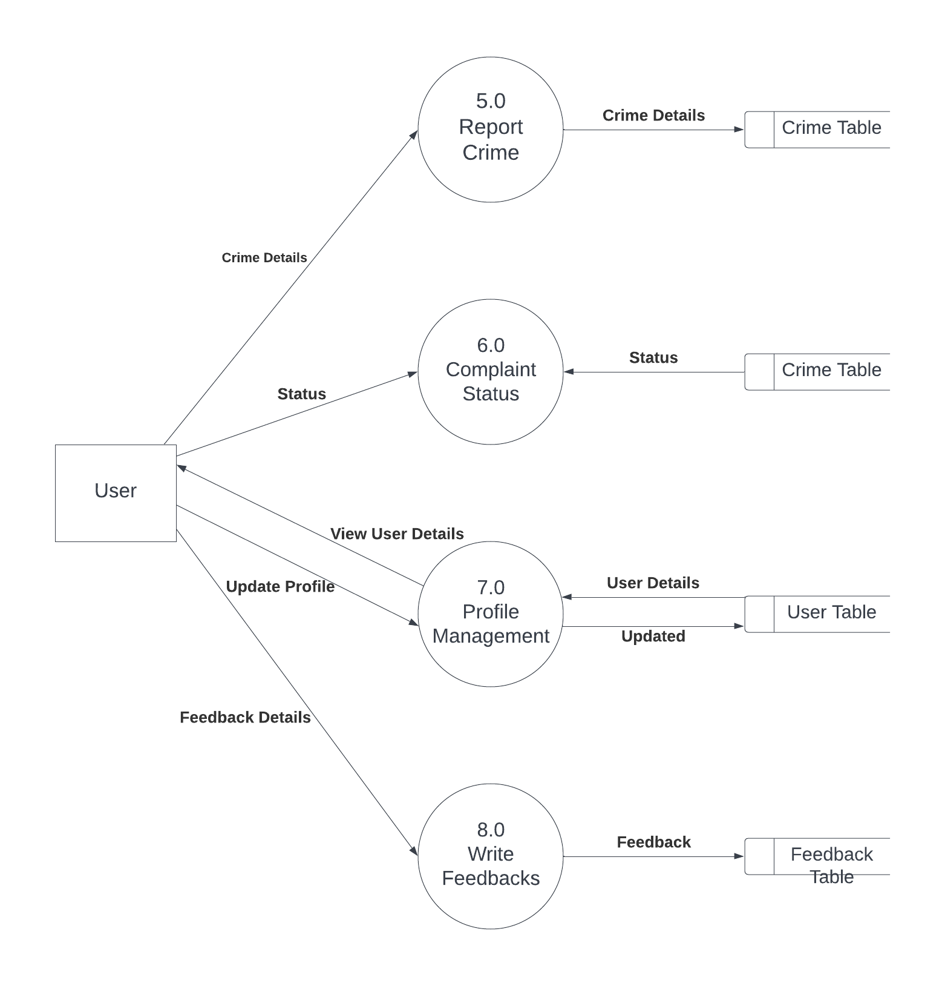

# **3. SYSTEM DESIGN**

## **3.1 INPUT DESIGN**

The quality of the system input determines the quality of the system output. Input specification describes the manner in which data enter the system for processing. Input design features can ensure the reliability of the system and procedure result from accurate data, or they can result in the production or erroneous information. The input design also determines whether the user can interact efficiently with the system.

In our system almost all inputs are being taken from the databases. To provide adequate inputs we have to select necessary values from the databases and arrange it to the appropriate controls.

### Admin

Admin is the one who controls the whole system. The administrator is the super user of this application. Only admins have access into the admin page. Admin can access the page using their login id and password. Admin can approve/reject complaints and remove users.

### User

The user of the system is the members. User can register their username and password to create Account.They also Can Report Complaints and write Feedback of the System.Users can also Update their Profiles.

## **3.2 OUTPUT DESIGN**

One of the important features of an information system for users is the output procedures. Output is the information delivered to users through the information system. Without quality of the output, the entire system appears to be unnecessary that users will avoid using it. Users generally merit the system solely by its output. Inorder to create the most useful output possible, one works with the user through an interactive process, until the result is considered to be satisfactory.

**Admin**

Admin can view all the details of registered users.It is also possible to Remove unwanted users.They Can also view the Registered Complaints and take actions for it.

### User

User can check the Status of their Registered Complaints.They can also view the Updated Profile.

## **3.3 TABLE DESIGN**

The data design transforms the information domain model created during analysis into the data structures that will be required to implement the software. The data objects and relationships defined in the entity relationship diagram and the detailed data content depicted in the data directory provide the basis for the data design activity.

The overall objective in the development of database technology has been to treat data as an organizational resource and as an integrated whole. Database Management System allows data to be protected and organized separately from other resources. Database is a integrated collection of data. This is the difference between logical and physical data.

The organization of data in the database aims to achieve three major objectives:

* Data integration
* Data integrity
* Data independence

The databases are implemented using a DBMS package. Each particular DBMS has unique characteristics and general techniques for database design. There are 6 major steps in design process.

The first 5 steps are usually done on paper and finally the design is implemented.

* Identify the table and relationships
* Identify the data that is needed for each table and relationship
* Resolve the relationship
* Verify the design
* Implement the design

The database uses tables for storage. A table also contain records, which is a set of fields. All records in a table have the same set of fields with different information.

The various database tables that are used in the project are the following:

1. **Tablename : Login**

**Description: To store login Credentials**

**Primary key : Username**

|  |  |  |  |
| --- | --- | --- | --- |
| **Fieldname** | **Datatype** | **Size** | **Description** |
| Username | Varchar | 25 | username to login |
| Password | Varchar | 25 | password to login |
| Role | Varchar | 10 | Admin/user to login |

1. **Tablename : Registeration**

**Description :To store User Details**

**Primary key : Username**

|  |  |  |  |
| --- | --- | --- | --- |
| **Fieldname** | **Datatype** | **Size** | **Description** |
| Fullname | varchar | 25 | name of user/admin |
| Username | varchar | 25 | username to signup |
| Password | varchar | 25 | password to signup |
| Email |  | 50 | Email id of the user |
| Aadhar no | varchar | 20 | Aadhar of user |

1. **Tablename : Crime**

**Description : To store Crime Details**

**Primary key : Complaint id**

|  |  |  |  |
| --- | --- | --- | --- |
| **Fieldname** | **Datatype** | **Size** | **Description** |
| Complaint id | Int |  | Id of complaint |
| Username | Varchar | 25 | Username of the user |
| Complaint title | Varchar | 25 | Title of complaint |
| Name of suspect | Varchar | 25 | Name of suspect |
| Date of crime | Date |  | Date crime occur |
| Crime location | Varchar | 100 | Loction of crime |
| Complaint details | Varchar | 200 | Define the complaint |
| Victim details | Varchar | 200 | Full details of victim |
| Status | Varchar | 25 | Admin review status |

1. **Tablename : Feedback**

**Description : To store Feedback Details**

**Primary key : Complaint id**

|  |  |  |  |
| --- | --- | --- | --- |
| **Fieldname** | **Datatype** | **Size** | **Description** |
| Username | Varchar | 25 | Username of the user |
| Review | Varchar | 25 | Review |
| Rating | Varchar | 25 | Rating from 1 to 5 |
| Date | Date |  | Date of review |

# **4. SYSTEM TESTING AND IMPLEMENTATION**

## **4.1 SYSTEM TESTING**

Testing is the process of examining the software to compare the actual behavior with that of the expected behavior. The major goal of software testing is to demonstrate that faults are not present. In order to achieve this goal, the tester executes the program with the intent of finding errors. Though testing cannot show absence of errors but by not showing their presence it is considered that these are not present.

System testing is defined as the process by which one detects the defects in the software. Any software development organization or team has to performs several processes. Software testing is one among them. It is the final opportunity of any programmer to detect and rectify any defects that may have appeared during the software development stage. Testing is a process of testing a program with the explicit intention of finding errors that makes the program fail to short system testing and quality assurance is a review in software products and related documentation for completion, correctness, reliability and maintainability.

System testing is the first stage of implementation, which is aimed at ensuring that the system works accurately and efficiently before live operation commences Testing is vital to the success of the system. System testing makes a logical assumption that if all the parts of the system are correct and the goal will be successfully achieved. A series of testing are performed for the proposed system before the proposed system is ready for user acceptance testing

The testing steps are

* Unit testing
* Integration testing
* Validation
* Output testing
* Acceptance testing

System Testing provides the file assurance that software once validated mast combined with all other system elements. System testing verifies whether all elements have been combined properly and that overall system function and performance is achieved. FA the integration of modules, the validation test was carried out over the system. It was that all the modules work well together and meet the overall system function and performance.

### Unit Testing

Unit testing is carried out screen-wise, each screen being identified as an object. Attention is diverted to individual modules, independently to one another to locate errors. This has enabled the detection of errors in coding and logic.

Various test cases are prepared. For each module these test cases are implemented and it is checked whether the module is executed as per the requirements and outputs the desired result. In this test each service input and output parameters are checked

In unit testing

* Module interface was tested to ensure that information properly flows into and out of the program under test.
* Boundary condition was tested to ensure that module operates properly at boundaries established to limit or restrict processing.
* All independent paths through the control structures were executed to ensure that all statements in the modules have been executed at least once. Error handling paths were also tested

### Integration Testing

Integration testing is a systematic technique for constructing the program structure while at the same time conducting tests to uncover errors associated with interfacing.

Unit tested module were taken and a single program structure was built that has been dictated by the design. Incremental integration has been adopted here.

The modules are tested separately for accuracy and modules are integrated tooth in using bottom up integration i.e., by integrating from moving from bottom to the top the system is checked and errors found during integration are rectified. In this testing individual modules were combined and he module wise Shifting was verified to be alright.

The entire software was developed and tested in small segments, where errors were easy to locate and rectify. Program builds (group of modules) were constructed corresponding to the successful testing of user interaction, data manipulation analysis, and display processing and database management.

### Validation Testing

Validation testing is done to ensure complete assembly of the error-free software. Validation can be termed successful only if it functions in manner. Reasonably expected by the student under validation is alpha and beta testing. The student-side validation is done in this testing phase. It is checked whether the data passed to each student is valid or not. Entering incorrect values does the validation testing and it is checked whether the errors are being considered. Incorrect values are to be discarded. The errors are rectified.

In "Gym Management System" verifications are done correctly. So, there is no chance for users to enter incorrect values. It will give error messages by using different validations. The validation testing is done very clearly and found it is error free.

### Output Testing

After performing the validation testing the next step is output testing of the proposed system, since no system could be useful if it does not produce the required output in a specific format.

The output format on the screen was found to be correct as the format was designed in the system design phase according to the user needs. For the hard copy also, the output comes out as specified requirement by the user. Hence output testing does not result in any Correction in the system output. This project is developed based on the user choice. It is user friendly. The output format is very clear to user. Output testing is done on Smart builders correctly.

### e. Acceptance testing

Acceptance involves running a suite of tests on the completed system. Each individual test, known as a Case, exercise particular operating condition of the operating condition of the user's environment or feature of the system, and will result in a pass fail, or Boolean outcome.

## **4.2 SYSTEM IMPLEMENTATION**

The implementation is the final state and it is an important phase. It involves the invalid programming system testing, user training and the operational running of developed proposed system that constitutes the application subsystems. A major task of preparing for implementation is education of users, which should really have been taken place much carrier in the project when they were belong involved in the investigation and design work. During the implementation phase system actually take physical shape. In order to develop a system implemented planning is very essential.

The implementation phase of the software development is concerned with translating design specification into source code. The user tests the developed system and changes are made according to their needs. Our system has been successfully implemented.

Before implementation several tests have been conducted to ensure that no errors are encountered during the operation. The implementation phase ends with an evaluation of the system after placing into the operation for a period of time.

The process of putting the developed system in actual use is called system implementation. This includes all those activities that take place to convert from old system to new system. The system can be implemented only after testing is done and is found to be working to specifications. The implementation stage is a systems project in its own right.

The implementation stage involves following tasks:

* Careful planning.
* Investigation of system and constraints.
* Design of method to achieve change over.
* Evaluation of the changeover method.

In the case of this project all the screens are designed first. For making it to be executable, codes are written on each screen and performs the implementation by creating the database and connecting to the server. After that the system, is Checked, whether it performs all the transactions Correctly. Then databases are cleared and made it to be usable to the technicians.

### Implementation Plans

The following are the step involved in the implementation plan of "Smart Builders":

* Test system with sample data
* Detection and correction of errors
* Make the necessary changes in the system
* Check the existing system
* Installation of hardware and software utilities
* Training and involvement of user personals

# **5. SECURITY TECHNOLOGIES & POLICIES**

The protection of computer-based resources that includes hardware, software, data procedures and people against unauthorized use or natural.

Disaster is known as System Security.

System Security can be divided into four related issues:

* Security
* Integrity
* Privacy
* Confidentiality

**SYSTEM SECURITY** refers to the technical innovations and procedures applied to the hardware and operation systems to protect against deliberate or accidental damage from a defined threat.

**DATA SECURITY** is the protection of data from loss, disclosure, modification and destruction.

**SYSTEM INTEGRITY** refers to the power functioning of hardware and programs, appropriate physical security and safety against external threats such as caves dropping and wiretapping

**PRIVACY** defines the rights of the user or organizations to determine what information they are willing to share with or accept from others and how the organization can be protected against unwelcome, unfair or excessive dissemination of information about it.

**CONFIDENTIALITY** is a special status given to sensitive information in a database to minimize the possible invasion of privacy. It is an attribute of information that characterizes its need for protection.

**SECURITY IN SOFTWARE** System security refers to various validations on data in form of checks and controls to avoid the system from failing. It is always important to ensure that only valid data is entered and only valid operations are performed on the system.

The system employees two types check and controls:

**CLIENT-SIDE VALIDATION** Various client-side validations are used to ensure on the client side that only valid data is entered. Client-side validation saves server time and load to handle invalid data. Some checks imposed are:

* Forms cannot be submitted without filling up the mandatory data so that manual mistakes of submitting empty fields that are mandatory can be sorted out at the client side to save the server time and load.
* Tab-indexes are set according to the need and taking into account the ease of user while working with the system.

**SERVER-SIDE VALIDATION** Some checks cannot be applied at client side. Server-side checks are necessary to save the system from failing and intimating the user that some invalid operation has been performed or the performed operation is restricted. Some of the serverside checks imposed is:

* Server-side constraint has been imposed to check for the validity of primary key and foreign key. A primary key value cannot be duplicated. Any attempt to duplicate the primary value results into a message intimating the user about those values through the forms using foreign key can be updated only of the existing foreign key values.
* User is intimating through appropriate messages about the successful operations or exceptions occurring at server side.
* Various Access Control Mechanisms have been built so that one user may not agitate upon another. Access permissions to various types of users are controlled according to the organizational structure. Only permitted users can log on to the system and can have access according to their category. User name, passwords and permissions are controlled over the server side.
* Using server-side validation, constraints on several restricted operations are imposed

## **6. MAINTENANCE**

Software maintenance is the modification of a software product delivery to correct faults, to improve performance or other attributes. Maintenance is the case with which a program can be corrected if any error is encountered, adapted if its environment changes or enhanced if the customer desires a change in requirement. Maintenance follows conversation to extend that changes are necessary to maintain satisfactory operations relative to changes in the user's environment.

Maintenance often includes minor enhancements or corrections to problems that surface in the system's operation. Maintenance is also done based on fixing the problems reported, changing the interface with other software or hardware enhancing the software.

## **CATEGORIES OF MAINTENANCE**

### a. Corrective Maintenance

Corrective maintenance is the most commonly used maintenance approach, but it is easy to see its limitations. When equipment fails, it often leads to downtime in production, and sometimes damages other parts. In most cases, this is expensive. Also, if the equipment needs to be replaced, the cost of replacing it alone can be substantial. Reliability of systems maintained by this type of maintenance is unknown and cannot be measured. Corrective maintenance is possible since the consequences of failure or wearing out are not significant and the cost of this maintenance is not great

### b. Perfective Maintenance

Modification of a software product alter delivery to improve performance or maintainability. This term is used to describe changes undertaken to expand the existing requirements of the system. A successful piece or software lends to be subjected to a the Succession of changes resulting in an increase in us requirements. This is based an premise that as the software becomes useful, the user experiment with new cases beyond the of Scope for which it was initially developed. Vxpansi01 n requirements can take the form enhancement of existing system functionality and improvement in computational efficiency.

**c. Adaptive Maintenance**

Modification of a software product performed after delivery to keep a are product usable a changed or changing environment. Adaptive maintenance includes any work initiated as a consequence of moving the software to a different hardware or software platform. It is a change driven by the need to accommodate modifications in the enviroment of software system. The environment in this context refers to the totality of all conditions and influences which act from outside upon the system. A change to the whole or part of this environment will Warrant a corresponding modification of the software.

### Preventive Maintenance

Preventive maintenance is a schedule of planned maintenance actions aimed at the prevention of breakdowns and failures. The primary goal of preventive maintenance is to prevent the failure of equipment before it actually occurs. It is designed to preserve and enhance equipment reliability by replacing worn components before they actually fail. Preventive maintenance activities include equipment checks, partial or complete overhauls at specified periods

Long-term benefits of preventive maintenance include:

* Improved system reliability.
* Decreased cost of replacement.
* Decreased system downtime.

## **7. SCOPE FOR FUTURE ENHANCEMENT**

In future we can use Image recognisation instead of using heterogeneous database more over High

speed, accuracy and non-redundant data are the main advantages of the proposed system. In the proposed

system the user is provided with a choice of data screen, which are similar in formats to the source

documents. Data entry errors can be minimized through validity checks. After the verification only the

data are placed the permanent database. The software can be developed further to include a lot of

modules because the proposed system is developed on the view of future, for example we should

develop the system as a database independent using JDBC so we can connect it to any other database,

Now the proposed system is based on PC and intranet but in the future if we need to convert it into

internet then we need to change the front end only because we are developing this on the basis of OOP

technology and most of the business logic’s are bounded in the class files and module like reusable

components.

In future we can use Image recognisation instead of using heterogeneous database more over High

speed, accuracy and non-redundant data are the main advantages of the proposed system. In the proposed

system the user is provided with a choice of data screen, which are similar in formats to the source

documents. Data entry errors can be minimized through validity checks. After the verification only the

data are placed the permanent database.

In future we can use Image recognisation instead of using heterogeneous database more over High

speed, accuracy and non-redundant data are the main advantages of the proposed system

In future we can use Image recognisation instead of using heterogeneous database more over High

speed, accuracy and non-redundant data are the main advantages of the proposed system

In future we can use Image recognisation instead of using heterogeneous database more over High

speed, accuracy and non-redundant data are the main advantages of the proposed system

In future we can use Image recognisation instead of using heterogeneous database more over High

speed, accuracy and non-redundant data are the main advantages of the proposed system

In future we can use Image Recognition instead of using heterogenous database more over high speed, accuracy and non-redundant data are the main advantages of the proposed system.The software can be developed further to include a lot of modules because the proposed system is developed on the view of future, for example we should develop the system as a database independent using JDBC so we can connect it to any other database.

**8. CONCLUSION**

The proposed Crime Report System Project is a very effective plus efficient GUI-based component. This software is well tested: it works properly to meet the user requirements as described in the project. Currently the system is web-based giving all the required user result details.

### 9. BIBLIOGRAPHY

1. **Pankaj Jalote**." ***SOFTWARE ENGINEERING***", Third Edition, SpringPublishers, Narosa Publishing House.

2. **Rob. Peter** and **Coronel, Carlos**. "***DATABASE SYSTEMS DESIGNAND MANAGEMENT***, Fifth Edition, Thomson Learning Publication.

3. **Pressman**, **Roger S**. "***SOFTWARE ENGINEERING***". Sixth Edition, McGraw-

Hill Publication.

4. **Bayross, Ivan**. "***SQL/MYSQL***" Second Revised Edition, BPB Publications.

5. **Dave W Mercer, Allan Kent, Steven D Nowicki, David Mercer, Dan Squier,**

**Wankyu Choi** – “***Beginning PHP***",Wiley Publishing.Inc

6. "***Programming PHP***" **Rasmus Lerdorf** and **Kevin Tafore**,Shroff Publisher and

Distributors Pvt.Ltd

7. https://www.stackoverflow.com

8. https://www.w3schools.com

9. <https://en.wikipedia.org>

### 10. APPENDIX

### 10.1 SCREENSHOTS

**Home Page**

### 

**Login Page**

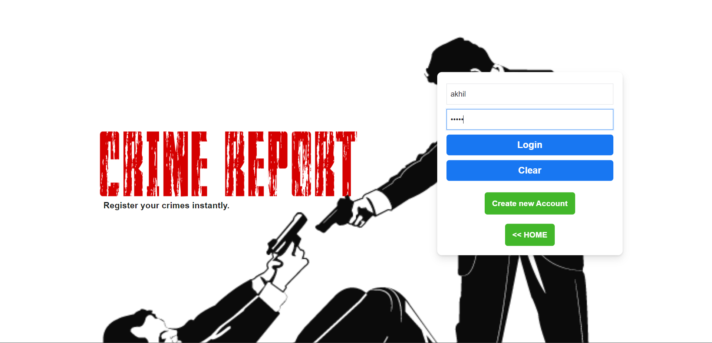

**New User Registration**

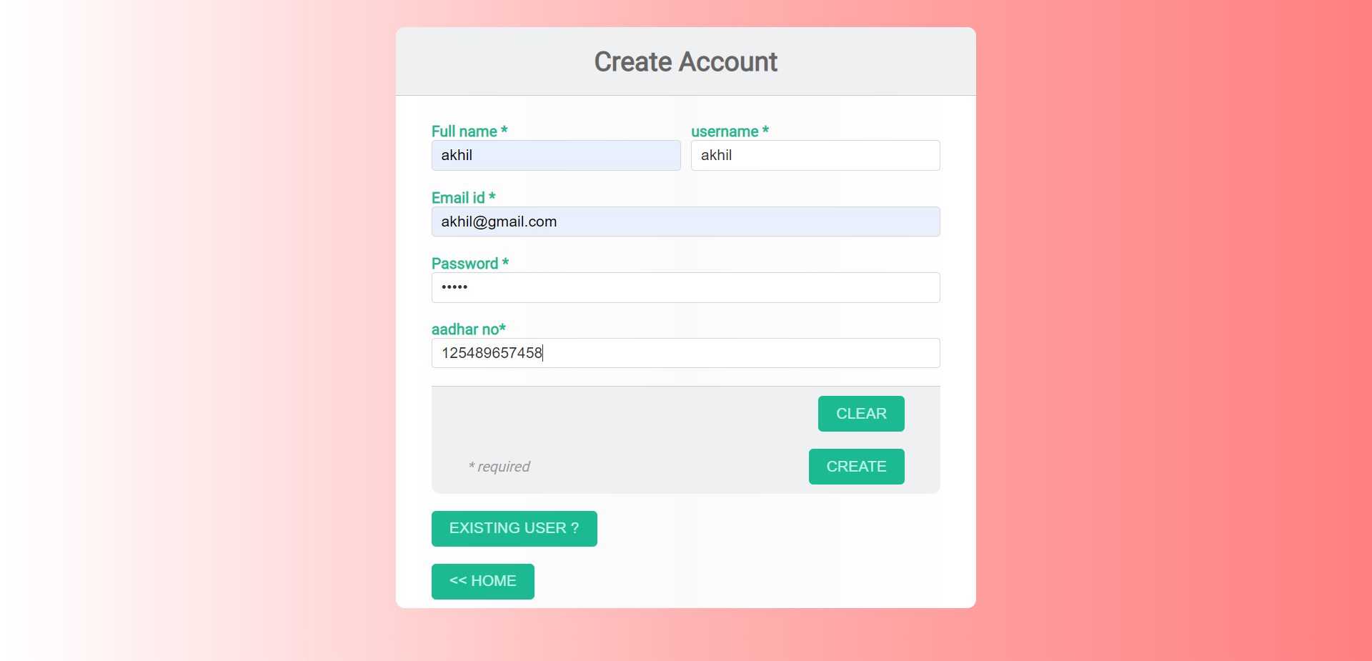

**Register Crime**

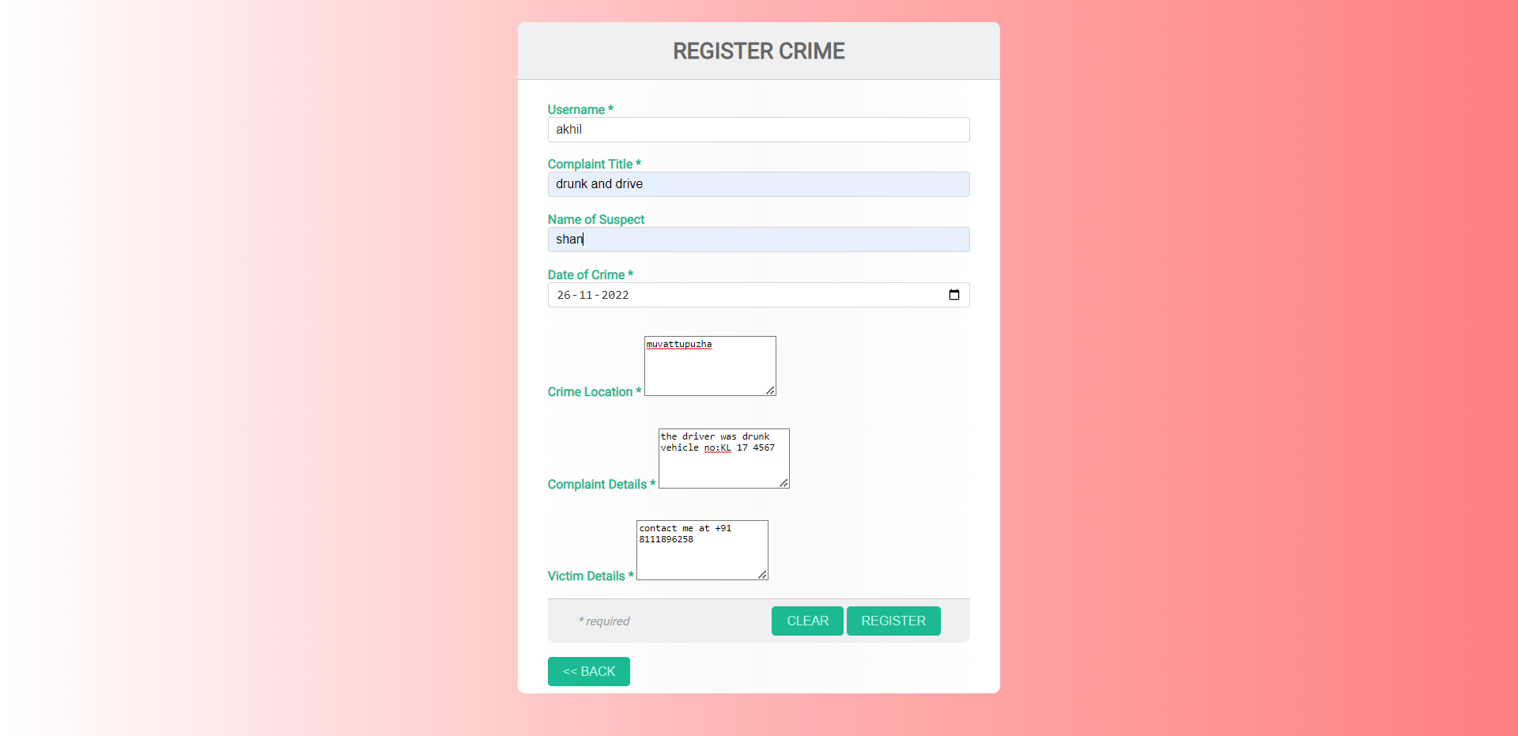

**Update Profile**

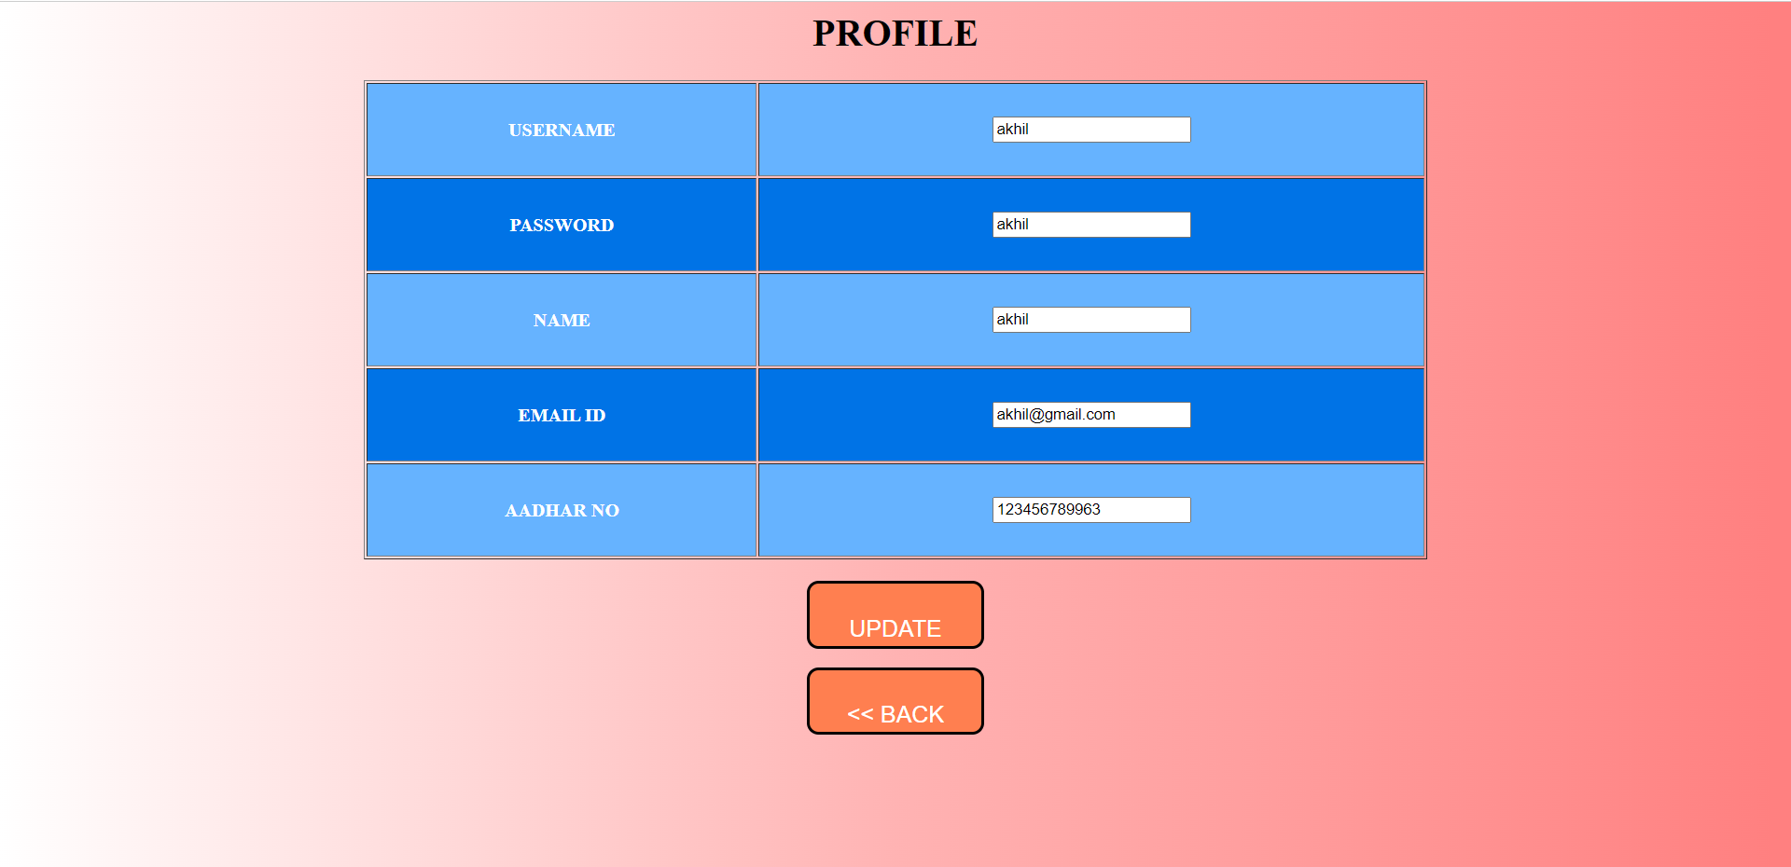

**Complaint Status**

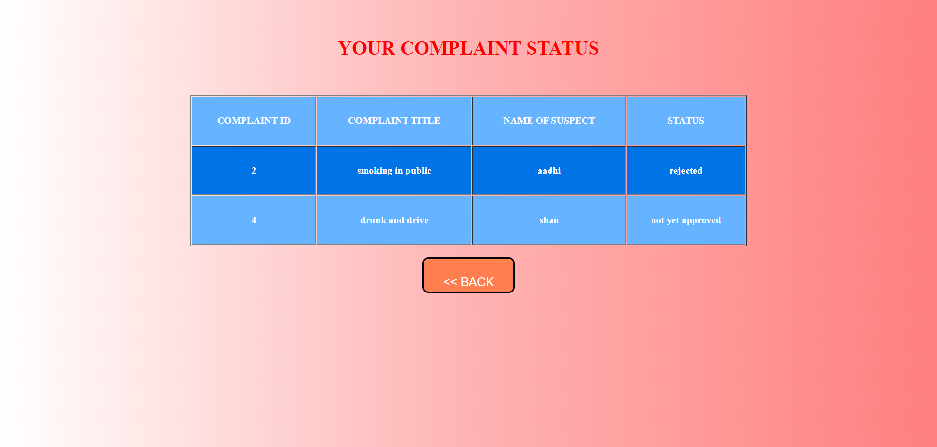

**Feedback**

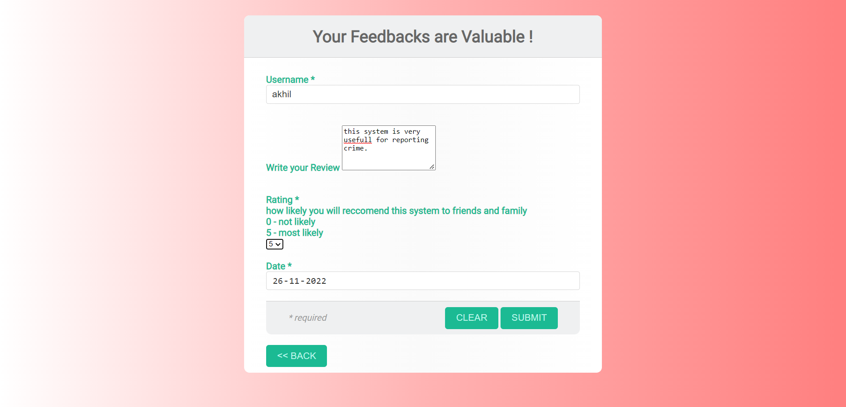

**Complaint Details**

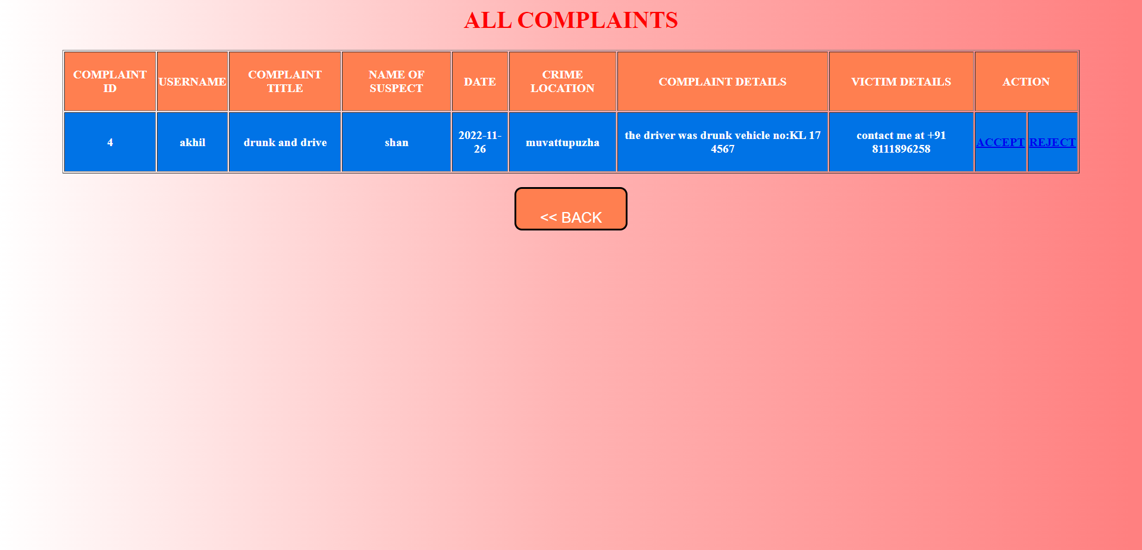

**User Details**

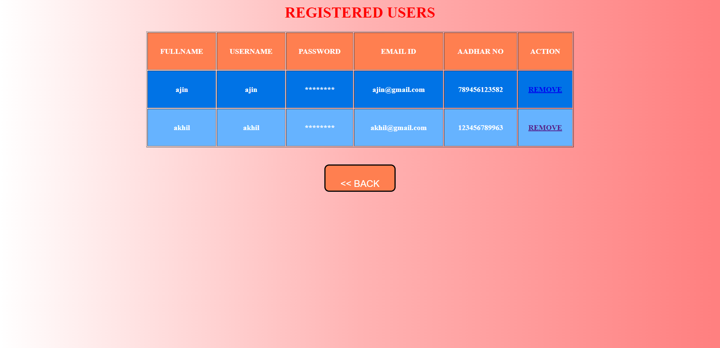

**Feedback Details**

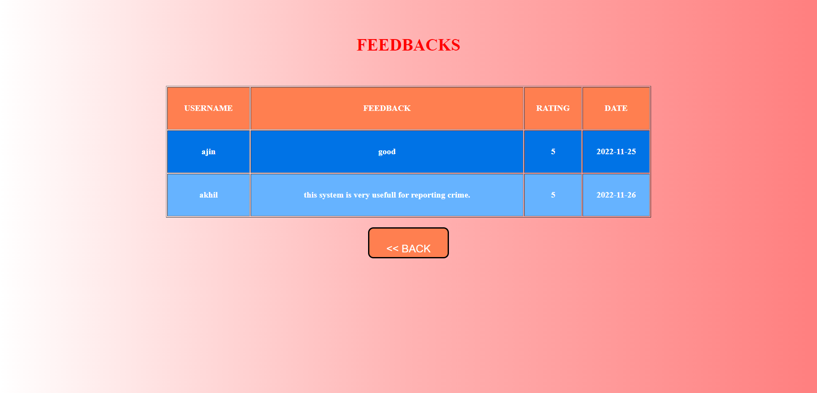

**Enquiry Page**

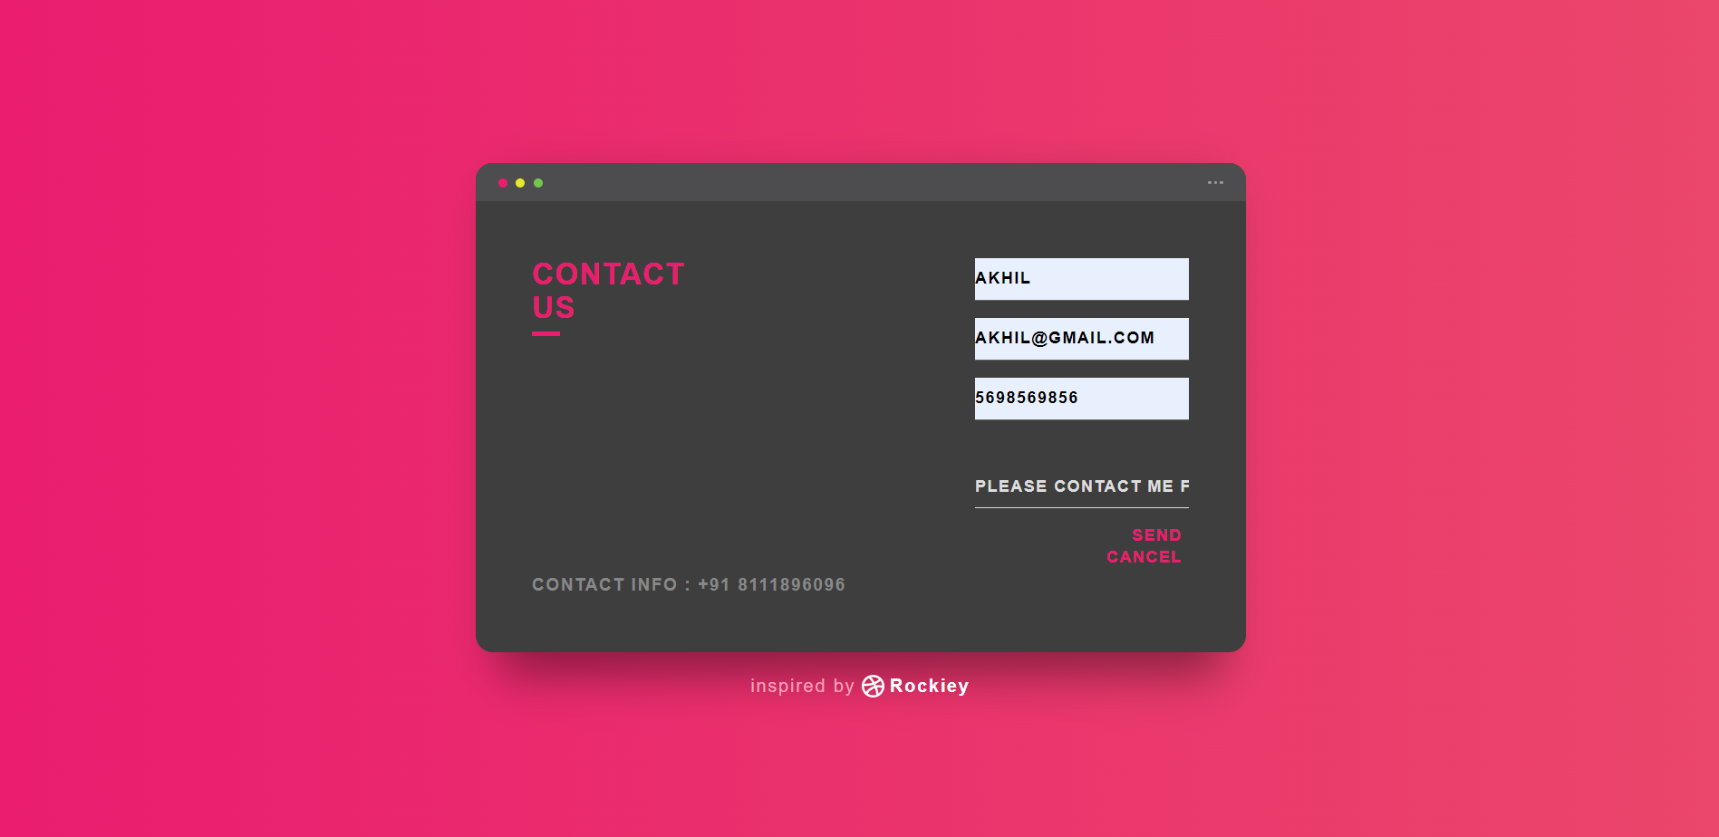

**Enquiry Details**

