WEEK 2 PROJECT REPORT

Exploratory Data Analysis
of Netflix Titles
Dataset-based analysis using Python

Project | YUVA Internship – Week 2
Dataset | Netflix Movies and TV Shows
Tools | Python, Pandas, Matplotlib, Seaborn

1. Executive Summary
This project performs exploratory data analysis (EDA) on a public dataset of Netflix movies and television shows. The notebook contains 8,807 records and 12 original columns. The analysis examines content type, release years, countries, genres, ratings, movie durations and the years in which titles were added to the dataset. Data preparation included converting the date-added field to a datetime type, replacing selected missing categorical values with “Unknown”, and checking for duplicate records.
The dataset contains 6,131 movies (69.62%) and 2,676 TV shows (30.38%). The most frequent listed genre/category is International Movies (2,752 records), and TV-MA is the most common rating (3,207 records). The average parsed movie duration is approximately 99.58 minutes. These findings describe this dataset snapshot; they should not be interpreted as a live or complete representation of Netflix's current catalogue.

2. Objective
The objective is to explore the structure and characteristics of the Netflix titles dataset, summarize its numerical and categorical variables, visualize important distributions and trends, and interpret patterns that can be observed from the available records.

3. Dataset Description and Source
The dataset file used in the notebook is named netflix_titles.csv. It contains 8,807 rows and 12 columns: show_id, type, title, director, cast, country, date_added, release_year, rating, duration, listed_in and description. The file was downloaded from the Hugging Face dataset repository below, which hosts a copy of the Netflix titles dataset.
Dataset download: https://huggingface.co/datasets/hugginglearners/netflix-shows/resolve/main/netflix_titles.csv
The notebook uses a public dataset mirror. The dataset is a static snapshot, so the analysis is limited to the records and fields present in that file. The notebook does not establish the date on which the underlying catalogue snapshot was originally collected.

4. Tools and Libraries
Python was used for the analysis. Pandas handled data loading, cleaning, grouping and summary calculations. NumPy was imported for numerical work. Matplotlib and Seaborn were used to create visualizations. The requests library downloaded the CSV file.

5. Data Understanding and Quality Checks
The initial inspection identified 8,807 rows and 12 columns. The dataset had 11 object-type columns and one integer column (release_year). The initial missing-value counts were:
Column | Missing records
director | 2,634
cast | 825
country | 831
date_added | 10
rating | 4
duration | 3
The initial duplicate-row check returned 0. The cleaning step filled missing values in director, cast, country and rating with “Unknown”, converted date_added to datetime, and extracted year_added and month_added. No rows were removed because the duplicate check found none.
After cleaning, the dataset remained at 8,807 rows and had 14 columns. Ten date_added values remained missing, which also resulted in ten missing year_added and month_added values. Three duration values remained missing. These fields were not imputed in the notebook and are retained as missing rather than being assigned unsupported values.

6. Exploratory Analysis and Visualizations

6.1 Movies and TV Shows
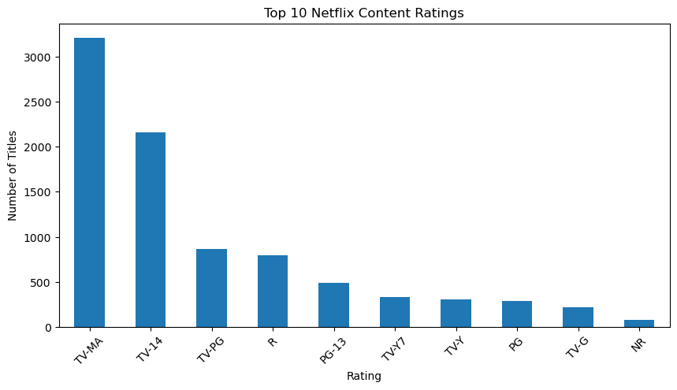
The dataset contains 6,131 movies and 2,676 TV shows. Movies account for 69.62% of the records, while TV shows account for 30.38%. The dataset therefore has a larger representation of movies than TV shows.

6.2 Release-Year Distribution
[Chart image not found in notebook outputs: release_year_trend.png]
The release_year field ranges from 1925 to 2021. The median release year is 2017 and the mean is approximately 2014.18. The distribution is concentrated in more recent release years, although older titles are also present. This chart counts titles by their release year, not by the year they were added to Netflix.

6.3 Country Field
[Chart image not found in notebook outputs: top_countries.png]
The United States is the most frequent country value (2,818 records), followed by India (972), the United Kingdom (419), Japan (245) and South Korea (199). The notebook counts the country field as recorded in each row; entries containing multiple countries are not split into individual countries. “Unknown” is excluded from the plotted top-country chart.

6.4 Content Ratings
[Chart image not found in notebook outputs: content_ratings.png]
TV-MA is the most common rating, with 3,207 records. The rating field contains 17 unique non-missing values in the initial dataset, and four records had no rating before cleaning. Missing ratings were represented as “Unknown” during cleaning.

6.5 Genre / Listed-In Categories
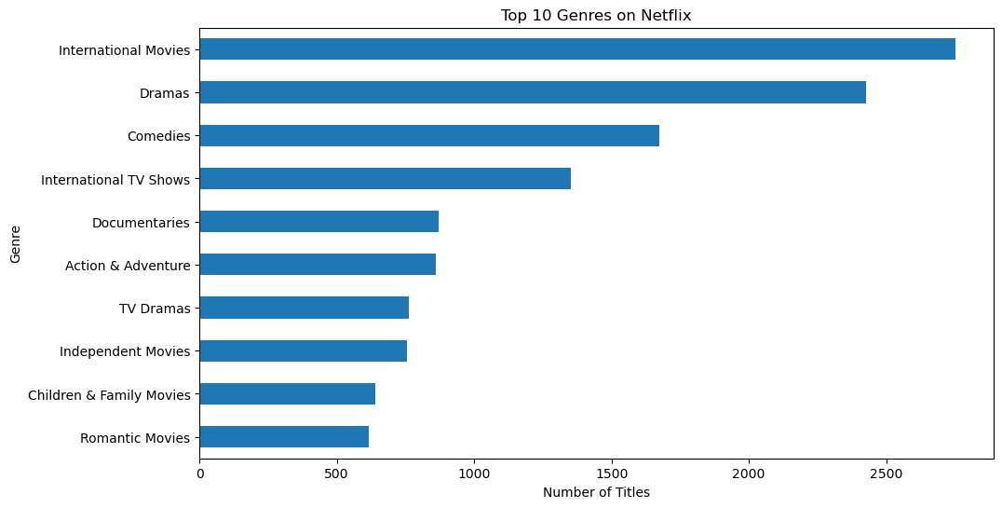
The listed_in field was split on commas so that titles assigned to multiple categories could contribute to each category count. International Movies is the most frequent category (2,752), followed by Dramas (2,427) and Comedies (1,674). These are category assignments, so a title may be counted in more than one category.

6.6 Movie Duration
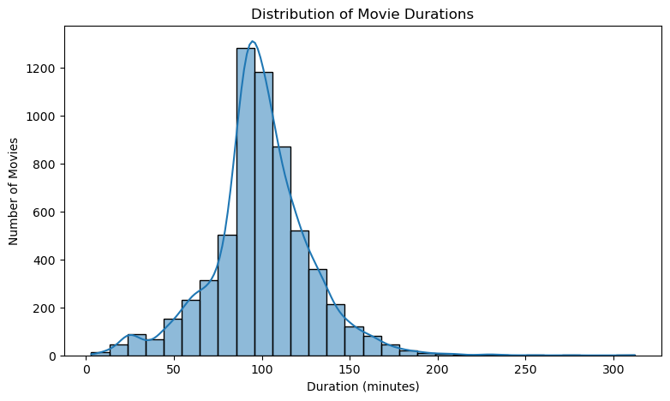
After filtering to Movie records and extracting the numeric part of duration, 6,128 movies had a parsed duration. The mean is 99.58 minutes, the median is 98 minutes, and the standard deviation is 28.29 minutes. The minimum is 3 minutes and the maximum is 312 minutes. The three missing duration records are not included in these statistics.

6.7 Content Composition
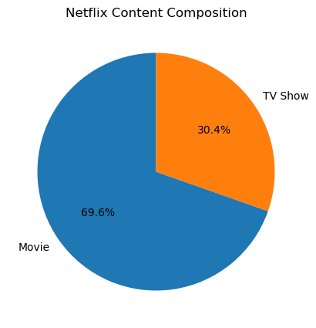
The composition chart reinforces the content-type comparison: movies form approximately 69.62% of the dataset and TV shows approximately 30.38%.

6.8 Titles Added by Year
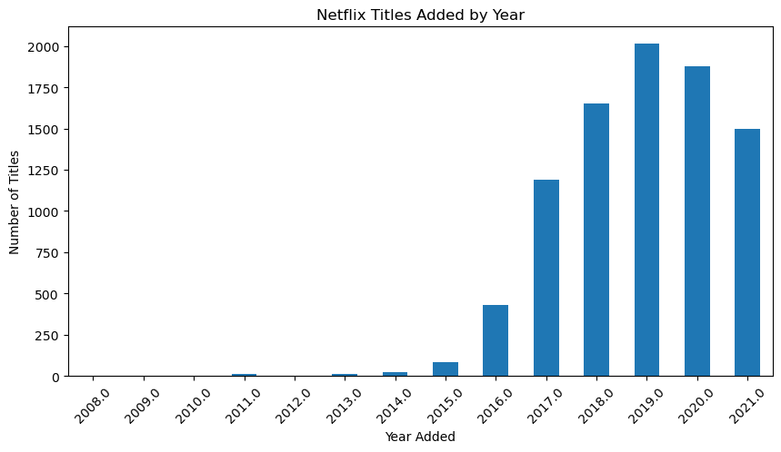
The date_added field was converted to datetime and its year component was extracted. The chart shows how many records in this dataset have each year_added value. Ten records have no date_added value and therefore do not appear in the year-based counts. These counts describe additions recorded in this snapshot, not Netflix's current rate of acquisition.

6.9 Correlation Between Release Year and Year Added
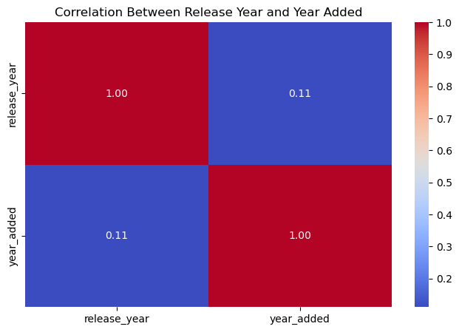
The notebook calculates the Pearson correlation between release_year and year_added and plots it as a heatmap. The calculation uses records with both values available. This is an association between two date-related fields, not evidence that one variable causes the other. Older titles can be added to the service long after their original release.

7. Key Findings
- The dataset contains 8,807 titles, with movies representing 69.62% and TV shows 30.38%.
- The most frequent country value is United States (2,818), followed by India (972).
- International Movies is the most frequent listed_in category (2,752), followed by Dramas (2,427).
- TV-MA is the most frequent content rating (3,207).
- The average movie duration is 99.58 minutes, based on 6,128 records with a parsed duration.
- The release years span 1925–2021, with a median release year of 2017.
- The cleaning process retained all 8,807 rows; selected categorical missing values were labelled Unknown.

8. Limitations and Considerations
- The dataset is a static public snapshot and should not be treated as a live Netflix catalogue.
- Ten date_added values and three duration values remain missing after the notebook's cleaning steps.
- The country chart counts the recorded country strings; multi-country entries were not expanded into individual countries.
- Genre counts are not mutually exclusive because one title can have multiple listed_in categories.
- The correlation between release year and year added indicates association only and does not establish causation.
- The notebook's movie-duration extraction uses the first numeric value in the duration string and focuses on movie records.

9. Conclusion
The exploratory analysis provides an overview of the Netflix titles represented in the selected public dataset. It shows that movies make up the majority of records, identifies the most frequent recorded country, listed-in category and content rating, and summarizes the distribution of movie durations and release years. The visualizations make these patterns easier to compare. The analysis also documents missing data and limitations, which is important when interpreting the results. Further work could examine trends by content type, compare movie and TV show release patterns, and normalize multi-country and multi-category fields for more detailed analysis.

10. Reproducibility
The accompanying Jupyter Notebook, YUVA_Week2_Netflix_EDA.ipynb, contains the executed Python cells and outputs used for this report. The cleaned dataset and summary CSV files are generated by the notebook. To reproduce the analysis, run the notebook in order in an environment with Pandas, NumPy, Matplotlib, Seaborn and Requests installed, and with internet access for downloading the CSV file.

Appendix: Selected Code Snippets

Load the dataset
df = pd.read_csv("netflix_titles.csv")
print("Dataset shape:", df.shape)

Prepare selected fields
df_clean = df.copy()
df_clean["date_added"] = pd.to_datetime(
df_clean["date_added"].str.strip(), errors="coerce"
)
for col in ["director", "cast", "country", "rating"]:
df_clean[col] = df_clean[col].fillna("Unknown")
df_clean = df_clean.drop_duplicates()

Count genre assignments
genres = df_clean["listed_in"].dropna().str.split(", ").explode()
top_genres = genres.value_counts().head(10)

Extract movie duration
movies = df_clean[df_clean["type"] == "Movie"].copy()
movies["duration_minutes"] = (
movies["duration"].str.extract(r"(\d+)")[0].astype(float)
)

Additional Visualizations

Release-Year Distribution
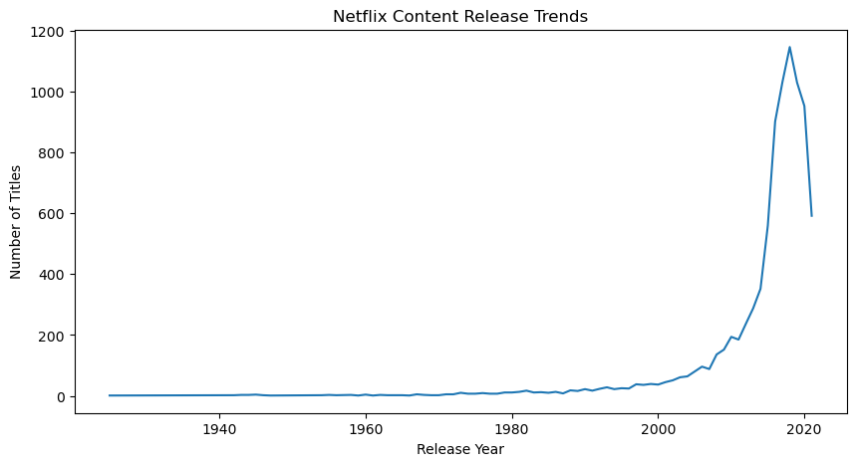
The release_year field ranges from 1925 to 2021. The median release year is 2017 and the mean is approximately 2014.18. The distribution is concentrated in more recent release years, while older titles are also represented.

Top Recorded Countries
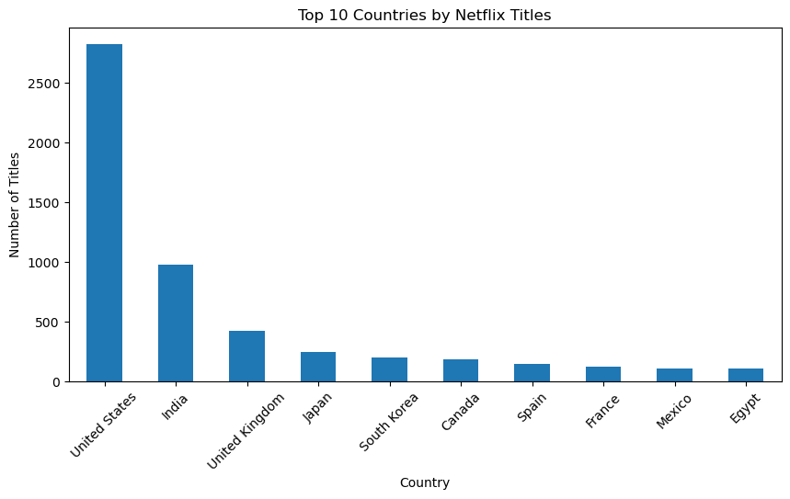
The United States is the most frequent recorded country value (2,818 records), followed by India (972), the United Kingdom (419), Japan (245) and South Korea (199). The chart counts country strings as stored; multi-country entries are not split into individual countries.

Content Ratings
TV-MA is the most common rating, with 3,207 records. Four rating values were missing before cleaning and were represented as “Unknown” in the cleaned dataset.

