WEEK 3 PROJECT REPORT

Wholesale Customer
Segmentation
Unsupervised Learning using K-Means and Hierarchical Clustering
Project | YUVA Internship – Week 3
Dataset | UCI Wholesale Customers
Tools | Python, Pandas, Scikit-learn, Matplotlib, Seaborn, SciPy

1. Executive Summary
This project applies unsupervised learning to segment wholesale customers based on their annual spending across six product categories: Fresh, Milk, Grocery, Frozen, Detergents_Paper and Delicassen. The dataset contains 440 customers and eight original columns. The six spending variables were standardized before clustering.
K-Means with two clusters produced groups of 389 and 51 customers and a silhouette score of 0.5472. The two-cluster hierarchical solution produced groups of 434 and 6 customers and a silhouette score of 0.7925. The hierarchical score is higher, but its very small six-customer group suggests a highly uneven partition that should be interpreted cautiously. The K-Means profiles show a larger group with comparatively lower Milk, Grocery and Detergents_Paper spending, and a smaller group with much higher average spending in those categories.

2. Objective
The objective is to identify groups of wholesale customers with similar spending patterns, apply and compare K-Means and Agglomerative (Hierarchical) clustering, visualize the resulting groups, and interpret how the segments could inform customer-focused business decisions.

3. Dataset and Source
The analysis uses the Wholesale Customers dataset from the UCI Machine Learning Repository. It contains 440 records and eight variables: Channel, Region, Fresh, Milk, Grocery, Frozen, Detergents_Paper and Delicassen. The spending fields represent annual spending amounts for the corresponding product categories. Channel and Region are coded categorical fields.
Official source: https://archive.ics.uci.edu/dataset/292/wholesale+customers

4. Data Inspection and Preprocessing
The dataset had 440 rows and eight columns. All columns were numeric in the loaded file, and the initial inspection found zero missing values and zero duplicate rows. The six spending variables were selected as clustering features. Channel and Region were excluded from the distance calculation because they are coded categories rather than continuous spending measures.
StandardScaler was applied to the six spending variables so that differences in their original scales would not dominate the distance-based clustering algorithms. The standardized feature matrix had 440 rows and six columns. The original dataset was retained, and the cluster labels were appended to it.

5. Selecting the Number of Clusters
K-Means models were evaluated for K values from 2 through 10 using inertia (within-cluster sum of squares) and silhouette score. Inertia decreased as K increased, as expected. The silhouette scores were: K=2: 0.5472; K=3: 0.5483; K=4: 0.3485; K=5: 0.3690; K=6: 0.3782; K=7: 0.3343; K=8: 0.3201; K=9: 0.3090; and K=10: 0.3112.

Elbow Method
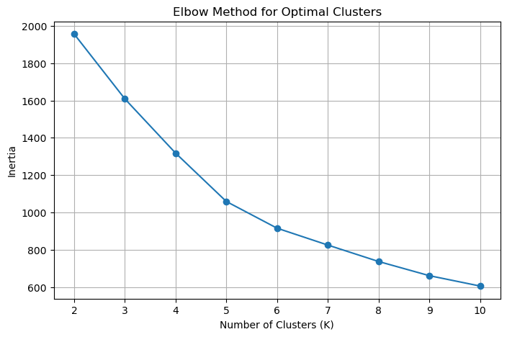
The elbow plot shows the reduction in inertia as the number of clusters increases. It is used alongside the silhouette score rather than as a stand-alone rule.

Silhouette Score
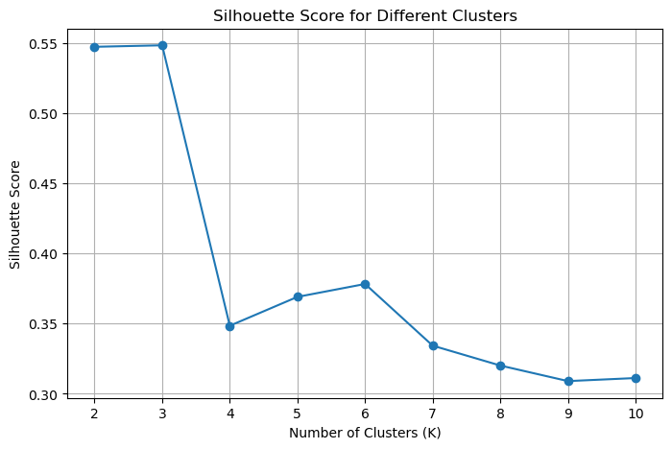
K=3 has the highest tested silhouette score (0.5483), but it exceeds K=2 (0.5472) by only 0.0011. The improvement is extremely small. The notebook proceeded with K=2, providing a simpler two-segment baseline. This is a practical choice, not proof that K=2 is uniquely optimal; a three-cluster profile could be explored as a sensitivity check.

6. K-Means Clustering Results
K-Means was fitted with K=2, random_state=42 and n_init=10. The resulting cluster sizes were:
Cluster | Customers
0 | 389
1 | 51
The K-Means silhouette score was 0.5472. The PCA projection retained 72.46% of the standardized data variance across its first two principal components, providing a useful two-dimensional view, although some information is necessarily lost when reducing six dimensions to two.
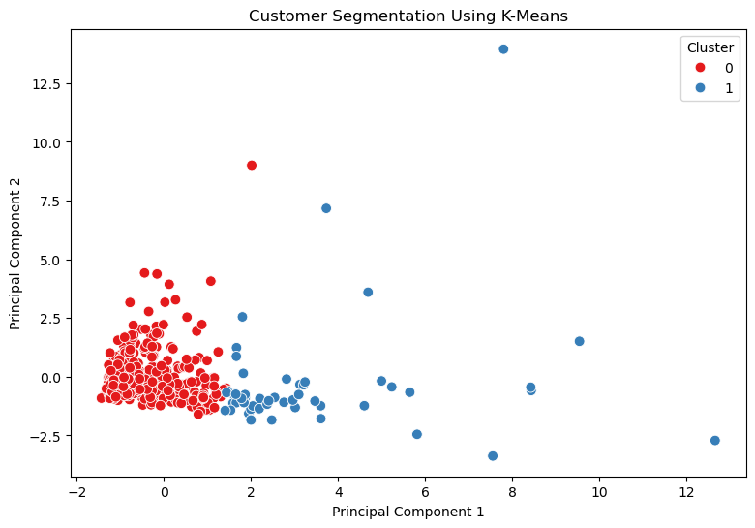
The PCA scatter plot visualizes the K-Means assignments in two dimensions. PCA is used only for visualization; clustering itself was performed on all six standardized spending variables.

7. K-Means Cluster Profiles
Cluster | Fresh | Milk | Grocery | Frozen | Detergents/Paper | Delicassen
0 | 12,157.30 | 4,028.17 | 5,402.72 | 3,066.07 | 1,667.69 | 1,256.89
1 | 10,802.76 | 19,282.33 | 27,390.25 | 3,116.67 | 12,139.73 | 3,568.84
Cluster 0 contains 389 customers and has lower average spending on Milk, Grocery and Detergents_Paper than Cluster 1. Cluster 1 contains 51 customers and shows substantially higher average spending in these three categories. Average Fresh and Frozen spending is relatively similar between the two groups. These descriptions are based on the cluster means and should be treated as relative spending profiles, not as pre-existing customer labels.
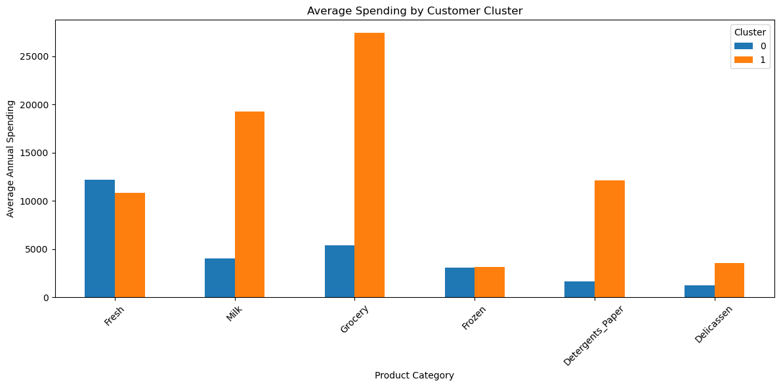

8. Hierarchical Clustering
Agglomerative clustering with Ward linkage was applied to the same standardized six-feature matrix, using two clusters. The dendrogram provides a hierarchical view of how observations or groups merge as linkage distance increases.
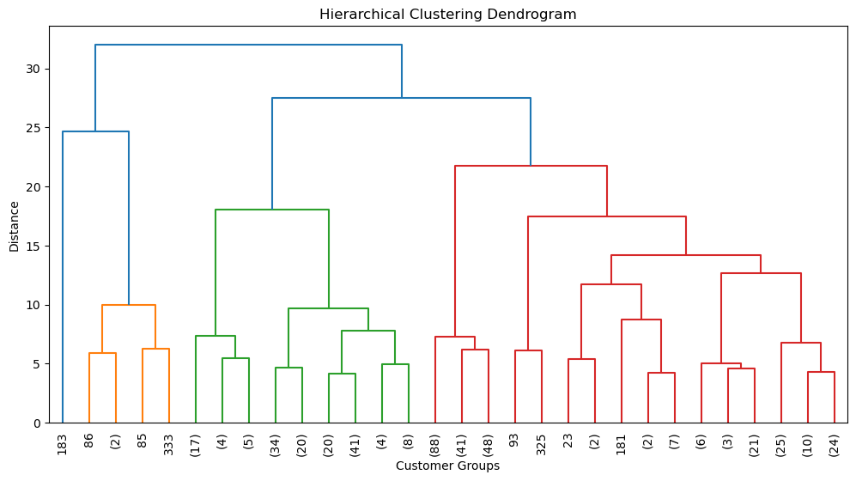
The resulting hierarchical groups contained 434 and 6 customers. Its silhouette score was 0.7925. Although this score is higher than the K-Means score, the extreme group-size imbalance indicates that the solution may primarily isolate a small set of unusual observations. A higher silhouette score should therefore not be interpreted as automatically making this the more useful business segmentation.
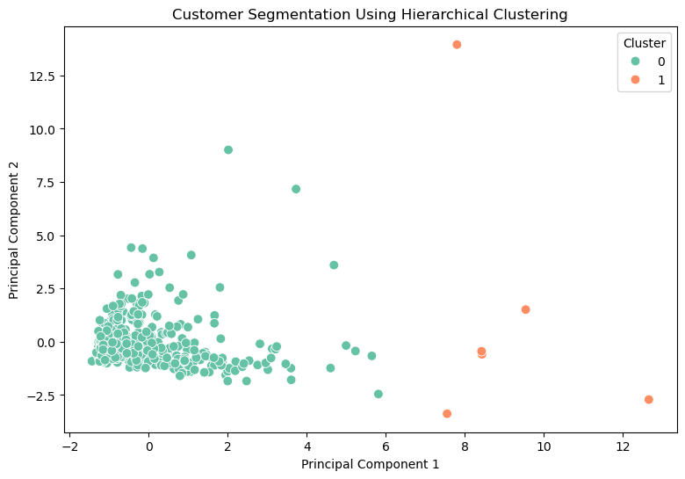

9. Algorithm Comparison
Algorithm | Clusters | Cluster sizes | Silhouette
K-Means | 2 | 389 / 51 | 0.5472
Hierarchical (Ward) | 2 | 434 / 6 | 0.7925
The methods produce different partitions. K-Means gives two substantial segments, including a smaller high-spending group. Hierarchical clustering achieves a higher silhouette score but creates a very small group of six customers. For an initial business segmentation, K-Means is easier to interpret as a two-segment summary. The choice should be validated with business context and, ideally, tested against alternative values of K and outlier-sensitive preprocessing.

10. Business Interpretation and Recommendations
- Use the larger K-Means Cluster 0 as a broad customer group with comparatively lower spending on Milk, Grocery and Detergents_Paper. Product-specific promotions can be considered after checking customer-level needs and profitability.
- Treat K-Means Cluster 1 as a smaller group with much higher average spending in Milk, Grocery and Detergents_Paper. Consider account-management attention, product availability planning and retention initiatives for these customers.
- Fresh and Frozen spending means are similar across the two K-Means clusters, so those categories alone do not explain the main separation in this solution.
- Review the six customers isolated by hierarchical clustering individually before treating them as a distinct commercial segment. They may be unusual accounts or influential observations.
- Before operational use, validate segments with sales teams and additional variables such as order frequency, margin, location, channel and customer tenure.

11. Limitations
- The dataset has 440 records and a limited set of annual spending variables; it does not include profitability, order frequency, customer tenure or transaction-level behavior.
- Spending distributions are highly variable, and extreme values can influence distance-based clustering.
- Cluster labels such as 0 and 1 are arbitrary identifiers, not ranked customer grades.
- The silhouette score does not measure business usefulness and can favor compact, uneven partitions.
- The hierarchical solution's six-customer cluster requires further investigation.
- The K-Means selection of K=2 is a practical simple solution; K=3 had a marginally higher silhouette score, so the final cluster count is not unambiguously determined by the score alone.

12. Conclusion
The project demonstrates how unsupervised learning can be used to explore customer spending patterns. After standardizing six annual spending features, K-Means identified a large group and a smaller group with substantially higher average spending on Milk, Grocery and Detergents_Paper. Hierarchical clustering produced a higher silhouette score but isolated only six customers in one cluster, which limits its immediate usefulness as a broad segmentation. K-Means provides a more balanced and interpretable starting point for business discussion, while further validation and testing of alternative cluster counts are recommended.

13. Reproducibility
The accompanying Jupyter Notebook, YUVA_Week3_Customer_Clustering.ipynb.ipynb, contains the executed code and outputs. The notebook saves the clustered dataset, cluster profile, algorithm comparison table and visualization images. The analysis can be reproduced using Python with Pandas, NumPy, Matplotlib, Seaborn, Scikit-learn and SciPy.

