Output-1:

Applied the tweaked densenet architecture from scratch on TrainingData.csv and a customised data set reviews.csv which is based on reviews dataset

Results on DES:

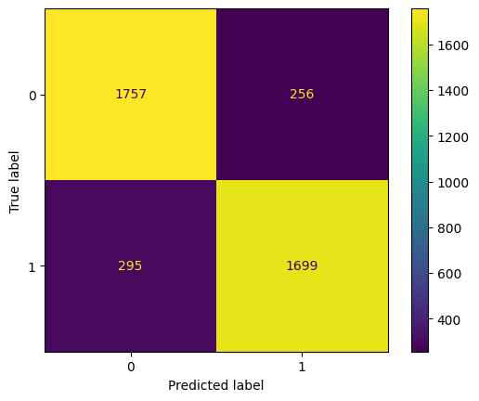
1. On TrainingData.csv

random accuracy : 0.8728266269249876
DES accuracy : 0.8520561685055166
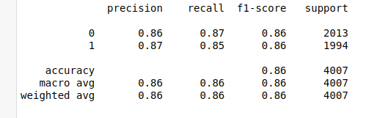
2. reviews.csv(25000 = 12500 des + 12500 random)

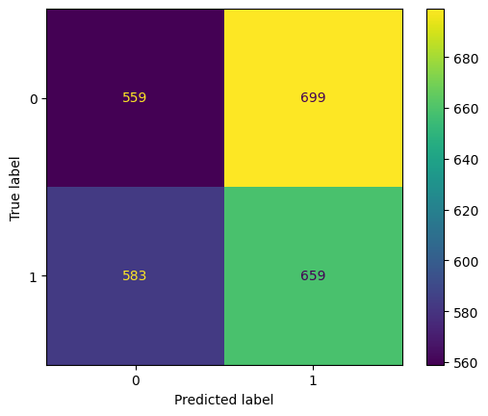
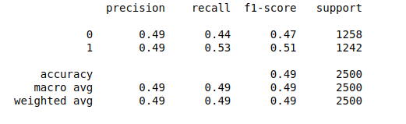

Observation: Results are inconsistent, should try on learning how TrainingData.csv has been generated and also work with other datasets to check for consistency in results.

Output – 2:
Applied same on AES data

1. on TrainingData.csv
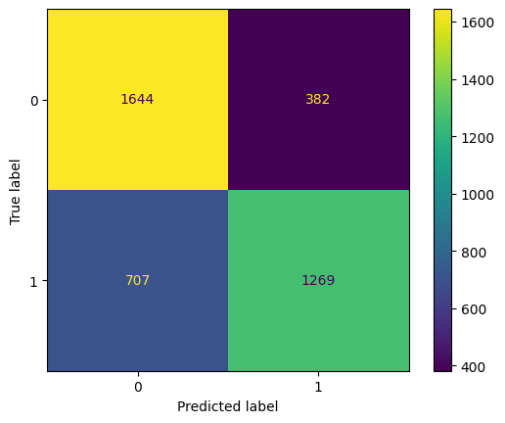
random_accuracy = 0.8114511352418559
AES accuracy = 0.6422064777327935

2. on reviews.csv
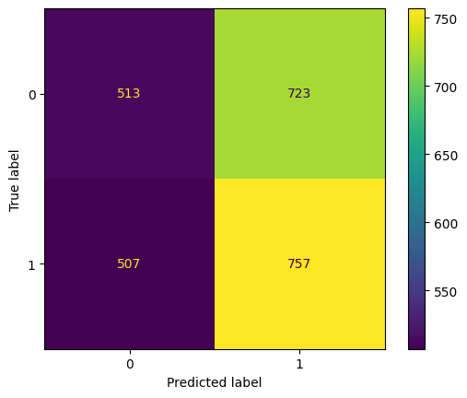
random_accuracy = 0.41504854368932037
AES accuracy = 0.5988924050632911

Output – 3
AES – round reduced result
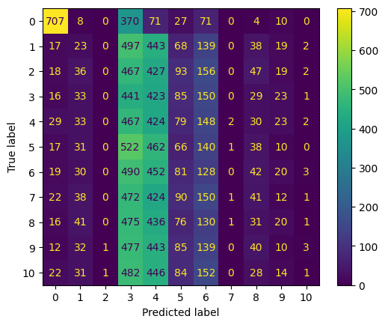
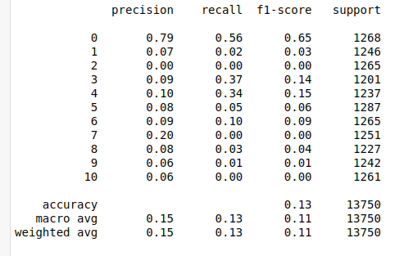

Output – 4
Rotation invariant – left shift – DES

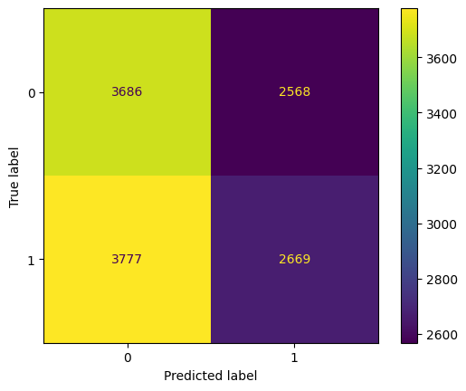

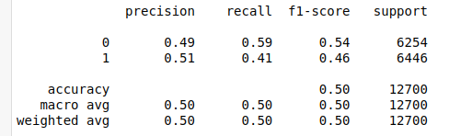

DES – right shift
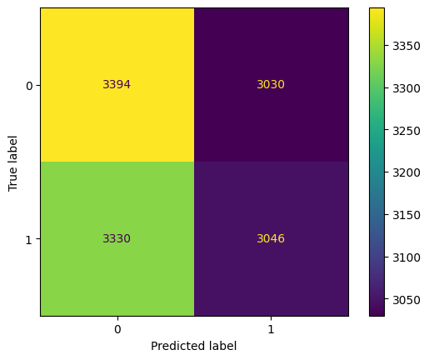
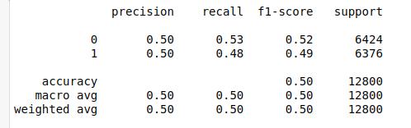

DES – both shifts
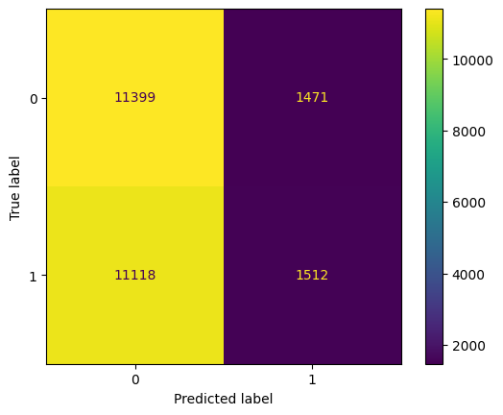
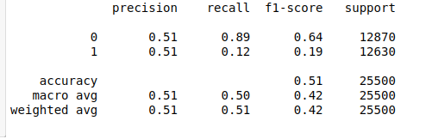

Output – 5
Rotation invariant – left shift – AES
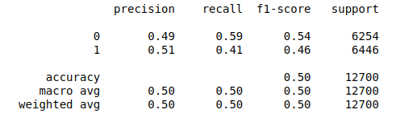

Rotation invariant – right shift – AES

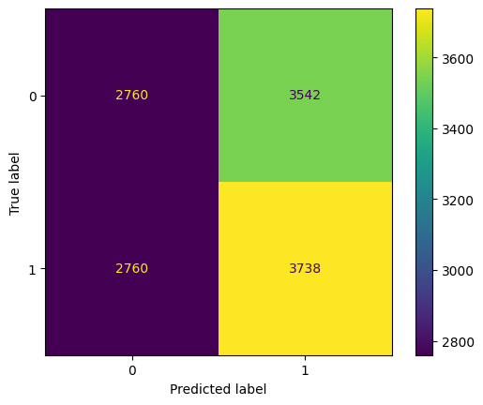
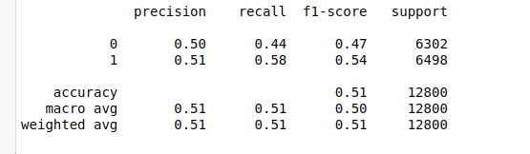
Both shifts
