WTH = 0.5

oS = 30

Filename (no extensions!) Phase_Data/Run6_0

----------------------------------------------------------

Resonances Found: 1

UNFIT data:

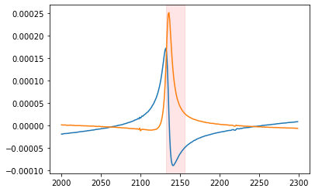

----------------------------------------------------------------------------//

ERROR - DAMPING NEGATIVE: Fitting has failed to produce realistic results

/---------------------------FIT 1---average----------------------------------/

Peak 1 of 1 at 11868819.67247306 Hz | FIT Goodness: RSquared = 0.9945462359253959

----------------------------------------------------------

ABSORPTION AMPLITUDE: -1.76019301736102e-08 V

ELASTIC AMPLITUDE: -1.76019301736102e-08 V

RESONANCE AMPLITUDE: -135.349686173369 V

RESONANCE QUALITY: -528.9630730056017

-------------------

phase shift: -108.80343872643988 radians

C:\Program Files\Python3.8\lib\site-packages\scipy\optimize\minpack.py:807: OptimizeWarning: Covariance of the parameters could not be estimated

warnings.warn('Covariance of the parameters could not be estimated',

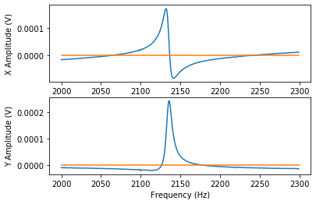

[[inf inf inf inf]

[inf inf inf inf]

[inf inf inf inf]

[inf inf inf inf]]

/---------------------------FIT 2---peakless---------------------------------/

Peak 1 of 1 at 2135.037498714196 Hz | FIT Goodness: RSquared = 0.9999986586910062

----------------------------------------------------------

ABSORPTION AMPLITUDE: 0.009710821571740363 V

ELASTIC AMPLITUDE: 0.009710821571740363 V

RESONANCE AMPLITUDE: -4.90603249961454 V

RESONANCE QUALITY: 758.2346952912677

-------------------

phase shift: -37.38374344609204 radians

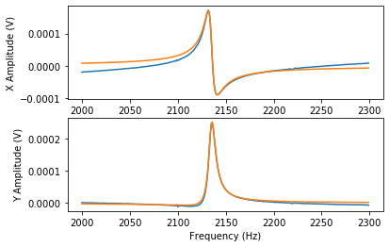

[[ 2.06907313e-03 2.13064255e-06 -3.26216799e-05 -7.70819608e-04]

[ 2.13064255e-06 5.17264098e-04 -7.85907682e-05 7.80422133e-05]

[-3.26216799e-05 -7.85907682e-05 1.77684782e-05 1.80073552e-07]

[-7.70819608e-04 7.80422133e-05 1.80073552e-07 4.27313351e-04]]

----------------------------------------------------------------------------//