WTH = 0.5

oS =30

Filename (no extensions!) Phase_Data/Run7_5

----------------------------------------------------------

Resonances Found: 1

UNFIT data:

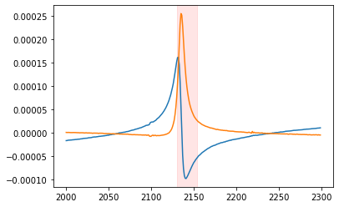

----------------------------------------------------------------------------//

ERROR - DAMPING NEGATIVE: Fitting has failed to produce realistic results

/---------------------------FIT 1---average----------------------------------/

Peak 1 of 1 at 10605865.656859353 Hz | FIT Goodness: RSquared = 0.9942232056026139

----------------------------------------------------------

ABSORPTION AMPLITUDE: -1.504409375698411e-08 V

ELASTIC AMPLITUDE: -1.504409375698411e-08 V

RESONANCE AMPLITUDE: -134.0685280068643 V

RESONANCE QUALITY: -388.4787644844232

-------------------

phase shift: -102.07373876281963 radians

C:\Program Files\Python3.8\lib\site-packages\scipy\optimize\minpack.py:807: OptimizeWarning: Covariance of the parameters could not be estimated

warnings.warn('Covariance of the parameters could not be estimated',

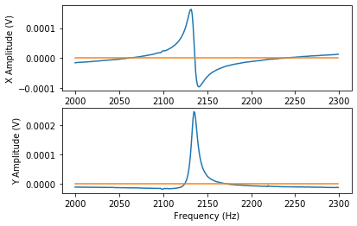

[[inf inf inf inf]

[inf inf inf inf]

[inf inf inf inf]

[inf inf inf inf]]

/---------------------------FIT 2---peakless---------------------------------/

Peak 1 of 1 at 2134.914682774867 Hz | FIT Goodness: RSquared = 0.999998788266062

----------------------------------------------------------

ABSORPTION AMPLITUDE: 0.0032126257115851226 V

ELASTIC AMPLITUDE: 0.0032126257115851226 V

RESONANCE AMPLITUDE: -4.852913665757102 V

RESONANCE QUALITY: 769.0666880780591

-------------------

phase shift: -12.325498297709562 radians

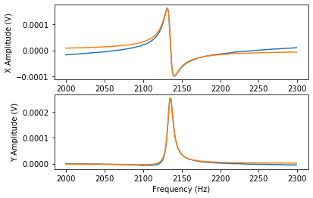

[[ 1.58077994e-03 1.60563362e-06 -1.38939954e-05 -5.80289731e-04]

[ 1.60563362e-06 3.95192067e-04 -5.98010839e-05 3.22275581e-05]

[-1.38939954e-05 -5.98010839e-05 1.37142882e-05 1.35591246e-07]

[-5.80289731e-04 3.22275581e-05 1.35591246e-07 3.22834390e-04]]

----------------------------------------------------------------------------//