WTH = 0.4

oS = 30

Filename (no extensions!) Phase_Data/Run8_10

----------------------------------------------------------

Resonances Found: 1

UNFIT data:

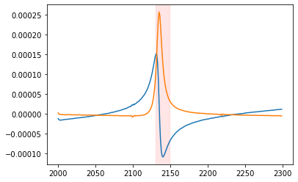

----------------------------------------------------------------------------//

ERROR - DAMPING NEGATIVE: Fitting has failed to produce realistic results

/---------------------------FIT 1---average----------------------------------/

Peak 1 of 1 at 21743873.3936111 Hz | FIT Goodness: RSquared = 0.9948768275649524

----------------------------------------------------------

ABSORPTION AMPLITUDE: -7.180386864184855e-09 V

ELASTIC AMPLITUDE: -7.180386864184855e-09 V

RESONANCE AMPLITUDE: -128.8738434659574 V

RESONANCE QUALITY: -723.2897278010001

-------------------

phase shift: -114.41802831848723 radians

C:\Program Files\Python3.8\lib\site-packages\scipy\optimize\minpack.py:807: OptimizeWarning: Covariance of the parameters could not be estimated

warnings.warn('Covariance of the parameters could not be estimated',

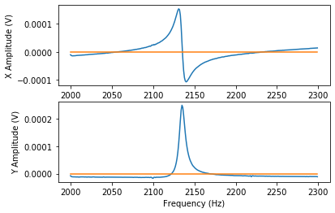

[[inf inf inf inf]

[inf inf inf inf]

[inf inf inf inf]

[inf inf inf inf]]

/---------------------------FIT 2---peakless---------------------------------/

Peak 1 of 1 at 2134.8785659480627 Hz | FIT Goodness: RSquared = 0.999999019750127

----------------------------------------------------------

ABSORPTION AMPLITUDE: 0.02120176929369038 V

ELASTIC AMPLITUDE: 0.02120176929369038 V

RESONANCE AMPLITUDE: -4.800375248085654 V

RESONANCE QUALITY: 775.7748882336164

-------------------

phase shift: -81.51873390457409 radians

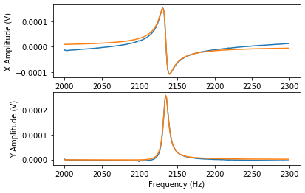

[[ 1.89603281e-03 1.90931916e-06 -1.53582332e-05 -7.16262446e-04]

[ 1.90931916e-06 4.74004793e-04 -7.46193184e-05 3.50781414e-05]

[-1.53582332e-05 -7.46193184e-05 1.72621223e-05 1.67336850e-07]

[-7.16262446e-04 3.50781414e-05 1.67336850e-07 3.97622730e-04]]

----------------------------------------------------------------------------//