WTH = 0.2

oS = 30

Filename (no extensions!) Phase_Data/Run9_15

----------------------------------------------------------

Resonances Found: 1

UNFIT data:

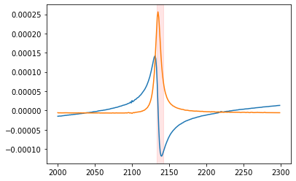

----------------------------------------------------------------------------//

/---------------------------FIT 1---average----------------------------------/

Peak 1 of 1 at 2134.8619188350503 Hz | FIT Goodness: RSquared = 0.9999997376804647

----------------------------------------------------------

ABSORPTION AMPLITUDE: 0.017412583555621957 V

ELASTIC AMPLITUDE: 0.017412583555621957 V

RESONANCE AMPLITUDE: -4.499410756134572 V

RESONANCE QUALITY: 802.6170831602595

-------------------

phase shift: -69.03806741719116 radians

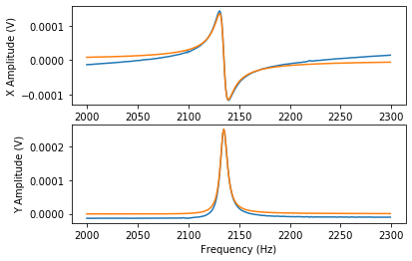

[[ 3.11378748e-03 3.02716452e-06 -5.83547642e-05 -1.32338615e-03]

[ 3.02716452e-06 7.78440327e-04 -1.47116893e-04 1.28358290e-04]

[-5.83547642e-05 -1.47116893e-04 3.52112594e-05 3.09120159e-07]

[-1.32338615e-03 1.28358290e-04 3.09120159e-07 7.12301581e-04]]

/---------------------------FIT 2---peakless---------------------------------/

Peak 1 of 1 at 2134.8315720812807 Hz | FIT Goodness: RSquared = 0.9999999098061007

----------------------------------------------------------

ABSORPTION AMPLITUDE: 0.025833302480915782 V

ELASTIC AMPLITUDE: 0.025833302480915782 V

RESONANCE AMPLITUDE: -4.7254017387085305 V

RESONANCE QUALITY: 779.2114516734624

-------------------

phase shift: -100.45301413569928 radians

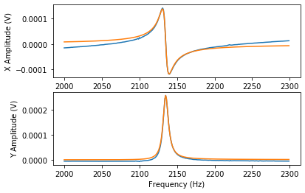

[[ 1.13744838e-03 -1.15200193e-06 -2.13367012e-05 -4.95441282e-04]

[-1.15200193e-06 2.84361949e-04 5.24445466e-05 -4.92801766e-05]

[-2.13367012e-05 5.24445466e-05 1.21863022e-05 1.16190136e-07]

[-4.95441282e-04 -4.92801766e-05 1.16190136e-07 2.71892166e-04]]

----------------------------------------------------------------------------//