Task 1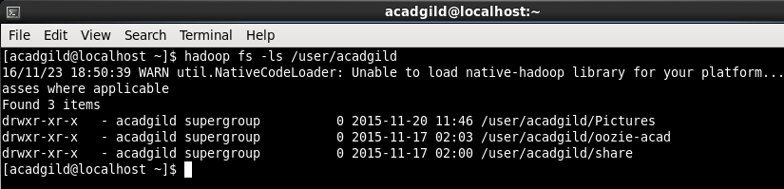

Directory exists! Now creating directory Hadoop using command **hadoop fs –mkdir /user/acadgild/hadoop**

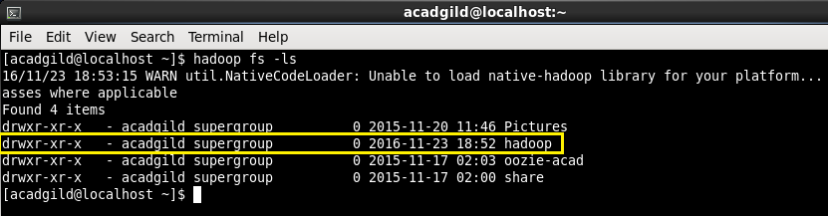

Task 2

