**Assignment 2.2**

Task: Create a file max-temp.txt in local FS. Put some 10-15 records of date and temperature example: dd-mm-yyyy,temperature Example: 10-01-1990,10 10-02-1991,20 Move this file to HDFS at /user/acadgild/hadoop.

Task: Change the permission of the file /user/acadgild/hadoop/max-temp.txt, such that only the owner and the group members have full control over the file. Others do not have any control over it.

**// to create a file and insert text**

cat > max-temp.txt

**// to append data to existing file**

cat >> max-temp.txt

**(Snapshot)**

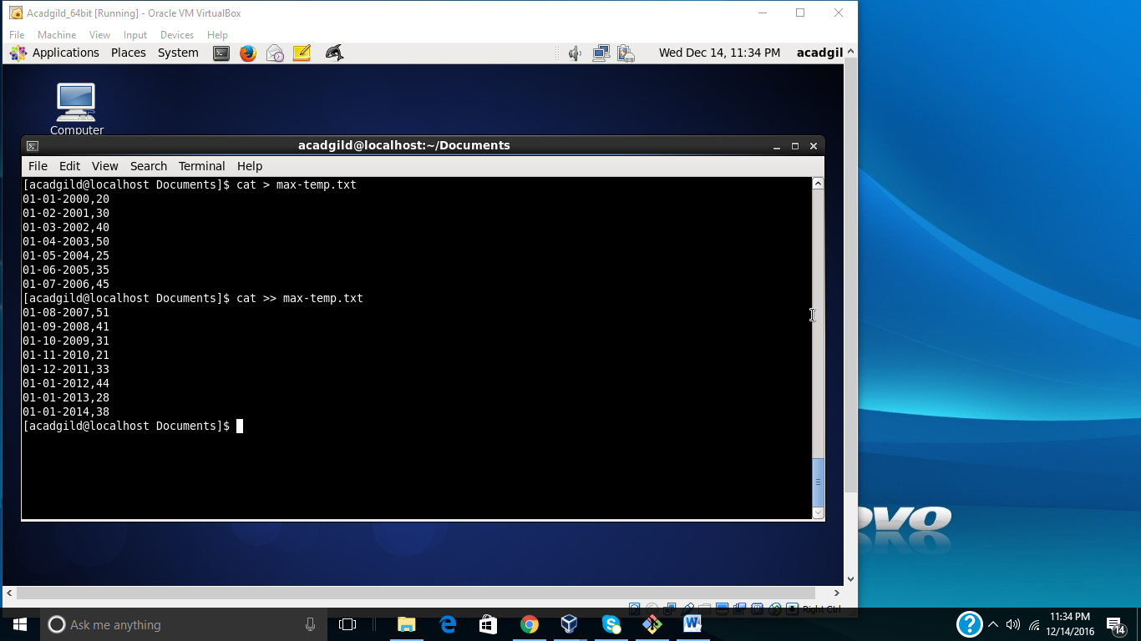

**// display content of file**

cat max-temp.txt

**(Snapshot)**

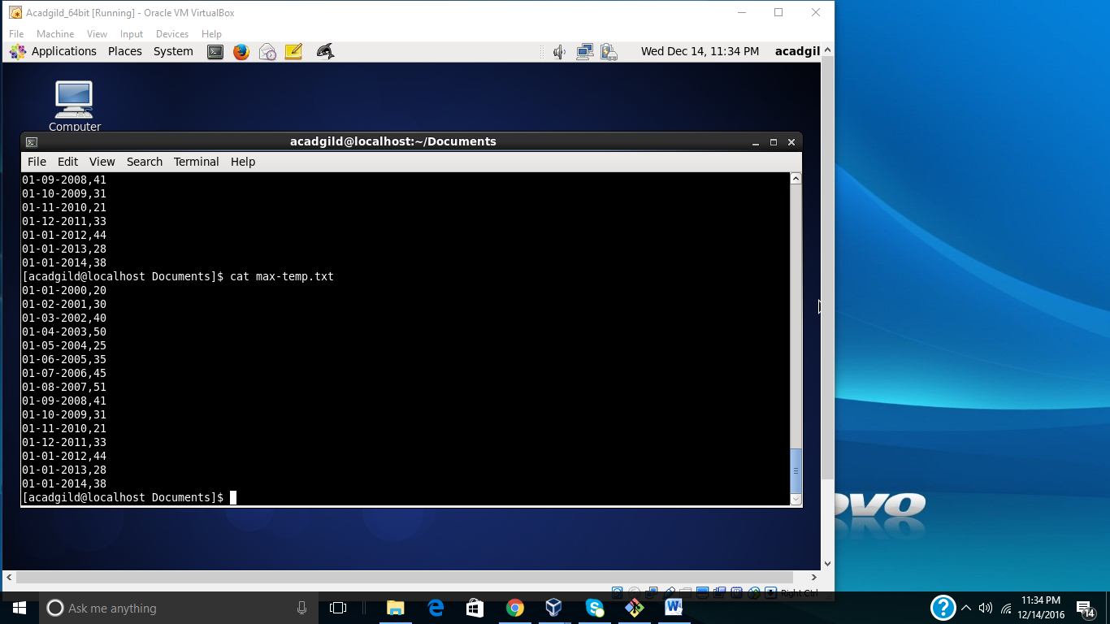

**// command to move file to HDFS**

hadoop fs –put max-temp.txt /user/acadgild/hadoop/

**// command to list all the files under library**

hadoop fs –ls /user/acadgild/hadoop/

**// command to change permission**

hadoop fs –chmod 770 /user/acadgild/hadoop/max-temp.txt

**(Snapshot)**

