Credit Card Fraud Detection

Phase 4: Development part 2


Submitted by:
ABHIJITH S S - 961721104001
ADARSH L S – 961721104003
ANANDHU S - 961721104302
AKHIL S S - 961721104301
ASHKAR MOHAMMED A M – 961721104305

Credit Card Fraud Detection:

Business Understanding
Credit Card Fraud Detection is a classic class-imbalance problem where the number of fraud transactions is much lesser than the number of legitimate transaction for any bank. Most of the approaches involve building model on such imbalanced data, and thus fails to produce results on real-time new data because of overfitting on training data and a bias towards the majoritarian class of legitimate transactions. Thus, we can see this as an anomaly detection problem.
- What time does the Credit Card Frauds usually take place?
- What are the general trends of amounts for Credit Card Fraud Transactions?
- How do we balance the data to not let the model overfit on legitimate transactions?
# Importing Required Libraries
import pandas as pd
import numpy as np
import matplotlib.pyplot as plt
import seaborn as sns
from sklearn.linear_model import LogisticRegression
from sklearn.svm import SVC
from sklearn.neighbors import KNeighborsClassifier
from sklearn.tree import DecisionTreeClassifier
from sklearn.ensemble import RandomForestClassifier
from sklearn.linear_model import SGDClassifier
from mlxtend.plotting import plot_learning_curves
from sklearn.model_selection import train_test_split
from imblearn.over_sampling import SMOTE
from sklearn.metrics import precision_score, recall_score, f1_score, roc_auc_score, accuracy_score, classification_report
from sklearn.model_selection import KFold, StratifiedKFold
from sklearn.preprocessing import StandardScaler
from sklearn.pipeline import Pipeline
from sklearn.model_selection import GridSearchCV
from sklearn.metrics import make_scorer, matthews_corrcoef
import warnings
warnings.filterwarnings("ignore")

Data Understanding
The Dataset we use is the Kaggle Credit Card Fraud Detection Dataset enlisted in the following link: Link
- The Data has 32 features from V1-V28 which are unknown for confidentiality, TIme, Amount and Class
- The input features are V1-V28, Time and Amount
- The target variable is Class
- The Data does not have any missing values as evident from the below mentioned code, thus need not be handled
- The Data consists of all numerical features, and only the Target Variable Class is a categorical feature.
  - Class 0: Legitimate Transaction
  - Class 1: Fraud Transaction
# Read Data into a Dataframe
df = pd.read_csv('creditcard.csv')
df
Time V1 V2 V3 V4 V5 \
0 0.0 -1.359807 -0.072781 2.536347 1.378155 -0.338321
1 0.0 1.191857 0.266151 0.166480 0.448154 0.060018
2 1.0 -1.358354 -1.340163 1.773209 0.379780 -0.503198
3 1.0 -0.966272 -0.185226 1.792993 -0.863291 -0.010309
4 2.0 -1.158233 0.877737 1.548718 0.403034 -0.407193
... ... ... ... ... ... ...
284802 172786.0 -11.881118 10.071785 -9.834783 -2.066656 -5.364473
284803 172787.0 -0.732789 -0.055080 2.035030 -0.738589 0.868229
284804 172788.0 1.919565 -0.301254 -3.249640 -0.557828 2.630515
284805 172788.0 -0.240440 0.530483 0.702510 0.689799 -0.377961
284806 172792.0 -0.533413 -0.189733 0.703337 -0.506271 -0.012546
V6 V7 V8 V9 ... V21 V22 \
0 0.462388 0.239599 0.098698 0.363787 ... -0.018307 0.277838
1 -0.082361 -0.078803 0.085102 -0.255425 ... -0.225775 -0.638672
2 1.800499 0.791461 0.247676 -1.514654 ... 0.247998 0.771679
3 1.247203 0.237609 0.377436 -1.387024 ... -0.108300 0.005274
4 0.095921 0.592941 -0.270533 0.817739 ... -0.009431 0.798278
... ... ... ... ... ... ... ...
284802 -2.606837 -4.918215 7.305334 1.914428 ... 0.213454 0.111864
284803 1.058415 0.024330 0.294869 0.584800 ... 0.214205 0.924384
284804 3.031260 -0.296827 0.708417 0.432454 ... 0.232045 0.578229
284805 0.623708 -0.686180 0.679145 0.392087 ... 0.265245 0.800049
284806 -0.649617 1.577006 -0.414650 0.486180 ... 0.261057 0.643078
V23 V24 V25 V26 V27 V28 Amount \
0 -0.110474 0.066928 0.128539 -0.189115 0.133558 -0.021053 149.62
1 0.101288 -0.339846 0.167170 0.125895 -0.008983 0.014724 2.69
2 0.909412 -0.689281 -0.327642 -0.139097 -0.055353 -0.059752 378.66
3 -0.190321 -1.175575 0.647376 -0.221929 0.062723 0.061458 123.50
4 -0.137458 0.141267 -0.206010 0.502292 0.219422 0.215153 69.99
... ... ... ... ... ... ... ...
284802 1.014480 -0.509348 1.436807 0.250034 0.943651 0.823731 0.77
284803 0.012463 -1.016226 -0.606624 -0.395255 0.068472 -0.053527 24.79
284804 -0.037501 0.640134 0.265745 -0.087371 0.004455 -0.026561 67.88
284805 -0.163298 0.123205 -0.569159 0.546668 0.108821 0.104533 10.00
284806 0.376777 0.008797 -0.473649 -0.818267 -0.002415 0.013649 217.00
Class
0 0
1 0
2 0
3 0
4 0
... ...
284802 0
284803 0
284804 0
284805 0
284806 0
[284807 rows x 31 columns]

Data Preparation
- The Data does not have any missing values and hence, need not be handled.
- The Data has only Target Variable Class as the categorical variable.
- Remaining Features are numerical and need to be only standardized for comparison after balancing the dataset
- The mean of the amount of money in transactions is 88.34
- The standard deviation of amount of money in transactions is 250.12
- The time is distributed throughout the data equitably and hence, serves as an independent feature
- It is best to not remove or drop any data or features in this case and try to tune the model assuming them as independent features initially
# Describe Data
df.describe()
Time V1 V2 V3 V4 \
count 284807.000000 2.848070e+05 2.848070e+05 2.848070e+05 2.848070e+05
mean 94813.859575 1.165980e-15 3.416908e-16 -1.373150e-15 2.086869e-15
std 47488.145955 1.958696e+00 1.651309e+00 1.516255e+00 1.415869e+00
min 0.000000 -5.640751e+01 -7.271573e+01 -4.832559e+01 -5.683171e+00
25% 54201.500000 -9.203734e-01 -5.985499e-01 -8.903648e-01 -8.486401e-01
50% 84692.000000 1.810880e-02 6.548556e-02 1.798463e-01 -1.984653e-02
75% 139320.500000 1.315642e+00 8.037239e-01 1.027196e+00 7.433413e-01
max 172792.000000 2.454930e+00 2.205773e+01 9.382558e+00 1.687534e+01
V5 V6 V7 V8 V9 \
count 2.848070e+05 2.848070e+05 2.848070e+05 2.848070e+05 2.848070e+05
mean 9.604066e-16 1.490107e-15 -5.556467e-16 1.177556e-16 -2.406455e-15
std 1.380247e+00 1.332271e+00 1.237094e+00 1.194353e+00 1.098632e+00
min -1.137433e+02 -2.616051e+01 -4.355724e+01 -7.321672e+01 -1.343407e+01
25% -6.915971e-01 -7.682956e-01 -5.540759e-01 -2.086297e-01 -6.430976e-01
50% -5.433583e-02 -2.741871e-01 4.010308e-02 2.235804e-02 -5.142873e-02
75% 6.119264e-01 3.985649e-01 5.704361e-01 3.273459e-01 5.971390e-01
max 3.480167e+01 7.330163e+01 1.205895e+02 2.000721e+01 1.559499e+01
... V21 V22 V23 V24 \
count ... 2.848070e+05 2.848070e+05 2.848070e+05 2.848070e+05
mean ... 1.656562e-16 -3.444850e-16 2.578648e-16 4.471968e-15
std ... 7.345240e-01 7.257016e-01 6.244603e-01 6.056471e-01
min ... -3.483038e+01 -1.093314e+01 -4.480774e+01 -2.836627e+00
25% ... -2.283949e-01 -5.423504e-01 -1.618463e-01 -3.545861e-01
50% ... -2.945017e-02 6.781943e-03 -1.119293e-02 4.097606e-02
75% ... 1.863772e-01 5.285536e-01 1.476421e-01 4.395266e-01
max ... 2.720284e+01 1.050309e+01 2.252841e+01 4.584549e+00
V25 V26 V27 V28 Amount \
count 2.848070e+05 2.848070e+05 2.848070e+05 2.848070e+05 284807.000000
mean 5.340915e-16 1.687098e-15 -3.666453e-16 -1.220404e-16 88.349619
std 5.212781e-01 4.822270e-01 4.036325e-01 3.300833e-01 250.120109
min -1.029540e+01 -2.604551e+00 -2.256568e+01 -1.543008e+01 0.000000
25% -3.171451e-01 -3.269839e-01 -7.083953e-02 -5.295979e-02 5.600000
50% 1.659350e-02 -5.213911e-02 1.342146e-03 1.124383e-02 22.000000
75% 3.507156e-01 2.409522e-01 9.104512e-02 7.827995e-02 77.165000
max 7.519589e+00 3.517346e+00 3.161220e+01 3.384781e+01 25691.160000
Class
count 284807.000000
mean 0.001727
std 0.041527
min 0.000000
25% 0.000000
50% 0.000000
75% 0.000000
max 1.000000
[8 rows x 31 columns]
df.columns
Index(['Time', 'V1', 'V2', 'V3', 'V4', 'V5', 'V6', 'V7', 'V8', 'V9', 'V10',
'V11', 'V12', 'V13', 'V14', 'V15', 'V16', 'V17', 'V18', 'V19', 'V20',
'V21', 'V22', 'V23', 'V24', 'V25', 'V26', 'V27', 'V28', 'Amount',
'Class'],
dtype='object')
df.isna().sum()
Time 0
V1 0
V2 0
V3 0
V4 0
V5 0
V6 0
V7 0
V8 0
V9 0
V10 0
V11 0
V12 0
V13 0
V14 0
V15 0
V16 0
V17 0
V18 0
V19 0
V20 0
V21 0
V22 0
V23 0
V24 0
V25 0
V26 0
V27 0
V28 0
Amount 0
Class 0
dtype: int64
def countplot_data(data, feature):
'''
Method to compute countplot of given dataframe
Parameters:
data(pd.Dataframe): Input Dataframe
feature(str): Feature in Dataframe
'''
plt.figure(figsize=(10,10))
sns.countplot(x=feature, data=data)
plt.show()
def pairplot_data_grid(data, feature1, feature2, target):
'''
Method to construct pairplot of the given feature wrt data
Parameters:
data(pd.DataFrame): Input Dataframe
feature1(str): First Feature for Pair Plot
feature2(str): Second Feature for Pair Plot
target: Target or Label (y)
'''
sns.FacetGrid(data, hue=target, size=6).map(plt.scatter, feature1, feature2).add_legend()
plt.show()
countplot_data(df, df.Class)
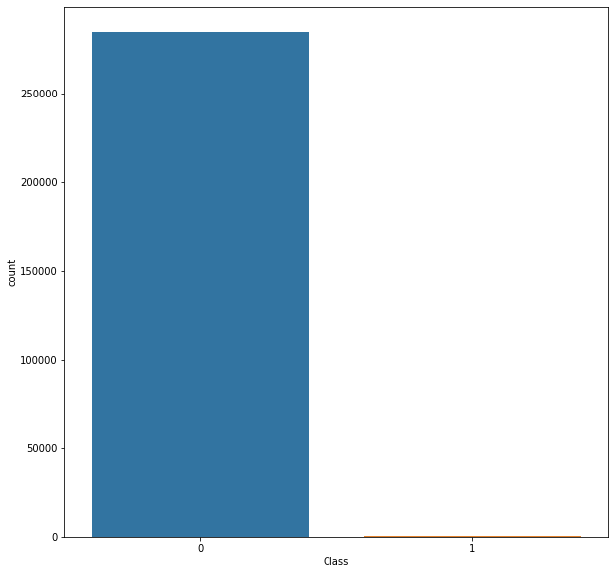

Insights:
- The Dataset has 32 columns with unknown features labelled V1 to V28, Time, Amount and Class
- The target variable is 'Class' and rest of the variables are input features
- The Class has the following values:
  - 0: Legitimate Transactions
  - 1: Fraud Transactions
- The Dataset is highly imbalanced as evident from the countplot with majoritarian class label '0' and minority class label '1'
- Thus, if we run the model on such imbalanced data we may end up highly overfitting it on the data and resulting in non-deployable model
- Hence, we will perform Synthetic Minority Oversampling on the data to balance it out as shown later after exploring other features.

What is relationship of fraud transactions with amount of money?
Let us try to determine the nature of transactions which are fraud and obtain a relevant set of the same with respect to their amount.
- We hypothesise based on our scatter plot that all fraud transactions occur for an amount less than 2500.
pairplot_data_grid(df, "Time", "Amount", "Class")
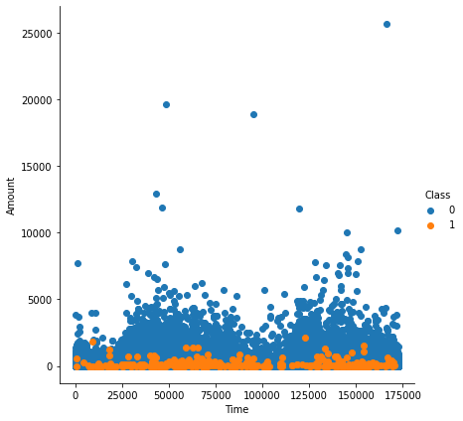
pairplot_data_grid(df, "Amount", "Time", "Class")
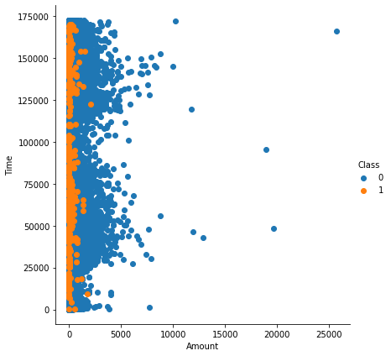

Insights:
- It can be observed that the fraud transactions are generally not above an amount of 2500.
- It can also be observed that the fraud transactions are evenly distributed about time.
- Let us try to prove it
amount_more = 0
amount_less = 0
for i in range(df_refine.shape[0]):
if(df_refine.iloc[i]["Amount"] < 2500):
amount_less += 1
else:
amount_more += 1
print(amount_more)
print(amount_less)
449
284358
percentage_less = (amount_less/df.shape[0])*100
percentage_less
99.84234938045763
Hence, we observe that the 99.85% of transactions amount to less than 2500. Let us see how many of these are fraud and others legitimate
fraud = 0
legitimate = 1
for i in range(df_refine.shape[0]):
if(df_refine.iloc[i]["Amount"]<2500):
if(df_refine.iloc[i]["Class"] == 0):
legitimate += 1
else:
fraud+=1
print(fraud)
print(legitimate)
492
283867
df_refine = df[["Time", "Amount", "Class"]]
sns.pairplot(df_refine, hue="Class", size=6)
plt.show()
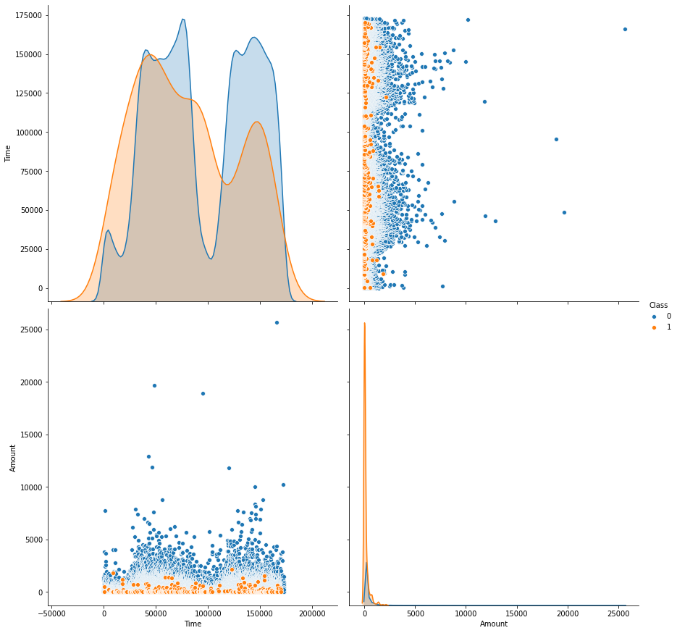
df.Class.value_counts()
0 284315
1 492
Name: Class, dtype: int64
Thus, we can conclude that since the number of fraud transaction below the amount of 2500 is same as the number of total fraud transactions. Hence, all fraud transactions are less than 2500.

What is the relationship between Time and Transactions?
sns.FacetGrid(df_refine, hue="Class", size=6).map(sns.distplot,"Time").add_legend()
plt.show()
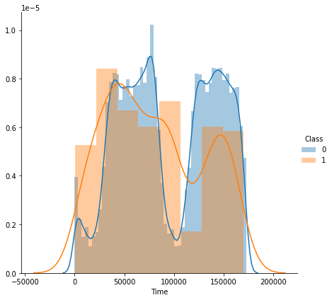
From the above distribution plot, it is clear that the fraudulent transactions are spread throughout the time period

Modelling
- Study the Feature Correlations of the given data
- Plot a Heatmap
- Run GridSearch on the Data
- Fine Tune the Classifiers
- Create Pipelines for evaluation
plt.figure(figsize=(20,20))
df_corr = df.corr()
sns.heatmap(df_corr)
<matplotlib.axes._subplots.AxesSubplot at 0x7f397f77d700>
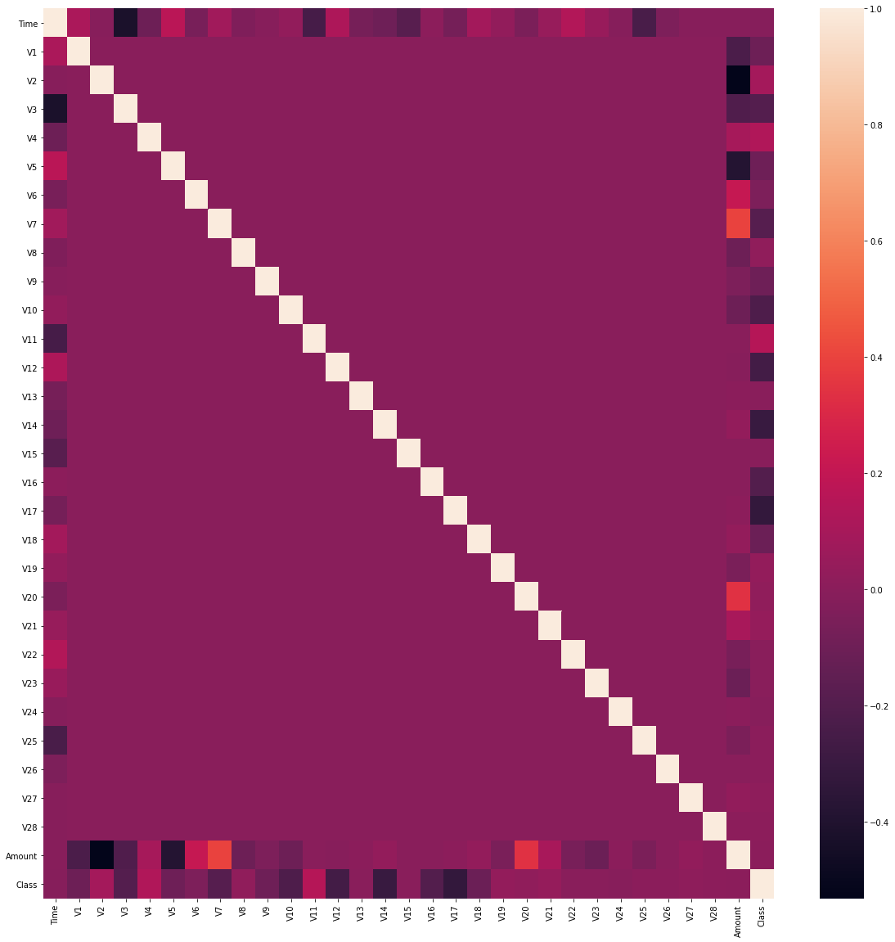
# Create Train and Test Data in ratio 70:30
X = df.drop(labels='Class', axis=1) # Features
y = df.loc[:,'Class'] # Target Variable
X_train, X_test, y_train, y_test = train_test_split(X, y, test_size=0.3, random_state=1, stratify=y)

How will you balance the fraud and legitimate transactions in data?
# Use Synthetic Minority Oversampling
sm = SMOTE(random_state=42)
X_res, y_res = sm.fit_resample(X_train, y_train)
from sklearn.feature_selection import mutual_info_classif
mutual_infos = pd.Series(data=mutual_info_classif(X_res, y_res, discrete_features=False, random_state=1), index=X_train.columns)
mutual_infos.sort_values(ascending=False)
V14 0.535037
V10 0.464777
V12 0.456051
V17 0.438193
V4 0.427426
V11 0.404044
Amount 0.392941
V3 0.387191
V16 0.335318
V7 0.304175
V2 0.291492
V9 0.256679
Time 0.247989
V21 0.235031
V27 0.229915
V1 0.220743
V18 0.198264
V8 0.174393
V6 0.171974
V28 0.170493
V5 0.157362
V20 0.107488
V19 0.099837
V23 0.067332
V24 0.063567
V26 0.046973
V25 0.031607
V22 0.031539
V13 0.024931
V15 0.022442
dtype: float64
sns.countplot(y_res)
<matplotlib.axes._subplots.AxesSubplot at 0x7f1e74ae2ac0>
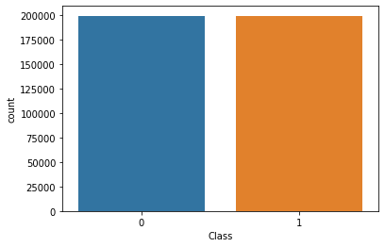
Hence, we can say that the most correlated features after resolving class imbalance using Synthetic Minority Oversampling are V14, V10, V4, V12 and V17.

Evaluation
We make use of AUC-ROC Score, Classification Report, Accuracy and F1-Score to evaluate the performance of the classifiers
# Evaluation of Classifiers
def grid_eval(grid_clf):
"""
Method to Compute the best score and parameters computed by grid search
Parameter:
grid_clf: The Grid Search Classifier
"""
print("Best Score", grid_clf.best_score_)
print("Best Parameter", grid_clf.best_params_)
def evaluation(y_test, grid_clf, X_test):
"""
Method to compute the following:
1. Classification Report
2. F1-score
3. AUC-ROC score
4. Accuracy
Parameters:
y_test: The target variable test set
grid_clf: Grid classifier selected
X_test: Input Feature Test Set
"""
y_pred = grid_clf.predict(X_test)
print('CLASSIFICATION REPORT')
print(classification_report(y_test, y_pred))
print('AUC-ROC')
print(roc_auc_score(y_test, y_pred))
print('F1-Score')
print(f1_score(y_test, y_pred))
print('Accuracy')
print(accuracy_score(y_test, y_pred))
# The parameters of each classifier are different
# Hence, we do not make use of a single method and this is not to violate DRY Principles
# We set pipelines for each classifier unique with parameters
param_grid_sgd = [{
'model__loss': ['log'],
'model__penalty': ['l1', 'l2'],
'model__alpha': np.logspace(start=-3, stop=3, num=20)
}, {
'model__loss': ['hinge'],
'model__alpha': np.logspace(start=-3, stop=3, num=20),
'model__class_weight': [None, 'balanced']
}]
pipeline_sgd = Pipeline([
('scaler', StandardScaler(copy=False)),
('model', SGDClassifier(max_iter=1000, tol=1e-3, random_state=1, warm_start=True))
])
MCC_scorer = make_scorer(matthews_corrcoef)
grid_sgd = GridSearchCV(estimator=pipeline_sgd, param_grid=param_grid_sgd, scoring=MCC_scorer, n_jobs=-1, pre_dispatch='2*n_jobs', cv=5, verbose=1, return_train_score=False)
grid_sgd.fit(X_res, y_res)
Fitting 5 folds for each of 80 candidates, totalling 400 fits
[Parallel(n_jobs=-1)]: Using backend LokyBackend with 4 concurrent workers.
[Parallel(n_jobs=-1)]: Done 42 tasks | elapsed: 48.4s
[Parallel(n_jobs=-1)]: Done 192 tasks | elapsed: 3.2min
[Parallel(n_jobs=-1)]: Done 400 out of 400 | elapsed: 6.0min finished
GridSearchCV(cv=5, error_score=nan,
estimator=Pipeline(memory=None,
steps=[('scaler',
StandardScaler(copy=False,
with_mean=True,
with_std=True)),
('model',
SGDClassifier(alpha=0.0001,
average=False,
class_weight=None,
early_stopping=False,
epsilon=0.1, eta0=0.0,
fit_intercept=True,
l1_ratio=0.15,
learning_rate='optimal',
loss='hinge',
max_iter=1000,
n_iter_no_change=...
3.35981829e-01, 6.95192796e-01, 1.43844989e+00, 2.97635144e+00,
6.15848211e+00, 1.27427499e+01, 2.63665090e+01, 5.45559478e+01,
1.12883789e+02, 2.33572147e+02, 4.83293024e+02, 1.00000000e+03]),
'model__class_weight': [None, 'balanced'],
'model__loss': ['hinge']}],
pre_dispatch='2*n_jobs', refit=True, return_train_score=False,
scoring=make_scorer(matthews_corrcoef), verbose=1)
grid_eval(grid_sgd)
Best Score 0.9560162686072134
Best Parameter {'model__alpha': 0.001, 'model__loss': 'log', 'model__penalty': 'l1'}
evaluation(y_test, grid_sgd, X_test)
CLASSIFICATION REPORT
precision recall f1-score support
0 1.00 0.99 1.00 85295
1 0.14 0.91 0.25 148
accuracy 0.99 85443
macro avg 0.57 0.95 0.62 85443
weighted avg 1.00 0.99 0.99 85443
AUC-ROC
0.9479720619851928
F1-Score
0.2460973370064279
Accuracy
0.990391254988706
pipeline_rf = Pipeline([
('model', RandomForestClassifier(n_jobs=-1, random_state=1))
])
param_grid_rf = {'model__n_estimators': [75]}
grid_rf = GridSearchCV(estimator=pipeline_rf, param_grid=param_grid_rf, scoring=MCC_scorer, n_jobs=-1, pre_dispatch='2*n_jobs', cv=5, verbose=1, return_train_score=False)
grid_rf.fit(X_res, y_res)
Fitting 5 folds for each of 1 candidates, totalling 5 fits
[Parallel(n_jobs=-1)]: Using backend LokyBackend with 4 concurrent workers.
[Parallel(n_jobs=-1)]: Done 5 out of 5 | elapsed: 10.5min finished
GridSearchCV(cv=5, error_score=nan,
estimator=Pipeline(memory=None,
steps=[('model',
RandomForestClassifier(bootstrap=True,
ccp_alpha=0.0,
class_weight=None,
criterion='gini',
max_depth=None,
max_features='auto',
max_leaf_nodes=None,
max_samples=None,
min_impurity_decrease=0.0,
min_impurity_split=None,
min_samples_leaf=1,
min_samples_split=2,
min_weight_fraction_leaf=0.0,
n_estimators=100,
n_jobs=-1,
oob_score=False,
random_state=1,
verbose=0,
warm_start=False))],
verbose=False),
iid='deprecated', n_jobs=-1,
param_grid={'model__n_estimators': [75]}, pre_dispatch='2*n_jobs',
refit=True, return_train_score=False,
scoring=make_scorer(matthews_corrcoef), verbose=1)
grid_eval(grid_rf)
Best Score 0.9997538267139271
Best Parameter {'model__n_estimators': 75}
evaluation(y_test, grid_rf, X_test)
CLASSIFICATION REPORT
precision recall f1-score support
0 1.00 1.00 1.00 85295
1 0.90 0.86 0.88 148
accuracy 1.00 85443
macro avg 0.95 0.93 0.94 85443
weighted avg 1.00 1.00 1.00 85443
AUC-ROC
0.9323445023075716
F1-Score
0.879725085910653
Accuracy
0.9995903701883126
pipeline_lr = Pipeline([
('model', LogisticRegression(random_state=1))
])
param_grid_lr = {'model__penalty': ['l2'],
'model__class_weight': [None, 'balanced']}
grid_lr = GridSearchCV(estimator=pipeline_lr, param_grid=param_grid_lr, scoring=MCC_scorer, n_jobs=-1, pre_dispatch='2*n_jobs', cv=5, verbose=1, return_train_score=False)
grid_lr.fit(X_res, y_res)
Fitting 5 folds for each of 2 candidates, totalling 10 fits
[Parallel(n_jobs=-1)]: Using backend LokyBackend with 4 concurrent workers.
[Parallel(n_jobs=-1)]: Done 10 out of 10 | elapsed: 28.0s finished
GridSearchCV(cv=5, error_score=nan,
estimator=Pipeline(memory=None,
steps=[('model',
LogisticRegression(C=1.0,
class_weight=None,
dual=False,
fit_intercept=True,
intercept_scaling=1,
l1_ratio=None,
max_iter=100,
multi_class='auto',
n_jobs=None,
penalty='l2',
random_state=1,
solver='lbfgs',
tol=0.0001,
verbose=0,
warm_start=False))],
verbose=False),
iid='deprecated', n_jobs=-1,
param_grid={'model__class_weight': [None, 'balanced'],
'model__penalty': ['l2']},
pre_dispatch='2*n_jobs', refit=True, return_train_score=False,
scoring=make_scorer(matthews_corrcoef), verbose=1)
grid_eval(grid_lr)
Best Score 0.959816277887179
Best Parameter {'model__class_weight': None, 'model__penalty': 'l2'}
evaluation(y_test, grid_lr, X_test)
CLASSIFICATION REPORT
precision recall f1-score support
0 1.00 0.99 1.00 85295
1 0.15 0.91 0.26 148
accuracy 0.99 85443
macro avg 0.57 0.95 0.63 85443
weighted avg 1.00 0.99 0.99 85443
AUC-ROC
0.948212404326479
F1-Score
0.2557251908396946
Accuracy
0.9908711070538253
pipeline_knn = Pipeline([
('model', KNeighborsClassifier(n_neighbors=5))
])
param_grid_knn = {'model__p': [2]}
grid_knn = GridSearchCV(estimator=pipeline_knn, param_grid=param_grid_knn, scoring=MCC_scorer, n_jobs=-1, pre_dispatch='2*n_jobs', cv=5, verbose=1, return_train_score=False)
grid_knn.fit(X_res, y_res)
Fitting 5 folds for each of 1 candidates, totalling 5 fits
[Parallel(n_jobs=-1)]: Using backend LokyBackend with 4 concurrent workers.
[Parallel(n_jobs=-1)]: Done 5 out of 5 | elapsed: 15.9min finished
GridSearchCV(cv=5, error_score=nan,
estimator=Pipeline(memory=None,
steps=[('model',
KNeighborsClassifier(algorithm='auto',
leaf_size=30,
metric='minkowski',
metric_params=None,
n_jobs=None,
n_neighbors=5, p=2,
weights='uniform'))],
verbose=False),
iid='deprecated', n_jobs=-1, param_grid={'model__p': [2]},
pre_dispatch='2*n_jobs', refit=True, return_train_score=False,
scoring=make_scorer(matthews_corrcoef), verbose=1)
grid_eval(grid_knn)
Best Score 0.9980623930056313
Best Parameter {'model__p': 2}
evaluation(y_test, grid_knn, X_test)
CLASSIFICATION REPORT
precision recall f1-score support
0 1.00 1.00 1.00 85295
1 0.50 0.86 0.63 148
accuracy 1.00 85443
macro avg 0.75 0.93 0.82 85443
weighted avg 1.00 1.00 1.00 85443
AUC-ROC
0.9283095789968995
F1-Score
0.6318407960199005
Accuracy
0.9982678510820079

The number of fraud transactions are very few comparted to legitimate transactions and it has to be balanced in order for a fair comparison to prevent the model from overfitting.Credit Card Fraud Detection

Data frames
import pandas as pd
df = pd.read_csv('creditcard.csv')
df
Time V1 V2 V3 V4 V5 \
0 0.0 -1.359807 -0.072781 2.536347 1.378155 -0.338321
1 0.0 1.191857 0.266151 0.166480 0.448154 0.060018
2 1.0 -1.358354 -1.340163 1.773209 0.379780 -0.503198
3 1.0 -0.966272 -0.185226 1.792993 -0.863291 -0.010309
4 2.0 -1.158233 0.877737 1.548718 0.403034 -0.407193
... ... ... ... ... ... ...
284802 172786.0 -11.881118 10.071785 -9.834783 -2.066656 -5.364473
284803 172787.0 -0.732789 -0.055080 2.035030 -0.738589 0.868229
284804 172788.0 1.919565 -0.301254 -3.249640 -0.557828 2.630515
284805 172788.0 -0.240440 0.530483 0.702510 0.689799 -0.377961
284806 172792.0 -0.533413 -0.189733 0.703337 -0.506271 -0.012546
V6 V7 V8 V9 ... V21 V22 \
0 0.462388 0.239599 0.098698 0.363787 ... -0.018307 0.277838
1 -0.082361 -0.078803 0.085102 -0.255425 ... -0.225775 -0.638672
2 1.800499 0.791461 0.247676 -1.514654 ... 0.247998 0.771679
3 1.247203 0.237609 0.377436 -1.387024 ... -0.108300 0.005274
4 0.095921 0.592941 -0.270533 0.817739 ... -0.009431 0.798278
... ... ... ... ... ... ... ...
284802 -2.606837 -4.918215 7.305334 1.914428 ... 0.213454 0.111864
284803 1.058415 0.024330 0.294869 0.584800 ... 0.214205 0.924384
284804 3.031260 -0.296827 0.708417 0.432454 ... 0.232045 0.578229
284805 0.623708 -0.686180 0.679145 0.392087 ... 0.265245 0.800049
284806 -0.649617 1.577006 -0.414650 0.486180 ... 0.261057 0.643078
V23 V24 V25 V26 V27 V28 Amount \
0 -0.110474 0.066928 0.128539 -0.189115 0.133558 -0.021053 149.62
1 0.101288 -0.339846 0.167170 0.125895 -0.008983 0.014724 2.69
2 0.909412 -0.689281 -0.327642 -0.139097 -0.055353 -0.059752 378.66
3 -0.190321 -1.175575 0.647376 -0.221929 0.062723 0.061458 123.50
4 -0.137458 0.141267 -0.206010 0.502292 0.219422 0.215153 69.99
... ... ... ... ... ... ... ...
284802 1.014480 -0.509348 1.436807 0.250034 0.943651 0.823731 0.77
284803 0.012463 -1.016226 -0.606624 -0.395255 0.068472 -0.053527 24.79
284804 -0.037501 0.640134 0.265745 -0.087371 0.004455 -0.026561 67.88
284805 -0.163298 0.123205 -0.569159 0.546668 0.108821 0.104533 10.00
284806 0.376777 0.008797 -0.473649 -0.818267 -0.002415 0.013649 217.00
Class
0 0
1 0
2 0
3 0
4 0
... ...
284802 0
284803 0
284804 0
284805 0
284806 0
[284807 rows x 31 columns]
df['Class'].value_counts()
0 284315
1 492
Name: Class, dtype: int64

Data Pre-processing
from sklearn.model_selection import train_test_split
from sklearn.preprocessing import StandardScaler
scalar = StandardScaler()
X = df.drop('Class', axis=1)
y = df.Class
X = scalar.fit_transform(X)
X_train, X_test, y_train, y_test = train_test_split(X, y, test_size=0.2, random_state=1)

Modeling
from sklearn.svm import SVC
model_svc = SVC()
model_svc.fit(X_train, y_train)
SVC()
model_svc.score(X_train,y_train)
0.9996752178015756
model_svc.score(X_test,y_test)
0.999385555282469
y_predict = model_svc.predict(X_test)

Implementing Report
from sklearn.metrics import classification_report , confusion_matrix
import numpy as np
cm = np.array(confusion_matrix(y_test, y_predict, labels=[1,0]))
confusion = pd.DataFrame(cm, index=['is Fraud', 'is Normal'],columns=['predicted fraud','predicted normal'])
confusion
predicted fraud predicted normal
is Fraud 55 32
is Normal 3 56872
import seaborn as sns
sns.heatmap(confusion, annot=True)
<matplotlib.axes._subplots.AxesSubplot at 0x1a0374fe948>
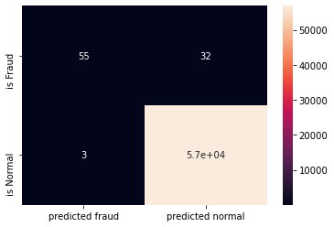
print(classification_report(y_test, y_predict))
precision recall f1-score support
0 1.00 1.00 1.00 56875
1 0.95 0.63 0.76 87
accuracy 1.00 56962
macro avg 0.97 0.82 0.88 56962
weighted avg 1.00 1.00 1.00 56962
from google.colab import drive
drive.mount('/content/drive')
Go to this URL in a browser: https://accounts.google.com/o/oauth2/auth?client_id=947318989803-6bn6qk8qdgf4n4g3pfee6491hc0brc4i.apps.googleusercontent.com&redirect_uri=urn%3aietf%3awg%3aoauth%3a2.0%3aoob&response_type=code&scope=email%20https%3a%2f%2fwww.googleapis.com%2fauth%2fdocs.test%20https%3a%2f%2fwww.googleapis.com%2fauth%2fdrive%20https%3a%2f%2fwww.googleapis.com%2fauth%2fdrive.photos.readonly%20https%3a%2f%2fwww.googleapis.com%2fauth%2fpeopleapi.readonly
Enter your authorization code:
··········
Mounted at /content/drive
from matplotlib import pyplot as plt
import warnings
warnings.filterwarnings("ignore")
import seaborn as sns
import pandas as pd
import numpy as np
from imblearn.over_sampling import SMOTE
from sklearn.preprocessing import StandardScaler
from sklearn.model_selection import train_test_split
import tensorflow as tf
from tensorflow.keras.layers import Dense
from tensorflow.keras.layers import Input
from tensorflow.keras.models import Model
df = pd.read_csv("/content/drive/My Drive/creditcard.csv", encoding="utf-8")
df
Time V1 V2 ... V28 Amount Class
0 0.0 -1.359807 -0.072781 ... -0.021053 149.62 0
1 0.0 1.191857 0.266151 ... 0.014724 2.69 0
2 1.0 -1.358354 -1.340163 ... -0.059752 378.66 0
3 1.0 -0.966272 -0.185226 ... 0.061458 123.50 0
4 2.0 -1.158233 0.877737 ... 0.215153 69.99 0
... ... ... ... ... ... ... ...
284802 172786.0 -11.881118 10.071785 ... 0.823731 0.77 0
284803 172787.0 -0.732789 -0.055080 ... -0.053527 24.79 0
284804 172788.0 1.919565 -0.301254 ... -0.026561 67.88 0
284805 172788.0 -0.240440 0.530483 ... 0.104533 10.00 0
284806 172792.0 -0.533413 -0.189733 ... 0.013649 217.00 0
[284807 rows x 31 columns]
df.head()
Time V1 V2 V3 ... V27 V28 Amount Class
0 0.0 -1.359807 -0.072781 2.536347 ... 0.133558 -0.021053 149.62 0
1 0.0 1.191857 0.266151 0.166480 ... -0.008983 0.014724 2.69 0
2 1.0 -1.358354 -1.340163 1.773209 ... -0.055353 -0.059752 378.66 0
3 1.0 -0.966272 -0.185226 1.792993 ... 0.062723 0.061458 123.50 0
4 2.0 -1.158233 0.877737 1.548718 ... 0.219422 0.215153 69.99 0
[5 rows x 31 columns]
fig, ax = plt.subplots(figsize=(20,10))
corr = df.corr()
sns.heatmap(corr, cmap="gray", ax=ax)
ax.set_title("Imbalanced Correlation Matrix", fontsize=14)
plt.show()
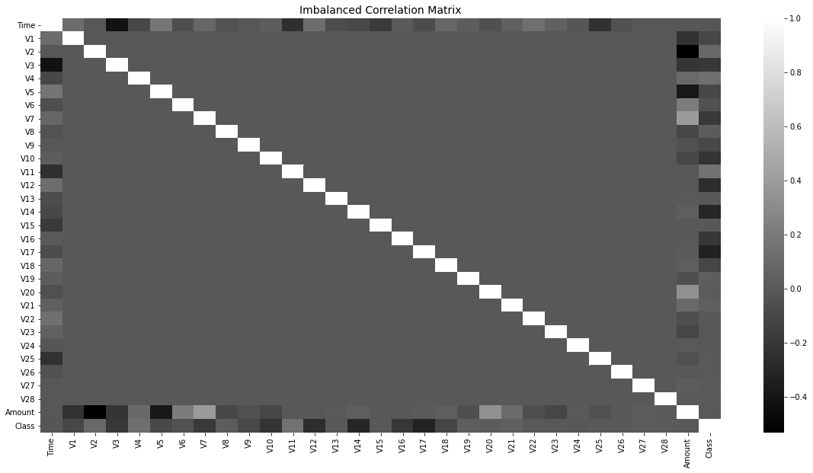
sns.countplot(x='Class',data=df)
<matplotlib.axes._subplots.AxesSubplot at 0x7f690eb54f60>
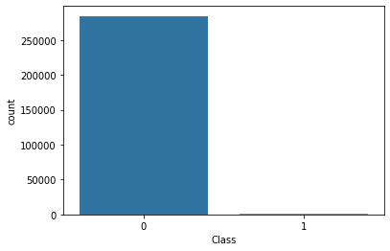
sm = SMOTE(sampling_strategy='minority', random_state=7)
resampled_X, resampled_Y = sm.fit_resample(df.drop('Class', axis=1), df['Class'])
oversampled_df = pd.concat([pd.DataFrame(resampled_X), pd.DataFrame(resampled_Y)], axis=1)
oversampled_df.columns = df.columns
oversampled_df['Class'].value_counts()
1 284315
0 284315
Name: Class, dtype: int64
sns.countplot(x='Class', data=oversampled_df)
<matplotlib.axes._subplots.AxesSubplot at 0x7f6908f63a20>
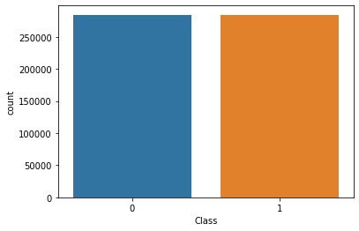
fig, ax = plt.subplots(figsize=(20,10))
corr = oversampled_df.corr()
sns.heatmap(corr, cmap='YlGnBu', annot_kws={'size':30}, ax=ax)
ax.set_title("Imbalanced Correlation Matrix", fontsize=14)
plt.show()
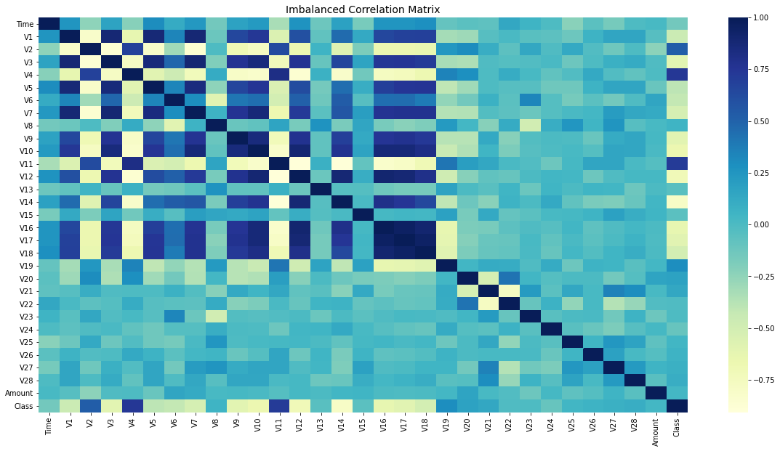
sc = StandardScaler()
X = oversampled_df.iloc[:, 1:-1].values
y = oversampled_df.iloc[:, -1].values
y = y.reshape(-1, 1)
print(X.shape, y.shape)
X = sc.fit_transform(X)
print(X[0])
(568630, 29) (568630, 1)
[ 0.20495125 -0.54573636 1.0045184 -0.30168224 0.31098779 0.6920209
0.55516986 -0.03644768 0.76125221 0.67923829 -0.92061643 0.57128753
-0.94634073 0.71704508 1.64724241 0.48636415 0.62706212 0.50679008
0.04977222 0.06379384 -0.14589103 0.24649907 -0.10441593 0.22564242
0.16596895 -0.48756152 0.05492719 -0.14984388 0.2455859 ]
x_train, x_test, y_train, y_test = train_test_split(X, y, test_size=0.3, random_state=42)
adam = tf.keras.optimizers.Adam(learning_rate=0.0005)
x_features = X.shape[1]
y_features = y.shape[1]
i = Input(shape=(x_features,))
x = Dense(64, activation='relu')(i)
x = Dense(64, activation='relu')(x)
o = Dense(y_features, activation='sigmoid')(x)
model = Model(i,o)
model.compile(loss="binary_crossentropy", metrics=['accuracy'], optimizer=adam)
print(model.summary())
callback = tf.keras.callbacks.EarlyStopping(
monitor='val_loss', min_delta=0, patience=10, verbose=0, mode='auto',
baseline=None, restore_best_weights=True
)
Model: "model"
_________________________________________________________________
Layer (type) Output Shape Param #
=================================================================
input_1 (InputLayer) [(None, 29)] 0
_________________________________________________________________
dense (Dense) (None, 64) 1920
_________________________________________________________________
dense_1 (Dense) (None, 64) 4160
_________________________________________________________________
dense_2 (Dense) (None, 1) 65
=================================================================
Total params: 6,145
Trainable params: 6,145
Non-trainable params: 0
_________________________________________________________________
None
r = model.fit(x_train, y_train, epochs=100, batch_size=512, verbose=1, validation_data=(x_test, y_test), callbacks=[callback])
Epoch 1/100
778/778 [==============================] - 3s 4ms/step - loss: 0.1122 - accuracy: 0.9588 - val_loss: 0.0468 - val_accuracy: 0.9844
Epoch 2/100
778/778 [==============================] - 3s 4ms/step - loss: 0.0336 - accuracy: 0.9883 - val_loss: 0.0260 - val_accuracy: 0.9929
Epoch 3/100
778/778 [==============================] - 3s 4ms/step - loss: 0.0198 - accuracy: 0.9939 - val_loss: 0.0165 - val_accuracy: 0.9945
Epoch 4/100
778/778 [==============================] - 3s 4ms/step - loss: 0.0133 - accuracy: 0.9965 - val_loss: 0.0117 - val_accuracy: 0.9974
Epoch 5/100
778/778 [==============================] - 3s 4ms/step - loss: 0.0095 - accuracy: 0.9978 - val_loss: 0.0096 - val_accuracy: 0.9977
Epoch 6/100
778/778 [==============================] - 3s 4ms/step - loss: 0.0074 - accuracy: 0.9984 - val_loss: 0.0068 - val_accuracy: 0.9986
Epoch 7/100
778/778 [==============================] - 3s 4ms/step - loss: 0.0060 - accuracy: 0.9987 - val_loss: 0.0061 - val_accuracy: 0.9986
Epoch 8/100
778/778 [==============================] - 3s 4ms/step - loss: 0.0050 - accuracy: 0.9989 - val_loss: 0.0051 - val_accuracy: 0.9989
Epoch 9/100
778/778 [==============================] - 3s 4ms/step - loss: 0.0042 - accuracy: 0.9991 - val_loss: 0.0046 - val_accuracy: 0.9989
Epoch 10/100
778/778 [==============================] - 3s 4ms/step - loss: 0.0037 - accuracy: 0.9992 - val_loss: 0.0041 - val_accuracy: 0.9990
Epoch 11/100
778/778 [==============================] - 3s 4ms/step - loss: 0.0033 - accuracy: 0.9993 - val_loss: 0.0037 - val_accuracy: 0.9993
Epoch 12/100
778/778 [==============================] - 3s 4ms/step - loss: 0.0029 - accuracy: 0.9994 - val_loss: 0.0035 - val_accuracy: 0.9992
Epoch 13/100
778/778 [==============================] - 3s 4ms/step - loss: 0.0027 - accuracy: 0.9994 - val_loss: 0.0037 - val_accuracy: 0.9991
Epoch 14/100
778/778 [==============================] - 3s 4ms/step - loss: 0.0024 - accuracy: 0.9995 - val_loss: 0.0035 - val_accuracy: 0.9990
Epoch 15/100
778/778 [==============================] - 3s 4ms/step - loss: 0.0022 - accuracy: 0.9995 - val_loss: 0.0032 - val_accuracy: 0.9992
Epoch 16/100
778/778 [==============================] - 3s 4ms/step - loss: 0.0020 - accuracy: 0.9996 - val_loss: 0.0027 - val_accuracy: 0.9994
Epoch 17/100
778/778 [==============================] - 3s 4ms/step - loss: 0.0020 - accuracy: 0.9995 - val_loss: 0.0027 - val_accuracy: 0.9993
Epoch 18/100
778/778 [==============================] - 3s 4ms/step - loss: 0.0018 - accuracy: 0.9996 - val_loss: 0.0023 - val_accuracy: 0.9996
Epoch 19/100
778/778 [==============================] - 3s 4ms/step - loss: 0.0016 - accuracy: 0.9996 - val_loss: 0.0025 - val_accuracy: 0.9994
Epoch 20/100
778/778 [==============================] - 3s 4ms/step - loss: 0.0015 - accuracy: 0.9997 - val_loss: 0.0025 - val_accuracy: 0.9993
Epoch 21/100
778/778 [==============================] - 3s 4ms/step - loss: 0.0015 - accuracy: 0.9996 - val_loss: 0.0022 - val_accuracy: 0.9994
Epoch 22/100
778/778 [==============================] - 3s 4ms/step - loss: 0.0014 - accuracy: 0.9997 - val_loss: 0.0024 - val_accuracy: 0.9994
Epoch 23/100
778/778 [==============================] - 3s 4ms/step - loss: 0.0013 - accuracy: 0.9997 - val_loss: 0.0022 - val_accuracy: 0.9996
Epoch 24/100
778/778 [==============================] - 3s 4ms/step - loss: 0.0012 - accuracy: 0.9997 - val_loss: 0.0022 - val_accuracy: 0.9995
Epoch 25/100
778/778 [==============================] - 3s 4ms/step - loss: 0.0014 - accuracy: 0.9997 - val_loss: 0.0025 - val_accuracy: 0.9993
Epoch 26/100
778/778 [==============================] - 3s 4ms/step - loss: 0.0011 - accuracy: 0.9997 - val_loss: 0.0027 - val_accuracy: 0.9993
Epoch 27/100
778/778 [==============================] - 3s 4ms/step - loss: 9.9902e-04 - accuracy: 0.9997 - val_loss: 0.0023 - val_accuracy: 0.9995
Epoch 28/100
778/778 [==============================] - 3s 4ms/step - loss: 9.9616e-04 - accuracy: 0.9997 - val_loss: 0.0021 - val_accuracy: 0.9995
Epoch 29/100
778/778 [==============================] - 3s 4ms/step - loss: 8.8531e-04 - accuracy: 0.9998 - val_loss: 0.0020 - val_accuracy: 0.9995
Epoch 30/100
778/778 [==============================] - 3s 4ms/step - loss: 0.0010 - accuracy: 0.9997 - val_loss: 0.0018 - val_accuracy: 0.9996
Epoch 31/100
778/778 [==============================] - 3s 4ms/step - loss: 8.5445e-04 - accuracy: 0.9998 - val_loss: 0.0019 - val_accuracy: 0.9995
Epoch 32/100
778/778 [==============================] - 3s 4ms/step - loss: 9.3442e-04 - accuracy: 0.9997 - val_loss: 0.0016 - val_accuracy: 0.9997
Epoch 33/100
778/778 [==============================] - 3s 4ms/step - loss: 7.1790e-04 - accuracy: 0.9998 - val_loss: 0.0016 - val_accuracy: 0.9996
Epoch 34/100
778/778 [==============================] - 3s 4ms/step - loss: 7.2516e-04 - accuracy: 0.9998 - val_loss: 0.0016 - val_accuracy: 0.9996
Epoch 35/100
778/778 [==============================] - 3s 4ms/step - loss: 9.1578e-04 - accuracy: 0.9997 - val_loss: 0.0020 - val_accuracy: 0.9994
Epoch 36/100
778/778 [==============================] - 3s 4ms/step - loss: 6.7762e-04 - accuracy: 0.9998 - val_loss: 0.0015 - val_accuracy: 0.9997
Epoch 37/100
778/778 [==============================] - 3s 4ms/step - loss: 6.5826e-04 - accuracy: 0.9998 - val_loss: 0.0015 - val_accuracy: 0.9996
Epoch 38/100
778/778 [==============================] - 3s 4ms/step - loss: 7.5355e-04 - accuracy: 0.9998 - val_loss: 0.0016 - val_accuracy: 0.9996
Epoch 39/100
778/778 [==============================] - 3s 4ms/step - loss: 7.1149e-04 - accuracy: 0.9998 - val_loss: 0.0015 - val_accuracy: 0.9996
Epoch 40/100
778/778 [==============================] - 3s 4ms/step - loss: 5.8838e-04 - accuracy: 0.9999 - val_loss: 0.0024 - val_accuracy: 0.9994
Epoch 41/100
778/778 [==============================] - 3s 4ms/step - loss: 5.2743e-04 - accuracy: 0.9999 - val_loss: 0.0015 - val_accuracy: 0.9997
Epoch 42/100
778/778 [==============================] - 3s 4ms/step - loss: 7.9482e-04 - accuracy: 0.9998 - val_loss: 0.0019 - val_accuracy: 0.9995
Epoch 43/100
778/778 [==============================] - 3s 4ms/step - loss: 6.0553e-04 - accuracy: 0.9998 - val_loss: 0.0013 - val_accuracy: 0.9997
Epoch 44/100
778/778 [==============================] - 3s 4ms/step - loss: 6.0704e-04 - accuracy: 0.9998 - val_loss: 0.0020 - val_accuracy: 0.9995
Epoch 45/100
778/778 [==============================] - 3s 4ms/step - loss: 6.3886e-04 - accuracy: 0.9998 - val_loss: 0.0015 - val_accuracy: 0.9996
Epoch 46/100
778/778 [==============================] - 3s 4ms/step - loss: 5.7343e-04 - accuracy: 0.9998 - val_loss: 0.0013 - val_accuracy: 0.9997
Epoch 47/100
778/778 [==============================] - 3s 4ms/step - loss: 4.2137e-04 - accuracy: 0.9999 - val_loss: 0.0018 - val_accuracy: 0.9996
Epoch 48/100
778/778 [==============================] - 3s 4ms/step - loss: 6.0087e-04 - accuracy: 0.9998 - val_loss: 0.0016 - val_accuracy: 0.9997
Epoch 49/100
778/778 [==============================] - 3s 4ms/step - loss: 5.2967e-04 - accuracy: 0.9999 - val_loss: 0.0012 - val_accuracy: 0.9998
Epoch 50/100
778/778 [==============================] - 3s 4ms/step - loss: 5.2438e-04 - accuracy: 0.9998 - val_loss: 0.0012 - val_accuracy: 0.9997
Epoch 51/100
778/778 [==============================] - 3s 4ms/step - loss: 5.0218e-04 - accuracy: 0.9998 - val_loss: 0.0018 - val_accuracy: 0.9996
Epoch 52/100
778/778 [==============================] - 3s 4ms/step - loss: 6.3864e-04 - accuracy: 0.9998 - val_loss: 0.0020 - val_accuracy: 0.9995
Epoch 53/100
778/778 [==============================] - 3s 4ms/step - loss: 6.7778e-04 - accuracy: 0.9998 - val_loss: 0.0016 - val_accuracy: 0.9996
Epoch 54/100
778/778 [==============================] - 3s 4ms/step - loss: 4.3683e-04 - accuracy: 0.9999 - val_loss: 0.0017 - val_accuracy: 0.9996
Epoch 55/100
778/778 [==============================] - 3s 4ms/step - loss: 7.2916e-04 - accuracy: 0.9998 - val_loss: 0.0018 - val_accuracy: 0.9996
Epoch 56/100
778/778 [==============================] - 3s 4ms/step - loss: 4.6164e-04 - accuracy: 0.9999 - val_loss: 0.0017 - val_accuracy: 0.9996
Epoch 57/100
778/778 [==============================] - 3s 4ms/step - loss: 4.3985e-04 - accuracy: 0.9999 - val_loss: 0.0022 - val_accuracy: 0.9995
Epoch 58/100
778/778 [==============================] - 3s 4ms/step - loss: 4.4691e-04 - accuracy: 0.9999 - val_loss: 0.0015 - val_accuracy: 0.9996
Epoch 59/100
778/778 [==============================] - 3s 4ms/step - loss: 6.0507e-04 - accuracy: 0.9998 - val_loss: 0.0010 - val_accuracy: 0.9998
Epoch 60/100
778/778 [==============================] - 3s 4ms/step - loss: 4.2673e-04 - accuracy: 0.9999 - val_loss: 0.0027 - val_accuracy: 0.9995
Epoch 61/100
778/778 [==============================] - 3s 4ms/step - loss: 3.7599e-04 - accuracy: 0.9999 - val_loss: 0.0019 - val_accuracy: 0.9996
Epoch 62/100
778/778 [==============================] - 3s 4ms/step - loss: 6.4678e-04 - accuracy: 0.9998 - val_loss: 0.0024 - val_accuracy: 0.9995
Epoch 63/100
778/778 [==============================] - 3s 4ms/step - loss: 3.3452e-04 - accuracy: 0.9999 - val_loss: 0.0013 - val_accuracy: 0.9997
Epoch 64/100
778/778 [==============================] - 3s 4ms/step - loss: 4.5338e-04 - accuracy: 0.9999 - val_loss: 0.0022 - val_accuracy: 0.9995
Epoch 65/100
778/778 [==============================] - 3s 4ms/step - loss: 5.2037e-04 - accuracy: 0.9998 - val_loss: 0.0013 - val_accuracy: 0.9997
Epoch 66/100
778/778 [==============================] - 3s 4ms/step - loss: 3.9358e-04 - accuracy: 0.9999 - val_loss: 0.0014 - val_accuracy: 0.9997
Epoch 67/100
778/778 [==============================] - 3s 4ms/step - loss: 4.2975e-04 - accuracy: 0.9999 - val_loss: 0.0018 - val_accuracy: 0.9997
Epoch 68/100
778/778 [==============================] - 3s 4ms/step - loss: 3.7875e-04 - accuracy: 0.9999 - val_loss: 0.0012 - val_accuracy: 0.9997
Epoch 69/100
778/778 [==============================] - 3s 4ms/step - loss: 5.4449e-04 - accuracy: 0.9998 - val_loss: 0.0017 - val_accuracy: 0.9997
results = model.evaluate(x_test, y_test, batch_size=5, verbose=1)
print("Loss: %.2f" % results[0])
print("Acc: %.2f" % results[1])
34118/34118 [==============================] - 74s 2ms/step - loss: 0.0010 - accuracy: 0.9998
Loss: 0.00
Acc: 1.00
print(r.history.keys())
plt.plot(r.history['loss'])
plt.plot(r.history['val_loss'])
plt.legend(['loss', 'val_loss'])
plt.show()
plt.plot(r.history['accuracy'])
plt.plot(r.history['val_accuracy'])
plt.legend(['accuracy', 'val_accuracy'])
plt.show()
dict_keys(['loss', 'accuracy', 'val_loss', 'val_accuracy'])
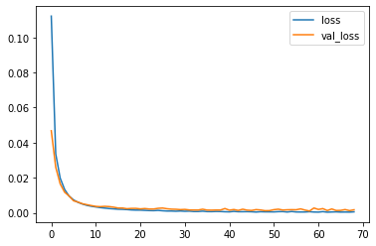
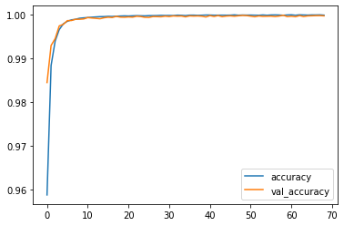
y_pred = model.predict(x_test)
y_pred = np.round(y_pred, decimals=0).astype(int)
df_pred = pd.concat([pd.DataFrame(x_test), pd.DataFrame(y_test)], axis=1)
df_pred.columns = df.drop('Time', axis=1).columns
df_pred.rename(columns={"Class":"Old_class"}, inplace=True)
df_pred['New_class'] = y_pred
cm = pd.crosstab(df_pred["New_class"], df_pred['Old_class'])
true_pos = np.sum(np.diag(cm))
false_pos = cm[0][1]
false_neg = cm[1][0]
precision = true_pos / (true_pos + false_pos) * 100
recall = true_pos / (true_pos + false_neg) * 100
f1 = 2 * (precision * recall) / (precision + recall)
print("Precision: %.3f%%" % (precision))
print("Recall: %.3f%%" % (recall))
print("F1: %.3f%%" % (f1))
Precision: 99.981%
Recall: 100.000%
F1: 99.991%

Conclusion
- The K-Nearest Neighbors Classifier tuned with Grid Search with the best parameter being the Euclidean Distance (p=2) outperforms its counterparts to give a test accuracy of nearly 99.8% and a perfect F1-Score with minimal overfitting
- SMOTE overcomes overfitting by synthetically oversampling minority class labels and is successful to a great degree

Summary
- All Fraud Transactions occur for an amount below 2500. Thus, the bank can infer clearly that the fraud committers try to commit frauds of smaller amounts to avoid suspicion.
- The fraud transactions are equitable distributed throughout time and there is no clear relationship of time with commiting of fraud.

