DBMS CORNERSTONE PROJECT
RESTAURANT MANAGEMENT SYSTEM
A RELATIONAL DATABASE MANAGEMENT SYSTEM PROJECT
Submitted by
25B11CS525: AKHIL SANTOSH
25B11CS397: VENKATESH
25B11CS320: LALITHAPRASAD
25B11CSA62: PUNEETH KUMAR
[CSE 14]
CERTIFICATE
This is to certify that the project entitled “Restaurant Management System” is a bonafide DBMS project carried out by 25B11CS525: AKHIL SANTOSH, 25B11CS397: VENKATESH, 25B11CS320: LALITHAPRASAD, and 25B11CSA62: PUNEETH KUMAR under the guidance of the concerned faculty during the academic year [ACADEMIC YEAR].
The project work demonstrates the design and implementation of a relational database for restaurant operations, including customer management, employee management, dining-table management, menu management, order processing, billing, and payment management.
Project Guide: Dr. Vydehi mam

ACKNOWLEDGEMENT
I would like to express my sincere gratitude to my project guide, faculty members, and institution for their valuable guidance and support during the development of the Restaurant Management System DBMS project.
I also thank my classmates, friends, and family members for their encouragement and assistance throughout the preparation of the database design, SQL implementation, testing, and documentation.
Finally, I am grateful for the opportunity to apply database management concepts such as entity relationship modelling, relational schema design, normalization, SQL queries, keys, and constraints to a practical restaurant management scenario.

TABLE OF CONTENTS
- Cover Page
- Certificate
- Acknowledgement
- Table of Contents
- Abstract
- Introduction
- System Analysis
- Database Design
- ER Diagram
- Relational Schema
- Table Design
- Normalization
- SQL Implementation
- SQL Queries & Screenshots
- Conclusion & Future Enhancements
- References

ABSTRACT
The Restaurant Management System is designed to automate and manage essential restaurant activities through a centralized relational database. The system stores and manages information related to customers, employees, dining tables, menu items, orders, order items, bills, and payments. The database reduces unnecessary redundancy, maintains data integrity through primary and foreign keys, and supports efficient retrieval of restaurant information using SQL queries.
The database is organized into related relations and follows normalization principles up to Third Normal Form (3NF). The system supports customer management, employee management, dining-table management, menu management, order processing, billing, payment tracking, and restaurant reporting. The project provides a structured foundation that can later be extended into a complete web or mobile restaurant application.

LIST OF FIGURES
Figure 1. ER Diagram of Restaurant Management System
Figure 2. Proposed Three-Layer Restaurant Management Application Architecture
Figure 3. Customer / Order Management Screen – Illustrative
Figure 4. Menu and Dining Table Management Screen – Illustrative
Figure 5. Billing / Payment Screen – Illustrative
Figure 6. Restaurant Report Generation Screen – Illustrative

LIST OF TABLES
Table 1. Major Database Entities
Table 2. Customer Table Structure
Table 3. Employee Table Structure
Table 4. Dining Table Structure
Table 5. Menu Table Structure
Table 6. Orders Table Structure
Table 7. Order Item Table Structure
Table 8. Bill Table Structure
Table 9. Payment Table Structure
Table 10. Keys and Constraints
Table 11. Sample Data Records

ACRONYMS
- DBMS – Database Management System
- ER – Entity Relationship
- SQL – Structured Query Language
- DDL – Data Definition Language
- DML – Data Manipulation Language
- DQL – Data Query Language
- DCL – Data Control Language
- TCL – Transaction Control Language
- PK – Primary Key
- FK – Foreign Key
- 1NF – First Normal Form
- 2NF – Second Normal Form
- 3NF – Third Normal Form

1. INTRODUCTION

1.1 Brief Information about the Project
A Restaurant Management System is a database application that manages restaurant information and operational processes. The project provides a centralized relational database for customers, employees, dining tables, menu items, orders, order items, bills, and payments. It is intended to replace fragmented manual records and disconnected files with a structured database that supports consistent storage, efficient retrieval, and reporting.

1.2 Motivation and Contribution of Project
The project is motivated by common problems in restaurant record management such as duplicate customer information, difficulty in tracking orders, manual billing, inconsistent table status, time-consuming searches, and difficulty in generating consolidated sales reports. A centralized relational database provides a systematic approach to storing related restaurant data and enforcing relationships through keys and constraints.
- Centralizing restaurant records in one relational database.
- Reducing duplicate and inconsistent information.
- Maintaining referential integrity using primary and foreign keys.
- Supporting faster order, billing, and payment queries.
- Managing menu items and dining-table availability.
- Providing a foundation for restaurant reporting and future application development.

1.3 Objectives of the Project
- Develop a centralized restaurant database.
- Manage customer records.
- Maintain employee information and roles.
- Manage dining tables and their status.
- Maintain menu items, categories, prices, and availability.
- Handle customer orders and order items.
- Generate bills and record discounts.
- Record and track customer payments.
- Reduce duplicate data and update anomalies.
- Maintain referential integrity.
- Support efficient SQL queries and restaurant reports.

1.4 Scope of the Project
The scope covers database-oriented management of core restaurant operations. The core scope includes customer, employee, dining-table, menu, order, order-item, bill, and payment data. The database can be used as the backend for an administrative restaurant application and can be extended later with inventory, supplier management, reservations, delivery management, kitchen order management, employee attendance, customer loyalty, and web/mobile interfaces.

2. SYSTEM ANALYSIS

2.1 Existing System
- Manual record maintenance.
- Multiple Excel sheets or disconnected files.
- Duplicate customer and order information.
- Difficulty in tracking available and occupied tables.
- Time-consuming order and billing searches.
- Difficulty in generating consolidated sales reports.
- Higher possibility of data-entry and billing errors.

2.2 Proposed System
The proposed system uses a centralized relational database. It organizes restaurant information into related tables and uses primary keys, foreign keys, uniqueness rules, NOT NULL conditions, and default values to maintain consistency. The system supports customer, employee, dining-table, menu, order, billing, and payment management.
- Centralized restaurant database
- Customer management
- Employee and role management
- Dining-table management
- Menu management
- Order and order-item management
- Billing and discount management
- Payment tracking
- SQL-based reporting
- Referential integrity

2.3 Functional Requirements
Module | Functional Requirement
Customer Management | Add, update, search, and display customer details.
Employee Management | Store employee details and maintain employee roles.
Dining Table Management | Maintain table capacity and current table status.
Menu Management | Maintain menu items, categories, prices, and availability.
Order Management | Create orders and associate customers, employees, and dining tables.
Order Item Management | Maintain menu items, quantities, and unit prices within orders.
Billing Management | Generate bills, record total amounts, and maintain discounts.
Payment Management | Record payment amount, date, status, and payment type.
Search and Reporting | Retrieve restaurant, order, sales, billing, and payment information using SQL queries.

2.4 Non-Functional Requirements
- Performance – queries should return results efficiently for normal restaurant workloads.
- Integrity – invalid references and duplicate key values should be prevented.
- Security – database privileges should be controlled for authorized users.
- Usability – forms and reports should be understandable to restaurant staff.
- Reliability – transactions should preserve a consistent database state.
- Scalability – the design should support growth in customers, menu items, orders, and transactions.

2.5 Requirements Specification
Category | Suggested Requirement
Hardware | Intel i3 or above; 4 GB RAM minimum; adequate storage; standard display and keyboard/mouse.
Operating System | Windows 10/11 or an equivalent supported platform.
Database | MySQL, Oracle, PostgreSQL, or another relational DBMS compatible with the implementation.
Application | A web, desktop, or mobile interface may be developed as the application layer.

3. DATABASE DESIGN

3.1 Major Entities
Entity | Description
Customer | Stores customer records and contact information.
Employee | Stores employee details and role information.
Dining Table | Stores restaurant table capacity and availability status.
Menu | Stores food and beverage item information.
Orders | Stores customer orders and their associated customer, employee, and table.
Order Item | Stores the relationship between orders and menu items; ORDER_ITEM_ID is the simple primary key.
Bill | Stores billing information generated for an order.
Payment | Stores payment information associated with a bill.

3.2 ER Model
The ER model represents the major entities and their relationships in the Restaurant Management System. The supplied ER diagram identifies Customer, Employee, Dining Table, Menu, Order, Order Item, Bill, and Payment entities. It also shows Employee specialization into Manager, Waiter, and Cashier, and Payment specialization into Cash Payment, Card Payment, and UPI Payment.

3.3 Relationships
Relationship | Description
Customer → Orders | One customer can place many orders.
Employee → Orders | One employee can handle many orders.
Dining Table → Orders | A dining table can be associated with multiple orders over time.
Orders → Order Item | One order can contain multiple order-item records.
Menu → Order Item | One menu item can occur in multiple order-item records.
Orders → Bill | An order can generate a bill; the implemented schema allows one bill per order.
Bill → Payment | A bill can have an associated payment; the implemented schema allows one payment per bill.
Employee → Manager/Waiter/Cashier | Employee roles are represented through the Role attribute and shown as specialization in the ER model.
Payment → Cash/Card/UPI | Payment type is represented through Payment_Type and shown as specialization in the ER model.

4. ER DIAGRAM
Figure 1 presents the Entity Relationship Diagram of the Restaurant Management System. The diagram shows the entities, attributes, primary identifiers, relationships, and cardinalities used to model restaurant operations.
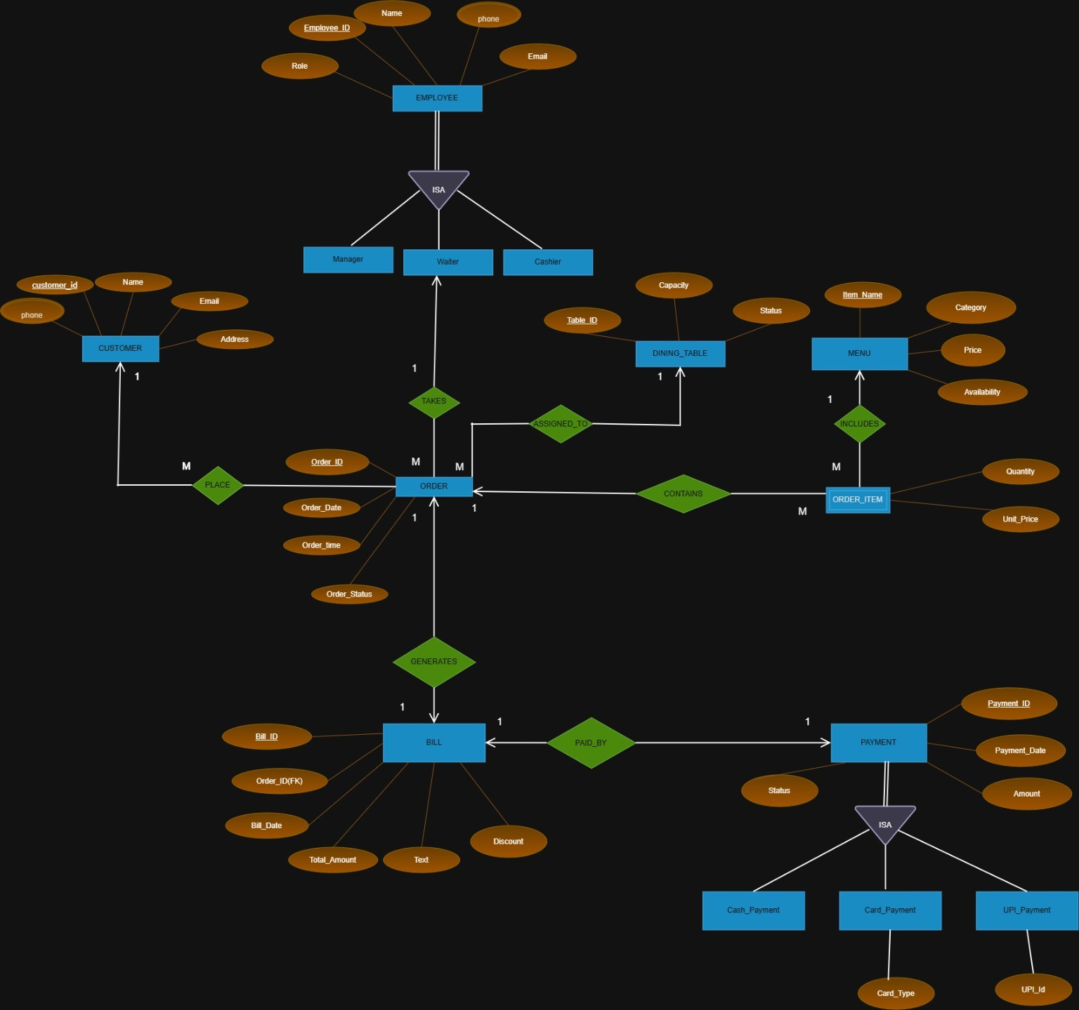
Figure 1: ER Diagram of Restaurant Management System

5. RELATIONAL SCHEMA
Relation | Relational Schema
CUSTOMER | Customer_ID (PK), Name, Phone, Email, Address
EMPLOYEE | Employee_ID (PK), Name, Phone, Email, Role
DINING_TABLE | Table_ID (PK), Capacity, Status
MENU | Item_ID (PK), Item_Name, Category, Price, Availability
ORDERS | Order_ID (PK), Customer_ID (FK), Employee_ID (FK), Table_ID (FK), Order_Date, Order_Time, Order_Status
ORDER_ITEM | Order_ID (PK, FK), Item_ID (PK, FK), Quantity, Unit_Price
BILL | Bill_ID (PK), Order_ID (FK, UNIQUE), Bill_Date, Total_Amount, Discount
PAYMENT | Payment_ID (PK), Bill_ID (FK, UNIQUE), Payment_Date, Amount, Status, Payment_Type

The relational schema represents the implemented restaurant database. Orders reference customers, employees, and dining tables. ORDER_ITEM resolves the many-to-many relationship between Orders and Menu using ORDER_ITEM_ID as a simple primary key. Bill references Orders, while Payment references Bill.

6. TABLE DESIGN

6.1 Customer Table
Attribute | Data Type | Constraint | Description
Customer_ID | INT | PK | Unique customer identifier
Name | VARCHAR(50) | NOT NULL | Customer name
Phone | VARCHAR(15) | UNIQUE, NOT NULL | Customer contact number
Email | VARCHAR(50) | UNIQUE, NOT NULL | Customer email address
Address | VARCHAR(100) | NOT NULL | Customer address

6.2 Employee Table
Attribute | Data Type | Constraint | Description
Employee_ID | INT | PK | Unique employee identifier
Name | VARCHAR(50) | NOT NULL | Employee name
Phone | VARCHAR(15) | UNIQUE, NOT NULL | Employee phone number
Email | VARCHAR(50) | UNIQUE, NOT NULL | Employee email
Role | VARCHAR(30) | NOT NULL | Employee role such as manager, waiter, or cashier

6.3 Dining Table
Attribute | Data Type | Constraint | Description
Table_ID | INT | PK | Unique dining-table identifier
Capacity | INT | NOT NULL | Maximum number of customers
Status | VARCHAR(20) | NOT NULL | Current table status

6.4 Menu Table
Attribute | Data Type | Constraint | Description
Item_ID | INT | PK | Unique menu-item identifier
Item_Name | VARCHAR(50) | NOT NULL | Name of food or beverage item
Category | VARCHAR(30) | NOT NULL | Menu category
Price | DECIMAL(10,2) | NOT NULL | Price of the menu item
Availability | VARCHAR(20) | NOT NULL | Availability status

6.5 Orders Table
Attribute | Data Type | Constraint | Description
Order_ID | INT | PK | Unique order identifier
Customer_ID | INT | NOT NULL, FK | References Customer
Employee_ID | INT | NOT NULL, FK | References Employee
Table_ID | INT | NOT NULL, FK | References Dining Table
Order_Date | DATE | NOT NULL | Date of order
Order_Time | TIME | NOT NULL | Time of order
Order_Status | VARCHAR(20) | NOT NULL | Current order status

6.6 Order Item Table
Attribute | Data Type | Constraint | Description
Order_Item_ID | INT | PK | Unique order-item identifier
Order_ID | INT | NOT NULL, FK | References Orders
Item_ID | INT | NOT NULL, FK | References Menu
Quantity | INT | NOT NULL | Number of units ordered
Unit_Price | DECIMAL(10,2) | NOT NULL | Price per item at the time of order

6.7 Bill Table
Attribute | Data Type | Constraint | Description
Bill_ID | INT | PK | Unique bill identifier
Order_ID | INT | UNIQUE, NOT NULL, FK | References Orders
Bill_Date | DATE | NOT NULL | Date on which bill is generated
Total_Amount | DECIMAL(10,2) | NOT NULL | Total bill amount
Discount | DECIMAL(10,2) | DEFAULT 0 | Discount applied to the bill

6.8 Payment Table
Attribute | Data Type | Constraint | Description
Payment_ID | INT | PK | Unique payment identifier
Bill_ID | INT | UNIQUE, NOT NULL, FK | References Bill
Payment_Date | DATE | NOT NULL | Payment date
Amount | DECIMAL(10,2) | NOT NULL | Amount paid
Status | VARCHAR(20) | NOT NULL | Payment status
Payment_Type | VARCHAR(20) | NOT NULL | Payment method such as cash, card, or UPI

6.9 Keys and Constraints
Constraint Type | Applied To / Purpose
Primary Key | Customer_ID, Employee_ID, Table_ID, Item_ID, Order_ID, Order_Item_ID, Bill_ID, Payment_ID
Foreign Key | Orders.Customer_ID → Customer.Customer_ID; Orders.Employee_ID → Employee.Employee_ID; Orders.Table_ID → Dining_Table.Table_ID.
Foreign Key | Order_Item.Order_ID → Orders.Order_ID; Order_Item.Item_ID → Menu.Item_ID.
Foreign Key | Bill.Order_ID → Orders.Order_ID; Payment.Bill_ID → Bill.Bill_ID.
NOT NULL | Required identifiers, names, contact details, transaction dates, and transaction values.
UNIQUE | Customer phone/email, Employee phone/email, Bill.Order_ID, and Payment.Bill_ID.
DEFAULT | Bill.Discount has a default value of 0.

6.10 Sample Data Records
Table | Identifier | Main Data | Value / Date | Additional
CUSTOMER | 1 | ravi | 9876543210 | tirupati
EMPLOYEE | 101 | suresh | 9000000001 | manager
DINING_TABLE | 1 | 2 | available | —
MENU | 101 | chicken biryani | biryani | 250
ORDERS | 501 | customer 1 / employee 102 / table 2 | 2026-09-20 | completed
ORDER_ITEM | 501 / 101 | 2 | 250 | —
BILL | 1001 | order 501 | 500 | 20
PAYMENT | 2001 | bill 1001 | 480 | upi

6.11 Normalization Overview

7. NORMALIZATION
Normalization organizes the restaurant data into related relations to reduce unnecessary repetition and improve data consistency. Our normalization is presented from 1NF to 3NF using the Restaurant Management System data.

7.1 Unnormalized Form (UNF)
Before normalization, customer, employee, dining-table, order, and menu-item information can be kept together in one record. If an order contains multiple items, repeating item groups can occur. This causes repeated data and makes updates difficult.

7.2 First Normal Form (1NF)
In 1NF, every field contains a single atomic value and repeating groups are removed. We represent each order item as a separate row. We use Record_ID as a simple primary key.
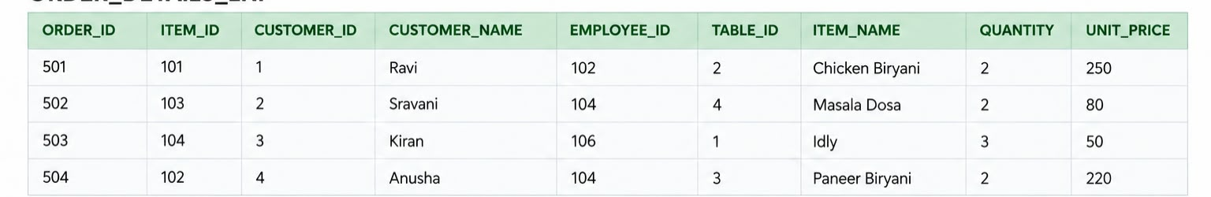

7.3 Second Normal Form (2NF)
For our project presentation, the 1NF data is divided into exactly two relations. ORDERS_2NF stores order, customer, employee, and table information. ORDER_ITEM_2NF stores the individual menu item information for each order. Both relations use simple single-column primary keys. 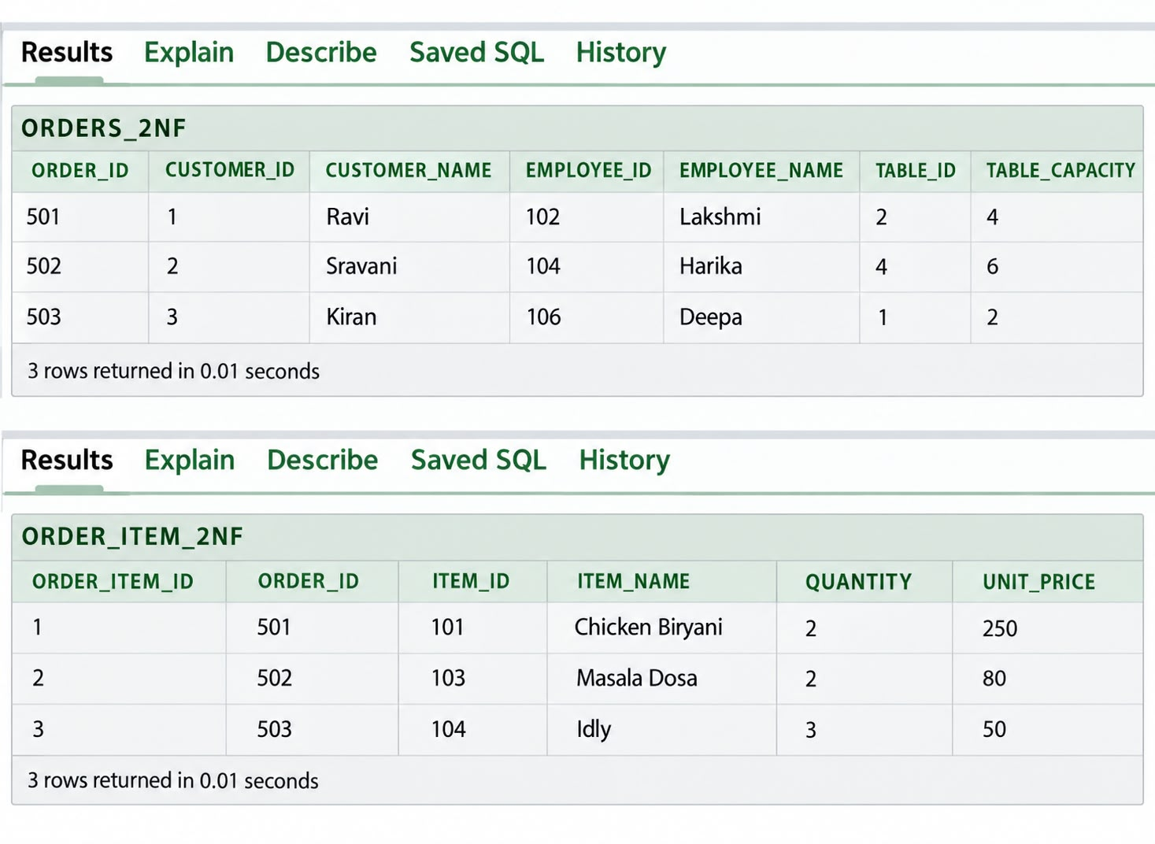

7.4 Third Normal Form (3NF)
In 3NF, non-key information that belongs to a different entity is separated into its own relation. From the two 2NF relations, we separate Customer, Employee, Dining Table, and Menu details from transaction data. The final 3NF relations are CUSTOMER, EMPLOYEE, DINING_TABLE, MENU, ORDERS, ORDER_ITEM, BILL, and PAYMENT. ORDER_ITEM uses ORDER_ITEM_ID as its simple primary key.
Relation | Reason for Separation
Customer | Stores customer-specific attributes once.
Employee | Stores employee-specific attributes and role.
Dining Table | Stores table capacity and status.
Menu | Stores menu-item details, category, price, and availability.
Orders | Stores order-specific information and references customer, employee, and table.
Order Item | Stores the relationship between orders and menu items; ORDER_ITEM_ID is the simple primary key.
Bill | Stores billing information associated with an order.
Payment | Stores payment information associated with a bill.

8. SQL IMPLEMENTATION

8.1 DDL – Data Definition Language
Customer
CREATE TABLE customer (
customer_id INT PRIMARY KEY,
name VARCHAR(50) NOT NULL,
phone VARCHAR(15) UNIQUE NOT NULL,
email VARCHAR(50) UNIQUE NOT NULL,
address VARCHAR(100) NOT NULL
);
Employee
CREATE TABLE employee (
employee_id INT PRIMARY KEY,
name VARCHAR(50) NOT NULL,
phone VARCHAR(15) UNIQUE NOT NULL,
email VARCHAR(50) UNIQUE NOT NULL,
role VARCHAR(30) NOT NULL
);
Dining Table
CREATE TABLE dining_table (
table_id INT PRIMARY KEY,
capacity INT NOT NULL,
status VARCHAR(20) NOT NULL
);
Menu
CREATE TABLE menu (
item_id INT PRIMARY KEY,
item_name VARCHAR(50) NOT NULL,
category VARCHAR(30) NOT NULL,
price DECIMAL(10,2) NOT NULL,
availability VARCHAR(20) NOT NULL
);
Orders
CREATE TABLE orders (
order_id INT PRIMARY KEY,
customer_id INT NOT NULL,
employee_id INT NOT NULL,
table_id INT NOT NULL,
order_date DATE NOT NULL,
order_time TIME NOT NULL,
order_status VARCHAR(20) NOT NULL,
FOREIGN KEY (customer_id) REFERENCES customer(customer_id),
FOREIGN KEY (employee_id) REFERENCES employee(employee_id),
FOREIGN KEY (table_id) REFERENCES dining_table(table_id)
);
Order Item
CREATE TABLE order_item (
order_item_id INT PRIMARY KEY,
order_id INT NOT NULL,
item_id INT NOT NULL,
quantity INT NOT NULL,
unit_price NUMBER(10,2) NOT NULL,
FOREIGN KEY (order_id) REFERENCES orders(order_id),
FOREIGN KEY (item_id) REFERENCES menu(item_id)
);
Bill
CREATE TABLE bill (
bill_id INT PRIMARY KEY,
order_id INT UNIQUE NOT NULL,
bill_date DATE NOT NULL,
total_amount DECIMAL(10,2) NOT NULL,
discount DECIMAL(10,2) DEFAULT 0,
FOREIGN KEY (order_id) REFERENCES orders(order_id)
);
Payment
CREATE TABLE payment (
payment_id INT PRIMARY KEY,
bill_id INT UNIQUE NOT NULL,
payment_date DATE NOT NULL,
amount DECIMAL(10,2) NOT NULL,
status VARCHAR(20) NOT NULL,
payment_type VARCHAR(20) NOT NULL,
FOREIGN KEY (bill_id) REFERENCES bill(bill_id)
);

8.2 DML – Data Manipulation Language
The following examples demonstrate insertion of records into the restaurant database. The complete project dataset contains 15 records in each table.
INSERT INTO customer
VALUES (1, 'ravi', '9876543210', 'ravi@gmail.com', 'tirupati');
INSERT INTO employee
VALUES (101, 'suresh', '9000000001', 'suresh@gmail.com', 'manager');
INSERT INTO dining_table
VALUES (1, 2, 'available');
INSERT INTO menu
VALUES (101, 'chicken biryani', 'biryani', 250, 'yes');
INSERT INTO orders
VALUES (501, 1, 102, 2, '2026-09-20', '13:00:00', 'completed');
INSERT INTO order_item
VALUES (1, 501, 101, 2, 250);
INSERT INTO bill
VALUES (1001, 501, '2026-09-20', 500, 20);
INSERT INTO payment
VALUES (2001, 1001, '2026-09-20', 480, 'paid', 'upi');

8.3 DQL – Data Query Language
SELECT * FROM customer;
SELECT customer_id, name, phone
FROM customer
WHERE address = 'hyderabad';
SELECT item_name, price
FROM menu
WHERE price > 150;
SELECT o.order_id, c.name AS customer_name
FROM orders o
JOIN customer c ON o.customer_id = c.customer_id;

9. SQL QUERIES & SCREENSHOTS
Note: The output panels below are Oracle Database Express Edition-style representations of the expected results produced from the project dataset.
The following query set is prepared to provide a 30-query SQL section for the Restaurant Management System. The examples cover selection, filtering, joins, aggregation, grouping, subqueries, sorting, and reporting. Exact outputs depend on the records inserted in the final project database.

Q1. Display all customers
Purpose: Displays all customer records.
SELECT * FROM customer;
Output:
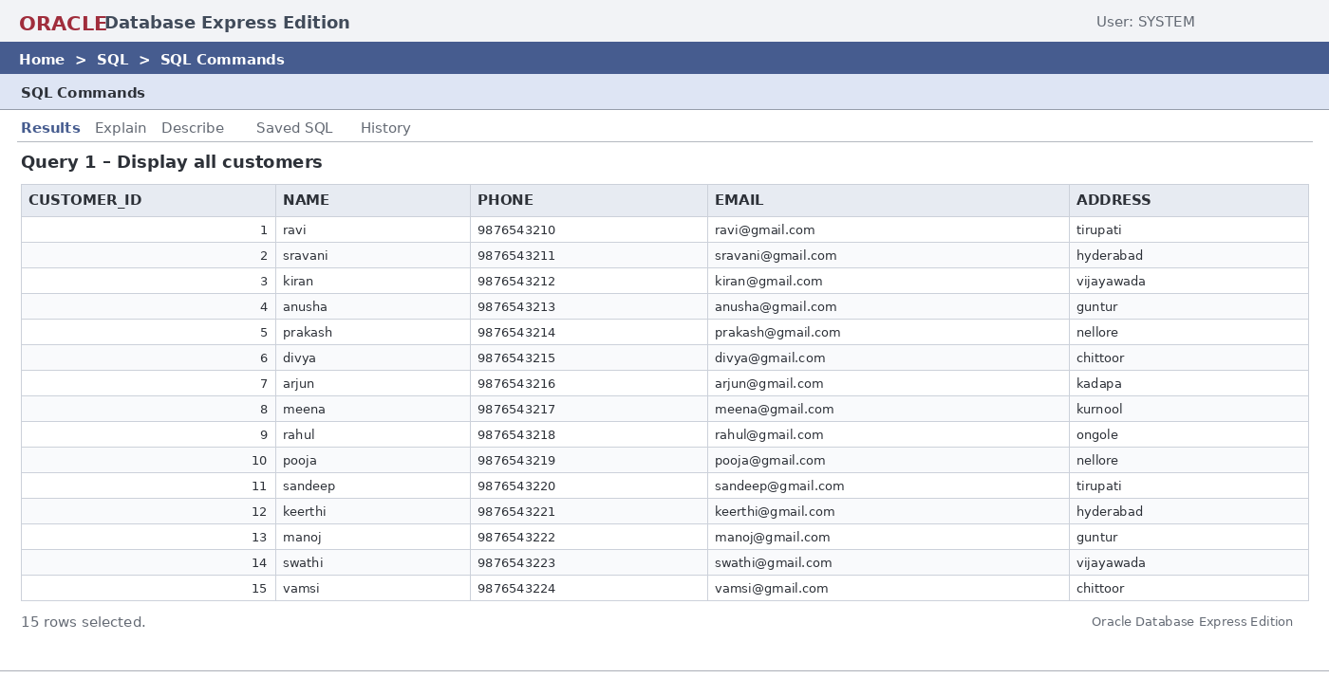

Q2. Display customers from Hyderabad
Purpose: Displays customers whose address is Hyderabad.
SELECT customer_id, name, phone
FROM customer
WHERE address = 'hyderabad';
Output:
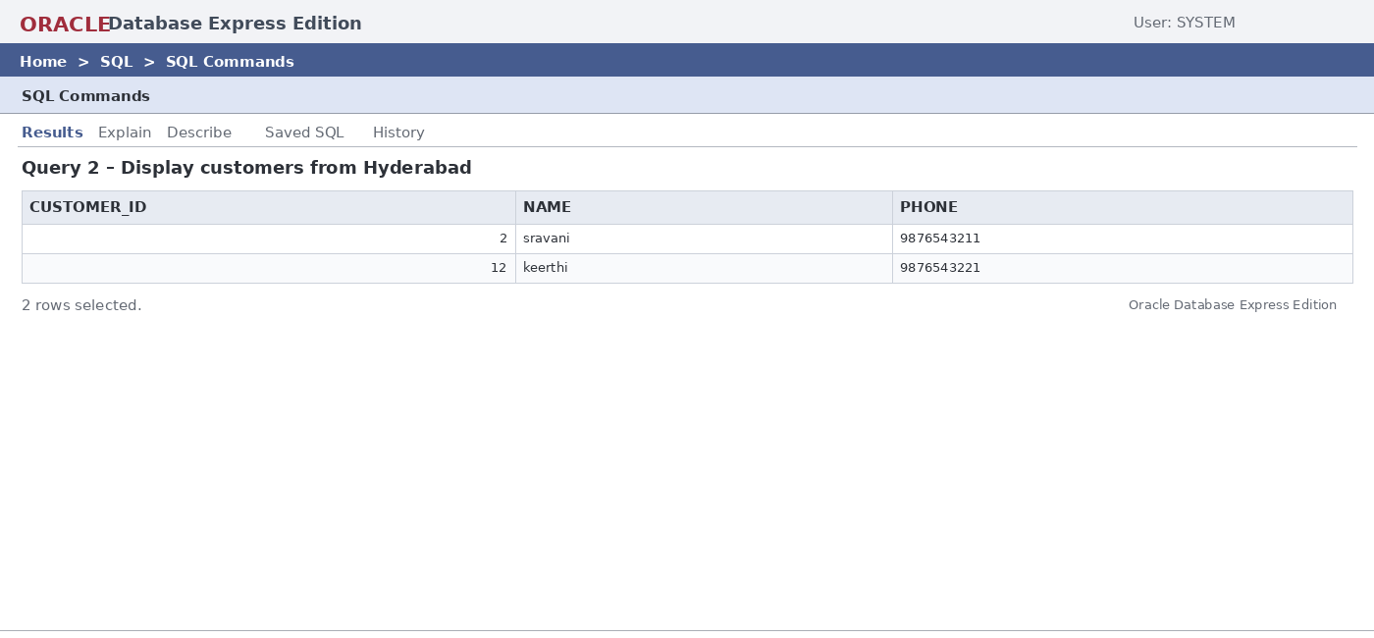

Q3. Display menu items with price greater than 150
Purpose: Filters menu items by price.
SELECT item_name, price
FROM menu
WHERE price > 150;
Output:
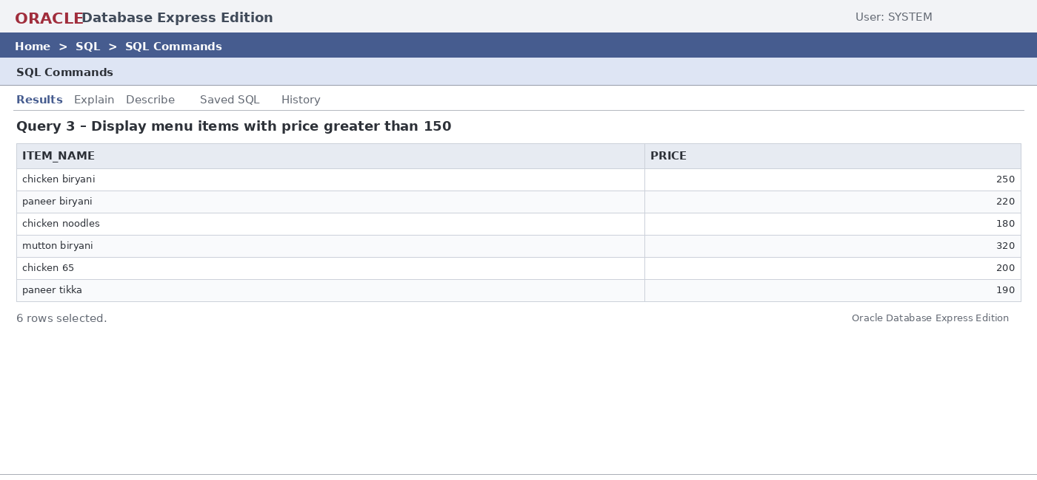

Q4. Display available dining tables
Purpose: Displays currently available tables.
SELECT table_id, capacity
FROM dining_table
WHERE status = 'available';
Output:
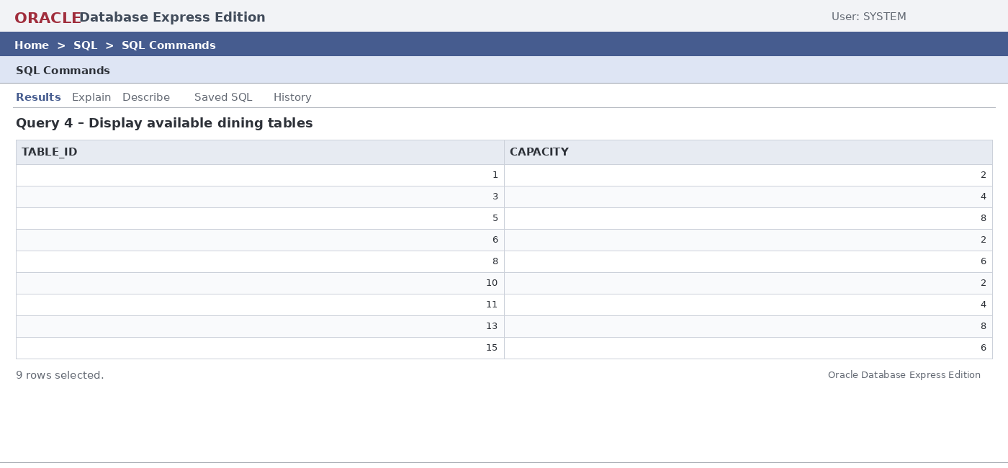

Q5. Display completed orders
Purpose: Displays completed restaurant orders.
SELECT order_id, customer_id, order_date
FROM orders
WHERE order_status = 'completed';
Output:
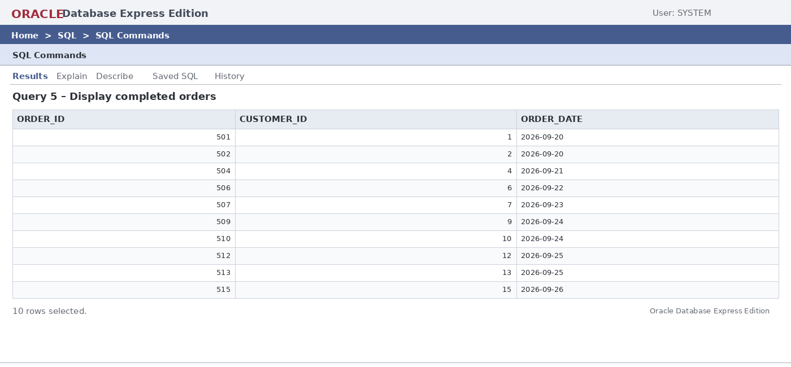

Q6. Find the highest menu price
Purpose: Finds the maximum menu price.
SELECT MAX(price) AS highest_price
FROM menu;
Output:
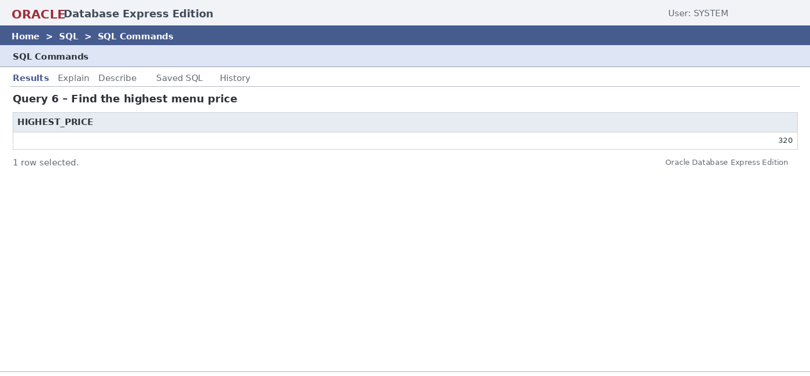

Q7. Count total customers
Purpose: Counts all customers.
SELECT COUNT(*) AS total_customers
FROM customer;
Output:
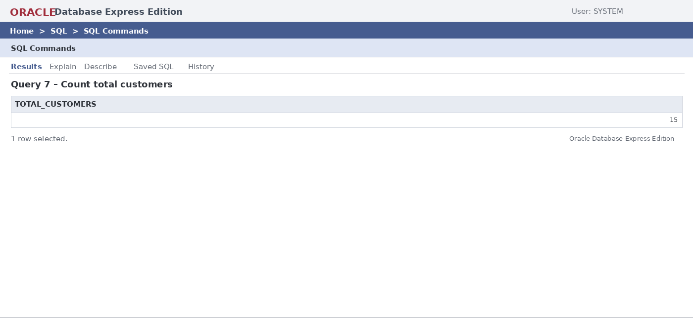

Q8. Customer-wise order details
Purpose: Combines orders with customer names.
SELECT
o.order_id,
c.name AS customer_name,
o.order_date,
o.order_status
FROM orders o
JOIN customer c
ON o.customer_id = c.customer_id
ORDER BY o.order_id;
Output:
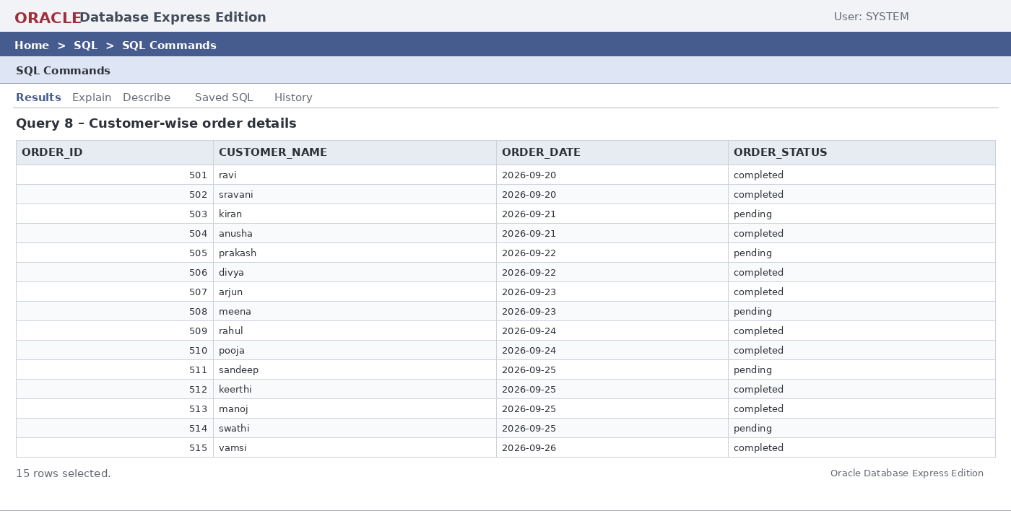

Q9. Order items with menu details
Purpose: Displays item details and calculates item totals.
SELECT
oi.order_id,
m.item_name,
oi.quantity,
oi.unit_price,
oi.quantity * oi.unit_price AS item_total
FROM order_item oi
JOIN menu m
ON oi.item_id = m.item_id;
Output:
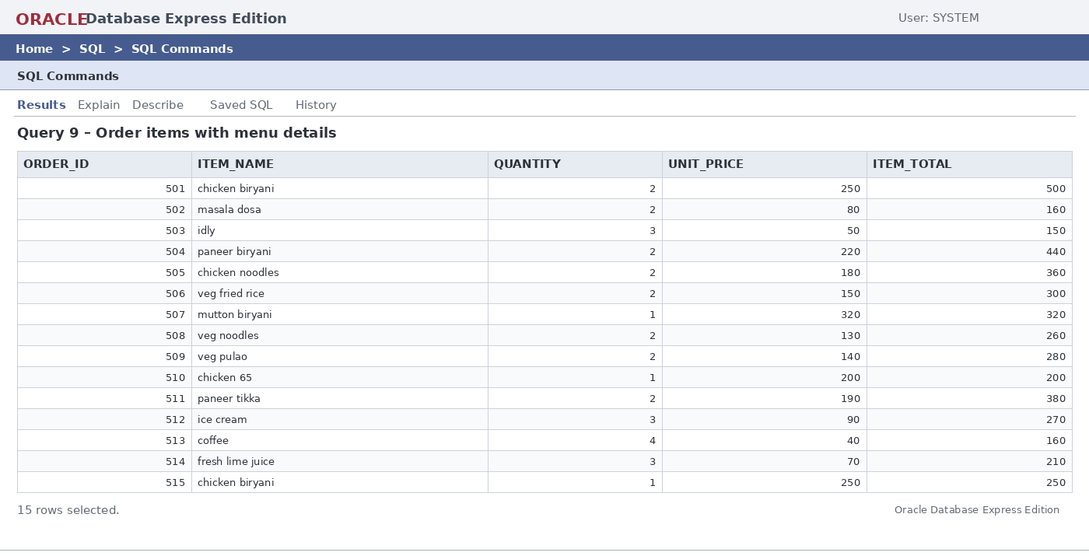

Q10. Total sales by payment type
Purpose: Groups payments by cash, card, and UPI.
SELECT
payment_type,
COUNT(*) AS number_of_payments,
SUM(amount) AS total_amount
FROM payment
GROUP BY payment_type;
Output:
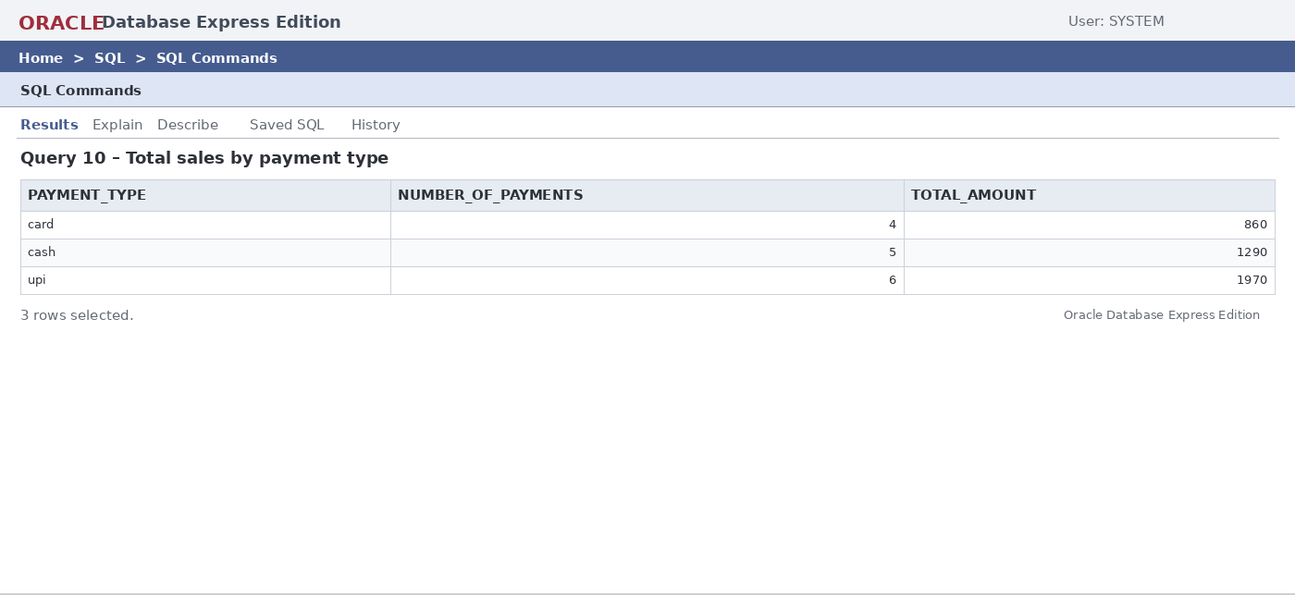

Q11. Number of orders handled by each employee
Purpose: Counts orders handled by employees.
SELECT
e.employee_id,
e.name,
e.role,
COUNT(o.order_id) AS total_orders
FROM employee e
JOIN orders o
ON e.employee_id = o.employee_id
GROUP BY e.employee_id, e.name, e.role
ORDER BY total_orders DESC;
Output:
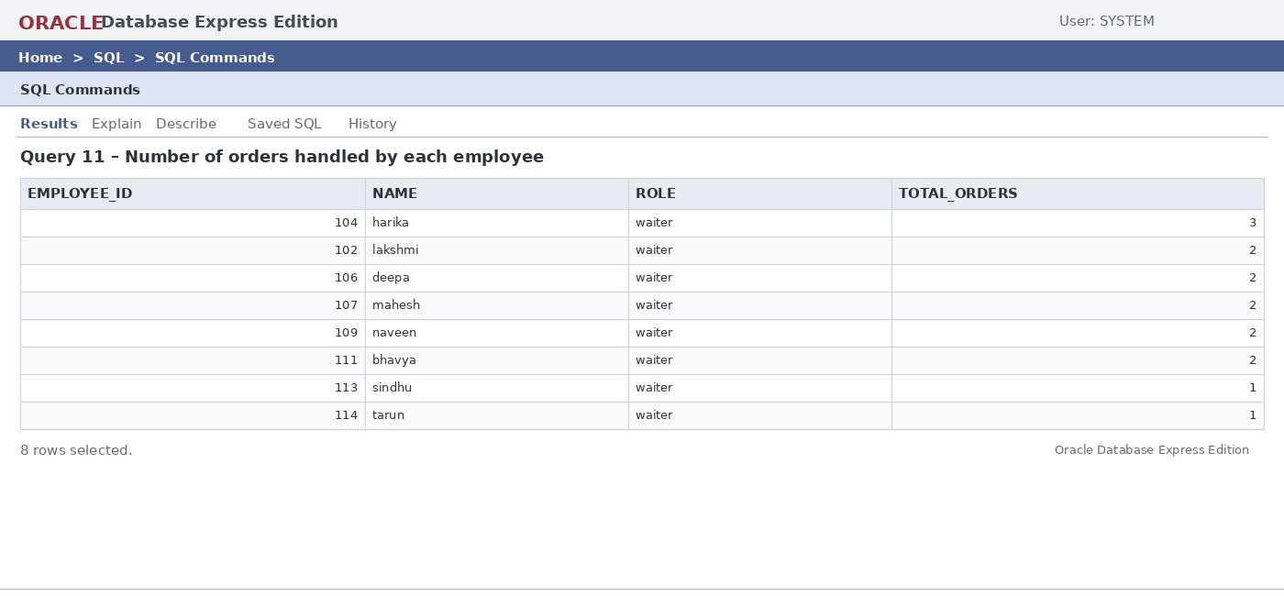

Q12. Categories having average price above 150
Purpose: Finds menu categories whose average price exceeds 150.
SELECT
category,
AVG(price) AS average_price
FROM menu
GROUP BY category
HAVING AVG(price) > 150;
Output:
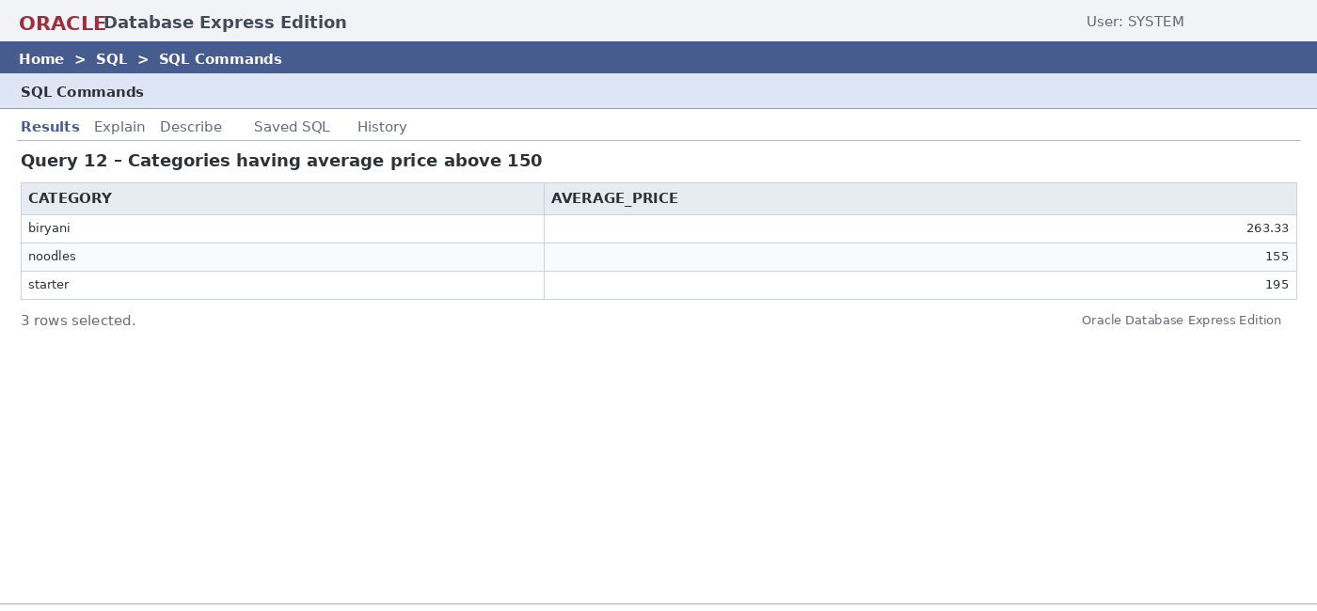

Q13. Customers whose bill amount is greater than 300
Purpose: Displays bills above 300.
SELECT
c.name AS customer_name,
b.bill_id,
b.total_amount
FROM customer c
JOIN orders o ON c.customer_id = o.customer_id
JOIN bill b ON o.order_id = b.order_id
WHERE b.total_amount > 300
ORDER BY b.total_amount DESC;
Output:
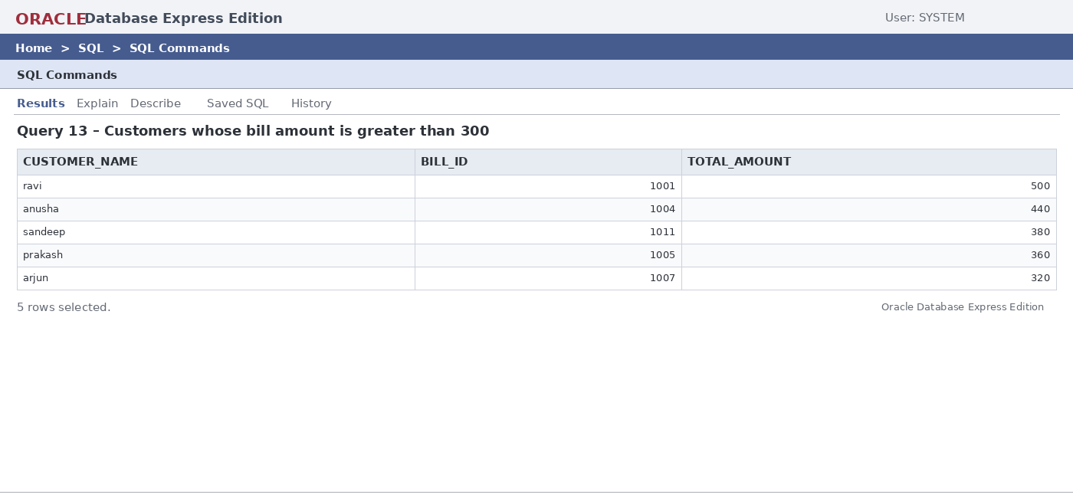

Q14. Find the most expensive menu item
Purpose: Uses a subquery to find the most expensive item.
SELECT item_name, price
FROM menu
WHERE price = (
SELECT MAX(price)
FROM menu
);
Output:
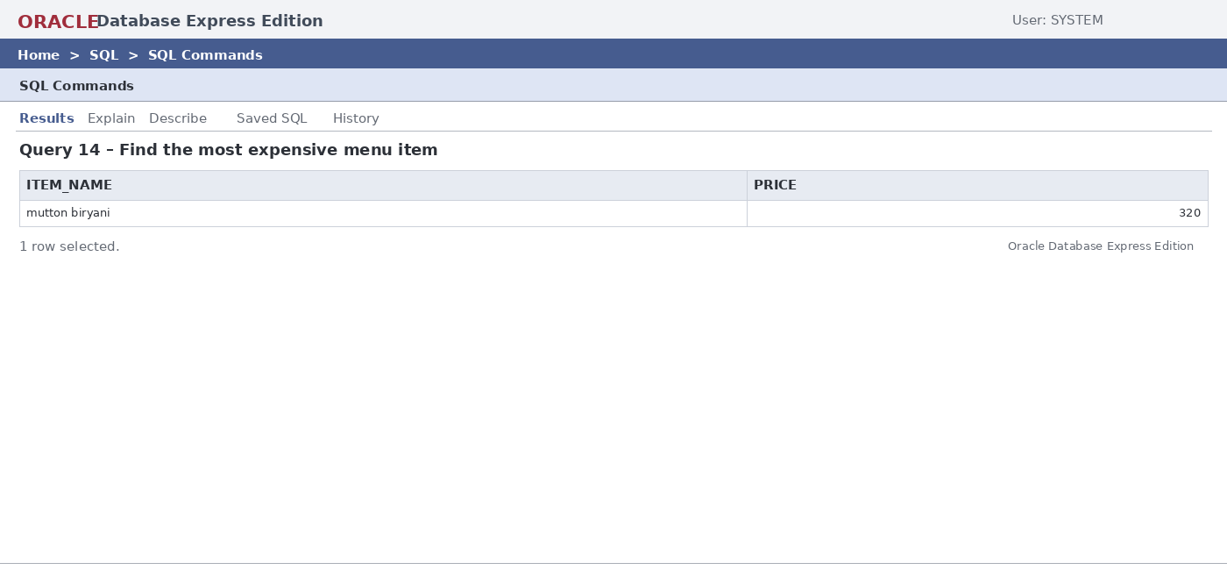

Q15. Complete order, bill and payment details
Purpose: Combines order, customer, bill, and payment information.
SELECT
o.order_id,
c.name AS customer_name,
b.total_amount,
b.discount,
p.amount AS paid_amount,
p.payment_type,
p.status AS payment_status
FROM orders o
JOIN customer c ON o.customer_id = c.customer_id
JOIN bill b ON o.order_id = b.order_id
JOIN payment p ON b.bill_id = p.bill_id
ORDER BY o.order_id;
Output:
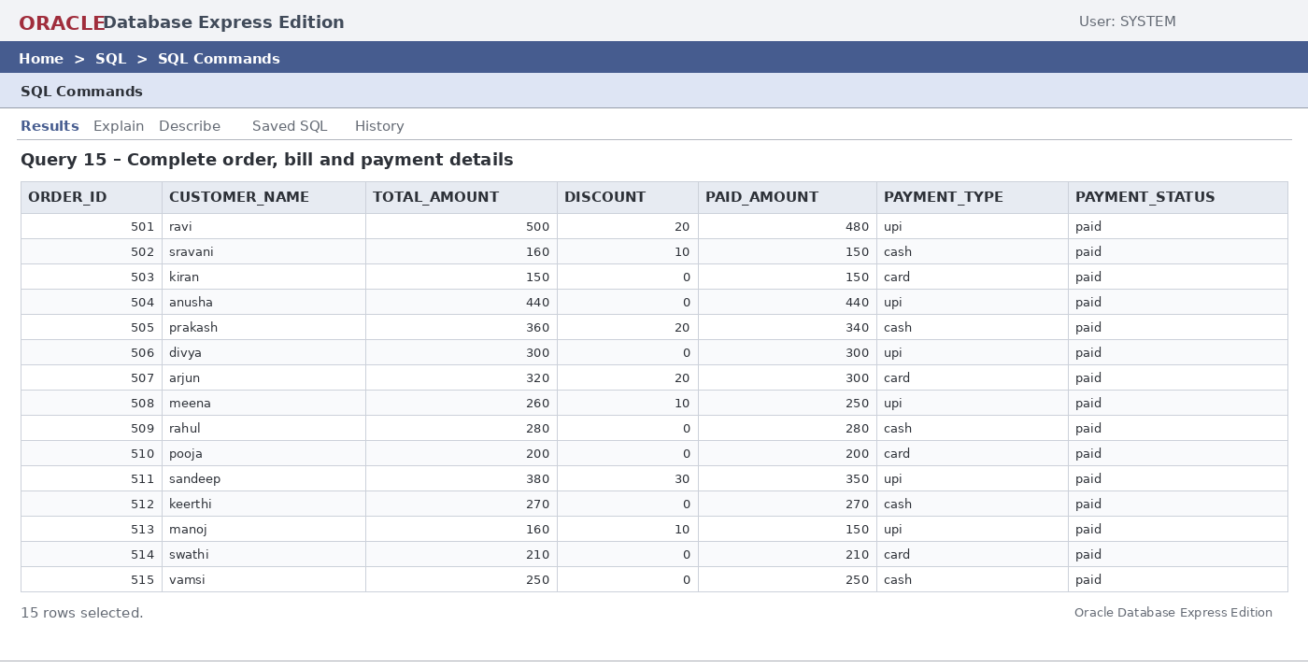

Q16. Count orders by status
Purpose: Counts pending and completed orders.
SELECT
order_status,
COUNT(*) AS total_orders
FROM orders
GROUP BY order_status;
Output:
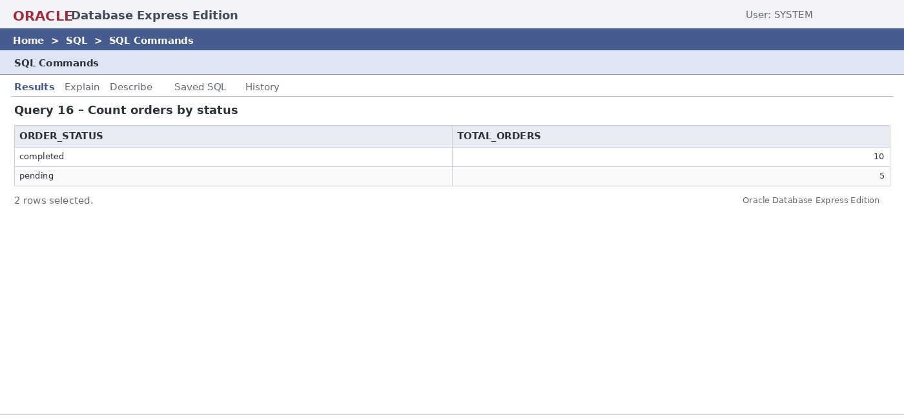

Q17. Average menu price by category
Purpose: Calculates average item price for each category.
SELECT
category,
AVG(price) AS average_price
FROM menu
GROUP BY category
ORDER BY average_price DESC;
Output:
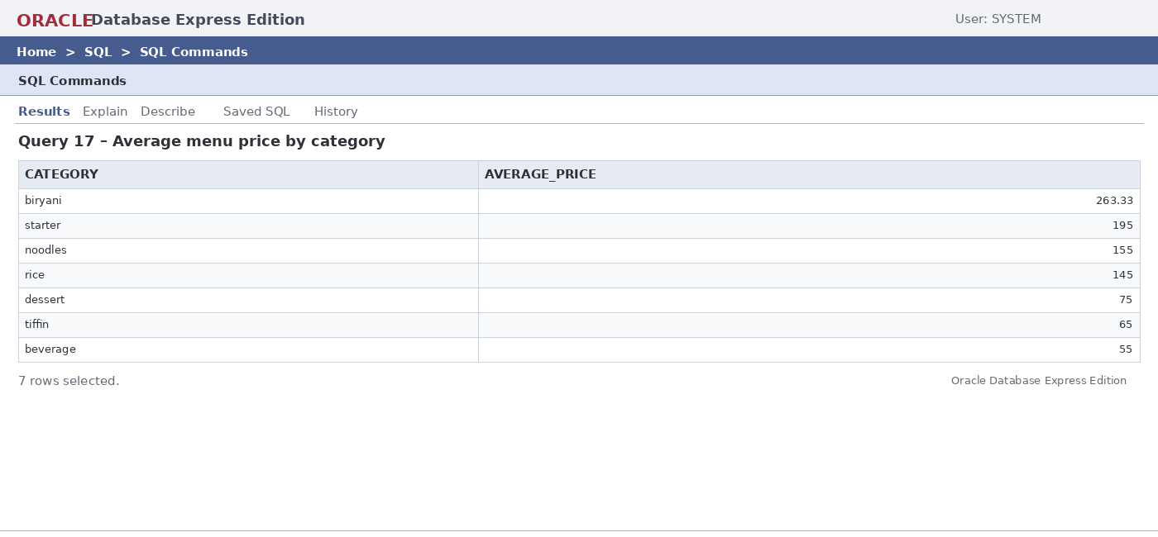

Q18. Total quantity ordered for each menu item
Purpose: Calculates total quantity sold for each menu item.
SELECT
m.item_name,
SUM(oi.quantity) AS total_quantity
FROM order_item oi
JOIN menu m ON oi.item_id = m.item_id
GROUP BY m.item_name
ORDER BY total_quantity DESC;
Output:
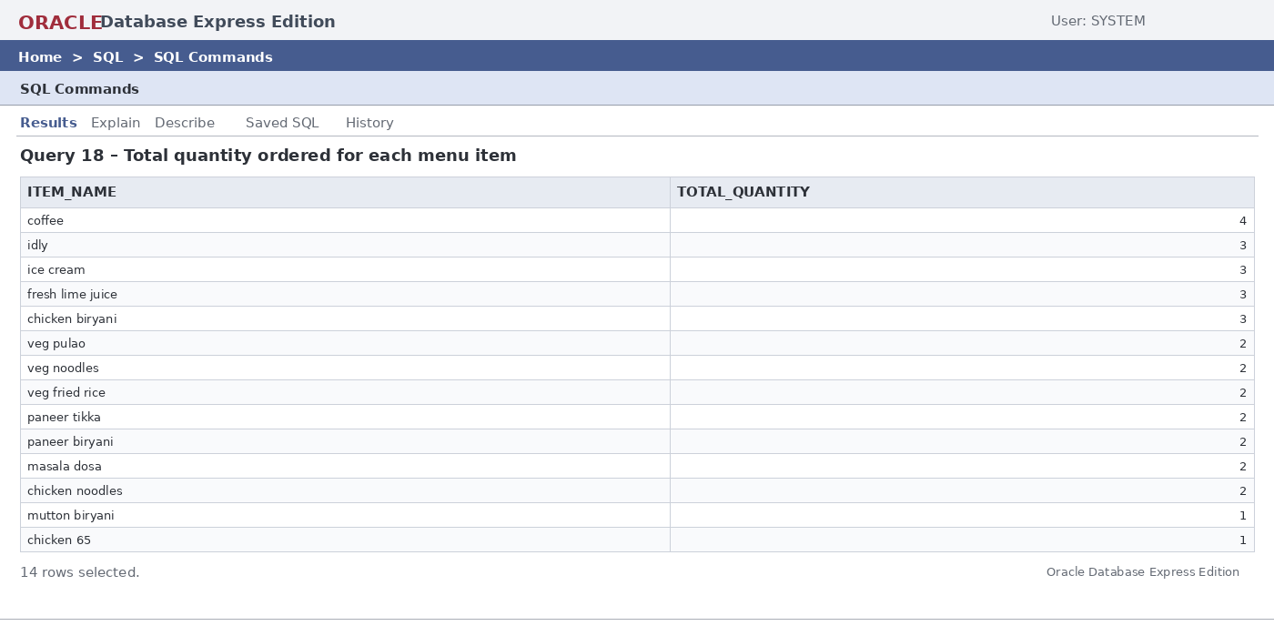

Q19. Most ordered menu item
Purpose: Identifies the menu item with the highest ordered quantity.
SELECT
m.item_name,
SUM(oi.quantity) AS total_quantity
FROM order_item oi
JOIN menu m ON oi.item_id = m.item_id
GROUP BY m.item_name
ORDER BY total_quantity DESC
LIMIT 1;
Output:
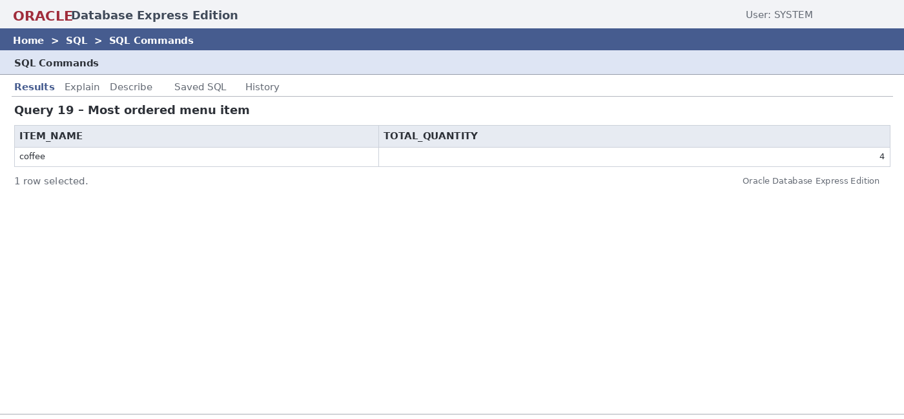

Q20. Total paid amount by customer
Purpose: Calculates total payment made by each customer.
SELECT
c.name AS customer_name,
SUM(p.amount) AS total_paid
FROM customer c
JOIN orders o ON c.customer_id = o.customer_id
JOIN bill b ON o.order_id = b.order_id
JOIN payment p ON b.bill_id = p.bill_id
GROUP BY c.customer_id, c.name
ORDER BY total_paid DESC;
Output:
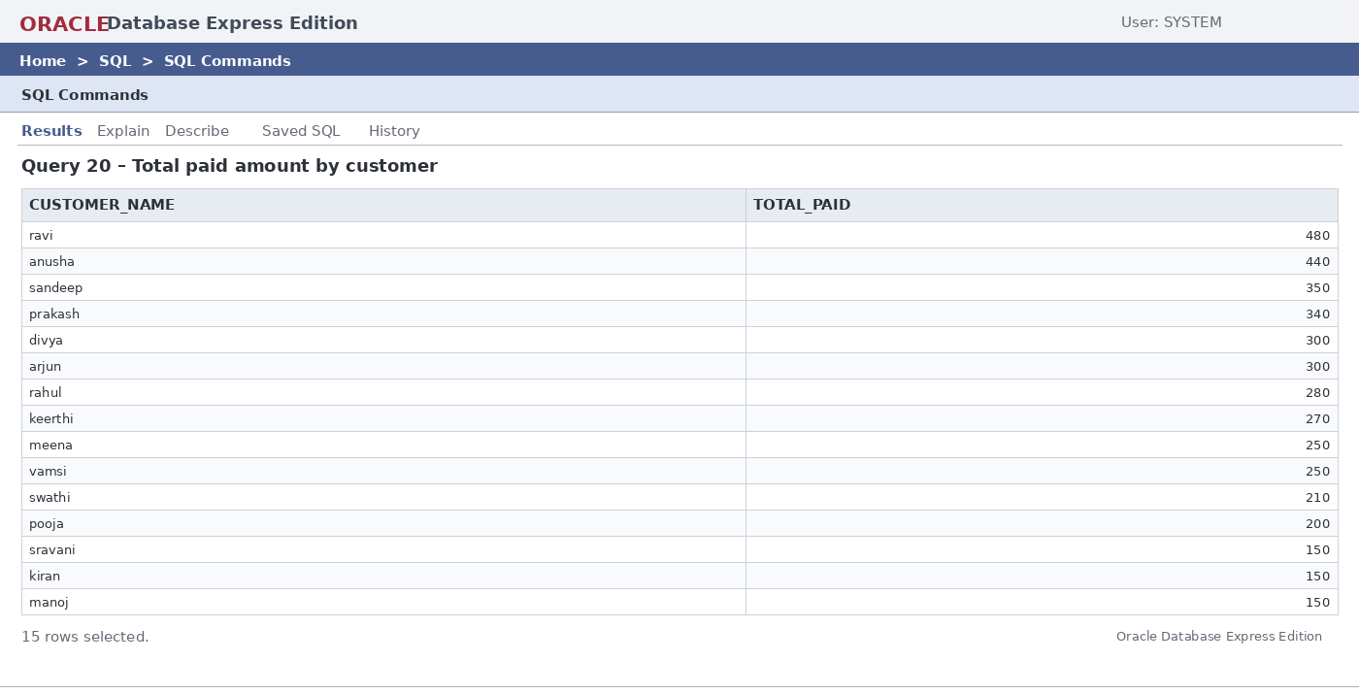

Q21. Display occupied dining tables
Purpose: Displays occupied restaurant tables.
SELECT
table_id,
capacity,
status
FROM dining_table
WHERE status = 'occupied';
Output:
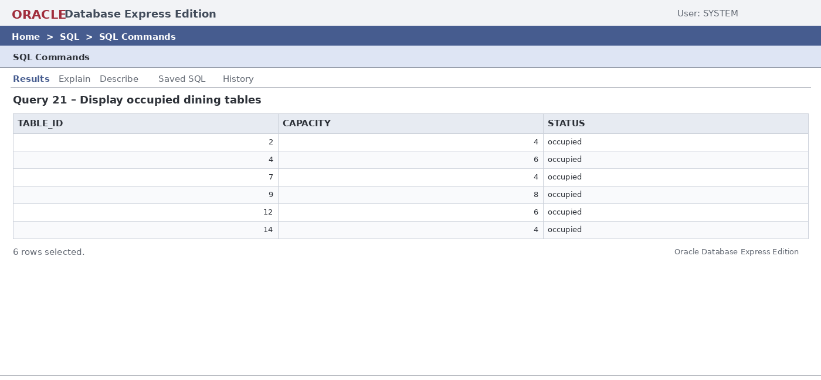

Q22. Display orders handled by waiters
Purpose: Displays orders handled by employees whose role is waiter.
SELECT
o.order_id,
e.name AS waiter_name,
o.order_date,
o.order_status
FROM orders o
JOIN employee e ON o.employee_id = e.employee_id
WHERE e.role = 'waiter';
Output:
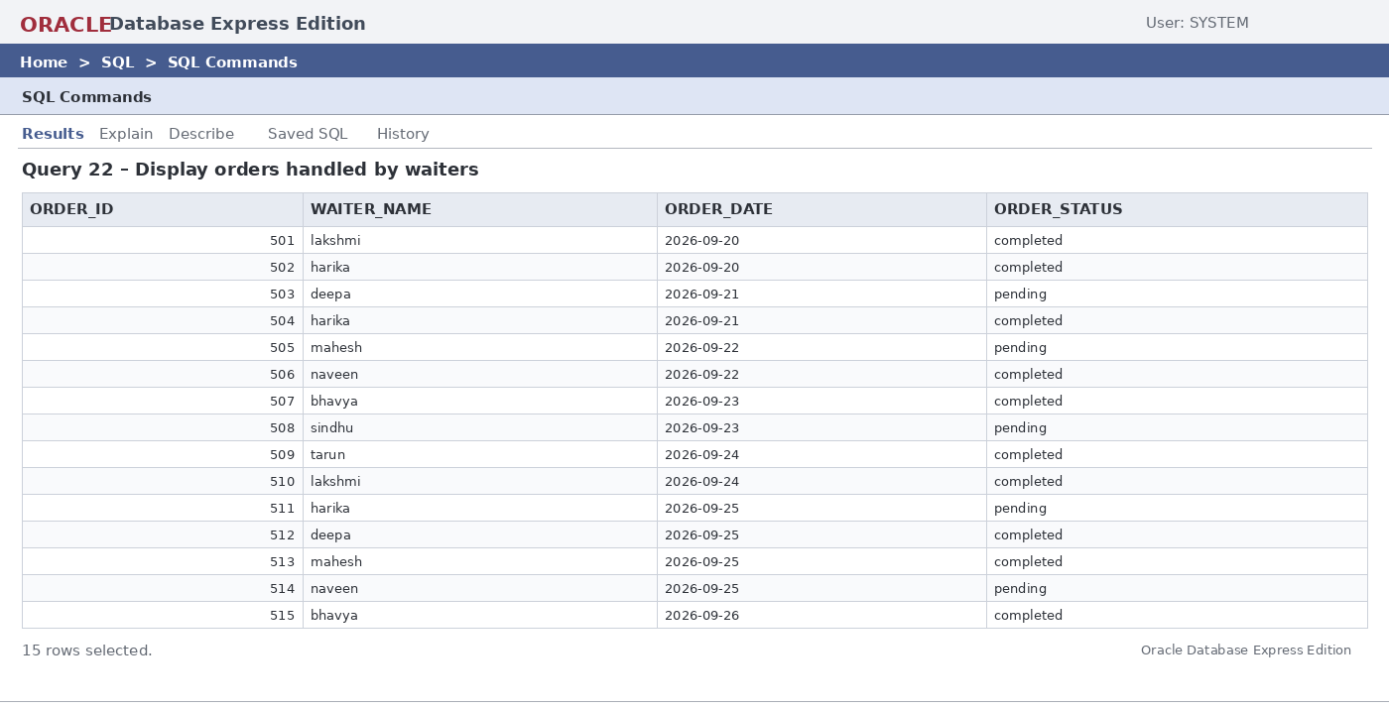

Q23. Average payment amount by payment type
Purpose: Calculates the average payment for each payment method.
SELECT
payment_type,
AVG(amount) AS average_payment
FROM payment
GROUP BY payment_type;
Output:
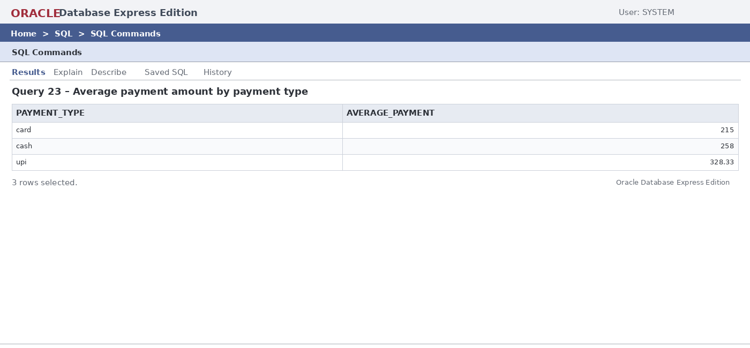

Q24. Bills where discount is greater than zero
Purpose: Displays bills on which a discount was applied.
SELECT
bill_id,
order_id,
total_amount,
discount
FROM bill
WHERE discount > 0;
Output:
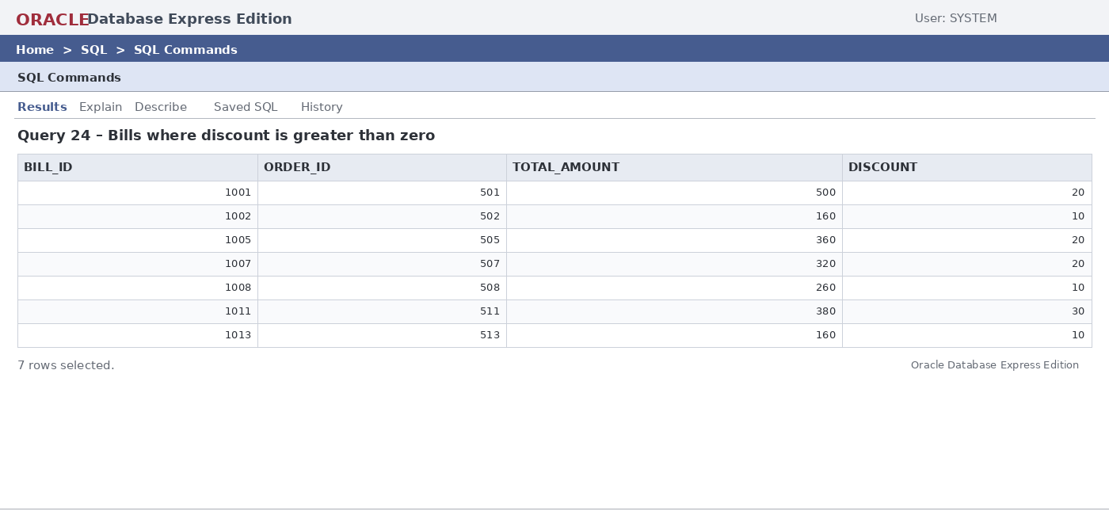

Q25. Display pending orders
Purpose: Displays orders that are still pending.
SELECT
order_id,
customer_id,
employee_id,
table_id,
order_date,
order_status
FROM orders
WHERE order_status = 'pending';
Output:
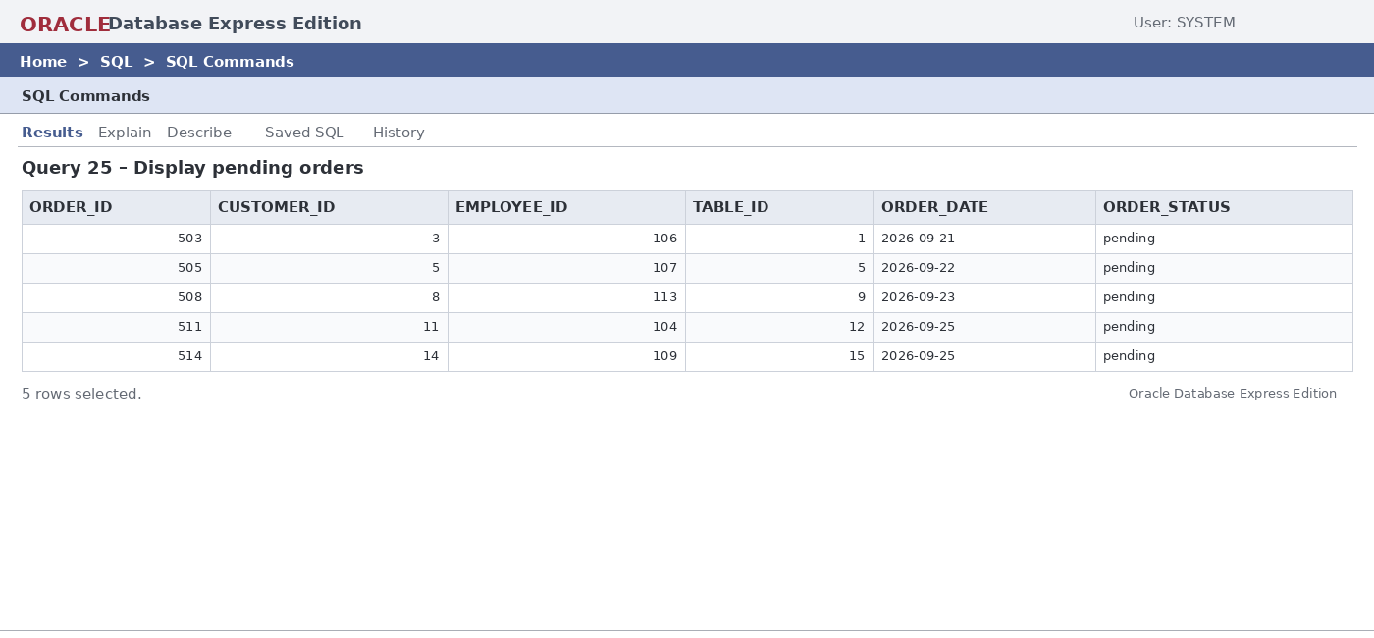

Q26. Count menu items by category
Purpose: Counts menu items in each category.
SELECT
category,
COUNT(*) AS item_count
FROM menu
GROUP BY category
ORDER BY item_count DESC;
Output:
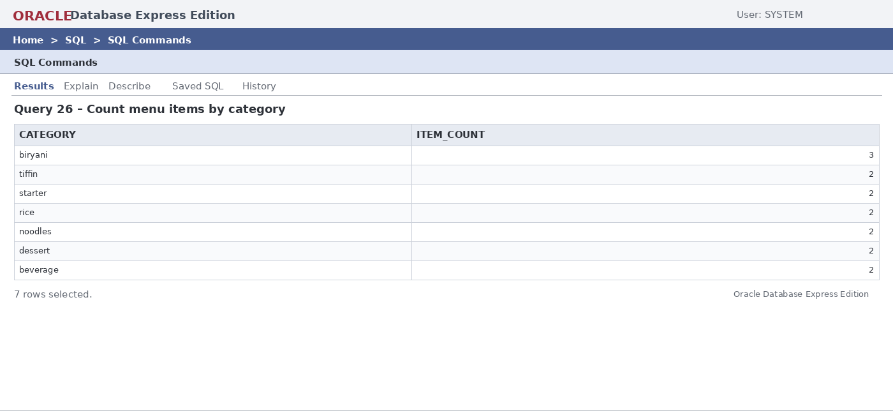

Q27. Count orders placed by each customer
Purpose: Counts the number of orders placed by each customer.
SELECT
c.customer_id,
c.name,
COUNT(o.order_id) AS total_orders
FROM customer c
JOIN orders o ON c.customer_id = o.customer_id
GROUP BY c.customer_id, c.name
ORDER BY total_orders DESC;
Output:
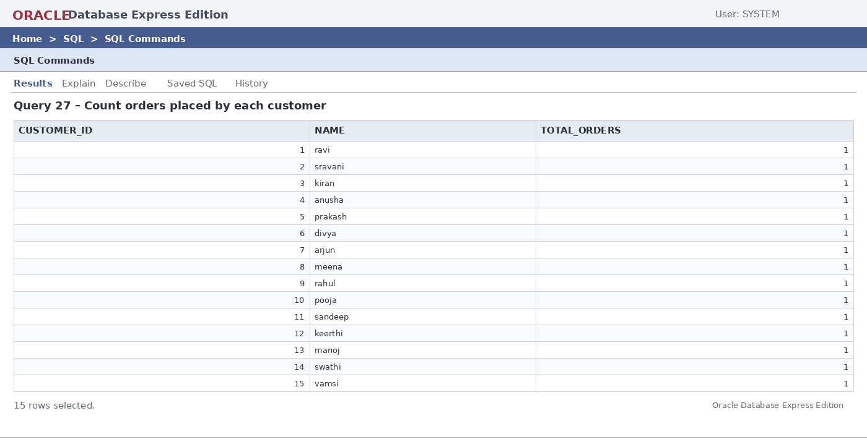

Q28. Display all paid payments above 300
Purpose: Displays paid transactions above 300.
SELECT
payment_id,
bill_id,
amount,
payment_type
FROM payment
WHERE status = 'paid'
AND amount > 300;
Output:
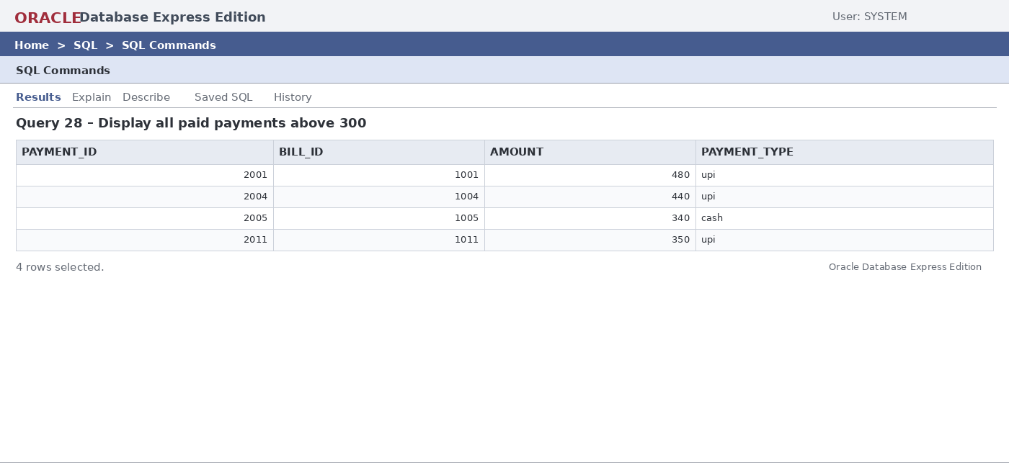

Q29. Available menu items priced between 100 and 250
Purpose: Filters available menu items within a price range.
SELECT
item_name,
category,
price
FROM menu
WHERE availability = 'yes'
AND price BETWEEN 100 AND 250
ORDER BY price DESC;
Output:
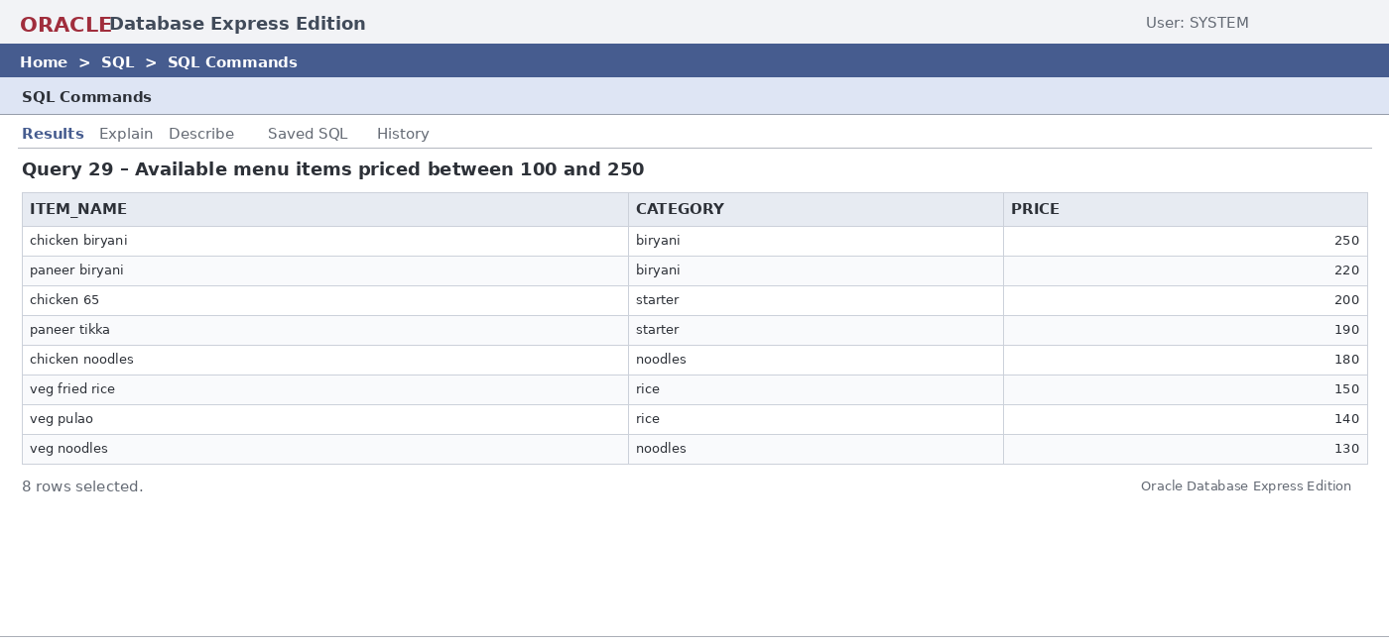

Q30. Customers with bills greater than 300
Purpose: Produces a customer billing report for bills above 300.
SELECT
c.name AS customer_name,
b.bill_id,
b.total_amount
FROM customer c
JOIN orders o ON c.customer_id = o.customer_id
JOIN bill b ON o.order_id = b.order_id
WHERE b.total_amount > 300
ORDER BY b.total_amount DESC;
Output:
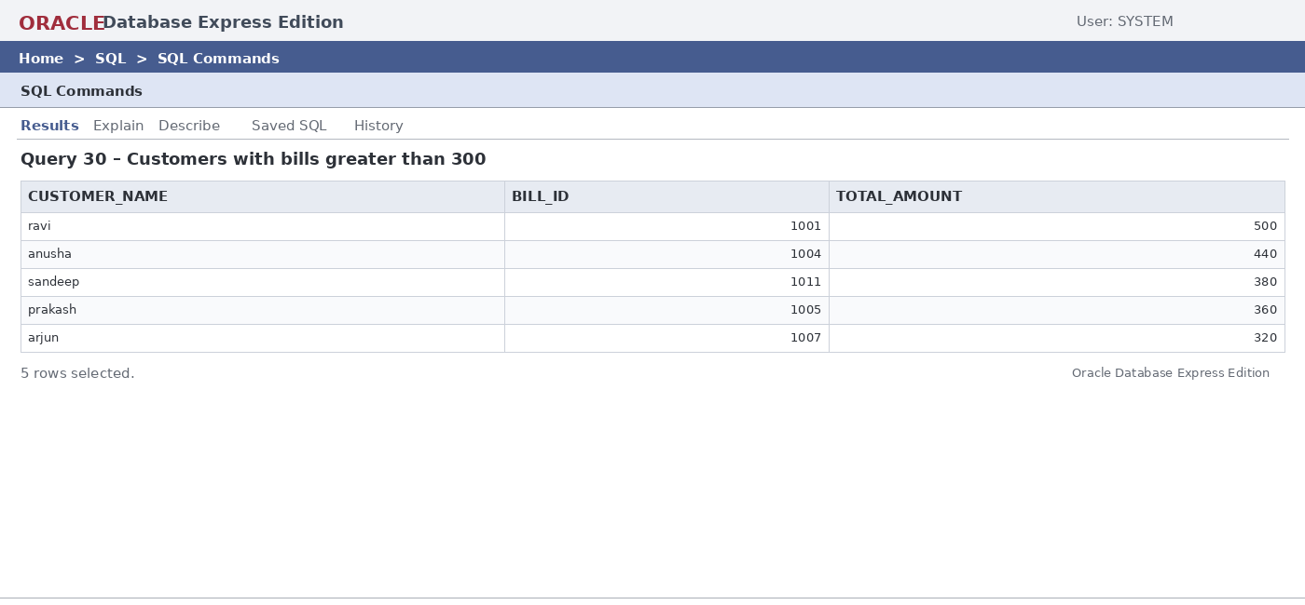

10. CONCLUSION
The Restaurant Management System provides a structured relational database solution for managing core restaurant operations. The design organizes customers, employees, dining tables, menu items, orders, order items, bills, and payments into related relations and applies primary keys, foreign keys, uniqueness rules, NOT NULL conditions, and default values to support data integrity.
The normalization process up to 3NF reduces unnecessary redundancy and helps avoid update anomalies. The SQL implementation and query set demonstrate database creation, data insertion, retrieval, joins, aggregation, grouping, subqueries, and restaurant reporting. The project therefore provides a suitable DBMS cornerstone implementation that can be extended into a complete restaurant management application.

11. FUTURE ENHANCEMENTS
- Online table reservation and booking management.
- Inventory and stock management.
- Supplier and purchase management.
- Kitchen order and food preparation tracking.
- Online food ordering and delivery management.
- Customer loyalty and membership management.
- Employee attendance and shift management.
- QR-code based digital menu and ordering.
- Automated sales dashboards and analytics.
- Role-based access control for administrators and staff.
- Backup, recovery, audit logging, and stronger database security.
- Web and mobile application integration.

12. REFERENCES
- Korth, H. F., Silberschatz, A., and Sudarshan, S., Database System Concepts, McGraw Hill.
- Elmasri, R. and Navathe, S. B., Fundamentals of Database Systems, Pearson.
- Restaurant Management System database schema and SQL implementation developed for the project.
- Entity Relationship Diagram prepared for the Restaurant Management System.

