 | Bill Payment System(144)  Technical Design Document
 | Prepared By / Last Updated By | Reviewed By | Approved By
Name | Akhil Surnedi
Role
Signature
Date | 21/12/2019

Table of Contents

1.0 Introduction 3
1.1 Purpose of this document 3
1.2 Project overview 3
2.0 Solution Summary 3
2.1 Scope 3
2.2 Assumptions 3
2.3 Dependencies 3
2.4 Risks 3
3.0 Schematic Diagram 3
4.0 System Design 4
4.1 Proposed design 4
4.2 Component inventory 4
5.0 Database Design 4
5.1 Data Model 4
5.2 Tables Structure 4
6.0 Appendices 4
6.1 Glossary 4
6.2 Other 5
7.0 Terms & Conditions 5
8.0 Change Log 5

Introduction

Purpose of this document
The purpose of this document is to document the technical design, component details and Database design. This will also capture the scope, assumptions, risk, dependencies of this project.

Project overview
Bill Payment System is a portal for the users to pay their bills online to its subscribed vendors using the payment gateways approved by the vendors for its own and an admin who manages the efficient working of the above.

Solution Summary

Scope
This scope of Bill Payment System is to allow the normal user to pay their bills to their specific vendors to which they have subscribed for, allowing the vendors to edit their details and also allowing them to report any issue they have to the admin. The admin can accept the registration form of the vendors allowing them to get officially register on this website and also allowing admin to reply to the issues reported by vendors and normal users.

Assumptions
The following are assumed while developing the project:
- There are multiple admins.
- There are multiple vendors.
- There are multiple users/subscribers.
- All the users have their dues clear for a vendor.

Dependencies
The following are the dependencies for this project.
Data.sql file to be run after hosting the project microservices.

Risks
The following are the risks of this project:
- Accessing the modules that are still under development.
- Changes made to database disallows login..

Schematic Diagram
Bill Payment System:
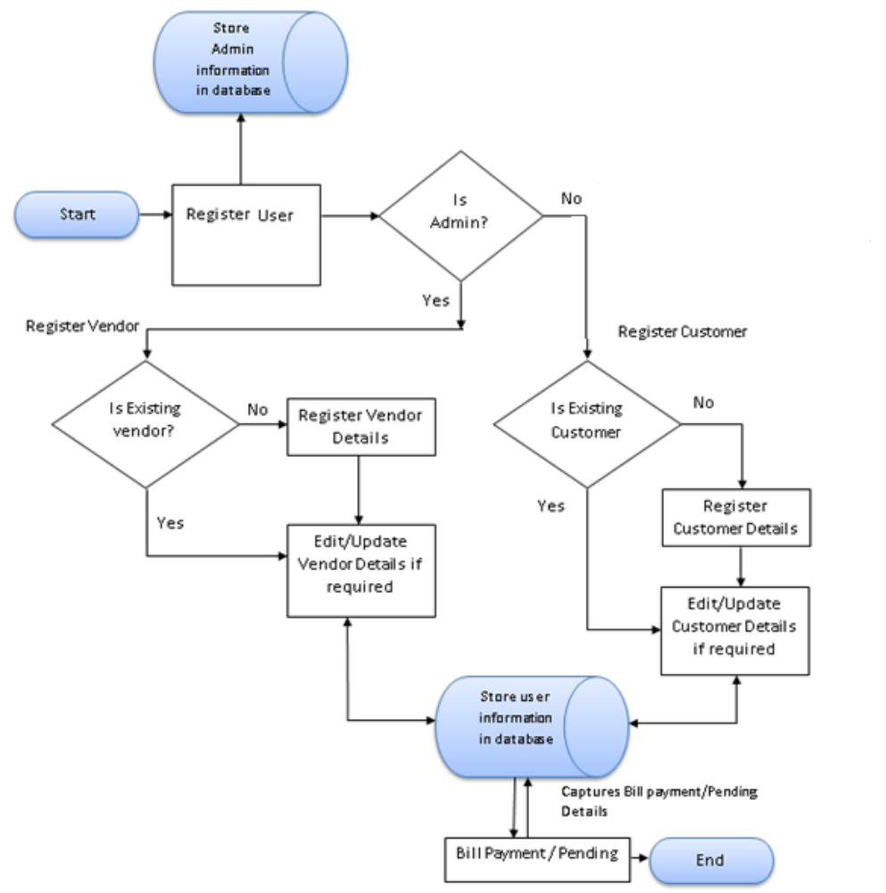

Vendor Home:

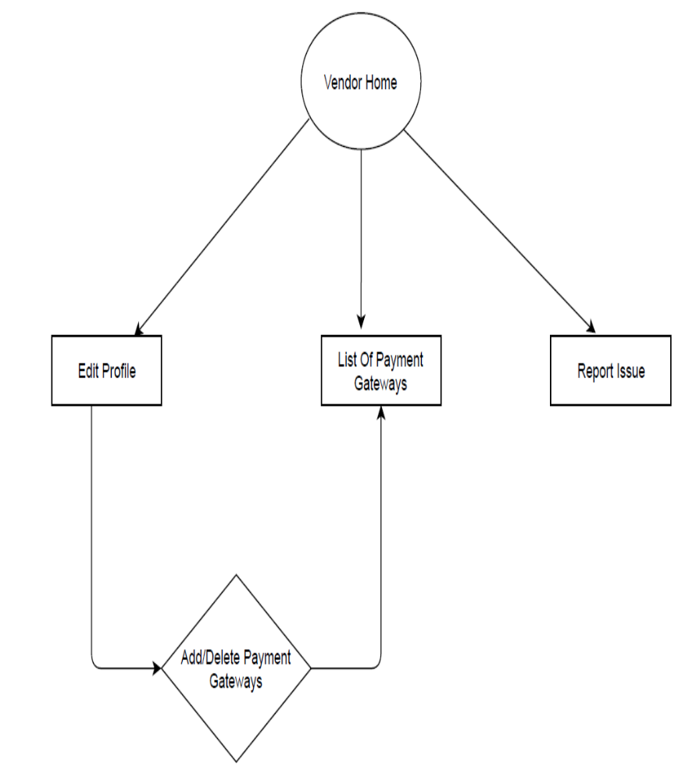

Admin Home:
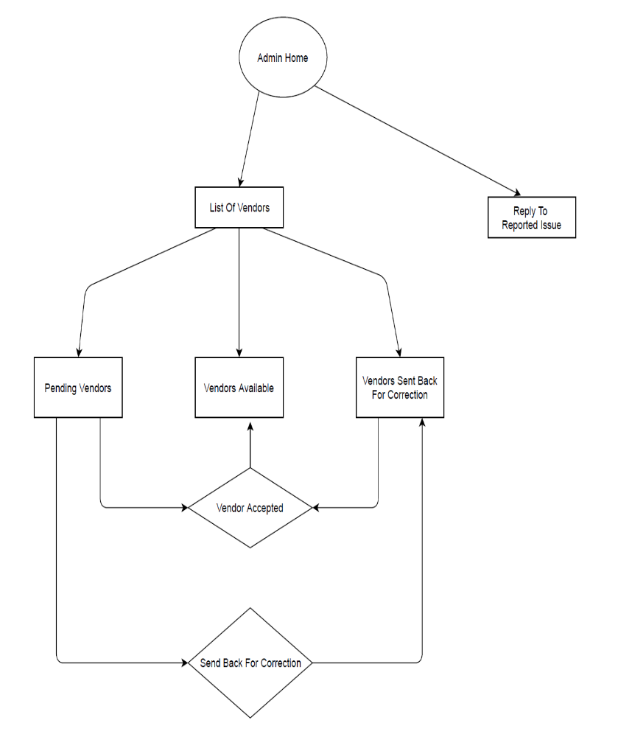

User Home:
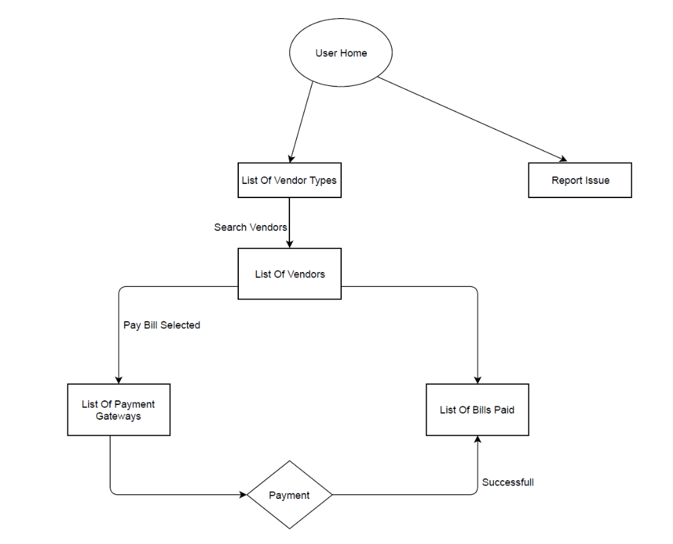

System Design

Proposed design
Below are the design objectives that shall be fulfilled post the execution of this project:
- Role based registration & credential authentication
- Accessing the vendor details by admin
- Retrival of vendors based on vendor types
- Generation of bill
- Payment of bills by the user
- Obtaining vendor/subscriber information
- Accessing the courses based on subscribed services

Component inventory
High level component breakdown:
- Login Component
- User/Admin Signup Component
- Vendor Registration Component
- User Dashboard
- Admin Dashboard
- Vendor Dashboard

Database Design

Data Model
Database includes various tables and their interdependencies with one another which can be seen in the below table structure.
The tables include:
- User table: Includes name ,age ,gender and other relevant details of the user
- Role table: Includes name of the role and code of the role which is the primary key of the table
- Vendor Type table: Includes id which is primary key, image and vendor type name.
- Vendor table: Includes name of vendor, company registration no., address, year of establishment and other relevant details of vendor and vendor id which is the primary key of the table.
- Bill table: Includes the name of the person who paid the bill, the amount paid, the number months paid for and other relevant details for the bill and bill id which is the primary key of the table.
- Payment Gateway table: Includes the payment gateway name and the id as the primary key of the table.
- Issue table: Includes the issue, reply of the issue userid for which user reported the issue and issueid as the primary key of the table.
- User_HAS_VENDOR: Includes the many to many relation between the user and the vendor.
- VENDOR_HAS_PAYMENT_GATEWAY table: Includes the many to many relation for the vendor and the payment gateway tables.

Tables Structure
User Table:
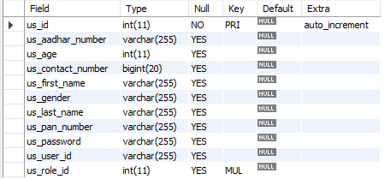

Role Table:
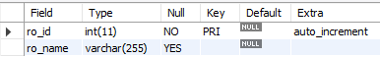

Vendor Type Table:
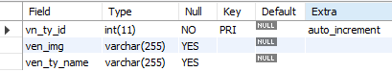

Vendor Table:
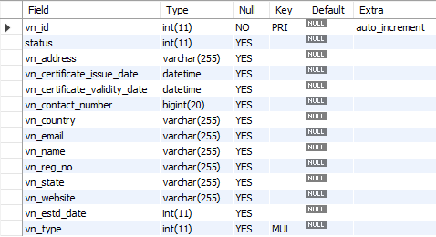

Bill Table:
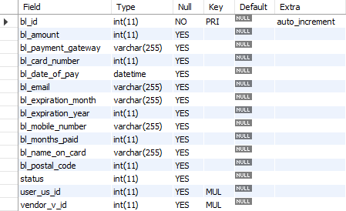

Payment Gateway Table:
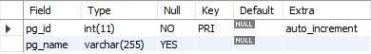

Issue Table:
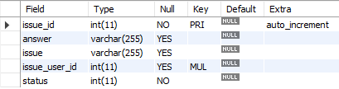

User Has Vendor Table:
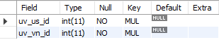

Vendor Has Payment Gateway Table:
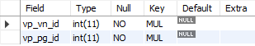

Terms & Conditions
Associates shall be solely responsible for all its acts and omissions under this program. Interns will comply at all times with all applicable laws. Interns shall not use Cognizant’s name, logo and trademark in any promotional materials or other communications with third parties without the prior written consent of Cognizant. Any materials used by interns in relation to program will not infringe the copyrights, trademarks, patents, trade secrets or other intellectual property rights, privacy or similar rights of any person or entity. Interns agrees not to post, draw, make, display any content that is threatening, libelous, obscene, defamatory, abusive, pornographic, or advocates/encourages any conduct that could constitute a criminal offence or give rise to any civil liability. Cognizant its associates’ personal details including but not limited to name, address, contact number shall not be shared or forwarded to any third party, without prior written consent of Cognizant, its associates. All intellectual property provided by Cognizant, as part of program shall be owned exclusively by Cognizant. Intern shall indemnify, defend and indemnify Cognizant its associates, officers, directors from and against any claims, demands, loss, damage, liability, causes of action, judgments, or costs and expenses of every nature (including attorney’s fees and expenses) incurred by Cognizant based on any claim that any breach of terms and conditions of this program

Change Log
Please note that this table needs to be maintained even if a Configuration Management tool is used.
Version Number | Changes made
V<n.n> | <If the change details are not explicitly documented in the table below, reference should be provided here>
V<n.n> | Page no | Changed by | Effective date | Changes effected

