**Professional Summary:**

* Over 2.6 Years of progressive, professional experience in **DevOps** and **Software Configuration Management** which includes **Build setup**, Continuous Integration, Source Code Management process setup.
* Hands on Experience in DevOps tools like **Git, GitHub, Maven, Nexus, Jenkins, Ansible**.
* Experience in using source code management tool **GIT**.
* Experience in using build tool **Maven**.
* Hands on experience in Automation of build process (**Build Automation**) using the Git, Maven and **Jenkins**.
* Experience in using **Nexus Repository** to store the Build artifacts.
* Experienced in large production environments using configuration management tool like **Ansible.**
* Wrote **Playbook, Modules** and utilized community Playbooks as well.
* Good working experience in **Linux environment**.
* Deploying the JAR and WAR into Tomcat Application Server.
* knowledge in **Amazon AWS** Cloudwhich includes services like: **EC2, S3, EBS, VPC, Subnets**, **ELB, Auto scaling** and **Security Groups.**
* Knowledge in creating containers with **Docker**.
* Good interaction with developers, managers, and team members to coordinated job tasks and strong commitment to work.
* Ability to learn new technologies quickly.

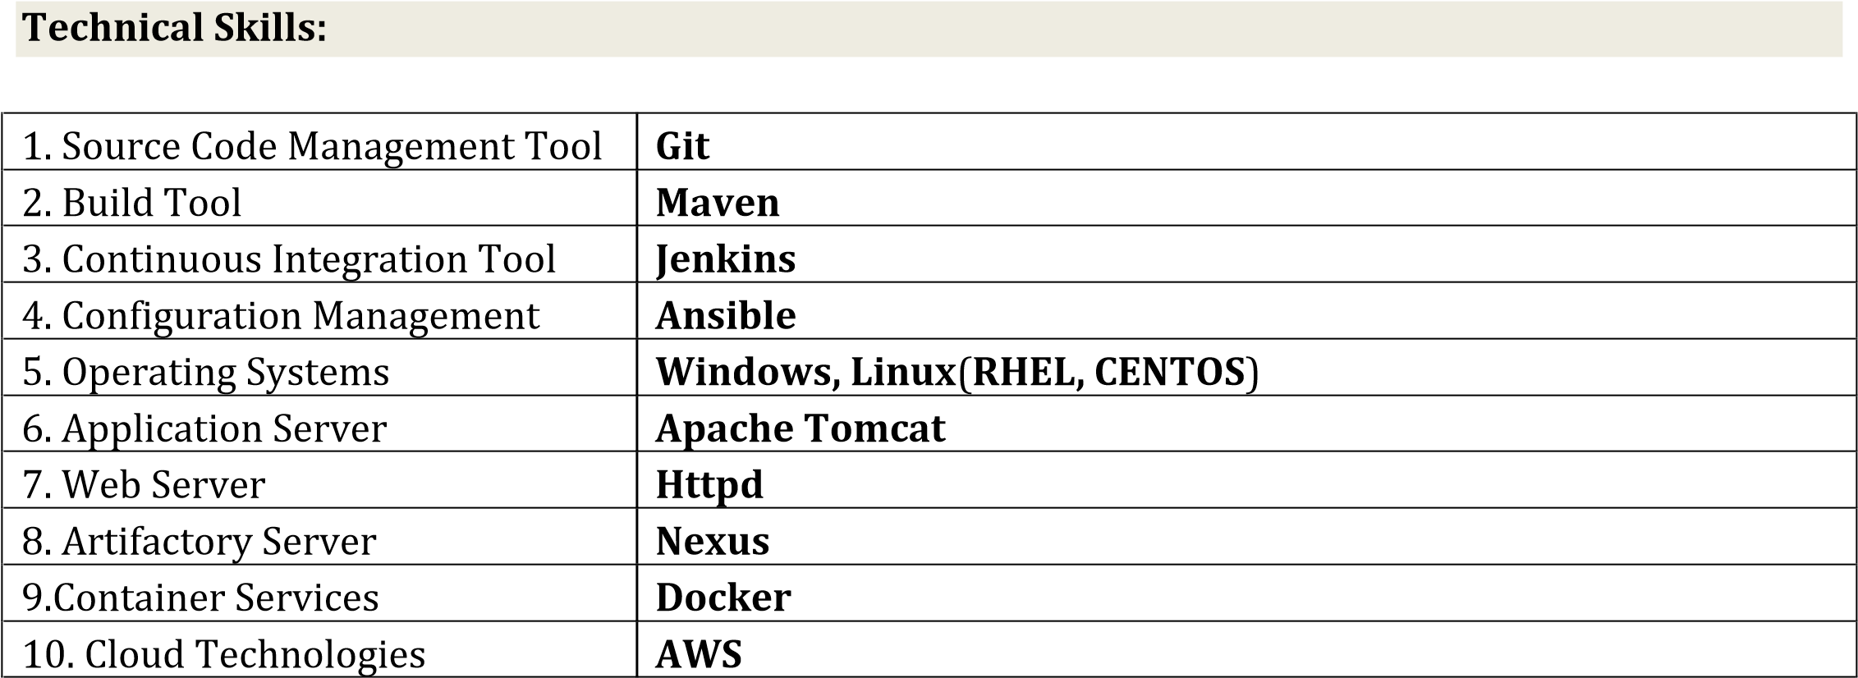

**Roles and Responsibilities:**

* Involved in creating the company's DevOps strategy in a mix environment of Linux (**Ubuntu, CentOS, RHEL**).
* Worked on Branching and Merging, Resolving Branching Strategy maintaining Branching strategy using **GIT.**
* Resolved conflicts related to merging of source code.
* Installing and configuring **Jenkins,** Installing plug-in, configuring security.
* Creating a Jenkins master and slave for the implementation of multiple **parallel builds**.
* Creating Jenkins build jobs based on the requirement.
* Integrated Git, Jenkins, Maven in accomplishing continuous integration with poll SCM, build trigger.
* Deploying the generated artifacts using Ansible.
* Automated the process of storing build artifacts in nexus repository.
* Setting up the Ansible **Master** and Ansible **Nodes.**
* Automating the process of Server configuration through **Ansible Playbooks**.
* Designed **Ansible Modules** to manage configurations and automate installation process.
* Responsible for writing Ansible playbooks for installing the packages and configuring, updating the remote servers.
* Knowledge in Launching Amazon EC2 Cloud Instances(RHEL) using Ansible playbooks and configuring the launched instances.

**Environment: Git, Maven, Jenkins, Nexus, Ansible, Linux.**

**Roles and Responsibilities:**

* Analyze and resolve conflicts related to merging of source code.
* Corresponded with other departments to resolve Build dependencies**.**
* Resolved issues for developers commit, update, and synchronization, worked on branches.
* Worked with Maven directory structure to build a project.
* Configured **Maven** and Jenkins to deploy the generated artifacts to **Artifactory**.
* Responsible for creating jobs in **Jenkins** and monitoring daily operations in Jenkins.
* Scheduled Build jobs, configured build pipeline and automated deployment using Jenkins.
* Implemented the setup for **Master slave architectur**e to improve the Performance ofJenkins, implemented parallel builds.
* Enforced Continuous Integration by configuring **Git, Maven, Jenkins.**
* Performed all necessary day-to-day support for project like **Check-in, Checkouts, branching, tagging**, and conflict resolution.
* Setting up the environment for new developers on the machine.
* Interacting with developers to sort out issues related to **Build Automation**.
* Communicate effectively with the Clients in the weekly status calls and other meetings.

**Environment: Git, Maven, Jenkins, Nexus, Linux.**