Assignment#3 Akhil Suryadevara

A20391322

The first thing to do is to login as a store manager

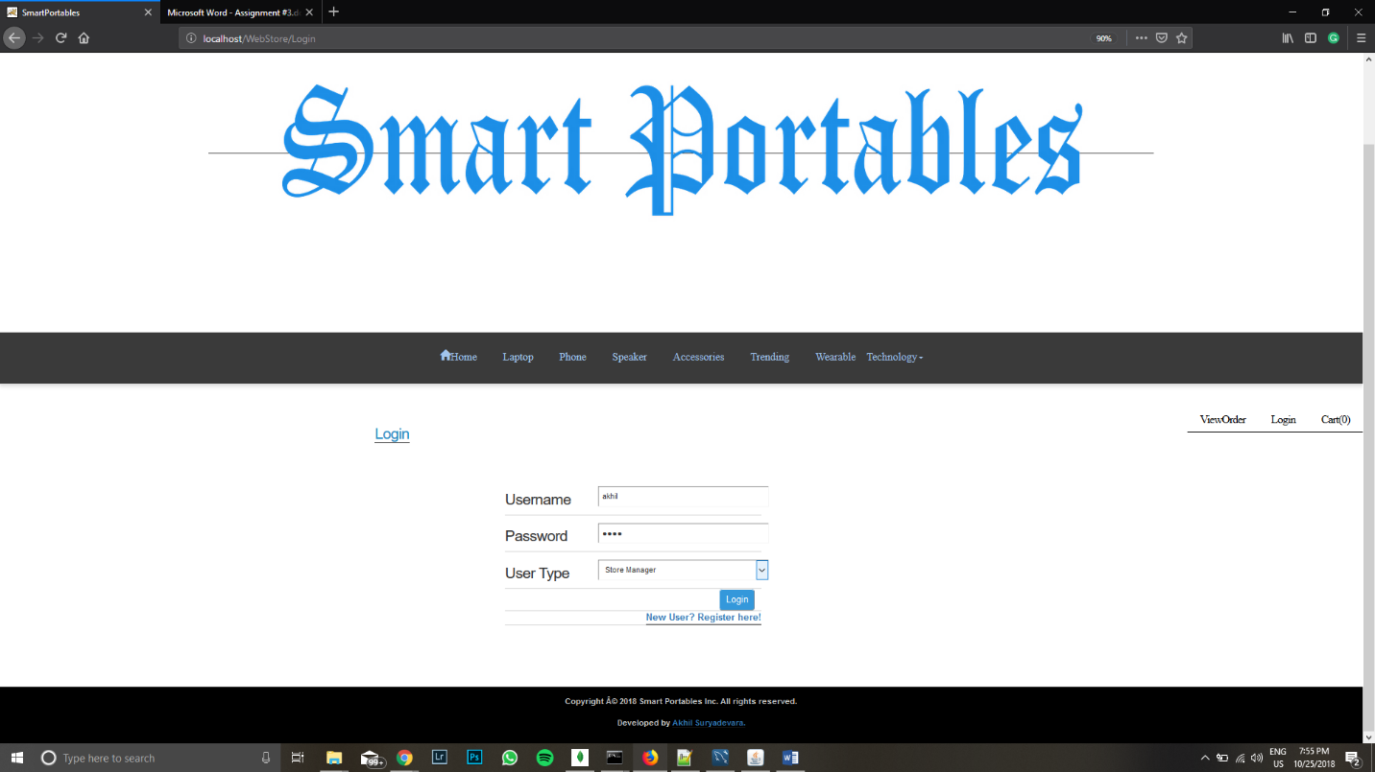

After logging in the first thing we see are two new sections Inventory and sales report

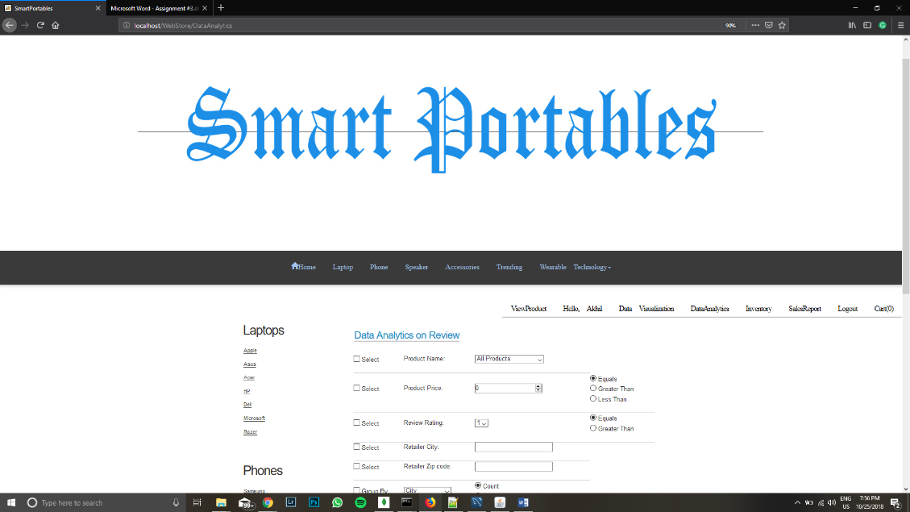

Then one column added is the inventory column in productdetails table and orderTime in the orders table.

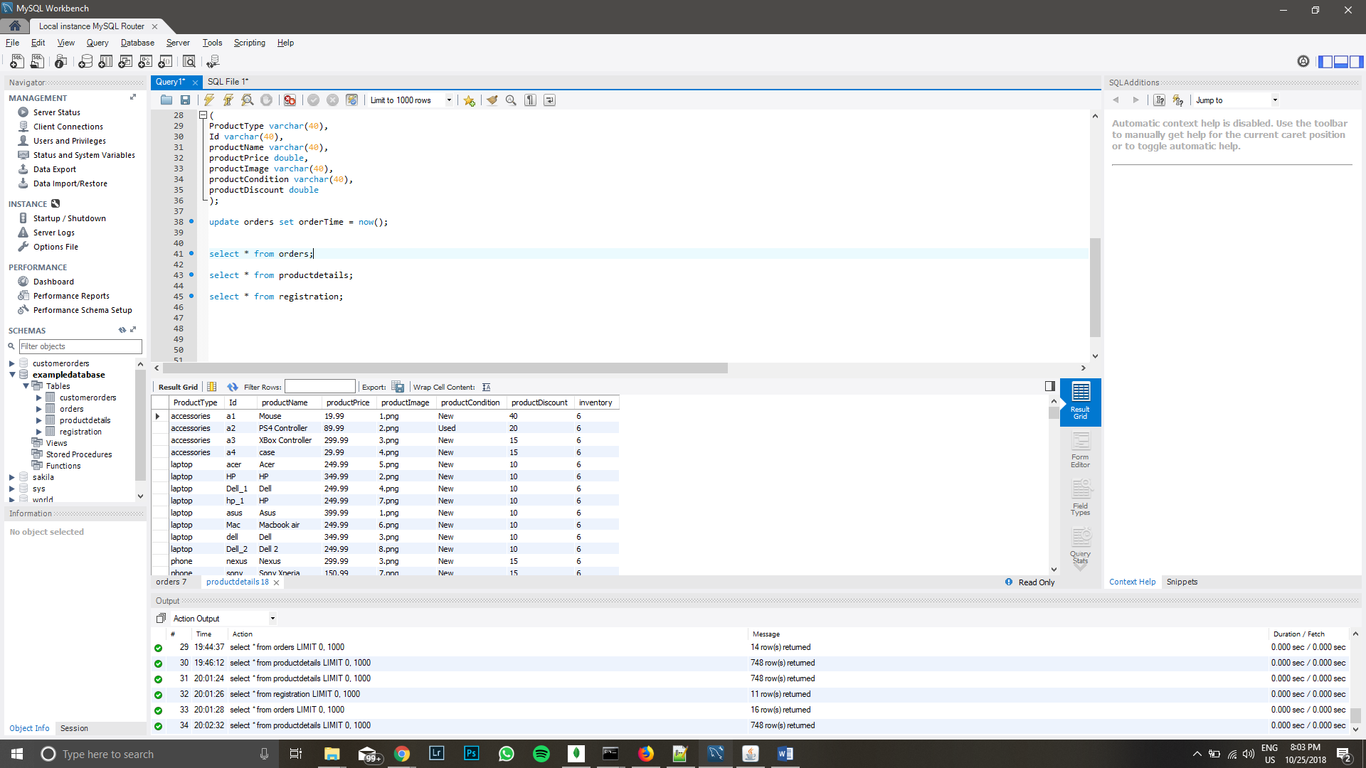

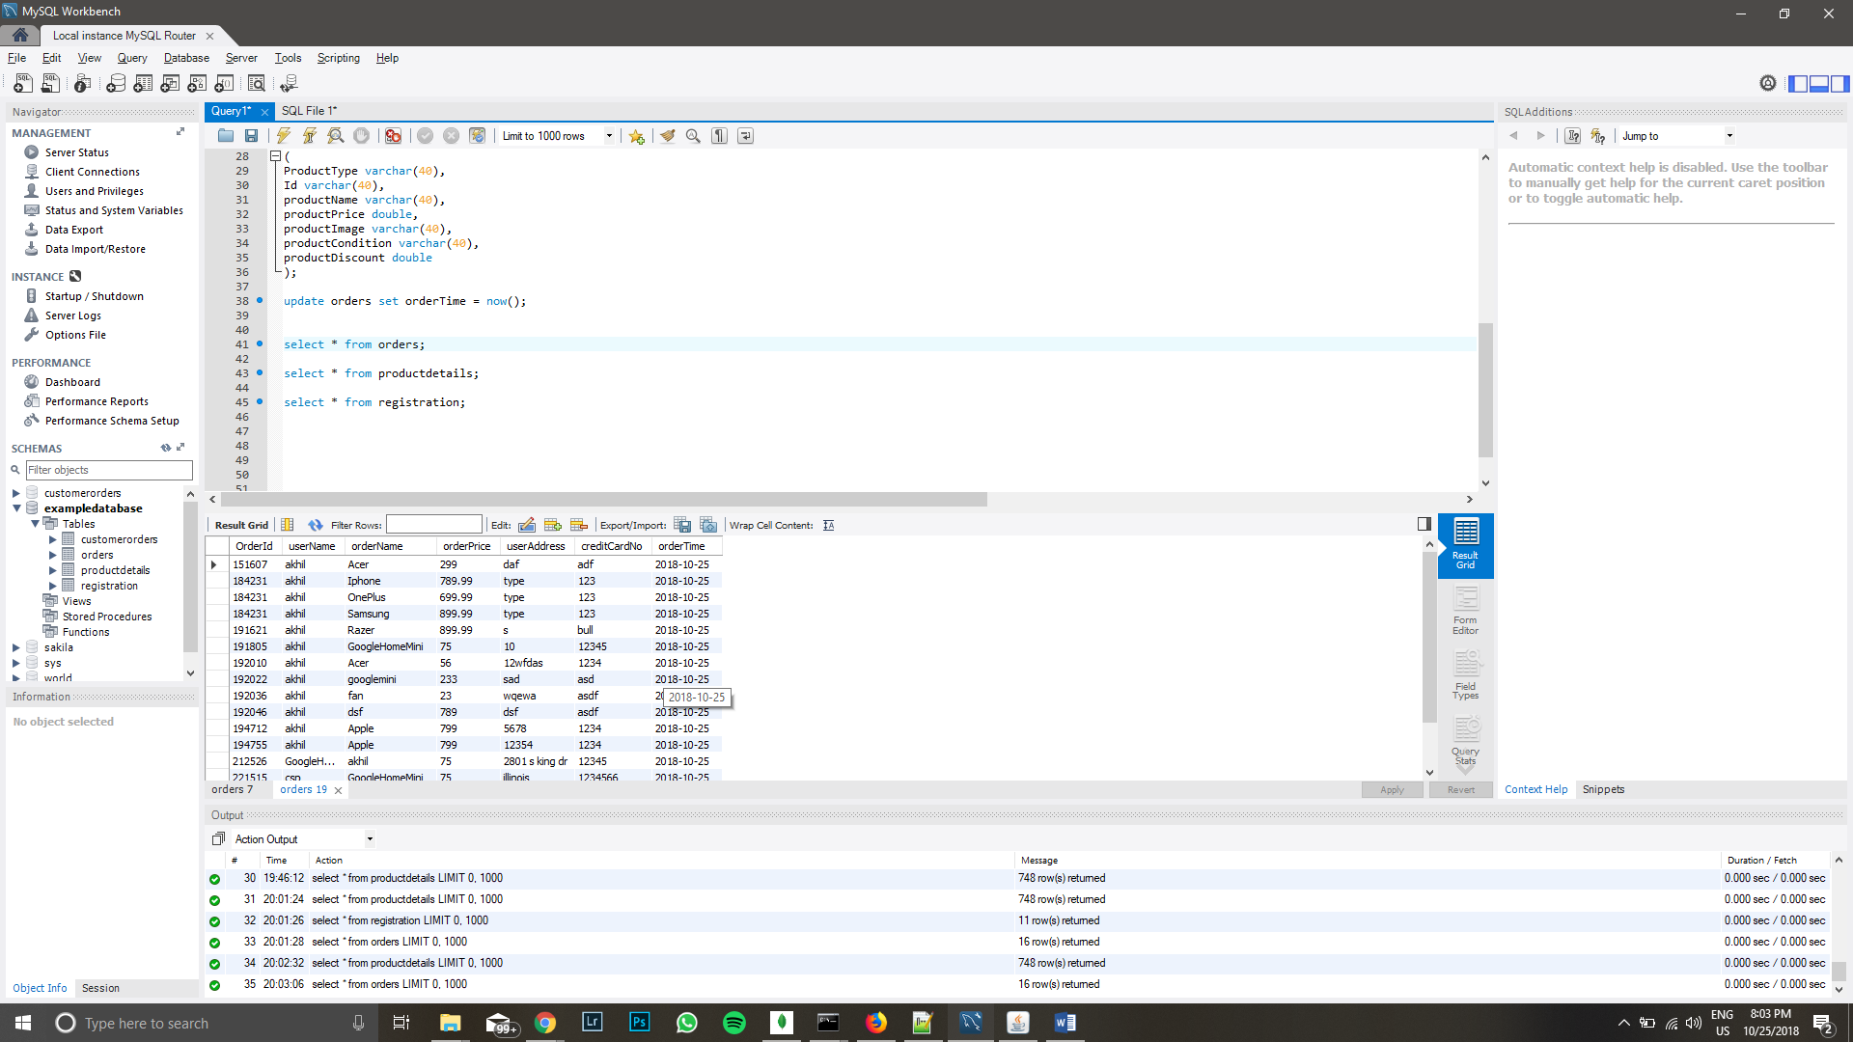

Now a table is generated for all the products and how many of them are available in the productdetails table

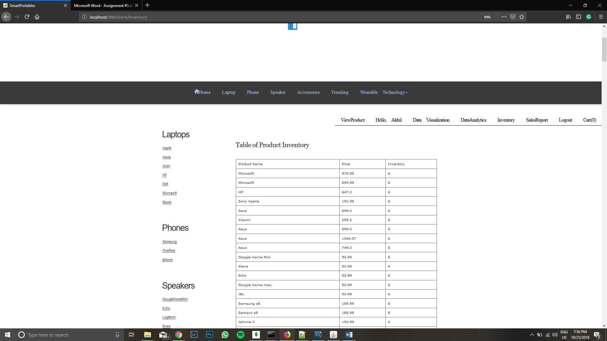

A bar chart is then generated with the help of Gson for the number of products available. The default given is 6 so every product shows the same. 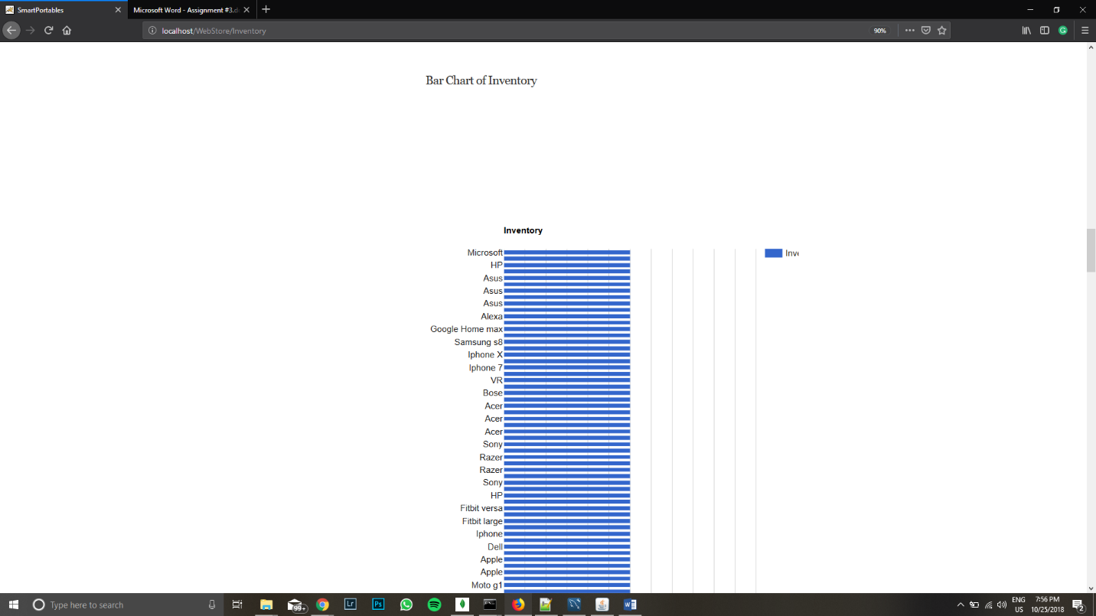

After scrolling down, you can find all the products which are on sale.

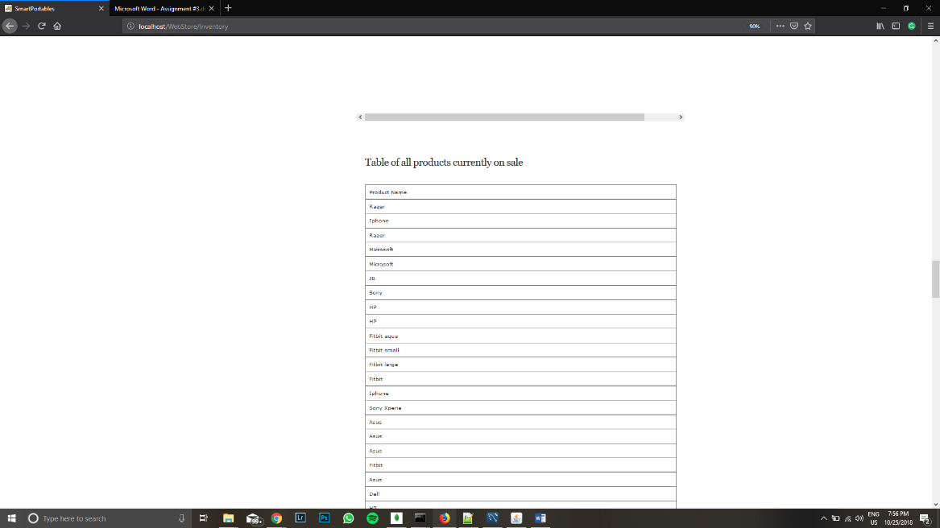

Which on scrolling further shows a table of all products who have manufacturer rebates.

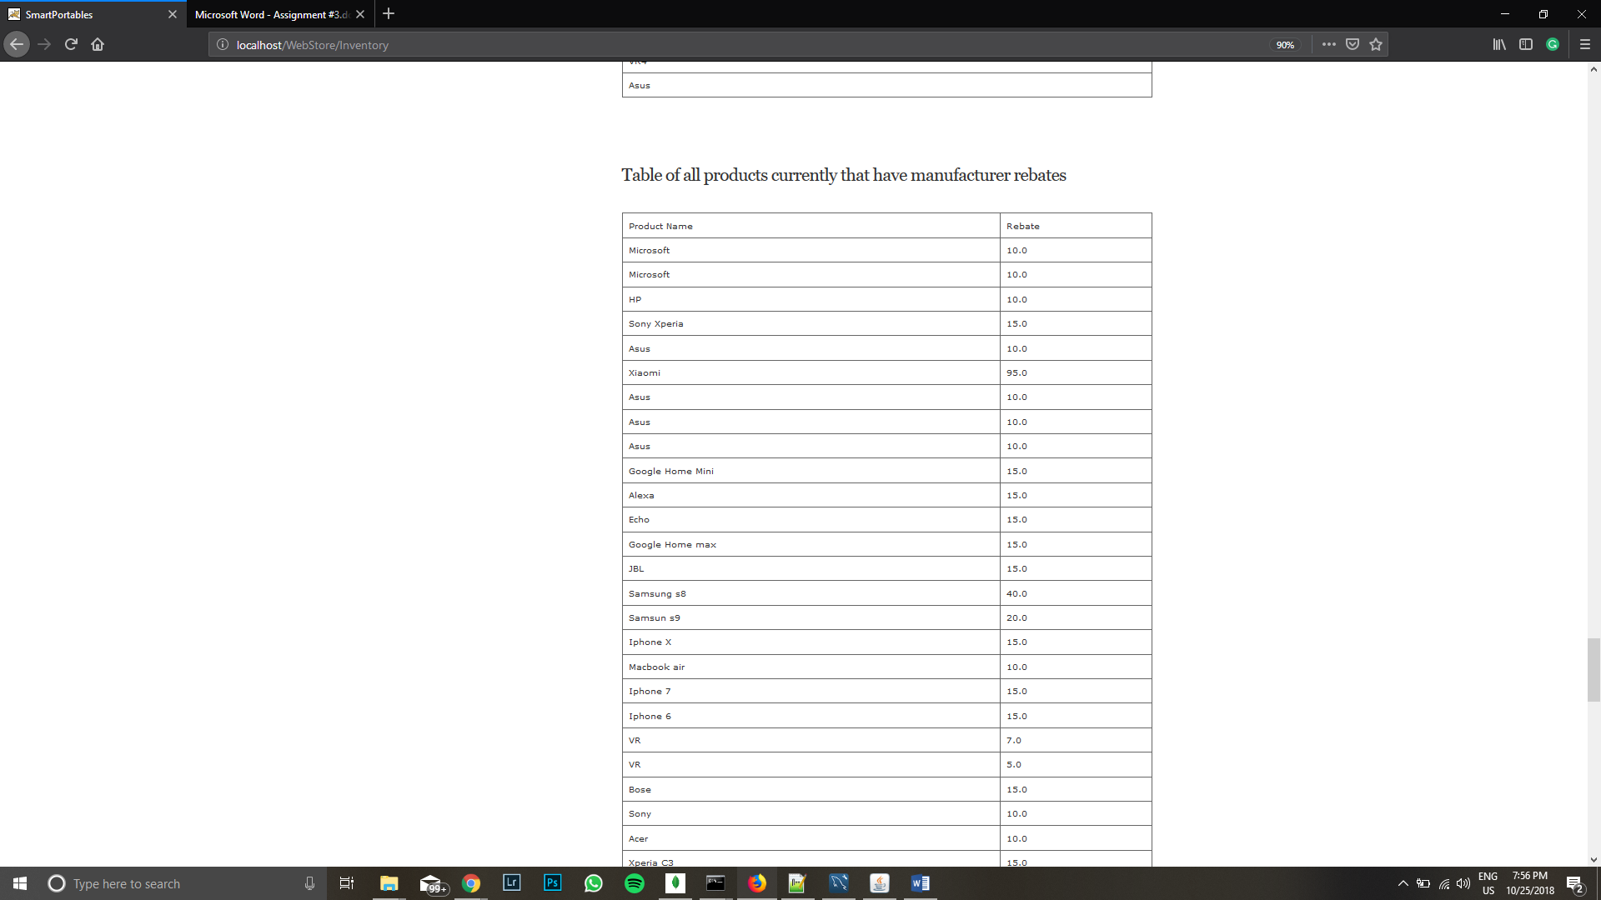

Next, we click on the SalesReport tab which shows all the products that are ordered by the customer and the number of products that have been sold. 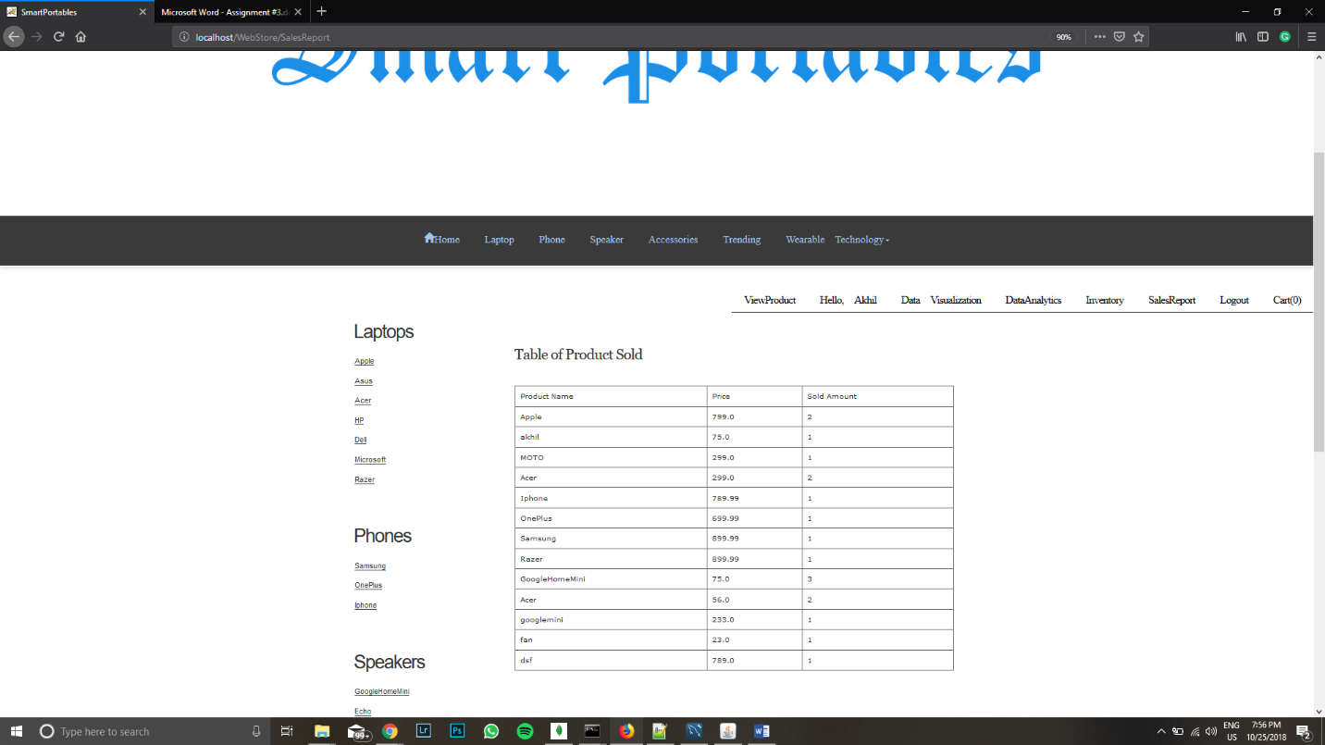

Now further scrolling down shows a bar chart for the number of products sold for each product

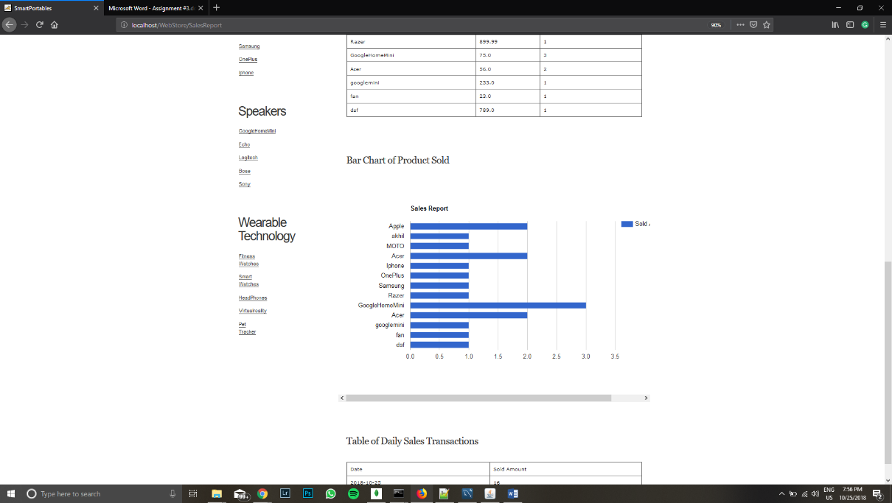

Now, upon scrolling further gives daily transactions. There is just one because I created all the order today. If I did this tomorrow there would be one more row.

