**Page - 1**

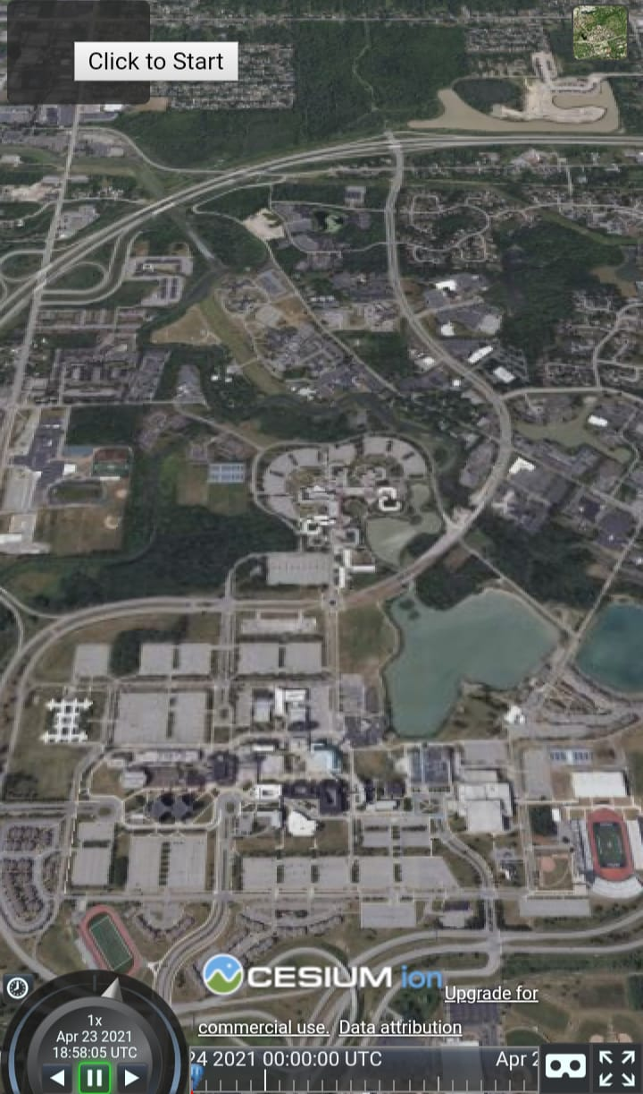

Click here to select manually

Click here to get your current location

**Find landmarks on your route**

* **To select initial location**

**Display:**

box with the above text

**Buttons:**

1. “Click here to select manually”: Upon clicking this Page 2 Appears
2. “Click here to get your current location”: Upon clicking this Page 3 Appears

**Functions:**

selectManually:

Search bar and graphics as shown in page 2

getCurrentLocation:

Get current co-ordinates and place a blue pin on the map, with graphics in page 3

**Page - 2**



Clear Pin

Select destination

Previous

Enter

The location entered was not found

Long press on map / Type in Initial location

**Display:**

box with blue background, search bar, blue pin (not clickable), four buttons.

**Buttons:**

1. “Previous”: Go to Previous page
2. “Enter”: Search the text in text box with APIs
3. “Select Destination”:
4. “Clear Pin”:

**Functions:**

1. previous:

Go to previous step

1. Enter:

Search the typed in text using API and place a blue pin on the resulting geolocation.

Display error message if location is not found (for 5 seconds)

1. selectDestination:

Page to select destination appears

If there is no blue pin on the map at the time of clicking this function. Display error message, “Initial location was not selected”

1. longPressOnMap:

Place a blue pin on the clicked locations

1. clearBluePin:

clear the Pin on the map

**Page - 3**



The location entered was not found

Previous

Clear Pin

Get Route

Enter

Long press on map / Type in Destination

**Display:**

box with blue background, search bar, red pin (not clickable), four buttons.

**Buttons:**

1. “Previous”:
2. “Enter”: Search the text in text box with APIs
3. “Get Route”:
4. “Clear Pin”:

**Functions:**

1. previous:

Go to previous step/page

1. enter:

Search the typed in text using API and place a red pin on the resulting geolocation.

Display error message if location is not found (for 5 seconds)

1. getRoute:

Follow road network from blue pin to red pin. Get watch position function.

If there is no red pin on the map at the time of clicking this function. Display error message, “Destination not selected”.

1. longPressOnMap:

Place a red pin on the selected location upon long pressing.

1. clearRedPin:

clear the red pin on the map

**Page - 4**



**31 mins**

Previous

Search along route

Initial location

Destination

**Display:**

On top:

box with blue background, location names/ coordinates, two pins (not clickable), an arrow from initial location to destination, two buttons.

On map:

Two pins and follow road network on the map, with avg time taken in mid of route, and our current location as maroon circle.

**Buttons:**

1. “Previous”
2. “Select along route”:

**Functions:**

1. previous:

Go to previous step

1. searchAlongRoute:

Go to Page 5

**Page - 5**



McDonald’s

3 min

Close

Previous

McDonald’s

6 min

Open

Search landmark along route

Get new route

McDonald’s

2 min

Close

Enter

**Display:**

On top:

Box with blue background, search bar, yellow pins (not clickable), three buttons.

On map:

Two pins and follow road network on the map, with avg time taken in mid of route, and our current location as marron circle.

**Buttons:**

1. “Previous”
2. “Get new route”:
3. “Enter”:

**Functions:**

1. previous:

Go to previous step/page

1. enter:

Search the typed in text using API and display all the location’s available along route with pop up dialogue box (clickable). Upon clicking one pop up that gets highlighted.

1. getNewRoute:

Get a new route from blue pin to highlighted pop up box and from selected popup box to red pin. And go to page 6

**Page - 6**



Previous

Your Destination

Mc Donald’s

Your location

**Display:**

On top:

box with blue background, three location names, three pins (not clickable), two arrows from initial location to intermediate stop to destination, one button.

On map:

Three pins and follow road network on the map, with avg time taken in mid of route, and our current location as marron circle.

**Buttons:**

1. “Previous”

**Functions:**

1. previous:

Go to previous step/page