


Safety Plan Lane Assistance
Document Version: [Version]
Template Version 1.0, Released on 2017-06-21

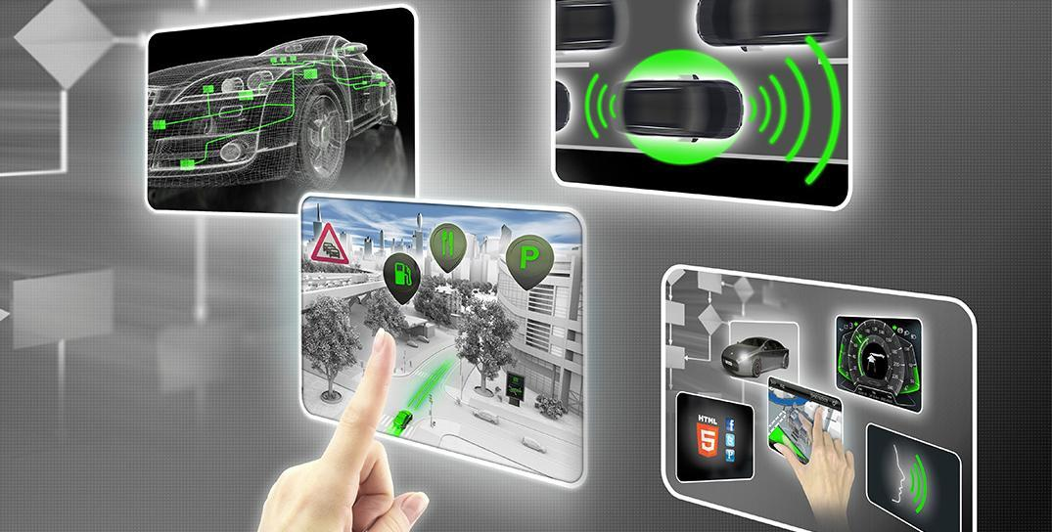

Document history

Date | Version | Editor | Description
03rd May, 2018 | 1.0 | Akhil Umat | Initial Safety Plan Document

Table of Contents

Document history
Table of Contents
Introduction
Purpose of the Safety Plan
Scope of the Project
Deliverables of the Project
Item Definition
Goals and Measures
Goals
Measures
Safety Culture
Safety Lifecycle Tailoring
Roles
Development Interface Agreement
Confirmation Measures

Introduction

Purpose of the Safety Plan
The Purpose of the safety plan is to provide an overall framework for the Lane Assistance item, and to assign roles and responsibilities for the functional safety for this item.

Scope of the Project
[Instructions: Nothing to do here. This is for your information.]

For the lane assistance project, the following safety lifecycle phases are in scope:

Concept phase
Product Development at the System Level
Product Development at the Software Level

The following phases are out of scope:

Product Development at the Hardware Level
Production and Operation

Deliverables of the Project
[Instructions: Nothing to do here. This is for your information.]

The deliverables of the project are:

Safety Plan
Hazard Analysis and Risk Assessment
Functional Safety Concept
Technical Safety Concept
Software Safety Requirements and Architecture

Item Definition
The lane assistance item alerts the driver that the vehicle has accidently departed its lane, and attempts to steer the vehicle back to the center of the road.

The Lane Assistance System will have two functions:
- Lane departure warning
- Lane keeping assistance

The lane departure warning function shall apply an oscillating steering torque to provide the driver a haptic feedback

The lane keeping assistance function shall apply the steering torque when active in order to stay in ego lane

The subsystems which are inside the item and which are responsible for each function are mentioned below:-
- Camera system
- Electronic Power Steering system
- Car Display system

Other car subsystems like the steering wheel lie outside of this item

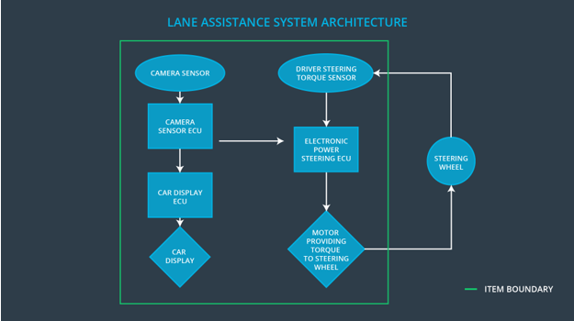

Goals and Measures

Goals
Analyze Lane Departure warning system and Lane keeping assistance for possible defects and to plan how to minimize risk associated with it to accepted levels.

Measures

Measures and Activities | Responsibility | Timeline
Follow safety processes | Safety Manager | Constantly
Create and sustain a safety culture | Safety Manager | Constantly
Coordinate and document the planned safety activities | Safety Manager | Constantly
Allocate resources with adequate functional safety competency | Project Manager | Within 2 weeks of start of project
Tailor the safety lifecycle | Safety Manager | Within 4 weeks of start of project
Plan the safety activities of the safety lifecycle | Safety Manager | Within 4 weeks of start of project
Perform regular functional safety audits | Safety Auditor | Once every 2 months
Perform functional safety pre-assessment prior to audit by external functional safety assessor | Safety Manager | 3 months prior to main assessment
Perform functional safety assessment | Safety Accessor | Conclusion of functional safety activities

Safety Culture
- High priority: safety has the highest priority among competing constraints like cost and productivity
- Accountability: processes ensure accountability such that design decisions are traceable back to the people and teams who made the decisions
- Rewards: the organization motivates and supports the achievement of functional safety
- Penalties: the organization penalizes shortcuts that jeopardize safety or quality
- Independence: teams who design and develop a product should be independent from the teams who audit the work
- Well defined processes: company design and management processes should be clearly defined
- Resources: projects have necessary resources including people with appropriate skills
- Diversity: intellectual diversity is sought after, valued and integrated into processes
- Communication: communication channels encourage disclosure of problems

Safety Lifecycle Tailoring
For the lane assistance project, the following safety lifecycle phases are in scope:

Concept phase
Product Development at the System Level
Product Development at the Software Level

The following phases are out of scope:

Product Development at the Hardware Level
Production and Operation

Roles

Role | Org
Functional Safety Manager- Item Level | OEM
Functional Safety Engineer- Item Level | OEM
Project Manager - Item Level | OEM
Functional Safety Manager- Component Level | Tier-1
Functional Safety Engineer- Component Level | Tier-1
Functional Safety Auditor | OEM or external
Functional Safety Assessor | OEM or external

Development Interface Agreement

- What is the purpose of a development interface agreement?
DIA defines roles between companies involved in the production of a part. It also specifies what evidence and work products each party would provide to prove that work was done according to agreement. Ultimate goal is all parties develop product as per ISO26262 safety standards.

- What will be the responsibilities of your company versus the responsibilities of the OEM? Hint: In this project, the OEM is supplying a functioning lane assistance system. Your company needs to analyze and modify the various sub-systems from a functional safety viewpoint.
OEM will become the customer and Tier1(my company) will become the supplier. OEM will give requirements for the system and my company will develop that system following ISO26262 safety standards. OEM sometimes provide initial product design and Tier1 company completes the details.

Confirmation Measures

- What is the main purpose of confirmation measures?
Purpose of the confirmation measures is to make sure that project conforms to ISO26262 and project makes the vehicle safer.

- What is a confirmation review?
Ensures that the project complies with ISO 26262. As the product is designed and developed, an independent person would review the work to make sure ISO 26262 is being followed.

- What is a functional safety audit?
Checking to make sure that the actual implementation of the project conforms to the safety plan is called a functional safety audit.

- What is a functional safety assessment?
Confirming that plans, designs and developed products actually achieve functional safety is called a functional safety assessment.
]

A safety plan could have other sections that we are not including here. For example, a safety plan would probably contain a complete project schedule.

There might also be a "Supporting Process Management" section that would cover "Part 8: Supporting Processes" of the ISO 26262 functional safety standard. This would include descriptions of how the company handles requirements management, change management, configuration management, documentation management, and software tool usage and confidence.

Similarly, a confirmation measures section would go into more detail about how each confirmation will be carried out.

