**Git: Git** is a distributed version control system for tracking changes in source code during software development. It is designed for coordinating work among programmers, but it can be used to track changes in any set of files.

**Azure DevOps**: Azure DevOps Server is a Microsoft product that provides version control, reporting, requirements management, project management, automated builds, lab managements, testing and release management capabilities. It covers the entire application lifecycle, and enable DevOps capabilities.

Azure Repos:

Branches:

Master Branch:

Commit:

Pull request: Asking for reviews on new branch.

Branch polices: Branch polices are created for pull request like minimum numbers of reviewers, linked working item, check for comment resolution and build validation.

Every pull request must go through braches polices pipeline in order to commit.

Reviewers can see the open requests on pull request tab and approve accordingly.

Data Factory:

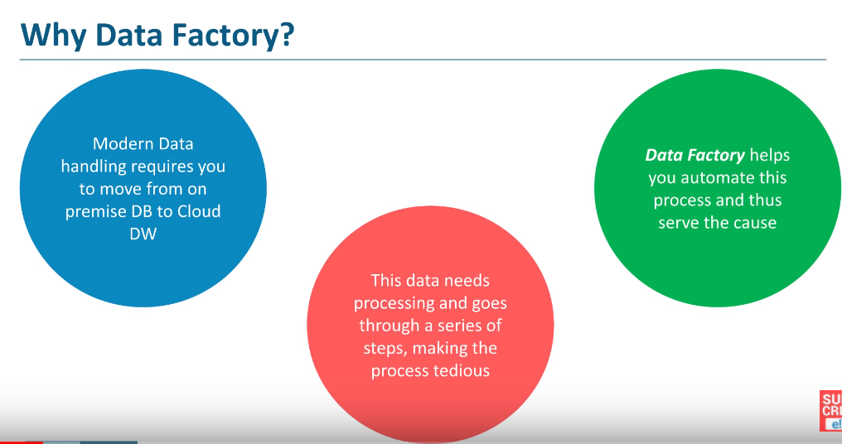

What is Data Factory?

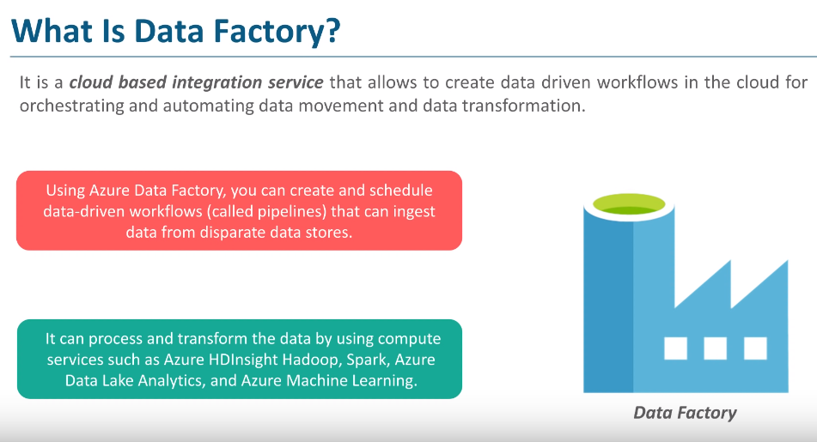

How does it works?

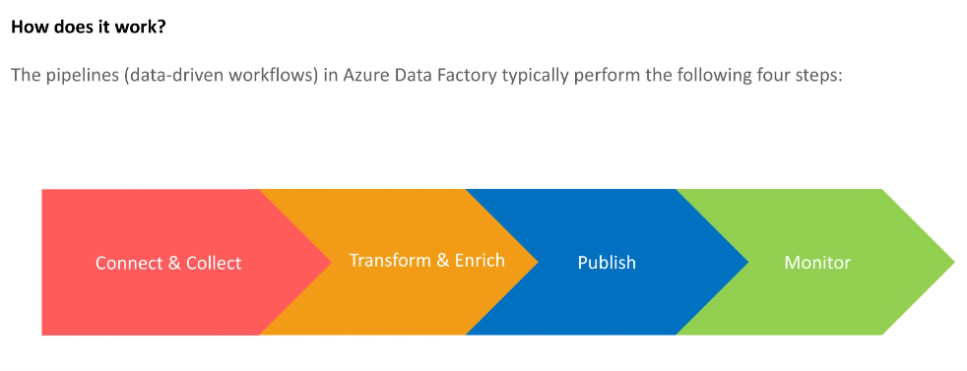

Connect & Collect:

It collect all the data from different resource and keeps that data into one location.

Transform & Enrich:

Running varies patterns on it. Creating schemas etc..,

Publish:

We can connect it through varies other softwares like power-BI and publish this data.

Monitor:

You can take look of data and analysis it in real time.

Data Factory Concepts:

