**Frontend Assignment: Interactive Cloud Risk Visualization (with Collapsible Nodes)**

## **🕑 Duration: 2 Hours**

**Tools Allowed**: Internet, AI tools like ChatGPT or Claude, documentation, GitHub, NPM packages.

## **📘 Background**

Your company manages a multi-cloud infrastructure across AWS, GCP, and SaaS providers. Security alerts and misconfigurations are constantly monitored and visualized via an interactive dashboard.

You’ve been asked to create a **graph-based component** that displays the distribution of **open alerts and misconfigurations**, similar to the visualization shown below:

*You may imagine or refer to something like this:  
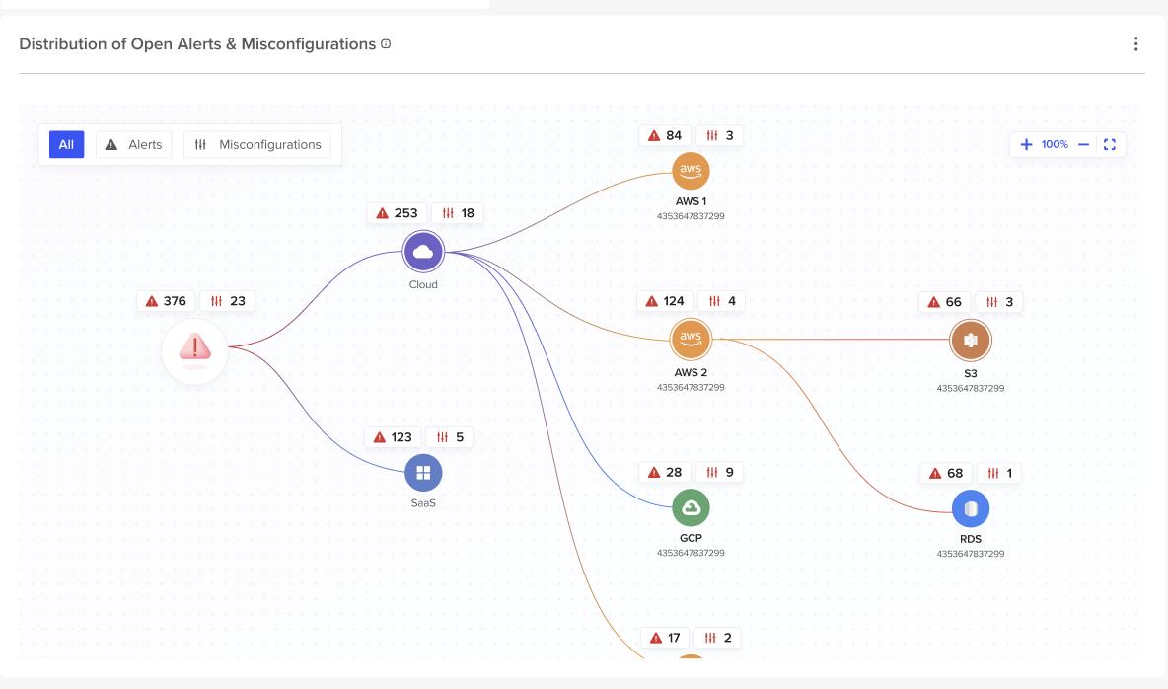*

## **📌 Objective**

Build a **graph visualization tool** in **React** that:

* Shows the hierarchy of cloud accounts and services
* Displays the number of **alerts** and **misconfigurations**
* Allows **interactive exploration** via filters and **collapsible nodes**

## **🧠 Requirements**

### **1. Data Representation**

Use the following **sample data** to model nodes and edges:

json

{

"nodes": [

{ "id": "cloud", "label": "Cloud", "type": "cloud", "alerts": 253, "misconfigs": 18, "children": ["aws1", "aws2", "gcp", "saas"] },

{ "id": "aws1", "label": "AWS 1", "type": "aws", "alerts": 84, "misconfigs": 3, "children": ["s3"] },

{ "id": "aws2", "label": "AWS 2", "type": "aws", "alerts": 124, "misconfigs": 4, "children": ["rds"] },

{ "id": "gcp", "label": "GCP", "type": "gcp", "alerts": 28, "misconfigs": 9 },

{ "id": "saas", "label": "SaaS", "type": "saas", "alerts": 123, "misconfigs": 5 },

{ "id": "s3", "label": "S3", "type": "service", "alerts": 66, "misconfigs": 3 },

{ "id": "rds", "label": "RDS", "type": "service", "alerts": 68, "misconfigs": 1 }

],

"edges": [

{ "source": "cloud", "target": "aws1" },

{ "source": "cloud", "target": "aws2" },

{ "source": "cloud", "target": "gcp" },

{ "source": "cloud", "target": "saas" },

{ "source": "aws1", "target": "s3" },

{ "source": "aws2", "target": "rds" }

]

}

## **Functional Requirements**

1. **Graph Visualization**
   * Use any graphing library (React Flow, D3.js, etc.)
   * Render the hierarchy of cloud → accounts → services
2. **Alert & Misconfiguration Display**
   * Each node displays:  
     + Count of alerts (🔺)
     + Count of misconfigurations (⚙️ or 🛠️)
3. **Collapsible Nodes**
   * Clicking on a node with children should **collapse/expand** it
   * Collapsing hides child nodes and their edges
4. **Interactivity**
   * Zoom & pan
   * Tooltip or side panel on hover/click showing details

## **✅ Bonus (Optional)**

* Node coloring based on severity (e.g., red for high alerts)
* Animated transitions on collapse/expand
* Responsive layout
* Custom icons for node types (Cloud, AWS, S3, etc.)

## **📦 Deliverables**

* A GitHub repo or a ZIP file containing:  
  + README.md with:  
    - Setup instructions
    - Brief explanation of how collapsibility and filtering are handled
  + A React app with:  
    - Graph rendering
    - Filtering logic
    - Collapsible node functionality

## **Evaluation Criteria**

| **Category** | **Weight** | **Details** |
| --- | --- | --- |
| Functionality | 40% | Graph renders correctly, collapses, filters work |
| Code Quality | 20% | Modular, readable, structured code |
| UX & Interactivity | 15% | Clear layout, responsive UI, good node labeling |
| Technical Reasoning | 15% | Clean data modeling, collapsibility logic |
| Documentation | 10% | README and code comments explaining key ideas |

## **Getting Started**

You may use:

* create-react-app or Vite for the project
* Graph libraries: React Flow, D3, visx, Cytoscape.js
* Any public icon packs (e.g., [Lucide Icons](https://lucide.dev/), FontAwesome)
* ChatGPT, Claude, Google