Industrial Internship Report on
”Food Delivery Application”
Prepared by
G.Akhiranandhan

Executive Summary
This report provides details of the Industrial Internship provided by upskill Campus and The IoT Academy in collaboration with Industrial Partner UniConverge Technologies Pvt Ltd (UCT). The internship focuses on applying technical knowledge to a practical project/problem statement.
The project undertaken is a Food Delivery Application developed using the MERN stack. The application is designed to form a bridge between restaurants, customers, and delivery personnel. Customers will be able to discover restaurants, browse food items, place orders, and track deliveries, while restaurant owners will manage menus, prices, availability, and orders. Delivery personnel will handle assigned deliveries and update pickup and delivery status.
At the current stage, the project foundation has been implemented. The React frontend was created using Vite, the Node.js/Express backend was established, MongoDB integration was configured, React Router and Tailwind CSS were set up, and the authentication module is being integrated. Frontend-backend communication and Mongoose validation issues are also being tested and debugged.

TABLE OF CONTENTS
1 Preface 3
2 Introduction 4
2.1 About UniConverge Technologies Pvt Ltd 4
2.2 About upskill Campus 8
2.3 Objective 9
2.4 Reference 9
2.5 Glossary 10
3 Problem Statement 11
4 Existing and Proposed solution 12
5 Proposed Design/ Model 13
5.1 High Level Diagram (if applicable) 13
5.2 Low Level Diagram (if applicable) 13
5.3 Interfaces (if applicable) 13
6 Performance Test 14
6.1 Test Plan/ Test Cases 14
6.2 Test Procedure 14
6.3 Performance Outcome 14
7 My learnings 15
8 Future work scope 16

Preface
This internship project is being developed as a full-stack Food Delivery Application using the MERN stack. The work completed so far has focused on establishing the application foundation, setting up the development environment, creating the frontend and backend structure, integrating MongoDB, and implementing the initial authentication workflow.
Relevant industrial internships provide practical exposure to software development beyond classroom learning. This project helps in understanding how a real-world application is divided into frontend, backend, database, authentication, API integration, and future service modules.
The problem statement requires a platform that connects restaurants and consumers. Restaurants should be able to register and list food items with prices, customers should be able to browse nearby restaurants and order food, and the system should support restaurant order confirmation, delivery assignment, tracking, dynamic ETA, cart, payment, ratings, notifications, and analytics.
The internship opportunity provided through USC/UCT gives exposure to an industry-oriented development workflow and encourages implementation of a practical solution rather than only an academic prototype.
The project was planned incrementally. The initial stage covered project architecture and environment setup, followed by frontend and backend development, database integration, routing, authentication, API integration, and debugging. Subsequent stages will implement restaurant, ordering, payment, and delivery features.
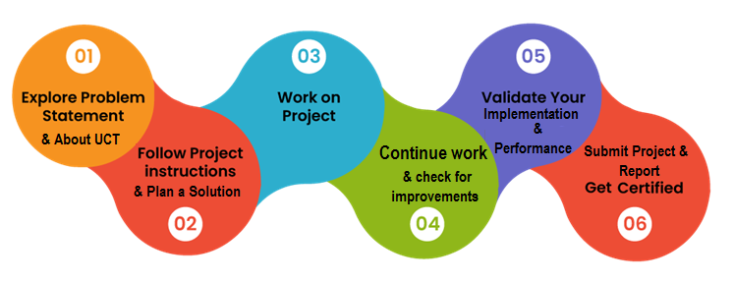
The work has provided practical learning in MERN stack development, React routing, REST API integration, MongoDB/Mongoose schema design, authentication, Tailwind CSS configuration, and debugging frontend-backend issues.
I would like to thank the internship organizers, mentors, faculty members, and everyone who provided guidance and support during the development of this project.
My message to juniors and peers is to build projects step by step, understand the reason behind each component, and learn to debug errors instead of depending only on ready-made solutions.

Introduction

About UniConverge Technologies Pvt Ltd
A company established in 2013 and working in Digital Transformation domain and providing Industrial solutions with prime focus on sustainability and RoI.
For developing its products and solutions it is leveraging various Cutting Edge Technologies e.g. Internet of Things (IoT), Cyber Security, Cloud computing (AWS, Azure), Machine Learning, Communication Technologies (4G/5G/LoRaWAN), Java Full Stack, Python, Front end etc.
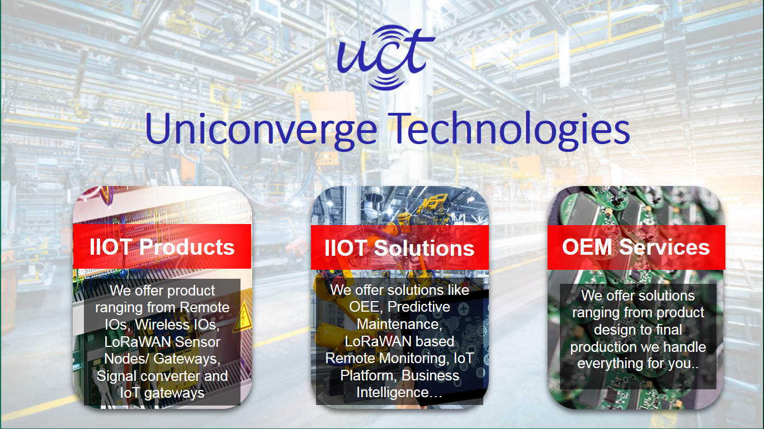
- UCT IoT Platform ()
UCT Insight is an IOT platform designed for quick deployment of IOT applications on the same time providing valuable “insight” for your process/business. It has been built in Java for backend and ReactJS for Front end. It has support for MySQL and various NoSql Databases.
- It enables device connectivity via industry standard IoT protocols - MQTT, CoAP, HTTP, Modbus TCP, OPC UA
- It supports both cloud and on-premises deployments.
It has features to
• Build Your own dashboard
• Analytics and Reporting
• Alert and Notification
• Integration with third party application(Power BI, SAP, ERP)
• Rule Engine

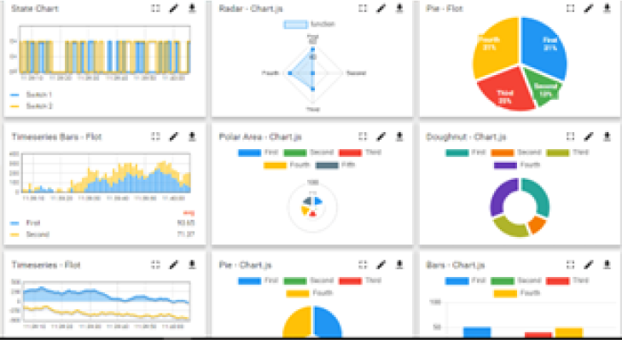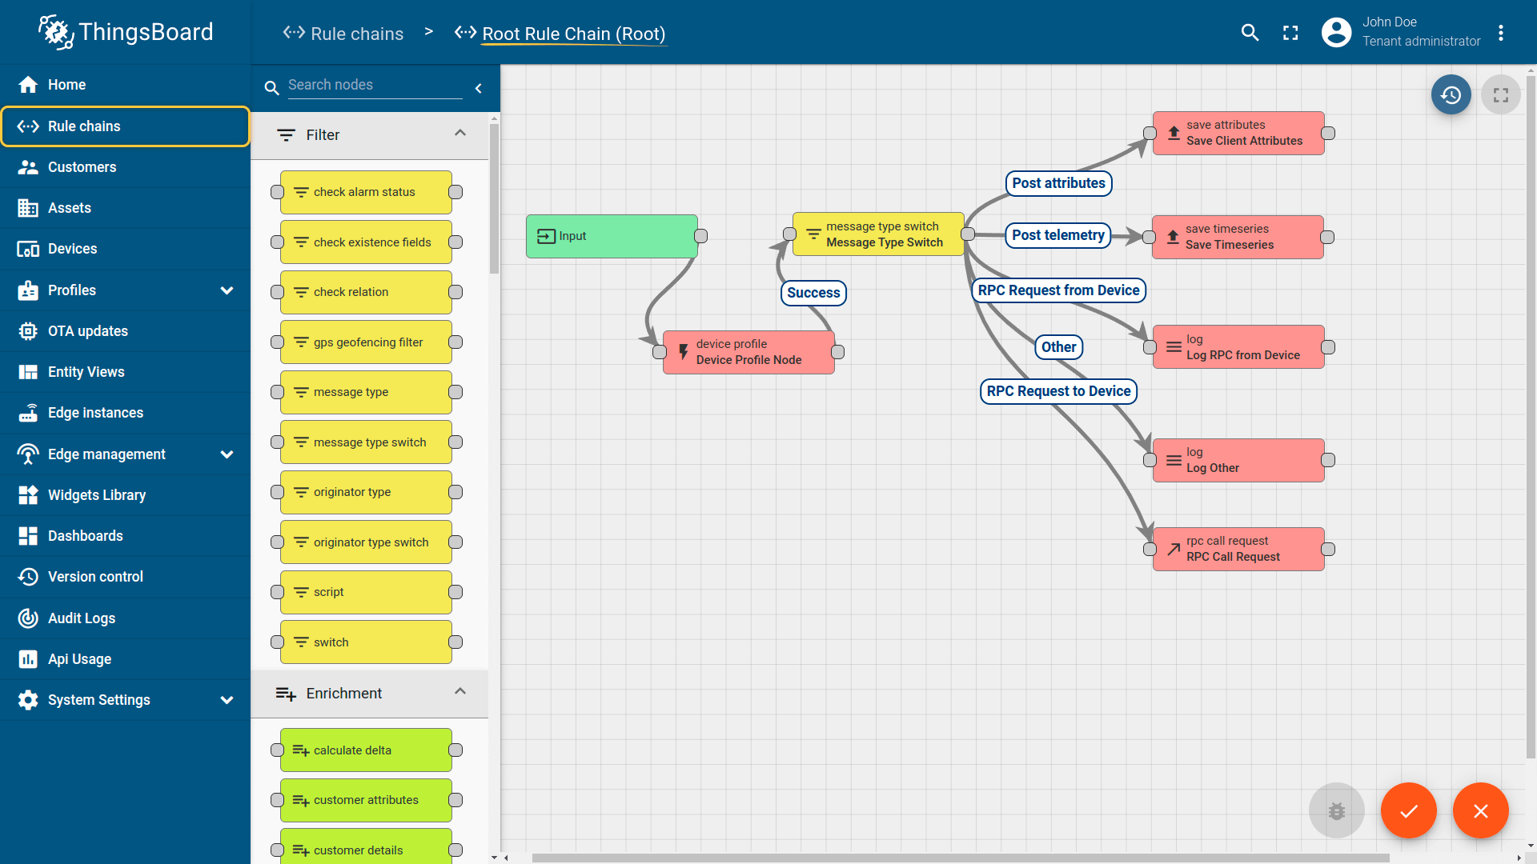

- Smart Factory Platform ()
Factory watch is a platform for smart factory needs.
It provides Users/ Factory
- with a scalable solution for their Production and asset monitoring
- OEE and predictive maintenance solution scaling up to digital twin for your assets.
- to unleased the true potential of the data that their machines are generating and helps to identify the KPIs and also improve them.
- A modular architecture that allows users to choose the service that they what to start and then can scale to more complex solutions as per their demands.
Its unique SaaS model helps users to save time, cost and money.
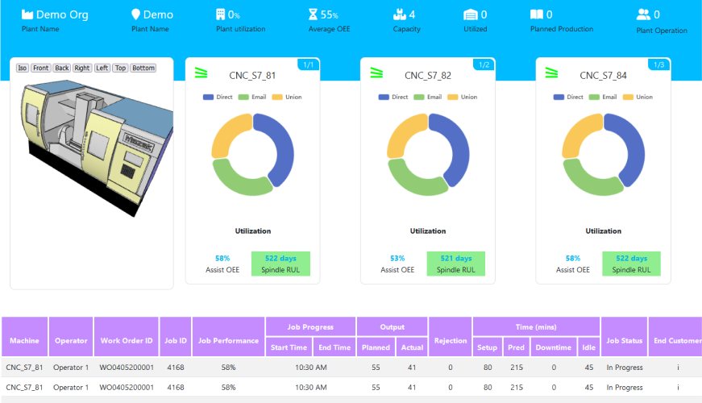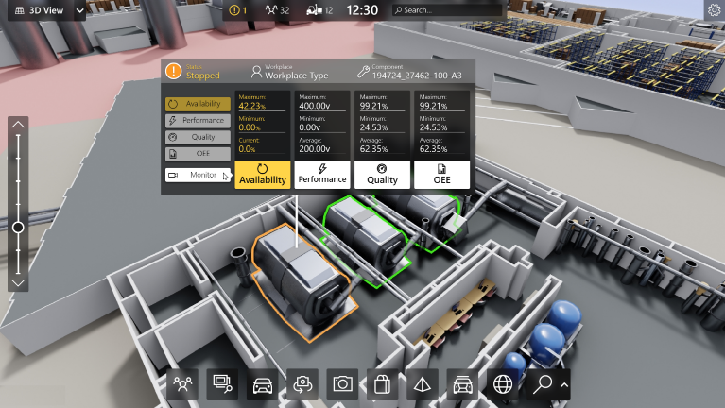

- 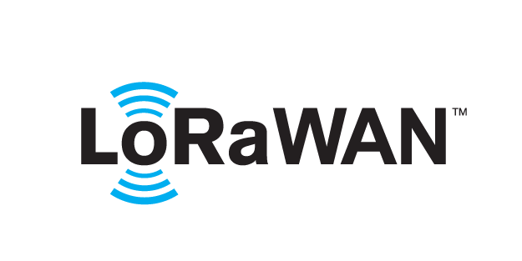 based Solution
UCT is one of the early adopters of LoRAWAN teschnology and providing solution in Agritech, Smart cities, Industrial Monitoring, Smart Street Light, Smart Water/ Gas/ Electricity metering solutions etc.
- Predictive Maintenance
UCT is providing Industrial Machine health monitoring and Predictive maintenance solution leveraging Embedded system, Industrial IoT and Machine Learning Technologies by finding Remaining useful life time of various Machines used in production process.
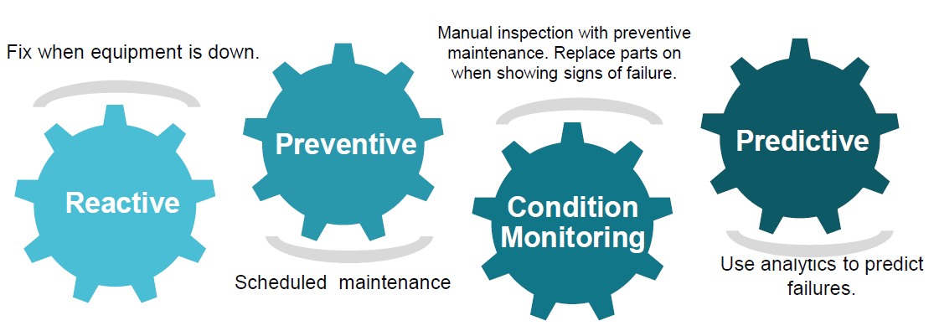

About upskill Campus (USC)
upskill Campus along with The IoT Academy and in association with Uniconverge technologies has facilitated the smooth execution of the complete internship process.
USC is a career development platform that delivers personalized executive coaching in a more affordable, scalable and measurable way.




Seeing need of upskilling in self paced manner along-with additional support services e.g. Internship, projects, interaction with Industry experts, Career growth Services
https://www.upskillcampus.com/
upSkill Campus aiming to upskill 1 million learners in next 5 year

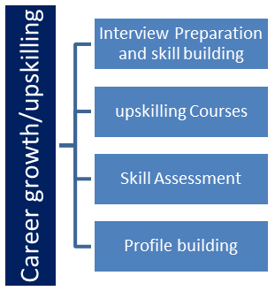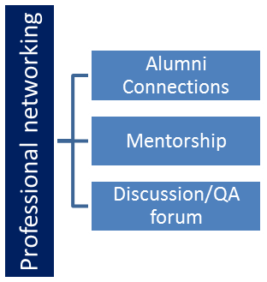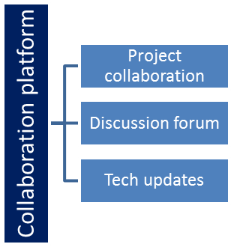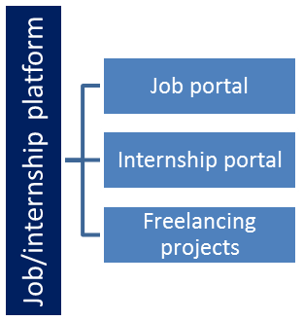

The IoT Academy
The IoT academy is EdTech Division of UCT that is running long executive certification programs in collaboration with EICT Academy, IITK, IITR and IITG in multiple domains.

Objectives of this Internship program
The objectives of this internship project are to:
☛ gain practical experience in full-stack web application development.
☛ implement a real-world food ordering and delivery workflow.
☛ understand frontend, backend, database, and API integration.
☛ improve problem-solving and debugging skills through practical implementation.
☛ develop a project that can be extended with real-time tracking, payments, recommendations, and analytics.

Reference
[1] MERN stack technologies and official documentation used during development.
[2] React, Vite, React Router, Express.js, MongoDB/Mongoose, JWT and bcryptjs documentation.
[3] Internship problem statement and project requirements provided through the internship program.

Glossary
Terms | Acronym
MERN | MongoDB, Express.js, React.js, Node.js
API | Application Programming Interface
JWT | JSON Web Token
UI | User Interface
ETA | Estimated Time of Arrival

Problem Statement
The assigned problem statement is to develop an application that forms a bridge between restaurants and consumers. Restaurant owners must be able to sign up and list food items with prices. Users must be able to sign up, view restaurants nearby, select food items, and place orders.
The system should allow restaurants to accept orders and assign delivery personnel. The customer should be able to view the delivery person's location and dynamic ETA. A common cart and payment experience should be provided across the application. Additional requirements include cuisine browsing, personalized recommendations, ratings and reviews, dish photos, restaurant dashboards, saved addresses and payment methods, favourites, recent orders, push notifications, online/Cash-on-Delivery payments, and analytics.

Existing and Proposed solution

Existing food delivery platforms commonly provide restaurant discovery, menu browsing, cart and checkout, order management, delivery tracking, ratings, and notifications. However, the project is intended to provide a tailored implementation where restaurant management, customer ordering, delivery workflows, and analytics are integrated into one application.
The proposed solution is a MERN-based Food Delivery Application with separate customer, restaurant owner, and delivery personnel workflows. It will provide restaurant/menu management, ordering, cart and payment, order processing, delivery assignment, location tracking, dynamic ETA, ratings, notifications, and analytics.
The planned value addition is a modular architecture that can be extended with personalized recommendations, cuisine-based discovery, favourites, recent orders, loyalty features, and data-driven restaurant analytics.

Code submission (GitHub link)
GitHub Repository: https://github.com/[YOUR-GITHUB-USERNAME]/upskillcampus

Report submission (GitHub link) — placeholder to be updated after uploading the report

Report Link: https://github.com/[YOUR-GITHUB-USERNAME]/upskillcampus/blob/main/FoodDeliveryApplication_P_Sai_Avinash_USC_UCT.pdf

Proposed Design/ Model

The proposed system follows a layered full-stack architecture. A customer interacts with the React frontend, which communicates with the Express/Node.js REST API. The backend authenticates users, processes application logic, and stores data in MongoDB through Mongoose. Restaurant and delivery workflows will use the same backend services and database.

High Level Diagram
CUSTOMER / RESTAURANT OWNER / DELIVERY DRIVER
↓
REACT FRONTEND + ROUTING
↓
EXPRESS / NODE.JS REST API

↓
MONGODB + MONGOOSE
↓
AUTHENTICATION • ORDERS • MENUS • DELIVERY
Future integrations: Mapping API • Payment Gateway • Notifications
Low Level Diagram
Customer → Login/Register → Restaurant Discovery → Menu → Cart → Checkout → Order → Restaurant Confirmation → Driver Assignment → Pickup → Live Tracking/ETA → Delivery

Interfaces
The main interfaces being developed are Login, Registration, Customer Dashboard, Restaurant Dashboard, Delivery Dashboard, Restaurant/Menu Management, Cart, Checkout/Payment, Order Tracking, and Ratings/Reviews. The current frontend uses React, React Router, and Tailwind CSS.

Performance Test

At the current development stage, testing has focused primarily on functional integration rather than large-scale performance benchmarking. The main constraints identified are API response reliability, database validation, authentication security, frontend responsiveness, and the future need for real-time location/ETA updates.
Initial constraints include correct request/response formats, consistent field names between frontend and backend, database schema validation, and reliable API connectivity.
These constraints are being handled through structured schemas, API testing, browser console inspection, backend terminal logging, password hashing, JWT authentication, and iterative debugging.
Initial testing identified frontend rendering issues and Mongoose validation errors during registration. These were used to trace the communication path from the React form to the Express API and then to the MongoDB model.
Detailed load, latency, concurrent-user, and real-time tracking benchmarks have not yet been completed because the project is still under development. Future testing should measure API response time, database performance, concurrent requests, notification delivery, and tracking/ETA update frequency.
In case you could not test them, but still you should mention how identified constraints can impact your design, and what are recommendations to handle them.

Test Plan / Test Cases

1. Start the Vite frontend and verify application rendering.
2. Verify React Router navigation between authentication pages.
3. Submit registration data and inspect the API request/response.
4. Verify backend validation and MongoDB schema handling.
5. Verify login and JWT generation after successful registration.
6. Test future order, payment, and delivery workflows as they are implemented.

Performance Outcome: Initial environment and integration testing is in progress. The Vite development server was successfully started, frontend-backend communication reached the backend, and validation errors were identified through testing. Full performance benchmarking will be performed after the core ordering and delivery modules are complete.

My learnings

This project has improved my understanding of full-stack development using the MERN stack. I have gained practical experience with React and Vite, React Router, Tailwind CSS, Express.js REST APIs, MongoDB/Mongoose, JWT authentication, password hashing, frontend-backend integration, and debugging. These skills will support my career growth in software development and full-stack application engineering.

Future work scope

Future work includes completing restaurant and menu management, customer restaurant discovery, cart and checkout, payment processing, order status management, delivery-driver assignment, mapping API integration, real-time driver location and dynamic ETA, push notifications, ratings/reviews, personalized recommendations, favourites, recent orders, loyalty features, and analytics. Performance and security testing will also be expanded before final deployment.

