**__Note - Extracting code can take more than 30 mins as each csv file is from 150 - 200 MB__**

**__ I am have extracted all files at once as Q3 and Q4 needs all files where are Q1 and Q2 need only 2021 file__**

Zip folder



Unzip

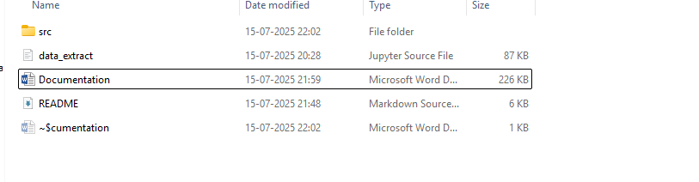

Open in VS Code.

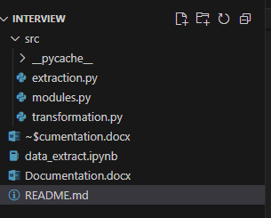

Open terminal. Navigate to src folder.

Run command – python extraction.py

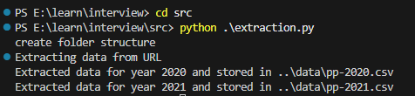

Creates data, results and intermediate folders.

Extracts and store csv files in data folder.

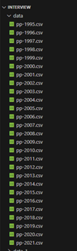

Run command -> python transformation.py

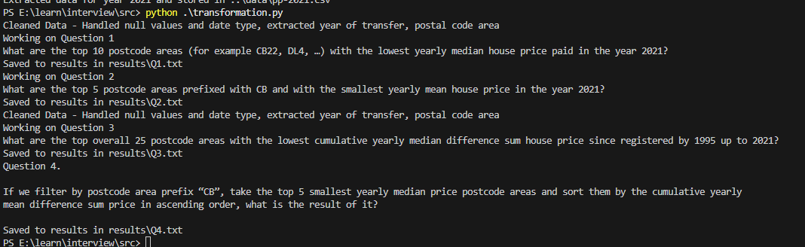

Creates text files in results folder and some intermediate files for exploring.

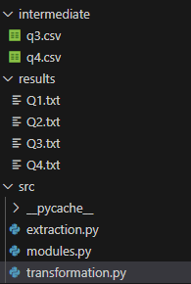

Results

