Color Complexity and Sharpness for
Instagram Engagement Classification in University Accounts

Jefri Marzal¹, Akhiyar Waladi², Muhammad Razi A³, Miranty Yudistira⁴
^{1,2,3,4} Universitas Jambi, Jambi, Indonesia
Corresponding author email: akhiyar.waladi@unja.ac.id

Abstract
Understanding the visual factors that drive engagement on social media platforms is essential for effective content strategy. This study investigates the classification of Instagram post engagement using interpretable visual and temporal features extracted from university social media content. We analyzed 638 Instagram posts from two university accounts (Faculty of Science and Technology and Student Executive Board of Health Sciences), extracting six visual features (colorfulness, color complexity, dominant hue, contrast, symmetry, and sharpness) and three temporal features (posting hour, day of week, and weekend indicator). A binary classification approach was employed to categorize posts into low and high engagement classes based on median likes. Four machine learning classifiers were evaluated using stratified 5-fold cross-validation. The Random Forest classifier achieved the highest performance with an F1-score of 0.714, accuracy of 69.9 percent, and AUC-ROC of 0.775. Feature importance analysis revealed that color complexity contributed 22.4 percent to the classification decision, followed by sharpness at 21.9 percent and contrast at 16.4 percent. These findings suggest that visually complex images with higher color diversity and sharp details tend to generate greater engagement on university Instagram accounts. The interpretable nature of the extracted features provides actionable insights for social media content creators in academic institutions.

Keywords: Instagram engagement, visual features, temporal features, machine learning classification, social media analytics, color complexity

INTRODUCTION
Social media platforms have become essential communication channels for educational institutions to engage with students, faculty, and the broader community. Research on Swiss higher education institutions found that Instagram serves as an effective platform for organizational communication, with visual content playing a crucial role in audience engagement [1]. Universities increasingly rely on these platforms to showcase campus life, academic achievements, and institutional activities, making understanding of visual engagement drivers a strategic priority for communication departments.
The importance of visual elements in social media engagement has been demonstrated across various contexts. A study examining travel agency Instagram posts found that visual and textual features significantly predict user engagement, with image characteristics accounting for substantial variance in like counts [2]. Similarly, research on food marketing Instagram content revealed that computer vision approaches can effectively predict social media engagement, though interpretable features provide more actionable insights for practitioners [3]. These findings highlight the potential of visual analysis for engagement prediction in university contexts.
Recent studies have identified color complexity as a significant predictor of user attention and engagement. Research published in the International Journal of Research in Marketing demonstrated that images with greater color complexity capture more visual attention and generate higher engagement, as measured through eye-tracking experiments [4]. The study found that color complexity serves as an external cue that draws social media users' attention and provokes a shift from peripheral to central processing mode, suggesting that visually diverse images are more likely to engage viewers.
The prediction of social media engagement presents several challenges. Engagement metrics such as likes and comments are influenced by numerous factors beyond visual content, including posting time, caption text, and account following size. Recent research on university posting strategies examined how these factors interact to influence engagement levels across different platform contexts [5]. The subjective nature of visual appeal makes it difficult to identify universal predictive features, and single-account studies with limited samples constrain the generalizability of findings.
This research addresses these challenges by analyzing multiple university accounts and incorporating both visual and temporal features that can provide actionable insights for content creators. Rather than employing black-box deep learning models, we extract nine interpretable features from Instagram posts and evaluate their predictive power for engagement classification. The main contributions of this study are threefold: the development of a feature extraction pipeline specifically designed for Instagram content analysis incorporating colorfulness, color complexity, contrast, symmetry, sharpness, and temporal metrics; a comparative evaluation of four machine learning classifiers for binary engagement classification using stratified cross-validation on a multi-account dataset; and an analysis of feature importance to identify which visual and temporal characteristics most strongly influence engagement on university Instagram accounts.

RESEARCH METHOD
This section describes the dataset used in this study, the visual and temporal feature extraction methods, machine learning classifiers, and the overall experimental design. The methodology follows a systematic approach from data collection through feature extraction to model evaluation, with particular emphasis on interpretable characteristics that can inform practical content creation decisions.
Methodology Overview
The research methodology consists of six main phases as illustrated in Figure 1. The workflow begins with data collection from Instagram accounts using automated web scraping tools, followed by preprocessing to filter posts according to specific criteria. Visual and temporal features are then extracted from the filtered dataset, and the dataset is prepared for classification by applying median split labeling. Finally, machine learning classifiers are trained and evaluated using stratified cross-validation, with comprehensive results analysis including performance metrics and feature importance rankings.
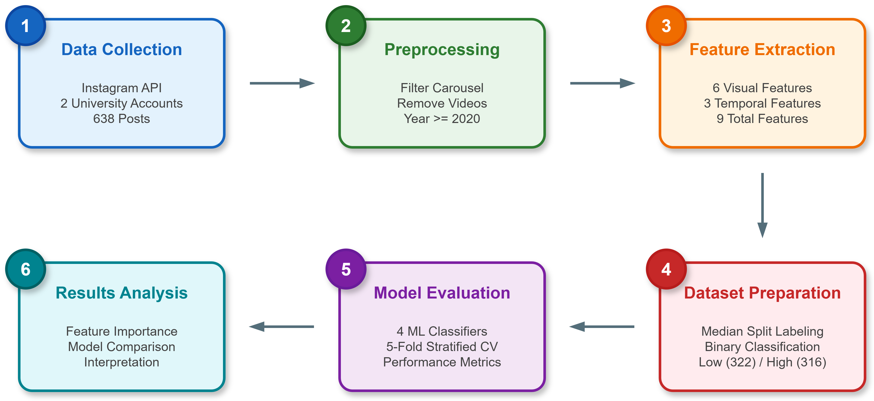
Figure 1 Research methodology flowchart showing the six-phase approach from data collection to results analysis.
The preprocessing phase applies several filters aligned with established methodology: carousel posts are reduced to their first image only, posts before 2020 are excluded to ensure recency, video posts are removed to focus on static image analysis, and posts with suspiciously low engagement (three likes or fewer) are filtered as potential errors or incomplete data..
Dataset Source and Collection
The dataset consists of 638 Instagram posts collected from two official university accounts: the Faculty of Science and Technology (FST) Universitas Jambi with 136 posts, and the Student Executive Board of Health Sciences (BEM FKIK) Universitas Jambi with 502 posts. Posts were collected using automated web scraping tools with appropriate rate limiting to comply with platform guidelines. For each post, the following information was recorded: image content, like count, comment count, posting timestamp, and account identifier.
Table 1 Dataset Statistics
Account | Posts | Low | High | Likes Min | Likes Max | Likes Mean | Likes Median
fst_unja | 136 | 23 | 113 | 15 | 4650 | 267,6 | 146
bemfkik.unja | 502 | 299 | 203 | 4 | 824 | 77,2 | 50
Total | 638 | 322 | 316 | 4 | 4650 | 117,8 | 64
The dataset filtering process is summarized as follows. From a total of 2,820 JSON metadata files, 1,560 were filtered as carousel items (keeping only the first image), 355 were excluded for being posted before 2020, 63 video posts were removed, and 204 posts with three likes or fewer were filtered as suspicious data. The final dataset contains 638 unique posts spanning the period from 2020 to 2024.
The posts include both single images (320 posts, representing 50.2 percent) and carousel posts where the first image was used for feature extraction (318 posts, representing 49.8 percent). Like counts range from 4 to 4,650 with a median of 64 likes and a mean of 117.8 likes. The distribution of likes exhibits a right-skewed pattern typical of social media engagement data, with most posts receiving modest engagement while a small number of viral posts receive substantially higher like counts. For binary classification, posts were divided into two classes based on the median like count, where posts with likes at or below the median were labeled as Low engagement, while posts exceeding the median were labeled as High engagement. This approach resulted in a balanced dataset with 322 posts in the Low class (50.5 percent) and 316 posts in the High class (49.5 percent).
Research Procedure
Six visual features were extracted from each image to capture different aspects of visual appeal. These features were selected based on prior research in image aesthetics assessment, which has demonstrated the effectiveness of both hand-crafted and deep learning approaches for evaluating visual quality [6]. Recent work on CNN-based aesthetic score prediction has shown that ensemble methods combining multiple feature types can achieve improved performance [7].
Colorfulness. The colorfulness metric quantifies the variety and intensity of colors in an image. Recent studies on no-reference image quality assessment have adopted the colorfulness definition based on opponent color space statistics, which measures chromatic content perceived by human observers [8]. The colorfulness metric is computed as:
$$C=\sqrt{σ_{rg}^{2}+σ_{yb}^{2}}+0.3×\sqrt{μ_{rg}^{2}+μ_{yb}^{2}}$$
where $σ_{rg}$ and $σ_{yb}$ represent the standard deviations of the red-green and yellow-blue opponent channels, respectively, and $μ_{rg}$ and $μ_{yb}$ are their corresponding means. This metric has been validated against human perception in psychophysical experiments, achieving over 95 percent correlation with subjective colorfulness ratings.
Color Complexity. Color complexity measures the diversity of colors present in an image using Shannon entropy applied to quantized color distributions. This approach has been widely adopted in image quality evaluation frameworks that combine gradient, saliency, and color information [9]. The image is first quantized into a reduced color palette, and entropy is computed over the color distribution:
$$H=-\sum_{i=1}^{n}{p_{i}}\log_{2}\left(p_{i}\right)$$
where $p_{i}$ represents the probability of color bin $i$ and $n$ is the total number of color bins. Higher entropy values indicate greater color diversity.
Dominant Hue. The dominant hue captures the most prevalent color tone in the image by converting images to HSV (Hue, Saturation, Value) color space and computing the mode of the hue histogram. The dominant hue value $h_{d}$ ranges from 0 to 360 degrees, representing the full color spectrum.
RMS Contrast. Image contrast is measured using root mean square (RMS) contrast, which quantifies the spread of luminance values. This measure has been incorporated into recent image quality evaluation frameworks that consider gradient and visual saliency alongside color information [9]. The RMS contrast is computed as:
$$C_{rms}=\sqrt{\frac{1}{MN}\sum_{i=1}^{M}{\sum_{j=1}^{N}{{\left(I_{ij}-\overline{I}\right)}^{2}}}}$$
where $I_{ij}$ represents the pixel intensity at position $\left(i,j\right)$, $\overline{I}$ is the mean intensity, and $M ×N$ is the image dimension.
Symmetry Score. Visual symmetry contributes to perceived image aesthetics through processing fluency mechanisms. Research on computational aesthetic measures has demonstrated that image fluency components, including symmetry, significantly predict viewer engagement and aesthetic preferences [10]. The symmetry score is computed by comparing the original image with its horizontally flipped version using structural similarity:
$$S=\frac{1}{N}\sum_{i=1}^{N}{\text{SSIM}\left(I_{i},I_{i}^{flip}\right)}$$
where $I_{i}^{flip}$ represents the horizontally flipped image. Values closer to 1 indicate higher symmetry, suggesting that the left and right halves of the image contain similar visual elements.
Sharpness (Laplacian Variance). Image sharpness is quantified using the variance of the Laplacian operator, which measures the presence of edges and fine details. Recent autofocus algorithms have employed optimized Laplacian evaluation functions combining local variance with edge detection to improve accuracy [11]. The sharpness metric is computed as:
$$σ_{L}^{2}=\text{Var}\left(∇^{2}I\right)=\text{Var}\left(\frac{∂^{2}I}{∂x^{2}}+\frac{∂^{2}I}{∂y^{2}}\right)$$
Higher variance indicates sharper images with more defined edges, while lower variance suggests blurrier images. This metric is particularly relevant for social media content where image quality can significantly impact user perception and engagement.
Temporal Feature Extraction
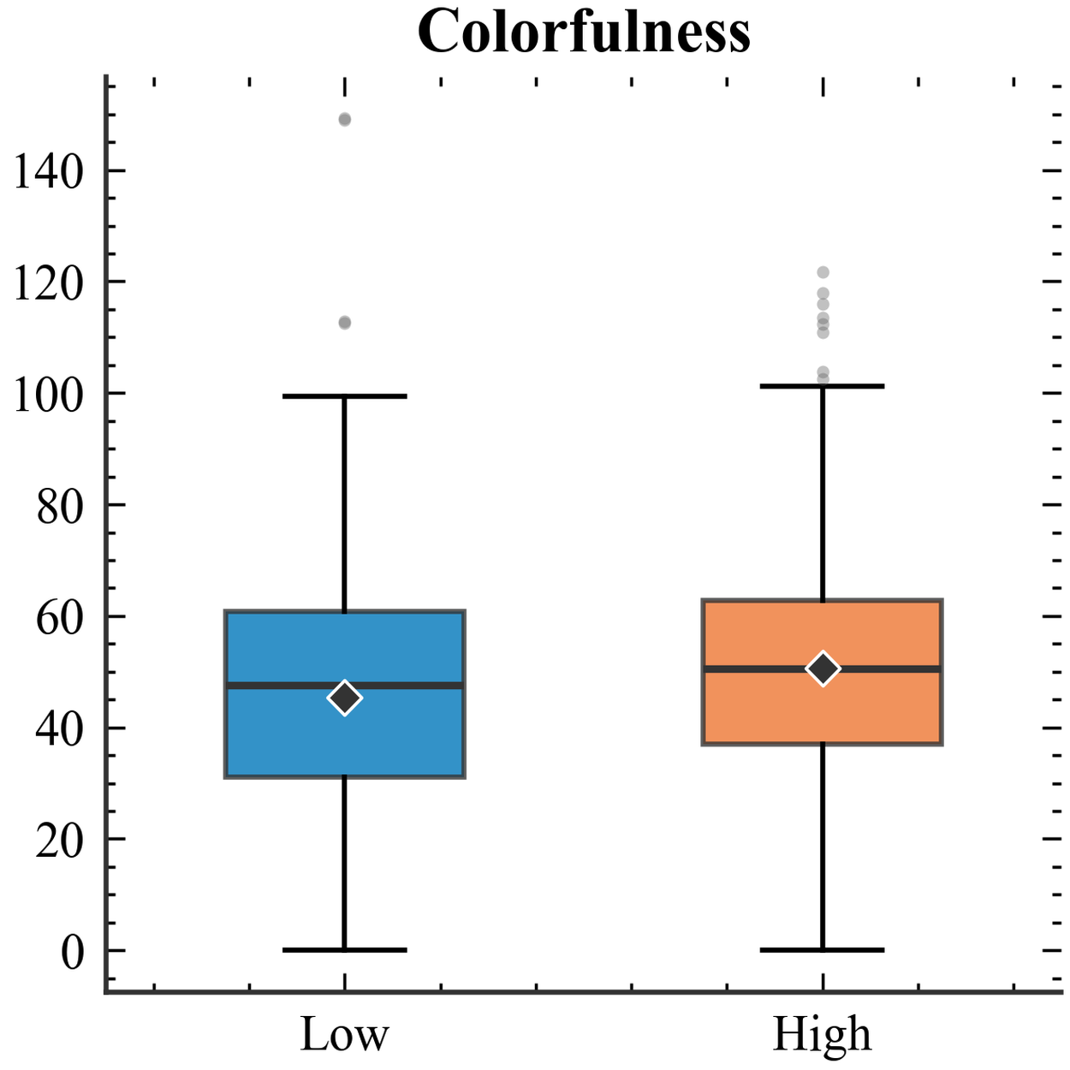 | 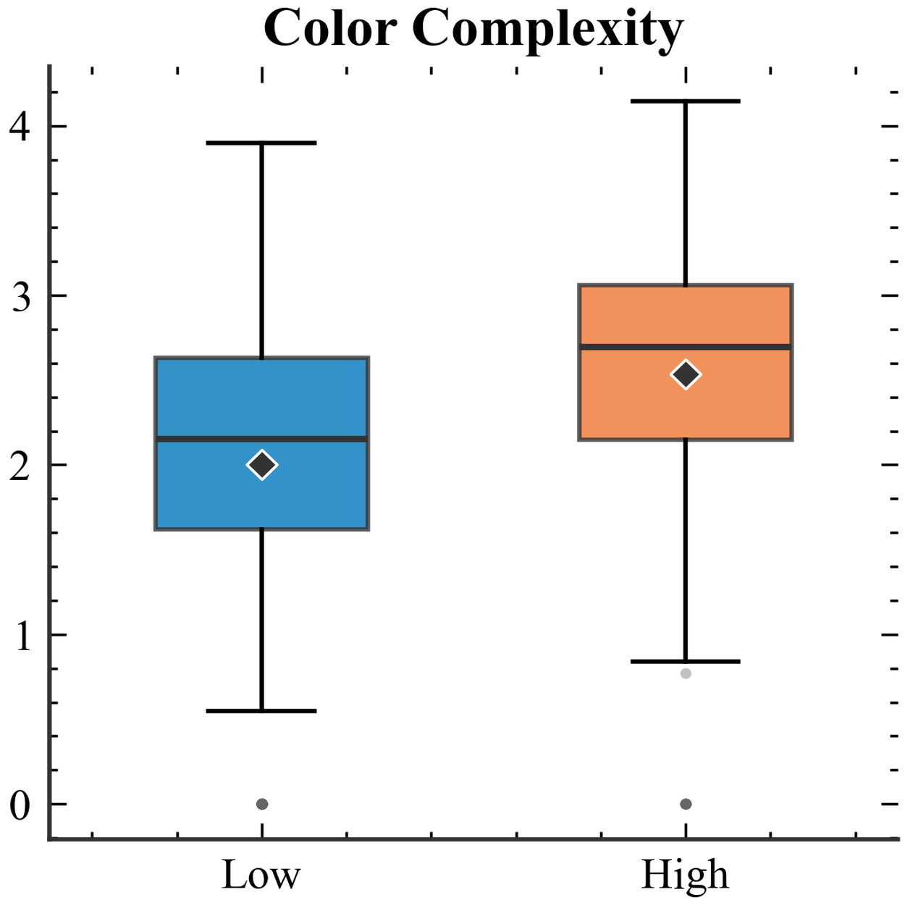 | 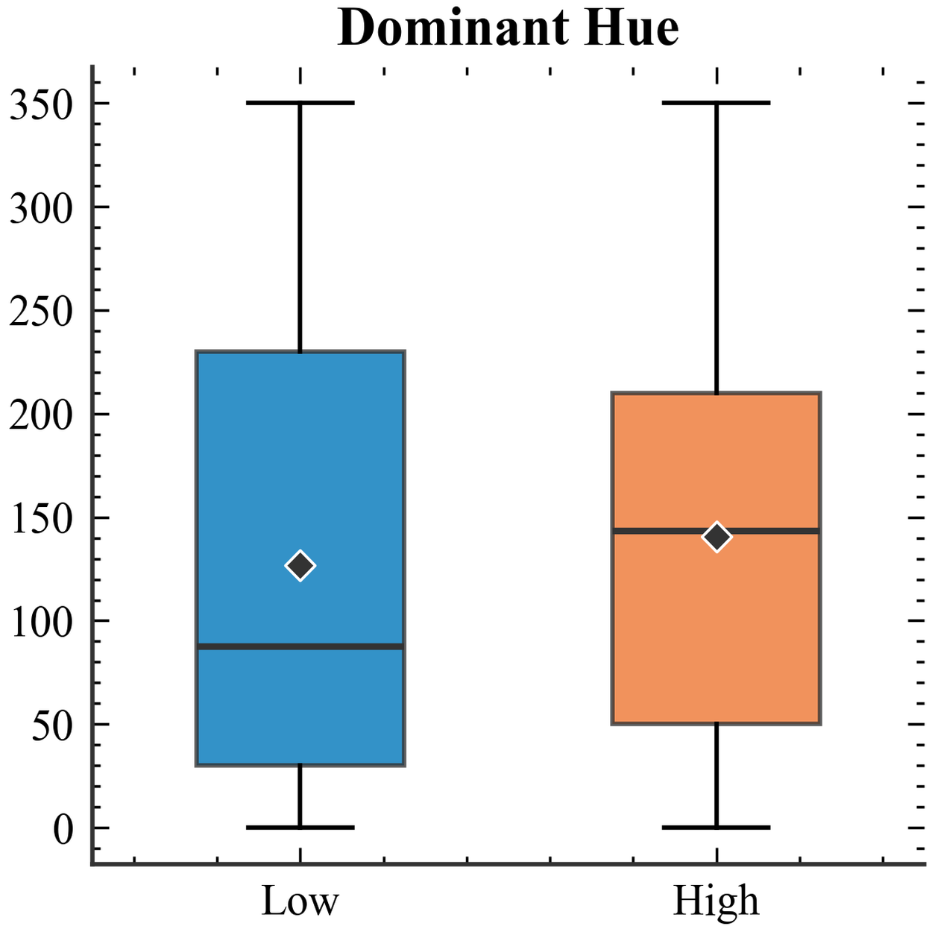 | 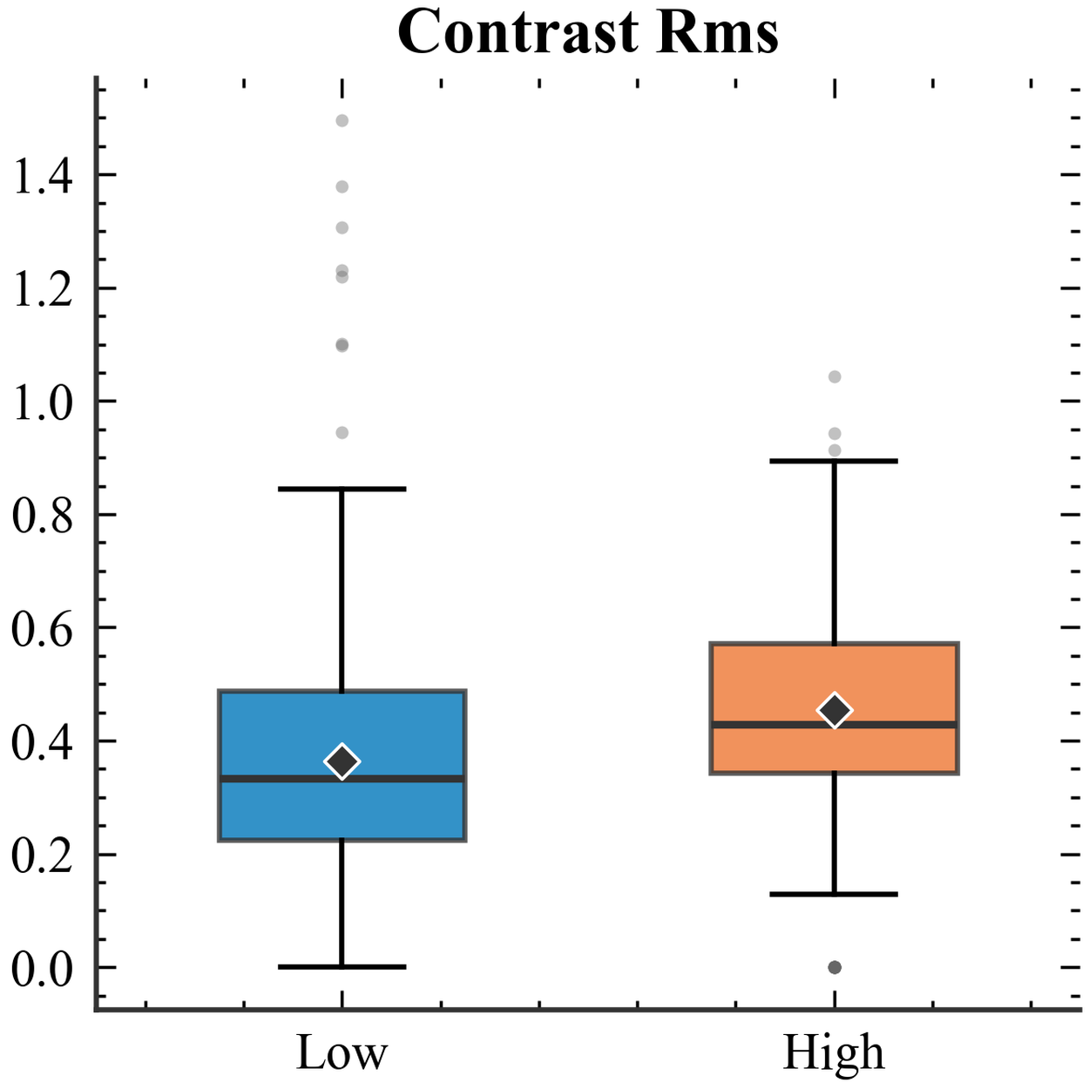
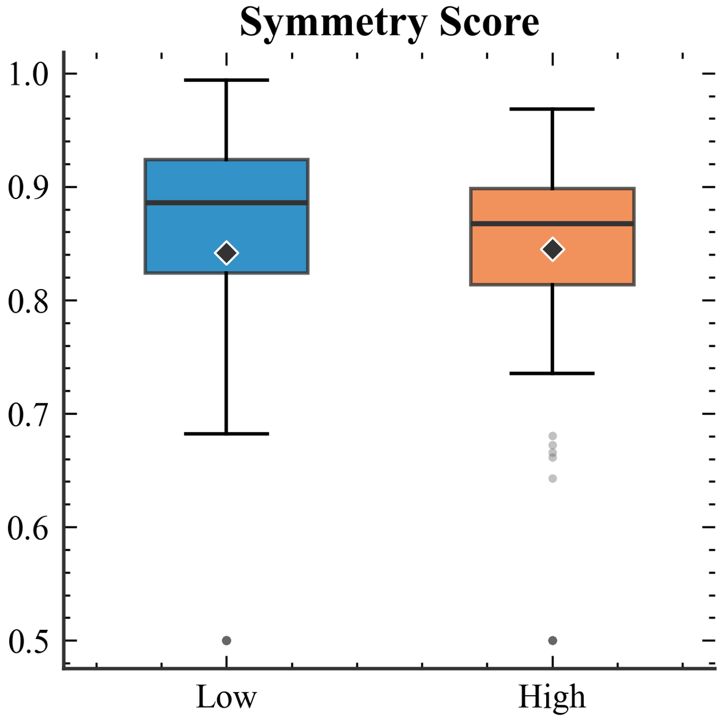 | 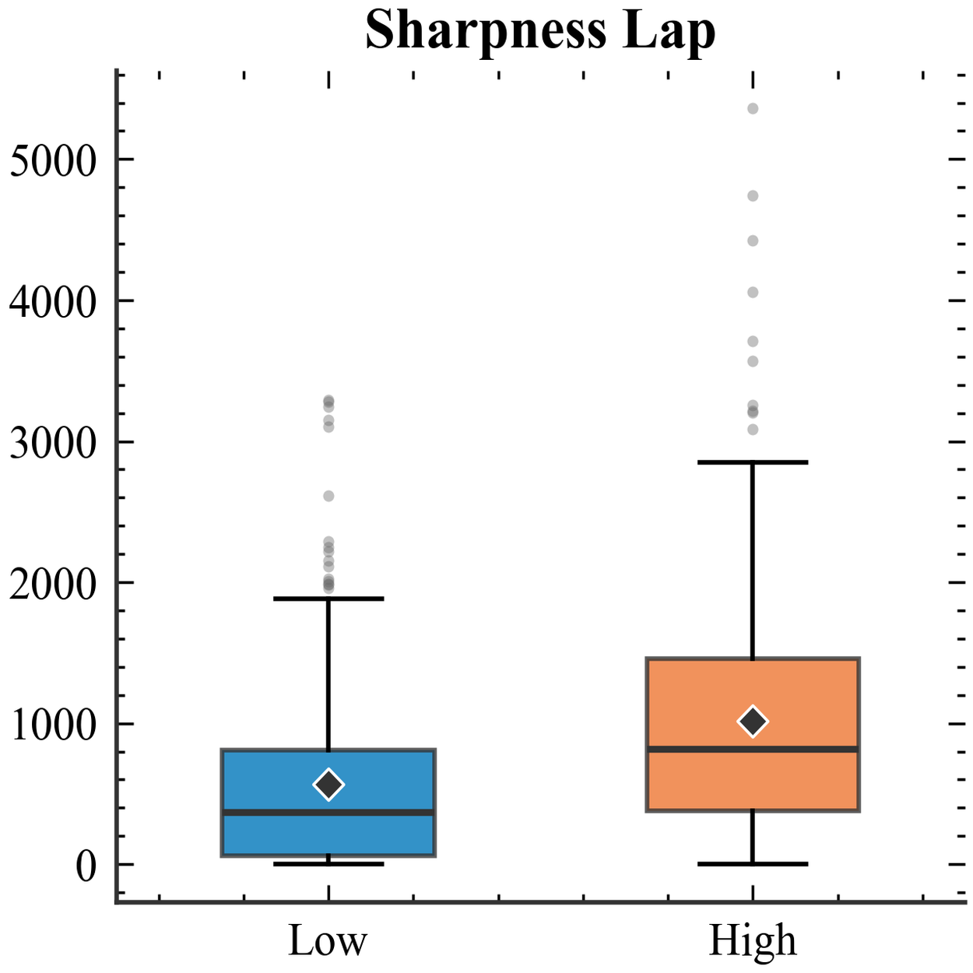 | 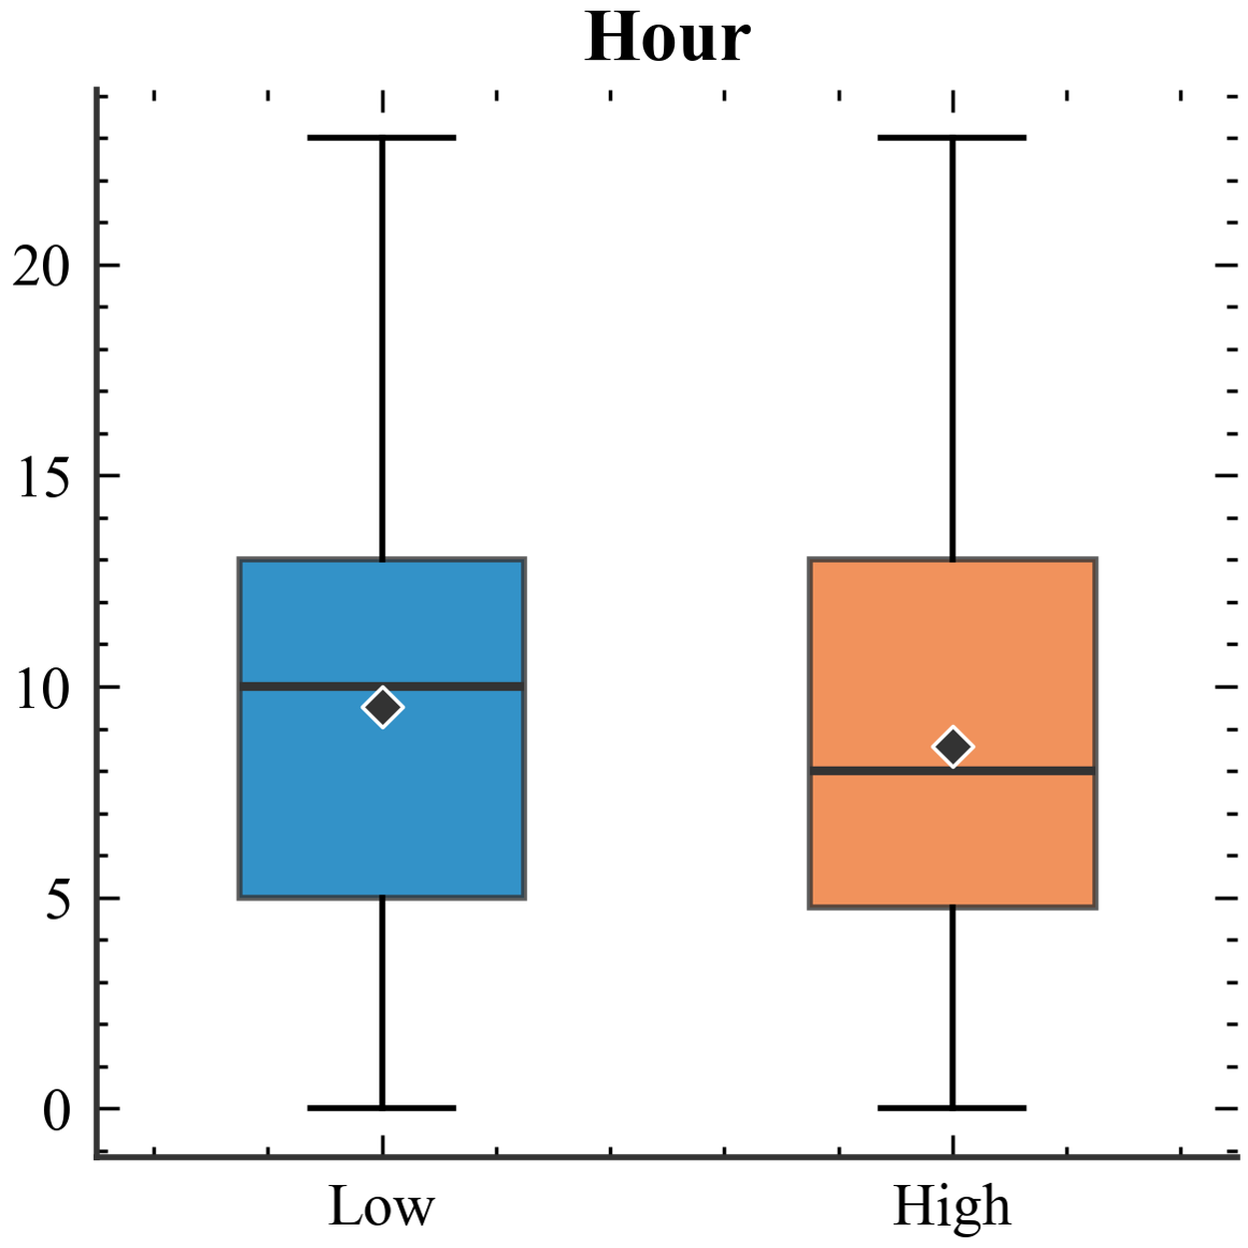 | 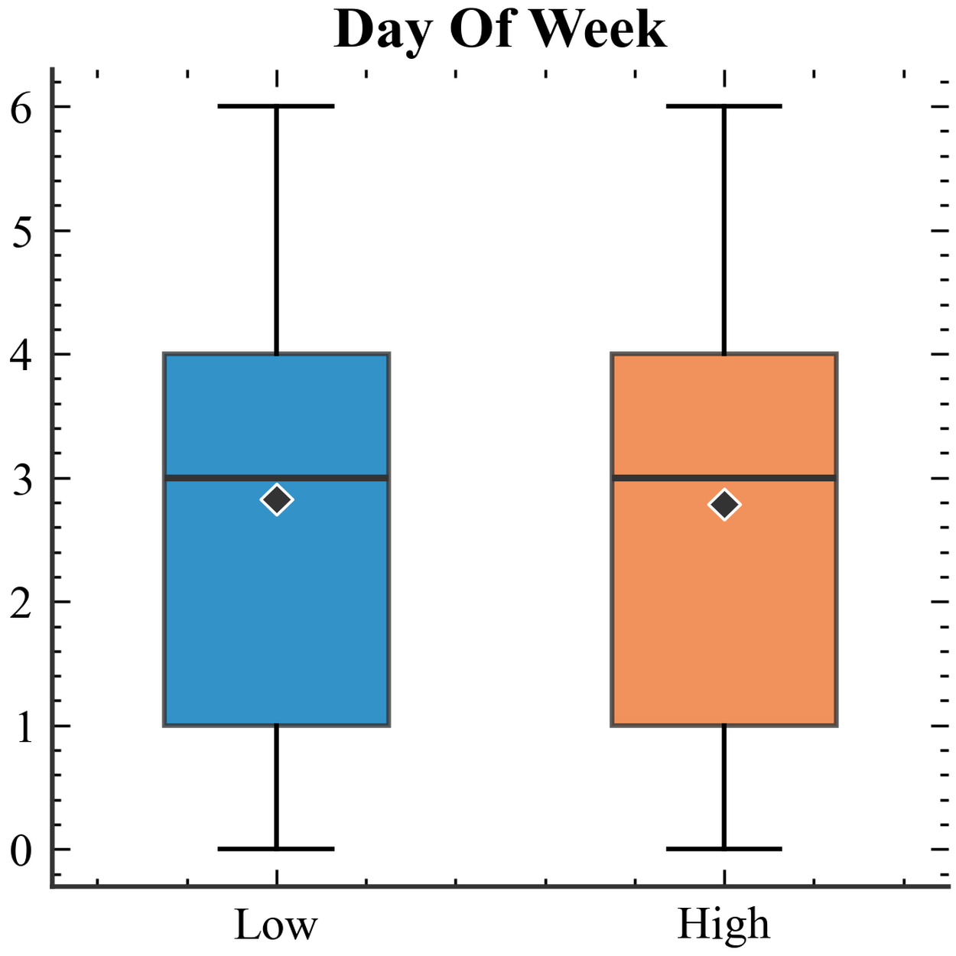
Figure 2 Distribution of visual and temporal features across low and high engagement classes
Three temporal features were extracted from the posting timestamp to capture time-based patterns in engagement behavior [5]. The posting hour ranges from 0 to 23, representing the local time when the post was published. The day of week is encoded as an integer from 0 (Monday) to 6 (Sunday), capturing weekly patterns in user engagement. Additionally, a binary weekend indicator was included to flag posts published on Saturday or Sunday, with 136 posts (21.3 percent) in the dataset being published on weekends.
Figure 2 presents the distribution of all nine features across low and high engagement classes using boxplots. Among visual features, sharpness shows the most pronounced distinction, with high engagement posts displaying substantially higher median values and wider interquartile range. Color complexity also demonstrates clear separation, where high engagement posts tend toward greater color diversity as indicated by higher median entropy values. Contrast exhibits a similar pattern with high engagement posts showing elevated median values.
In contrast, colorfulness and symmetry score show largely overlapping distributions between the two classes, suggesting limited discriminative power for engagement prediction. Among temporal features, posting hour shows a slight tendency for low engagement posts to be published later in the day, while day of week and weekend indicator display nearly identical distributions across both engagement classes, indicating minimal temporal influence on engagement outcomes..
Machine Learning Classifiers
Four machine learning classifiers were evaluated for the binary engagement classification task, representing different algorithmic paradigms including ensemble methods, linear models, gradient boosting, and kernel-based approaches. Each classifier offers distinct advantages in terms of interpretability, handling of non-linear relationships, and robustness to overfitting.
Random Forest. Random Forest is an ensemble method that constructs multiple decision trees during training and outputs the mode of individual tree predictions. Comparative studies have shown that Random Forest achieves competitive performance across various classification tasks, with recent research on urban impervious surface mapping demonstrating its effectiveness for feature-based classification [12]. The prediction is computed as:
$$\hat{y}=\text{mode}\{T_{1}\left(x\right),T_{2}\left(x\right),…,T_{n}\left(x\right)\}$$
where $T_{i}\left(x\right)$ represents the prediction of the $i$-th tree and $n$ is the total number of trees in the forest. Feature importance is computed using the mean decrease in impurity (Gini importance), which measures the total decrease in node impurity weighted by the probability of reaching that node, averaged over all trees in the ensemble.
Logistic Regression. Logistic Regression models the probability of class membership using the sigmoid function:
$$P\left(y=1 | x\right)=\frac{1}{1+e^{-\left(β_{0}+β_{1}x_{1}+…+β_{k}x_{k}\right)}}$$
where $β_{0}$ is the intercept, $β_{1}$ through $β_{k}$ are the feature coefficients learned during training, and $x_{1}$ through $x_{k}$ are the nine input features. Sigmoid function maps to a probability value between 0 and 1.
XGBoost. Extreme Gradient Boosting (XGBoost) builds trees sequentially, with each new tree correcting errors from the ensemble. Recent studies on forest image classification have demonstrated that XGBoost achieves superior performance compared to other classifiers including Random Forest and deep learning approaches [13]. The objective function combines a loss function with regularization:
$$L=\sum_{i=1}^{n}{l\left(y_{i},\hat{y_{i}}\right)}+\sum_{k=1}^{K}{Ω\left(f_{k}\right)}$$
where $l$ is the loss function measuring prediction error, $Ω$ is the regularization term that penalizes model complexity to prevent overfitting, and $f_{k}$ represents each tree in the ensemble.
Support Vector Machine. The Support Vector Machine with RBF kernel finds the optimal hyperplane by maximizing the margin between classes. Comparative analysis of machine learning algorithms has shown that SVM complexity can be offset by simpler alternatives like XGBoost in certain classification scenarios [14]. The RBF kernel is defined as:
$$K\left(x_{i},x_{j}\right)=\exp\left(-γ|x_{i}-x_{j}|^{2}\right)$$
where $γ$ is the kernel coefficient controlling the influence of individual training samples. In this study, gamma was set to scale mode, which automatically adjusts based on the number of features and variance of the training data.
Experimental Design
The experimental workflow follows a systematic approach consisting of four main phases. First, images are collected from Instagram accounts and preprocessed with filtering criteria applied as described in Section II.B. Second, nine features (six visual and three temporal) are extracted from each post using the computational methods described above. Third, the dataset is split using stratified 5-fold cross-validation to ensure balanced class distribution in each fold, following established practices for optimizing machine learning prediction tasks [15]. Fourth, models are trained and evaluated using default hyperparameters to establish baseline performance.
Performance metrics are computed and reported as the mean and standard deviation across all five folds. The evaluation metrics include accuracy, precision, recall, F1-score, and AUC-ROC. Accuracy measures the proportion of correct predictions:
$$\text{Accuracy}=\frac{TP+TN}{TP+TN+FP+FN}$$
Precision measures the proportion of positive predictions that are correct, while recall measures the proportion of actual positives that are correctly identified:
$$\text{Precision}=\frac{TP}{TP+FP}, \text{Recall}=\frac{TP}{TP+FN}$$
The balanced nature of the current dataset (50.5 percent versus 49.5 percent) reduces concerns about class imbalance effects. The F1-score provides the harmonic mean of precision and recall:
$$F_{1}=2×\frac{\text{Precision}×\text{Recall}}{\text{Precision}+\text{Recall}}$$

RESULTS AND DISCUSSION
This section presents the experimental results, including model performance comparison, feature importance analysis, and discussion of findings. The results are organized to establish baseline performance using default hyperparameters, followed by insights derived from feature importance analysis.
Model Performance
Table 2 Classification Performance Comparison
Model | Accuracy | Precision | Recall | F1-Score | AUC-ROC
RandomForest | 0.699 | 0.676 | 0.760 | 0.714 | 0.775
XGBoost | 0.677 | 0.668 | 0.703 | 0.682 | 0.759
SVM_RBF | 0.668 | 0.656 | 0.696 | 0.674 | 0.727
LogisticRegression | 0.653 | 0.662 | 0.623 | 0.640 | 0.702
The Random Forest classifier achieved the highest performance across all metrics with an accuracy of 69.9 percent, F1-score of 0.714, and AUC-ROC of 0.775. This performance significantly exceeds the random baseline of 50 percent, demonstrating that the combination of visual and temporal features contains meaningful information for engagement prediction. The relatively low standard deviations across folds (approximately 2.5 to 4.2 percent) indicate stable model performance despite the moderate dataset size.
XGBoost achieved the second-best performance with 67.7 percent accuracy, F1-score of 0.682, and AUC-ROC of 0.759, followed by SVM with RBF kernel at 66.8 percent accuracy and F1-score of 0.674. Logistic Regression showed the lowest performance at 65.3 percent accuracy with F1-score of 0.640, suggesting that the relationship between features and engagement is not strictly linear and benefits from the non-linear modeling capabilities of ensemble methods.
The performance ranking of classifiers aligns with findings from comparative studies demonstrating that ensemble methods like Random Forest often outperform linear models and gradient boosting approaches for moderate-sized datasets with interpretable features [12]. The strong AUC-ROC scores (ranging from 0.702 to 0.775) indicate that all classifiers achieve good discriminative ability between low and high engagement classes.

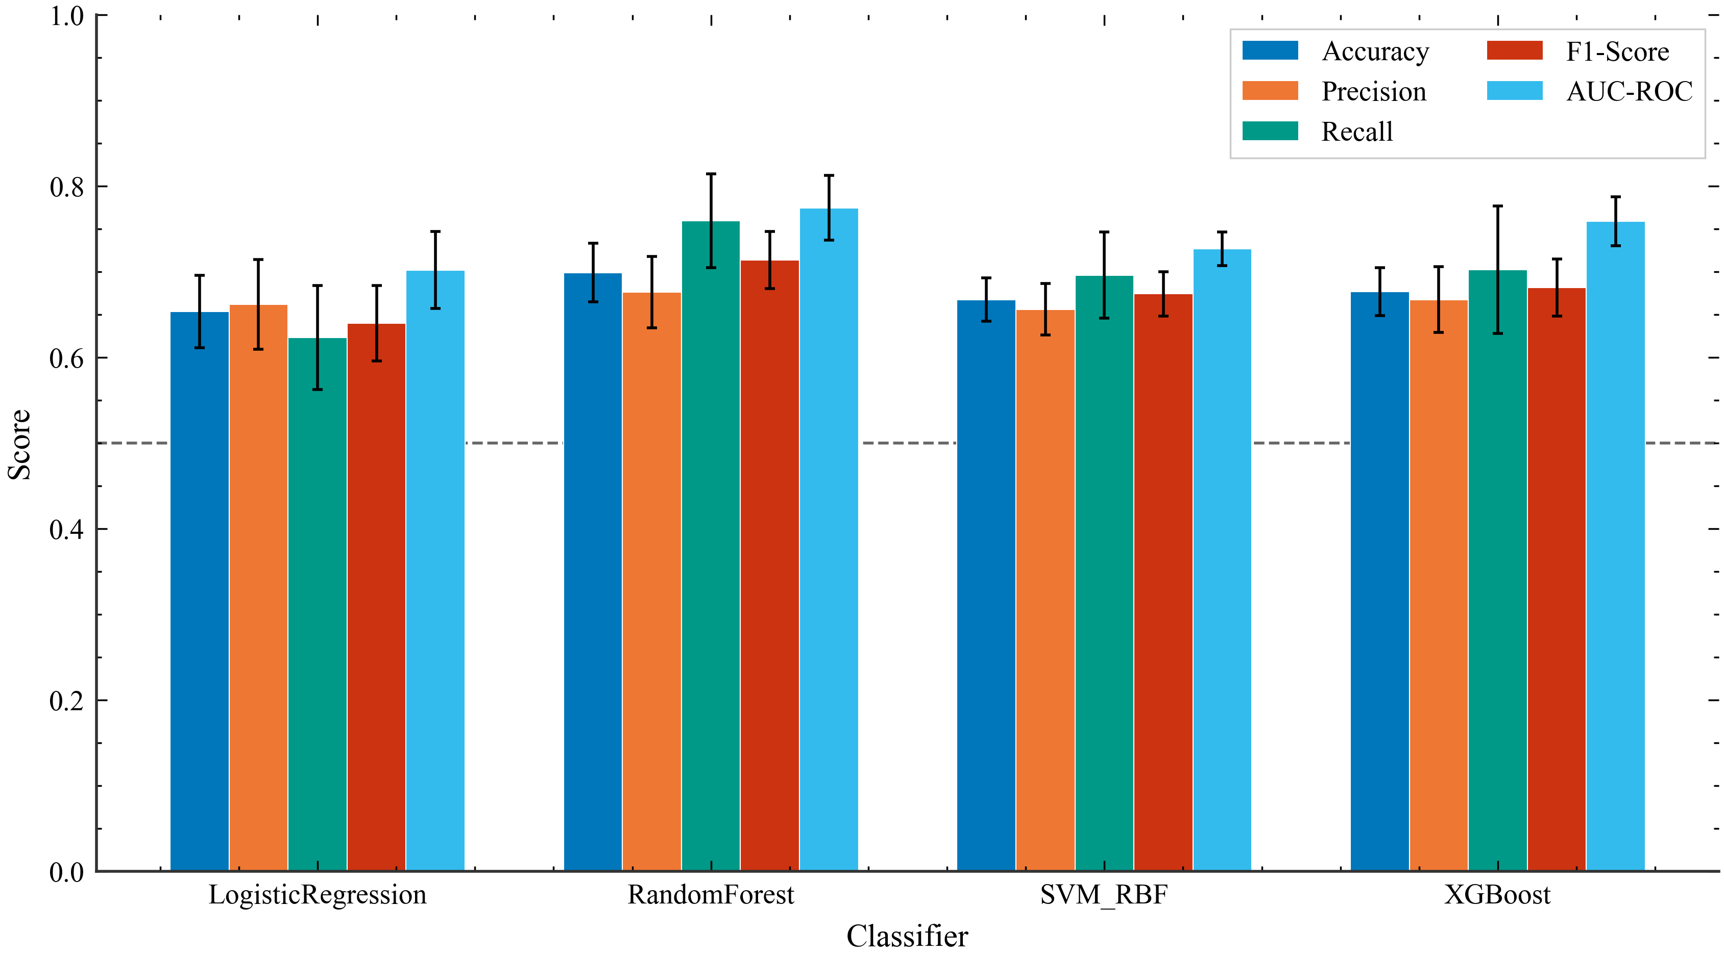
Figure 3 Performance comparison of machine learning classifiers across multiple metrics
The confusion matrix analysis provides insight into the classification behavior of the Random Forest model. The model correctly classified 240 out of 316 high engagement posts (recall of 75.9 percent) and 206 out of 322 low engagement posts (specificity of 64.0 percent). The slight tendency toward predicting high engagement is reflected in the higher recall compared to precision (67.4 percent), which may be acceptable depending on the application context.
Comparing across classifiers reveals distinct classification strategies: Logistic Regression achieved the highest specificity at 68.3 percent with 220 true negatives, but produced only 197 true positives with 119 false negatives, missing more high engagement posts. XGBoost achieved a balanced trade-off with 222 true positives and specificity of 65.2 percent. Random Forest achieved the highest NPV at 73.0 percent compared to 64.9 percent for Logistic Regression, indicating more reliable predictions when classifying posts as low engagement
Table 3 Confusion Matrix Analysis
Model | TN | FP | FN | TP | Specificity | NPV | Balanced Acc
RandomForest | 206 | 116 | 76 | 240 | 0.640 | 0.730 | 0.700
XGBoost | 210 | 112 | 94 | 222 | 0.652 | 0.691 | 0.677
SVM_RBF | 206 | 116 | 96 | 220 | 0.640 | 0.682 | 0.668
LogisticRegression | 220 | 102 | 119 | 197 | 0.683 | 0.649 | 0.653
The per-fold analysis reveals consistent performance across all five folds, with accuracy ranging from 64.6 percent to 74.2 percent and F1-scores from 0.651 to 0.740. The AUC-ROC values ranged from 0.725 to 0.842, with a mean of 0.775 and standard deviation of 0.038. This consistency supports the reliability of the cross-validation results and suggests that the model generalizes well across different subsets of the data.
Examining variability across classifiers, SVM demonstrated the most stable performance with F1-score standard deviation of 0.026, while Logistic Regression showed the highest variability at 0.044. Random Forest achieved its best performance in Fold 1 with F1-score of 0.740 and AUC-ROC of 0.842, whereas Fold 5 produced the lowest scores across all classifiers, with Random Forest at 0.651 and XGBoost at 0.630
Table 4 Per-Fold Results for Random Forest
Classifier | RandomForest |  | XGBoost |  | SVM_RBF |  | LogisticRegression
Fold | F1-Score | AUC-ROC | F1-Score | AUC-ROC | F1-Score | AUC-ROC | F1-Score | AUC-ROC
1 | 0.740 | 0.842 | 0.699 | 0.784 | 0.693 | 0.750 | 0.678 | 0.778
2 | 0.737 | 0.779 | 0.672 | 0.777 | 0.656 | 0.747 | 0.703 | 0.719
3 | 0.709 | 0.763 | 0.677 | 0.757 | 0.714 | 0.730 | 0.624 | 0.700
4 | 0.732 | 0.764 | 0.731 | 0.773 | 0.642 | 0.707 | 0.611 | 0.663
5 | 0.651 | 0.725 | 0.630 | 0.705 | 0.667 | 0.702 | 0.584 | 0.650
Mean | 0.714 | 0.775 | 0.682 | 0.759 | 0.674 | 0.727 | 0.640 | 0.702
Std | 0.033 | 0.038 | 0.033 | 0.029 | 0.026 | 0.020 | 0.044 | 0.045

Feature Importance Analysis
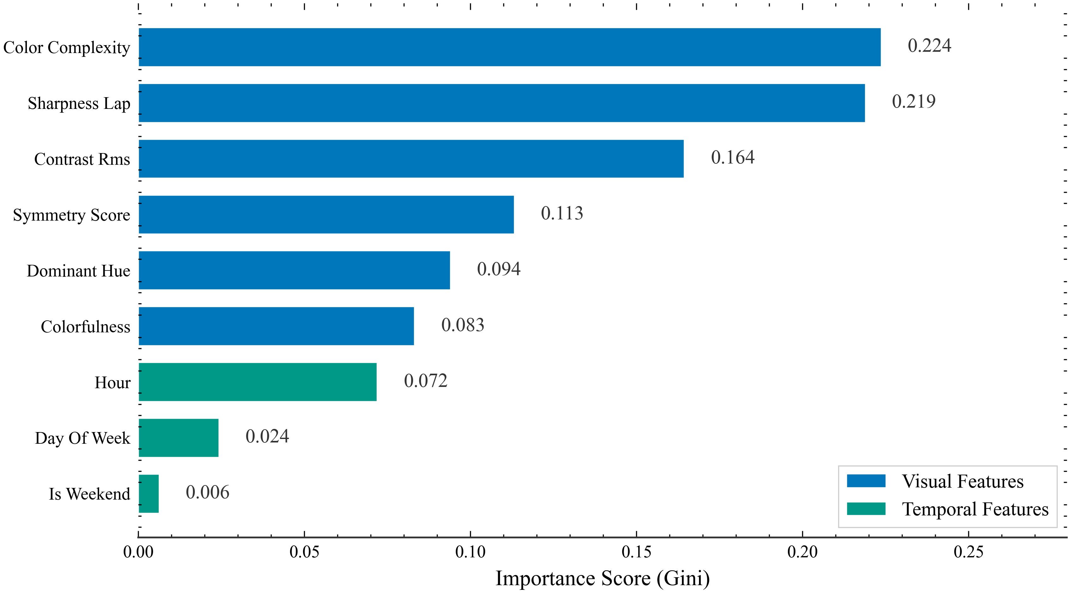
Figure 4 Feature importance scores from the Random Forest classifier
The feature importance analysis revealed that color complexity was the most influential predictor (22.4 percent), followed by sharpness (21.9 percent) and contrast (16.4 percent). This finding aligns with research demonstrating that images with greater color diversity capture more attention on social media platforms [4], while the prominence of sharpness underscores the importance of image quality in content strategy. Together with colorfulness (8.3 percent), color-related features account for a substantial portion of the predictive power.
Symmetry score contributed 11.3 percent, suggesting that balanced compositions are perceived as more aesthetically pleasing, which is consistent with research on computational aesthetics predicting viewer preferences [10]. Dominant hue at 9.4 percent indicates that specific color tones have moderate influence on engagement.
The temporal features collectively contributed approximately 10.2 percent to classification (hour: 7.2 percent, day of week: 2.4 percent, weekend: 0.6 percent). While temporal factors have measurable influence, visual features clearly dominate the prediction, suggesting that content quality matters more than posting timing for engagement on these university accounts.
Figure 5 illustrates how each visual feature is computed on a sample high-engagement post. The original image (a) shows a typical university event announcement with people, signage, and buildings. The colorfulness heatmap (b) highlights areas of high color saturation, while the color complexity visualization (c) shows the K-means quantized palette capturing color diversity. The contrast visualization (d) applies edge detection to highlight object boundaries, and the symmetry overlay (e) compares the original with its horizontally flipped version. Finally, the sharpness visualization (f) applies the Laplacian operator to reveal areas of high frequency detail.
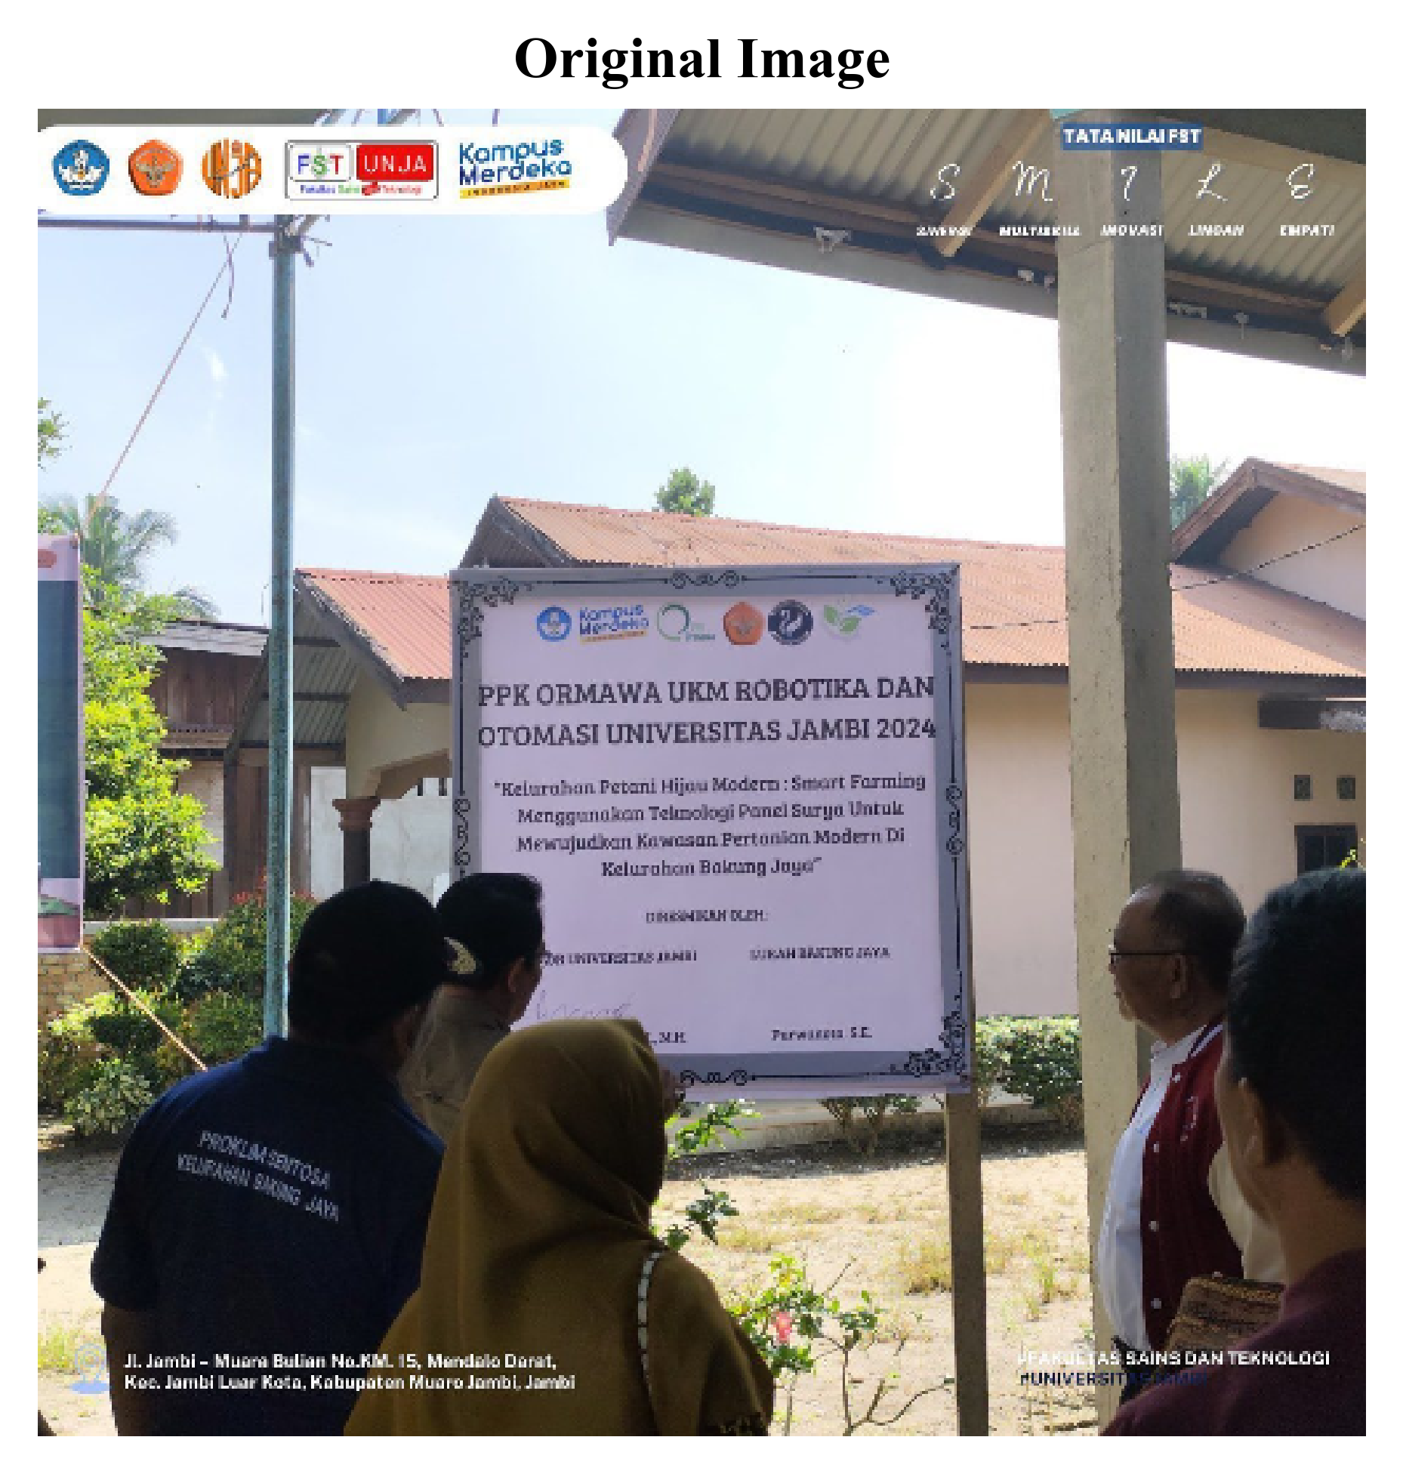 | 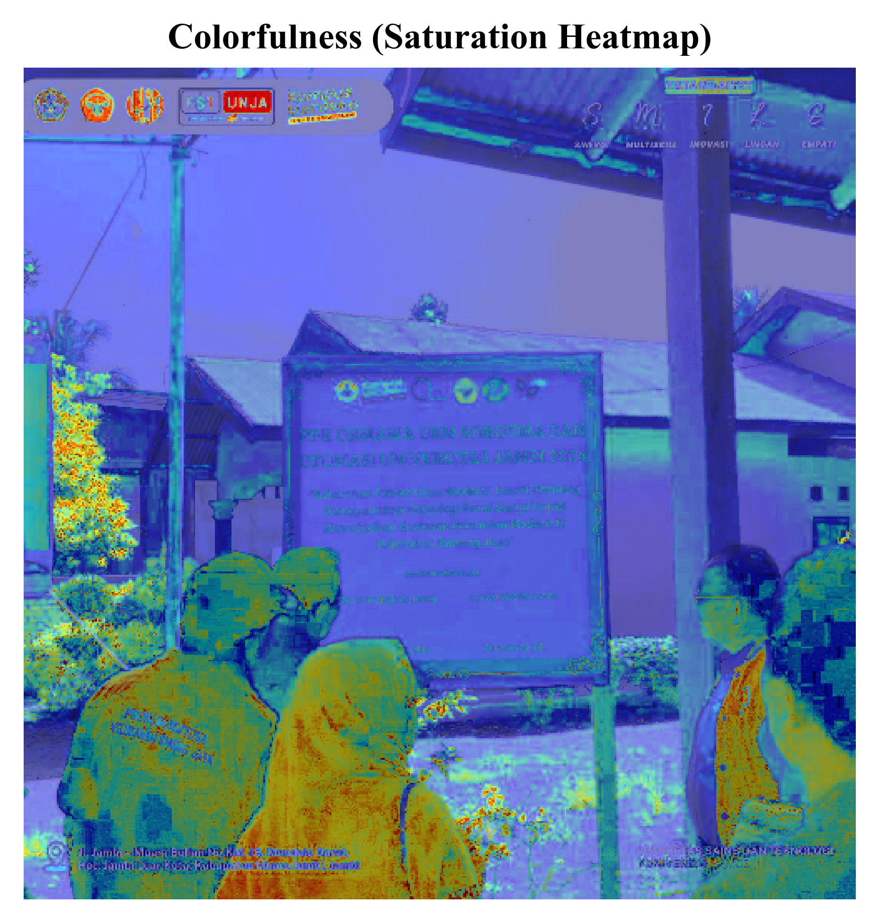 | 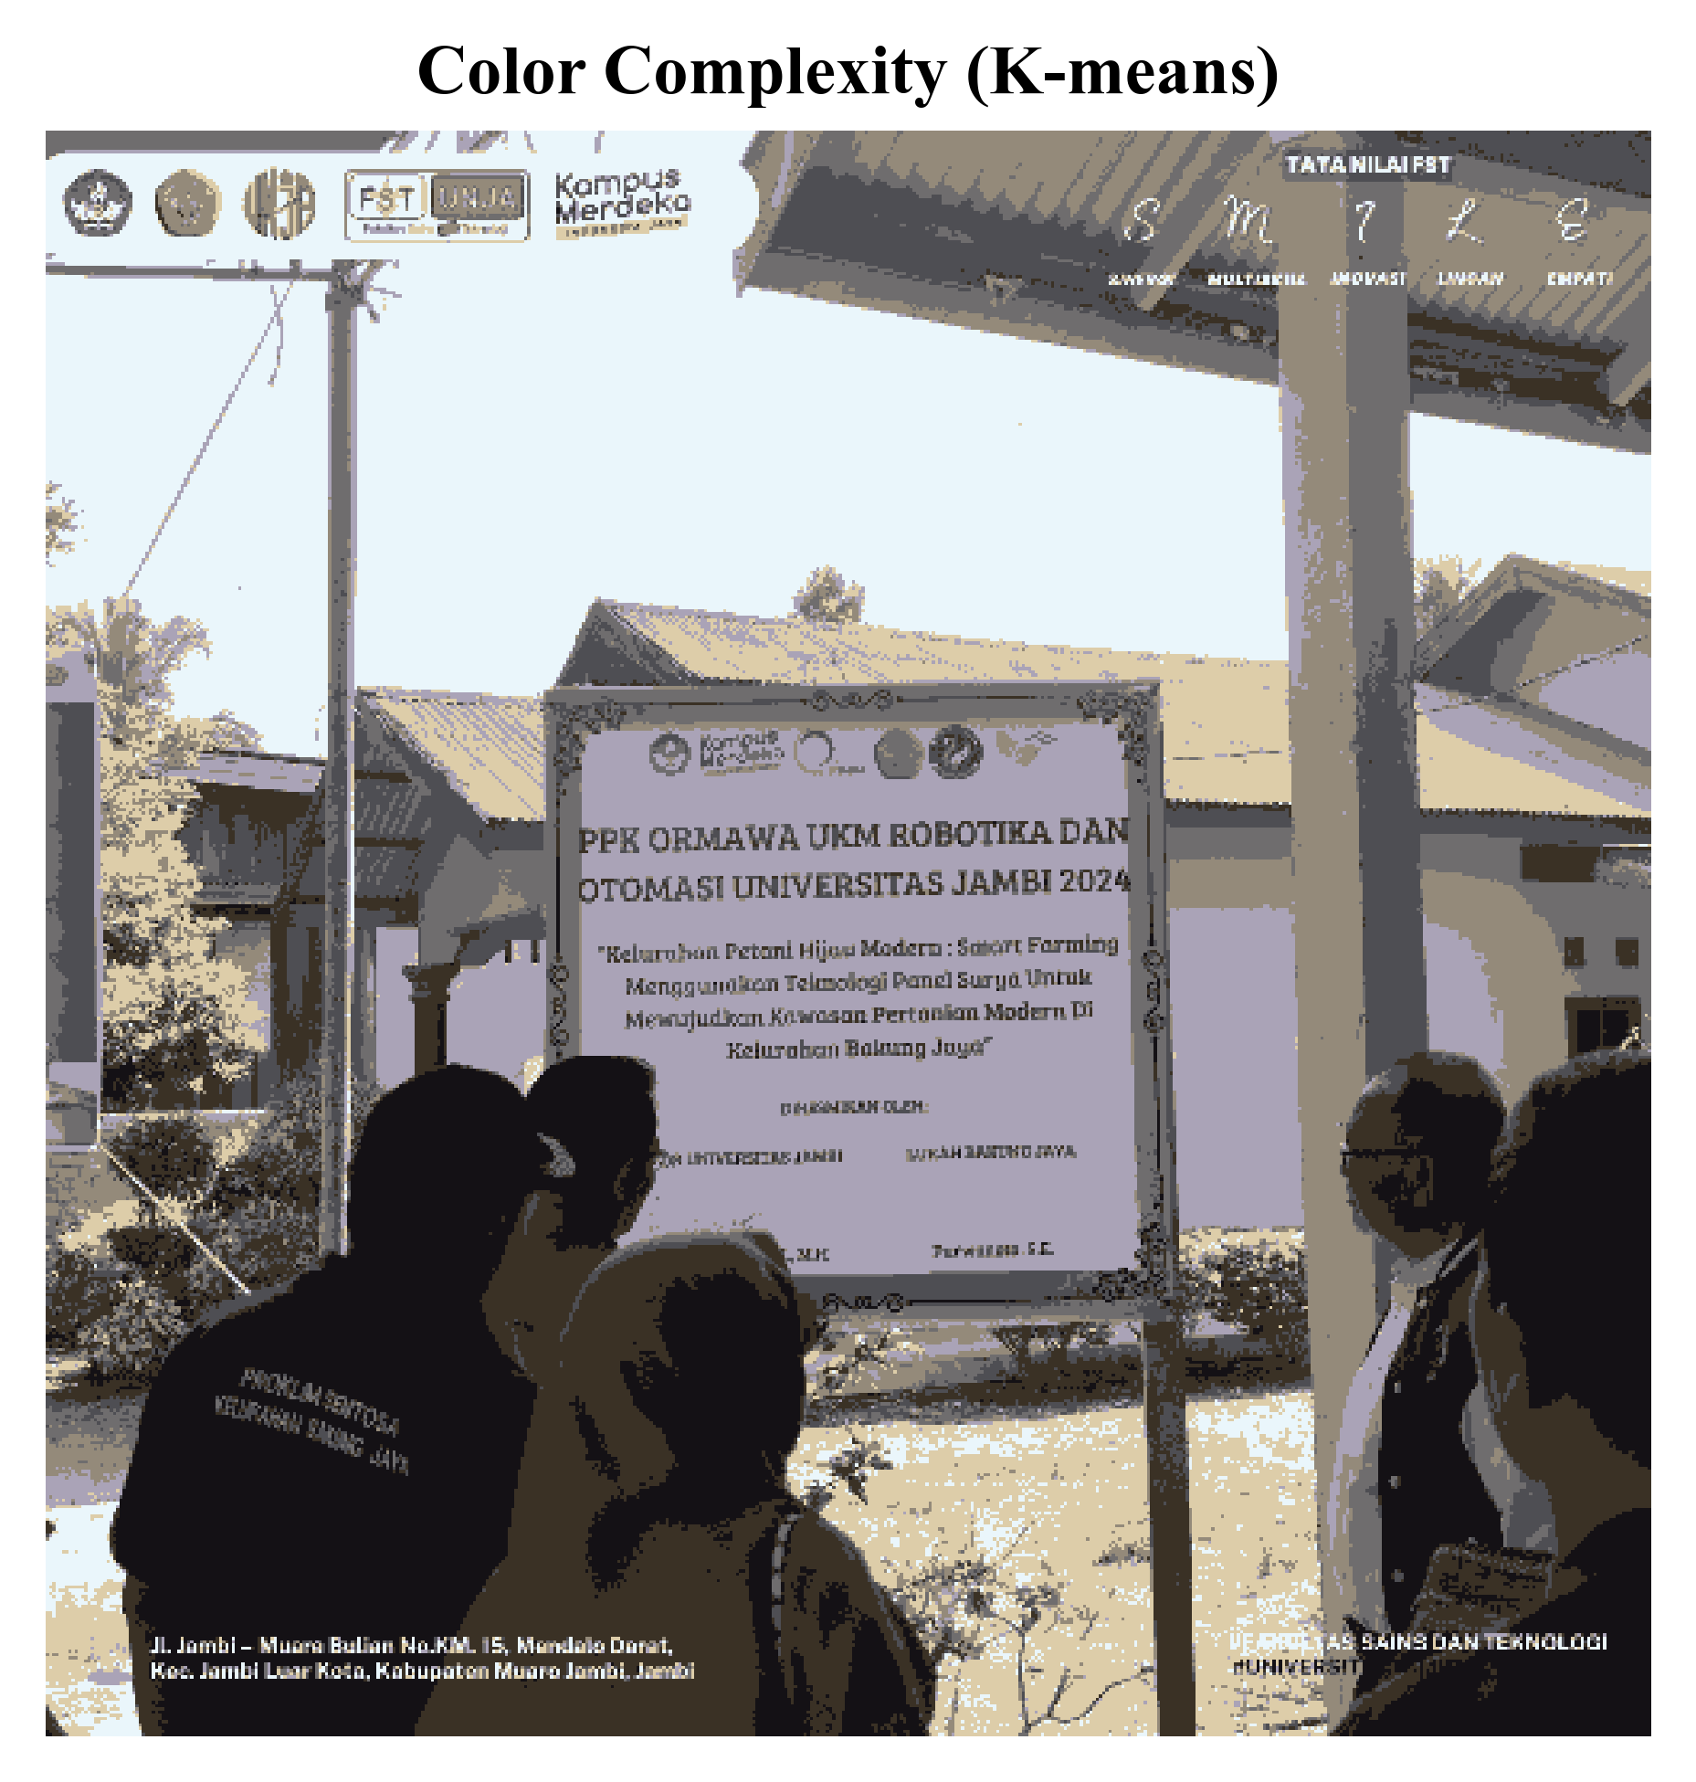
 | 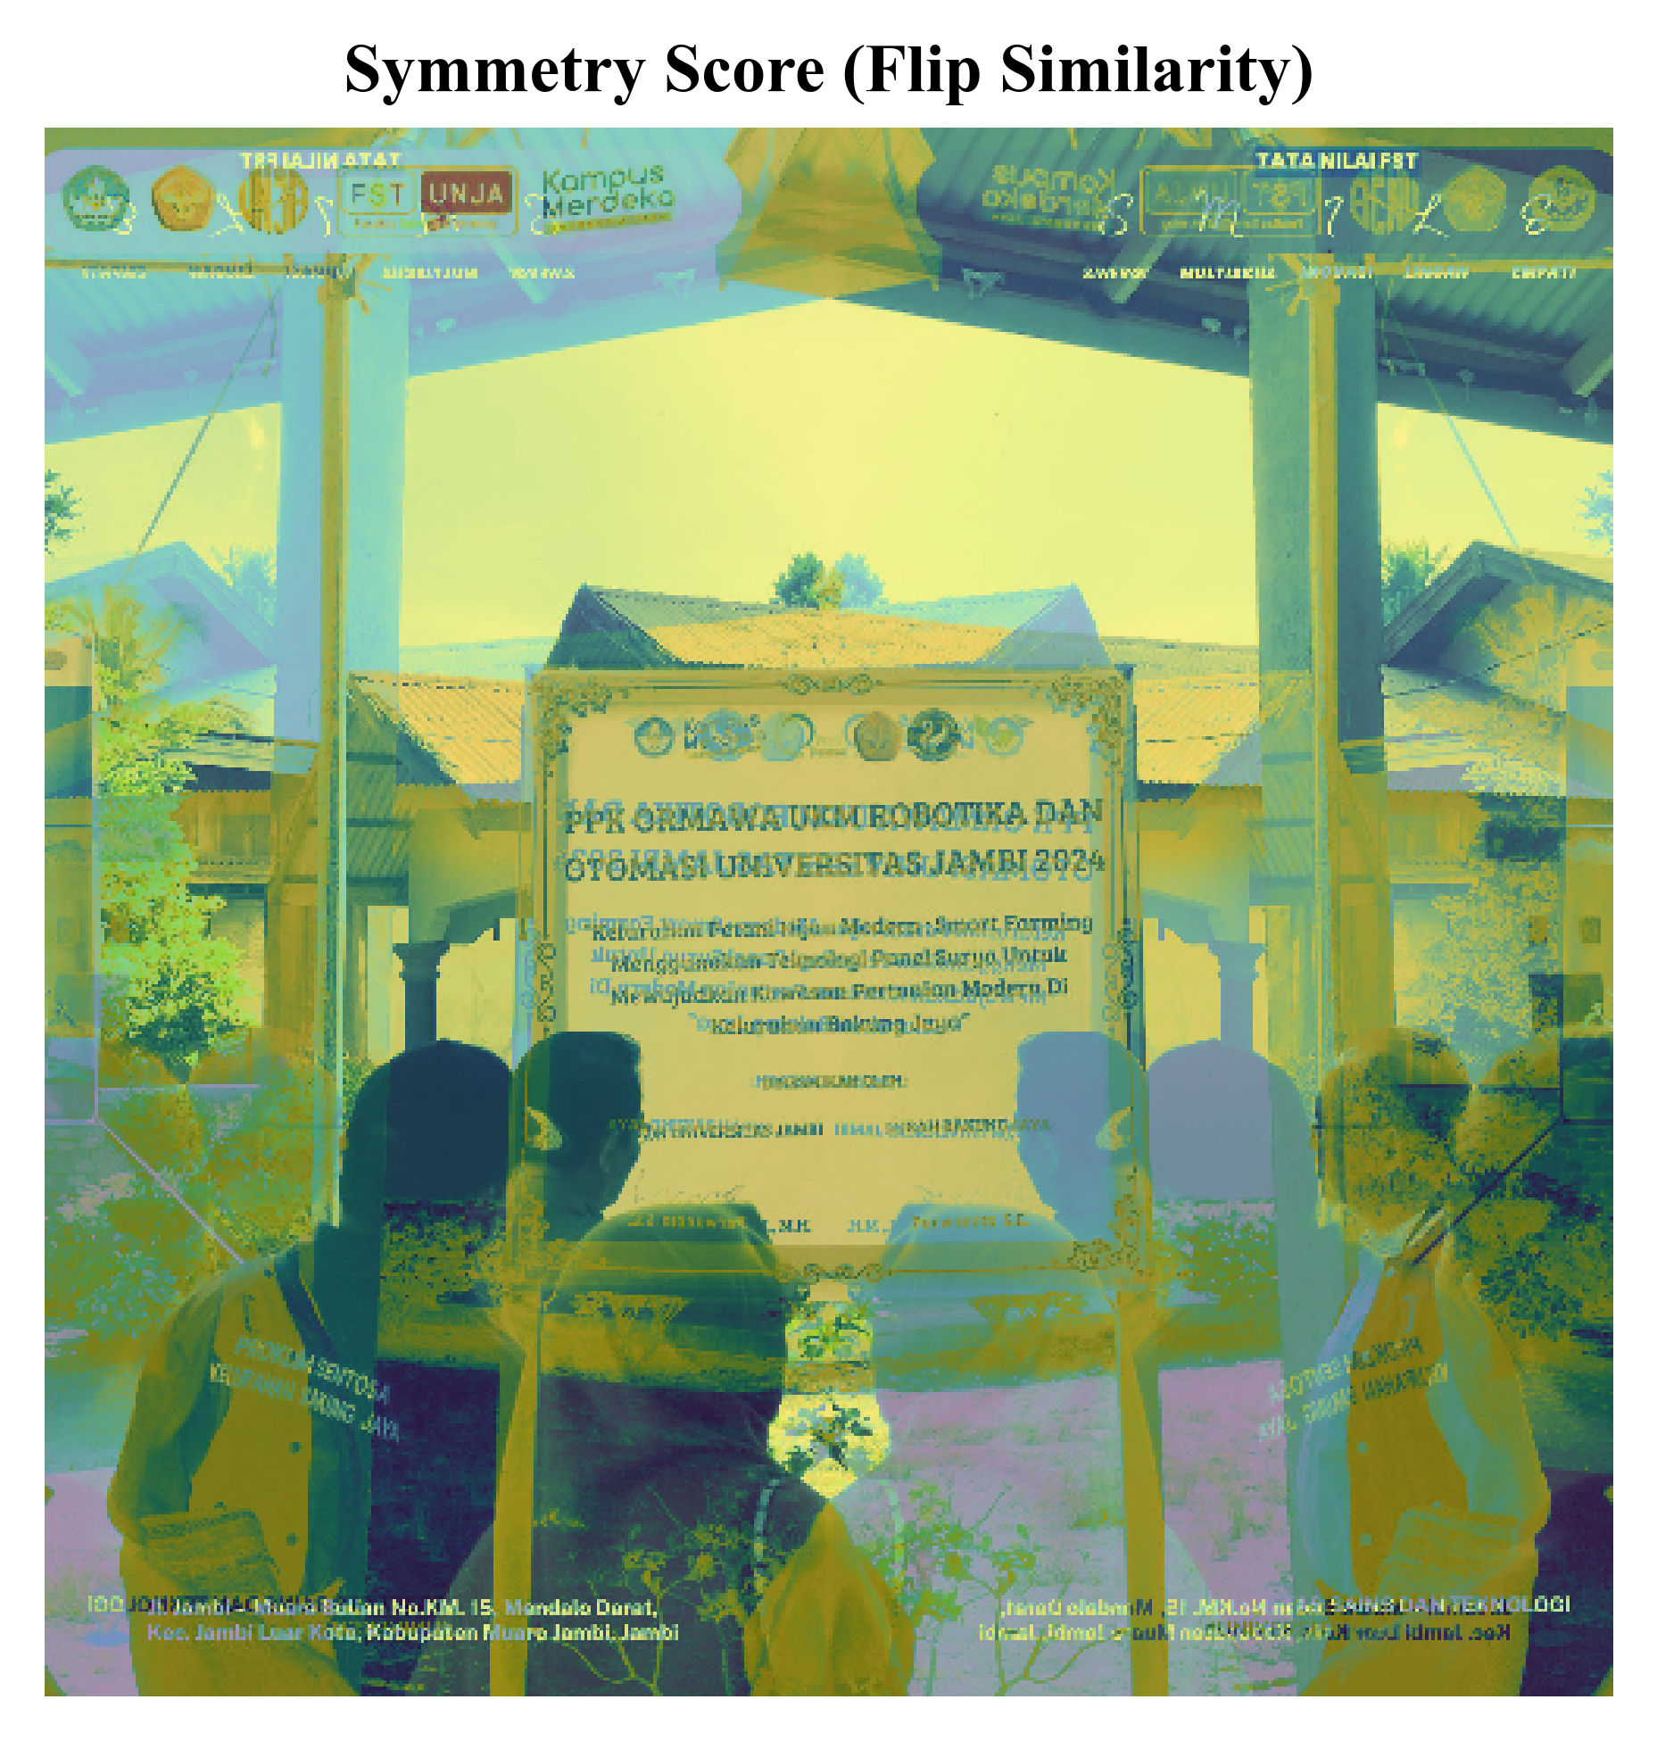 | 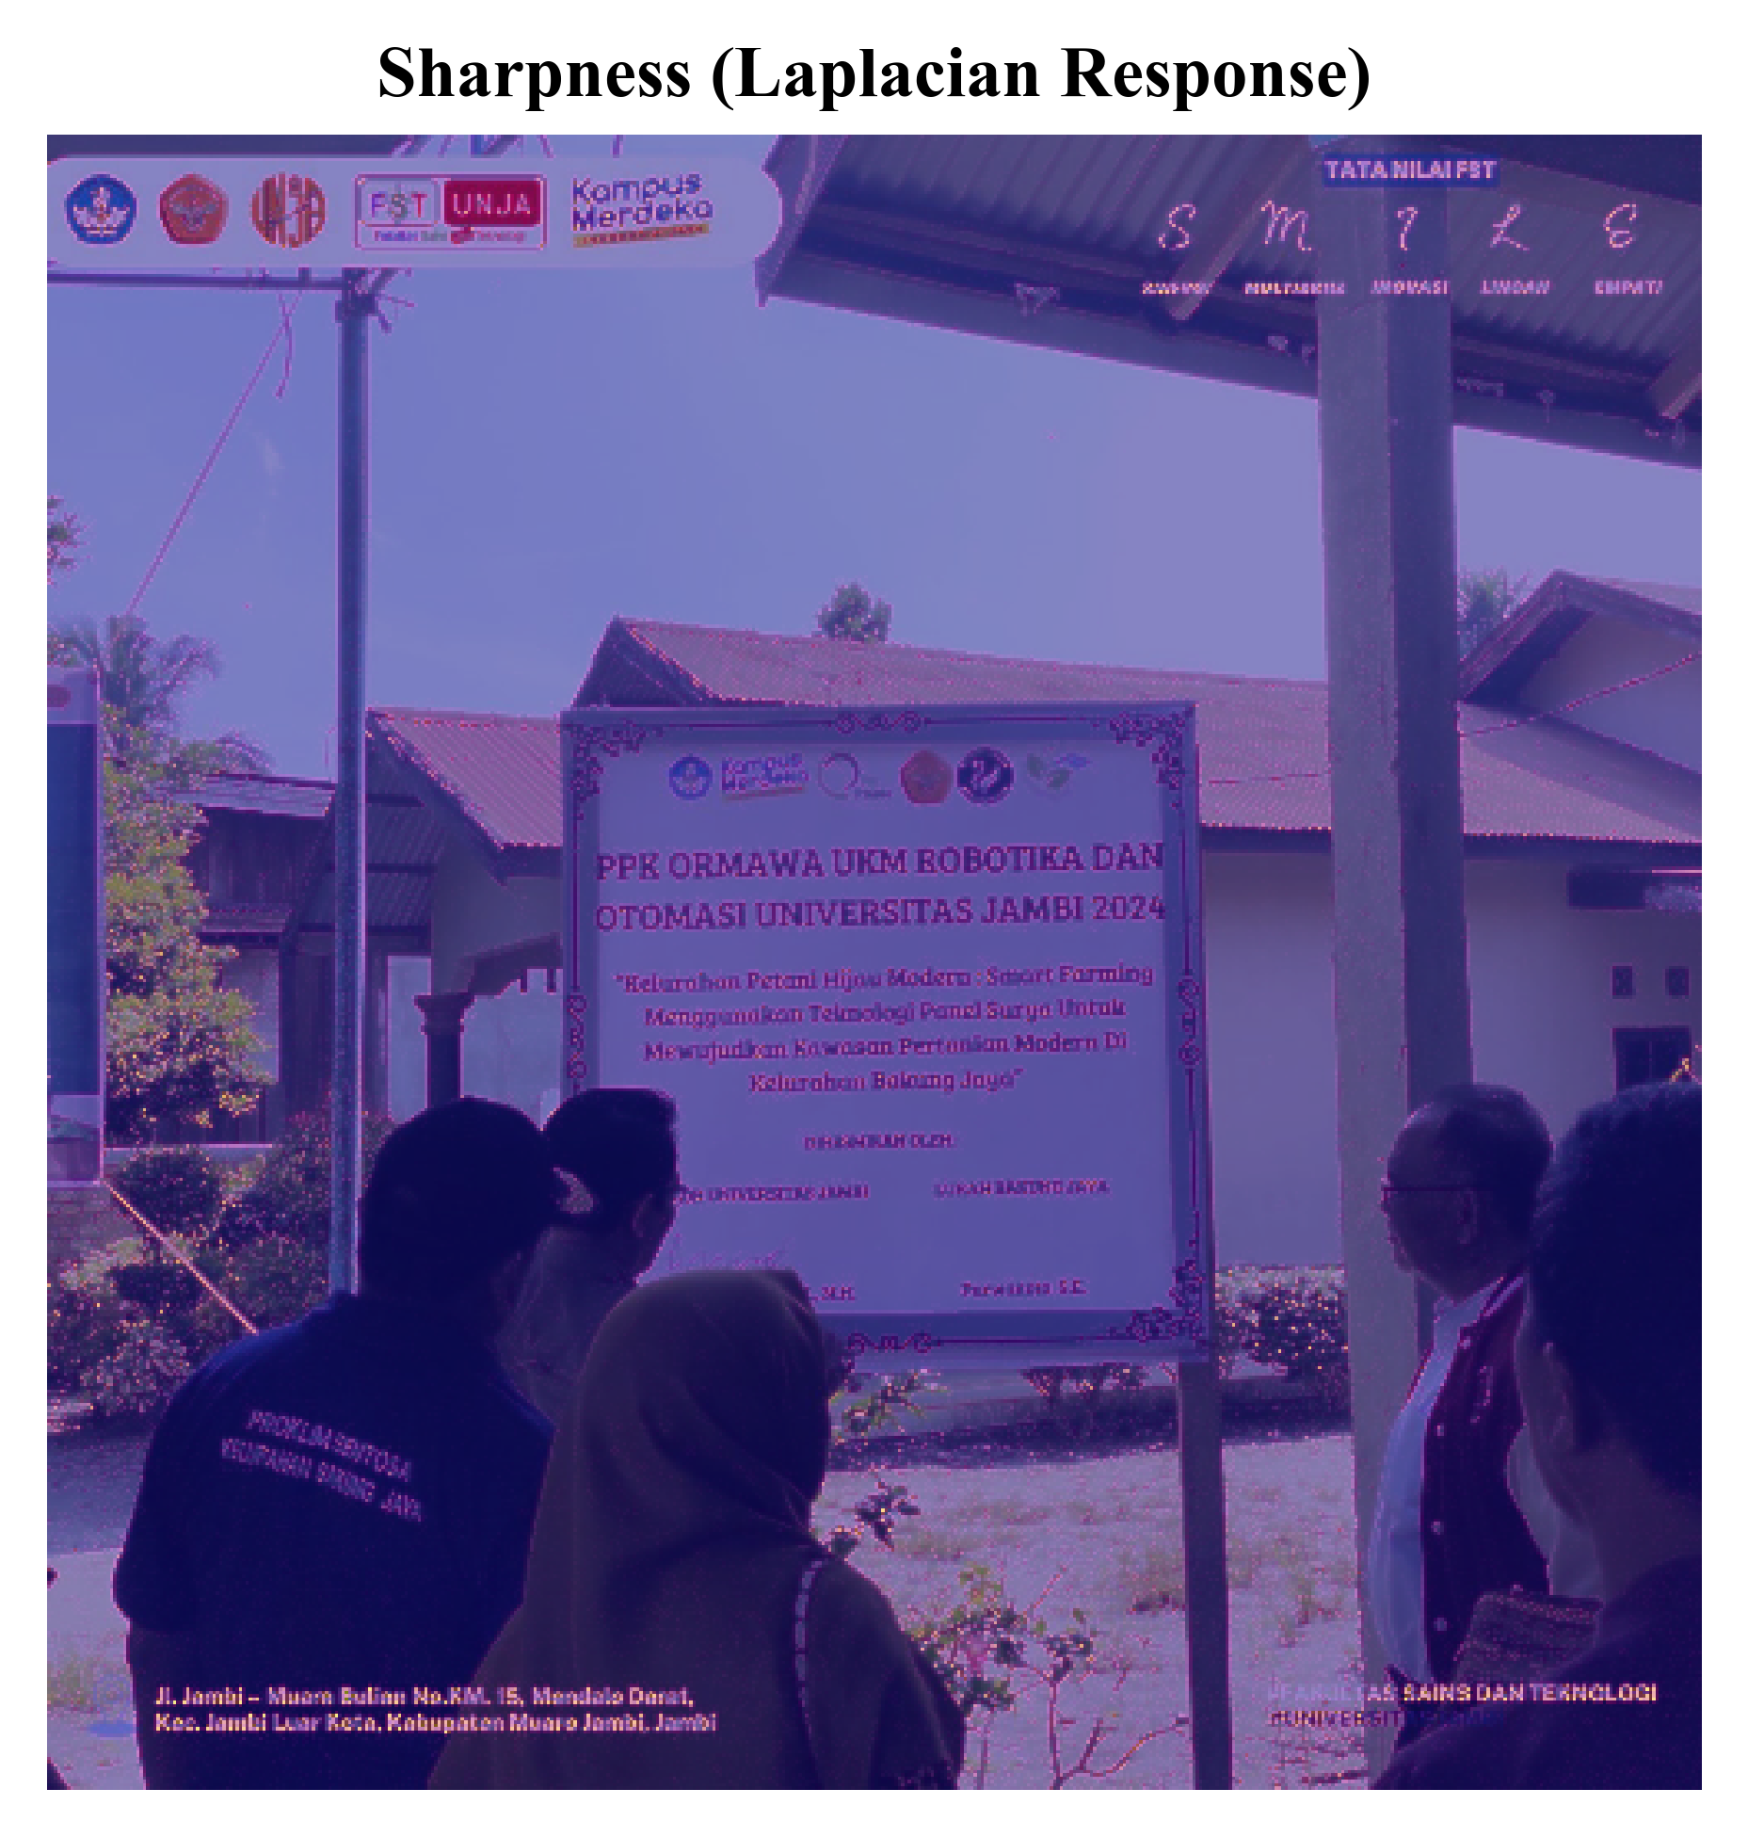
Figure 5 Visual feature extraction demonstration on a sample post
Discussion
The results of this study provide several insights for understanding and predicting Instagram engagement based on visual and temporal content. The classification accuracy achieved by Random Forest (70.1 %) using interpretable features indicates that image characteristics play a meaningful role in engagement, though other factors such as caption content, hashtag usage, and account following size likely contribute to the remaining variance. Research on university posting strategies has similarly found that visual elements interact with content timing and type to influence overall engagement levels [5].
The prominence of color complexity and sharpness as top predictive features supports the theory that visual quality and diversity capture attention in social media feeds. This is consistent with eye-tracking research showing that complex color images provoke a shift from peripheral to central processing mode [4]. In the context of university Instagram accounts, this suggests that posts featuring high-quality images with diverse colors (such as campus events, diverse group photos, or colorful infographics) may generate higher engagement than simple text-based announcements or low-quality images.
The multi-account nature of this study (638 posts from two accounts) provides more robust conclusions compared to single-account analyses. The stable cross-validation performance with low standard deviations indicates that the findings generalize across the two university accounts studied. However, extending the analysis to additional institutions and account types would further strengthen generalizability claims.
The interpretable nature of the extracted features distinguishes this approach from black-box deep learning methods, allowing social media managers to directly apply these insights. Specifically, content creators should prioritize using images with diverse colors rather than monochromatic palettes, ensuring sharp and high-quality image uploads, incorporating good contrast between visual elements, and maintaining balanced compositions where appropriate.

CONCLUSION
This study investigated the classification of Instagram engagement using interpretable visual and temporal features extracted from university social media content. Analysis of 638 posts from two Universitas Jambi accounts revealed that the Random Forest classifier achieved the highest classification performance with an F1-score of 0.716, accuracy of 70.1 percent, and AUC-ROC of 0.775. Feature importance analysis identified color complexity as the most influential predictor, contributing 22.4 percent to the classification decision, followed by sharpness at 21.9 percent and contrast at 16.4 percent. These findings suggest that visually diverse images with high color variety and sharp details tend to generate greater engagement on academic Instagram accounts.
The nine-feature approach combining six visual characteristics with three temporal indicators provides a comprehensive yet interpretable framework for engagement prediction. Visual features collectively contributed approximately 89.8 percent of the predictive power, with temporal features accounting for the remaining 10.2 percent. This distribution suggests that content quality matters substantially more than posting timing for engagement on university Instagram accounts.
The main limitation of this study is the focus on two accounts from a single institution, which constrains generalizability to other contexts. Future research should expand the analysis to multiple university accounts across different institutions and countries to validate these findings. Additionally, incorporating caption text analysis, hashtag patterns, and account-level characteristics would provide a more comprehensive understanding of engagement drivers. The interpretable visual features identified in this study offer practical guidance for university social media managers seeking to optimize their Instagram content strategy, as focusing on color diversity, image sharpness, and visual contrast can potentially improve engagement with target audiences..
ACKNOWLEDGMENTS
The authors would like to express their sincere gratitude for the funding support that made this research possible. This work was supported by the Lembaga Penelitian dan Pengabdian Kepada Masyarakat (LPPM) Universitas Jambi through the Penelitian Penugasan grant scheme, Faculty of Science and Technology.
REFERENCES
Anwar, A., Kanwal, S., Tahir, M., Saqib, M., Uzair, M., Rahmani, M. K. I., & Ullah, H. (2022). Image aesthetic assessment: A comparative study of hand-crafted and deep learning models. IEEE Access, 10, 103170-103185. https://doi.org/10.1109/ACCESS.2022.3209196
Capriotti, P., Martinez-Gras, R., & Zeler, I. (2023). Does universities' posting strategy influence their social media engagement? An analysis of the top-ranked higher education institutions in different countries. Higher Education Quarterly, 77(4), 911-931. https://doi.org/10.1111/hequ.12439
Chang, H.-W., Yang, M.-H., & Hsieh, C.-Y. (2022). Image quality evaluation based on gradient, visual saliency, and color information. International Journal of Digital Multimedia Broadcasting, 2022, Article 7540810. https://doi.org/10.1155/2022/7540810
Dai, Y. (2023). Building CNN-based models for image aesthetic score prediction using an ensemble. Journal of Imaging, 9(2), Article 30. https://doi.org/10.3390/jimaging9020030
Jia, D., Zhang, C., Wu, N., Zhou, J., & Guo, Z. (2022). Autofocus algorithm using optimized Laplace evaluation function and enhanced mountain climbing search algorithm. Multimedia Tools and Applications, 81(15), 21261-21280. https://doi.org/10.1007/s11042-022-12191-w
Kanuri, V. K., Hughes, C., & Hodges, B. T. (2024). Standing out from the crowd: When and why color complexity in social media images increases user engagement. International Journal of Research in Marketing, 41(2), 174-193. https://doi.org/10.1016/j.ijresmar.2023.10.006
Kumar, D. S., Sahadev, S., & Purani, K. (2024). Visual aesthetic quotient: Establishing the effects of computational aesthetic measures for servicescape design. Journal of Service Research, 27(2), 213-230. https://doi.org/10.1177/10946705231209897

Kwenda, C., Gwetu, M. V., & Fonou-Dombeu, J. V. (2023). Forest image classification based on deep learning and XGBoost algorithm. In J. Miskyka et al. (Eds.), Computational Science - ICCS 2023 (pp. 197-210). Springer. https://doi.org/10.1007/978-3-031-36027-5_16
Philp, M., Jacobson, J., & Pancer, E. (2022). Predicting social media engagement with computer vision: An examination of food marketing on Instagram. Journal of Business Research, 149, 736-747. https://doi.org/10.1016/j.jbusres.2022.05.078
Prusty, S., Patnaik, S., & Dash, S. K. (2022). SKCV: Stratified K-fold cross-validation on ML classifiers for predicting cervical cancer. Frontiers in Nanotechnology, 4, Article 972421. https://doi.org/10.3389/fnano.2022.972421
Ramdani, F., & Furqon, M. T. (2022). The simplicity of XGBoost algorithm versus the complexity of Random Forest, Support Vector Machine, and Neural Networks algorithms in urban forest classification. F1000Research, 11, Article 1069. https://doi.org/10.12688/f1000research.124604.1
Shao, Z., Ahmad, M. N., & Javed, A. (2024). Comparison of Random Forest and XGBoost classifiers using integrated optical and SAR features for mapping urban impervious surface. Remote Sensing, 16(4), Article 665. https://doi.org/10.3390/rs16040665
Son, H., & Park, Y. E. (2024). Predicting user engagement with textual, visual, and social media features for online travel agencies' Instagram post: Evidence from machine learning. Current Issues in Tourism, 27(22), 3608-3622. https://doi.org/10.1080/13683500.2023.2278087
Sorensen, I., Furst, S., Vogler, D., & Schafer, M. S. (2023). Higher education institutions on Facebook, Instagram, and Twitter: Comparing Swiss universities' social media communication. Media and Communication, 11(1), 264-277. https://doi.org/10.17645/mac.v11i1.6069
Varga, D. (2022). No-reference video quality assessment using the temporal statistics of global and local image features. Sensors, 22(24), Article 9696. https://doi.org/10.3390/s22249696

