**Data Mining Assignment Q1**

**Name: Akhlaq Ahmed**

**Student ID: 223195551**

1. **Plot the decision tree that can illustrate the traffic conflict problem in Table 1.**

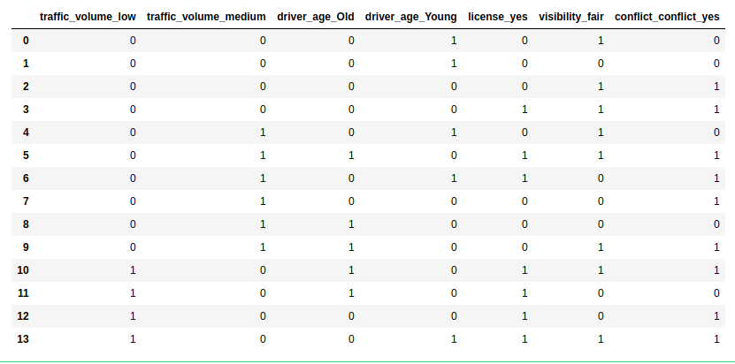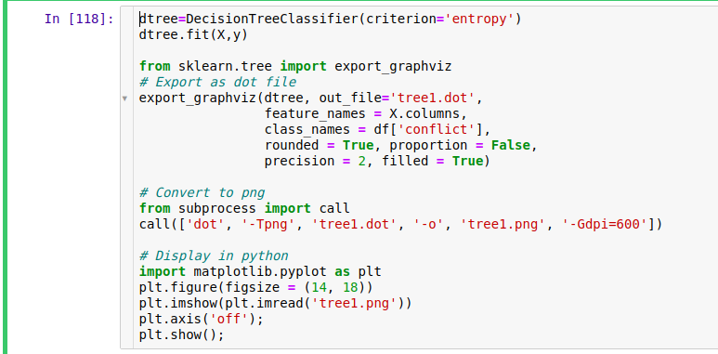

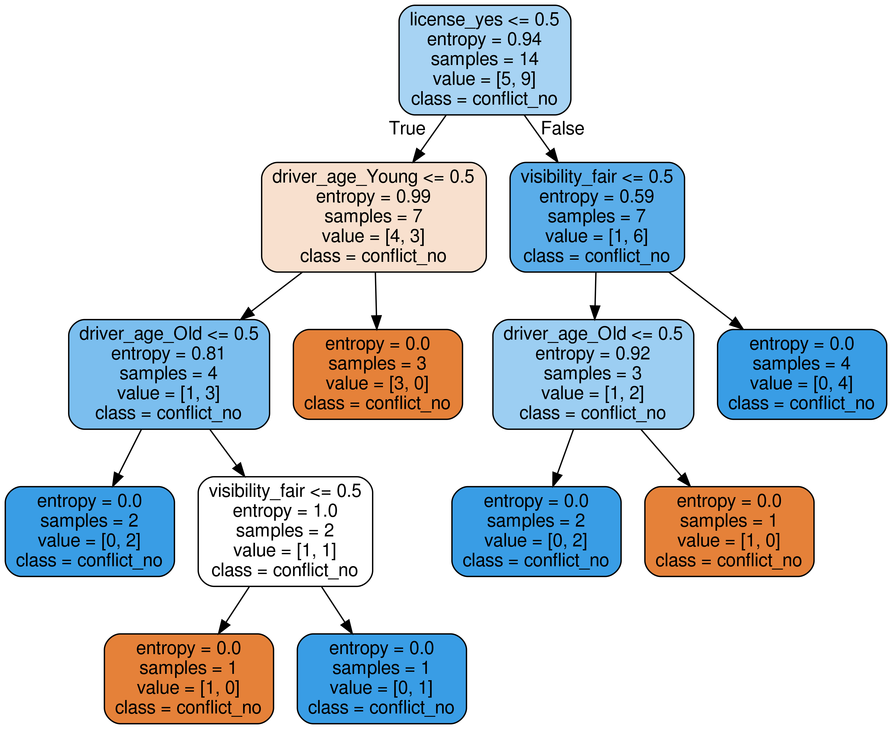

**2. Fill in Table 2 for the positive counts of conflict (pi) and negative counts of conflict (ni), and their totals.**

**Table 2. Positive and Negative Counts of Conflicts**

|  |  |  |  |
| --- | --- | --- | --- |
| **Traffic Volume** | **pi** | **ni** | **Total** |
| Low | 3 | 1 | 4 |
| Medium | 4 | 2 | 6 |
| High | 2 | 2 | 4 |
| Total | 9 | 5 | 14 |

**3. What is the probability of the class “conflict->yes” and the class “conflict -> no”?**

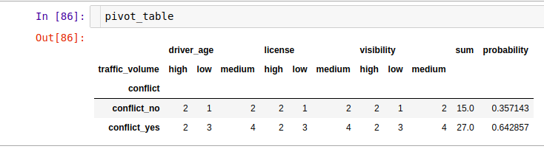

**4. Calculate the information gained by branching on attribute “Traffic Volume” using ID3/C4.5 method.**

