1D Convolutional Neural Networks

Convolutional Neural Network (CNN) models were developed for image classification, in which the model accepts a two-dimensional input representing an image’s pixels and color channels, in a process called feature learning.

This same process can be applied to one-dimensional sequences of data. The model extracts features from sequences data and maps the internal features of the sequence. A 1D CNN is very effective for deriving features from a fixed-length segment of the overall dataset, where it is not so important where the feature is located in the segment.

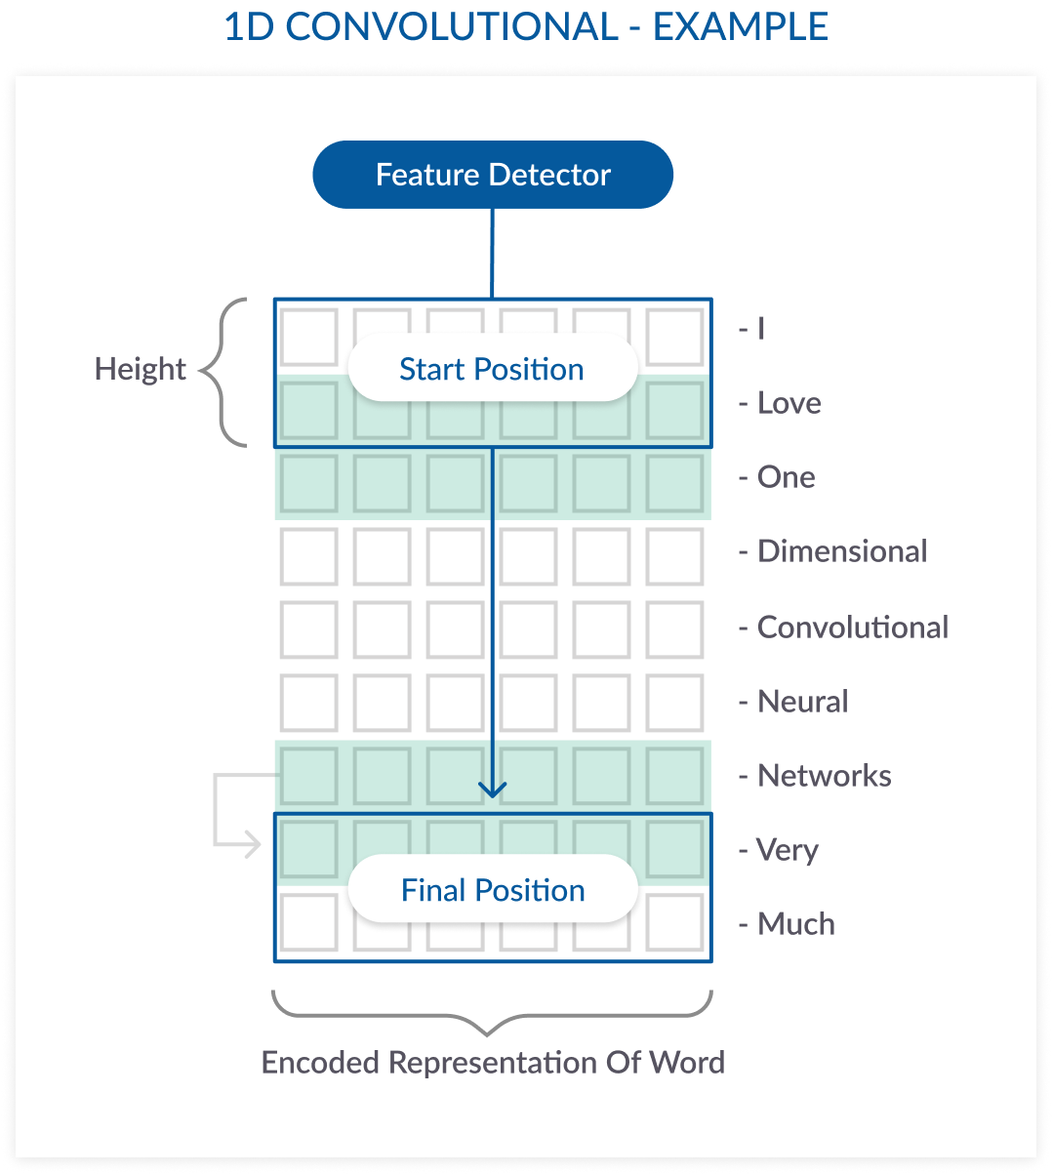

In this natural language processing (NLP) example, a sentence is made up of 9 words. Each word is a vector that represents a word. The filter covers at least one word; a height parameter specifies how many words the filter should consider at once. In this example the height is 2, meaning the filter moves 8 times to fully scan the data.

XGBOOST

XGBoost is a decision-tree-based ensemble Machine Learning algorithm that uses a gradient boosting framework. In prediction problems involving unstructured data (images, text, etc.) artificial neural networks tend to outperform all other algorithms or frameworks. However, when it comes to small-to-medium structured/tabular data, decision tree based algorithms are considered best-in-class right now. Please see the chart below for the evolution of tree-based algorithms over the years.

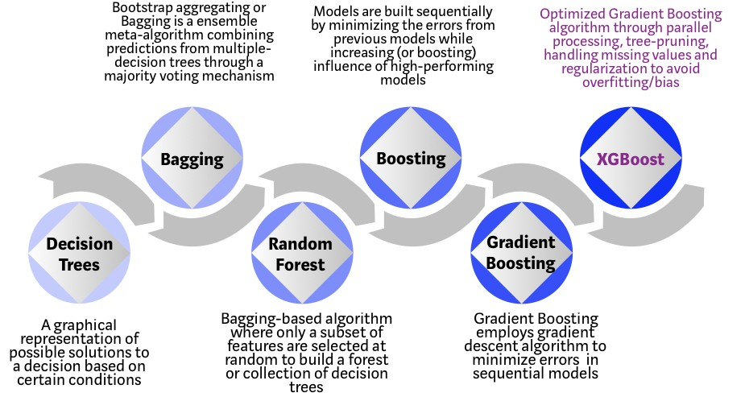
XGBoost algorithm was developed as a research project at the University of Washington. Tianqi Chen and Carlos Guestrin presented their paper at SIGKDD Conference in 2016 and caught the Machine Learning world by fire. Since its introduction, this algorithm has not only been credited with winning numerous Kaggle competitions but also for being the driving force under the hood for several cutting-edge industry applications. As a result, there is a strong community of data scientists contributing to the XGBoost open source projects with ~350 contributors and ~3,600 commits on GitHub. The algorithm differentiates itself in the following ways:

- A wide range of applications: Can be used to solve regression, classification, ranking, and user-defined prediction problems.
- Portability: Runs smoothly on Windows, Linux, and OS X.
- Languages: Supports all major programming languages including C++, Python, R, Java, Scala, and Julia.

Cloud Integration: Supports AWS, Azure, and Yarn clusters and works well with Flink, Spark, and other ecosystems.

Why does XGBoost perform so well?

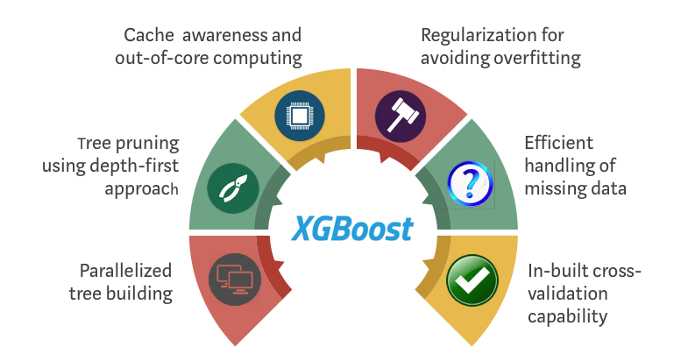
XGBoost and Gradient Boosting Machines (GBMs) are both ensemble tree methods that apply the principle of boosting weak learners (CARTs generally) using the gradient descent architecture. However, XGBoost improves upon the base GBM framework through systems optimization and algorithmic enhancements.

