# A

PROJECT REPORT ON

**REAL LEARNING APPLICATION**

By

ASHISH KOTECHA (CE-064) (17CEUOS066)

HARSH MORADIYA (CE-072) (17CEUOG056)

B.Tech CE Semester-VI

Subject: System Design Practice

Guided by:

Prof. Pandav K. Patel

Assistant Professor

Dept. of Comp. Engg.



Faculty of Technology

Department of Computer Engineering

Dharmsinh Desai University



Faculty of Technology

Department of Computer Engineering

Dharmsinh Desai University

**CERTIFICATE**

This is to certify that the practical / term work carried out in the subject of

System Design Practice and recorded in this journal is the

bonafide work of

Ashish Kotecha (CE-064) (17CEUOS066)

Harsh Moradiya (CE-072) (17CEUOG056)

of B.Tech semester **VI** in the branch of **Computer Engineering**

during the academic year **2019-2020**.

Prof. Pandav K. Patel Dr. C. K. Bhensdadia,

Assistant Professor, Head,

Dept. of Computer Engg., Dept. of Computer Engg.,

Faculty of Technology Faculty of Technology

Dharmsinh Desai University, Nadiad Dharmsinh Desai University, Nadiad

|  |  |  |
| --- | --- | --- |
|  |  |  |
|  |  |  |

Table of Contents

1. [Abstract](https://docs.google.com/document/d/18Q-oUCykZQG9Q66QML0M-YfbWUoI19OMBBqgaKEs2QE/edit#heading=h.gjdgxs) 4
2. [Introduction](https://docs.google.com/document/d/18Q-oUCykZQG9Q66QML0M-YfbWUoI19OMBBqgaKEs2QE/edit#heading=h.30j0zll) 5
3. [Software Requirements Specification](https://docs.google.com/document/d/18Q-oUCykZQG9Q66QML0M-YfbWUoI19OMBBqgaKEs2QE/edit#heading=h.1fob9te) 6
4. [Design](https://docs.google.com/document/d/18Q-oUCykZQG9Q66QML0M-YfbWUoI19OMBBqgaKEs2QE/edit#heading=h.1fob9te) 10
5. Implementation 19
6. [Testing 2](https://docs.google.com/document/d/18Q-oUCykZQG9Q66QML0M-YfbWUoI19OMBBqgaKEs2QE/edit#heading=h.2et92p0)4
7. [Screen-shots 2](https://docs.google.com/document/d/18Q-oUCykZQG9Q66QML0M-YfbWUoI19OMBBqgaKEs2QE/edit#heading=h.tyjcwt)5
8. Limitation and Future Extension 31
9. Conclusion32
10. [Bibliography](https://docs.google.com/document/d/18Q-oUCykZQG9Q66QML0M-YfbWUoI19OMBBqgaKEs2QE/edit#heading=h.4d34og8) 33

**1. Abstract**

**E**-learning is an education via the Internet, network, or standalone computer. E-learning refers to using electronic applications and processes to learn.. The information and communication systems, whether networked learning or not, serve as specific media to implement the learning process. This often involves both out-of-classroom and in-classroom educational experiences via technology, even as advances continue in regard to devices and curriculum. E-learning is the computer and network-enabled transfer of skills and knowledge. E-learning applications and processes include Web-based learning, computer-based learning, virtual education opportunities and digital collaboration. Content is delivered via the Internet, intranet/extranet, audio or video tape, satellite TV, and CD-ROM. That is to say E-learning systems contain both Learning Management System and Course management system. It can be self-pace or instructor-led and includes media in the form of text, image, animation, streaming video and audio. It is commonly thought that new technologies can make a big difference in education. In young ages especially, children can use the huge interactivity of new media, and develop their skills, knowledge, and perception of the world, under their parents' monitoring, of course.

Many proponents of e-learning believe that everyone must be equipped with basic knowledge in technology, as well as use it as a medium to reach a particular goal and aim. And our application Real-Learning provide e-learning

# **2. Introduction**

**2.1 Brief Introduction**

Real-Learning is a mobile application which helpful to learn things online ,means its a e-learning system . Using this app you can learn given courses based on your choice and also most important is this app provide self-paced learning so you can learn as you want , whenever you want . Real-Learning is also provide quiz feature so after learning any topic thoroughly you can test you knowledge through test and if you want then you can start any particular topic again . As a backend support we have implemented a web app through which admin can add new courses and can manage courses. Admin can also manage it’s content and quiz question. And it’s a live app so two way binding is there in our app . Means as soon as admin add or update any course, content or question it will directly reflect to user . We developed a front-end using  flutter  and dart language , because flutter supports a both ios and android so we need to write for one app for both . And for a back-end we used  django-python framework . We have try to develop a real life application.

**2.2 Tools/Technologies used**

**Technologies:**

1) Flutter (Dart)

2) Django Framework (Python)

3) Firebase Database

**Tools:**

Android Studio IDE

Sublime Text

**3. Software Requirement Specifications**

**3.1 Types of User**

1. Admin

2. Users (Learner)

**3.2 System Function Requirement**

**R.1 User functionalities**

**R.1.1 View Course**

**Description:** Users can view all course.

**Input:** User Command.

**Output:** All Course List**.**

**R.1.2 View Course Content**

**Description:** User can view Course Content to learn new couse

**Input:** Course Name

**Output:** Display All Tutorials.

**R.1.3 Take Quiz**

**Description:** User can take part in quiz topic wise.

**Input:** Select Topic

**Output:** All Questions related to topic.

**R.2 Admin functionalities:**

**R.2.1 View Dashboard**

**Description:** Admin can view dashboard for manage course, manage course-content and manage quiz.

**Input:** Admin login

**Output:** Display Dashboard.

**R.2.2 Add Course**

**Description:** Admin can add new course.

**Input:** Course details

**Output:** Added Successful/ Unsuccessful message.

**R.2.3 Update Course**

**Description:** Admin can update course details.

**Input:** Course Details

**Output:** Update status.

**R.2.4 Delete Course**

**Description:** Admin can delete any Course.

**Input:** Course name

**Output:** Deleted message.

**R.2.5 Add Course Content**

**Description:** Admin can add topic wise content for course.

**Input:** Content Details

**Output:** Added Successful/Unsuccessful message.

**R.2.6 Update Course Content**

**Description:** Admin can update topic wise content for course.

**Input:** Content Details

**Output:** Update status.

**R.2.7 Delete Course Content**

**Description:** Admin can delete topic wise content for course.

**Input:** Content Details

**Output:** Deleted message.

**R.2.8 Add Quiz**

**Description:** Admin can add topic wise quiz for course.

**Input:** Quiz Details

**Output:** Added Successful/Unsuccessful message.

**Common Functionalities (User, Admin):**

**R.3 User Authentication-Sign Up**

**Input:** User Details

**Output:** Data Stored Successfully

**Description:** User Enters Details Like User Id, Name, Password, Phone Number, E-Mail As Per Type Of User.

**R.4 User Login**

**Input:** User Credentials

**Output:** User Logged In Account/Error Message

**Description:** User Enters The Username/Email And Password And Checks Into The Web Application By Validating In Database.

**R.5 Log Out**

**Description:** User Logs Out Of The Website.

**4. Designs**

**Use case Diagram:**

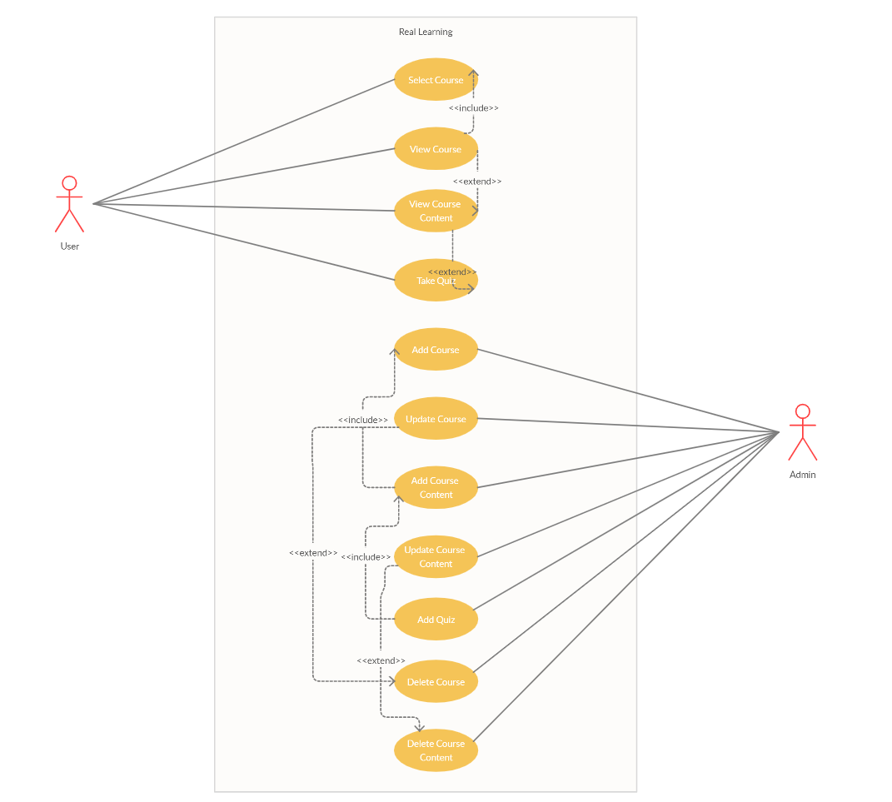

**Class diagrams**

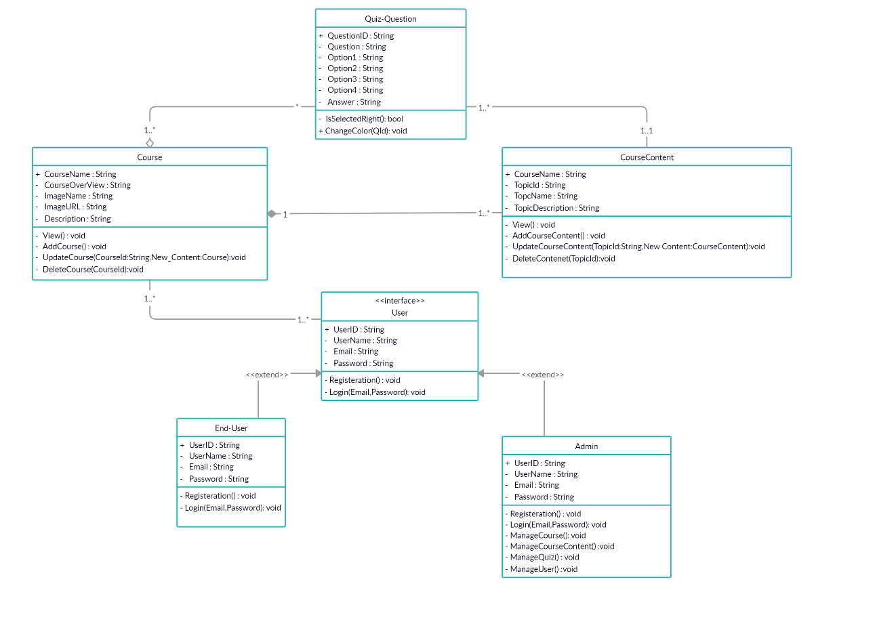

**Sequence diagrams**

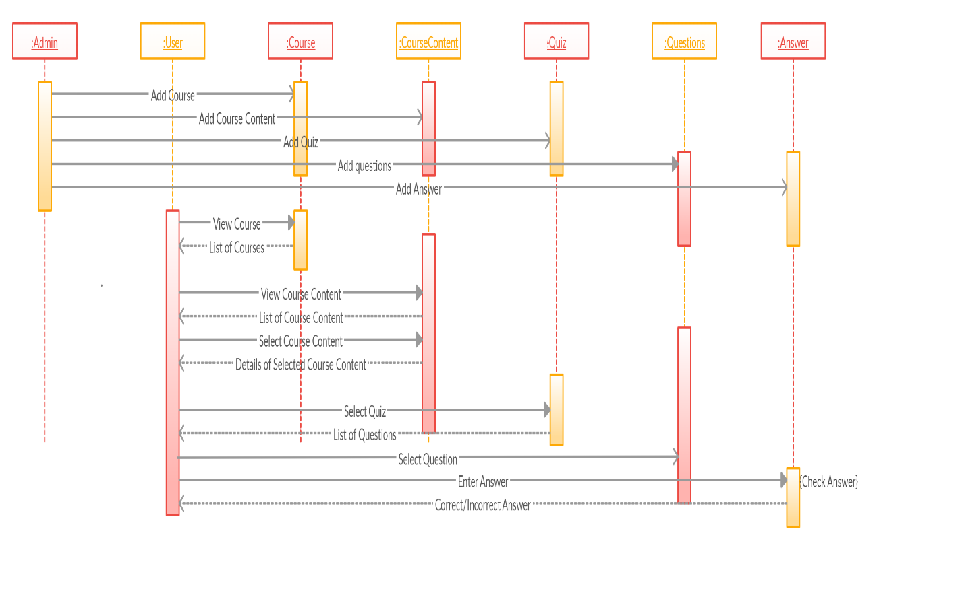

**Activity diagrams:**

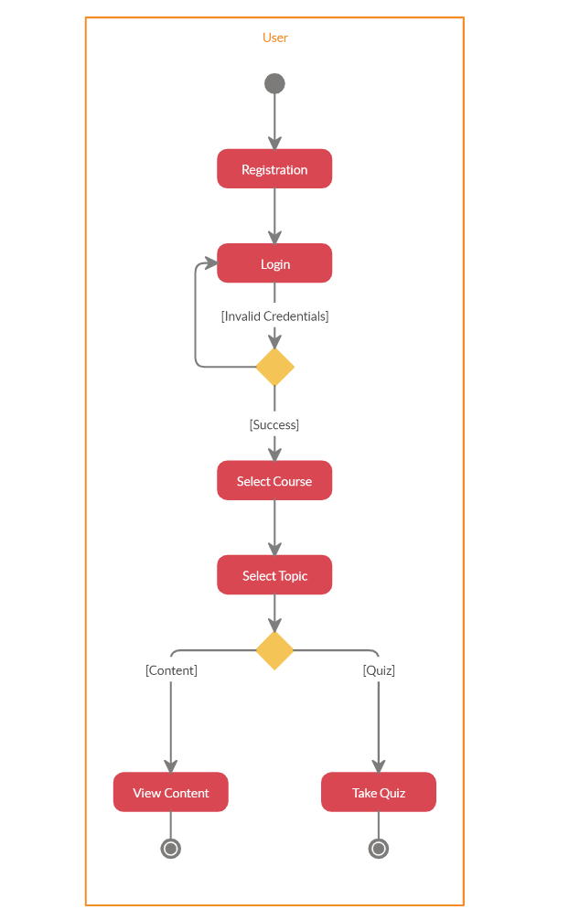

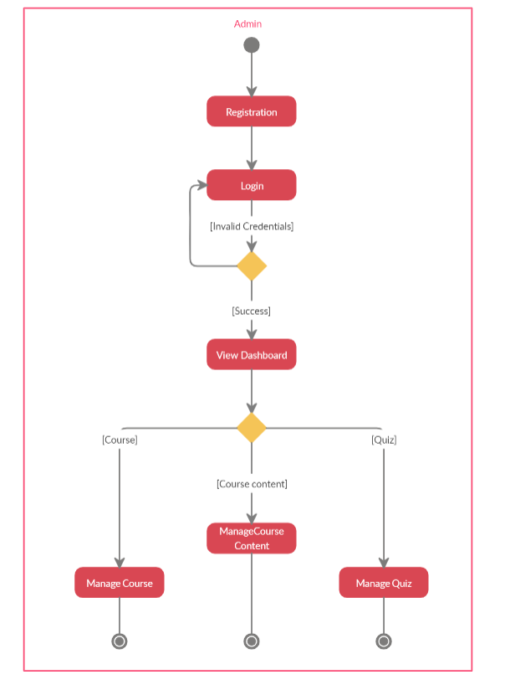

**State diagrams:**

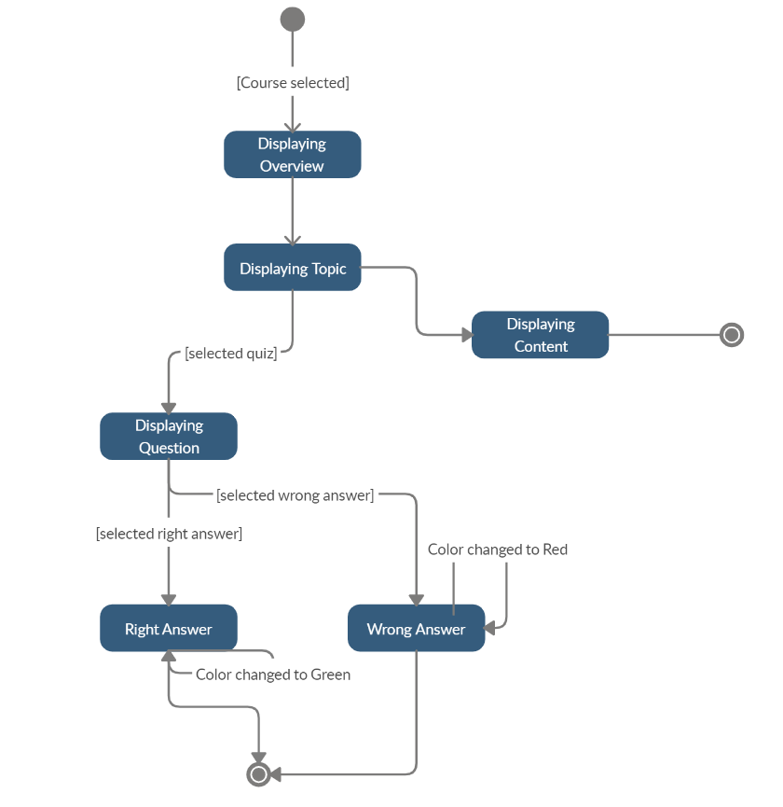

**E-R Diagram:**

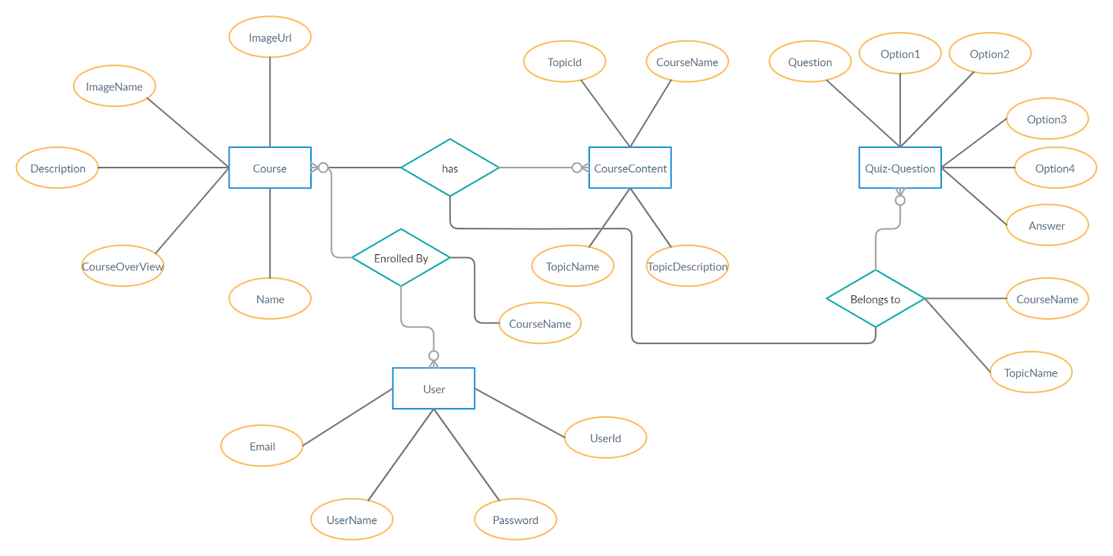

**Data Dictionary:**

|  |  |  |  |  |  |  |  |
| --- | --- | --- | --- | --- | --- | --- | --- |
| USER | | | | | | | |
| SR.NO | NAME | DATA TYPE | WIDTH | REQUIRED | UNIQUE | PK/FK | REFERENCE TABLE  DESCRIPTION |
| 1 | USERID | NUMERIC | 20 | YES | YES | PK |  |
| 2 | PASSWORD | VARCHAR | 20 | YES | NO |  |  |
| 3 | USERNAME | VARCHAR | 20 | YES | NO |  |  |
| 4 | EMAIL | VARCHAR | 20 | YES | YES |  |  |

|  |  |  |  |  |  |  |  |
| --- | --- | --- | --- | --- | --- | --- | --- |
| COURSE | | | | | | | |
| SR.NO | NAME | DATA  TYPE | WIDTH | REQUIRED | UNIQUE | PK/FK | REFERENCE TABLE  DESCRIPTION |
| 1 | ID | NUMERIC | 20 | YES | YES | PK |  |
| 2 | NAME | VARCHAR | 20 | YES | NO |  |  |
| 3 | DESCRIPTION | VARCHAR | 20 | YES | NO |  |  |
| 4 | IMAGENAME | VARCHAR | 20 | YES | NO |  |  |
| 5 | IMAGEURL | VARCHAR | 20 | YES | NO |  |  |
| 6 | COURSE  OVERVIEW | VARCHAR | 20 | YES | NO |  |  |

|  |  |  |  |  |  |  |  |
| --- | --- | --- | --- | --- | --- | --- | --- |
| COURSE_CONTENT | | | | | | | |
| SR.NO | NAME | DATA  TYPE | WIDTH | REQUIRED | UNIQUE | PK/FK | REFERENCE TABLE  DESCRIPTION |
| 1 | ID | NUMERIC | 20 | YES | YES | PK |  |
| 2 | COURSENAME | VARCHAR | 20 | YES | NO | FK | COURSE |
| 3 | TOPICNAME | VARCHAR | 20 | YES | NO |  |  |
| 4 | TOPIC  DESCRIPTION | VARCHAR | 20 | YES | NO |  |  |

|  |  |  |  |  |  |  |  |
| --- | --- | --- | --- | --- | --- | --- | --- |
| QUIZ | | | | | | | |
| SR.NO | NAME | DATA  TYPE | WIDTH | REQUIRED | UNIQUE | PK/FK | REFERENCE TABLE  DESCRIPTION |
| 1 | ID | NUMERIC | 20 | YES | YES | PK |  |
| 2 | TOPICNAME | NUMERIC | 20 | YES | YES | FK | COURSE_  CONTENT |
| 2 | QUESTION | VARCHAR | 20 | YES | NO |  |  |
| 3 | OPTION1 | VARCHAR | 20 | YES | NO |  |  |
| 4 | OPTION2 | VARCHAR | 20 | YES | NO |  |  |
| 5 | OPTION3 | VARCHAR | 20 | YES | NO |  |  |
| 6 | OPTION4 | VARCHAR | 20 | YES | NO |  |  |
| 7 | ANSWER | VARCHAR | 20 | YES | NO |  |  |

**5. Implementation Details**

**1. Modules**

●      **User Module:**

User module is basically manage all the activity of users. In this module user can register and login by giving some basic details.

User can view all course. User can see all the topics of any course and go through any particular topic of any course. Also user can take part in quiz for any particular topic of quiz.

●      **Admin Module:**

This module handles all the activity of the Admin.  Admin can add course, course content and quiz for all topics. Admin can also update the details of any course content or course. Also admin can delete the course content and whole course.

**2. Function Prototype**

**Users:**

* To get all course

Future GetAllCourse()

* TO get specific course

  Stateless widget CourseDetail()

* TO get all sub topic

Future getallsubTopic()

* To get quiz

Stateful widget Quiz()

**Admin:**

* Login:

def login(request)

* Add Course:

def courseupload(request)

* Add Course-Content:

def uploadcoursecontent(request)

* View Course:

def viewselectedcourse(request)

* View Course-Content:

def viewselectedtopic(request):

* Update Course:

def courseupdate(request)

* Update course content:

def coursecontentupdate(request)

* Add Question:

def addQuestion(request)

* Delete Course:

def deletecourse(request)

* Delete Course Content:

def addQuestion(request)

* Logout:

def logout(request)

**3. Flow Chart**

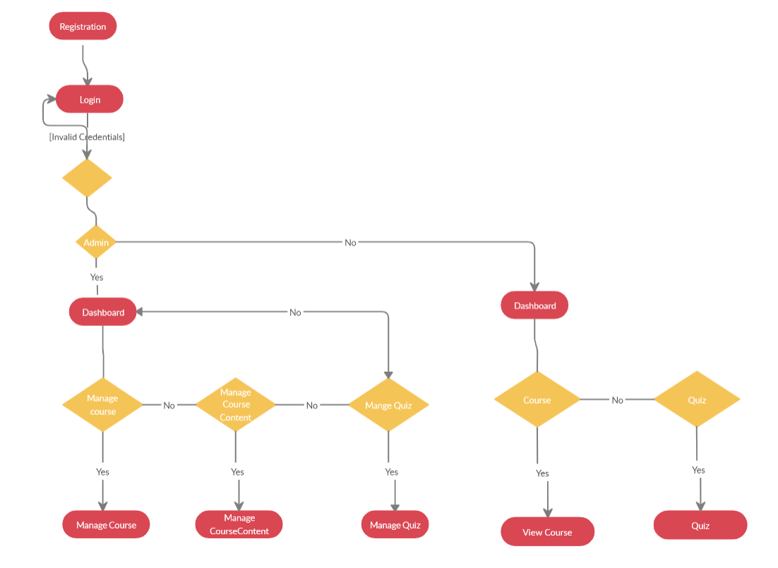

**6. Testing**

We performed black box testing.

If user does not provide password or wrong details system will throw error.

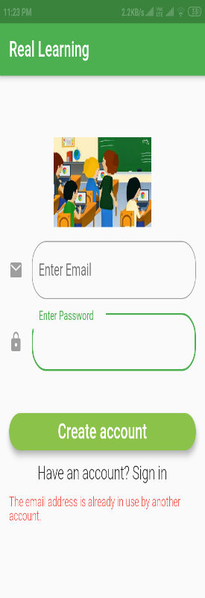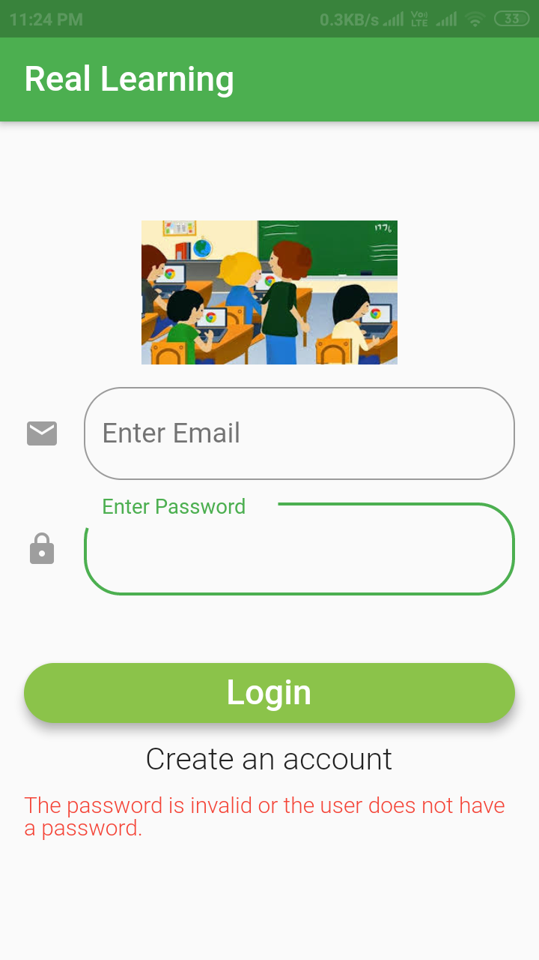

**7. Screenshot**

Users:

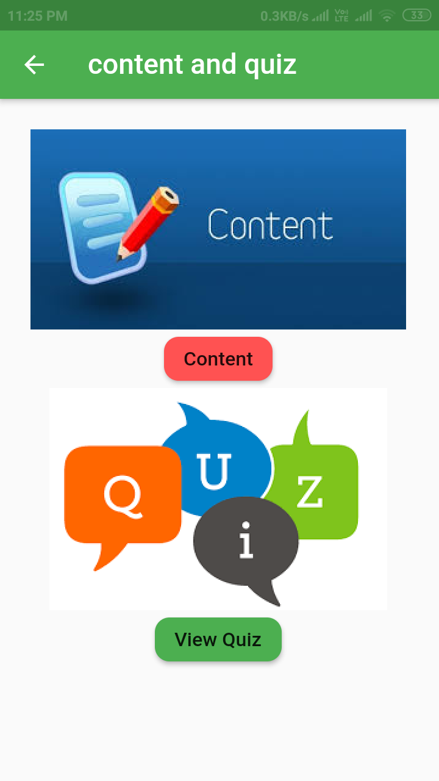After Login user can see all courses:

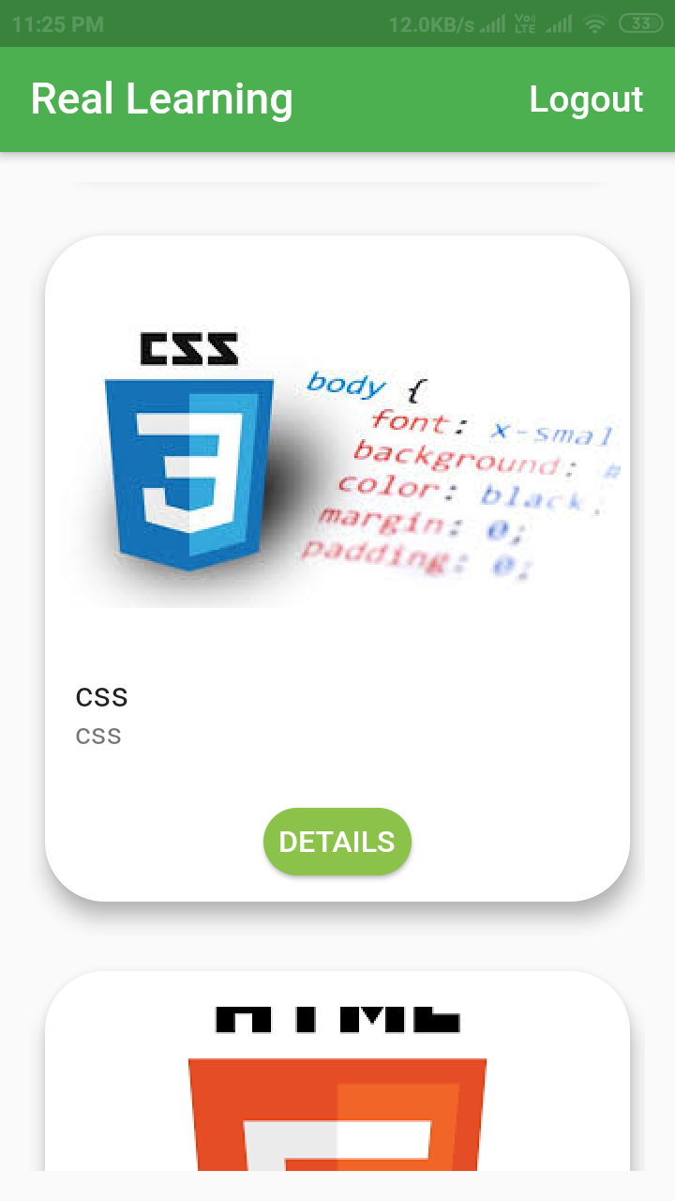

After Clicking on content or quiz user can see below screen. If answer of question is wrong then red color is displayed.

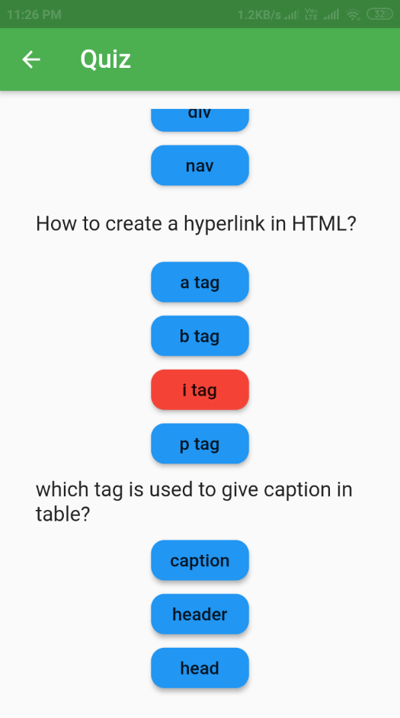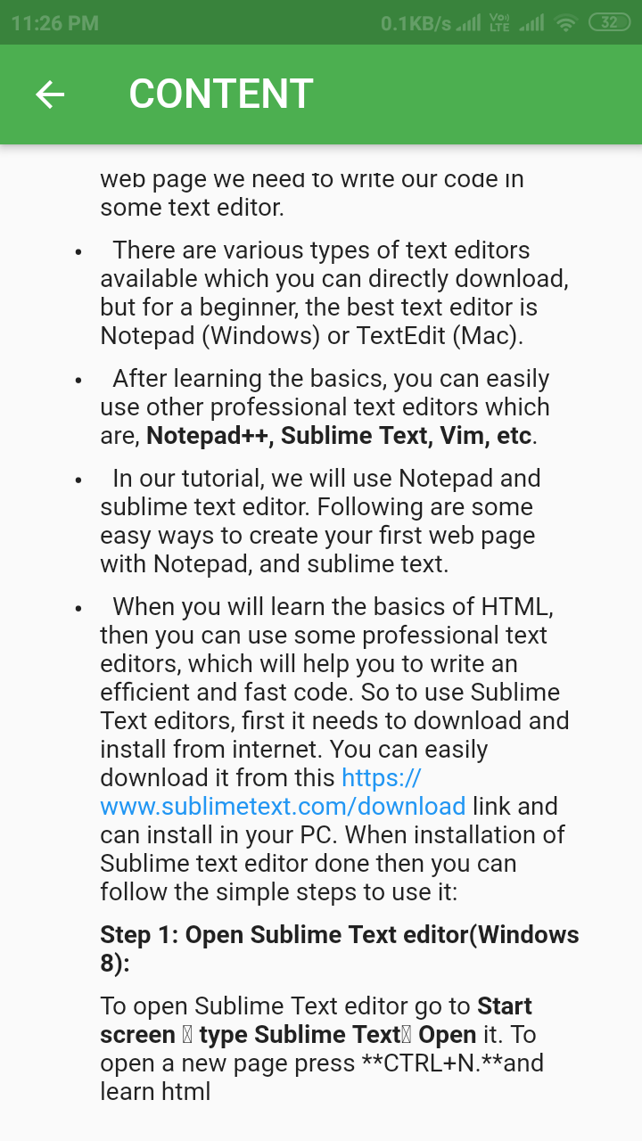

If answer of question is correct then green color is displayed.

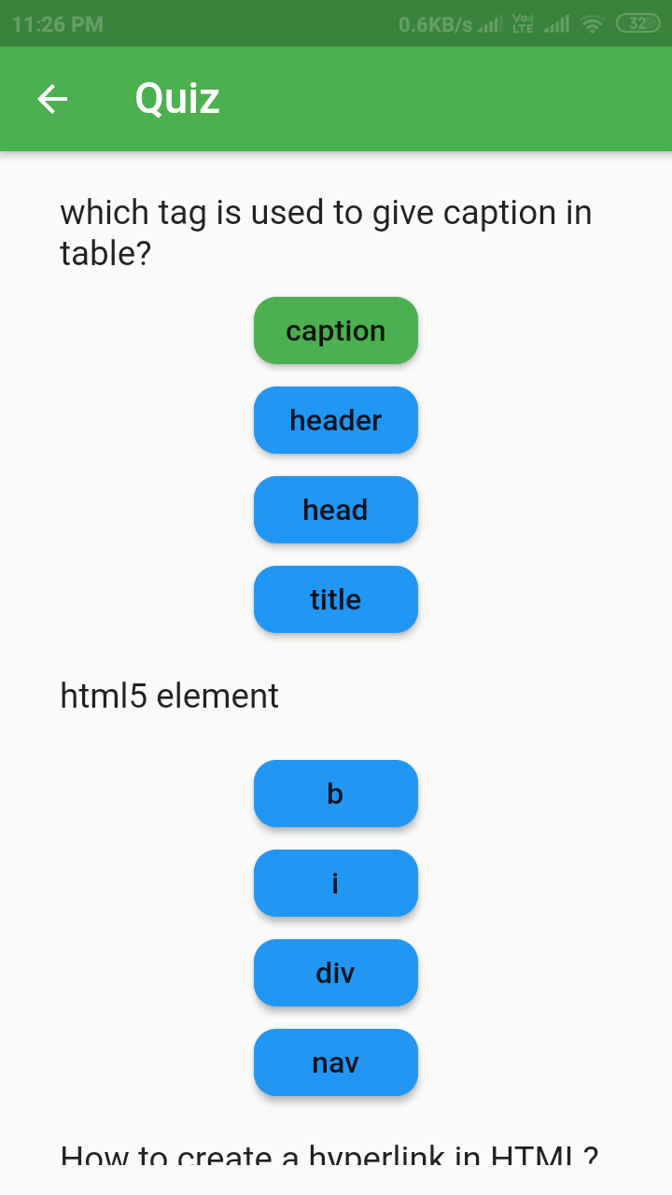

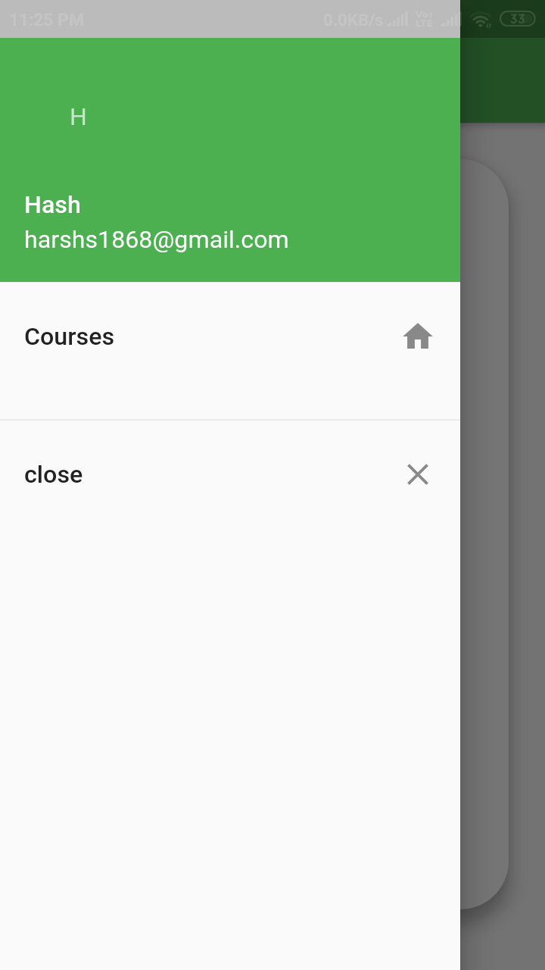

Admin:

1. Admin Dashboard:

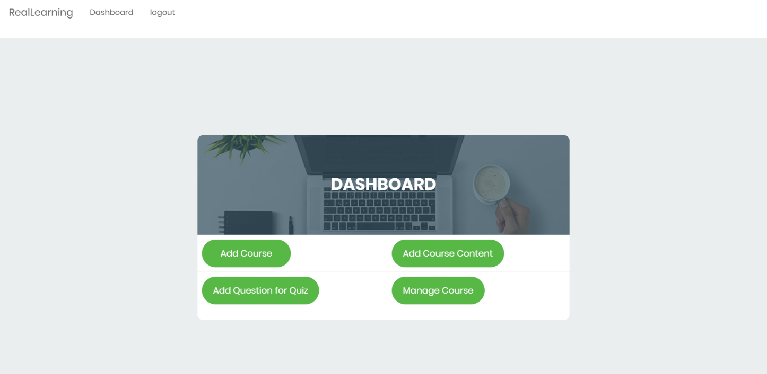

After login as Admin can see dashboard.

2. Add New Course:

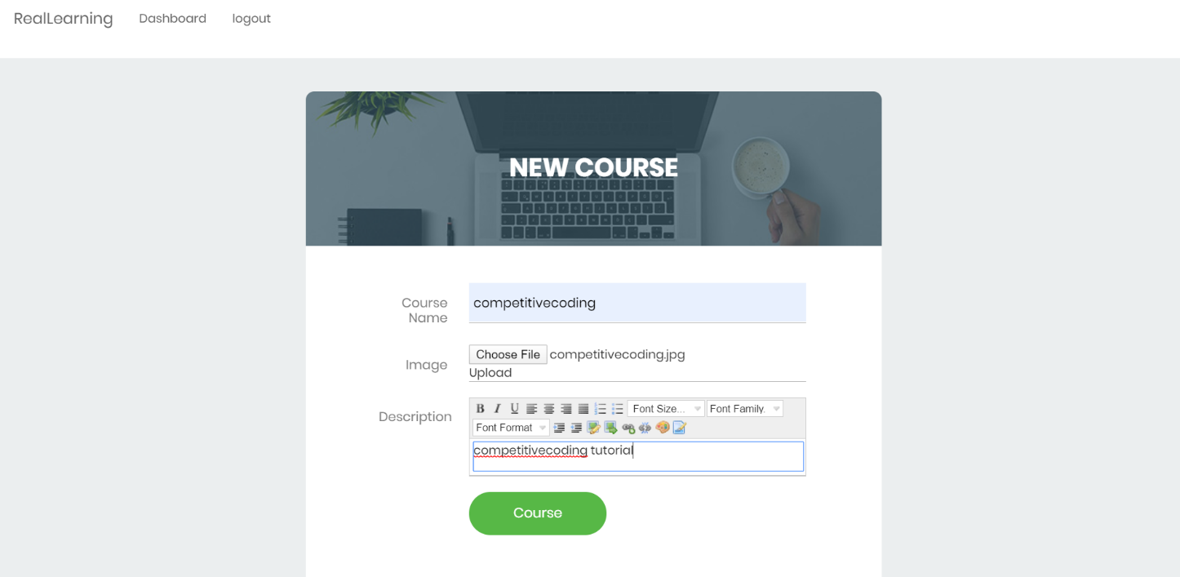

3. Add New Course-Content:

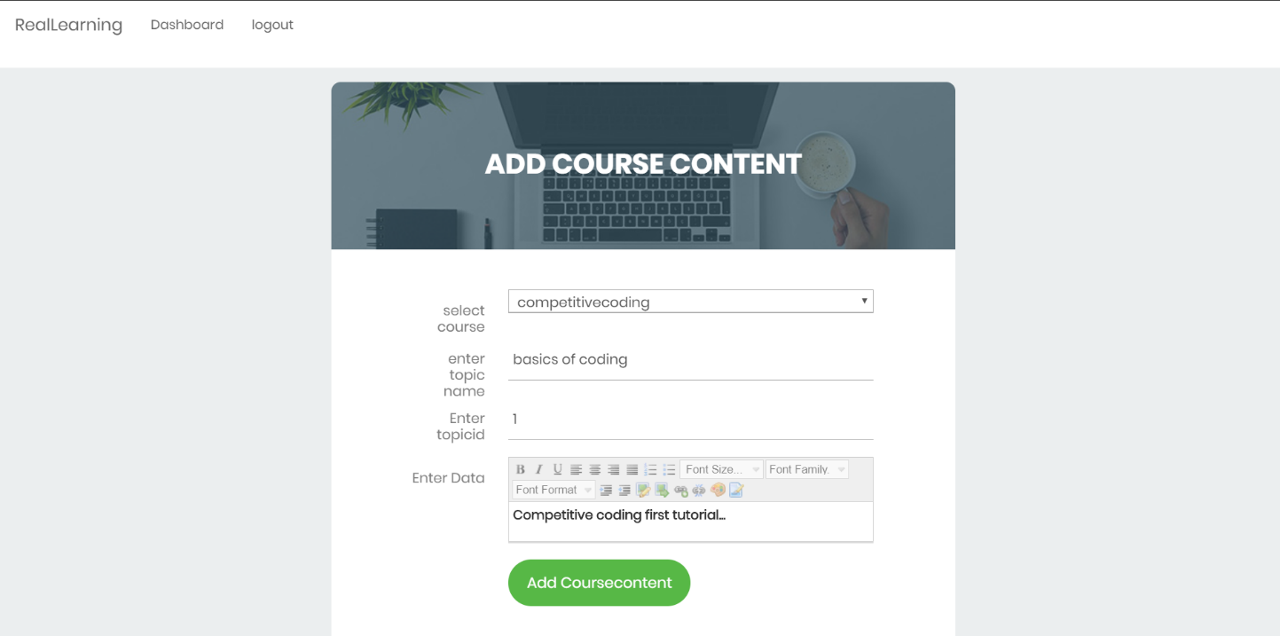

4. Manage Course:

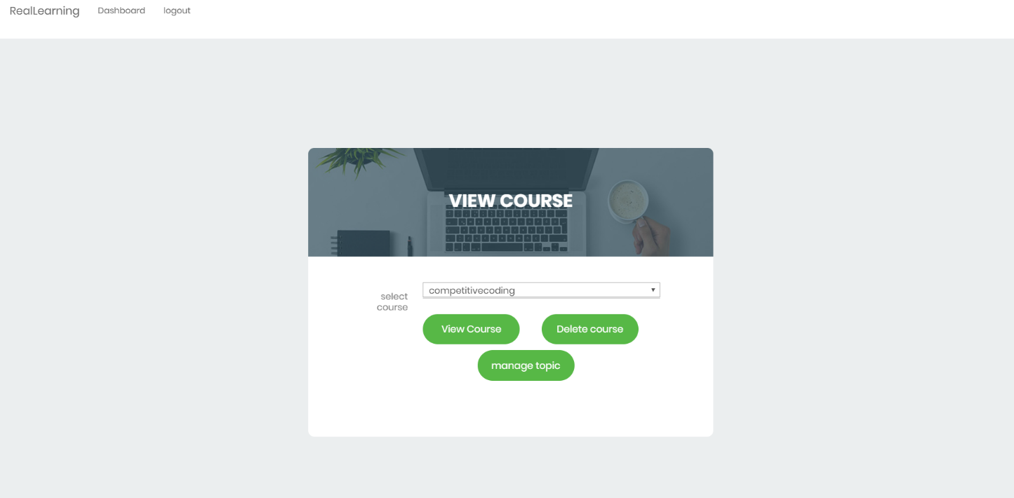

5. Update Course-Content:

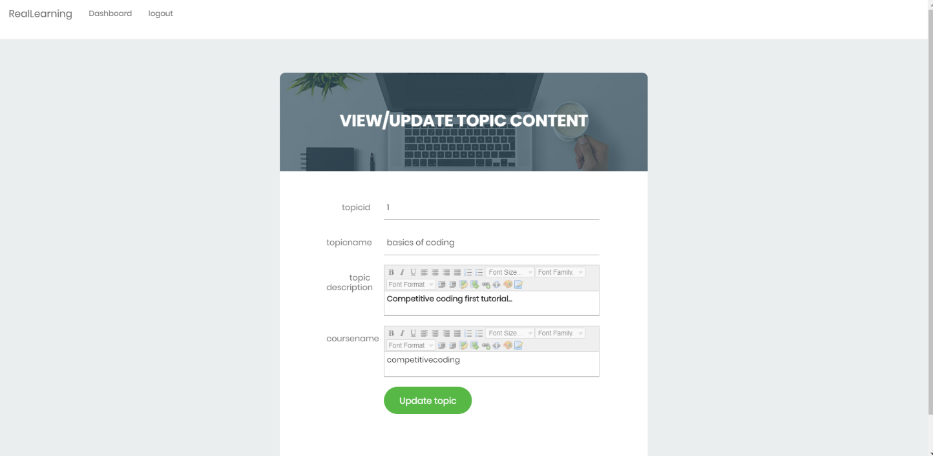

6. Add Question.

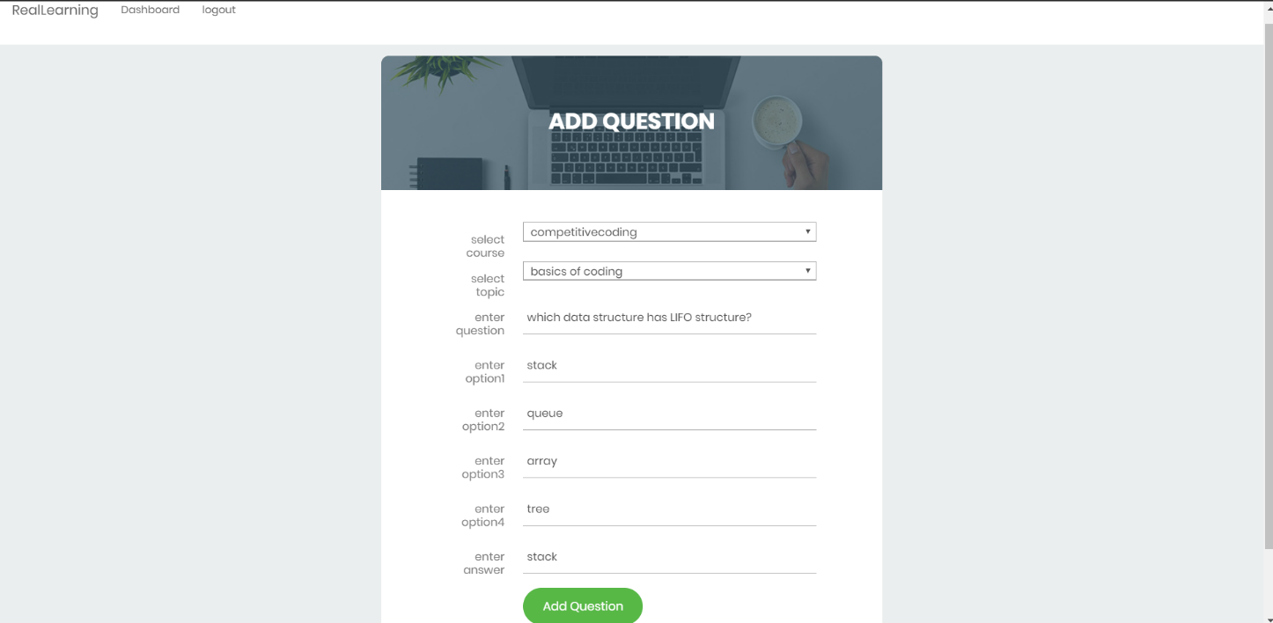

**8. Limitation and Future Extension**

**Limitations**

1. There is no enrollment feature for any course.
2. Currently system can not recommend any course based on learner’s past course.
3. Our system is not tracking user so that user can know how much course is completed and how many module he has finished.
4. Our system not providing video content ,currently it supports only image and text format. You can add your rich text.

**Future Extension**

1. We will try to add Augmented Reality for better user experience.
2. We will provide subscription feature for course.
3. We will provide video content for any particular topic.
4. We will also track the record of learner to provide suggestion for best course.
5. We will add recommendation system for user.

**9. Conclusion**

The functionality of this system is developed after understanding whole system flow and all module and it is as per requirement.

The functionality which were successfully  implemented :

1. Registration/Login

2. View Course

3. View Course Content

4. View Quiz

5. Manage Course

6. Manage Course Content

7. Manage Quiz

**10. Bibliography**

**Reference Links:**

<https://flutter.dev/docs>

<https://docs.djangoproject.com/en/3.0/>

<https://stackoverflow.com/>