Plantation use case test on the new Odoo 20 instance
Instance: http://167.71.222.157:8071, database odoo20_ss, module ss_plantation
Run date: 12 November 2026
Result: 40 of 40 browser steps passed; 20 of 21 API flow steps passed in the last full run, the 21st being a repeat-run issue explained below.

1. What was tested
The same plantation use case that was run on the old server (odoo20.kpmgroup.co.id) was run on the separate instance that now hosts only the plantation module. The test has two parts: a business flow driven through the JSON-2 API that creates the data, and a browser test (Playwright) that opens every screen in the Indonesian interface and creates an estate, division and block by hand.

Setup needed on this database
- The database only had a US company (USD). A second company, "My Indonesian Company" (IDR, Indonesian chart of accounts), was created as company 3 to hold the plantation data, as on the old server.
- The Indonesian company needed the plantation settings that a company created after installation does not get automatically: FFB, CPO and kernel products, the estate and consumption stock locations, and the receiving warehouse. The test sets them in step 1.1.
- Fixed-asset accounts need a depreciation model before a block can be capitalised. The test assigns one (step 4.1).
- The test scripts no longer depend on record numbers from the old server: they look up locations and units by name and create the sample employees.

2. Business flow (API)
Step | What it does | Result
1.1 | Warehouse and plantation settings (company products, locations, freshness limit) | Passed
1.2 | Input store location for the division | Passed
1.3 | Harvest pay schemes: piece rate, mixed, daily | Passed
1.4 | Pay schemes assigned to employees | Passed
1.5 | FFB reference prices: general and Smallholder tag | Passed
1.6 | Estate, division and six blocks | Passed
1.7 | Landmarks: mill and weighbridge | Passed
1.8 | Fertiliser product with opening stock in the input store | Passed
1.9 | Partners: smallholder supplier and buyer | Passed
2.1 | Field activity: fertilising block E101 with 200 kg NPK, marked Done (stock move) | Passed
2.2 | Harvest tallies for two days, confirmed | Passed
2.3 | Transport note for day 2, sent | Passed
2.4 | Weigh ticket: own estate to mill, with grade deductions and transport link | Passed
2.5 | Weigh ticket: bought from smallholder at the tag price (purchase order and receipt) | Passed
2.6 | Weigh ticket: sale of an FFB lot to a buyer (delivery) | Passed
2.7 | Mill: bill of materials and manufacturing order, OER and KER | Passed
3.1 | Compute Harvest Pay wizard for November 2026 | Passed
3.2 | Payslips with Add Harvest Pay, compute sheet | Passed
4.1 | Capitalise mature block E102 as an asset (wizard) | Passed on the first run; see note
4.2 | Yield and Cost report by month and division | Passed
4.3 | Extraction rates on the manufacturing order | Passed

Note on step 4.1: the full flow was run several times while the test data was being prepared. Each run adds new transactions, so on the last full run the block had already been capitalised and the step reported that. The step passed on the first run that reached it. The test now skips the step when the block already has an asset; that final form was not run again.

Key figures from the run
- Harvest pay for November 2026: Agus (mixed scheme) 2,320 kg, bonus Rp 80,000, penalty Rp 7,000, pay Rp 73,000. Siti (piece rate) Rp 378,300 on the payslip. Dewi (daily wage) had no harvest line.
- Tallies: day 1 has 240 bunches (estimated 3,495 kg); day 2 has 275 bunches (estimated 4,007.5 kg). The transport note for day 2 carries 340 bunches (estimated 4,930 kg).
- Block E102 was capitalised as asset "Plantation E102".

3. Screen test (browser, Indonesian interface)
40 of 40 steps passed. Every step opens a screen or performs an action and checks that no error appears. The first run used the English labels and failed because the new database's admin user works in Indonesian; the test has an Indonesian mode that reads the labels from the module translations, which was used here.
No. | Step | Result
1 | Login | Passed
2 | Home menu shows Plantation app | Passed
3 | Open Plantation app (Dashboards) | Passed
4 | Dashboards: spreadsheet dashboard renders | Passed
5 | Map: Leaflet map with estate layers | Passed
6 | Map: layer control | Passed
7 | Map: click a block shows popup | Passed
8 | Dashboards: Plantation > Owner | Passed
9 | Switch to the E2E company (company 2) holding transactions | Passed
10 | Master Data: Estates list | Passed
11 | Estate form | Passed
12 | Master Data: Divisions list | Passed
13 | Division form | Passed
14 | Master Data: Blocks list | Passed
15 | Block form (area, stage, boundary) | Passed
16 | Master Data: Landmarks list | Passed
17 | Landmark form | Passed
18 | Operations: Field Activities | Passed
19 | Operations: Harvest Tally | Passed
20 | Harvest tally form | Passed
21 | Operations: Transport Notes | Passed
22 | Operations: Weigh Tickets | Passed
23 | Weigh ticket form (confirmed, stock link) | Passed
24 | Mill: Extraction Rates (OER/KER) | Passed
25 | Payroll: Pay Schemes | Passed
26 | Pay scheme form | Passed
27 | Payroll: Harvest Pay | Passed
28 | Payroll: Compute Harvest Pay wizard | Passed
29 | Reporting: Yield and Cost pivot (earlier TypeError) | Passed
30 | Yield and Cost: graph view | Passed
31 | Config: Activity Types | Passed
32 | Config: Landmark Types | Passed
33 | Config: Grade Deductions | Passed
34 | Config: FFB Reference Prices | Passed
35 | Config: Settings | Passed
36 | Create estate via UI: fill form | Passed
37 | Create estate via UI: save | Passed
38 | Create division under new estate via UI | Passed
39 | Create block under new division via UI | Passed
40 | Click Set Mature button: block stage becomes Mature (TM) | Passed

The login step logs a browser warning that the page is not served over HTTPS. That is expected for this address; the field app is served over HTTPS at https://sawit.kpmgroup.co.id.

4. Screenshots
1. Login
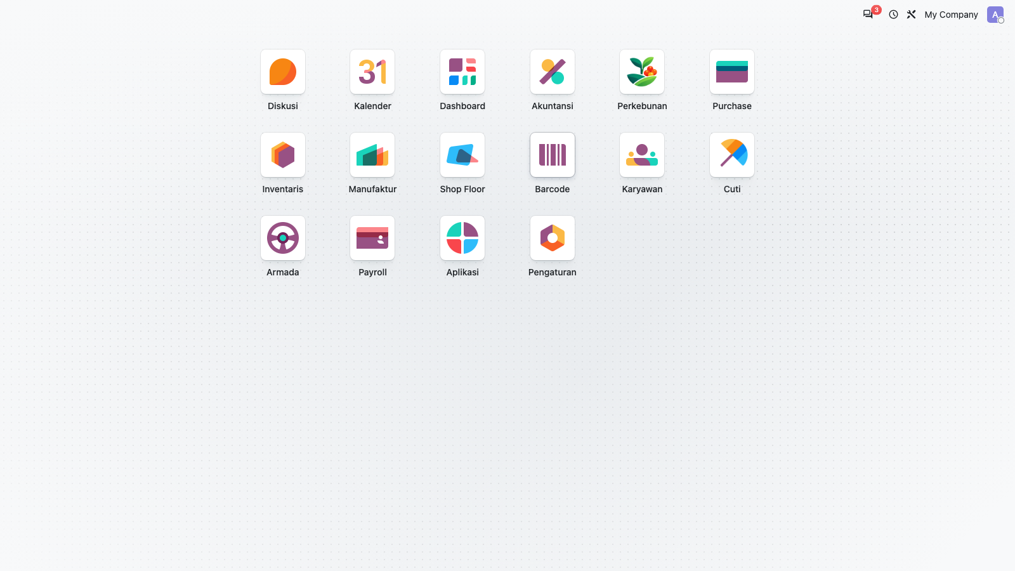
2. Home menu shows Plantation app
3. Open Plantation app (Dashboards)
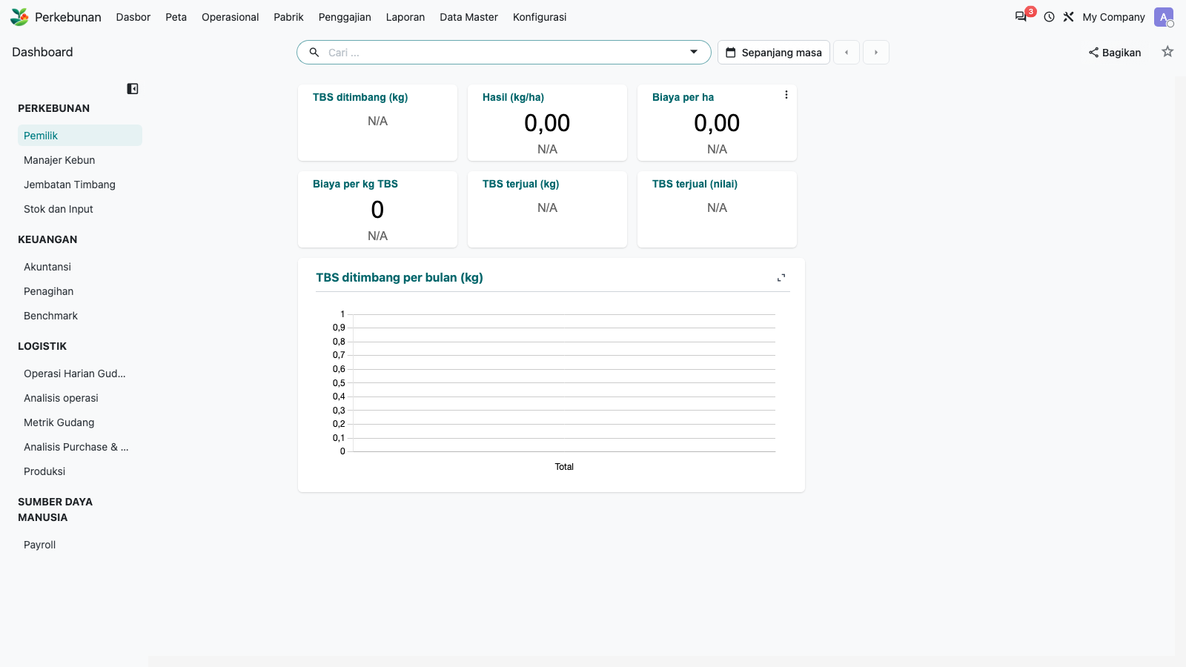
4. Dashboards: spreadsheet dashboard renders
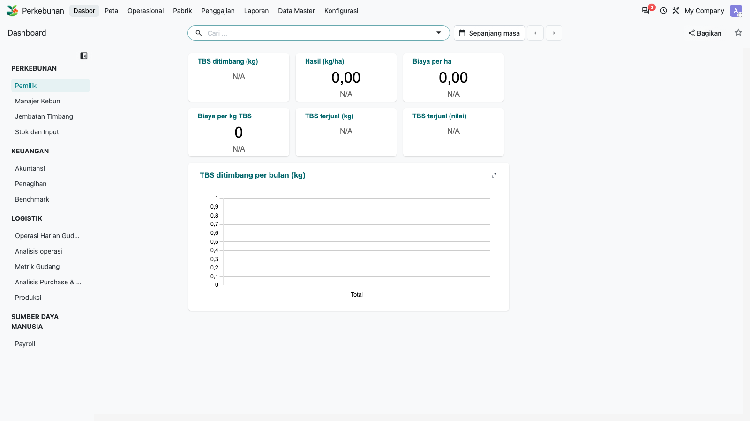
5. Map: Leaflet map with estate layers
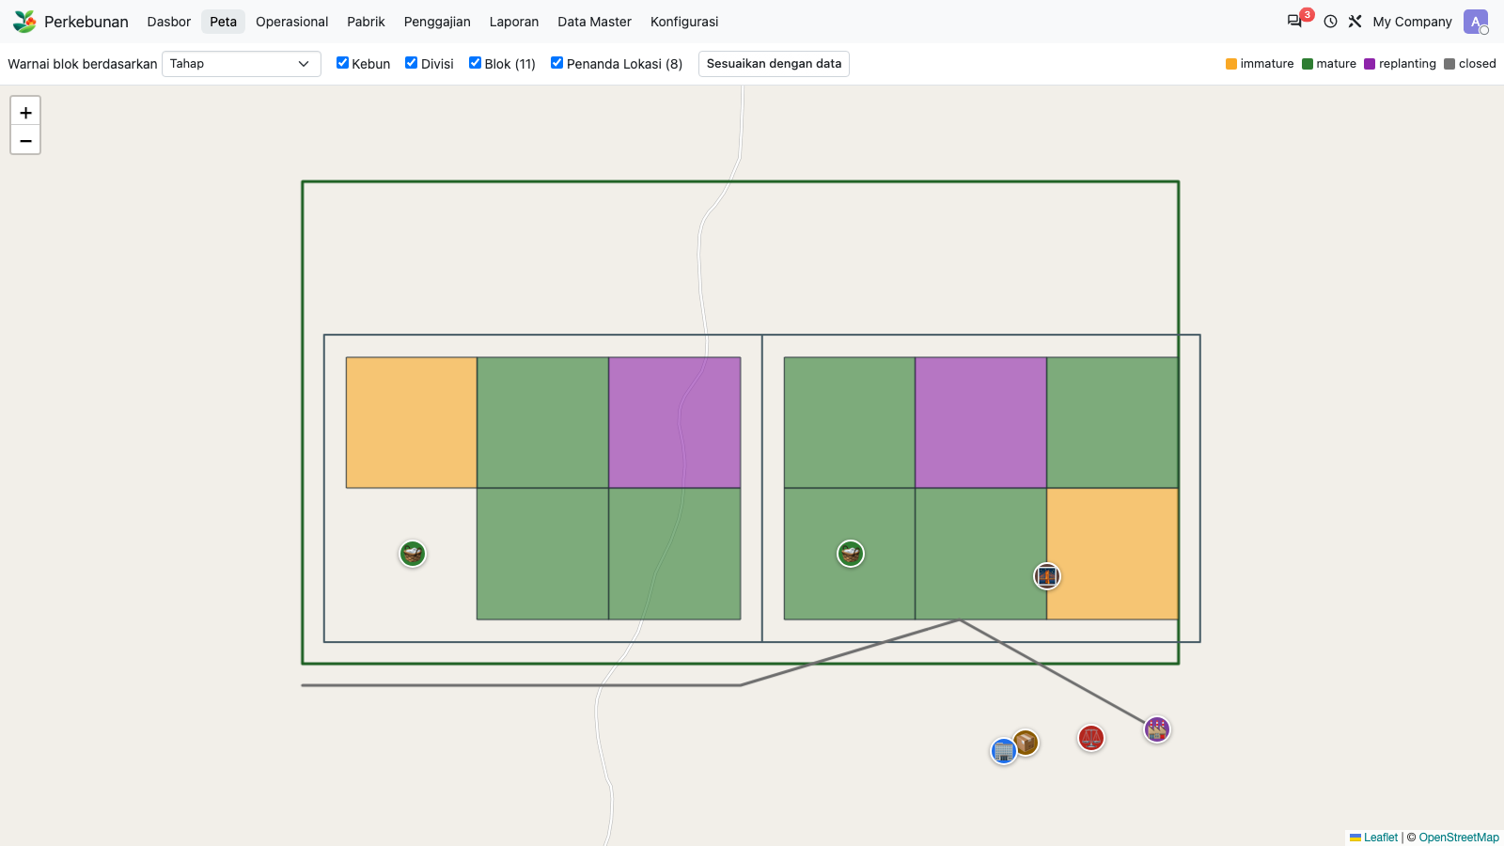
6. Map: layer control
7. Map: click a block shows popup
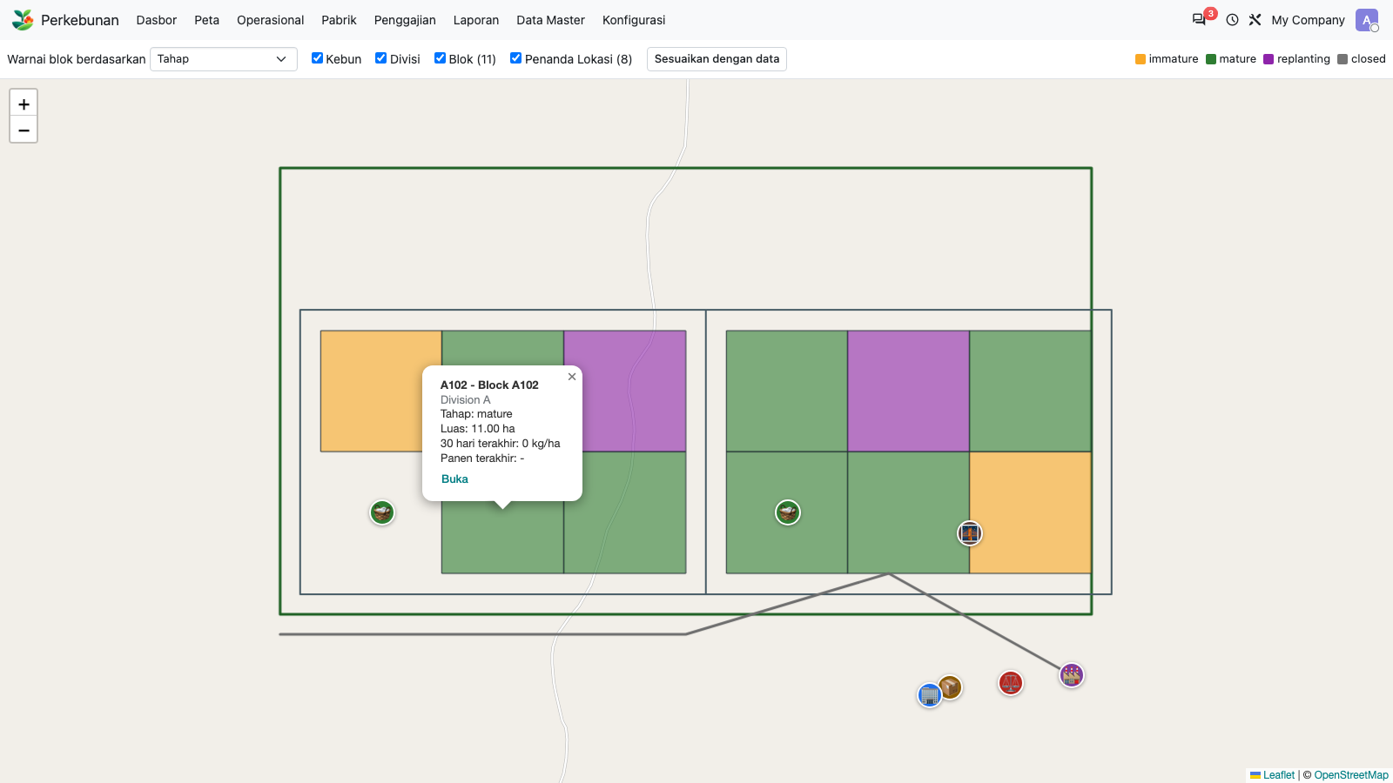
8. Dashboards: Plantation > Owner
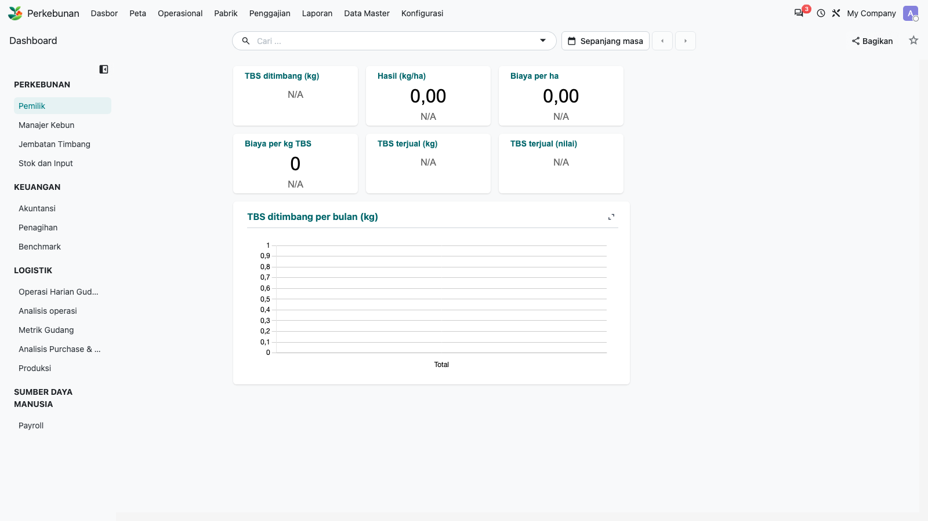
9. Switch to the E2E company (company 2) holding transactions
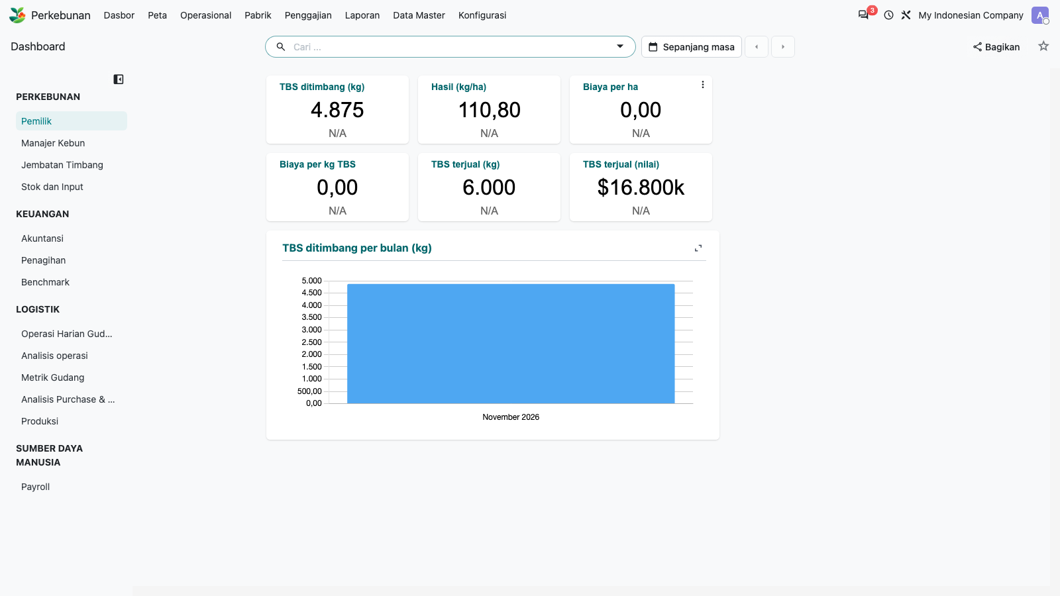
10. Master Data: Estates list
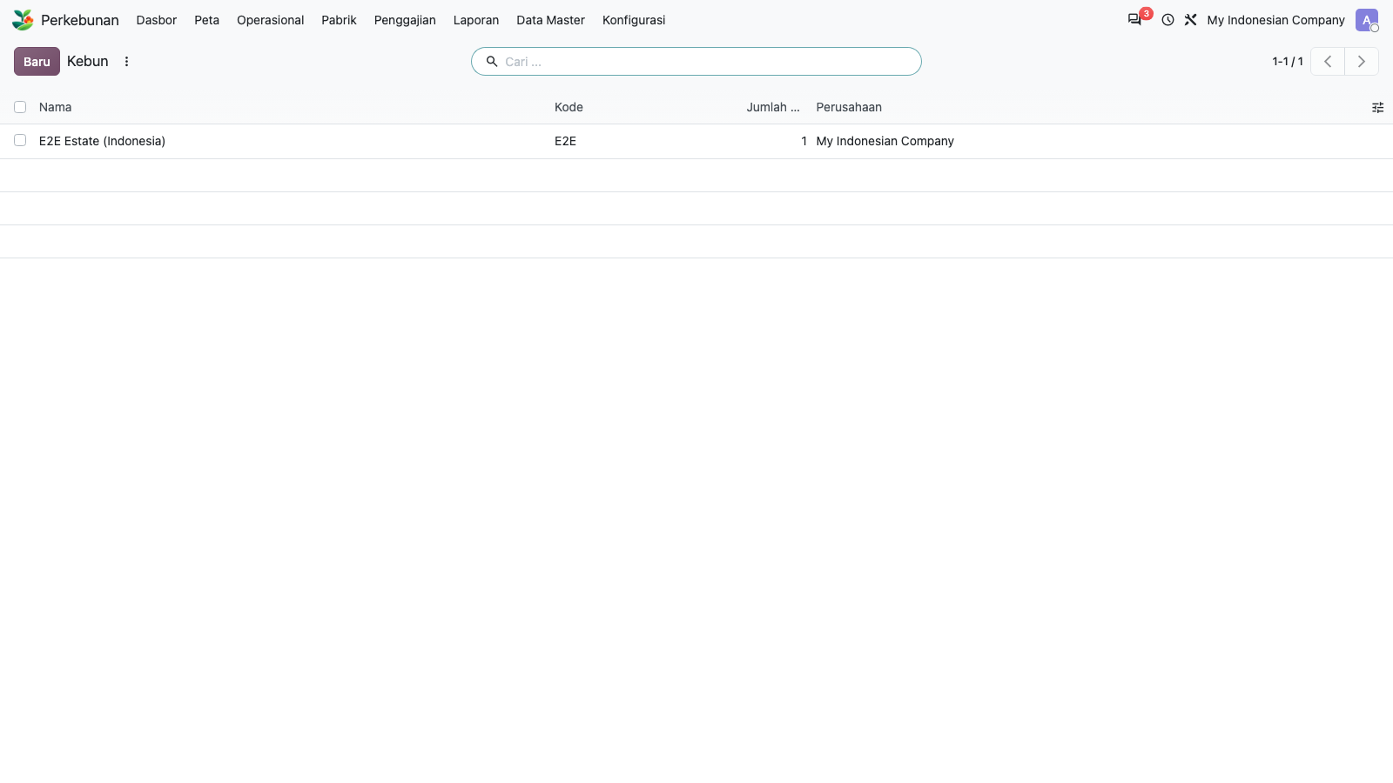
11. Estate form
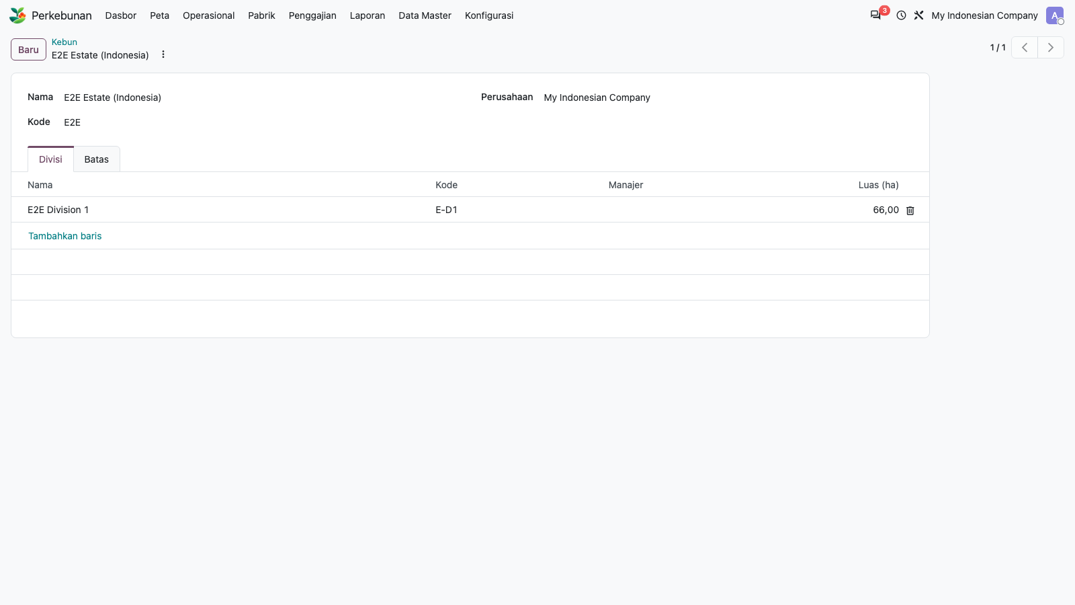
12. Master Data: Divisions list
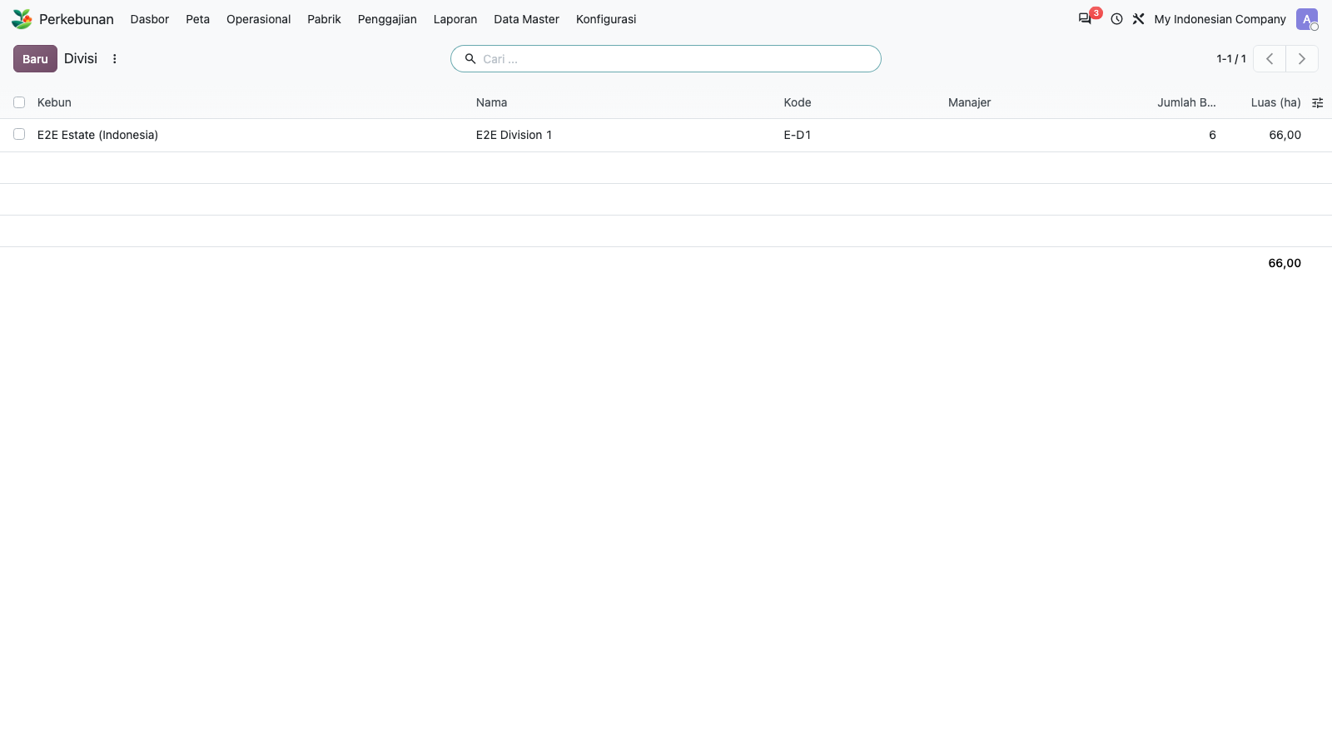
13. Division form
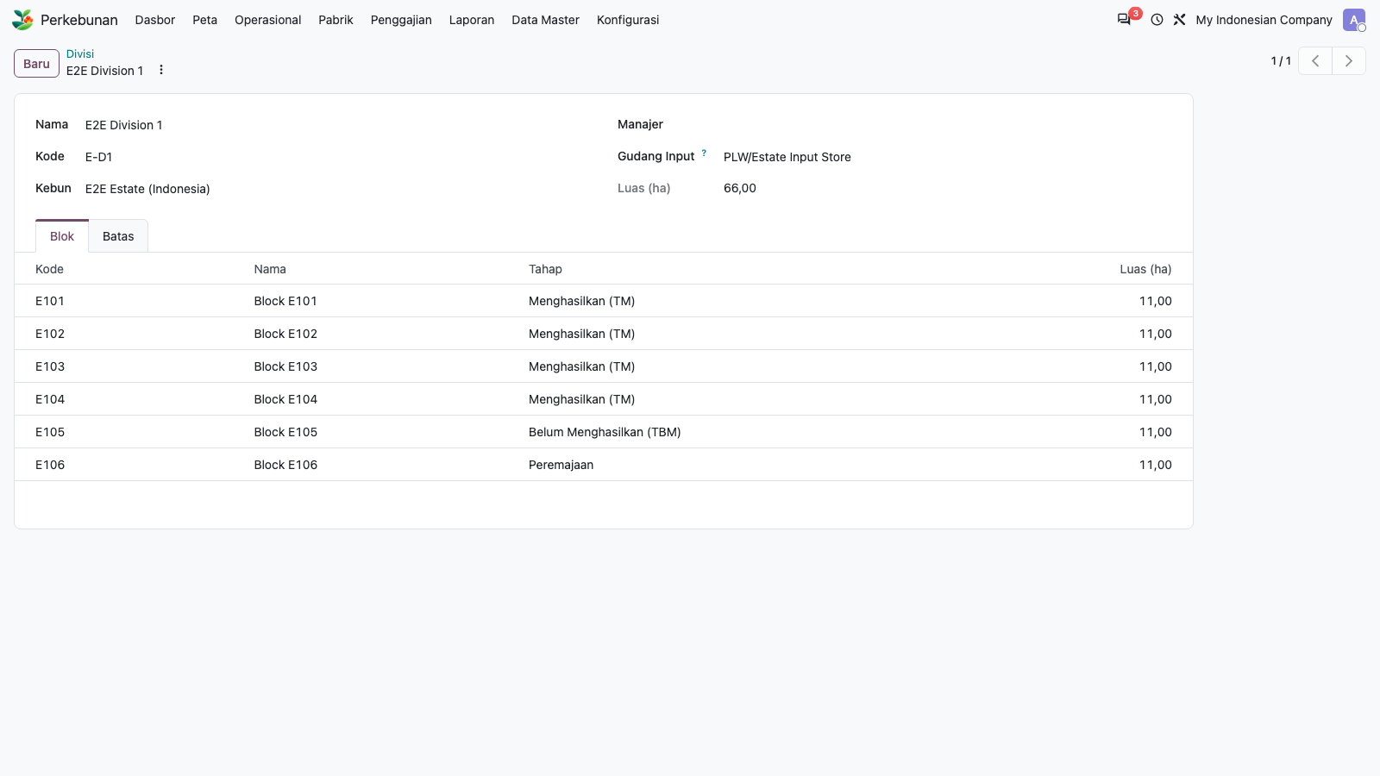
14. Master Data: Blocks list
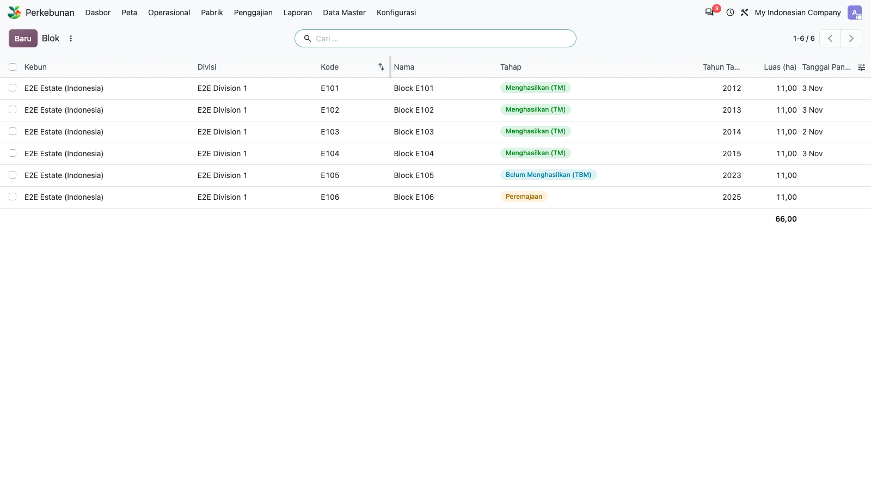
15. Block form (area, stage, boundary)
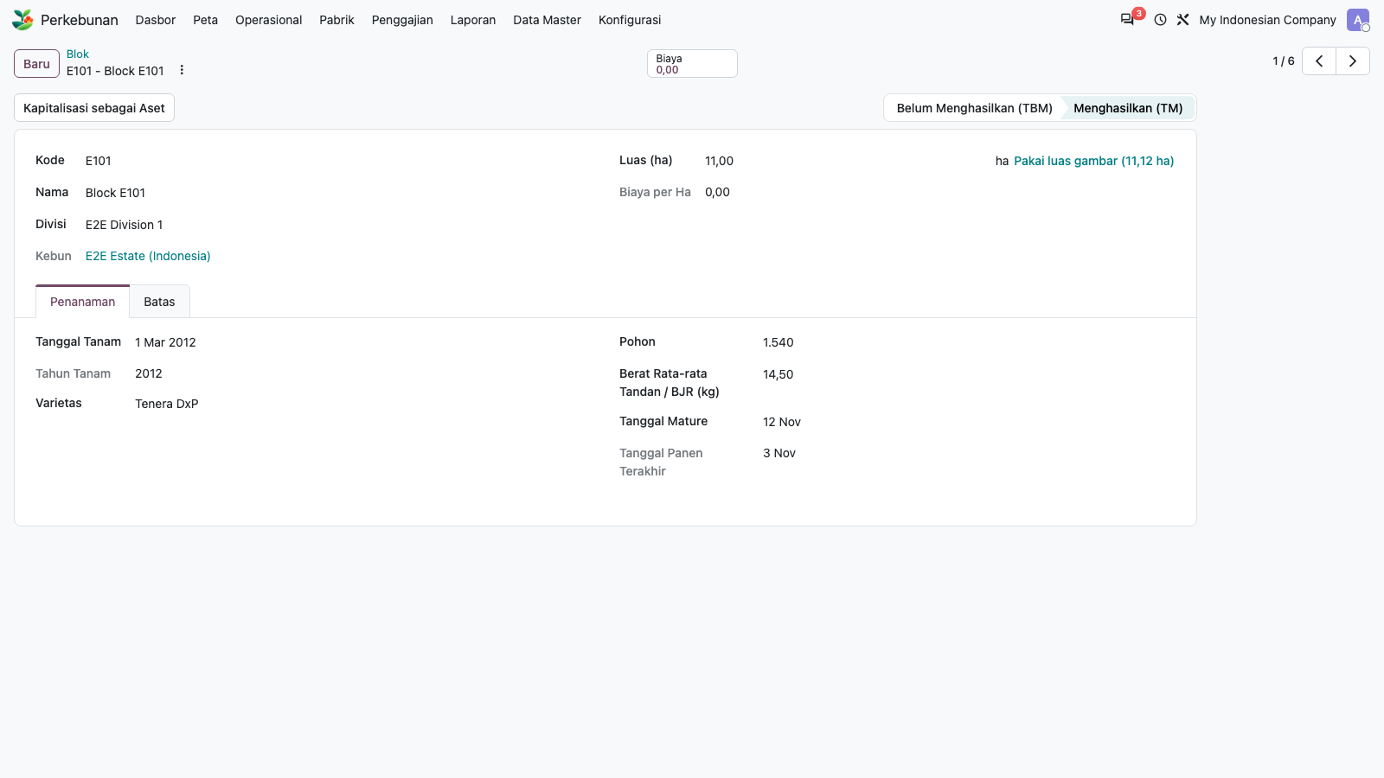
16. Master Data: Landmarks list
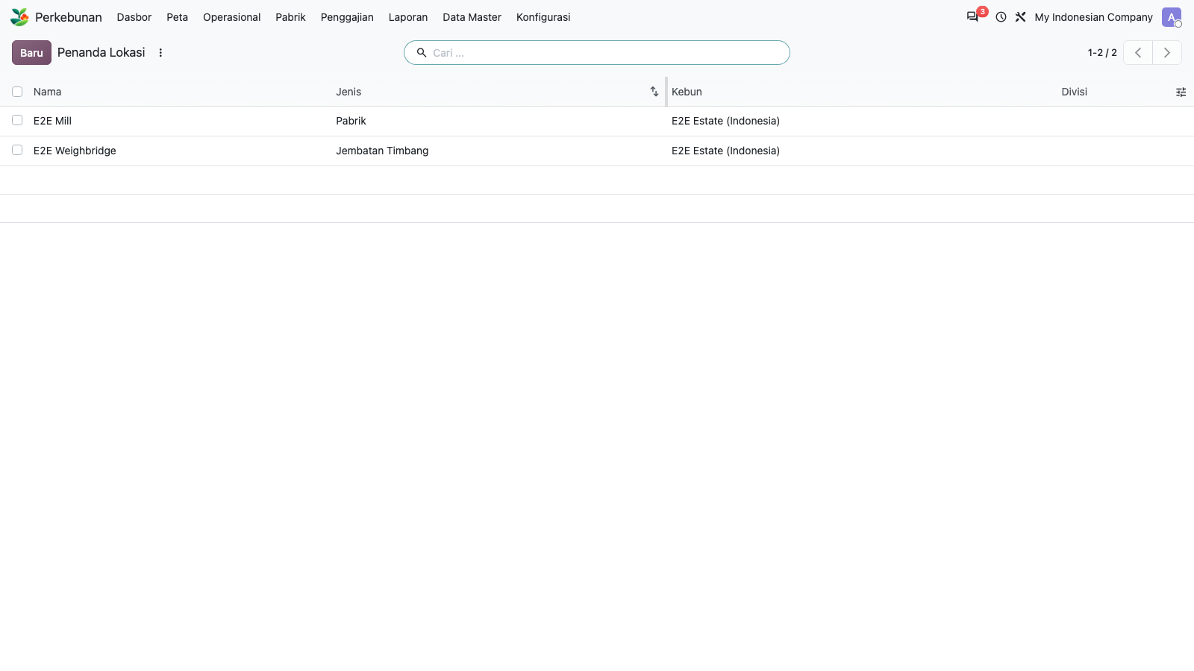
17. Landmark form
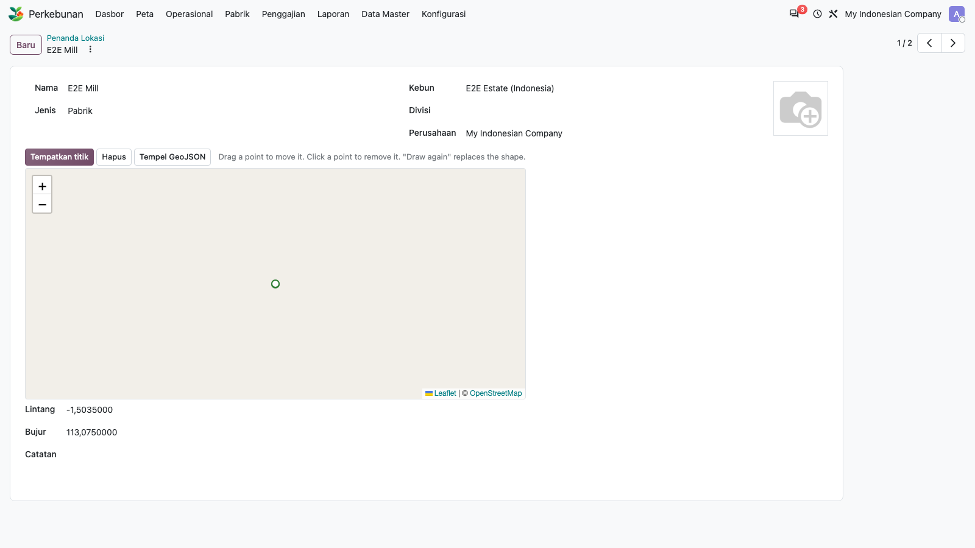
18. Operations: Field Activities
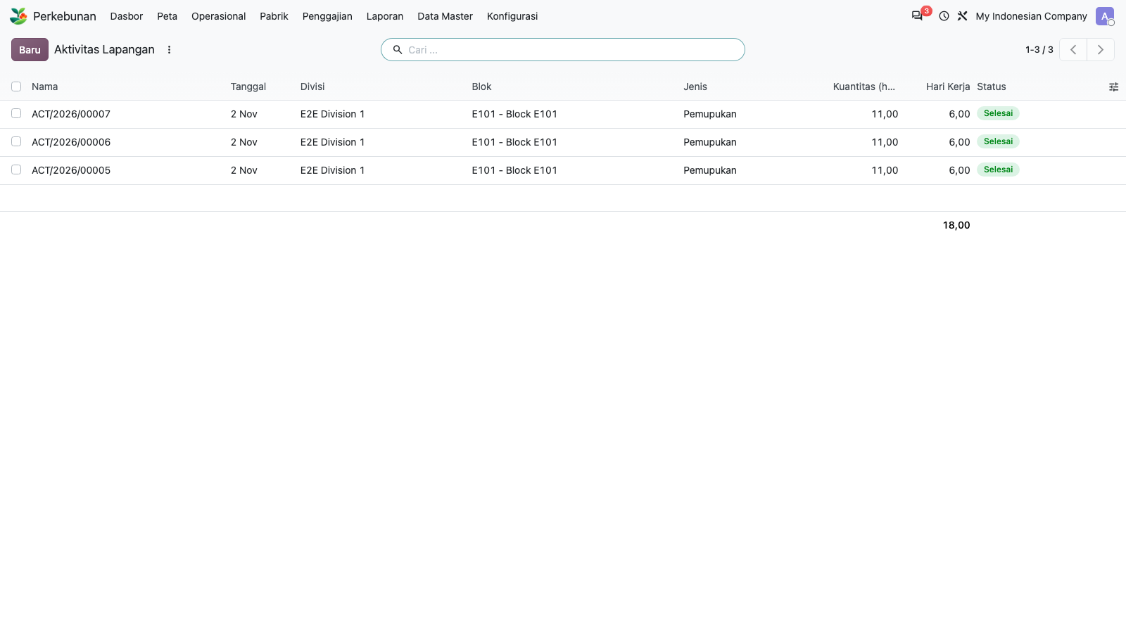
19. Operations: Harvest Tally
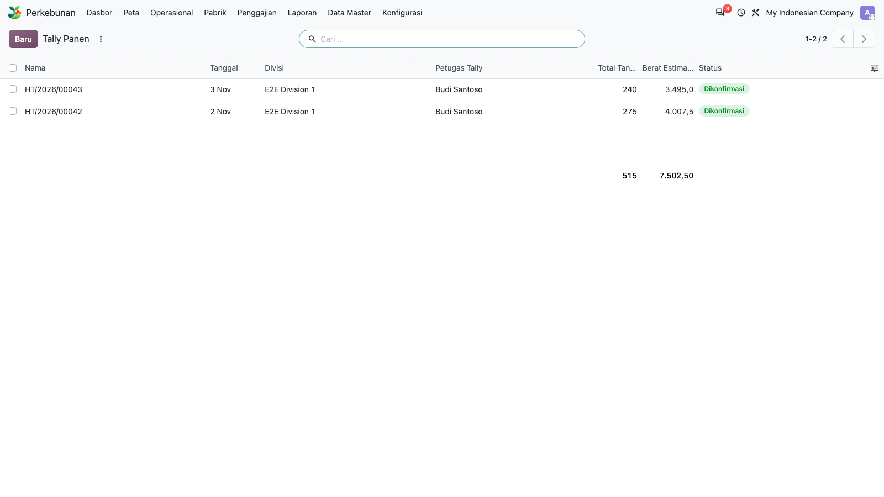
20. Harvest tally form
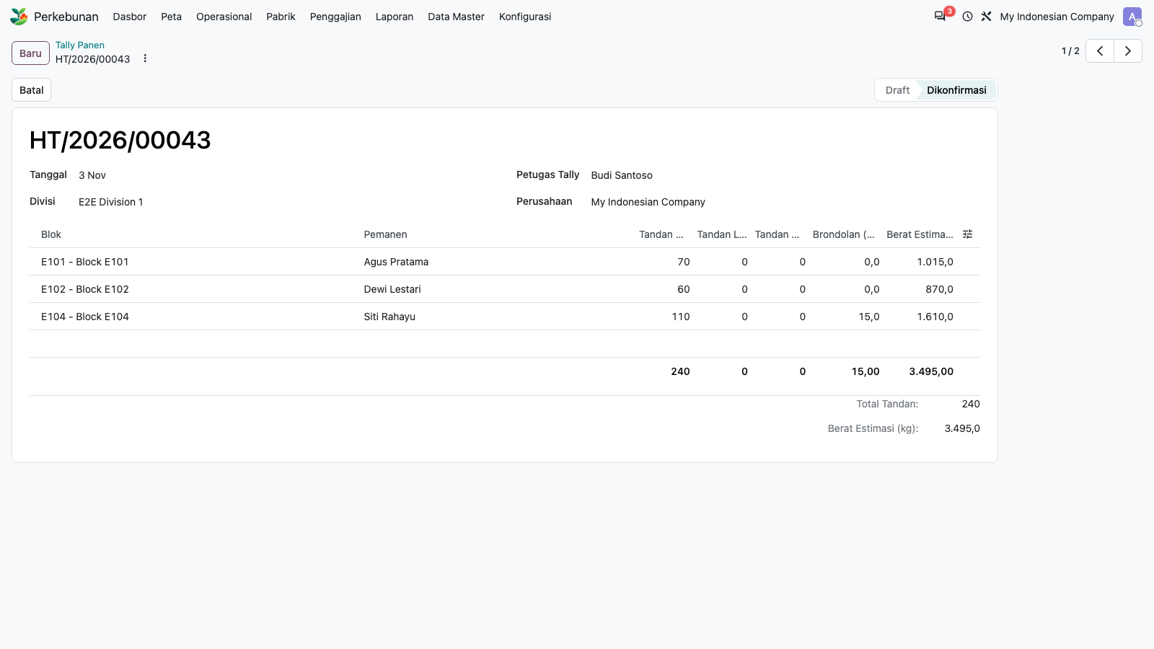
21. Operations: Transport Notes
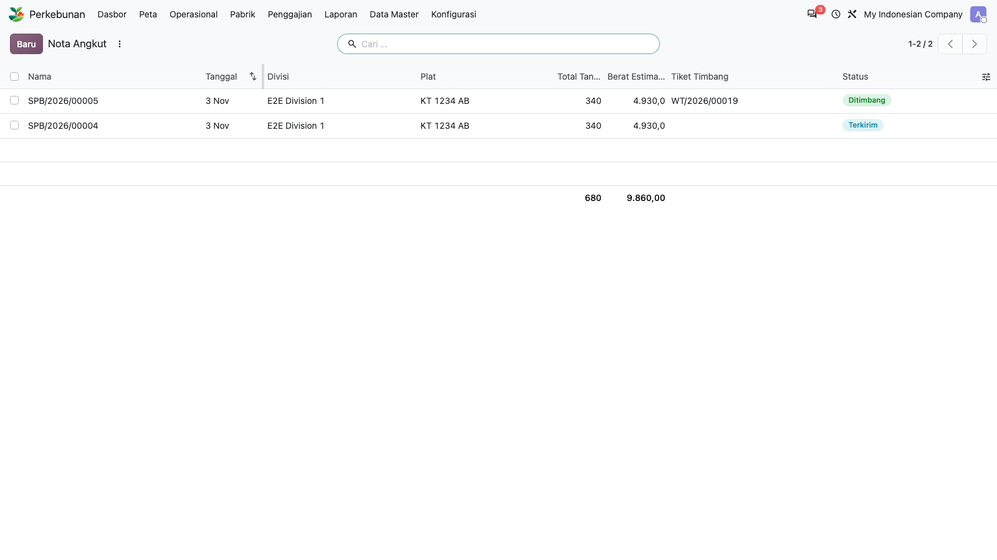
22. Operations: Weigh Tickets
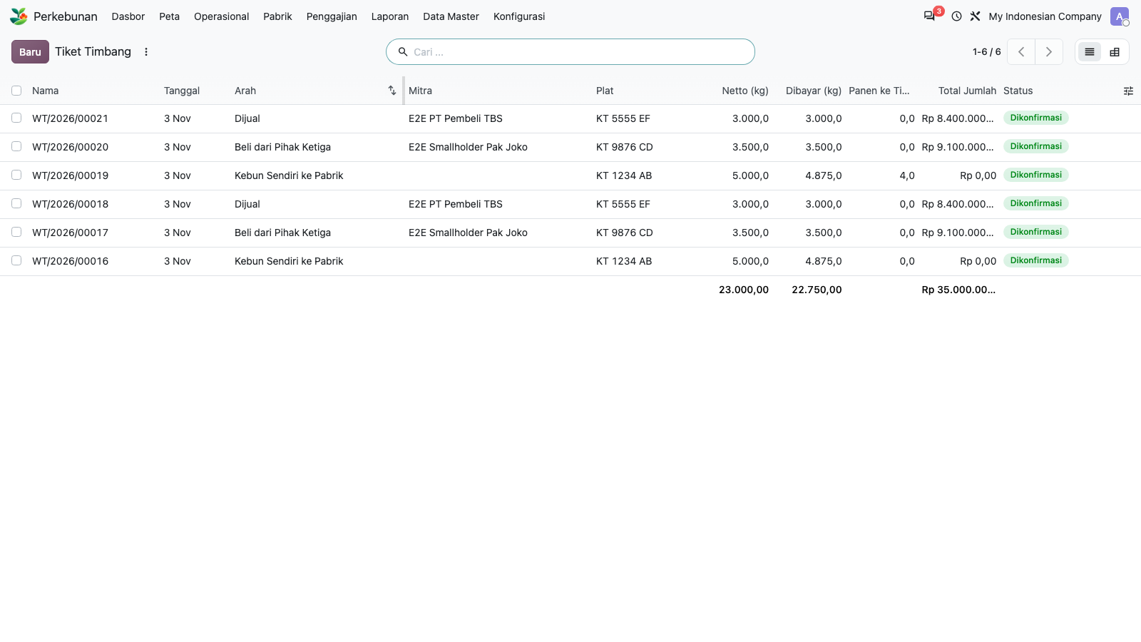
23. Weigh ticket form (confirmed, stock link)
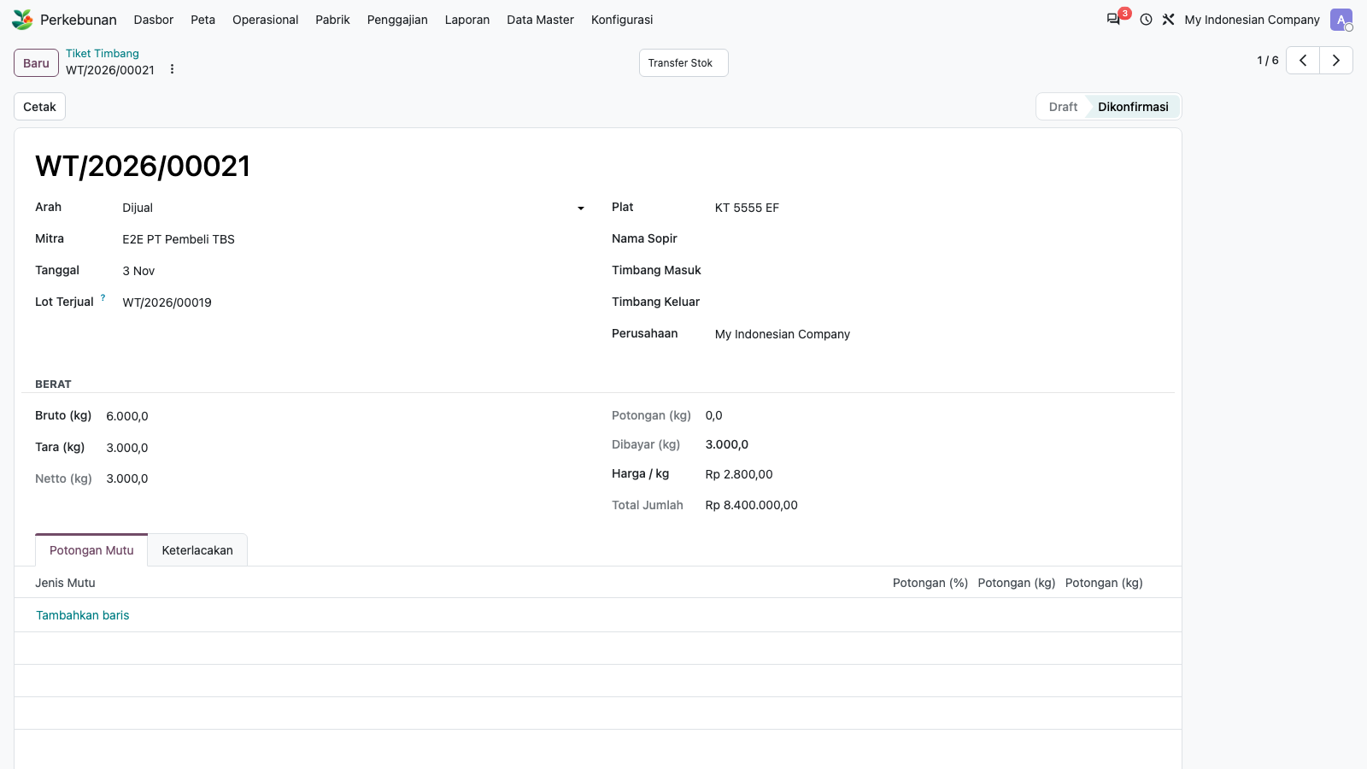
24. Mill: Extraction Rates (OER/KER)
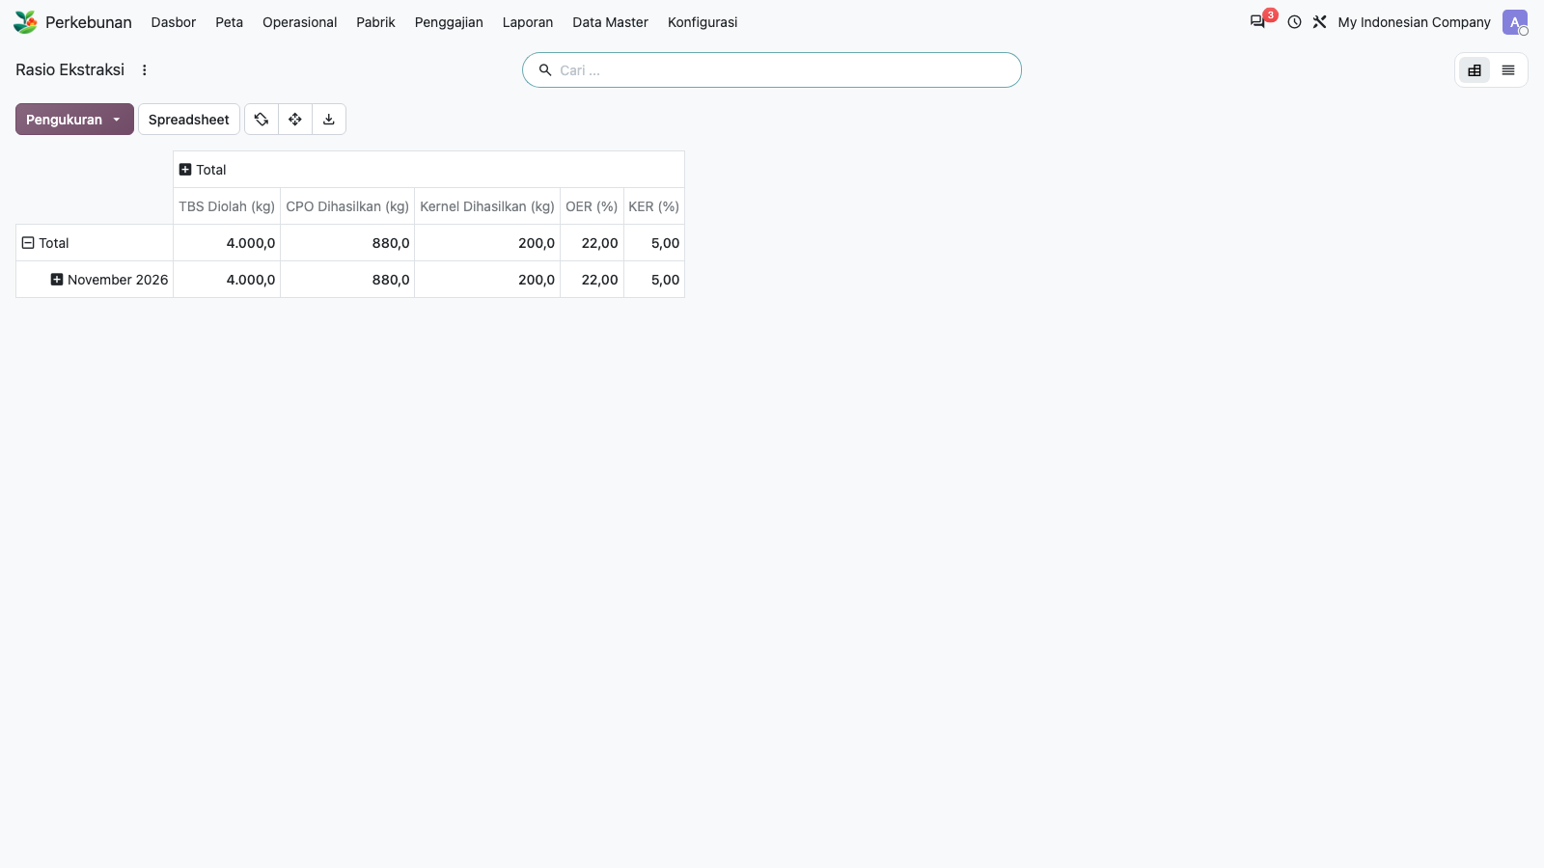
25. Payroll: Pay Schemes
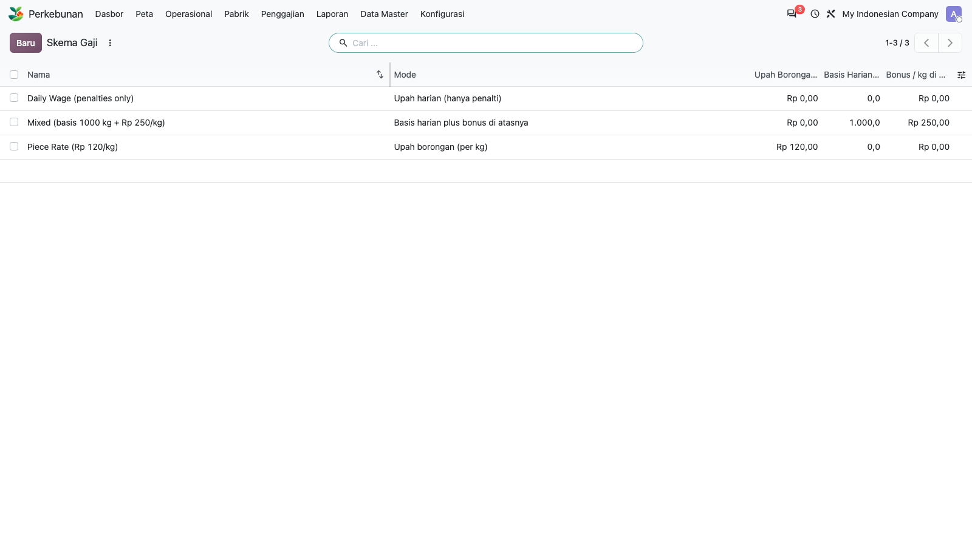
26. Pay scheme form
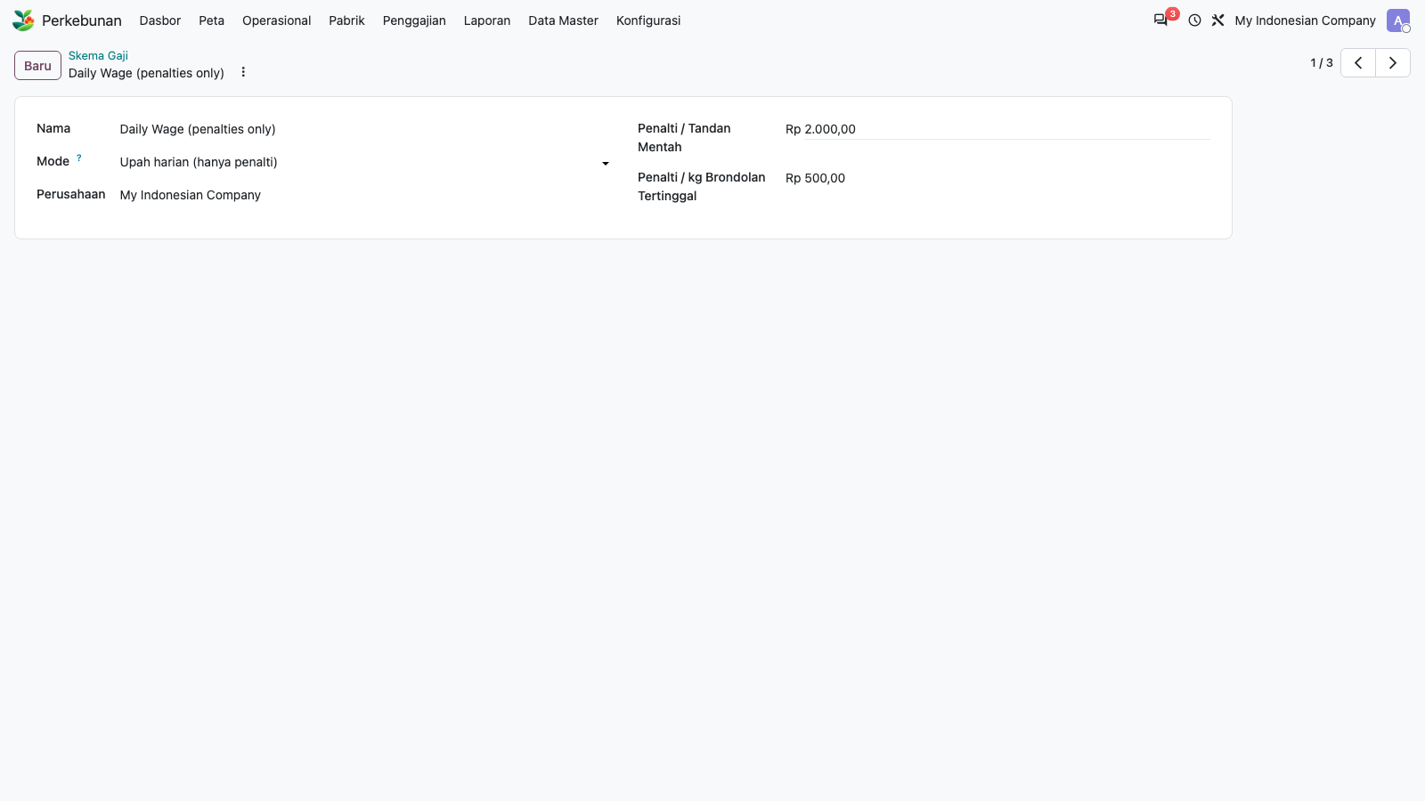
27. Payroll: Harvest Pay
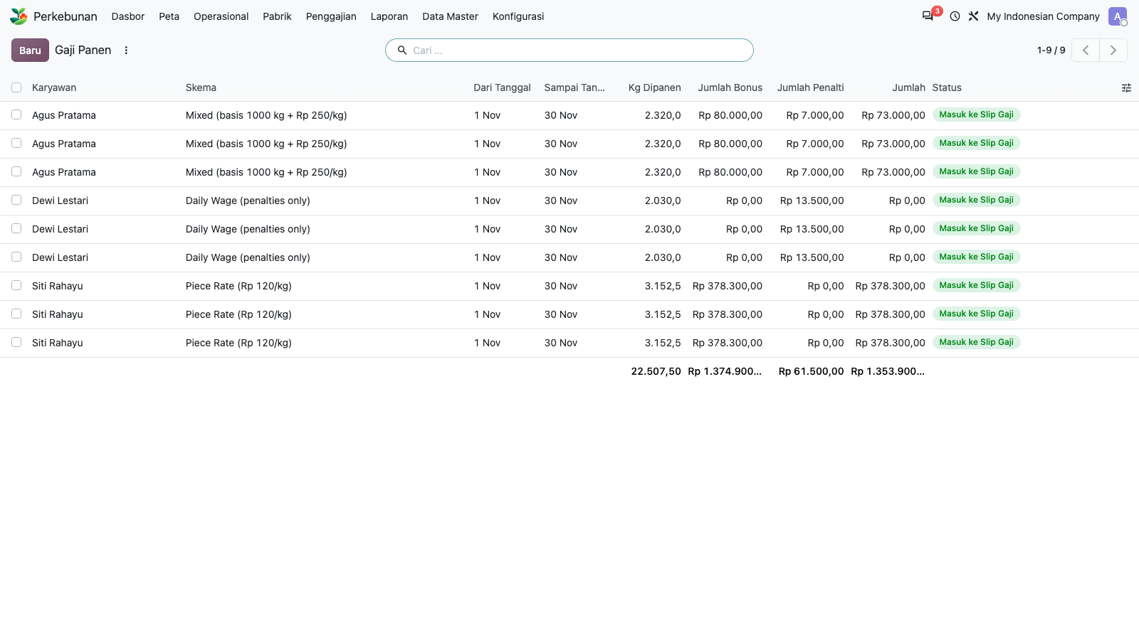
28. Payroll: Compute Harvest Pay wizard
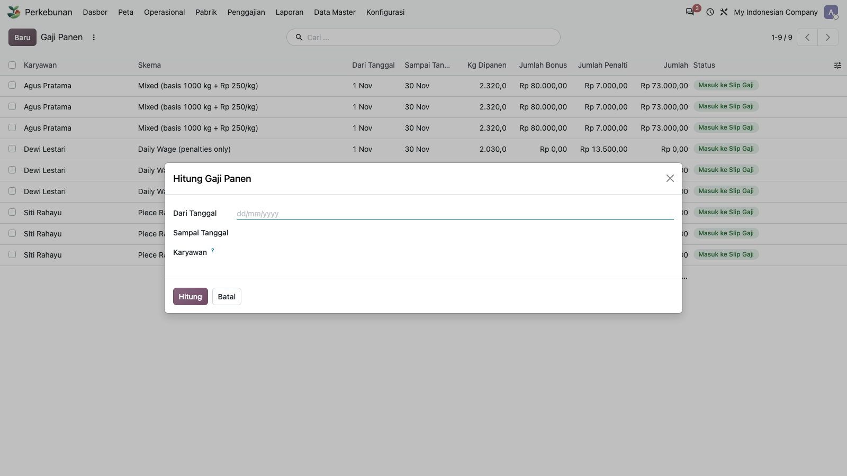
29. Reporting: Yield and Cost pivot (earlier TypeError)
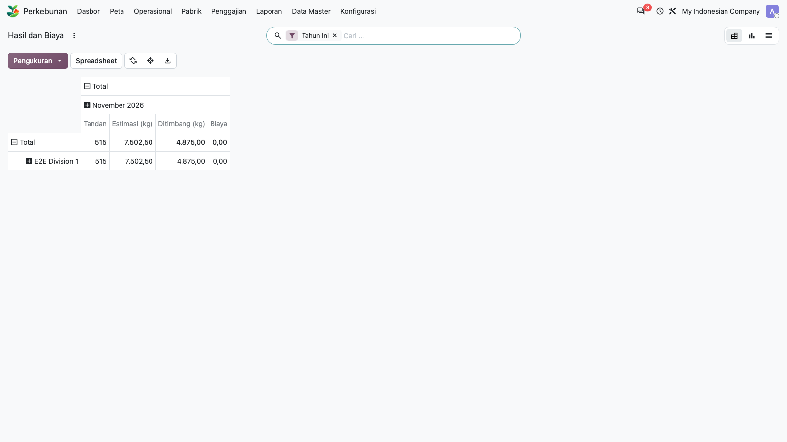
30. Yield and Cost: graph view
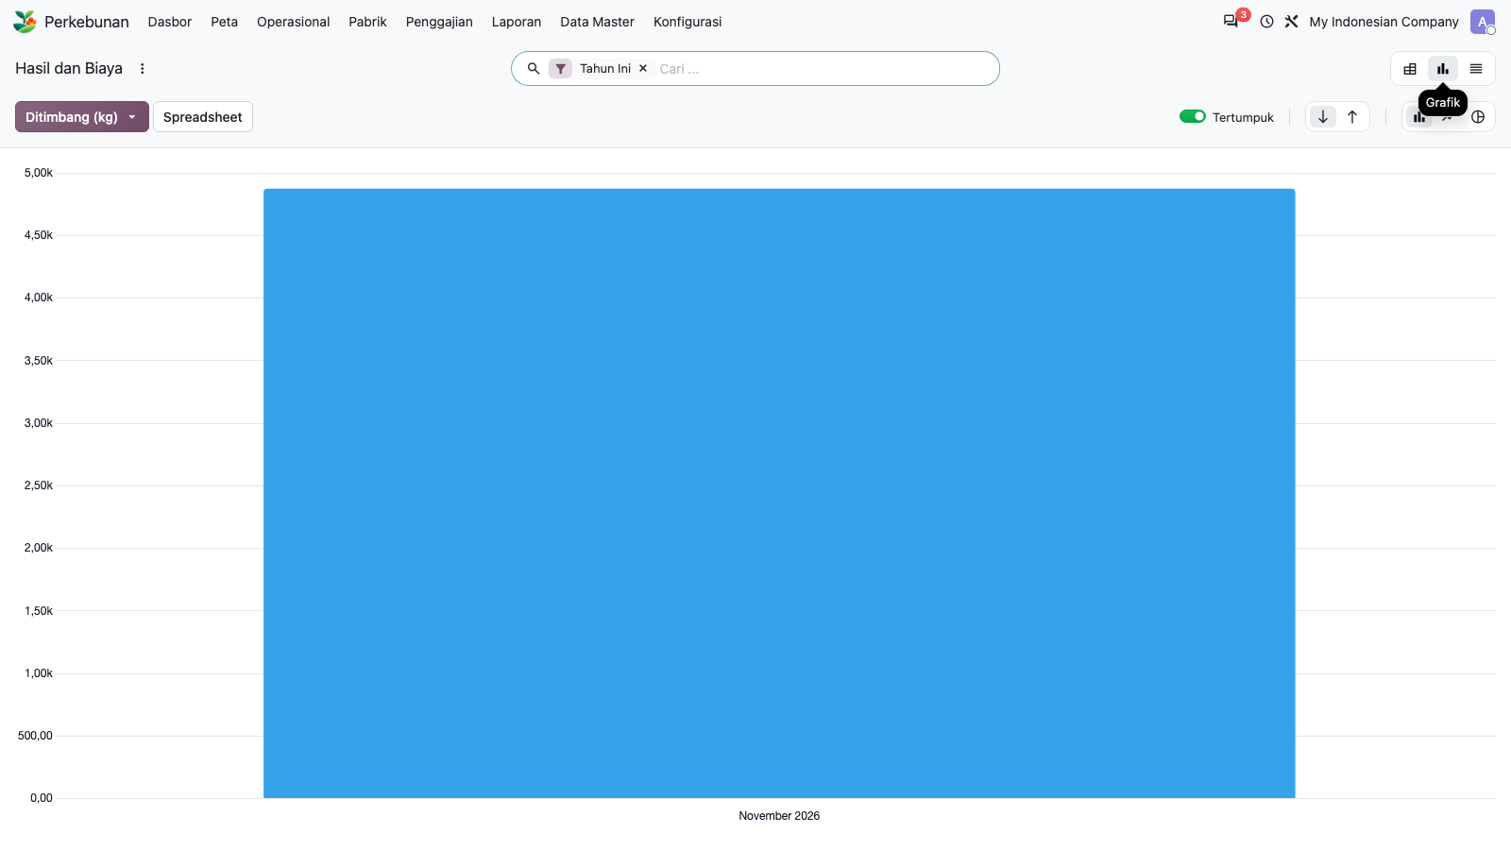
31. Config: Activity Types
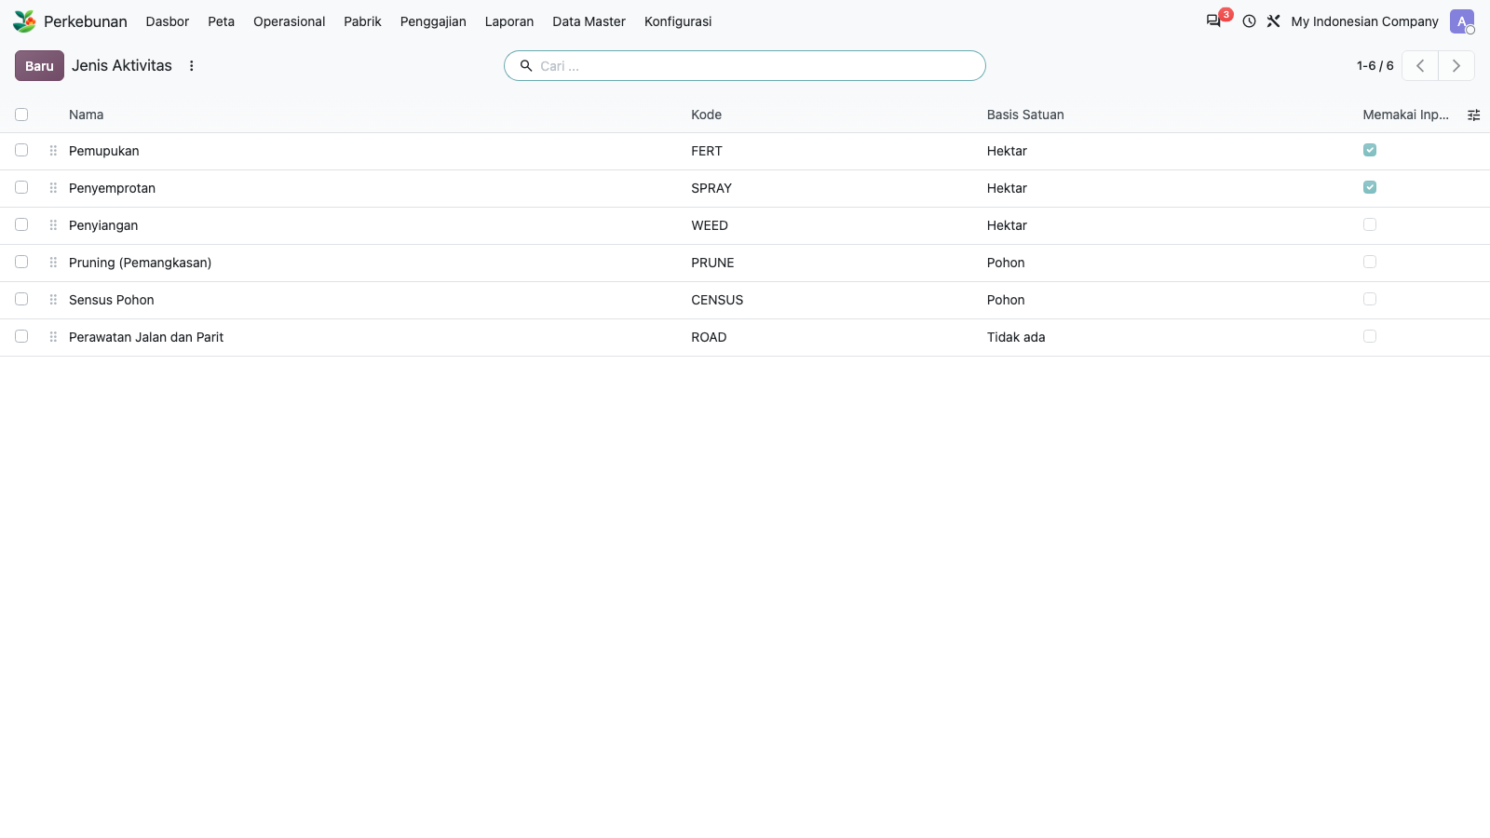
32. Config: Landmark Types
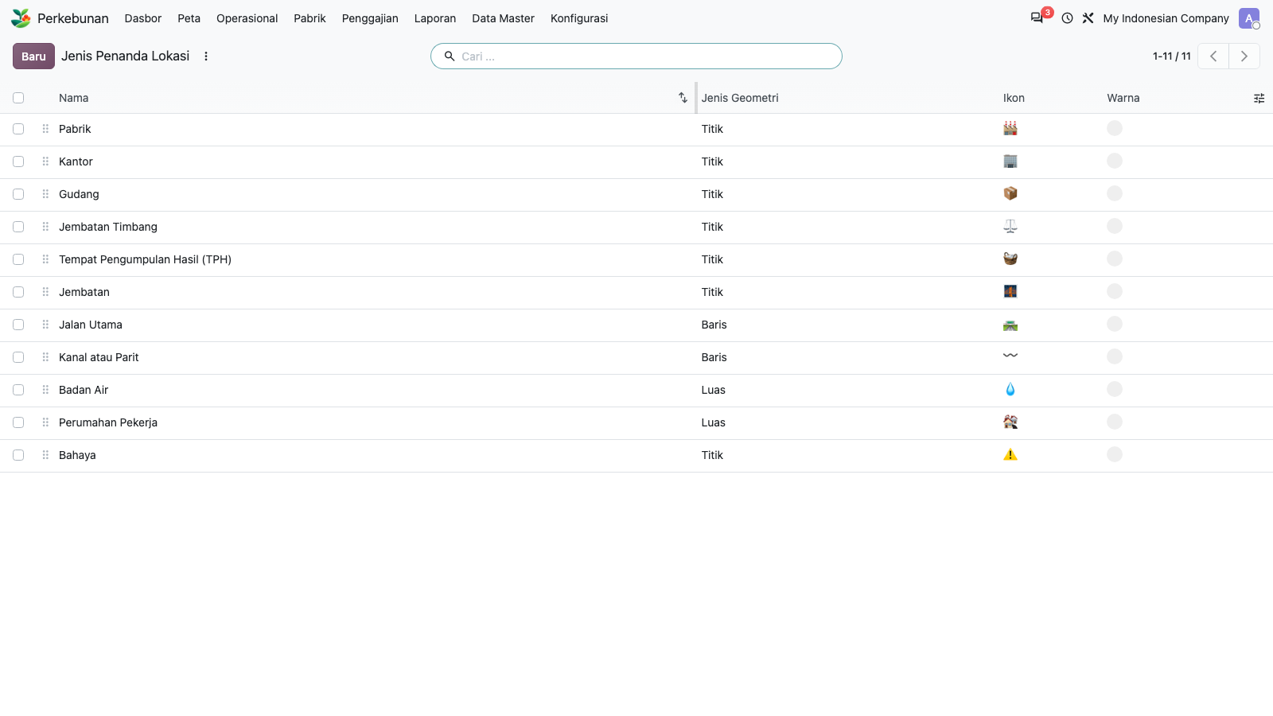
33. Config: Grade Deductions
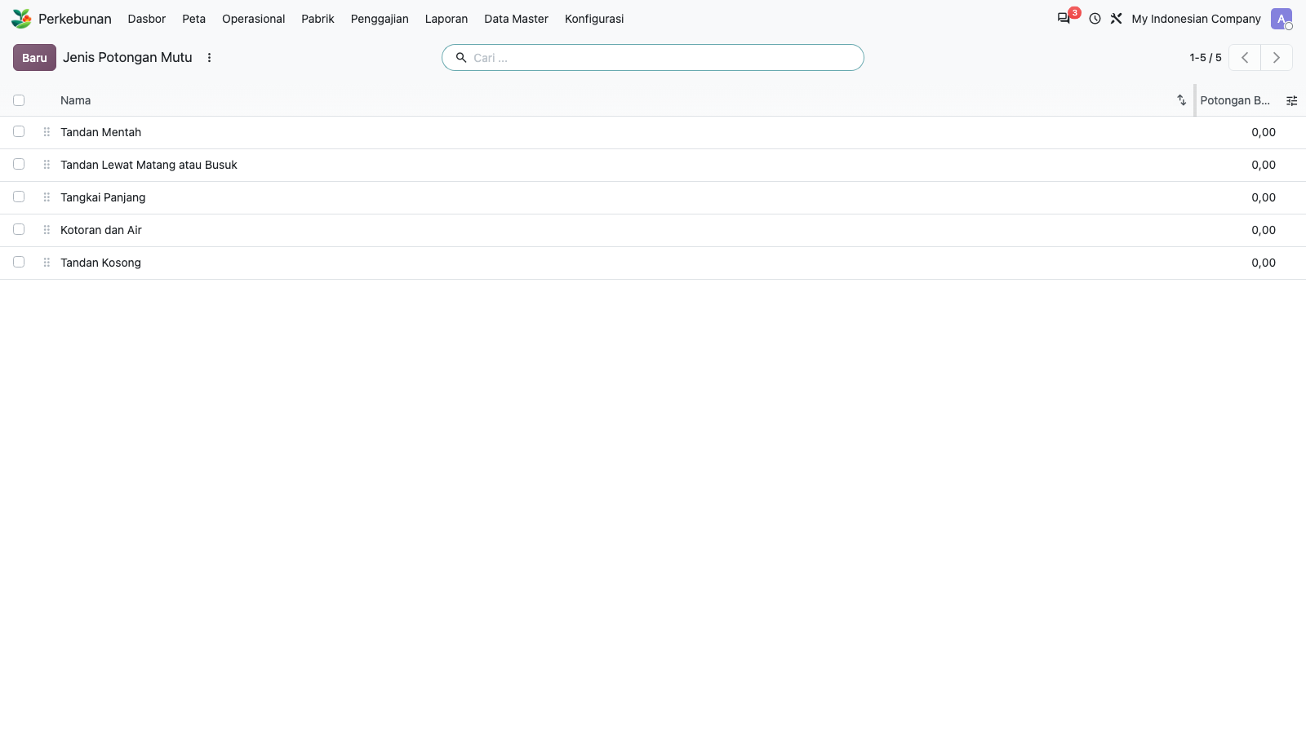
34. Config: FFB Reference Prices
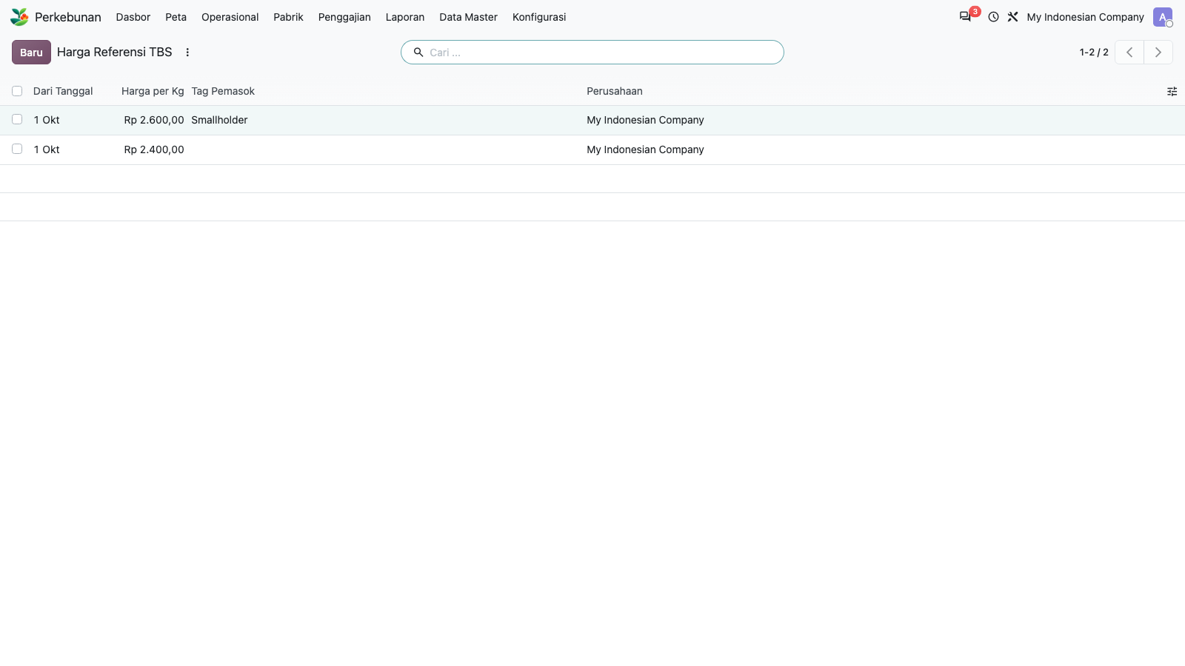
35. Config: Settings
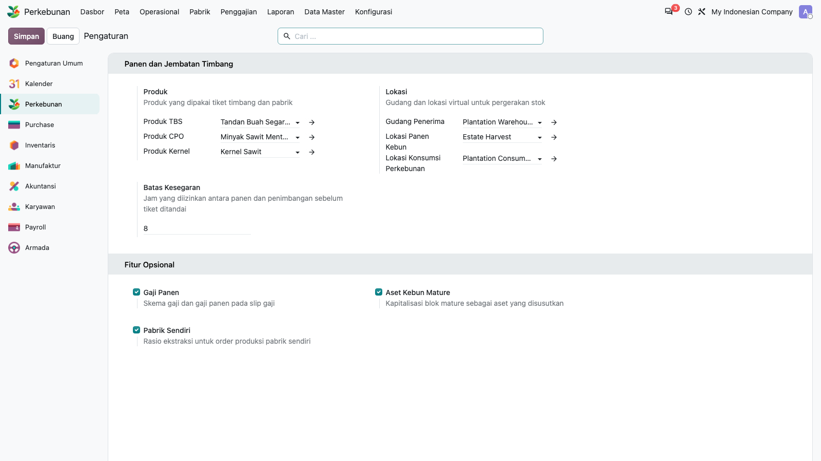
36. Create estate via UI: fill form
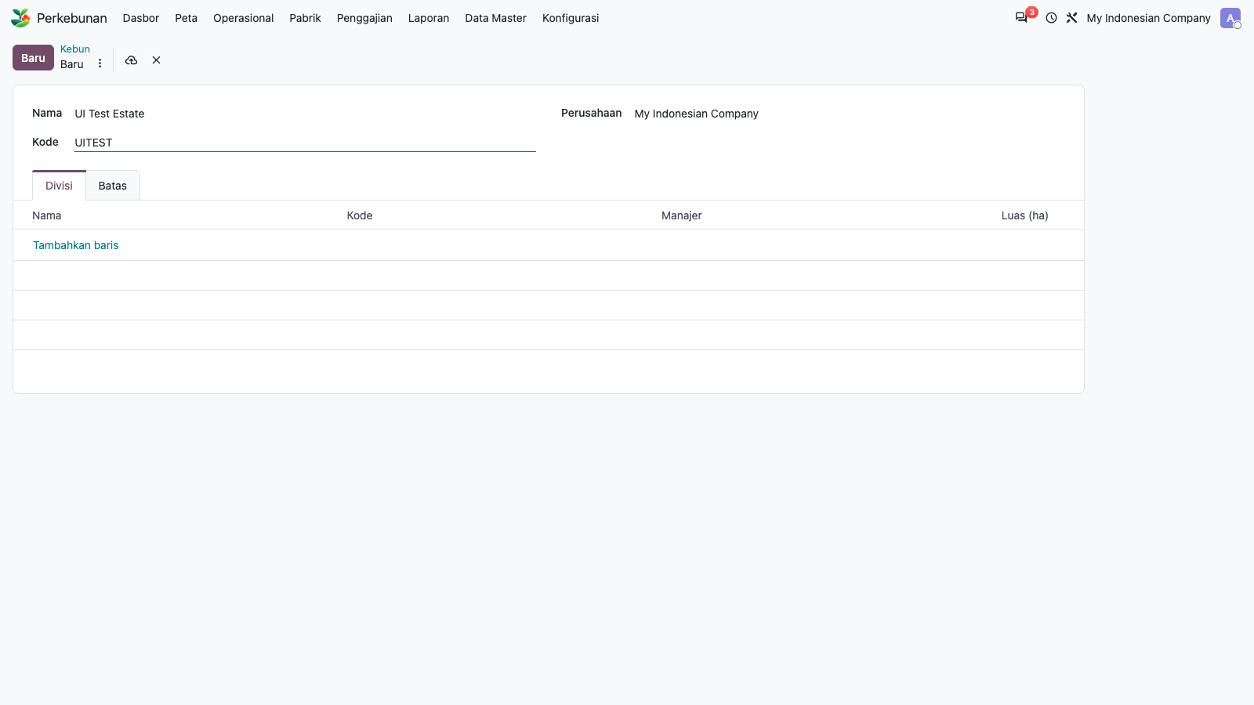
37. Create estate via UI: save
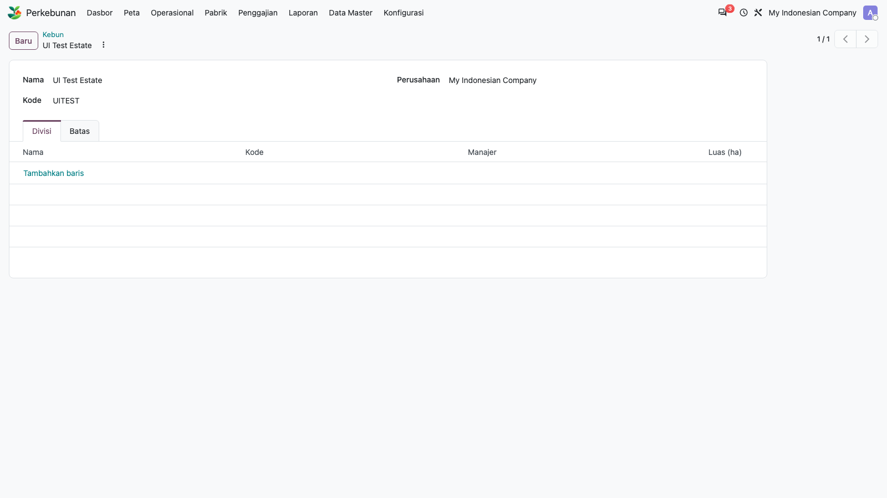
38. Create division under new estate via UI
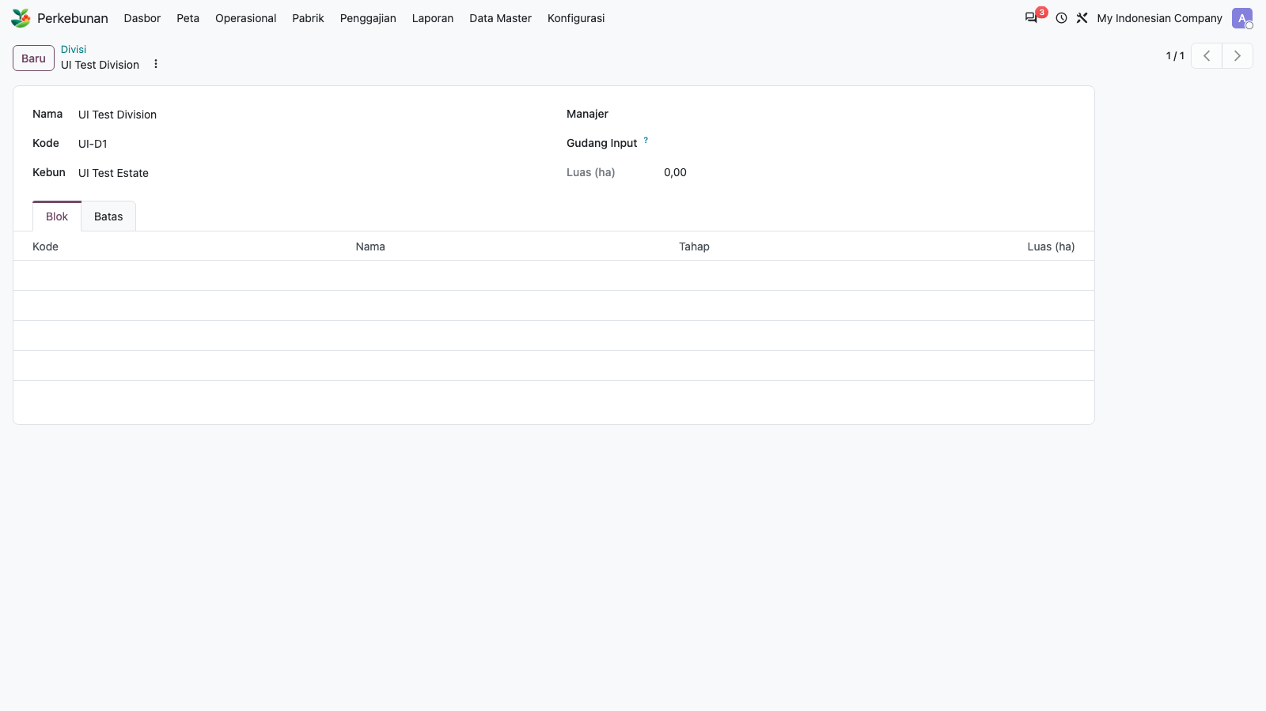
39. Create block under new division via UI
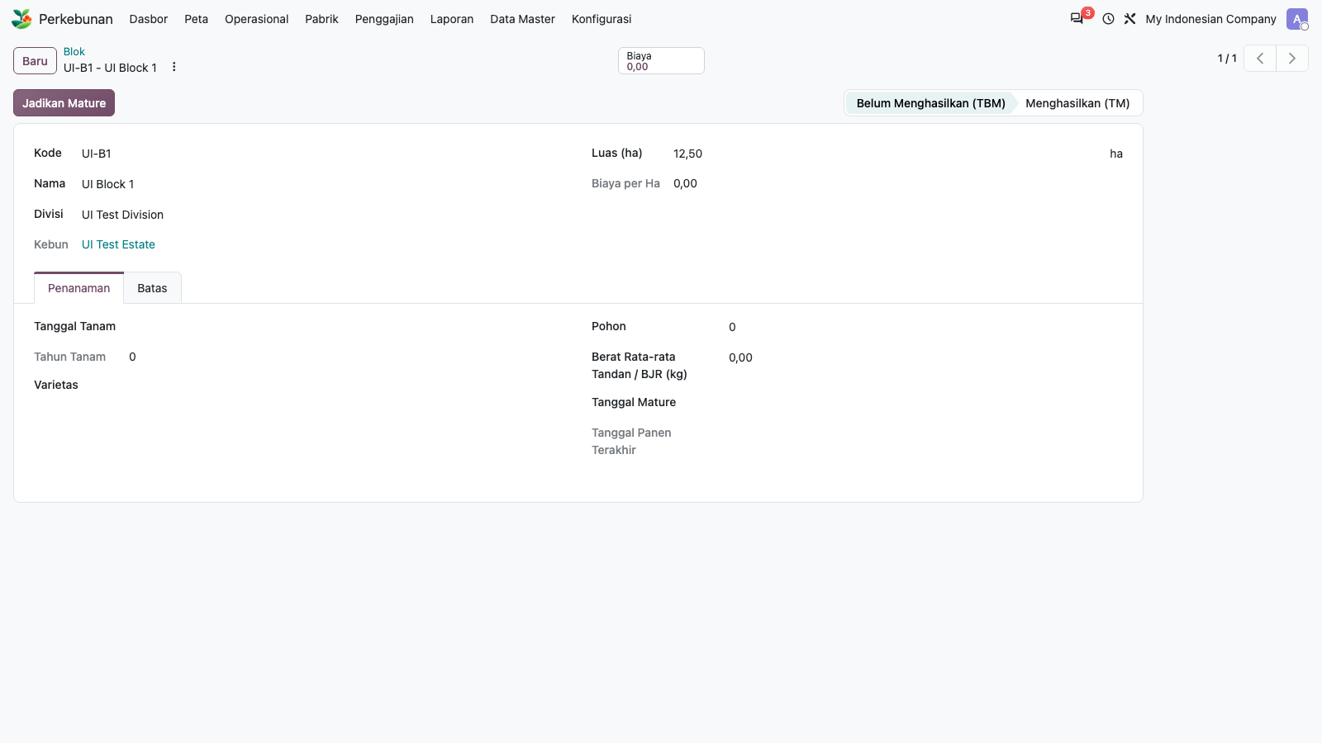
40. Click Set Mature button: block stage becomes Mature (TM)
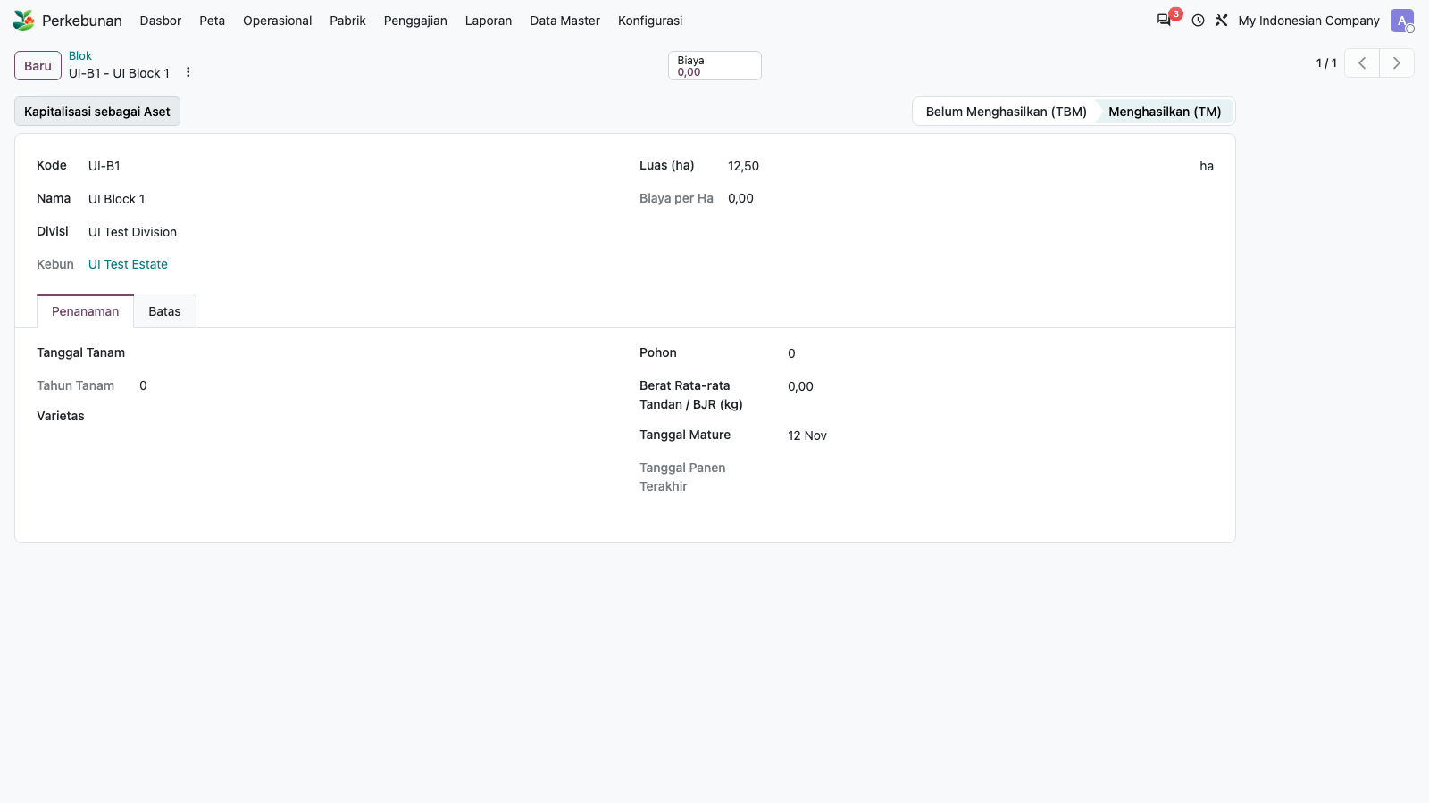

5. Housekeeping
The three records created by hand in the screen test (estate UITEST, division UI-D1, block UI-B1) were deleted afterwards. The API test data (estate E2E, tallies, tickets, payslips, asset) was left in company 3 so the screens have data to show.

