Plantation Management
Process Guide: step by step
For the Odoo 20 module ss_plantation (author Seasoft). This guide walks through the work in the order it happens, from first-time setup to month-end pay, with the screen to open and the fields to fill at each step.
Module | Plantation Management (ss_plantation 20.0.1.0.0)
Where | Plantation app in the Odoo main menu
Written | 2026-11-05
Screens shown | Captured from a live Odoo 20 server with sample data (company "My Indonesian Company")

How the whole process fits together
Plantation work follows one chain. Each stage produces records that the next stage uses, so the order below is the order to set things up and to run the day.
Stage | What you do | Where | Feeds
1. Setup (once) | Products, locations, activity types, deductions, prices, pay schemes | Configuration, Payroll | Everything below
2. Master data (once, then maintain) | Estate, divisions, blocks, landmarks on the map | Master Data, Map | Activities, tallies, cost
3. Field work (daily) | Record fertilising, spraying, pruning and other activities, with stock inputs | Operations > Field Activities | Block cost, stock
4. Harvest (daily) | Count bunches per harvester and block | Operations > Harvest Tally | Estimated kg, harvest pay
5. Transport (daily) | Group harvested fruit into a load going to the mill | Operations > Transport Notes | Weigh ticket
6. Weighbridge (daily) | Weigh own, bought and sold fruit; stock is posted | Operations > Weigh Tickets | Stock, purchases, yield
7. Mill (per run) | Process fruit into palm oil and kernel; read OER and KER | Manufacturing, Mill | Extraction rates
8. Pay (monthly) | Compute harvest pay and add it to the payslip | Payroll | Payslip
9. Assets (when a block matures) | Capitalise development cost as a depreciable asset | Master Data > Blocks | Accounting
10. Reports | Yield and cost, dashboards, map | Reporting, Dashboards, Map

Who can do what
Role (Plantation group) | Can do
Clerk | Field activities, harvest tallies, transport notes.
Weighbridge Operator | Everything a Clerk can do, plus issue and confirm weigh tickets.
Manager | Everything above, plus master data, prices, pay schemes, settings, and correcting a confirmed weigh ticket or harvesting a non-mature block.

Three optional features can be switched on in Settings: Harvest Pay, Mature Plantation Assets and Own Mill. Menus and fields for a feature only appear for users in that feature group.

Part A. One-time setup

A1. Plantation settings
Menu: Plantation > Configuration > Settings (Plantation tab). Do this first. Weigh tickets and the mill refuse to work until these are set.
1. Products. Choose the FFB product, the CPO product and the Kernel product. Each must be a storable product. Count the FFB product in kg or tonne, because weigh tickets are entered in kilograms and converted to the product unit.
2. Receiving Warehouse. The warehouse where fruit is received and delivered from.
3. Estate Harvest Location. A virtual location of type Production. Own-estate fruit is received from here.
4. Plantation Consumption Location. A virtual location of type Inventory loss. Field inputs (fertiliser, chemicals) are consumed to here.
5. Freshness Limit. Hours allowed between harvest and weighing. Default 8. A ticket over the limit is flagged with a warning.
6. Optional features. Tick Harvest Pay, Mature Plantation Assets and Own Mill as needed, then click Save.
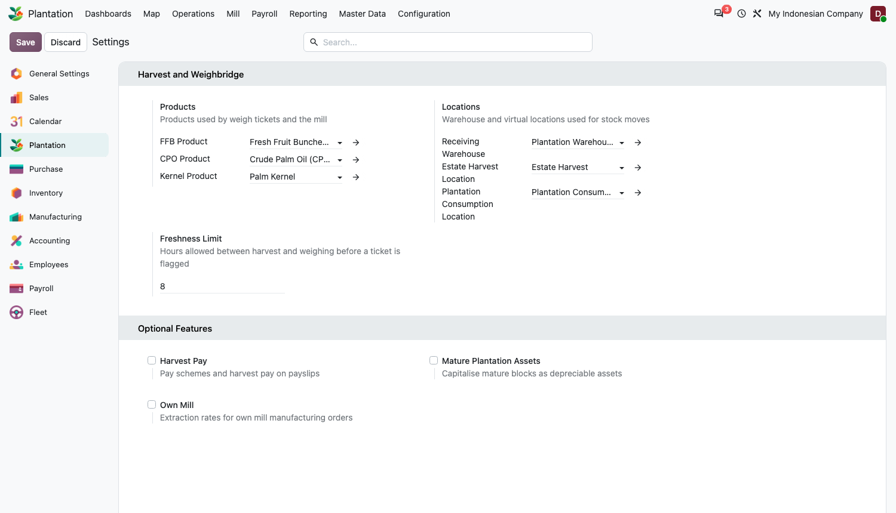
Figure 1. Plantation settings: products, locations, freshness limit and optional features.
Rule If an FFB product is counted in a unit that cannot be converted from kilograms (for example Units), confirming a weigh ticket is refused. Give the product kg or tonne.

A2. Activity types
Menu: Configuration > Activity Types. Six types are supplied: Fertilising, Spraying, Weeding, Pruning, Palm Census, Road and Drain Maintenance. Add your own with New.
- Uom Basis: Hectare, Palm or None. It decides what the Quantity on an activity means; with Hectare, the quantity defaults to the block area.
- Uses Stock Inputs: tick it for work that consumes products (fertiliser, chemicals).
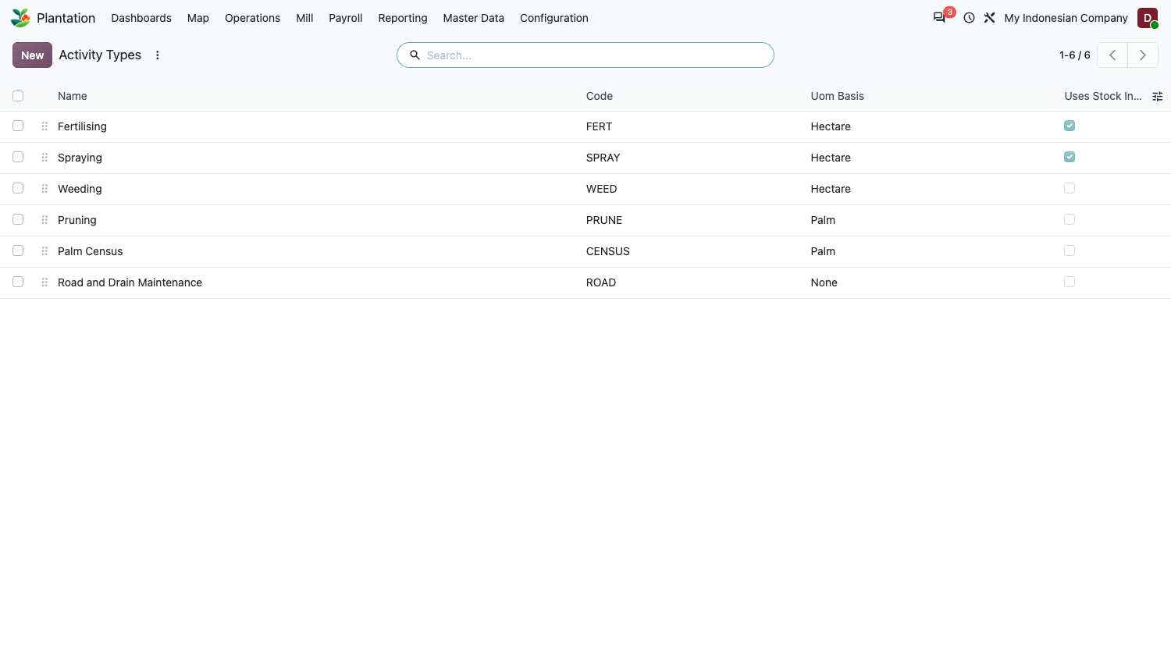
Figure 2. Activity types.

A3. Grade deductions
Menu: Configuration > Grade Deductions. These are the reasons a weigh ticket loses weight at the mill gate: Unripe Bunches, Overripe or Rotten Bunches, Long Stalks, Dirt and Water, Empty Bunches. Each has a default percentage you can set.
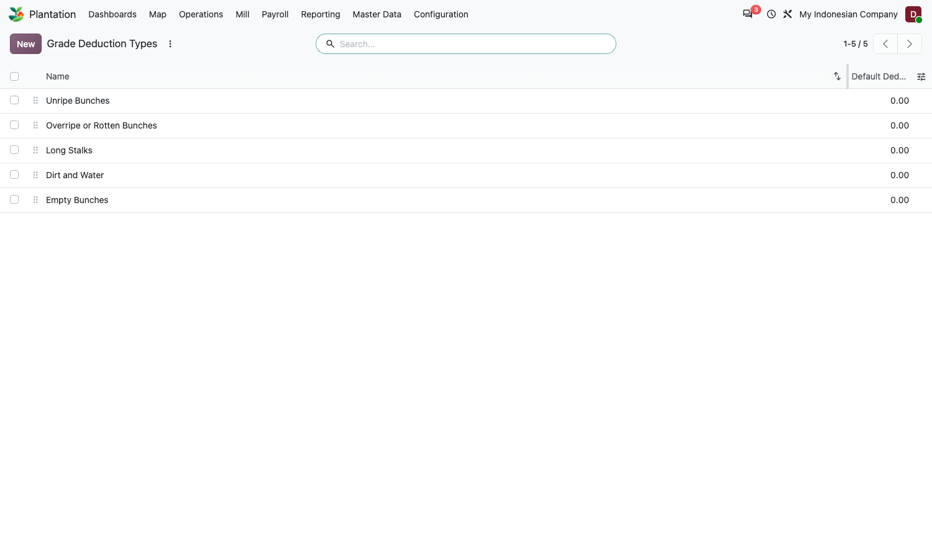
Figure 3. Grade deduction types.

A4. FFB reference prices
Menu: Configuration > FFB Reference Prices. Used to price fruit bought from third parties.
1. Click New.
2. Set Date From, Price per kg and, if the price only applies to some suppliers, a Supplier Tag. Leave the tag empty for a price valid for every supplier.
3. Save. Add a new line each time the price changes.
What happens On a Bought from Third Party ticket the price is the latest price valid on the ticket date. A price for the supplier's tag wins over the general price. You can still overwrite the price on the ticket.

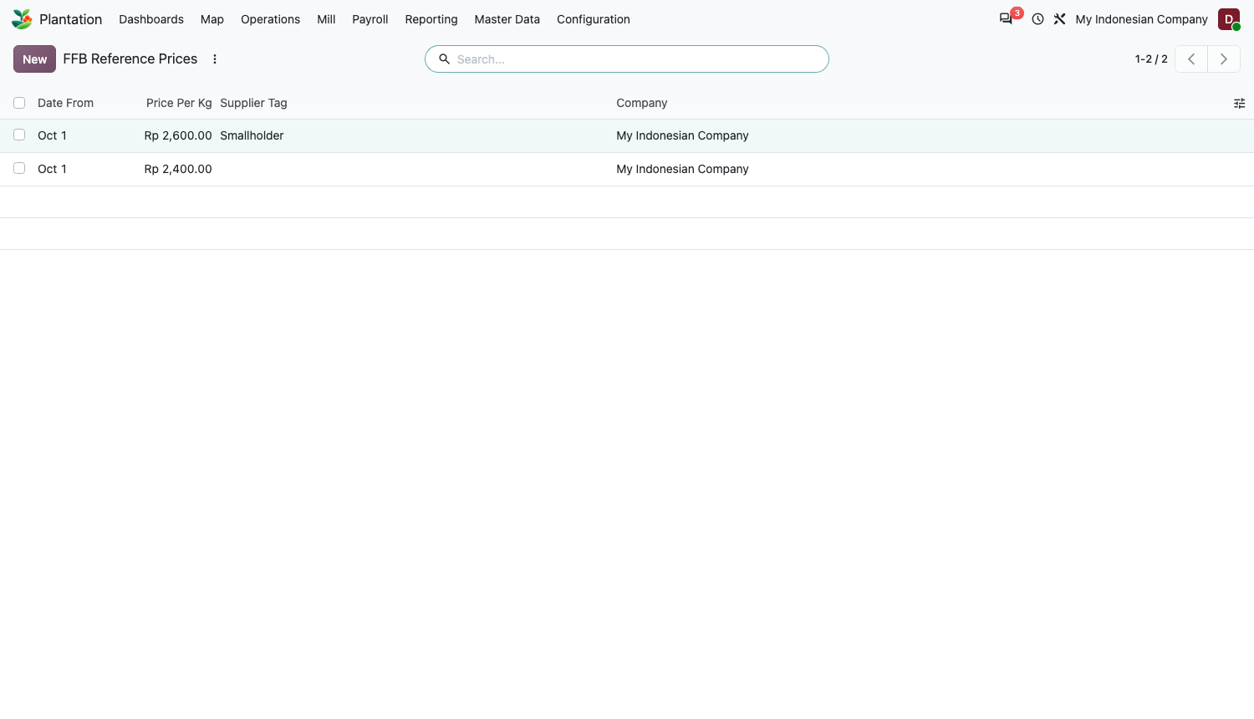
Figure 4. FFB reference prices by start date.

A5. Pay schemes and employees
Menu: Payroll > Pay Schemes (needs the Harvest Pay feature). A scheme says how a harvester's pay is worked out.
1. Click New and give the scheme a Name.
2. Choose the Mode (see the table below) and fill only the fields that mode uses.
3. Set the penalties: Penalty per Unripe Bunch and Penalty per kg of Loose Fruit Left.
4. Save. Then open each harvester in Employees and set Harvest Pay Scheme to the scheme that applies to them.
Mode | Fields used | Harvest pay for the period
Piece rate (per kg) | Piece Rate per kg | Total harvested kg x rate, minus penalties.
Daily basis plus bonus above it (mixed) | Daily Basis (kg), Bonus per kg above Basis | For each day, kg above the basis x bonus, added up, minus penalties.
Daily wage (penalties only) | Penalties | No bonus is calculated. The daily wage stays in the normal payroll contract, and penalties are recorded for reference.

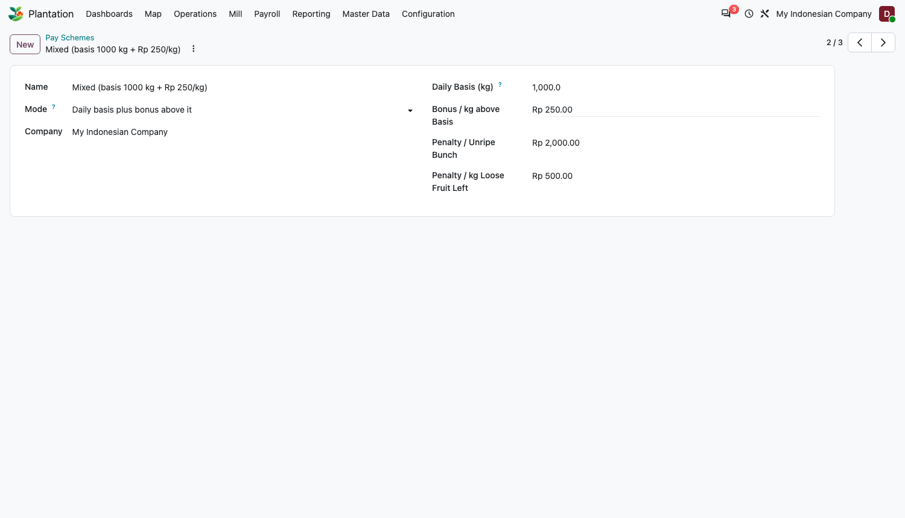
Figure 5. A mixed pay scheme: basis 1,000 kg a day, Rp 250 per kg above it, penalties for unripe bunches and loose fruit.
Tip The harvest pay amount never goes below zero: if penalties are larger than the bonus, the pay is zero for the period.

Part B. Master data
Master data is a hierarchy: an Estate has Divisions, and a Division has Blocks. Landmarks (mill, office, roads) sit on the map beside them.

B1. Estate
1. Menu: Master Data > Estates > New.
2. Enter Name and Code. The company defaults to the current company.
3. Optional: Boundary tab, paste or draw the estate outline (GeoJSON) so it appears on the map.
4. Save.
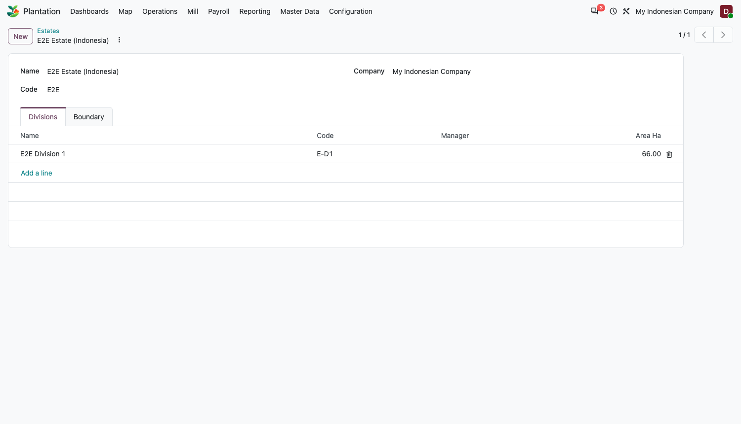
Figure 6. Estate with its divisions.

B2. Division
1. Menu: Master Data > Divisions > New.
2. Enter Name, Code and the Estate.
3. Manager and Input Store: set the Manager (employee) and the Input Store, the stock location that field inputs are taken from. Activities that use inputs need this.
4. Optional: Boundary.
5. Save.
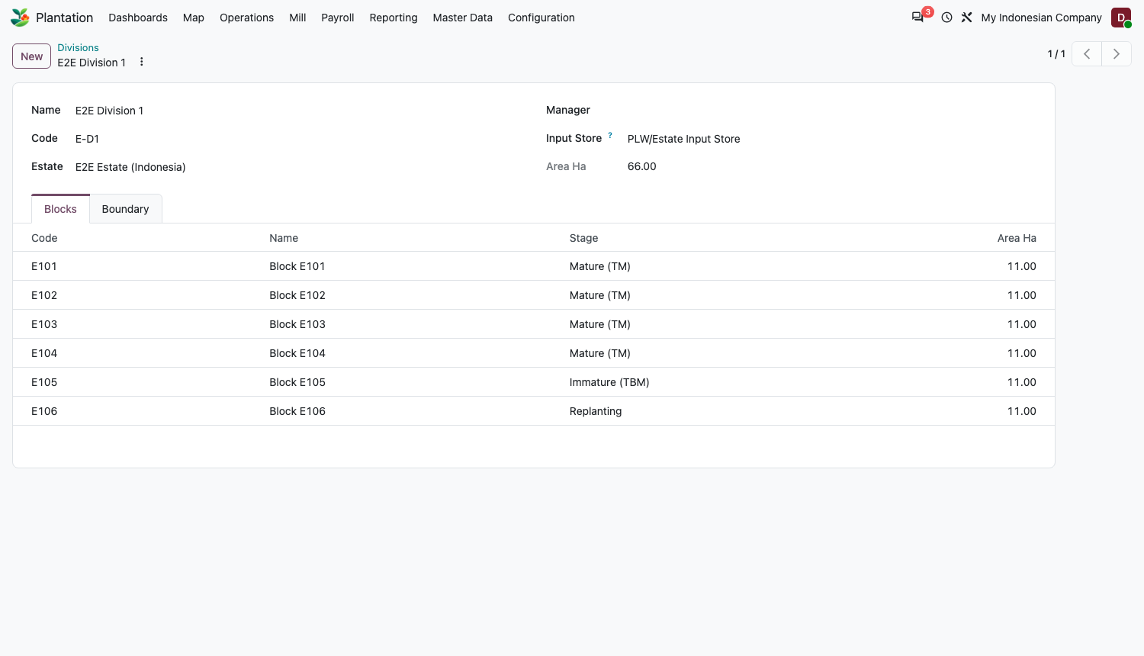
Figure 7. Division form.

B3. Block
A block is the smallest unit: it carries the area, the stage and the cost.
1. Menu: Master Data > Blocks > New.
2. Identify: Code (required), Name and Division. The Estate fills in itself.
3. Area: Area Ha is required and must be above zero. If you draw a boundary the system suggests an area; click Use drawn area to accept it.
4. Planting tab: Planting Date (the planting year follows), Palms, Variety and Avg Bunch Weight (kg). The average bunch weight drives every estimated harvest weight, so keep it current.
5. Stage: Immature (TBM) is the default. The stages are Immature, Mature, Replanting and Closed. Click Set Mature when the block starts to be harvested; this stamps the Mature Date.
6. Save.
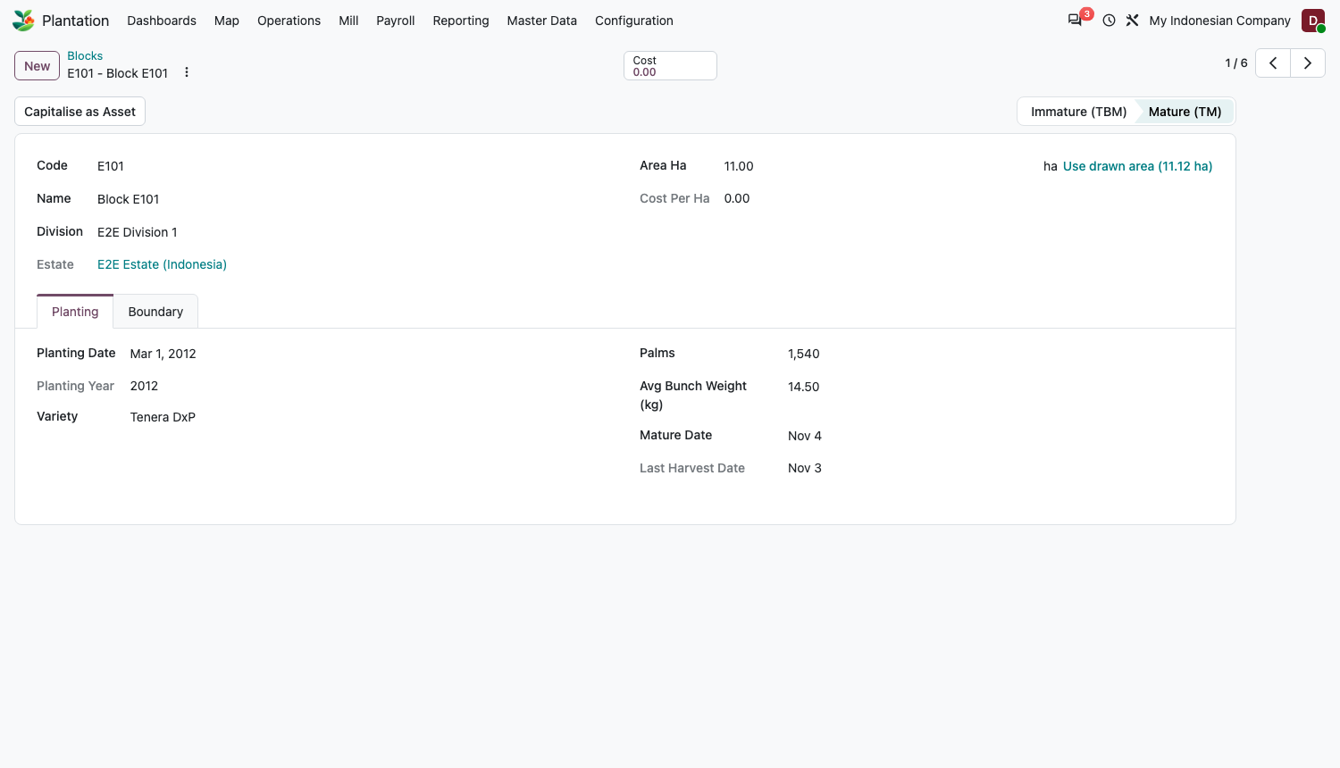
Figure 8. A mature block: stage bar, area, planting data and the Capitalise as Asset button.
Rule Only Mature blocks can be harvested. A block with activities or costs cannot be deleted; archive it instead.

Tip Each block gets its own analytic account (cost centre). Costs posted against it add up in Total Cost and Cost per Ha on the block.

B4. Landmarks and the map
1. Menu: Configuration > Landmark Types: check the types (Mill, Office, Store, Weighbridge, Collection Point (TPH), Bridge, Main Road, Canal or Drain, Water Body, Worker Housing, Hazard). Each type is a point, a line or an area.
2. Menu: Master Data > Landmarks > New: choose Name, Type and Estate, then place it on the map or paste GeoJSON. Optional: Note and Photo.
3. Bulk load: Master Data > Import Landmarks. Upload a GeoJSON file, or a CSV with the columns name, type, lat, lon. Pick a Default Type for rows that do not name a known type. The import stops with the row number if a row is wrong.
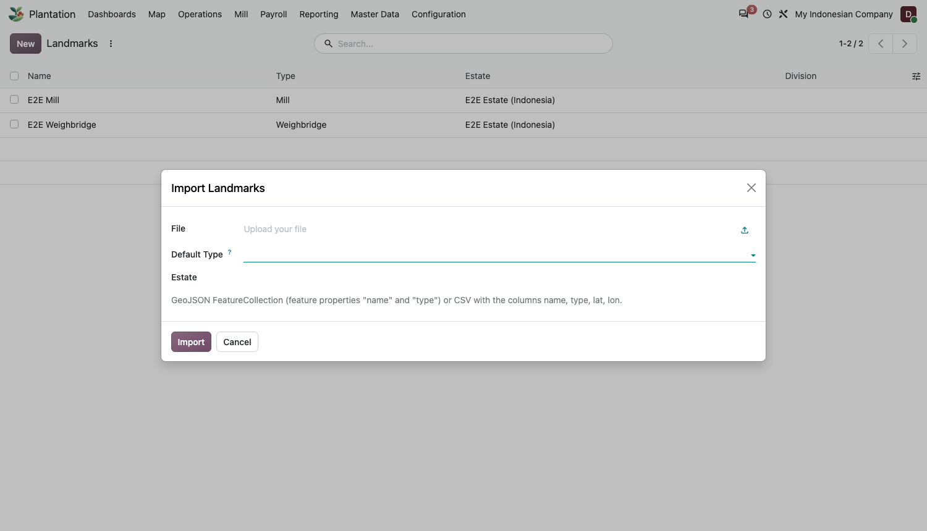
Figure 9. The landmark import dialog.
Open Plantation > Map to see everything together: estate and division outlines, blocks coloured by stage (or by yield over the last 30 days), the road lines and landmark icons. Use the layer checkboxes, Colour blocks by, and Fit to data.
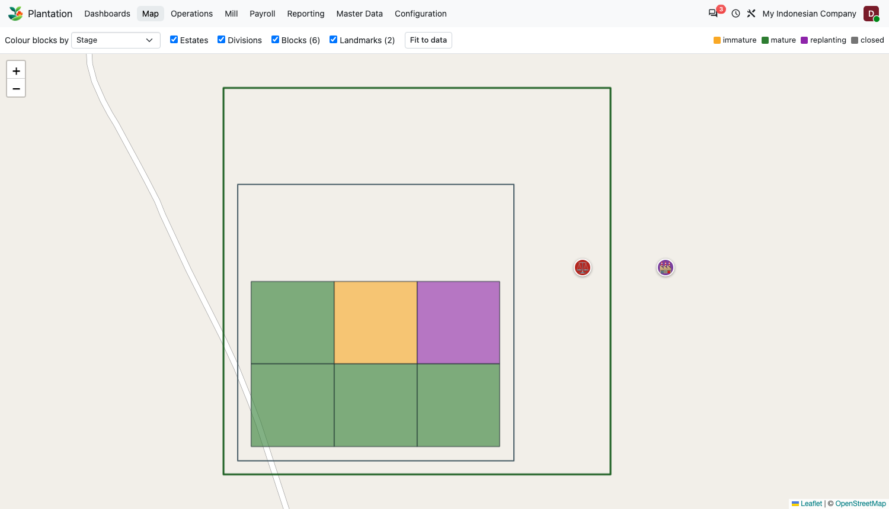
Figure 10. The plantation map.

Part C. Daily operations

C1. Field activity (fertilising, spraying, pruning and so on)
Menu: Operations > Field Activities > New. Use one activity per block and type of work.
1. Header: Date, Block, Type. Quantity fills in from the block area for hectare-based types; change it if you worked part of the block.
2. Man Days and Workers: enter the man days and, on the Workers tab, the employees who did the work.
3. Inputs tab: add each Product used with its Quantity and Unit. Quantity must be above zero.
4. Done: click Done when the work is finished.
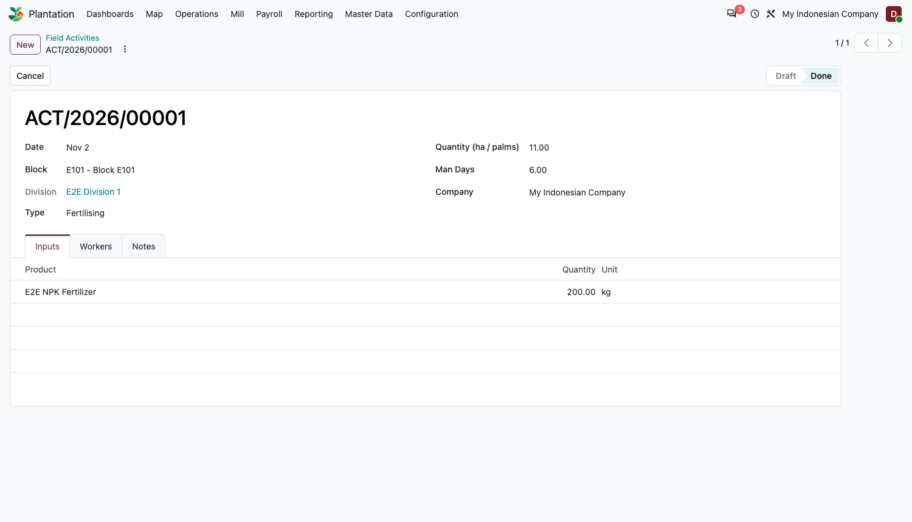
Figure 11. A completed fertilising activity with its stock input.
What happens Done removes the inputs from the division's Input Store and moves them to the Plantation Consumption Location, tagged with the block, so the cost lands on that block. Cancel on a done activity reverses the stock movement. Only a draft activity can be edited.

Rule Done needs an Input Store on the division and a Consumption Location in Settings. If either is missing you get a message naming what to set.

C2. Harvest tally
Menu: Operations > Harvest Tally > New. One tally covers one division for one day; each line is one harvester on one block.
1. Header: Date, Division and Tally Clerk.
2. Add a line for every harvester and block: Block, Harvester, Bunches Ripe, Bunches Unripe, Bunches Overripe, Loose Fruit kg. At inspection, add Loose Fruit Left (kg) if fruit was left on the ground.
3. Check the totals: Bunch Total and Est Weight Kg update as you type.
4. Confirm: click Confirm. Cancel and Set to Draft are available to undo.
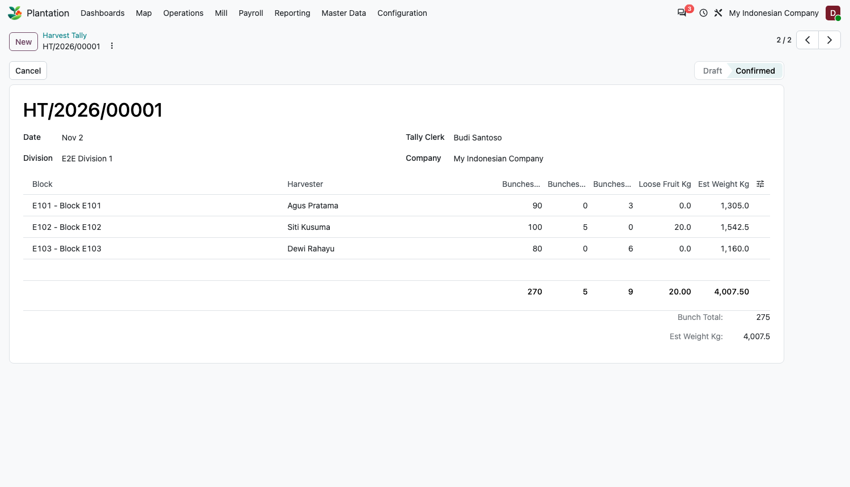
Figure 12. A confirmed tally with three harvesters.
Estimated weight of a line = (ripe bunches + overripe bunches) x the block's average bunch weight + loose fruit kg. Unripe bunches are not counted as harvested weight; they only attract a penalty.
Rule The block must belong to the tally's division and be Mature (only a Manager may override the stage). A harvester can have only one line per block per day. A tally with no lines cannot be confirmed. Only a draft tally can be edited.

What happens Confirming sets the block's Last Harvest Date. Confirmed tally lines are what the harvest pay and the yield report read.

C3. Transport note (SPB)
Menu: Operations > Transport Notes > New. A transport note describes one load travelling from the field to the mill.
1. Header: Date, Harvested At (the time the earliest fruit on the load was cut), Division, Vehicle or Plate, and Driver.
2. Lines: one line per Block with the number of Bunches (above zero). The estimated weight is worked out for you.
3. Send to Mill: click Send to Mill. The state moves from Draft to Sent.
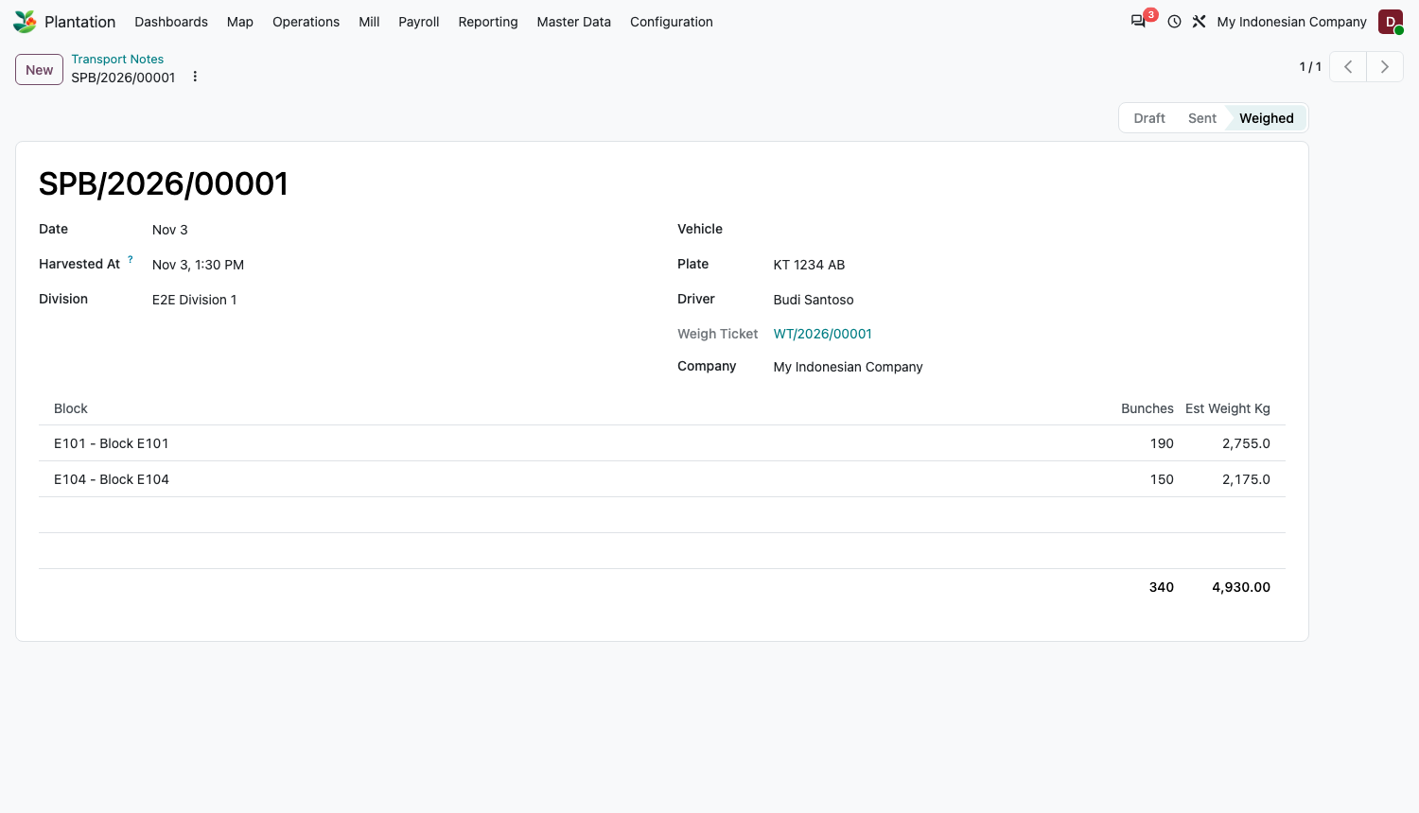
Figure 13. A weighed transport note, linked to its weigh ticket.
Tip Harvested At matters: the weighbridge compares it with the weigh-in time to check how fresh the fruit is.

C4. Weigh ticket
Menu: Operations > Weigh Tickets > New. The ticket has three types, chosen in Direction. All weights are in kilograms.
1. Direction: Own Estate to Mill, Bought from Third Party, or Sold.
2. Vehicle: Plate, Driver Name, Weighed In and Weighed Out times.
3. Weights: Gross Kg and Tare Kg. Net Kg = gross - tare.
4. Grade Deductions tab: add a line per reason (type, percent or kg). Payable Kg = net - deductions.
5. Direction-specific fields: see the three cases below.
6. Confirm: click Confirm. Print is available after confirmation.
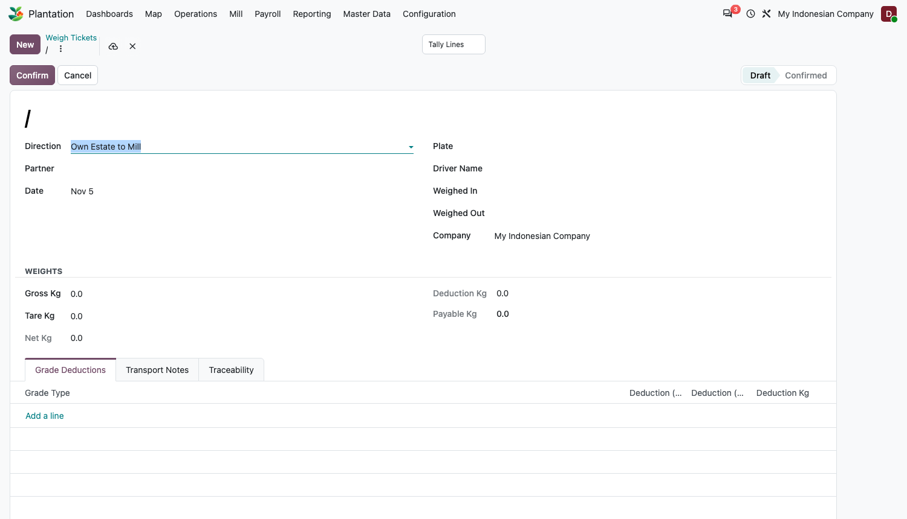
Figure 14. A new weigh ticket.

Case 1: Own Estate to Mill
1. Set Direction to Own Estate to Mill. A partner is not needed.
2. On the Transport Notes tab, add the transport notes that make up this load.
3. Enter the weights and confirm.
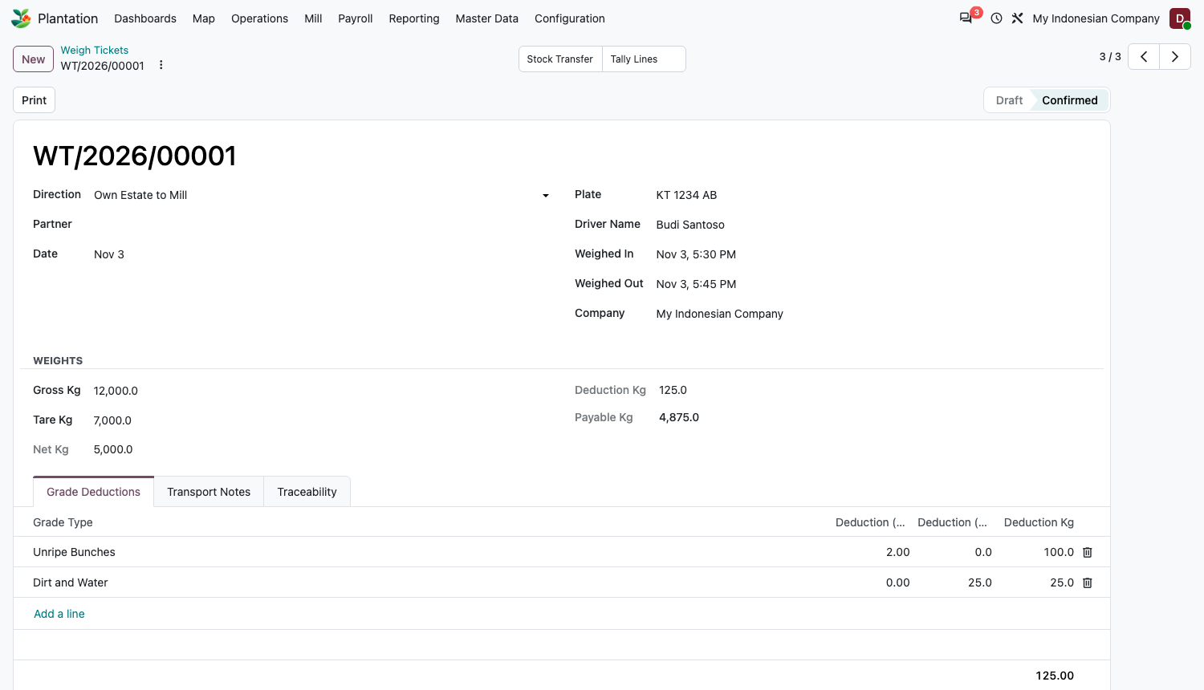
Figure 15. Own-estate ticket.
What happens A lot named after the ticket number is created, and the payable weight is received into the Receiving Warehouse from the Estate Harvest Location. The linked transport notes become Weighed. The Tally lines button gives traceability back to the tallies of the same blocks and dates.

Case 2: Bought from Third Party
1. Set Direction to Bought from Third Party and choose the supplier as Partner.
2. The Price per kg fills in from the FFB reference prices. Change it if this delivery was negotiated.
3. Enter weights and deductions, then Confirm.
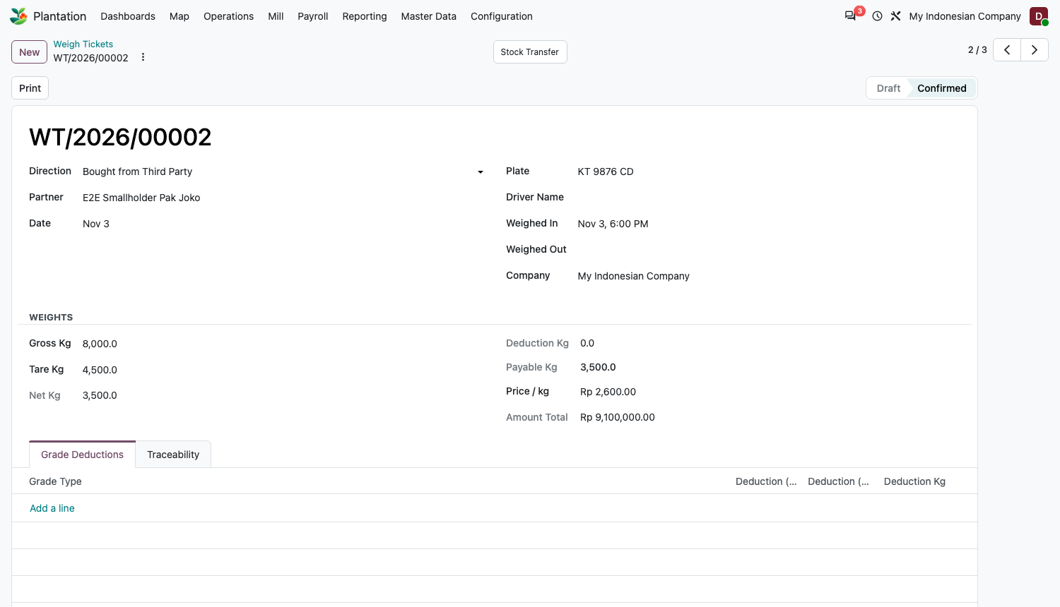
Figure 16. Third-party purchase: 3,500 kg at Rp 2,600 per kg gives Rp 9,100,000.
What happens A purchase order for the payable kg is created and confirmed, the receipt is validated with a new lot, and the ticket links to both. The order price is converted to the product's unit (for example Rp 2,000 per kg becomes Rp 2,000,000 per tonne for a product counted in tonnes). Taxes on the order follow the product's normal purchase tax.

Case 3: Sold
1. Set Direction to Sold and choose the customer as Partner.
2. Choose the Lot Sold, the lot being delivered. It is required.
3. Enter the weights and the Price per kg, then Confirm.
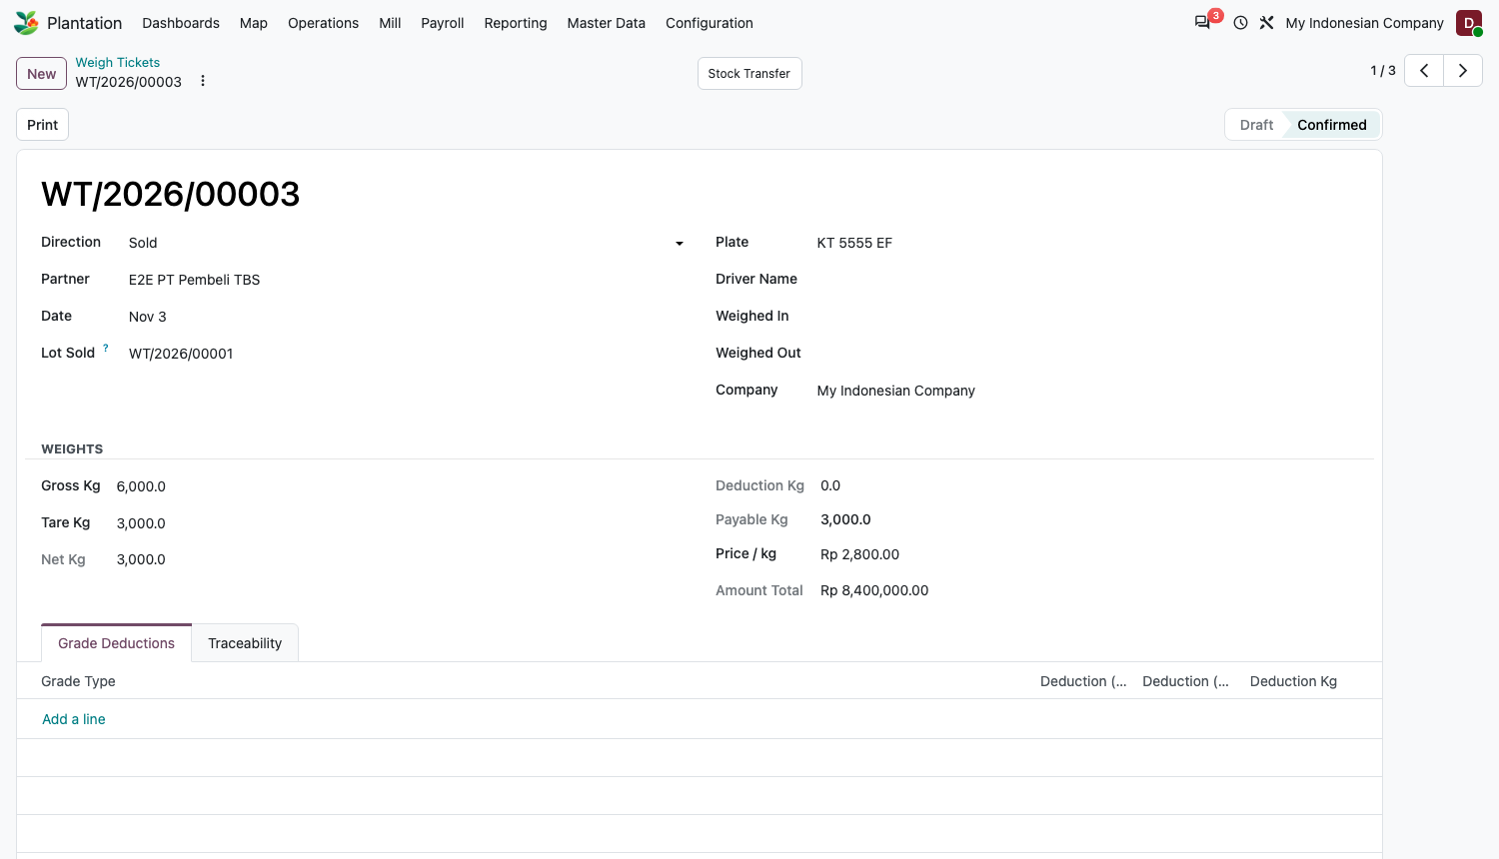
Figure 17. Sale ticket: 3,000 kg payable at Rp 2,800 per kg.
What happens A delivery of the payable kg is created from the Receiving Warehouse using the chosen lot and is validated. The ticket creates a delivery only; it does not create a sales order or an invoice, so invoice the customer from your normal sales process.

Warnings and rules on weigh tickets
- Freshness: if weigh-in is later than the Freshness Limit after the earliest Harvested At on the linked transport notes, an orange warning shows how many hours the fruit waited. It is a warning, not a block.
- Tare cannot exceed gross, and deductions cannot exceed net weight.
- A ticket with no payable weight cannot be confirmed. A partner is required for bought and sold tickets.
- A confirmed ticket cannot be cancelled. Return the stock and issue a new ticket. Only a Manager may change a confirmed ticket's data.

Part D. Mill
Switch on Own Mill in Settings. The oil extraction rate (OER) and kernel extraction rate (KER) are read from manufacturing orders; nothing is typed in.
1. Menu: Manufacturing > create a bill of materials: component FFB (the company FFB product), by-products or finished products CPO and Kernel. Count the quantities in kg or tonne.
2. Create and run a manufacturing order for that product, consume the FFB, and produce the CPO and kernel. Mark it done.
3. Open the order and its Extraction Rates tab, or Plantation > Mill > Extraction Rates for the pivot by month.
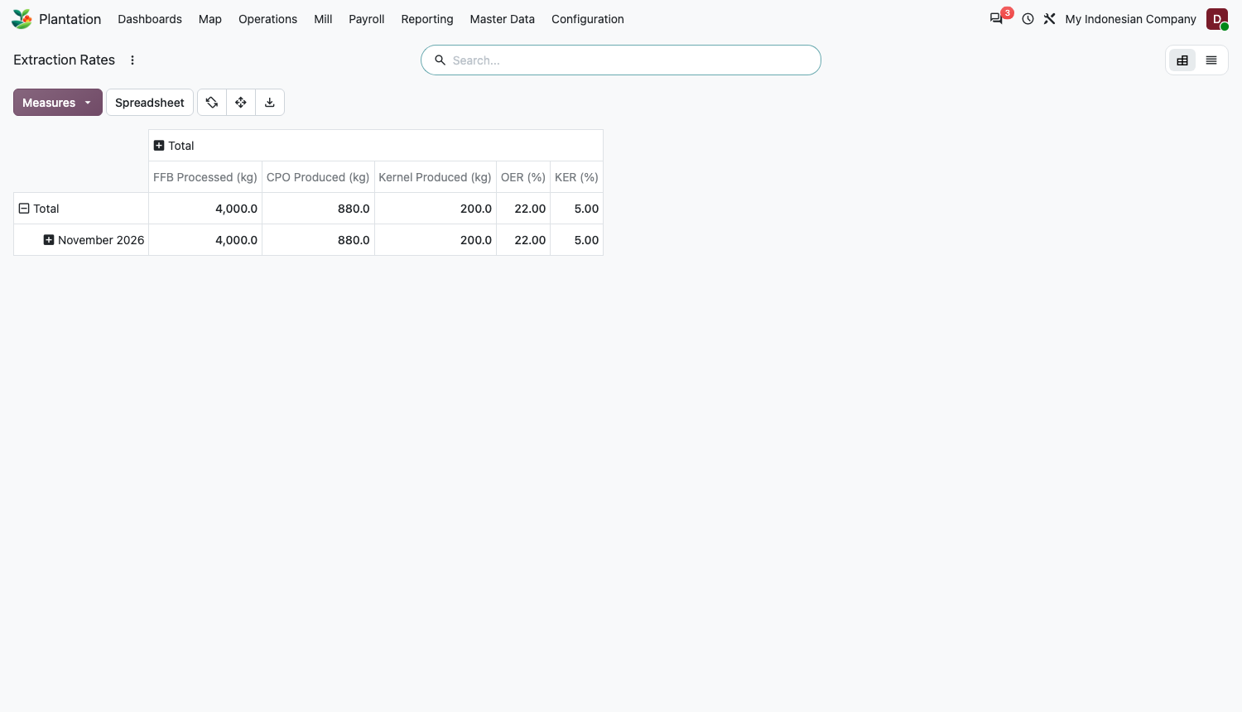
Figure 18. Extraction rates pivot: 4,000 kg FFB gave 880 kg CPO (OER 22 percent) and 200 kg kernel (KER 5 percent).
OER = CPO kg / FFB kg x 100. KER = kernel kg / FFB kg x 100. Quantities in tonnes or other weight units are converted to kilograms first, so rates stay correct whichever unit the products use.
Tip The rates use the products set in Settings. If an order shows zero, check that its raw material and finished products are the same FFB, CPO and Kernel products as in Settings.

Part E. Month-end harvest pay
Needs the Harvest Pay feature, pay schemes assigned to employees (A5), and confirmed tallies for the period.

E1. Compute harvest pay
1. Menu: Payroll > Compute Harvest Pay.
2. Enter Date From and Date To for the pay period. Leave Employees empty to include everyone with a pay scheme, or pick specific people.
3. Click Compute. The Harvest Pay list opens with one draft line per employee.
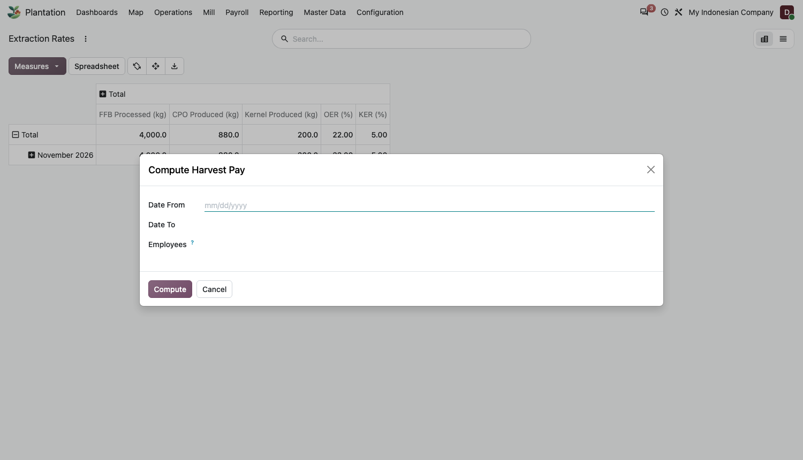
Figure 19. Compute Harvest Pay dialog.
What happens Each line shows harvested kg, bonus, penalty and the amount (bonus minus penalty, never below zero). Computing again for the same period replaces the draft lines, so you can fix a tally and recompute. Employees without a scheme are skipped.

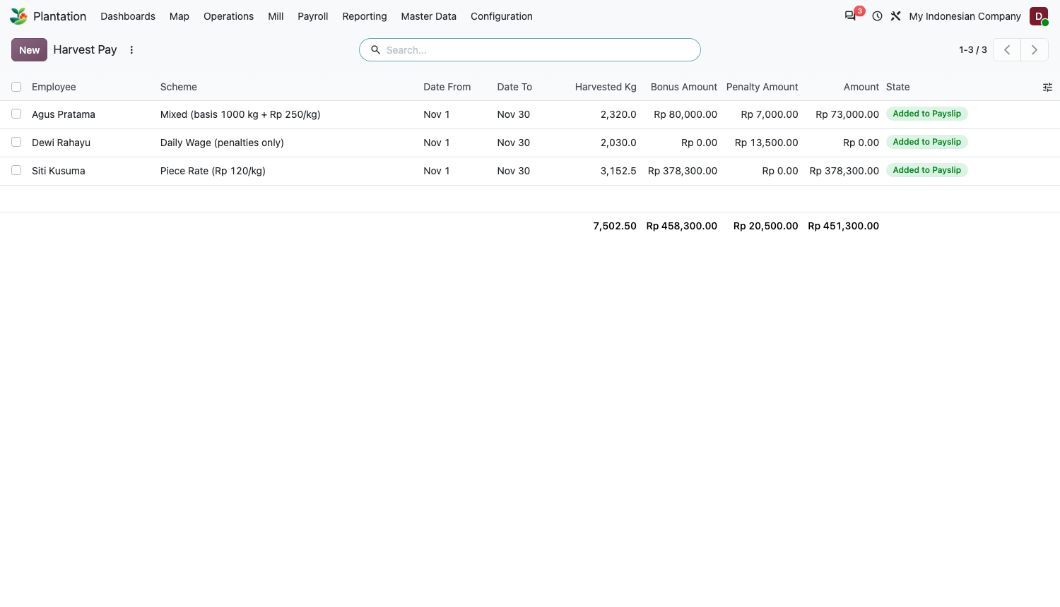
Figure 20. Harvest pay per employee for the period.
Worked example, mixed scheme (basis 1,000 kg a day, bonus Rp 250 per kg above, Rp 2,000 per unripe bunch, Rp 500 per kg loose fruit left): a harvester brings 1,300 kg on day one and 900 kg on day two. Bonus = (1,300 - 1,000) x 250 = Rp 75,000 (day two is under the basis and earns none). With 5 unripe bunches and 20 kg of loose fruit left, penalty = 5 x 2,000 + 20 x 500 = Rp 20,000. Harvest pay = 75,000 - 20,000 = Rp 55,000.

E2. Add to the payslip
1. Create the employee's payslip for the same period in Payroll as usual (it must use the Indonesian Regular Pay structure, which carries the Harvest Pay rule).
2. While the payslip is Draft, click Add Harvest Pay.
3. Check the Salary Inputs tab: a Harvest Pay (Premi Panen) line with the total amount is added.
4. Click Compute, then Validate as normal.
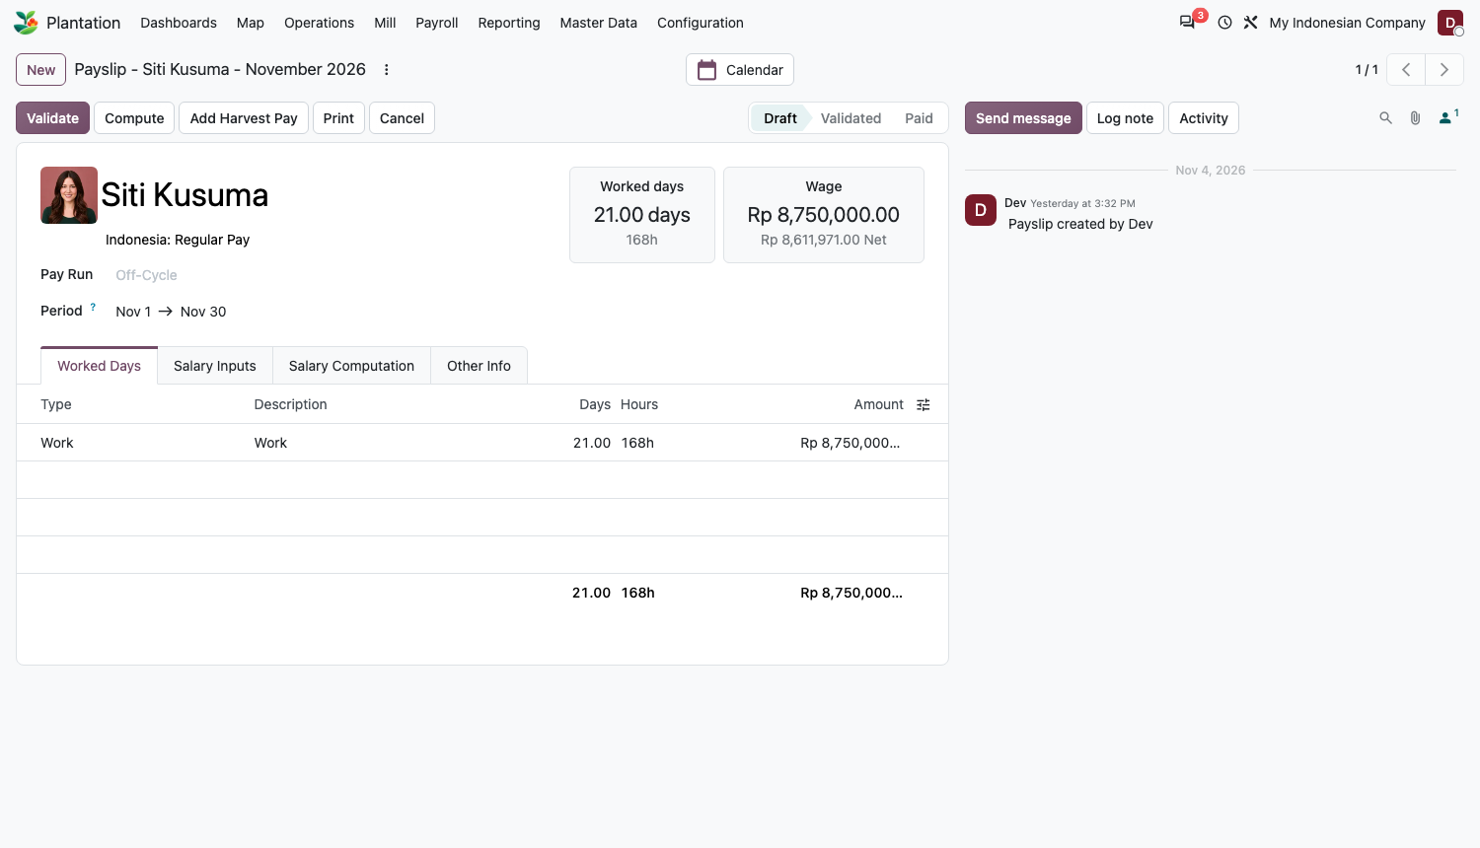
Figure 21. A draft payslip with the Add Harvest Pay button.
What happens The employee's draft harvest pay lines for the period are marked Added to Payslip and linked to the slip. Clicking Add Harvest Pay again replaces the input line rather than doubling it.

Rule Add Harvest Pay only works on a draft payslip, and only if harvest pay was computed for that period first.

Part F. Capitalise a mature block as an asset
Needs the Mature Plantation Assets feature. Use it once per block, when a block that was developed over several years becomes productive and its accumulated cost should start depreciating.
1. Make sure the block is Mature and its cost has built up (the Cost button on the block).
2. In Accounting > Configuration > Chart of Accounts, open the fixed-asset account you will use and set its Depreciation Model.
3. Open the block and click Capitalise as Asset.
4. In the dialog, check Name, Acquisition Date and Original Value (defaults to the block's total cost). Choose the Journal, the Asset Account and the Counterpart Account (the account holding development cost until capitalised).
5. Click Create Asset. A draft asset opens.
6. Validate the asset in Accounting to start depreciation.
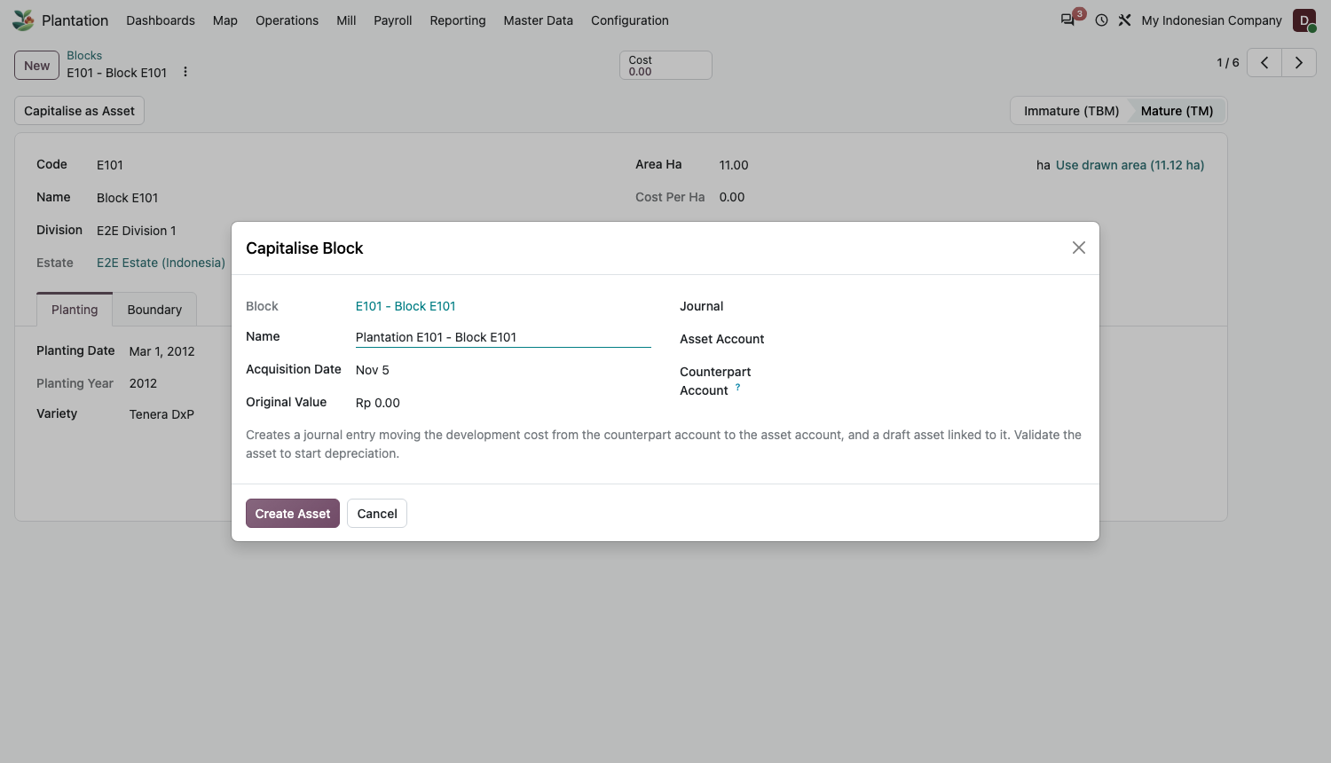
Figure 22. Capitalise Block dialog.
What happens A journal entry moves the cost from the counterpart account to the asset account, tagged to the block's cost centre, and a draft asset is created and linked to the block.

Rule Only a mature block can be capitalised, only once, and only if the asset account has a depreciation model; otherwise you get a message naming the account to fix.

Part G. Reports and dashboards

G1. Yield and Cost
Menu: Reporting > Yield and Cost. Pivot, graph and list views of bunches, estimated kg, weighed kg and cost by estate, division, block and month. The This Year filter is on by default; remove it for all dates. Click the plus signs to drill down.
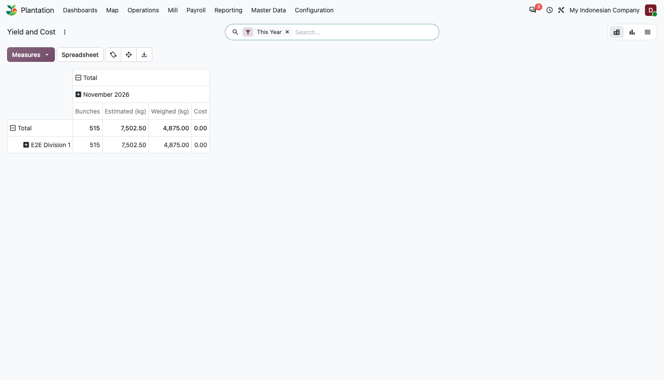
Figure 23. Yield and Cost pivot by division and month.

G2. Dashboards
Menu: Dashboards. The Plantation group holds four spreadsheet dashboards: Owner, Estate Manager, Weighbridge, and Stock and Inputs. They show weighed FFB, yield per hectare, cost per hectare and per kg, and FFB sold, with a period filter at the top. Cost figures stay at zero until inputs carry a cost price.

Quick reference

Checklists
Every day
- Record field activities and click Done.
- Enter and confirm the harvest tally for each division.
- Create the transport notes and Send to Mill.
- Weigh each load and confirm the weigh ticket.
Every month
- Check that all tallies in the period are confirmed.
- Payroll > Compute Harvest Pay for the period.
- On each draft payslip click Add Harvest Pay, Compute, Validate.
- Review Reporting > Yield and Cost and the dashboards.
When a block matures
- Click Set Mature on the block.
- Capitalise as Asset when you are ready to start depreciation.

Common messages and what to do
Message | Cause and fix
Set the FFB product and receiving warehouse in the Plantation settings. | Complete A1, then confirm the ticket again.
Set the estate harvest location in the Plantation settings. | Own-estate tickets need a Production-type location in Settings.
Choose the lot sold on ticket ... | A Sold ticket needs the Lot Sold field.
Ticket ... needs a partner / has no payable weight. | Add the supplier or customer; check gross, tare and deductions.
The FFB product ... cannot be converted from kilograms. | Change the FFB product's unit to kg or tonne.
Tare weight cannot exceed gross weight. / Grade deductions exceed the net weight. | Correct the weights or deductions.
A confirmed ticket cannot be cancelled. | Return the stock and issue a new ticket; a Manager can correct data.
Block ... is not in division ... / Only mature blocks can be harvested. | Use a block of that division, and set the block to Mature.
... already has a tally line for block ... on ... | One line per harvester per block per day; edit the existing line.
Tally ... has no lines. / Transport note ... has no lines. | Add at least one line before confirming or sending.
Only draft activities (tallies) can be edited. | Cancel and set to draft, edit, then confirm again.
Set the input store on division ... and the consumption location ... | Set the division's Input Store and the Consumption Location in Settings.
No draft harvest pay for ... in this period. | Run Payroll > Compute Harvest Pay for that period first.
No employee with a harvest pay scheme was found. | Assign a Harvest Pay Scheme on the employees.
Harvest pay can only be added to a draft payslip. | Set the payslip back to draft first.
Account ... has no depreciation model. | Set a depreciation model on the asset account, then retry.
Only a mature block can be capitalised. / Block ... already has an asset. | Set the block to Mature; a block is capitalised once.
Block ... has activities or costs. Archive it instead. | Use Archive, not Delete.

