ss_plantation: UI End-to-End Test Report
Playwright browser run against the dev server, with screenshots of every step.
Date | 2026-11-04
Server | https://odoo20.kpmgroup.co.id (Odoo 20 Enterprise)
Database | odoo20e
Module | ss_plantation 20.0.1.0.0, author Seasoft
Browser | Chromium (headless), 1600 x 900
Tool | Playwright for Python; script ss_plantation/e2e/ui_plantation.py
Result | 40 of 40 steps passed, 0 failed

Scope
Every Plantation menu entry was opened and checked for an error dialog and for the expected view. Master data, operations, mill, payroll, reporting and configuration screens were opened, and key records were opened as forms. A create flow (estate, division, block) was driven through the UI, including a many2one lookup, and a workflow button was clicked. Transactional screens were viewed in the company that holds the data created by the API end-to-end run (E2E estate, weigh tickets, mill orders, harvest pay).

Pass criteria
A step passes when the action completes, no Odoo error dialog appears, and the expected view element is present. Browser console errors are recorded against the step.

Summary of results
# | Step | Result
1 | Login | PASS
2 | Home menu shows Plantation app | PASS
3 | Open Plantation app (Dashboards) | PASS
4 | Dashboards: spreadsheet dashboard renders | PASS
5 | Map: Leaflet map with estate layers | PASS
6 | Map: layer control | PASS
7 | Map: click a block shows popup | PASS
8 | Dashboards: Plantation > Owner | PASS
9 | Switch to the E2E company (company 2) holding transactions | PASS
10 | Master Data: Estates list | PASS
11 | Estate form | PASS
12 | Master Data: Divisions list | PASS
13 | Division form | PASS
14 | Master Data: Blocks list | PASS
15 | Block form (area, stage, boundary) | PASS
16 | Master Data: Landmarks list | PASS
17 | Landmark form | PASS
18 | Operations: Field Activities | PASS
19 | Operations: Harvest Tally | PASS
20 | Harvest tally form | PASS
21 | Operations: Transport Notes | PASS
22 | Operations: Weigh Tickets | PASS
23 | Weigh ticket form (confirmed, stock link) | PASS
24 | Mill: Extraction Rates (OER/KER) | PASS
25 | Payroll: Pay Schemes | PASS
26 | Pay scheme form | PASS
27 | Payroll: Harvest Pay | PASS
28 | Payroll: Compute Harvest Pay wizard | PASS
29 | Reporting: Yield and Cost pivot (earlier TypeError) | PASS
30 | Yield and Cost: graph view | PASS
31 | Config: Activity Types | PASS
32 | Config: Landmark Types | PASS
33 | Config: Grade Deductions | PASS
34 | Config: FFB Reference Prices | PASS
35 | Config: Settings | PASS
36 | Create estate via UI: fill form | PASS
37 | Create estate via UI: save | PASS
38 | Create division under new estate via UI | PASS
39 | Create block under new division via UI | PASS
40 | Click Set Mature button: block stage becomes Mature (TM) | PASS

Findings and notes
- No failures in the final run. Earlier runs of the script exposed test-script issues only (wait strategy, a missing mandatory area on the block form), not module defects.
- The Yield and Cost report, which previously raised a client TypeError, loads correctly.
- The block form refuses a save without a positive area (constraint "The block area must be positive"), which is the intended behaviour.
- Cost shows 0.00 in the Yield and Cost pivot and on the owner dashboard because the sample inputs have no cost price or cost category; this is a data gap, not a defect.
- The map draws geometry on the dev server. The OpenStreetMap base tiles did not render in the headless capture, so the background is plain; geometry and markers are unaffected.
- The Plantation dashboards show N/A in company 1 because that company has no transactions.
- Test records created by the run (estate UITEST, division UI-D1, block UI-B1) were removed afterwards.

Step-by-step evidence

1. Login
PASS
Log in to the web client with the test user. Confirms the server, database and session are healthy.
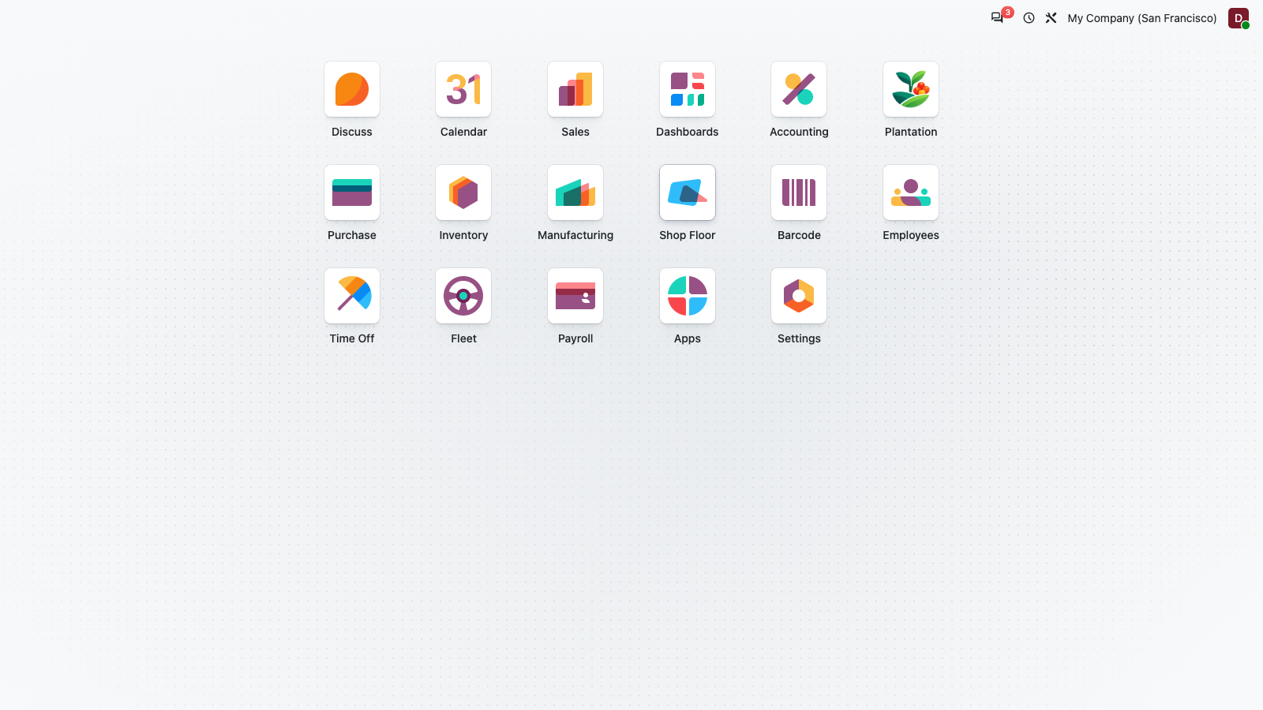
Figure 1: Login

2. Home menu shows Plantation app
PASS
The Plantation app tile is installed and visible in the home menu next to the standard apps.
Figure 2: Home menu shows Plantation app

3. Open Plantation app (Dashboards)
PASS
Opening the app lands on the Dashboards entry with the full Plantation menu bar: Dashboards, Map, Operations, Mill, Payroll, Reporting, Master Data, Configuration.
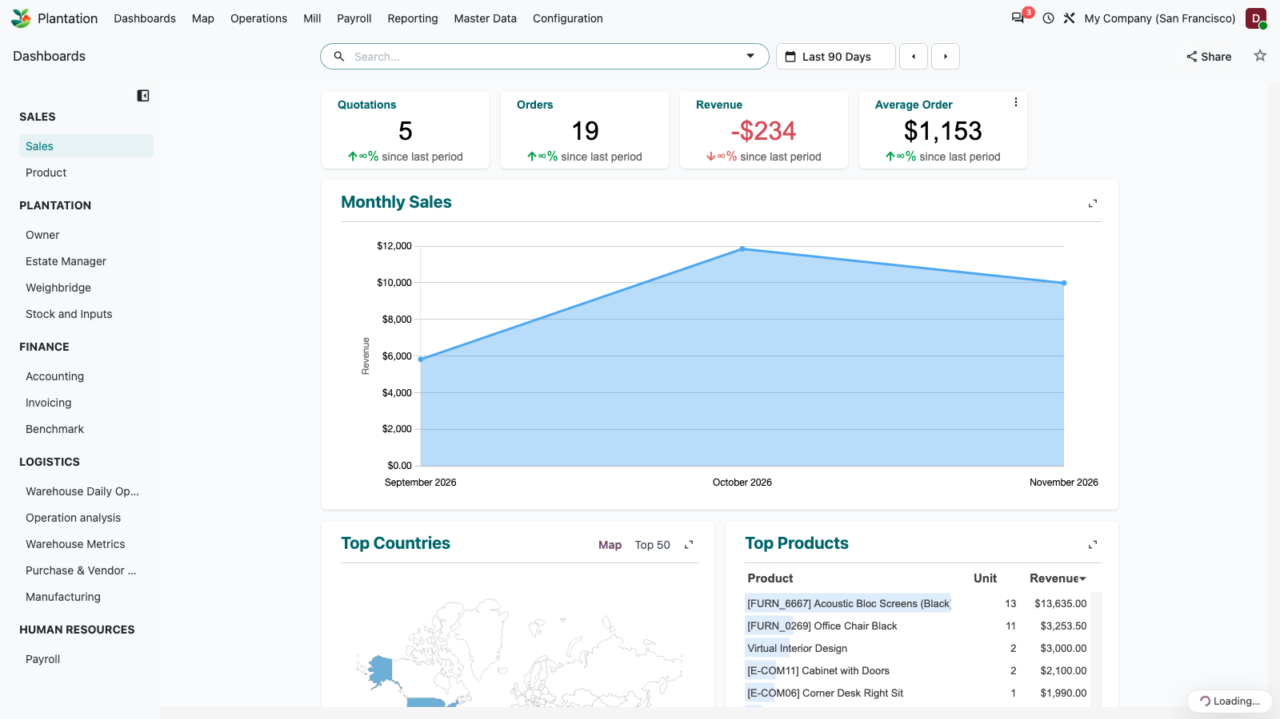
Figure 3: Open Plantation app (Dashboards)

4. Dashboards: spreadsheet dashboard renders
PASS
The Dashboards menu opens the spreadsheet dashboard action.
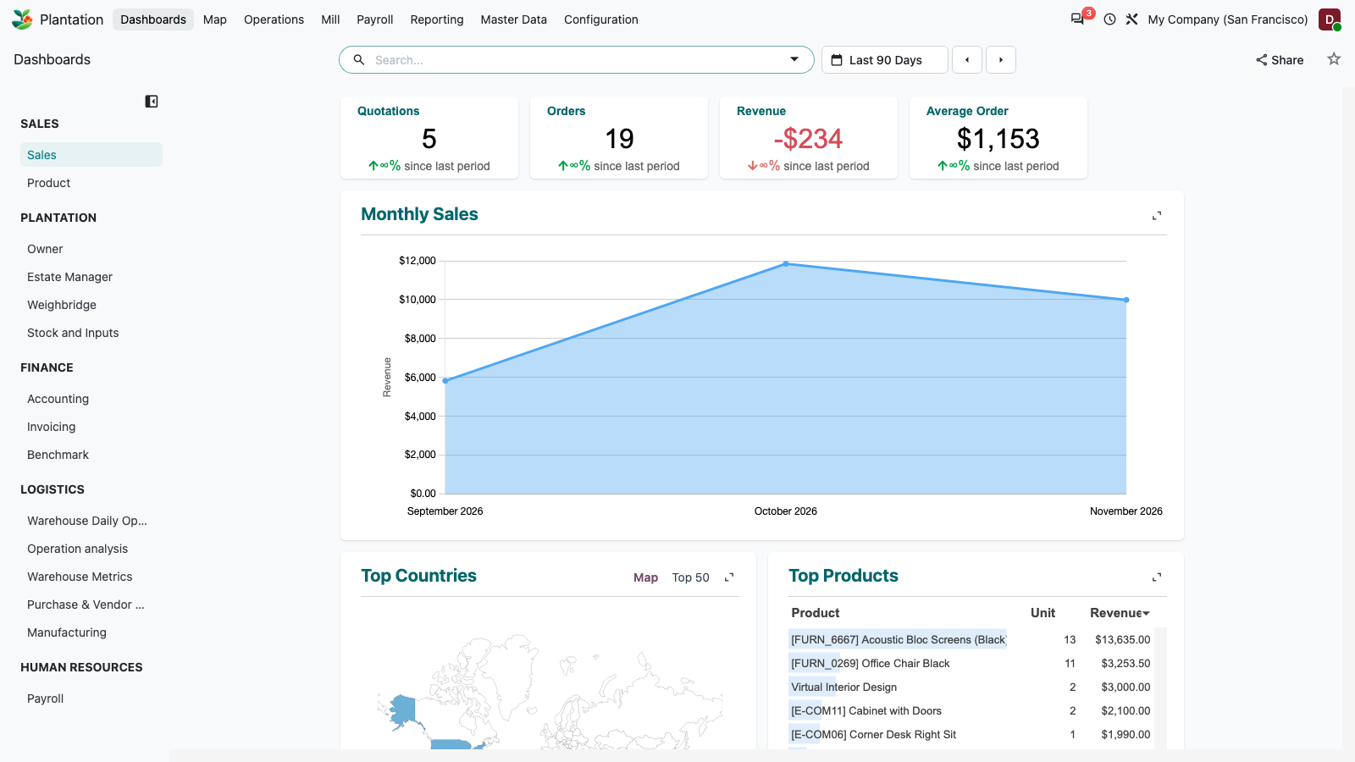
Figure 4: Dashboards: spreadsheet dashboard renders

5. Map: Leaflet map with estate layers
PASS
The map client action loads Leaflet, draws the estate boundary, divisions, 12 blocks coloured by stage, the main road line and 8 landmark markers. The legend (immature, mature, replanting, closed) and layer toggles show counts.
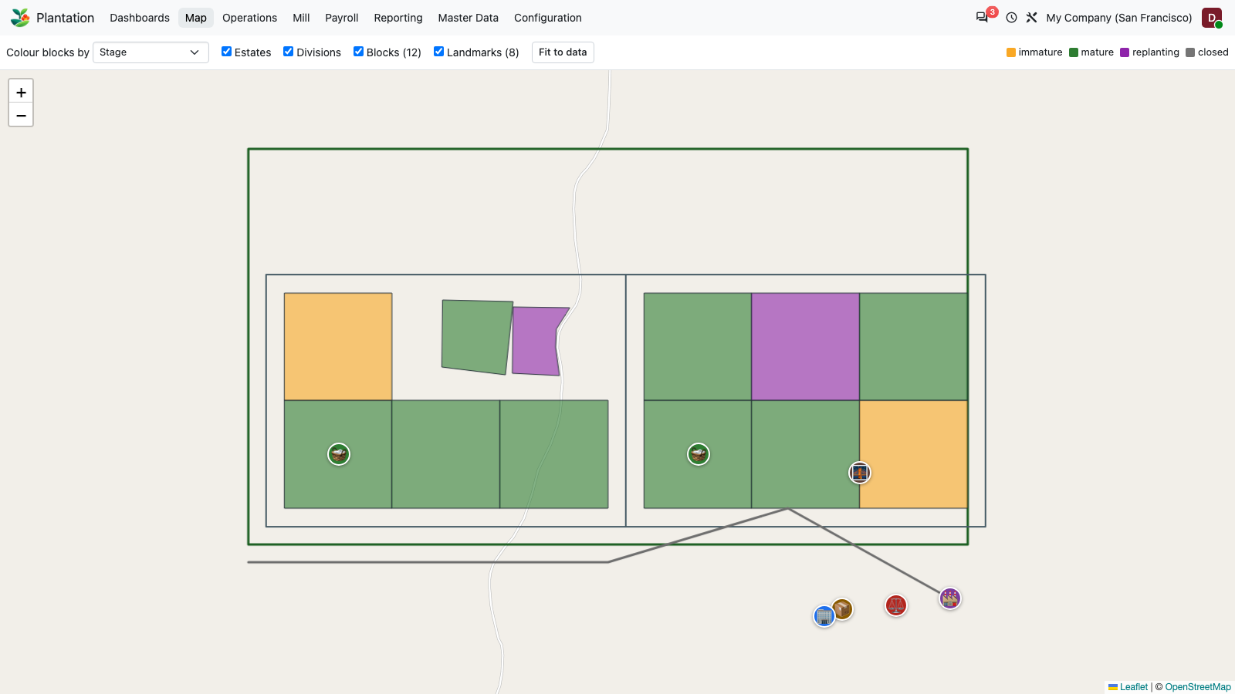
Figure 5: Map: Leaflet map with estate layers

6. Map: layer control
PASS
Toolbar: colour-by selector, layer checkboxes (Estates, Divisions, Blocks, Landmarks) and Fit to data.
Figure 6: Map: layer control

7. Map: click a block shows popup
PASS
Clicking a block polygon is handled without an error dialog.
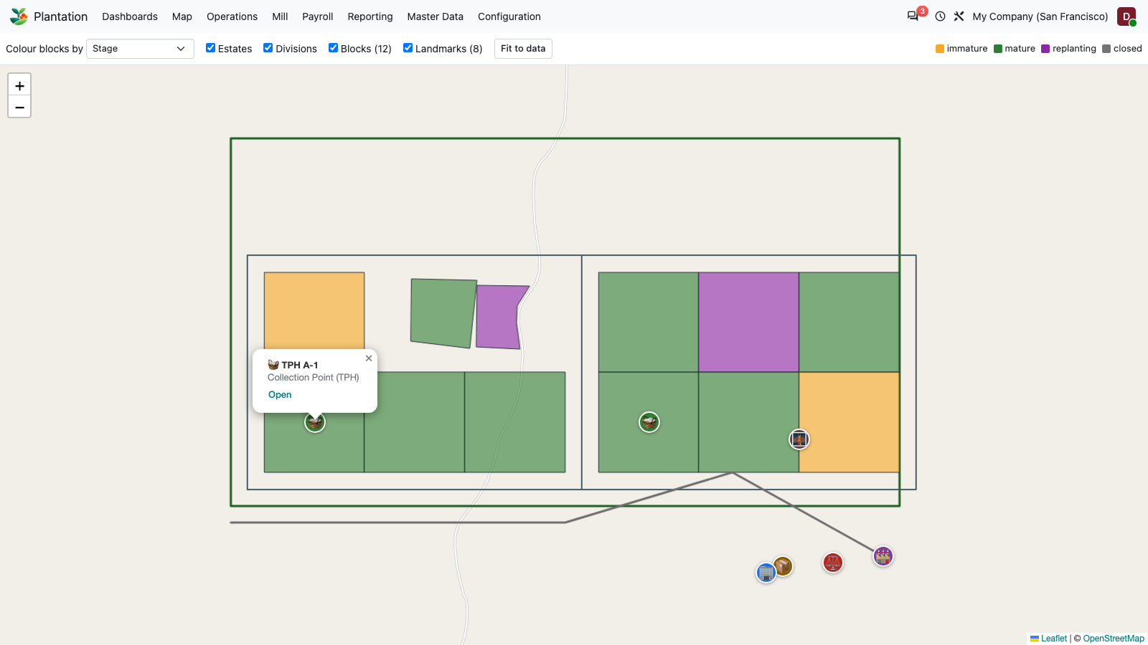
Figure 7: Map: click a block shows popup

8. Dashboards: Plantation > Owner
PASS
The Plantation dashboard group (Owner, Estate Manager, Weighbridge, Stock and Inputs) renders its KPI tiles and chart. Company 1 holds no transactions, so values are N/A or zero here.
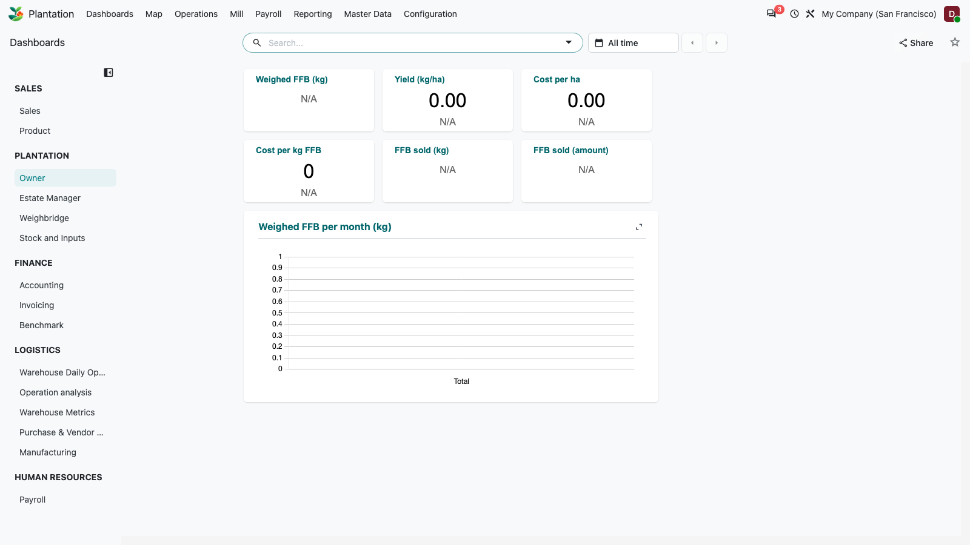
Figure 8: Dashboards: Plantation > Owner

9. Switch to the E2E company (company 2) holding transactions
PASS
Switches the active company to "My Indonesian Company", which holds the transactional data created by the API end-to-end run.
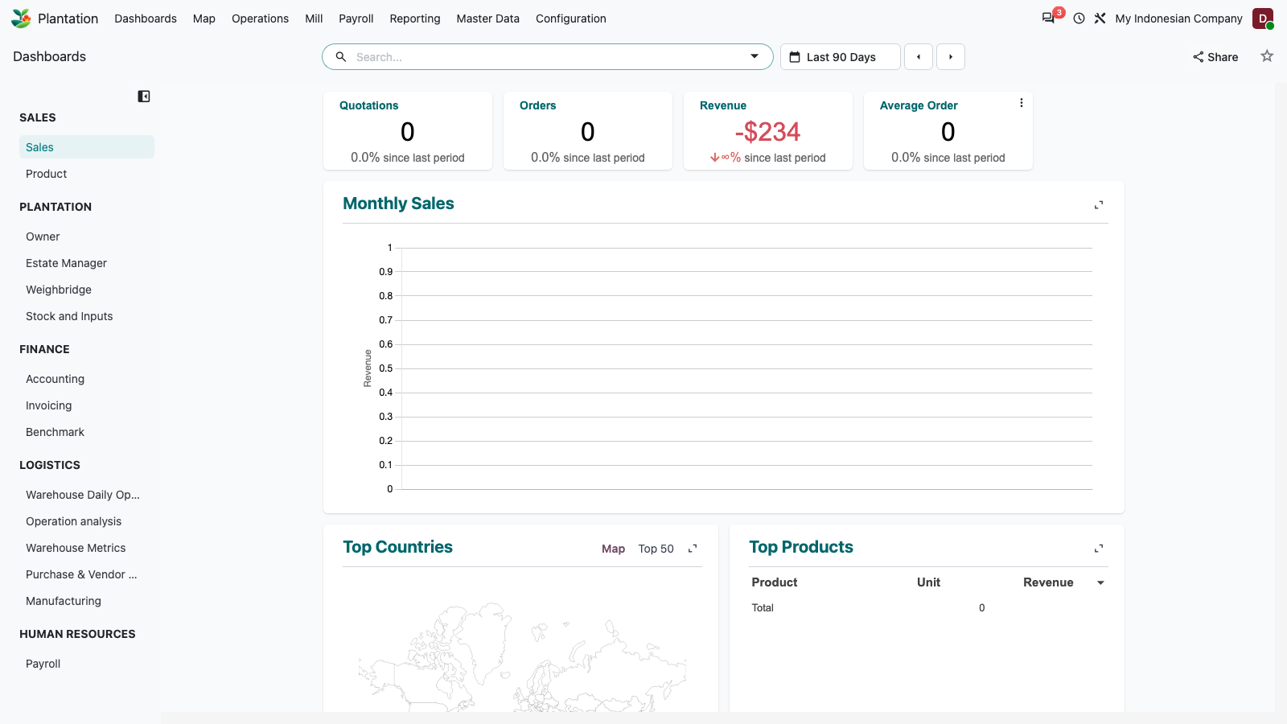
Figure 9: Switch to the E2E company (company 2) holding transactions

10. Master Data: Estates list
PASS
Estate list.
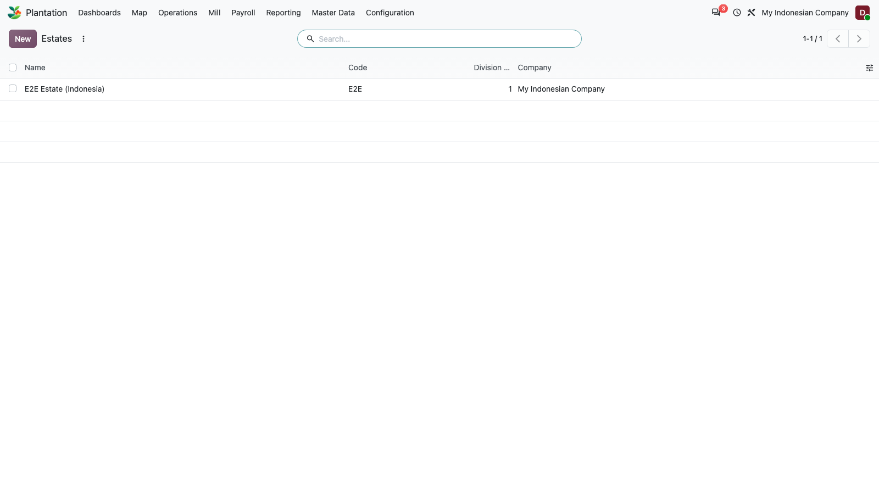
Figure 10: Master Data: Estates list

11. Estate form
PASS
Estate form with divisions and boundary tabs.
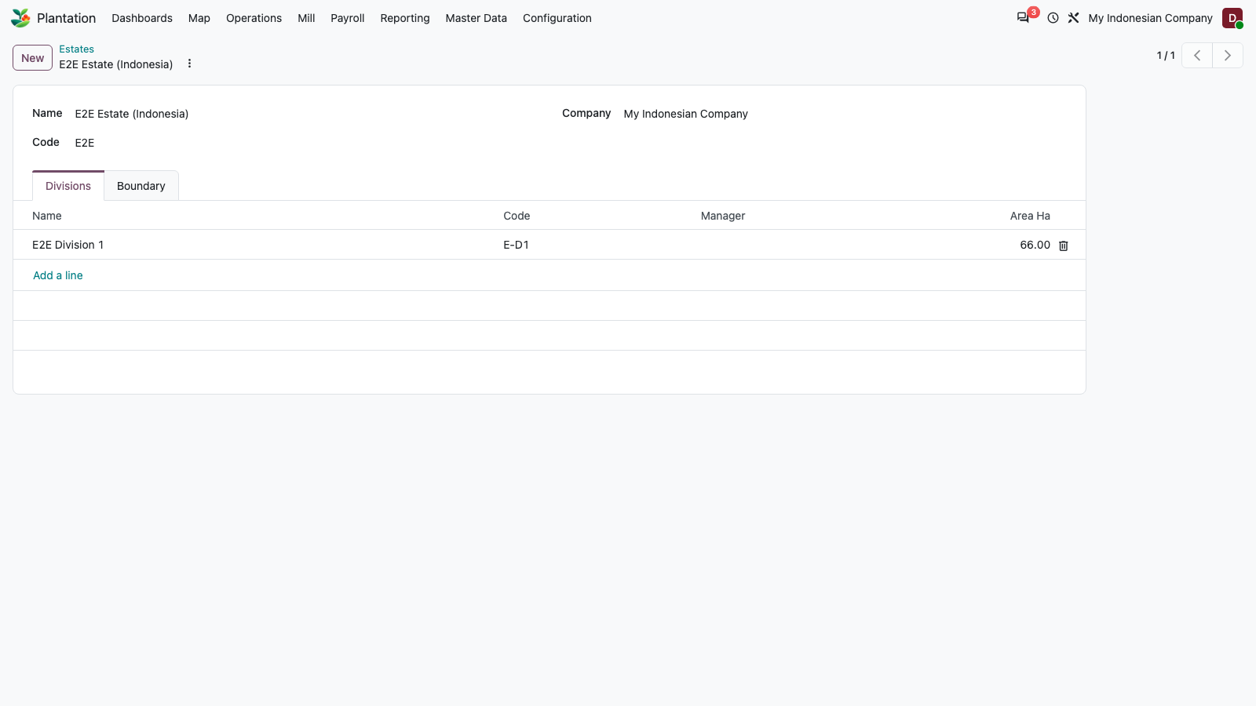
Figure 11: Estate form

12. Master Data: Divisions list
PASS
Division list.
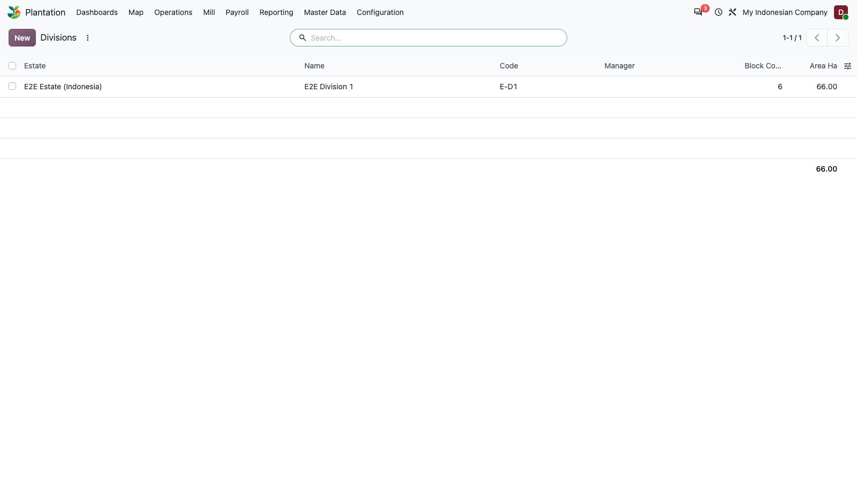
Figure 12: Master Data: Divisions list

13. Division form
PASS
Division form.
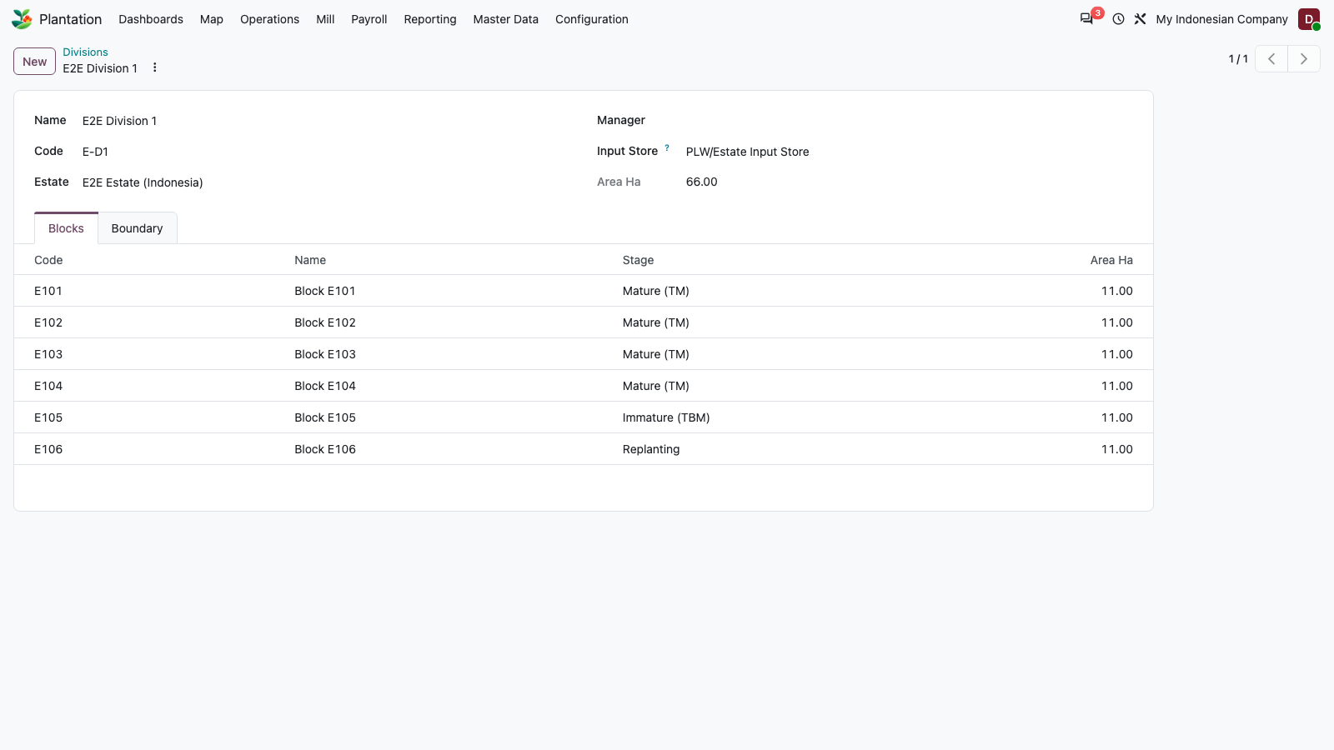
Figure 13: Division form

14. Master Data: Blocks list
PASS
Block list.
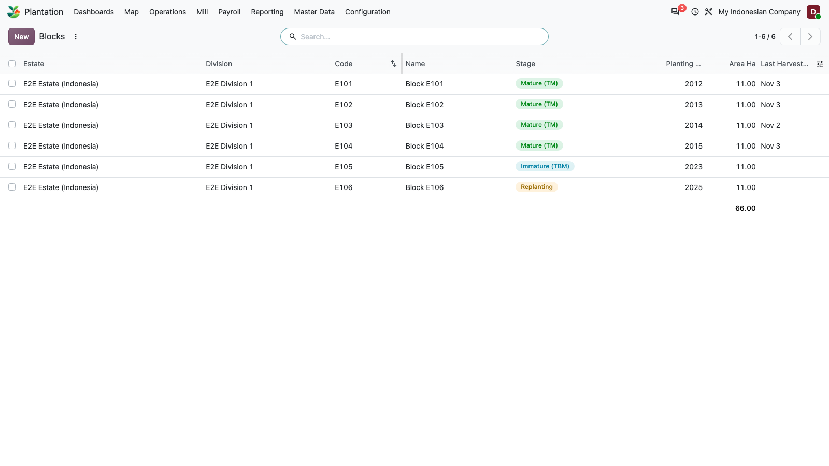
Figure 14: Master Data: Blocks list

15. Block form (area, stage, boundary)
PASS
Block form: area, planting, stage statusbar, cost smart button and boundary.
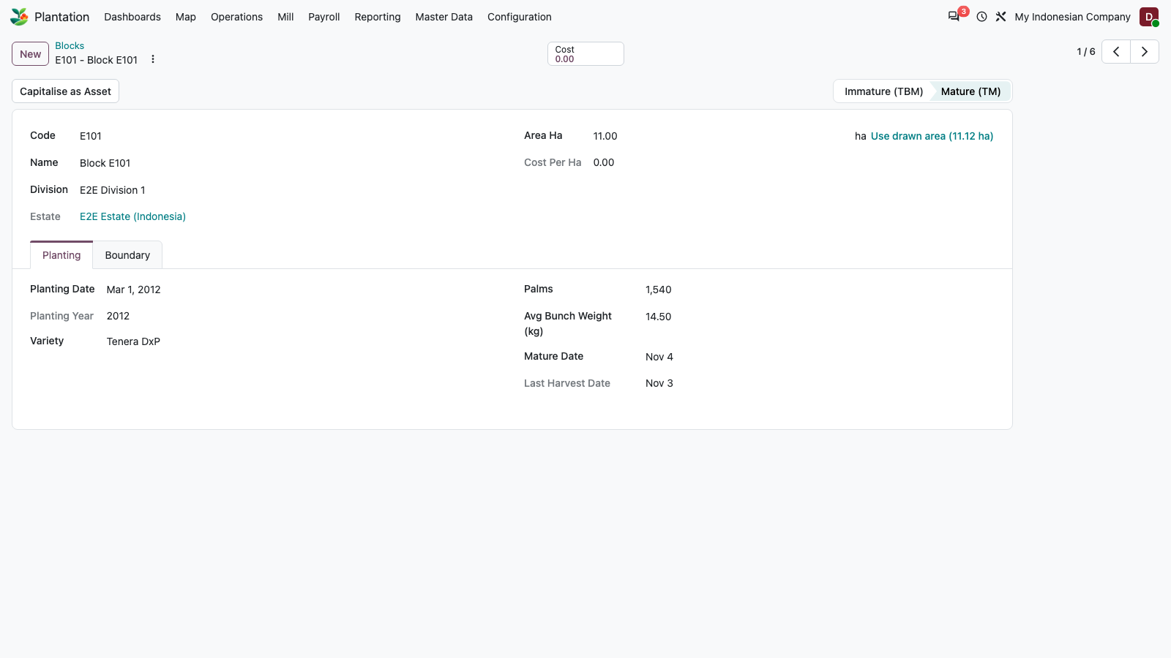
Figure 15: Block form (area, stage, boundary)

16. Master Data: Landmarks list
PASS
Landmark list.
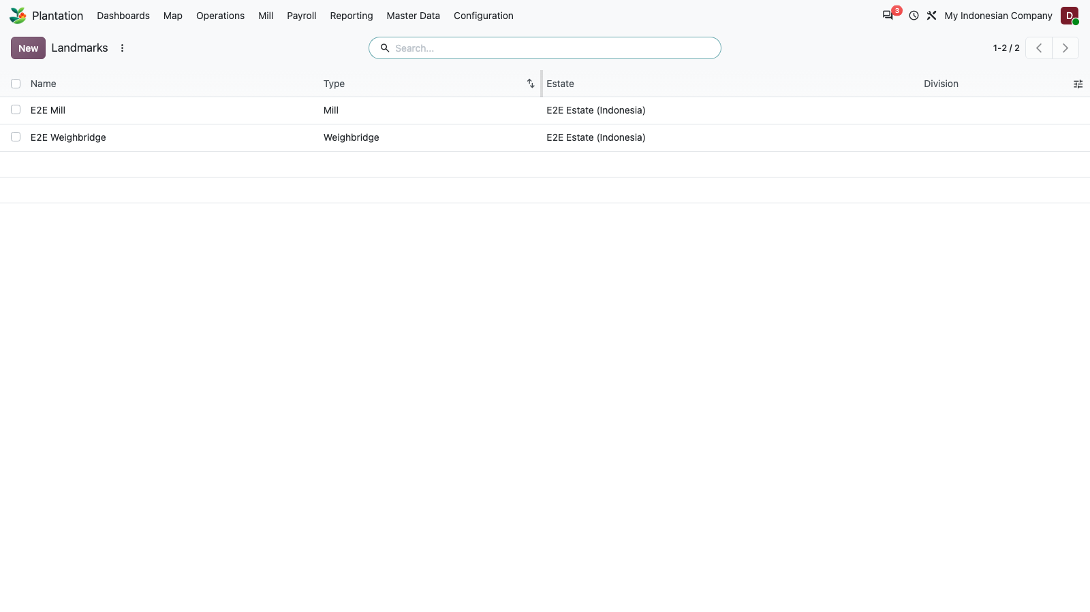
Figure 16: Master Data: Landmarks list

17. Landmark form
PASS
Landmark form.
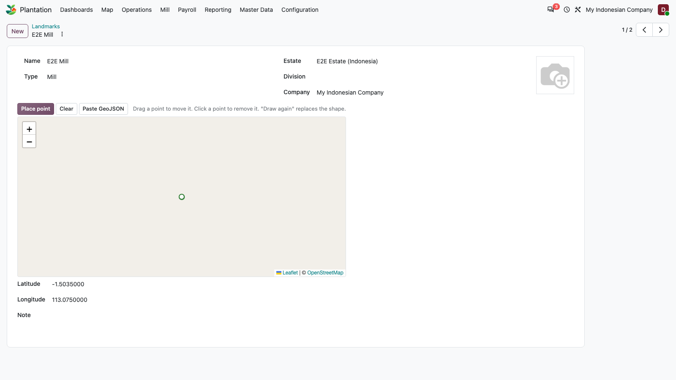
Figure 17: Landmark form

18. Operations: Field Activities
PASS
Field activities list.
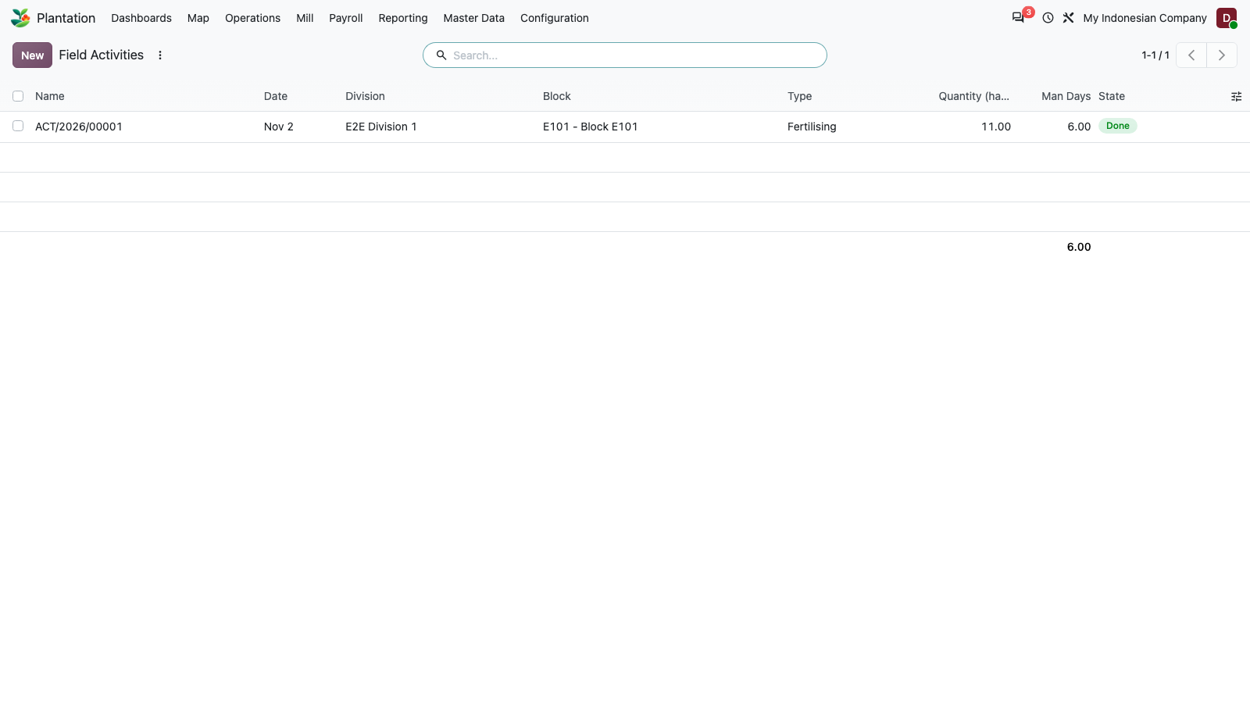
Figure 18: Operations: Field Activities

19. Operations: Harvest Tally
PASS
Harvest tally list.
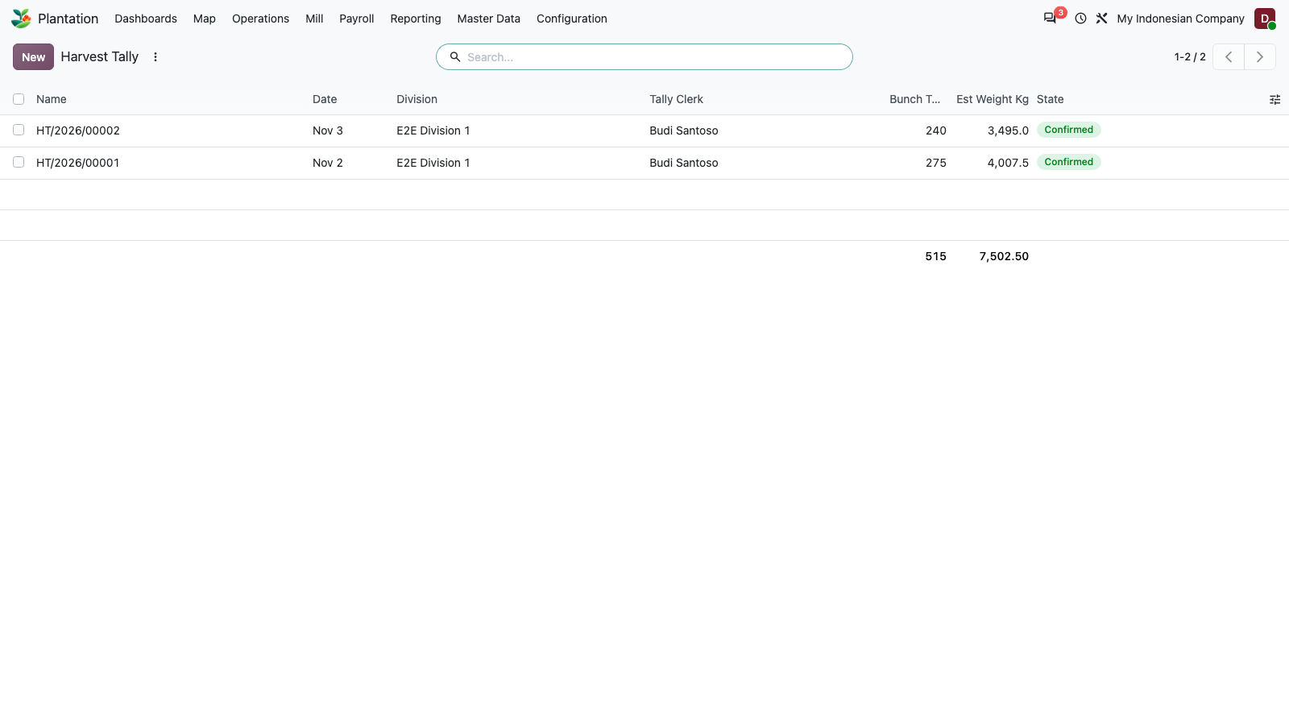
Figure 19: Operations: Harvest Tally

20. Harvest tally form
PASS
Harvest tally form.
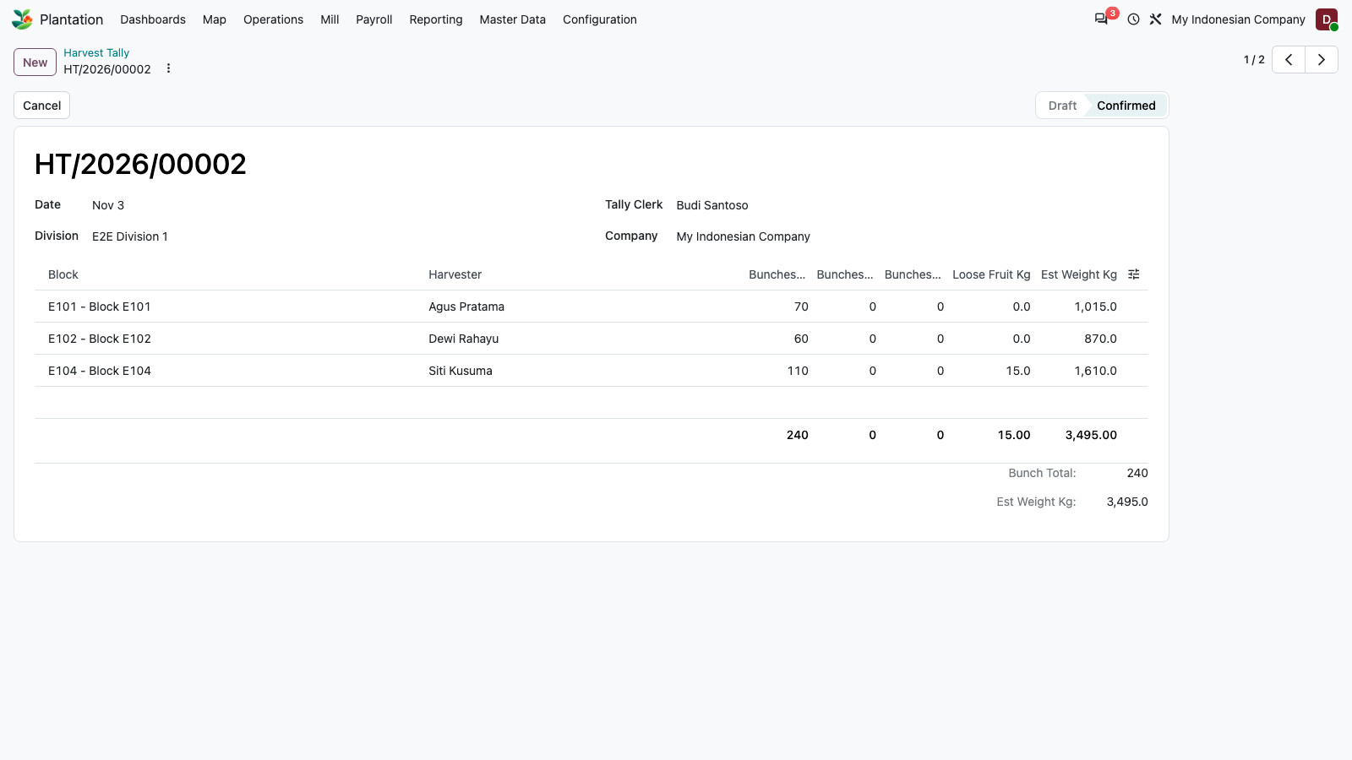
Figure 20: Harvest tally form

21. Operations: Transport Notes
PASS
Transport notes list.
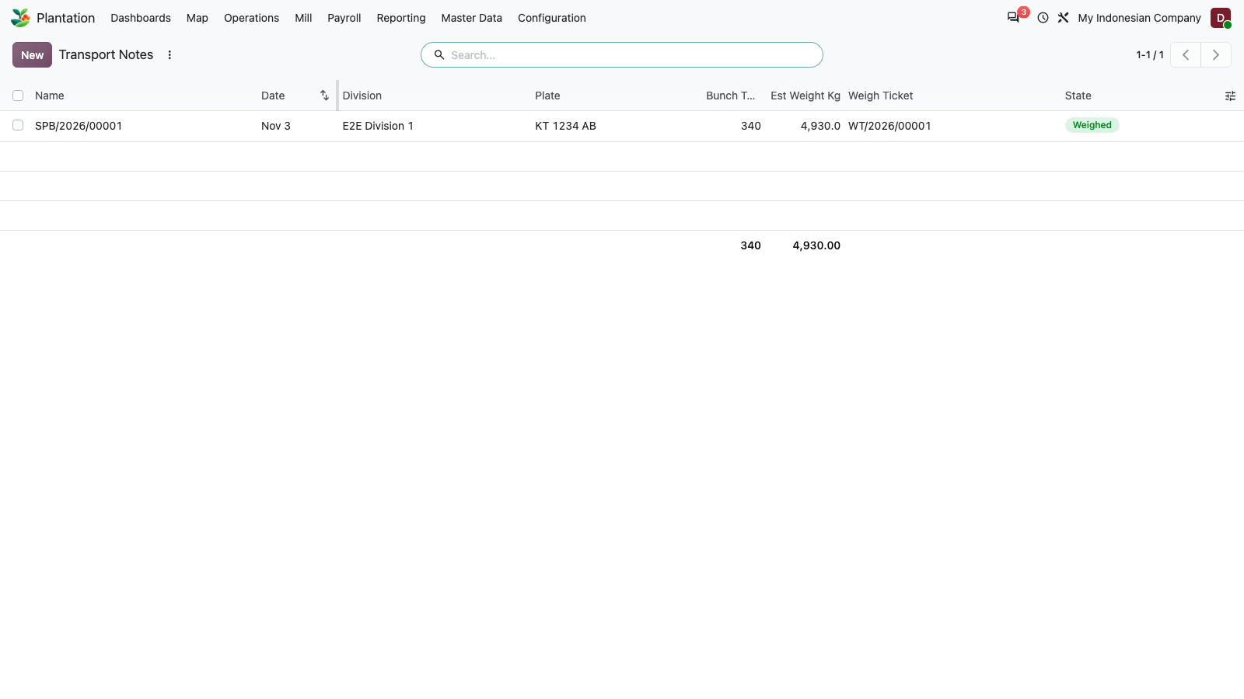
Figure 21: Operations: Transport Notes

22. Operations: Weigh Tickets
PASS
Weigh ticket list for estate, third-party and sold tickets.
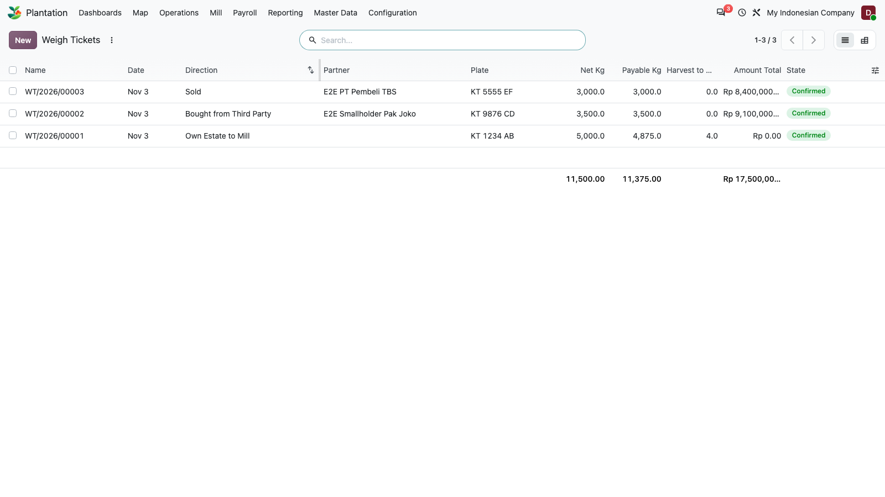
Figure 22: Operations: Weigh Tickets

23. Weigh ticket form (confirmed, stock link)
PASS
A confirmed sale ticket: gross 6,000 kg, tare 3,000 kg, payable 3,000 kg at Rp 2,800/kg = Rp 8,400,000, lot sold WT/2026/00001, linked Stock Transfer button and Print.
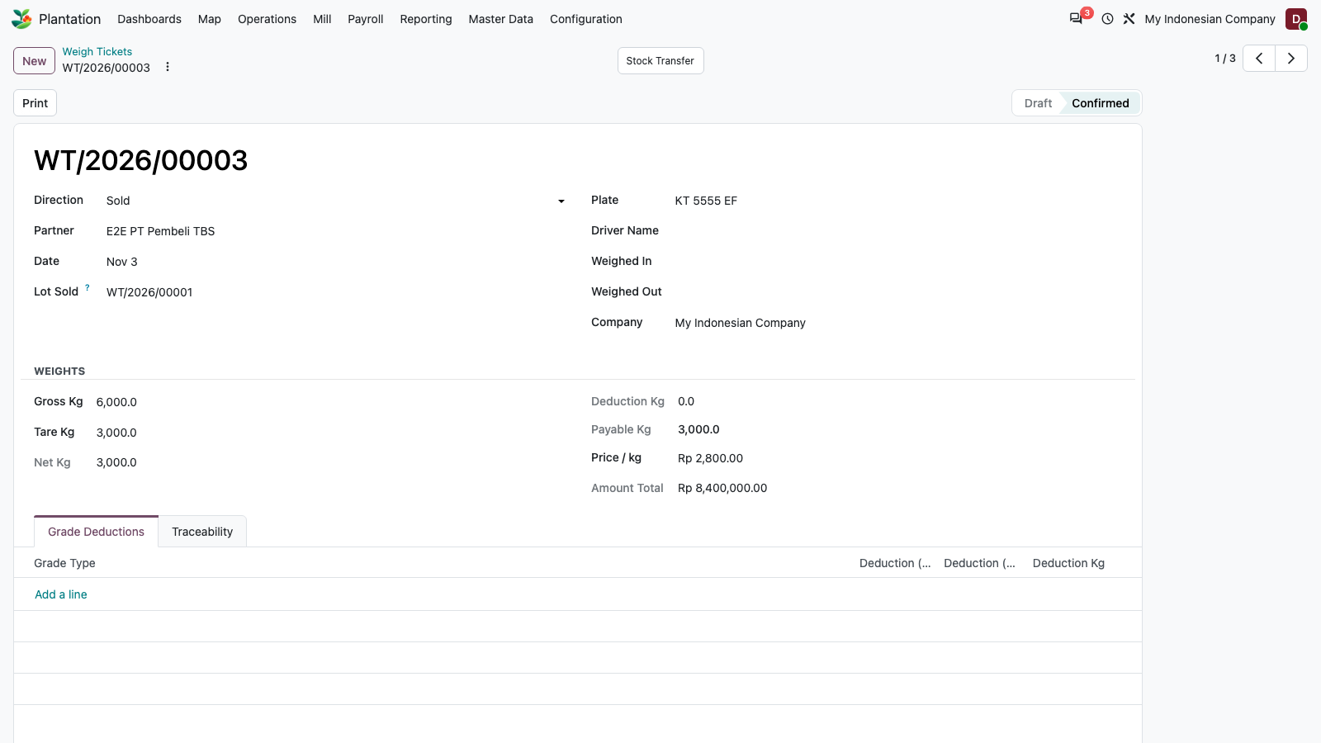
Figure 23: Weigh ticket form (confirmed, stock link)

24. Mill: Extraction Rates (OER/KER)
PASS
Extraction rates (OER / KER) screen.
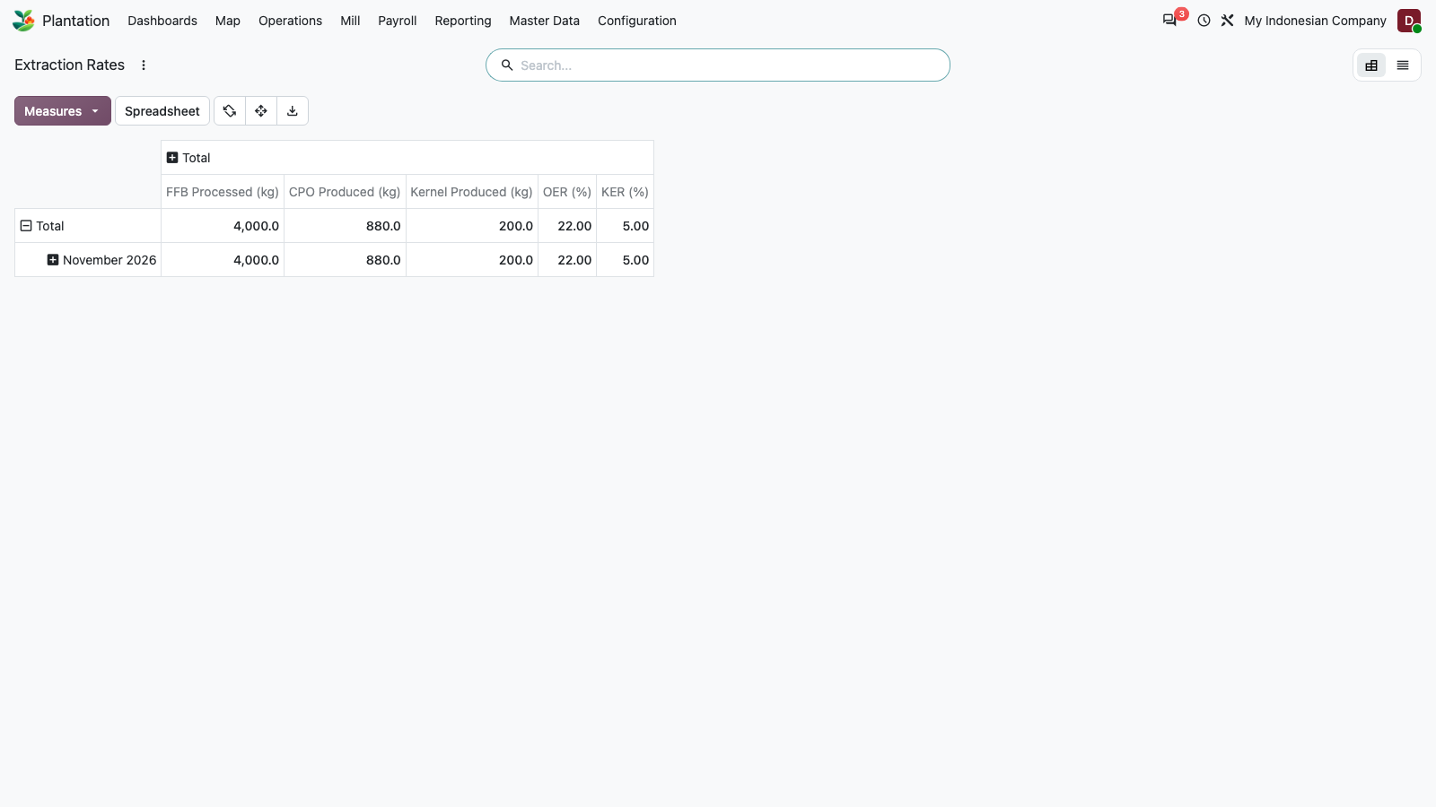
Figure 24: Mill: Extraction Rates (OER/KER)

25. Payroll: Pay Schemes
PASS
Harvest pay scheme list.
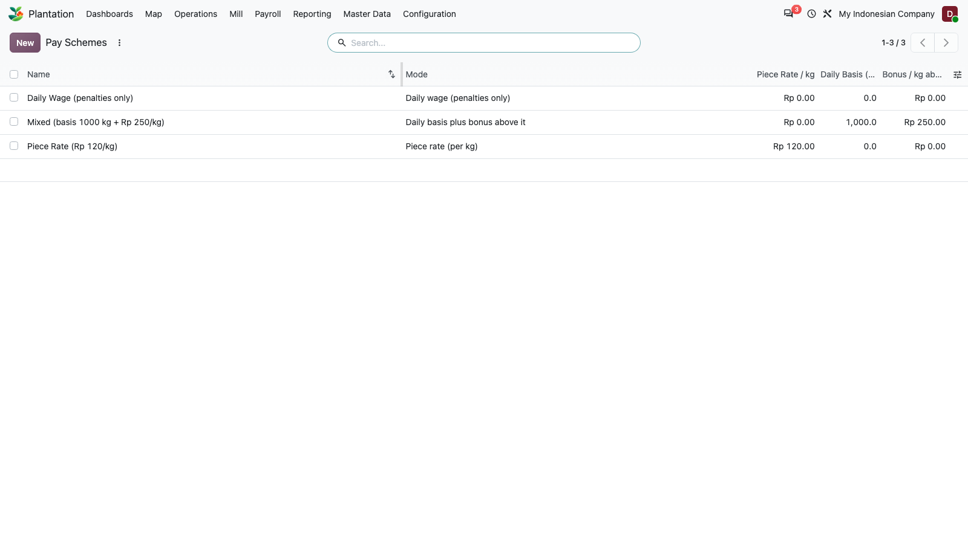
Figure 25: Payroll: Pay Schemes

26. Pay scheme form
PASS
Pay scheme form.
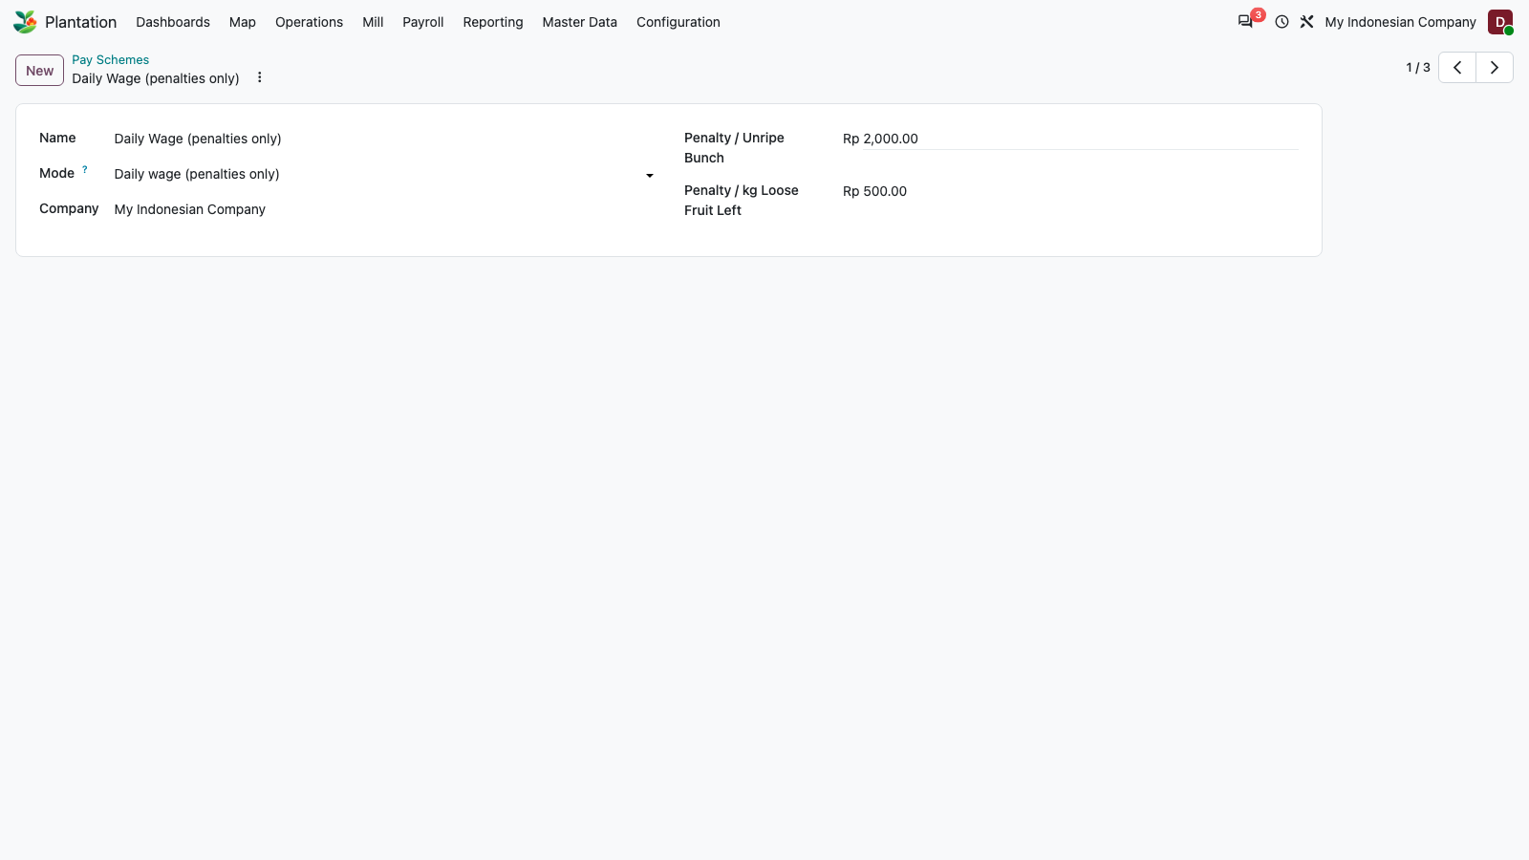
Figure 26: Pay scheme form

27. Payroll: Harvest Pay
PASS
Harvest pay records per employee.
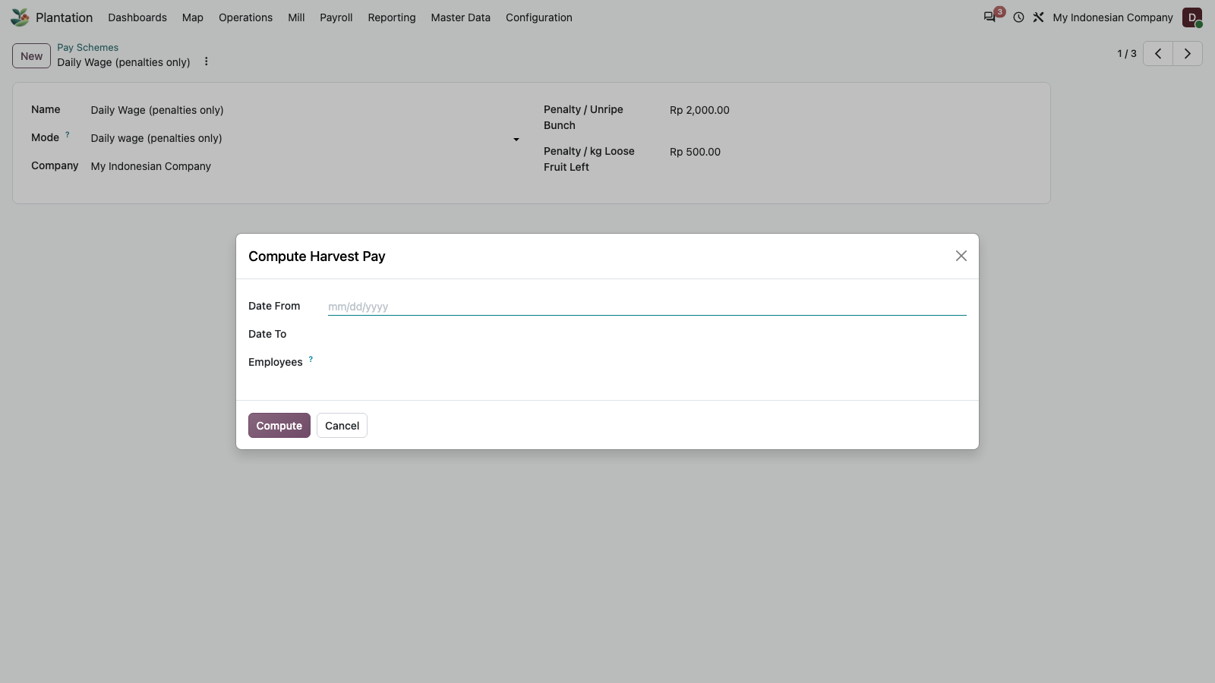
Figure 27: Payroll: Harvest Pay

28. Payroll: Compute Harvest Pay wizard
PASS
The Compute Harvest Pay wizard opens as a dialog.
Figure 28: Payroll: Compute Harvest Pay wizard

29. Reporting: Yield and Cost pivot (earlier TypeError)
PASS
Yield and Cost pivot, grouped by division and month with the default This Year filter. This screen raised a client TypeError earlier; it now loads: 515 bunches, 7,502.5 kg estimated, 4,875 kg weighed.
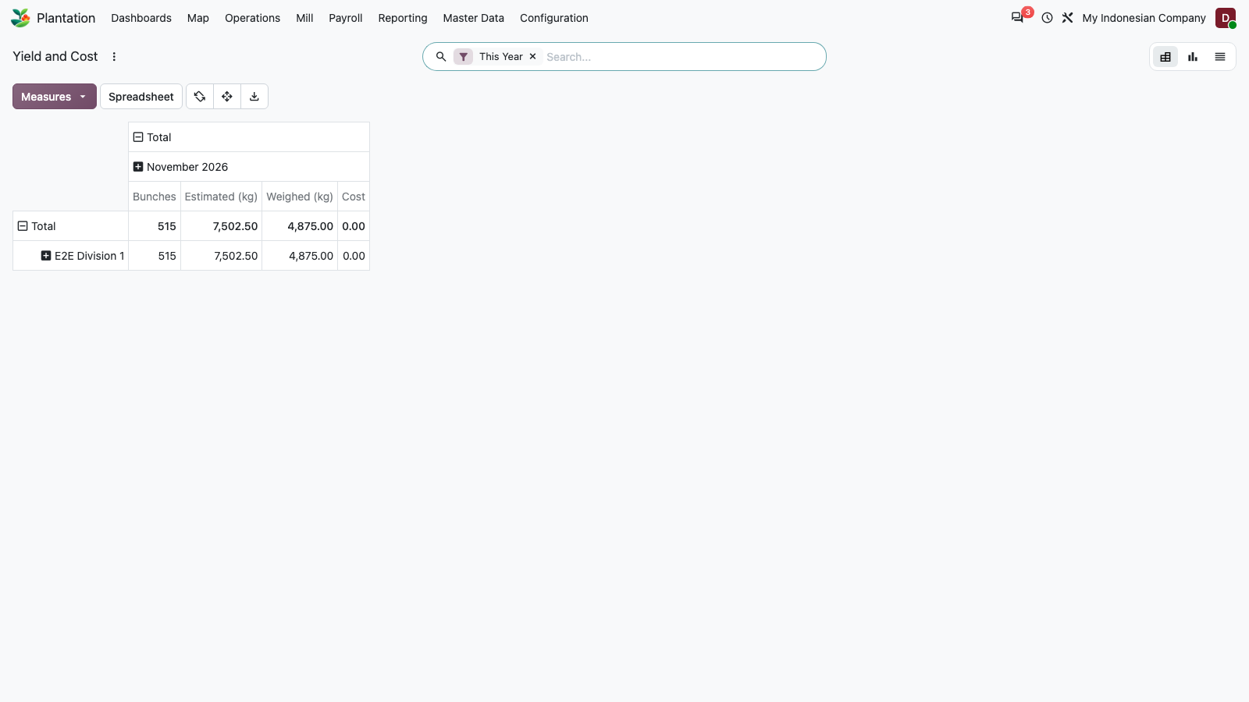
Figure 29: Reporting: Yield and Cost pivot (earlier TypeError)

30. Yield and Cost: graph view
PASS
Graph view of weighed kg by month.
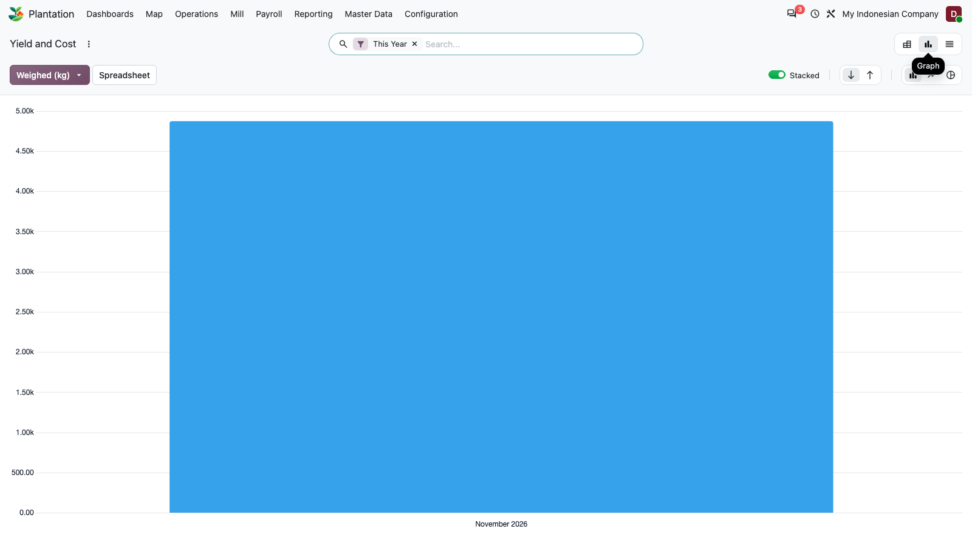
Figure 30: Yield and Cost: graph view

31. Config: Activity Types
PASS
Activity type configuration.
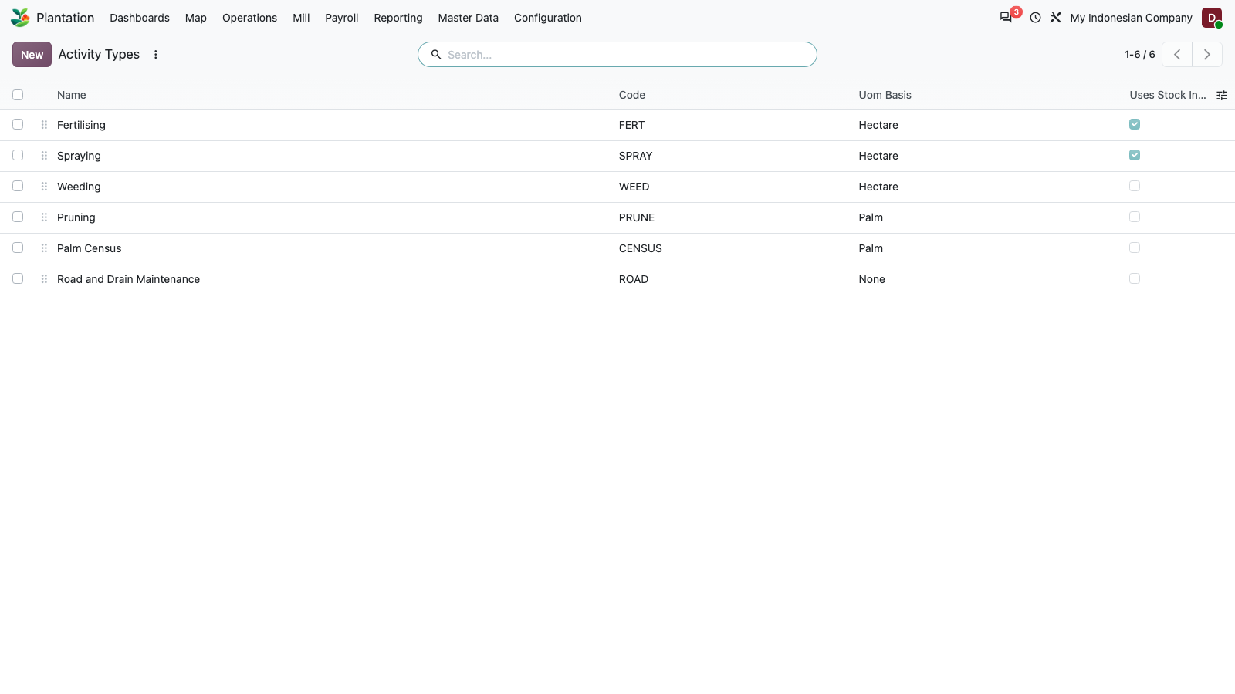
Figure 31: Config: Activity Types

32. Config: Landmark Types
PASS
Landmark type configuration.
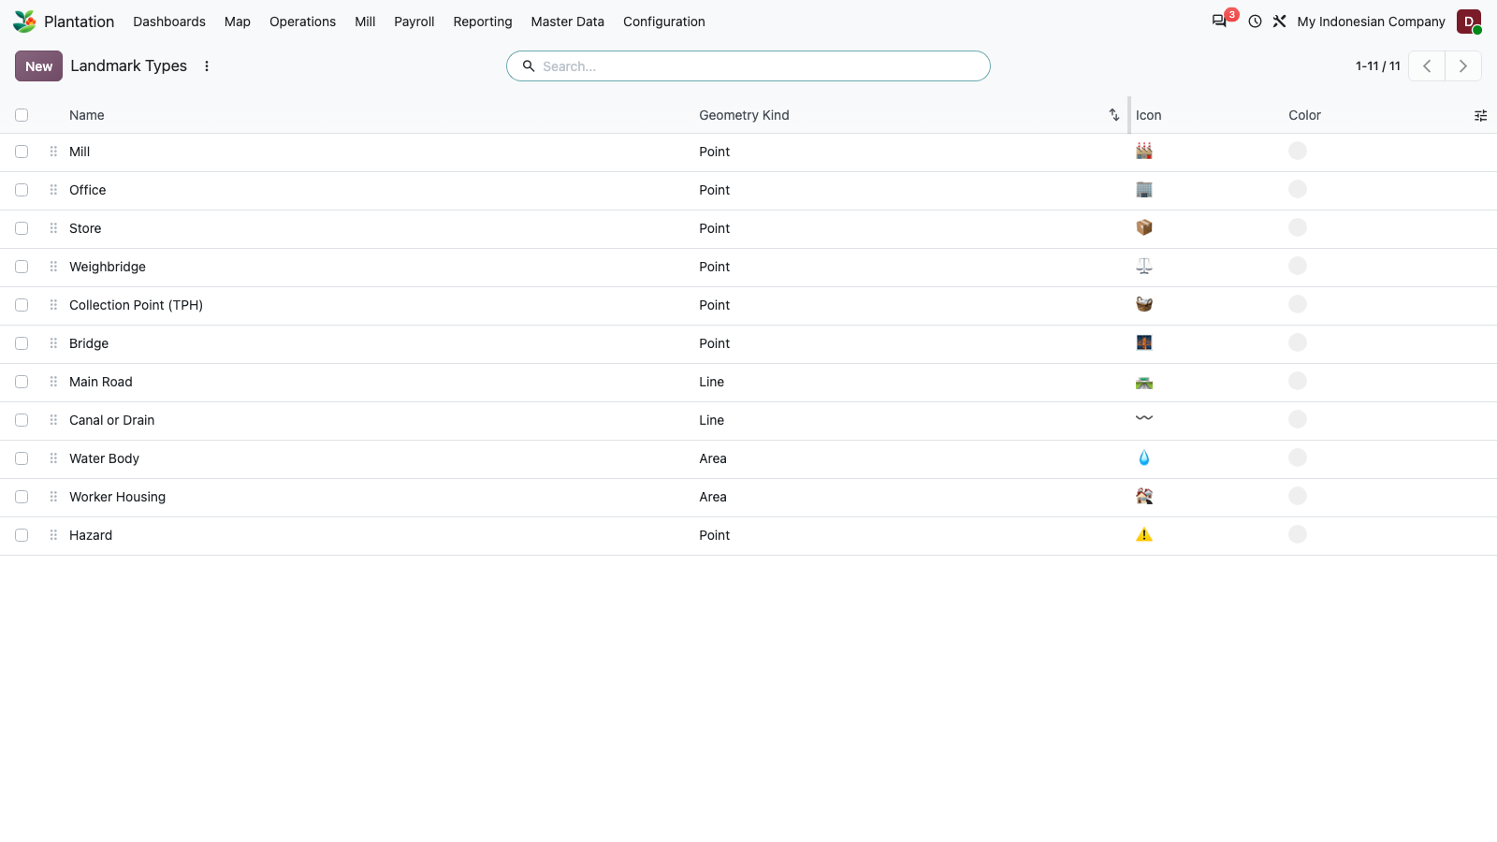
Figure 32: Config: Landmark Types

33. Config: Grade Deductions
PASS
Grade deduction configuration.
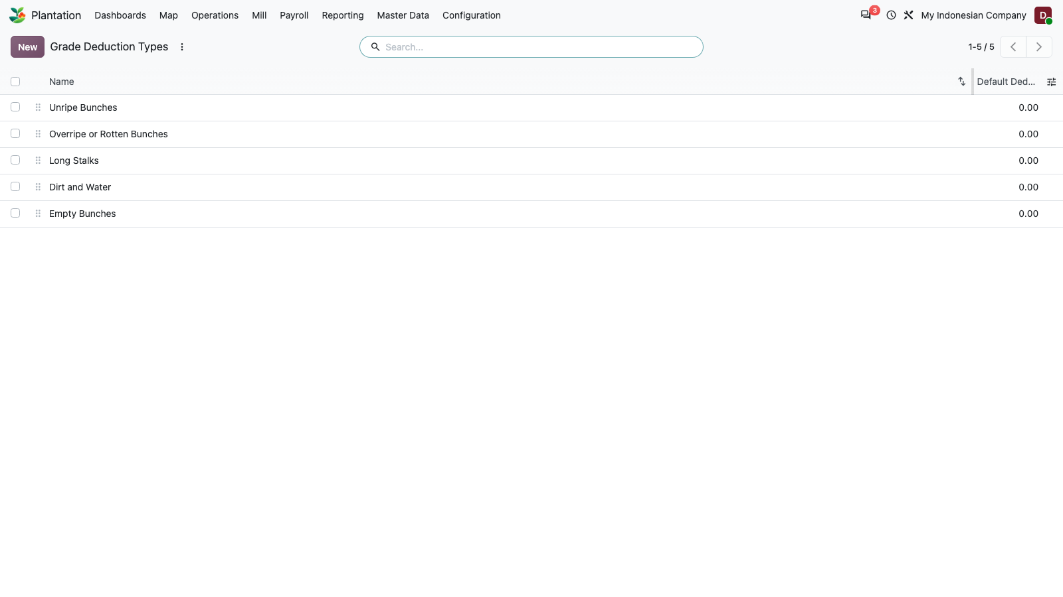
Figure 33: Config: Grade Deductions

34. Config: FFB Reference Prices
PASS
FFB reference price configuration.
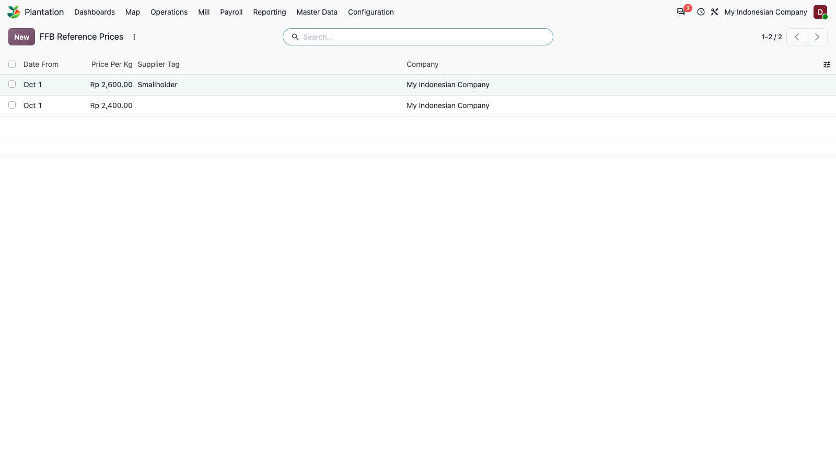
Figure 34: Config: FFB Reference Prices

35. Config: Settings
PASS
Plantation settings screen.
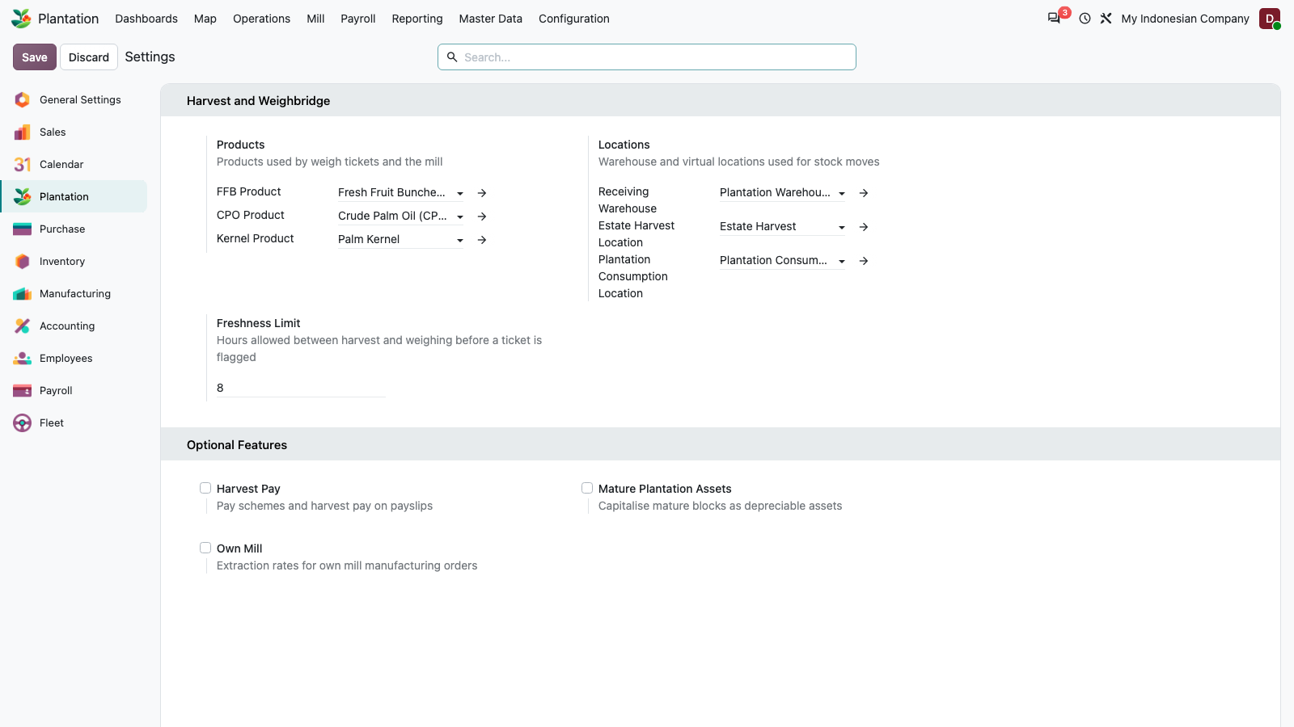
Figure 35: Config: Settings

36. Create estate via UI: fill form
PASS
Create flow: new estate, name and code typed into the form.
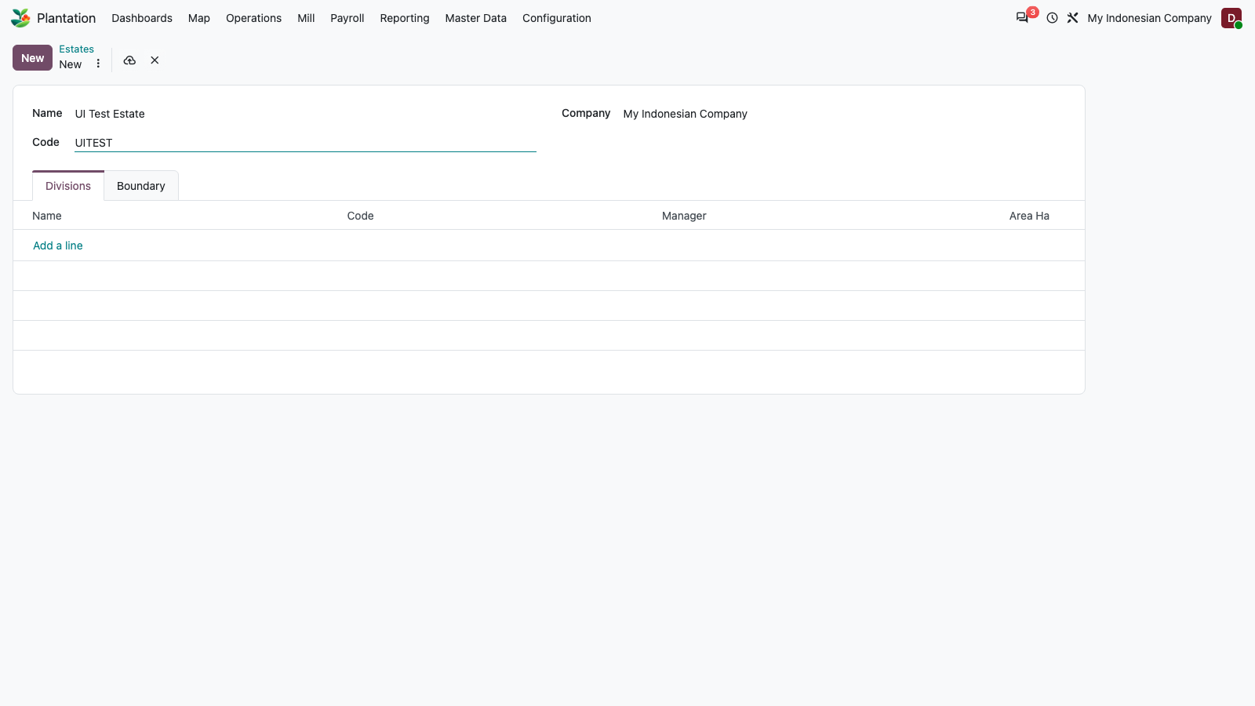
Figure 36: Create estate via UI: fill form

37. Create estate via UI: save
PASS
The estate saves and the form returns to a clean state.
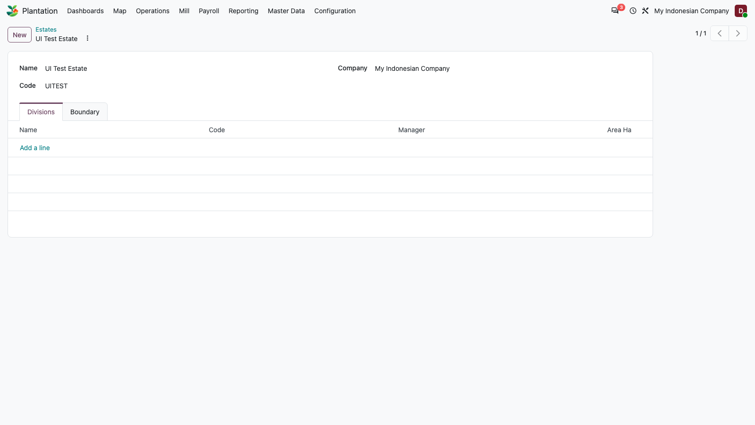
Figure 37: Create estate via UI: save

38. Create division under new estate via UI
PASS
A division is created under the new estate using the many2one dropdown.
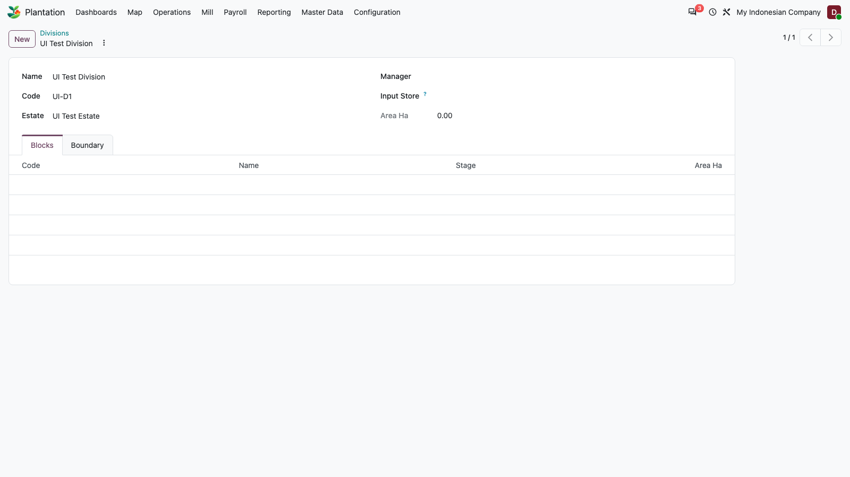
Figure 38: Create division under new estate via UI

39. Create block under new division via UI
PASS
A block of 12.5 ha is created under the new division. Area is mandatory; saving with no area is refused by a constraint.
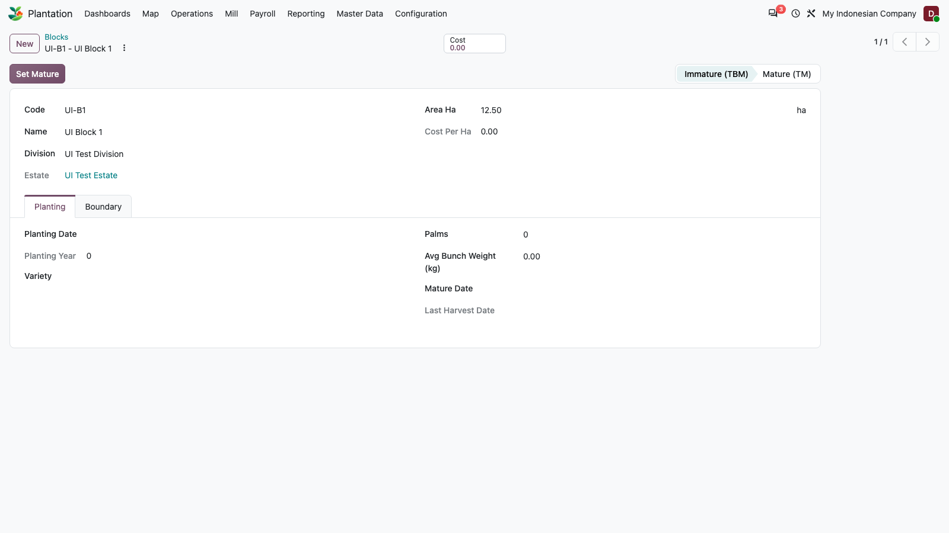
Figure 39: Create block under new division via UI

40. Click Set Mature button: block stage becomes Mature (TM)
PASS
Workflow button: Set Mature moves the block from Immature (TBM) to Mature (TM).
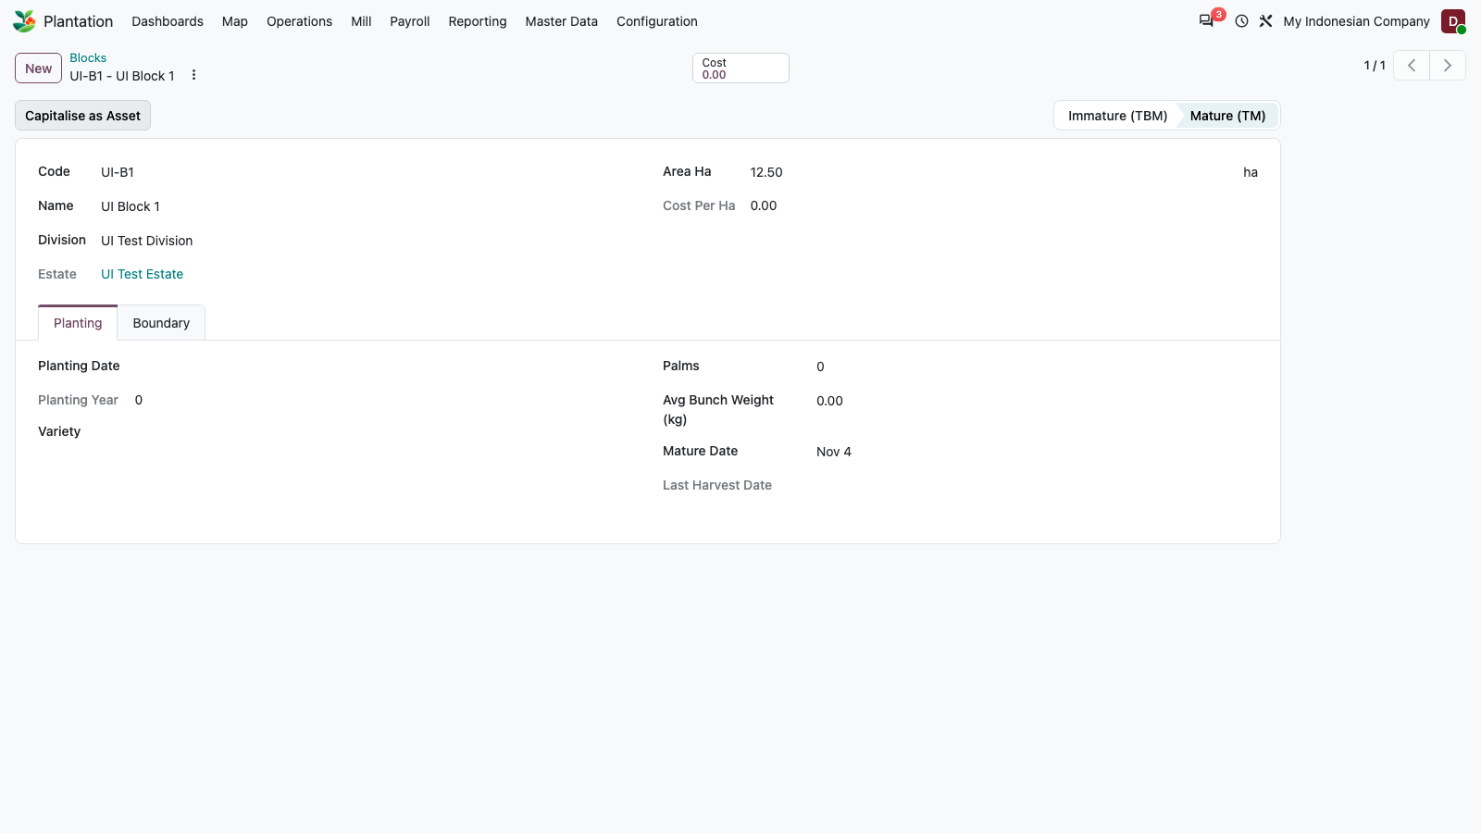
Figure 40: Click Set Mature button: block stage becomes Mature (TM)

