LAB-002 - Task-Only
Junos Core Skills | LAB-002 | Intermediate
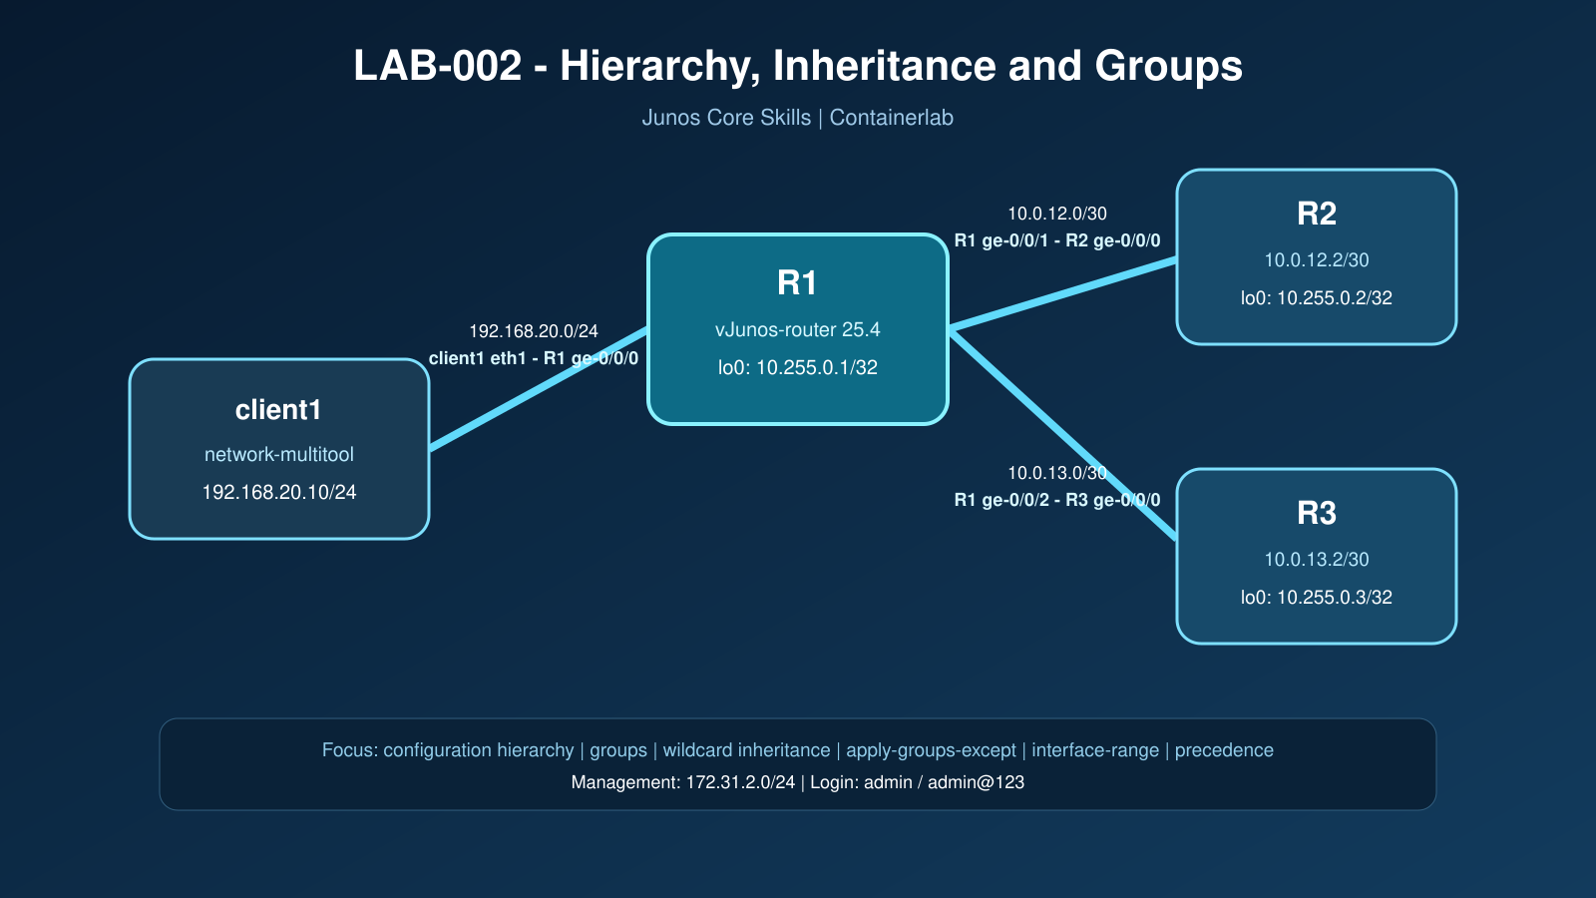

Assessment brief
You are standardizing configuration on three Junos PE/P routers. The baseline service is already operational. Your job is to reduce repeated configuration while preserving explicit exceptions and proving the effective configuration. Do not use redeployment to hide a failed change or recovery.
Item | Value
Phase | 1 - Junos Core Skills
Difficulty | Intermediate
Estimated time | 2 hours
Dependency | LAB-001
Mastery outcome | Build reusable groups, use `apply-groups-except`, build interface ranges, and inspect inherited configuration

Topology and addressing
Node | Interface | Address | Purpose
client1 | eth1 | 192.168.20.10/24 | Traffic and reachability test
R1 | ge-0/0/0 | 192.168.20.1/24 | Client LAN
R1 | ge-0/0/1 | 10.0.12.1/30 | R1-R2
R2 | ge-0/0/0 | 10.0.12.2/30 | R2-R1
R1 | ge-0/0/2 | 10.0.13.1/30 | R1-R3
R3 | ge-0/0/0 | 10.0.13.2/30 | R3-R1
R1/R2/R3 | lo0.0 | 10.255.0.1-3/32 | Router identity

Rules of engagement
- Capture pre-checks before each change.
- Use `show | compare`, `commit check`, and a meaningful commit comment.
- Prove effective configuration with inheritance display commands, not only the group definition.
- Run data-plane checks after every commit that can affect interfaces.
- Preserve evidence of precedence tests and the final cleanup.
- Do not open the solution guide until finished or blocked.

Task 1 - Deploy and prove the baseline
Deploy the topology from a clean state. Prove that all startup configurations were loaded, all intended interface addresses and static routes exist, and `scripts/verify.sh` returns `RESULT: PASS`.
Required evidence: deployment output, `show interfaces terse`, exact loopback routes, R1 exact static routes to R2/R3 loopbacks, and verification-script output.

Task 2 - Navigate the Junos hierarchy efficiently
On R1, demonstrate at least two safe methods to move between configuration hierarchy levels. Add a candidate-only system location, inspect it from the relevant hierarchy and from the top, then discard it without affecting active configuration.
Required evidence: hierarchy prompts, candidate diff, proof that active configuration did not change.

Task 3 - Build and apply a reusable system group
On all routers, create a group named `SP-BASE` that supplies:
- a login message containing `AUTHORIZED ACCESS ONLY`;
- NETCONF over SSH;
- the time zone `Asia/Jakarta`.
Apply the group globally. Avoid duplicating these statements as explicit active configuration. Prove both the group definition and the inherited effective configuration.
Required evidence: group definition, effective inherited configuration, comparison, validation, commit history.

Task 4 - Create a router-specific exception
R3 is a controlled exception and must not inherit `SP-BASE`. Use `apply-groups-except`; do not delete the group itself. Prove that R1 and R2 still inherit the group while R3 does not. Then restore inheritance on R3.
Required evidence: exclusion configuration, effective configuration on all three routers, rollback or corrective diff, final verification.

Task 5 - Use a wildcard interface group
On R1, create group `CORE-MTU` using a wildcard interface expression that targets only `ge-0/0/1` and `ge-0/0/2`. The group must supply an interface MTU of 2000. Apply it globally and prove:
- both core-facing interfaces inherit MTU 2000;
- the client-facing `ge-0/0/0` does not inherit it;
- existing addresses and reachability remain intact.
Required evidence: wildcard group definition, inherited views of all three interfaces, interface operational MTU, `RESULT: PASS`.

Task 6 - Apply an interface-level exception
Exclude `CORE-MTU` only from R1 `ge-0/0/2`, leaving `ge-0/0/1` inherited. Prove the difference in effective and operational configuration. Restore the standard after completing the observation.
Required evidence: before/after inheritance output, operational MTU, comparison, final restoration.

Task 7 - Compare explicit and interface-range configuration
On R1, create interface range `CORE-LINKS` containing `ge-0/0/1` and `ge-0/0/2`. Use the range to supply the common description `SP-CORE-MEMBER`.
The startup configuration already provides the explicit descriptions `R1-TO-R2` and `R1-TO-R3`. Do not assume that the range description will replace them. Determine which source wins, then temporarily remove the explicit description from `ge-0/0/1` and prove that the range description becomes effective. Restore the original description before completing the task.
Required evidence: interface-range definition, inheritance views before and after removing the explicit statement, operational descriptions, your precedence conclusion, final clean configuration.

Task 8 - Prove precedence between overlapping interface ranges
On R1, create two interface ranges named `HOLD-A` and `HOLD-B`. Make `ge-0/0/1` a member of both ranges. Configure `hold-time up 1000` under `HOLD-A` and `hold-time up 2000` under `HOLD-B`.
Before validation, predict whether Junos will reject the overlap or resolve it through inheritance priority. Run `commit check`, commit the configuration, and prove the effective value. Then place `HOLD-B` before `HOLD-A` in configuration order and prove whether the effective value changes. Remove both test ranges when finished.
Do not modify MTU in this task; MTU remains owned by the `CORE-MTU` group from Task 5.
Required evidence: initial range order, successful validation, inheritance output for both orders, your precedence conclusion, cleanup diff, final MTU inheritance, and `RESULT: PASS`.

Completion gate
LAB-002 is complete only when:
- startup configuration loading is proven;
- reusable groups and exceptions work as intended;
- inherited values are distinguished from explicitly configured values;
- explicit member-interface precedence over interface-range expansion is demonstrated;
- baseline forwarding remains healthy;
- overlapping interface-range priority is demonstrated and the test configuration is removed;
- all commits have useful comments and the final `verify.sh` result is PASS.

