JNCIE-SP MODULAR LAB
SYS-101
Initial System Settings
Task-Only Assessment
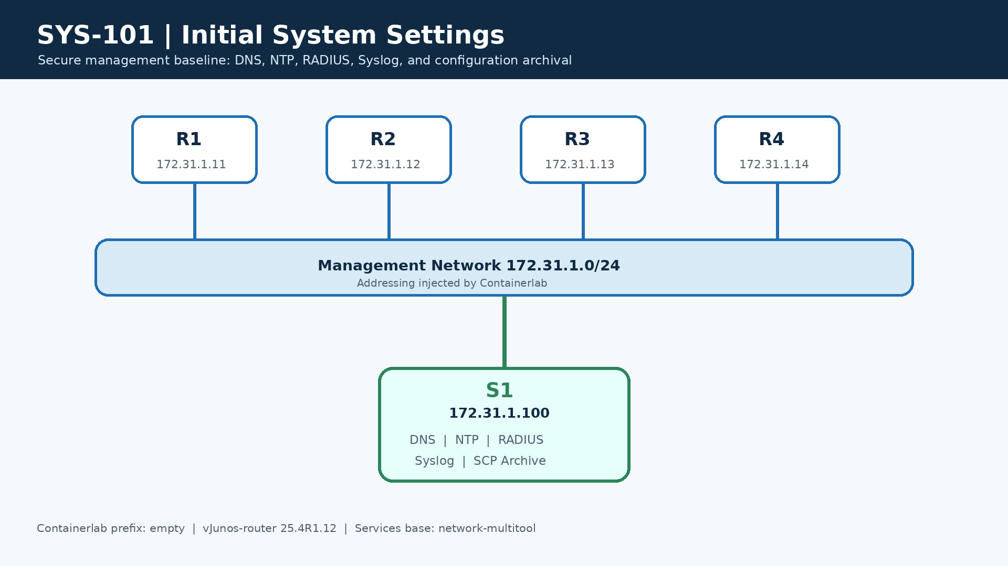
PLATFORM  vJunos-router 25.4 | DURATION  3 hours | TARGET  2 repetitions

Task-Only Assessment — Revision 3
Platform: Containerlab with four vJunos-router nodes and one services node
Time limit: 3 hours
Target repetitions: 2

Rules
- Do not open the solution guide before completing the first attempt.
- Preserve management access throughout the exercise.
- Use commit confirmed before AAA-sensitive changes.
- Record the requested evidence under evidence/.
- Do not reuse the lab credentials outside this isolated environment.

Addressing
Node | Containerlab management IP | Loopback | Required hostname | Role
R1 | 172.31.1.11/24 | 192.0.2.11/32 | R1 | Junos router
R2 | 172.31.1.12/24 | 192.0.2.12/32 | R2 | Junos router
R3 | 172.31.1.13/24 | 192.0.2.13/32 | R3 | Junos router
R4 | 172.31.1.14/24 | 192.0.2.14/32 | R4 | Junos router
S1 | 172.31.1.100/24 | — | S1 | DNS, NTP, RADIUS, Syslog and SCP archive
> Containerlab/vrnetlab injects management addressing, management-instance,
> mgmt_junos, and its default route. Do not configure them in startup files.
> The vJunos management interface visible inside each VM is fxp0.0 at
> 10.0.0.15/24, with management next hop 10.0.0.2.

Task 1 - Validate baseline and identity
Objective
Confirm startup configuration loading, injected management connectivity, S1
reachability, and production identity.

Requirements
- Deploy all five nodes and verify that they are operational.
- Confirm Containerlab management addresses and the injected fxp0.0 configuration.
- Change bootstrap hostnames to R1, R2, R3, and R4.
- Save deployment and management-interface evidence.

Task 2 - Central and local Syslog
Objective
Create troubleshooting evidence before implementing the remaining tasks.

Requirements
- jncie-sp-messages must record information and interactive commands.
- user-commands must record interactive commands.
- S1 must receive notice messages and configuration changes through mgmt_junos.
- User ops must receive warning messages when that user is logged in.
- Archive three local files with a size of 100 KB each.

Task 3 - Management services and retained route
Objective
Enable required management protocols and preserve a remote management route if
RPD is unavailable.

Requirements
- Enable SSH, Telnet, and FTP.
- Install 10.10.10.0/24 through 10.0.0.2 in mgmt_junos.
- Retain the route if RPD stops.
- Prevent the route from being advertised by dynamic routing protocols.

Task 4 - DNS and time zone
Objective
Provide consistent name resolution and administrative time display.

Requirements
- Use S1 as the DNS server through mgmt_junos.
- Use domain sys101.lab.
- Set Europe/Amsterdam as the time zone.
- Resolve and reach s1.sys101.lab through mgmt_junos.

Task 5 - Authenticated NTP
Objective
Synchronize every router with S1 using authenticated NTP.

Requirements
- Configure the node-specific loopback address shown in the addressing table.
- Use S1 as the operational NTP server through mgmt_junos.
- Use MD5 key ID 1 and key value workbook.
- Trust key ID 1 and associate it with S1.
- Demonstrate an authenticated, reachable NTP association and synchronized status.

Task 6 - Configuration archival over SCP
Objective
Archive configuration automatically after every commit.

Requirements
- Use S1 SCP with lab / lab123 through mgmt_junos.
- Store files in /srv/ftp/archive on S1.
- Configure transfer on commit.
- Trigger at least one post-configuration archive.
- Demonstrate a non-empty archived configuration on S1.

Task 7 - Authorization classes and RADIUS mappings
Objective
Map RADIUS identities to distinct Junos authorization profiles.

Requirements
- ops-class must have clear, network, reset, trace, and view permissions.
- noc-class must have all permissions but deny clear, configure, edit, and start-shell commands.
- Create local passwordless templates radius-ops and radius-noc for the two classes.
- Create local passwordless template remote with read-only authorization.
- Map RADIUS users ops and noc to their corresponding local templates with Juniper-Local-User-Name.
- Demonstrate permitted and denied actions for each constrained role and read-only authorization for an unmapped RADIUS user.

Task 8 - RADIUS authentication with local fallback
Objective
Use centralized authentication first while maintaining local recovery access.

Requirements
- Authentication order must be RADIUS followed by local password.
- Use S1 through mgmt_junos with shared secret workbook.
- Set retry to 1 and timeout to 2 seconds.
- Preserve local break-glass user lab / lab123.
- Prove RADIUS authentication while S1 is available.
- Prove local fallback while S1 RADIUS is unavailable without causing administrative lockout.

Final acceptance
Run:
bash scripts/verify.sh
The last line must be RESULT: PASS. Preserve all evidence and record the
attempt in the JNCIE-SP progress tracker.

