Table of Contents
OSPF 1
Lab 001 Single Domain 1
Lab 002 Stubbiness 2
Lab 003 Redistribution 4
Lab 004 Multiple Domains 6
Lab 005 Multi Domain 7
Lab 006 Virtual Link 8

OSPF
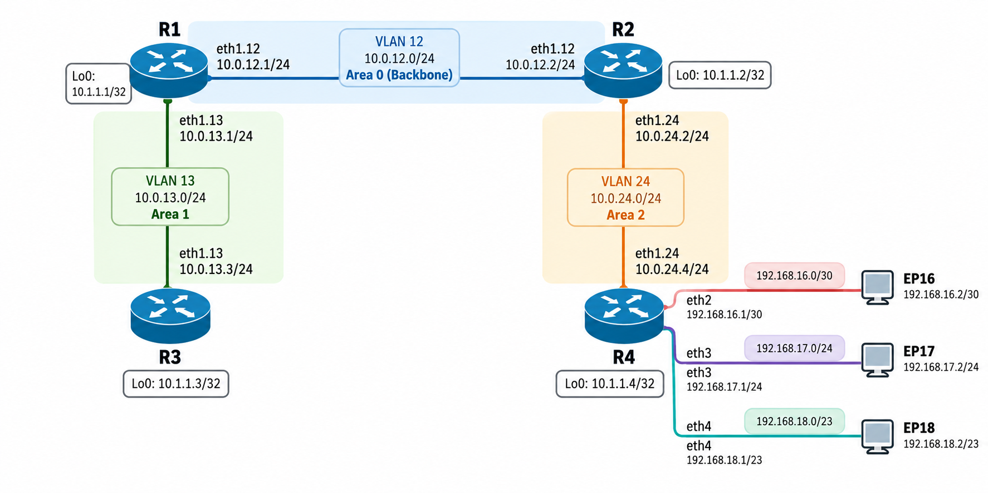
Figure 1 : baseline vlan topology

Lab 001 Single Domain

Load Config
N/A

Task 1
- Configure a unique, stable router ID on R1 and R2 using their loopback IPs.
- Enable OSPF Area 0 on the R1-R2 link.
- Set R1's priority on the Area 0 Ethernet link to 255 and R2's priority to 100, then commit the configuration.
- Keep both loopbacks advertised in Area 0 but prevent OSPF adjacency attempts on loopback interfaces by configuring them as passive.
- Verify the neighbor state, router IDs, interface, and DR/BDR roles.

Task 2
- Configure the router IDs on R3 and R4.
- Add R1-R3 to Area 1 and R2-R4 to Area 2.
- Force these router-to-router links to OSPF point-to-point network type.
- Configure the loopback on R3 as passive in Area 1 and the loopback on R4 as passive in Area 2.
- Configure the three R4 interfaces facing ep16, ep17, and ep18 as passive OSPF interfaces in Area 2. Do not create OSPF adjacencies with the hosts.
- Verify the neighbors and the OSPF interface types on all routers.

Task 3
- Before applying summarization, record how R1 and R3 learn these routes:
192.168.16.0/30
192.168.17.0/24
192.168.18.0/23
- On R2, configure an Area 2 summarization that covers those three prefixes using 192.168.16.0/21.
- Verify the summary route in R1's routing table and Area 0 LSDB.
- Verify the effect in R3's routing table as well.
- Confirm that the three more-specific routes are no longer individually advertised from Area 2 into Area 0, while the summary route is present.
- Verify traffic/reachability to all three endpoint networks after the change.

Lab 002 Stubbiness

Load Config
# r1,r2,r3,r4
conf
load replace /lab-configs/ospf.multiarea.conf
commit

Task 1
- On R4, configure static routes 192.168.29.0/24 and 192.168.30.0/24 via 192.168.16.2.
- Create a policy matching protocol static and apply it under protocols ospf export.
- Verify adjacencies, route tables, OSPF route path types, and LSDBs.

Task 2
- Configure Area 1 as stub on both R1 and R3.
- On the ABR R1, configure a default metric of 5 for the stub area.
- Do not configure no-summaries yet.
- Verify neighbor adjacency, area type, route table, and Area 1 LSDB.
Acceptance criteria:
- R1 and R3 remain Full neighbors.
- R3 no longer learns R4's Type-5 external routes 192.168.29.0/24 and
- 192.168.30.0/24 into Area 1.
- R3 can still learn inter-area Type-3 summary routes from the rest of OSPF.
- R3 has a default route originated by R1 with the configured metric behavior.

TASK 3
- Keep Area 1 configured as stub on R1 and R3.
- Add no-summaries on R1 only (the ABR). Leave default-metric 5 in place.
- Inspect R3's OSPF route table and Area 1 LSDB before and after the change.
Acceptance criteria:
- The R1-R3 adjacency remains Full.
- R3 keeps its own area routes, but the only route learned from other areas should be the default route 0.0.0.0/0.
- Area 1 should not receive the regular Type-3 inter-area summaries or Type-5 external LSAs. The default route is advertised as a Type-3 Summary LSA.

TASK 4
- Remove the stub configuration from R1 and R3, then configure both routers for NSSA on Area 1. An area cannot be both stub and NSSA.
- On R1, configure an NSSA default route with metric 1 and explicitly allow summary LSAs into Area 1.
- On R3, add static discard routes 192.168.71.0/24 and 192.168.72.0/24.
- Create an export policy matching protocol static and apply it under OSPF.
- Verify that R3 originates Type-7 NSSA LSAs for its two test routes, and that R1 translates those into Type-5 external LSAs for the rest of OSPF.
- Verify that Area 1 does not receive Type-5 routes originated outside the NSSA (for example R4's 192.168.29.0/24 and 192.168.30.0/24).
Acceptance criteria:
- R1-R3 remain Full neighbors in Area 1.
- R3's Area 1 LSDB includes Type-7/NSSA LSAs for 192.168.71.0/24 and 192.168.72.0/24.
- R1's external LSDB includes translated Type-5 routes for both prefixes.
- External routes originally advertised by R4 are not installed at R3 as Type-5 routes from outside Area 1.
- Inter-area summaries remain available in Area 1 while summaries are enabled.

TASK 5
- On R1 only, stop advertising inter-area summaries into Area 1 by replacing nssa summaries with nssa no-summaries.
- Configure the NSSA default-lsa type-7 option along with the default metric.
- Verify that R3 retains its own Type-7 external routes but receives only the default route from outside Area 1.
- Verify that R1 still translates R3's Type-7 external LSAs to Type-5 LSAs.
Acceptance criteria:
- R3's learned inter-area routes are suppressed except for the default.
- R3's locally originated Type-7 routes remain visible in Area 1.
- The translated Type-5 routes remain visible from R1 and other non-stub areas.

Lab 003 Redistribution

Load Config
# r1,r2,r3,r4
conf
load replace /lab-configs/ospf.multiarea.conf
commit

Task 1
- On R4, create static routes for 192.168.29.0/24 and 192.168.30.0/24 using next-hop 192.168.16.2. Verify both static routes are active in inet.0.
- Add a decoy active static route 198.51.100.0/24 with discard next-hop, but do not add it to the export policy.
- Create an OSPF export policy that matches protocol static AND matches only the exact prefixes-list 192.168.29.0/24 and 192.168.30.0/24.
- Apply that policy under protocols ospf export and commit.
- Verify the two target routes are advertised as Type-5 external LSAs.
- Verify that 198.51.100.0/24 is present as a local static route on R4 but is not present in the OSPF external LSDB on R1, R2, R3, or R4.
- Inspect the OSPF route path type and explain why an external route is not classified as intra-area or inter-area.
Acceptance criteria:
- R4 has active static routes 192.168.29.0/24 and 192.168.30.0/24.
- The two selected routes are visible in show ospf database external.
- Remote routers learn them as OSPF external routes.
- The decoy 198.51.100.0/24 does not appear in the OSPF LSDB.

TASK 2
- On both R1 and R2, configure a static 0.0.0.0/0 discard route. This is a control-plane simulation because the physical topology has no ISP-facing link.
- On each router, create an OSPF export policy matching protocol static and the exact route-filter 0.0.0.0/0 exact. Do not export every static route.
- Set a clear external metric and Type-2 external metric type, then accept the route. Apply the policy to OSPF and commit on R1 and R2.
- Inspect show ospf database external on all routers. Identify both default Type-5 LSAs by link-state ID and advertising router ID.
- On R3 and R4, inspect show ospf route and show route protocol ospf. Explain how two LSAs can exist for 0.0.0.0/0 while a router installs one active route or chooses one best path.
- As a withdrawal experiment, deactivate the default static route on R1 and commit. Confirm that R1's default LSA is withdrawn while R2's remains. Then reactivate R1's static route and confirm that its LSA returns.
Acceptance criteria:
- R1 and R2 each have an active static default route.
- Both default routes appear as Type-5 LSAs with distinct advertising routers.
- Other areas receive the default LSAs while Area 1 and Area 2 remain normal.
- With R1's route deactivated, R2's default LSA remains available in the LSDB.

TASK 4
- On R3, create discard static routes 192.168.71.0/24 and 192.168.72.0/24.
- Create a narrow OSPF export policy on R3 matching protocol static and those exact prefixes, then apply it to OSPF.
- Verify Type-5 LSAs originated by R3 in the external LSDB and inspect their path types from R1, R2, and R4.
- Explain the limitation: these routes are static, not RIP-learned. A real RIP-to-OSPF exercise requires a RIP peer/routing process and is outside this four-router fixed-topology lab.

TASK 5
- Modify R4's export policy so 192.168.29.0/24 is advertised as external Type 1 with metric 20, while 192.168.30.0/24 is advertised as external Type 2 with metric 20. Keep the exact-prefix filters in both terms.
- Verify the external route type and metric using show ospf route and the LSDB.
- Explain the difference between E1 (external metric plus internal OSPF cost) and E2 (external metric is the primary comparison).
- Restore Type 2 on both routes before finishing if you want the base solution.

Lab 004 Multiple Domains
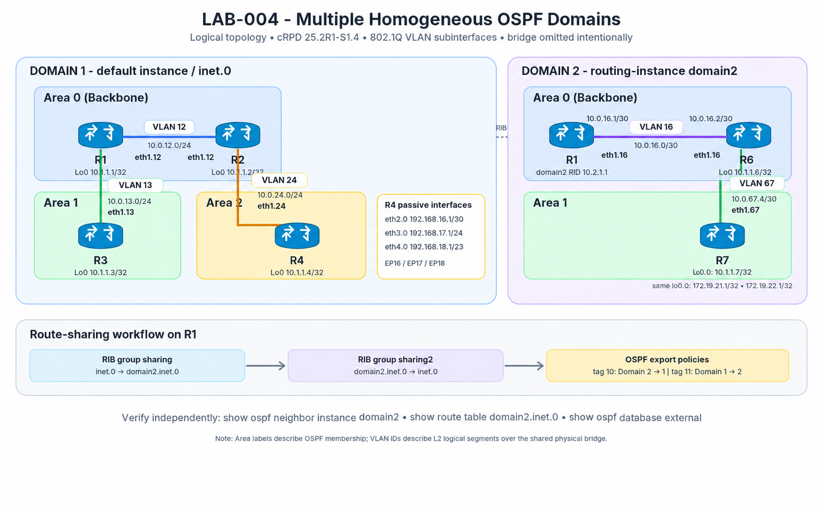
Figure 2 : Multiple OSPF Domain

Load Config
# r1,r2,r3,r4
conf
load replace /lab-configs/ospf.multiarea.conf
commit

Task 1
- On R1, create routing-instance domain2 with instance-type virtual-router.
- Assign R1's eth1.16 to domain2. Configure the instance router ID 10.2.1.1.
- Configure OSPF Area 0 on domain2 interface eth1.16.
- On R6, set router ID 10.1.1.6. Configure Area 0 on eth1.16 and advertise lo0.0 passively in Area 0.
- On R6 and R7, configure Area 1 on eth1.67. Set R7 router ID 10.1.1.7 and advertise R7's lo0.0 passively in Area 1. The three /32 addresses (10.1.1.7, 172.19.21.1, and 172.19.22.1) all reside on this single unit.
- Keep the default broadcast network type on VLAN 16 and VLAN 67 for this chapter exercise. Verify adjacency in both domains.
Acceptance criteria:
- At R1, show ospf neighbor instance domain2 shows R6 Full.
- At R6, show ospf neighbor shows R1 and R7 Full (under the relevant areas).
- At R7, R6 is Full.
- R1 shows distinct route tables inet.0 and domain2.inet.0.
# r1 shell
ip route show table all
ip rule show
ip -d link show type vrf
ip vrf show

ping -I __crpd-vrf1 -c 3 10.0.16.2

TASK 2
- On R1, Create RIB group sharing with import-rib [ inet.0 domain2.inet.0 ].
- Create RIB group sharing2 with import-rib [ domain2.inet.0 inet.0 ].
- Apply sharing under the main protocols ospf hierarchy.
- Apply sharing2 under routing-instances domain2 protocols ospf.
- Commit and inspect both RIBs again. Check which OSPF routes are now copied into the other table before enabling cross-domain external LSA export.

TASK 3
On R1 create the two policies :
- from_domain1 matches protocol ospf, sets external tag 11, then accepts.
- from_domain2 matches instance domain2, sets external tag 10, then accepts.
- Apply from_domain2 under the default protocols ospf export statement.
- Apply from_domain1 under routing-instances domain2 protocols ospf export.
- Commit. Verify OSPF route tables and external LSAs on R1, R2, R6 and R7.

Lab 005 Multi Domain

Load Config
# crpd
conf

load replace /lab-configs/ospf.multidomain.conf

Start from Task 4 BUILD OSPF IN AS 65002

Lab 006 Virtual Link

Load Config
# r1,r2,r3,r4
conf
load replace /lab-configs/ospf.multiarea.conf
commit

TASK 1
- Configure router IDs on R4 and R10 using 10.1.1.4 and 10.1.1.10.
- Put R4 eth1.410 and R10 eth1.410 in Area 2, both point-to-point. Area 2 must be a normal transit area, not a stub area.
- Put R10 lo0.0, eth2.0, and eth3.0 passively in Area 3. The latter two interfaces advertise 192.168.76.0/24 and 192.168.77.0/24.
- Verify all physical OSPF adjacencies and inspect OSPF databases on R2 and R10.
ACCEPTANCE CRITERIA
- R2-R4 and R4-R10 reach Full on Area 2.
- R10 advertises 192.168.76.0/24 and 192.168.77.0/24 in Area 3.
- R4 is the transit router between R2 and R10 inside Area 2.
- No virtual-link interface is present yet; all configured adjacencies are physical.
- On R1 and R2, verify that the Area 3 prefixes are not installed as OSPF routes.

TASK 2
- On R2, configure a virtual link under Area 0 with neighbor ID 10.1.1.10 and transit area 0.0.0.2.
- On R10, configure the reciprocal virtual link under Area 0 with neighbor ID 10.1.1.2 and transit area 0.0.0.2.
- Run `commit check`, then `commit`, on both routers.
- Verify the virtual-link neighbor reaches Full. Inspect the virtual interface detail to confirm the transit area.
ACCEPTANCE CRITERIA
- Both virtual-link endpoint configurations use Area 2 (0.0.0.2) as transit area.
- R2 identifies R10 by router ID 10.1.1.10; R10 identifies R2 by 10.1.1.2.
- A virtual OSPF interface is shown on both routers and its neighbor state is Full.
- The physical Area 0, Area 1, and Area 2 adjacencies remain Full.

TASK 3
- On R2, inspect show route 192.168.76.0/24 exact and show route 192.168.77.0/24 exact.
- Repeat the route checks on R1 and R3. Identify the route path type using `show ospf route` or `show ospf route inter` where supported.
- Inspect the Area 0 LSDB and the R10 Router LSA detail from R2. Identify the virtual link entry and verify that Area 3 prefixes are now visible in OSPF.
- Compare the results with TASK 3 and explain what changed after virtual-link establishment.

ACCEPTANCE CRITERIA
- R2 and R1 learn 192.168.76.0/24 and 192.168.77.0/24 through OSPF after the virtual link is Full; R3 also learns the prefixes through the multi-area domain.
- The routes are not external Type-5 LSAs; they are internal/inter-area routes.
- OSPF interface detail identifies a virtual interface with transit Area 2.
- The R10 Router LSA / Area 0 database shows the virtual-link relationship.

Lab 007 OSPF Interface Type

Load Config
# r1,r2,r3
conf
load replace /lab-configs/ospf.multiarea.conf
commit

