LAB-001
Safe Junos Configuration Workflow
SOLUTION GUIDE — EDITABLE WORD VERSION
Candidate configuration • Commit validation • Confirmed commit • Rollback • Rescue configuration • Concurrent sessions
Important Use this guide after attempting the task-only document or when genuinely blocked. The baseline includes the corrected R1 route to the R2 loopback.

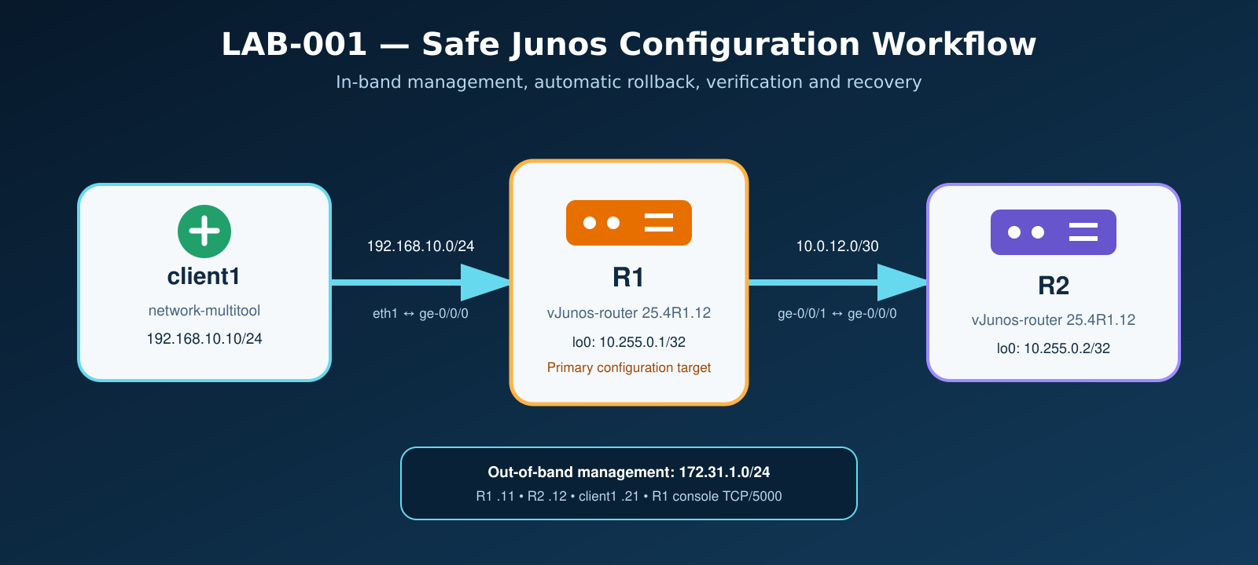

Lab reference
Item | Value
R1–R2 transit | 10.0.12.0/30 — R1 .1, R2 .2
R1 loopback | 10.255.0.1/32
R2 loopback | 10.255.0.2/32
Client LAN | 192.168.10.0/24 — R1 .1
Login | admin / admin@123

Operating method
- Read the task requirement before opening the configuration steps.
- Capture pre-check evidence before making a change.
- Use show | compare and commit check before activation.
- Verify the service, not only the configuration database.
- Use commit comments and preserve rollback evidence.

Task 0 — Baseline and corrected reachability
Objective Deploy the topology, confirm that the startup configuration is active, and establish a known-good data-plane baseline.

Task requirements
- Deploy all nodes with a clean state.
- Confirm R1, R2, and client1 are running.
- Verify client reachability to both transit and loopback addresses.
- Correct and persist the route to R2 loopback if using the earlier LAB-001 package.

Step-by-step guide
- Destroy the previous lab state and deploy the topology again.
containerlab destroy -t lab001.clab.yml --cleanup
containerlab deploy -t lab001.clab.yml
docker logs -f r1

- Wait for Junos startup, then run the baseline verification.
chmod +x scripts/verify.sh
./scripts/verify.sh

- If R2 loopback fails, add the missing route on R1.
configure
set routing-options static route 10.255.0.2/32 next-hop 10.0.12.2
commit check
commit comment "LAB-001: add route to R2 loopback"

- Make the fix persistent in configs/r1.conf.
routing-options {
static {
route 10.255.0.2/32 next-hop 10.0.12.2;
}
}

Verification
show route 10.255.0.2 exact
ping 10.255.0.2 source 10.255.0.1 count 5

Expected result R1 installs 10.255.0.2/32 as Static/5 through 10.0.12.2 via ge-0/0/1.0, and verify.sh reports PASS.

Task 1 — Candidate versus active configuration
Objective Distinguish uncommitted candidate changes from the active committed configuration.

Task requirements
- Create uncommitted system-location and interface-description changes.
- Compare candidate and active views.
- Discard the candidate safely without changing the active configuration.

Step-by-step guide
configure
set system location building JNCIE-LAB
set system location floor LAB-001
set interfaces ge-0/0/1 description SP-CORE-LINK
show | compare
run show configuration system location
run show configuration interfaces ge-0/0/1
rollback 0
show | compare

Explanation show in configuration mode reads the candidate. run show configuration reads the committed configuration. rollback 0 reloads active configuration into the candidate and discards uncommitted changes.

Task 2 — Validation failure and commit check
Objective Observe a deliberate validation failure, correct it, and separate syntax validation from operational verification.

Task requirements
- Reference an undefined prefix list and observe commit check failure.
- Create the missing object and pass validation.
- Commit with an audit-friendly comment.

Step-by-step guide
configure
set policy-options policy-statement LAB001-TEST term 10 from prefix-list LAB001-PREFIXES
set policy-options policy-statement LAB001-TEST term 10 then accept
commit check

Expected failure The policy references LAB001-PREFIXES before that object exists. Record the validation error.

set policy-options prefix-list LAB001-PREFIXES 192.0.2.0/24
commit check
show | compare
commit comment "LAB-001: create isolated policy validation example"
run show system commit

Key point A successful commit check proves configuration validation only. It does not prove that forwarding or a network service works.

Task 3 — Automatic rollback with commit confirmed
Objective Activate a temporary change, allow one automatic rollback, and permanently confirm a second verified attempt.

Task requirements
- Perform one confirmed commit without confirmation and observe rollback.
- Repeat the change and confirm it before the timer expires.

Attempt 1 — allow rollback
configure
set system location rack RACK-01
show | compare
commit check
commit confirmed 3
run show system commit
run show configuration system location

After the timeout
run show configuration system location
run show system commit

Attempt 2 — verify and confirm
set system location rack RACK-01
commit confirmed 3 comment "LAB-001: temporary rack change"
run show configuration system location
commit comment "LAB-001: confirm verified rack change"

Expected result The first change is automatically reverted. The second remains active because an ordinary commit confirms it before the deadline.

Task 4 — Management-loss simulation
Objective Use commit confirmed to recover automatically from a change that breaks client-side reachability.

Task requirements
- Record pre-change evidence.
- Move R1's client-facing address to the wrong subnet.
- Observe loss of reachability and automatic recovery from the console.

Pre-check
show system users
show interfaces ge-0/0/0 terse
show route 192.168.10.0/24 exact
show system commit

Apply the risky change
configure
delete interfaces ge-0/0/0 unit 0 family inet address 192.168.10.1/24
set interfaces ge-0/0/0 unit 0 family inet address 192.168.99.1/24
show | compare
commit check
commit confirmed 2 comment "LAB-001: management-loss recovery test"

Observe and verify recovery
show system commit
show interfaces ge-0/0/0 terse
# After timeout:
show configuration interfaces ge-0/0/0

Expected result 192.168.10.1/24 returns automatically and scripts/verify.sh passes again. An ordinary commit would require console access and manual rollback.

Task 5 — Manual rollback
Objective Create several committed revisions, inspect rollback history, and restore an earlier revision deliberately.

Task requirements
- Create three rack revisions with unique comments.
- Load rollback 1 and inspect the candidate diff before committing.
- Load rollback 2 for inspection, then return the candidate to active state.

Step-by-step guide
configure
set system location rack RACK-01
commit comment "LAB-001: rack revision 1"
set system location rack RACK-02
commit comment "LAB-001: rack revision 2"
set system location rack RACK-03
commit comment "LAB-001: rack revision 3"
run show system commit
rollback 1
show | compare
commit check
commit comment "LAB-001: restore preceding rack revision"
rollback 2
show | compare
rollback 0
show | compare

Key point Loading a rollback changes only the candidate. It becomes active only after commit. rollback 0 represents the current active committed configuration.

Task 6 — Rescue configuration
Objective Save a known-good checkpoint and restore it after an intentional bad change.

Task requirements
- Save the current configuration as rescue.
- Commit an intentional bad rack value.
- Load rescue, inspect the diff, validate, and commit the restoration.

Save the rescue configuration
request system configuration rescue save
show system configuration rescue

Create and restore an intentional bad value
configure
set system location rack WRONG-RACK
commit comment "LAB-001: intentional rescue test"
rollback rescue
show | compare
commit check
commit comment "LAB-001: restore known-good rescue configuration"

Caution A stale rescue configuration can remove legitimate changes made after it was saved. Always inspect show | compare before committing a rescue restoration.

Task 7 — Concurrent configuration sessions
Objective Compare shared, exclusive, and private configuration modes, including lock and merge behavior.

Task requirements
- Demonstrate shared-candidate visibility between two sessions.
- Acquire and release an exclusive lock.
- Commit non-overlapping private changes, then test an overlapping change.

Shared candidate
# Session A
configure
set system location building SHARED-A
show | compare
# Session B
configure
show | compare
# Cleanup
rollback 0
exit

Expected behavior Session B sees session A's uncommitted change because both use the shared candidate.

Exclusive candidate
# Session A
configure exclusive
# Session B
configure
# Session A
run show system users
exit

Expected behavior Session B receives a configuration lock error until session A exits exclusive mode.

Private candidates
# Session A
configure private
set system location building PRIVATE-A
show | compare
commit comment "LAB-001: private session A"
# Session B
configure private
set system location floor PRIVATE-B
show | compare
commit check
commit comment "LAB-001: private session B"

Conflict test Repeat with both sessions changing system location rack. Commit session A first, then inspect show | compare and commit check in session B. Record whether Junos merges or rejects the overlapping change.

Final assessment workflow
Execute this without relying on the preceding steps. The goal is to demonstrate a production-style change workflow end to end.
show interfaces ge-0/0/1 extensive
show route 10.0.12.0/30 exact
ping 10.0.12.2 rapid count 5
configure exclusive
set interfaces ge-0/0/1 description PROD-CORE-R1-R2
show | compare
commit check
commit confirmed 3 comment "LAB-001: change R1-R2 link description"
run show interfaces ge-0/0/1 descriptions
run ping 10.0.12.2 rapid count 5
commit comment "LAB-001: confirm verified R1-R2 description"
run show system commit

Mastery checklist
- ☐ Candidate versus active configuration
- ☐ commit check versus operational verification
- ☐ Confirmed commit activation and confirmation
- ☐ Automatic rollback after management loss
- ☐ rollback 0 and previous revisions
- ☐ Rescue configuration lifecycle
- ☐ Shared, exclusive, and private edit sessions
- ☐ Audit comments, evidence collection, and post-checks

