This post was republished to http://[::1]/usbn/ at 15:33:47 26/11/2018
Bahasa Inggris

Account http://[::1]/usbn/

 | XXJEBQUC1D
1 | KOMODO DRAGON  The Komodo Dragon is the world’s biggest lizard. It is a reptile, a cold-blooded animal. It is diurnal, most active during the day. The Komodo Dragon is a fast runner; it can run up to 11 mph (18 kph). It is also a good tree climber and swimmer.  The Komodo Dragon’s scientific name is Varanus komodoensis. It is in danger of extinction because of habitat lost. Its life span is about 20 years.  Komodo Dragons live on islands in Indonesia, including the island of Komodo. They live in hot, humid, grassy lowlands and in rainforests.  The Komodo Dragon is about 9 feet (2.8 m) long, but can get up to 10 feet (3 m) long and weighs up to 300 pounds (135 kg). It has large jaws, four short legs, and fivetoed feet with sharp claws. The tail is longer than the body. It senses chemicals with a long, yellow, forked tongue.  What is the text about? |  | b | 2
 | A | Komodo dragon in detail
 | B | Komodo dragon in general
 | C | Komodo dragon is a giant lizard
 | D | Komodo dragon is a rare animal
 | E
2 | KOMODO DRAGON  The Komodo Dragon is the world’s biggest lizard. It is a reptile, a cold-blooded animal. It is diurnal, most active during the day. The Komodo Dragon is a fast runner; it can run up to 11 mph (18 kph). It is also a good tree climber and swimmer.  The Komodo Dragon’s scientific name is Varanus komodoensis. It is in danger of extinction because of habitat lost. Its life span is about 20 years.  Komodo Dragons live on islands in Indonesia, including the island of Komodo. They live in hot, humid, grassy lowlands and in rainforests.  The Komodo Dragon is about 9 feet (2.8 m) long, but can get up to 10 feet (3 m) long and weighs up to 300 pounds (135 kg). It has large jaws, four short legs, and fivetoed feet with sharp claws. The tail is longer than the body. It senses chemicals with a long, yellow, forked tongue.  Paragraph 2 tells us about … |  | b | 2
 | A | Komodo dragon has a scientific name
 | B | This animal is almost extinct
 | C | They can live for 20 years
 | D | Its life span
 | E
3 | KOMODO DRAGON  The Komodo Dragon is the world’s biggest lizard. It is a reptile, a cold-blooded animal. It is diurnal, most active during the day. The Komodo Dragon is a fast runner; it can run up to 11 mph (18 kph). It is also a good tree climber and swimmer.  The Komodo Dragon’s scientific name is Varanus komodoensis. It is in danger of extinction because of habitat lost. Its life span is about 20 years.  Komodo Dragons live on islands in Indonesia, including the island of Komodo. They live in hot, humid, grassy lowlands and in rainforests.  The Komodo Dragon is about 9 feet (2.8 m) long, but can get up to 10 feet (3 m) long and weighs up to 300 pounds (135 kg). It has large jaws, four short legs, and fivetoed feet with sharp claws. The tail is longer than the body. It senses chemicals with a long, yellow, forked tongue.  “It is diurnal, most active during the day.”  The antonym of the underlined word is… |  | a | 2
 | A | nocturnal
 | B | mammal
 | C | extinct
 | D | Varanus komodoensis
 | E
4 | KOMODO DRAGON  The Komodo Dragon is the world’s biggest lizard. It is a reptile, a cold-blooded animal. It is diurnal, most active during the day. The Komodo Dragon is a fast runner; it can run up to 11 mph (18 kph). It is also a good tree climber and swimmer.  The Komodo Dragon’s scientific name is Varanus komodoensis. It is in danger of extinction because of habitat lost. Its life span is about 20 years.  Komodo Dragons live on islands in Indonesia, including the island of Komodo. They live in hot, humid, grassy lowlands and in rainforests.  The Komodo Dragon is about 9 feet (2.8 m) long, but can get up to 10 feet (3 m) long and weighs up to 300 pounds (135 kg). It has large jaws, four short legs, and fivetoed feet with sharp claws. The tail is longer than the body. It senses chemicals with a long, yellow, forked tongue.  Komodo uses its … for sensing the chemical |  | d | 2
 | A | nose
 | B | skin
 | C | ears
 | D | tongue
 | E
5 | 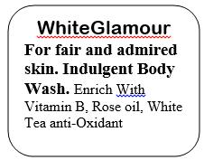  The text above is an advertisement of … |  | c | 2
 | A | hand and body lotion
 | B | moisturizer
 | C | body wash
 | D | hand soap
 | E
6 | Make into order “How to make Milkshake”.  a. Mix the blender for about two minutes.  b. Push the blender “on”  c. Plug the blender in.  d. Put 3 cups of milk and 6 tablespoons of ice cream into blender.  e. Unplug the blender.  f. Your ice is ready to serve.  g. Put the top of the blender |  | d | 2
 | A | b-c-d-g-a-f-e
 | B | b-d-c-g-a-f-e
 | C | c-b-d-g-a-f-e
 | D | c-d-g-b-a-e-f
 | E
7 | To make roast corn you will need:  Some ears of sweet corn, 5 or more table spoons of margarine, 2 cloves of garlic, a pinch of salt and you could add some chilies if you want them to taste hot.  First of all, you have to peel the corn skin. Then, you have to grind the garlic, salt, and chili (if desired). After that, you have to mix the margarine with the ground garlic mixture. Next, brush the corn with the margarine mixture and roast on a grill until a bit burned then brush the corn with the margarine mixture again and roast until cooked. Finally, Serve hot or warm.  How many ingredients are there stated in the text? |  | c | 2
 | A | 3
 | B | 4
 | C | 5
 | D | 6
 | E
8 |  |  | a | 2
  To make roast corn you will need:
  Some ears of sweet corn, 5 or more table spoons of margarine, 2 cloves of garlic, a pinch of salt and you could add some chilies if you want them to taste hot.
  First of all, you have to peel the corn skin. Then, you have to grind the garlic, salt, and chili (if desired). After that, you have to mix the margarine with the ground garlic mixture. Next, brush the corn with the margarine mixture and roast on a grill until a bit burned then brush the corn with the margarine mixture again and roast until cooked. Finally, Serve hot or warm.
  “Some ears of sweet corn, 5 or more table spoons of margarine, 2 cloves of garlic, a pinch of salt and you could add some chilies if you want them to taste hot.”
  The word “them” refers to..
 | A | corns
 | B | chilies
 | C | Garlic and salt
 | D | Margarine and salt
 | E
9 | To make roast corn you will need:  Some ears of sweet corn, 5 or more table spoons of margarine, 2 cloves of garlic, a pinch of salt and you could add some chilies if you want them to taste hot.  First of all, you have to peel the corn skin. Then, you have to grind the garlic, salt, and chili (if desired). After that, you have to mix the margarine with the ground garlic mixture. Next, brush the corn with the margarine mixture and roast on a grill until a bit burned then brush the corn with the margarine mixture again and roast until cooked. Finally, Serve hot or warm.  “Some ears of sweet corn, 5 or more table spoons of margarine, 2 cloves of garlic, a pinch of salt and you could add some chilies if you want them to taste hot.”  How many times should we brush the corn with the ground garlic mixture? |  | c | 2
 | A | never
 | B | once
 | C | twice
 | D | Three times
 | E
10 | To make roast corn you will need:  Some ears of sweet corn, 5 or more table spoons of margarine, 2 cloves of garlic, a pinch of salt and you could add some chilies if you want them to taste hot.  First of all, you have to peel the corn skin. Then, you have to grind the garlic, salt, and chili (if desired). After that, you have to mix the margarine with the ground garlic mixture. Next, brush the corn with the margarine mixture and roast on a grill until a bit burned then brush the corn with the margarine mixture again and roast until cooked. Finally, Serve hot or warm.  What should we do after grinding the seasons? |  | c | 2
 | A | Peel the corn skin
 | B | Brush the corn with the margarine mixture
 | C | Mix the margarine with the ground garlic mixture
 | D | Roast on a grill until a bit burned then brush the corn with the margarine mixture again and roast until cooked
 | E
11 | Nur : I’m not in a good mood today. My white shirt is stained. I think it’s better to use it for a cloth or something.  Nia : No! Don’t do that. Try my hints. First, put a paper towel under the stain. Then, spray the stain with hair spray. After that, rub the stain gently with a clean cloth. Continue rubbing until the stain is completely gone.  Nur : Are you sure?  Nia : Positive! I’ve already tried this tip several times and it works for me.  Nur : OK then, I’ll try it. Thanks so much, Nia.  The topic of dialog between Nur and Nia is …. |  | d | 2
 | A | My shirt is stained.
 | B | Towel is under stained
 | C | Nur is not in good mood
 | D | How to overcome the stained shirt.
 | E
12 | Nur : I’m not in a good mood today. My white shirt is stained. I think it’s better to use it for a cloth or something.  Nia : No! Don’t do that. Try my hints. First, put a paper towel under the stain. Then, spray the stain with hair spray. After that, rub the stain gently with a clean cloth. Continue rubbing until the stain is completely gone.  Nur : Are you sure?  Nia : Positive! I’ve already tried this tip several times and it works for me.  Nur : OK then, I’ll try it. Thanks so much, Nia.  The italic words express… |  | a | 2
 | A | Certainty
 | B | Repetition
 | C | Salutation
 | D | Obligation
 | E
13 | 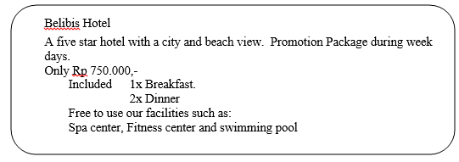  Based on the advertisement above, the correct statement is ... |  | a | 2
 | A | The fare is Rp 750,000.00 per day.
 | B | The fare is Rp 750,000.00 per week
 | C | The package is included two time breakfast
 | D | Swimming pool is not included to the package.
 | E
14 | For class IX students of SMPN Megang Sakti  In relation to the holding of additional lesson, It is expected that the class IX students of SMPN Cahaya Sakti can attend the class at 02.00 pm tomorrow.  The Vice Principle of SMPN Mg.Sakti  The announcement above means ... |  | b | 2
 | A | The Vice Principle hopes class IX students don’t come to school at 02.00 pm tomorrow.
 | B | The Vice Principle hopes class IX students come to school at 02.00 pm tomorrow
 | C | The Vice Principle will hold the meeting at 02.00 pm tomorrow
 | D | The Vice Principle will hold the meeting at SMPN Megang Sakt
 | E
15 | Opick : Din, there is a good film on Multi Screen Theatre this afternoon. Let’s watch it. I have  two free tickets.  Udin : Hmm, I’d love to. But, … I can. I’ve to see my grandma. She’s hospitalized.  Opick : O, sorry. Well, we can go some other time. What if I accompany you?  Udin : It’s okay. Please go, I can manage it myself. Moreover, grandma is getting better. |  | a | 2
 | A | I can’t say for certain
 | B | I’m absolutely sure
 | C | It’s undoubted
 | D | I’m afraid
 | E
16 | Madani : Umang, have you heard that our favorite teacher, Mr. Dahlan is awarded to be the best teacher?  Umang : ….  Madani : Yeah, here it is the article in the magazine. Read it yourself.  Umang : Wow, it’s great. Let’s congratulate him. |  | d | 2
 | A | Do you trust on him?
 | B | Do you think so?
 | C | Did he tell you?
 | D | Are you sure?
 | E
17 | Shafira : Hi, morning, Rahma.  Rahma : Hello, Fira. Look out! ….  Shafira : Yeah, it is. Shall we go to the beach?  Rahma : Brilliant idea. Let’s go. Cycling?  Shafira : Ok. |  | a | 2
 | A | What a beautiful day it is!
 | B | How nice is it today!
 | C | How dull the day is!
 | D | What a long day!
 | E
18 |   What is the purpose of the text above? It’s to… |  | c | 2
 | A | Invite people to come to Cute Cinema
 | B | Ask for people to come to Cute cinema
 | C | Persuade people to watch film in Cute Cinema
 | D | Announce that there is a new cinema in the town
 | E
19 | What kind of movie is played at the Cute cinema on March 2 2008? |  | b | 2
 | A | Comedy
 | B | Horror
 | C | Action
 | D | Drama
 | E
20 |   The word “Hospitalized” means… |  | c | 2
 | A | Stayed in a hospital
 | B | Lived in a hospital
 | C | Cured in a hospital
 | D | Worked in a hospital
 | E
21 | How to Make Tropical Fruit Juice  Put the slices of papaya, pineapple, red syrup together  with some ice cubes into a blender and blend on high for one minute.  Next, do the same to the remaining sour soup, vanilla syrup and some ice cubes.  Finally, pour the juice into some glasses, the white juice is on the bottom and the red juice is on the top  To make tropical fruit juice we need ….. |  | d | 2
 | A | Ice cubes, grapes, red syrup, apples and papaya.
 | B | Ice cubes, mango, red syrup, apples and papaya
 | C | Ice cubes, vanilla syrup, red syrup, apples and papaya.
 | D | Ice cubes, vanilla syrup, red syrup, pineaple and papaya.
 | E
22 | Rani : How often do you practice your English ?  Doni : Alhamdulillah.. I practice my English every day.  Rani : Oh really ? What a diligent student !  Doni : Thank you  The underlined words is showing….. |  | a | 2
 | A | Responding of Admiration
 | B | Responding of Graduation
 | C | Responding of Invitation
 | D | Responding of Information
 | E
23 | Ana : I’m very hungry !  Rani : Why you don’t eat this food  Ana : …………………………….. |  | c | 2
 | A | It is food.
 | B | What did they do ?
 | C | What a delicious food!
 | D | What an interesting plan!
 | E
24 | Titto : Which is our bus, Dad ?  Father: The new one over there.  Titto : ………….!!  Father: Yeah, that’s right. That’s the super executive bus. |  | d | 2
 | A | What a shame!
 | B | How terrible it is
 | C | How wonderful it is
 | D | What a comfortable bus it is
 | E
25 | 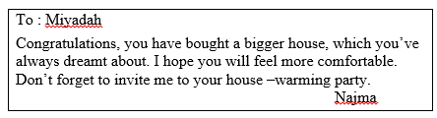  Why did Miyadah buy a bigger house? |  | d | 2
 | A | She wants to feel more relaxed
 | B | She wanted to invite all her friends
 | C | She dreamt to invite his friends to party
 | D | She always wanted to have a bigger house
 | E
26 | “ Ihope you will feel more comfortable “.  The underlined word can be replaced by…. |  | c | 2
 | A | think
 | B | say
 | C | wish
 | D | spend
 | E
27 | 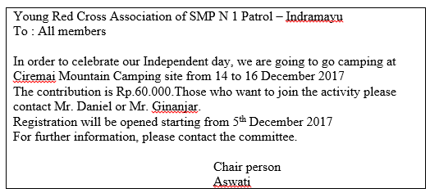  The camping will start on…. |  | b | 2
 | A | 5 December 2017
 | B | 14 December 2017
 | C | 15 December 2017
 | D | 16 December 2017
 | E
28 | Whom should you meet to register for the program? |  | d | 2
 | A | Aswati
 | B | The committee
 | C | The Chair person
 | D | Mr. Daniel or Ginanjar
 | E
29 | 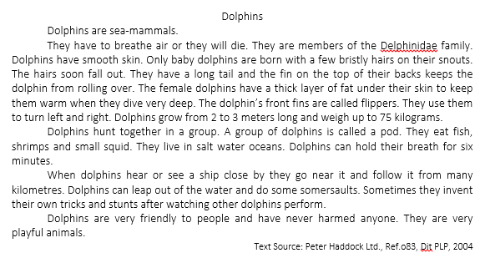  What is the purpose of the text above? |  | a | 2
 | A | To explain dolphins in general
 | B | To describe particular dolphins.
 | C | To show how to be friend with dolphins
 | D | To tell about one’s experience with dolphins
 | E
30 | The information about the habit and habitat of dolphins can be found in paragraph …. |  | b | 2
 | A | 2
 | B | 3
 | C | 4
 | D | 5
 | E
31 | What do dolphins use their long tail and fin on top of their backs? |  | b | 2
 | A | To keep them warm when diving deep.
 | B | To keep them from rolling over.
 | C | To turn right and left.
 | D | To hold their breath.
 | E
32 | Which of the followings is not correct fact of dolphins? |  | c | 2
 | A | Dolphins live in salt water ocean.
 | B | Dolphins eat other small sea livings.
 | C | Dolphins can hold their breath for six hours.
 | D | Dolphins have to breathe air because they are mammals.
 | E
33 | Dolphins can leap out of the water and do some somersaults.  The synonym of the underlined word is … high. |  | a | 2
 | A | jump
 | B | hop
 | C | sway
 | D | fly
 | E
34 | Rearrange the jumbled sentences into a good text.  (1) Unlike other fish, however, it does not have scales.  (2) This heavy ‘armor’ makes it hard to swim.  (3) Its body is covered with bony plates of ‘armor’.  (4) Just like a fish, a seahorse has a skeleton, gills and fins.  The best arrangement is …. |  | b | 2
 | A | (4)-(3)-(2)-(1)
 | B | (4)-(1)-(3)-(2)
 | C | (3)-(2)-(4)-(1)
 | D | (4)-(2)-(3)-(1)
 | E
35 | Rearrange the jumbled sentences into a good text.  (1) When the battery level is low, recharge it.  (2) Charging the cell phone is an easy thing to do.  (3) Then, plug the adapter into the wall outlet.  (4) First, plug the travel adapter into the phone.  (5) When the phone is completely charged (the battery icon stops blinking), unplug the adapter from the power outlet.  The best arrangement will be …. |  | c | 2
 | A | (5)-(4)-(1)-(3)-(2)
 | B | (4)-(2)-(1)-(5)-(3)
 | C | (2)-(4)-(3)-(5)-(1)
 | D | (1)-(4)-(2)-(3)-(5)
 | E
36 | Text for no. 36-39. Read the text and complete the blanks with suitable words.  Whales are sea-living mammals. … 36) therefore breathe air but cannot survive on land. Some species are very large indeed and the blue whale, which can exceed 30m length, is the … 37) animal to have lived on earth. Superficially, the whale … 38) rather like a fish, but there are important differences in external structure: its tail consists of a pair of broad, flat, horizontal paddles (the tail of a fish is vertical) and it has a single nostril on top of its large, broad head. The skin is … 39) and shiny and beneath it lies a layer of fat (blubber).This is up to 30cm in thickness and to conserve heat and body fluids. |  | a | 2
 | A | They
 | B | Their
 | C | Them
 | D | Theirs
 | E
37 | Text for no. 36-39. Read the text and complete the blanks with suitable words.  Whales are sea-living mammals. … 36) therefore breathe air but cannot survive on land. Some species are very large indeed and the blue whale, which can exceed 30m length, is the … 37) animal to have lived on earth. Superficially, the whale … 38) rather like a fish, but there are important differences in external structure: its tail consists of a pair of broad, flat, horizontal paddles (the tail of a fish is vertical) and it has a single nostril on top of its large, broad head. The skin is … 39) and shiny and beneath it lies a layer of fat (blubber).This is up to 30cm in thickness and to conserve heat and body fluids. |  | b | 2
 | A | largeness
 | B | largest
 | C | larger
 | D | large
 | E
38 | Text for no. 36-39. Read the text and complete the blanks with suitable words.  Whales are sea-living mammals. … 36) therefore breathe air but cannot survive on land. Some species are very large indeed and the blue whale, which can exceed 30m length, is the … 37) animal to have lived on earth. Superficially, the whales … 38) rather like a fish, but there are important differences in external structure: its tail consists of a pair of broad, flat, horizontal paddles (the tail of a fish is vertical) and it has a single nostril on top of its large, broad head. The skin is … 39) and shiny and beneath it lies a layer of fat (blubber).This is up to 30cm in thickness and to conserve heat and body fluids. |  | a | 2
 | A | look
 | B | looks
 | C | looked
 | D | looking
 | E
39 | Text for no. 36-39. Read the text and complete the blanks with suitable words.  Whales are sea-living mammals. … 36) therefore breathe air but cannot survive on land. Some species are very large indeed and the blue whale, which can exceed 30m length, is the … 37) animal to have lived on earth. Superficially, the whale … 38) rather like a fish, but there are important differences in external structure: its tail consists of a pair of broad, flat, horizontal paddles (the tail of a fish is vertical) and it has a single nostril on top of its large, broad head. The skin is … 39) and shiny and beneath it lies a layer of fat (blubber).This is up to 30cm in thickness and to conserve heat and body fluids. |  | a | 2
 | A | smooth
 | B | smoothen
 | C | smoothly
 | D | smoothness
 | E
40 | 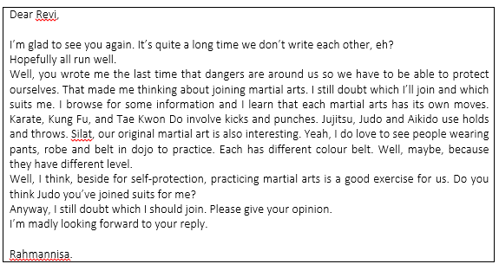  What is the purpose of the writer to write the letter? |  | c | 2
 | A | To offer something to one’s friend
 | B | To mention some kinds of martial art
 | C | To ask for one’s opinion about something
 | D | To introduce some martial arts to someone
 | E
41 | Which of the facts is not true? |  | b | 2
 | A | Revi practices Judo.
 | B | Rahmannisa is interested in Silat.
 | C | Martial Arts are good for health as well as for self protection.
 | D | Revi and Rahmannisa didn’t write to each other quite long time.
 | E
42 | How many martial arts are mentioned in the letter? |  | c | 2
 | A | 5
 | B | 6
 | C | 7
 | D | 8
 | E
43 | Which of the martial arts doesn’t involve kicks and punches? |  | a | 2
 | A | Judo
 | B | Karate
 | C | Kung Fu
 | D | Tae Kwon Do
 | E
44 |   What is the purpose of the text above? |  | a | 2
 | A | To advertise a product
 | B | To give tips to lose weight
 | C | To show how to lose weight
 | D | To inform how to use magic belt
 | E
45 | Lose your weight significantly …  The antonym of the underlined word is …. |  | a | 2
 | A | Gain
 | B | Lessen
 | C | Reduce
 | D | Decrease
 | E
46 | 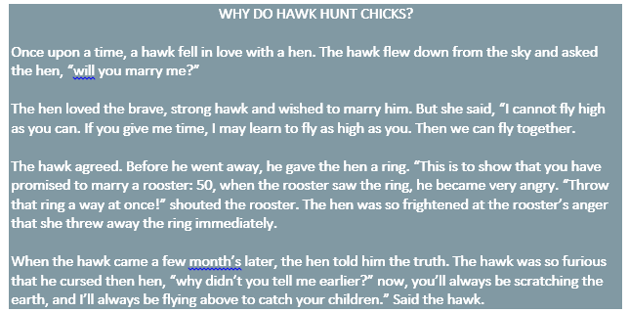  Why did the hawk curse the hen? |  | a | 2
 | A | The hen didn’t tell him the truth
 | B | The hawk didn’t want to marry the hen
 | C | The hen couldn’t fly as high as the hawk
 | D | The hawk couldn’t catch the hen children
 | E
47 | “The hen loved the brave, the strong hawk …” (paragraph 2  What is antonym of the underline word? |  | c | 2
 | A | Bold
 | B | Weak
 | C | Fear
 | D | Angry
 | E
48 | The hawk flew down from the sky and asked the hen,” will you marry me?”(paragraph 1).  What does the underlined utterance mean?  c  2
49 | Arrange the following sentences into a good paragraph  1. It all happened very quickly, people just stood and watched.  2. A car stopped outside the shop, and two men go out.  3. He threw the brick at the windows and smashed it.  4. They had masks on.  5. One of them held a brick in his hand.  6. One man took the coats from the window and the other put them in the back of the car.  The correct arrangement of the sentences is .....  b  2
50 | being – OSIS – on – Congratulation – elected – chairperson – as  1 2 3 4 5 6 7  The correct arrangement is…  b  2

