# SMART TOUR GUIDE

## A Project Report

## Submitted by

**AKHNA S J**

**TVE23MCA-2008**

To

## **APJ Abdul Kalam Technological University**

## in partial fulfilment of the requirements for the award of the degree

of

## **Master of Computer Applications**

# 

**Department of Computer Applications**

## College of Engineering

## Trivandrum-695016

## NOVEMBER 2024

## 

# Declaration

I undersigned hereby declare that the project report titled ”**Smart Tour Guide**” submitted for partial fulfilment of the requirements for the award of degree of Master of Computer Applications of the APJ Abdul Kalam Technological University, Kerala is a bonafide work done by me under supervision of **Dr. Liji P I.** This submission represents my ideas in my words and where ideas or words of others have been included. I have adequately and accurately cited and referenced the original sources. I also declare that I have adhered to ethics of academic honesty and integrity as directed in the ethics policy of the college and have not misrepresented or fabricated any data or idea or fact or source in my submission. I understand that any violation of the above will be a cause for disciplinary action by the Institute and/or University and can also evoke penal action from the sources which have thus not been properly cited or from whom proper permission has not been obtained. This report has not previously formed the basis for the award of any degree, diploma or similar title.

Place : Trivandrum

Date : 14/11/2024

**AKHNA S J**

**DEPARTMENT OF COMPUTER APPLICATIONS**

**COLLEGE OF ENGINEERING**

**TRIVANDRUM**



**CERTIFICATE**

This is to certify that the report entitled **Smart Tour Guide** submitted by **AKHNA S J** to the APJ Abdul Kalam Technological University in partial fulfilment of the requirements for the award of the Degree of Master of Computer Applications is a bonafide record of the project work carried out by him under my guidance and supervision. This report in any form has not been submitted to any University or Institute for any purpose.

**Dr. Liji P I Dr. Liji P I**

Head of the Department Head of the Department

College of Engineering Trivandrum College of Engineering Trivandrum

# Acknowledgement

First and foremost I thank GOD almighty and to my parents for the success of this project. I owe a sincere gratitude and heart full thanks to everyone who shared their precious time and knowledge for the successful completion of my project.

I am extremely thankful to Dr. Suresh K, Principal, College of Engineering Trivandrum for providing me with the best facilities and atmosphere which was necessary for the successful completion of this project.

I am extremely grateful to Dr. Liji P I, HOD, Dept of Computer Applications, for providing me with the best facilities and atmosphere for the creative work guidance and encouragement.

I express our sincere thanks to Dr. Liji P I, Department of Computer Applications, College of Engineering Trivandrum for her valuable guidance, support and advice that aided in the successful completion of my project.

I profusely thank the other Asst. Professors in the department and all other staff of CET, for their guidance and inspirations throughout my course of study.

I owe my thanks to my friends and all others who have directly or indirectly helped me in the successful completion of this project. No words can express my humble gratitude to my beloved parents and relatives who have been guiding me in all walks of my journey.

**AKHNA S J**

# Contents

**List of Figures 7**

**List of Tables 8**

**Abstract 9**

**Chapter 1 :** **Introduction**  **10**

**Chapter 2 :** **Problem Definition and Motivation**  **11**

2.1 Existing System 11

2.1.1 Limitations of Existing System 11

2.2 Proposed System 12

2.2.1 Advantages of Proposed System 12

**Chapter 3 :** **Requirement Analysis** **14**

3.1 Purpose 14

3.2 Overall Description 14

3.2.1 Hardware Requirements 14

3.2.2 Software Requirements 14

3.3 Functional Requirements 15

3.3.1 Flutter 15

3.3.2 Firestore 15

3.3.3 Firebase Database 15

3.4 Non-Functional Requirements 15

3.4.1 Performance Requirements 15

3.4.2 Security Requirements 15

**Chapter 4 :** **Design And Implementation** **1****6**

4.1 Overall Design 16

4.2 System Design 16

4.2.1 Database Schema 16

4.2.2 Backend Architecture 16

4.2.3 Front-end Framework 17

4.3 Methodology 17

4.3.1 Data Flow Diagram 17

4.4 Screenshots of user interface 21

**Chapter 5 :** **Coding** **2****6**

5.1 Introduction 26

5.2 Flutter 26

5.3 Dart 26

5.4 Firebase Firestore 26

5.5 FirebaseAuthentication 26

**Chapter 6 :** **Testing and Implementation****28**

6.1 Introduction 28

6.2 Testing Methods 28

6.2.1 Unit Testing 28

6.2.2 Integration Testing 28

6.2.3 Alpha Testing 29

6.2.4 Beta Testing 29

6.3 Test Cases 29

**Chapter 7 :** **Results and Discussion** **3****1**

7.1 Advantages and Limitations 31

7.1.1 Advantages 31

7.1.2 Limitations 32

**Chapter 8 :** **Conclusion and Future Scope** **3****3**

8.1 Conclusion 33

8.2 Future Scope 33

**Bibliography 3****5**

Websites 35

References 35

# 

# List of Figures

4.1: Level 0 Data Flow Diagram 18

4.2: Level 1.1 Data Flow Diagram 19

4.3: Level 1.2 Data Flow Diagram 20

4.4.1: Login Page 21

4.4.2: Register Page 21

4.4.3: Admin Dashboard Page 22

4.4.4: Admin Add Locations Page  22

4.4.5: Admin View Locations Page  22

4.4.6: Admin View Reviews Page  22

4.4.7: Explore Page 23

4.4.8: Categories Page 23

4.4.9: View Locations Page 23

4.4.10: Locations Details Page 23

4.4.11: Descriptions Details Page 24

4.4.12: Weather Details Page 24

4.4.13: Reviews Page 24

4.4.14: Add Review Page 24

4.4.15: Favourites Page 25

4.4.16: Similar Favourites Page 25

4.4.17: Shared Favourite Locations Page 25

4.4.18: Chats Page 25

# 

# List of Tables

6.3.1 Sign In Page Test Cases 31

6.3.2 Create Tourist Account Cases 31

6.3.3 Create Admin Account Cases 31

# Abstract

The Smart Tour Guide platform aims to revolutionize the tourism industry by providing a comprehensive, user-friendly platform for tourists to explore and plan their visits to various attractions. By replacing traditional tour guides with an interactive and convenient digital solution, this platform offers a modern alternative that enhances the travel experience.

Key features of the Smart Tour Guide platform include secure user authentication, which allows tourists to sign up, log in, and manage their profiles seamlessly. The app’s advanced search functionality, equipped with robust filters, enables users to find attractions based on categories such as adventurous activities, historical sites, cultural landmarks, family-friendly spots, and more. This tailored approach ensures that users can quickly locate attractions that align with their specific interests, making the exploration process more efficient and enjoyable.

Overall, the Smart Tour Guide platform is designed to meet the evolving needs of modern travelers, providing a streamlined, personalized, and immersive approach to exploring new destinations. By leveraging digital technology, the platform aims to make travel planning more efficient, enjoyable, and accessible for all.

# 

# Chapter 1

# Introduction

In today’s digital era, tourism applications are revolutionizing the way travelers plan and experience their journeys. With the vast amount of information available online, there is an increasing demand for personalized and user-friendly platforms that cater to individual preferences and simplify the planning process. The *Smart Tour Guide* app was developed to address this need by offering a comprehensive, tailored experience for travelers seeking to explore cities in India.

The *Smart Tour Guide* app combines advanced features such as location-based recommendations, real-time weather updates, and user interaction capabilities. The app allows users to browse popular tourist destinations, view categorized attractions, read descriptive details, and save their favorite spots. Leveraging Firebase Firestore as its backend, the app manages user data, reviews, ratings, and a favorites collection, enabling seamless storage and retrieval of information across sessions. Additionally, the app integrates data from external APIs for location images, maps, and weather details, enhancing the experience with dynamic and visually engaging content.

One of the key features of the *Smart Tour Guide* app is its user-defined filter system, which allows users to personalize their search based on city and type of activity. This functionality is complemented by the ability for users to rate and review locations, fostering a sense of community and engagement. Admin users can moderate and manage content, while tourists can interact with each other via a built-in chat feature, further enriching the user experience.

# Chapter 2

# Problem Definition and Motivation

## The traditional guided tourism model presents several challenges, including limited personalization, restricted availability, and high costs, particularly for private tours. Tourists seeking specific attractions often face difficulties as guided tours usually adhere to fixed routes that may not align with individual preferences. Additionally, there is no dedicated platform for connecting like-minded travelers who wish to explore together, limiting social engagement and shared experiences among tourists. This project aims to address these issues by providing a customizable, interactive platform that enables users to discover compatible travel partners and explore destinations based on personalized interests and real-time data.

## 2.1 Existing System

The existing system of guided tourism primarily relies on human tour guides who take tourists on predefined routes. While this provides some level of structure and knowledge sharing, it often lacks personalization, as guides may prioritize popular spots rather than tailoring tours to individual preferences. Additionally, tourists are bound by the guide's schedule, limiting their freedom to explore at their own pace. This dependency on human guides can also be inconvenient, particularly when guides are unavailable or overbooked. Furthermore, hiring a private tour guide can be costly, making it a less accessible option for budget-conscious travelers who may wish to explore more economically.

## 2.1.1 Limitations of Existing System

1. **Availability**: Guides typically work within specific hours, meaning tourists must adjust their schedules to match their availability, which can limit spontaneity. If a guide is unavailable during your preferred time, it may force you to alter your plans or miss out on certain experiences.
2. **Personalization**: Guides often offer one-size-fits-all recommendations that may not cater to your specific interests or preferences. Additionally, some guides may prioritize certain attractions due to personal ties or financial incentives, leading to biased suggestions.
3. **Convenience**: Relying on a physical guide can be inconvenient, as it requires coordination of meeting times and locations, which might not always align with your travel preferences. Moreover, having to follow the guide’s pace can limit your flexibility to explore places in your own time.
4. **Expensive**: Hiring a guide can significantly increase the cost of a trip, especially if guides charge high fees for their services. This added expense can strain your travel budget and reduce the funds available for other experiences or necessities.

## Proposed System

The proposed system will allow users to search for attractions in cities using customizable filters, such as activity type or interest, and display relevant results to enhance personalized travel experiences. Additionally, it will facilitate travel partner matching by enabling users to connect with like-minded individuals, while providing detailed attraction information, including maps, weather, ratings, reviews, and notifications for a comprehensive, interactive platform.

* Tourist Module: Enables tourists to search for attractions by city and category, view descriptions, and get personalized recommendations.
* TravelPartnerModule: Allows users to create profiles and connect with compatible travel partners.
* Attraction Management Module: Gives administrators tools to manage and update attraction details, images, and categories.
* Rating and Review Module: Lets tourists rate, review, and upload photos, fostering a community-driven feedback system.

Together, these modules will create a seamless, customer-centric platform that improves scheduling flexibility, task assignment efficiency, and communication across the entire service process.

## 2.2.1 Advantages of Proposed System

• User-Defined Filters:  
The platform allows users to search by city and choose from categories such as adventure, historical sites, and family-friendly spots, providing tailored recommendations to match each user’s travel preferences and interests.

• Travel Partner Matching:  
In addition to recommending attractions, the app enables users to connect with compatible travel companions by creating profiles and finding others with similar interests, making travel more social and enjoyable.

• Attraction Descriptions:  
The platform provides users with detailed descriptions of attractions, including maps and real-time weather conditions, allowing them to plan their visits with all necessary information at their fingertips.

• Favourites, Ratings, Reviews, and Messaging System:  
Users can save favourite attractions, rate and review sites, upload pictures, and communicate with other users, creating a community-focused experience that helps travelers make informed choices and share insights.

# Chapter 3

# Requirement Analysis

The requirement analysis outlines the purpose, overall description, hardware and software requirements, as well as functional and non-functional requirements for the development of the proposed Smart Tour Guide App.

## 3.1 Purpose

The purpose of the requirement analysis is to define the specifications and criteria that the must meet. This includes identifying the hardware and software components, functional capabilities, and non-functional attributes necessary for the successful implementation of the platform.

## 3.2 Overall Description

### 3.2.1 Hardware Requirements

* Processor: AMD Ryzen 5 5500U with Radeon Graphics
* Storage: 512 GB Hard Disk space
* Memory: 8 GB RAM

### 3.2.2 Software Requirements

* Operating System: Linux/Windows
* Back-end: Firebase
* Front-end: Flutter

## 3.3 Functional Requirements

### 3.3.1 Flutter

### The front-end and main application framework will be built using Flutter, providing a cross-platform solution for both Android and iOS. Flutter’s robust and flexible widget system will enable the creation of a visually appealing, responsive, and user-friendly interface, ensuring a smooth experience across devices.

### 3.3.2 Firebase

### Firebase will serve as the backend for the platform, offering real-time database management, secure authentication, and streamlined data storage. Firebase’s powerful features enable seamless integration for storing tourists data, locations, and reviews, as well as handling backend operations efficiently.

### 3.3.3 Firestore Database

### Firestore, Firebase’s NoSQL cloud database, will be used for storing hostel information, user data, and filtering options. Its real-time synchronization and querying capabilities allow for fast data retrieval, ensuring users experience minimal delay when searching for locations and viewing details.

### 4.3.4 Non-Functional Requirements

### 3.4.1 Performance Requirements

### The platform is expected to handle a significant volume of simultaneous users, ensuring responsive and efficient performance. Load testing will be conducted to validate its ability to handle varying workloads.

### 3.4.2 Security Requirements

### Security measures will be implemented to safeguard user data, ensure secure communication, and protect against common web vulnerabilities. The platform will adhere to industry-standard security practices, including data encryption and secure user authentication.

# Chapter 4

# Design And Implementation

This chapter focuses on the overall design and system design of the Service Provider App, providing insights into the architectural decisions, database schema, and key implementation details.

## 4.1 Overall Design

The overall design of the home services platform aims to create a customer-centric and efficient system, addressing the challenges of current manual and fragmented processes. The design principles focus on flexibility, scalability, and a seamless user experience. The platform is structured into two main modules: Tourist, and Admin, each with distinct functionalities. A centralized database ensures data consistency and enables effective communication among these modules, supporting real-time updates and streamlined task management.

## 4.2 System Design

The system design encompasses various components, including the database schema, backend architecture, and front-end framework.

4.2.1 Database Schema

The database schema is structured to store and manage user profiles, locations details, ratings, and filtering preferences. Collections within Firestore will be used to store different data, which includes tourists data, locations, favourites, and associated reviews. Tourists data will include authentication details. The database is optimized for real-time querying and efficient data retrieval, especially when applying filters or sorting options.

### 4.2.2 Backend Architecture

The backend of the platform utilizes Firebase as the primary service to handle data storage, user authentication, and real-time updates. Firebase Authentication handles secure login, ensuring safe user access. Firestore serves as the NoSQL database, allowing flexible data storage and real-time synchronization. Firebase Cloud Functions are employed to handle server-side logic such as processing filter queries. The backend is designed to be highly scalable, capable of handling a growing user base and a large amount of hostel data efficiently.

### 4.2.3 Front-end Framework

The front-end of the platform is built using Flutter, providing a cross-platform solution for both Android and iOS devices. The design ensures a responsive and mobile-friendly interface with a focus on simplicity and ease of navigation. Flutter’s widget-based approach allows for a customizable UI, ensuring an intuitive experience for users when searching, filtering, and viewing service details. Firebase integration in the front-end ensures that real-time data updates, such as availability or ratings, are seamlessly reflected. The use of custom UI elements and styling contributes to the platform’s modern and user-friendly interface.

## The system design emphasizes a modular and scalable architecture, with separate components for user management, locations, review details. The next phase involves the implementation of these components, ensuring they meet the specific requirements and objectives of the smart tour guide platform.

## 4.3 Methodology

### 4.3 Data Flow Diagram

A Data Flow Diagram (DFD) is a graphical representation that illustrates the flow of data within a system. It depicts how data is input, processed, stored, and output by showing the relationships between different components. In a DFD, processes are represented by circles or rounded rectangles, data stores by open-ended rectangles, external entities by rectangles, and data flows by arrows.

In this system, the DFD will illustrate how data flows between the two main modules—Tourist, and Admin—and the centralized database, providing an overview of data interactions in searching, filtering locations and managing reviews. Different levels of DFDs can provide progressively more detail about these interactions and data processing steps.

Level 0 DFD

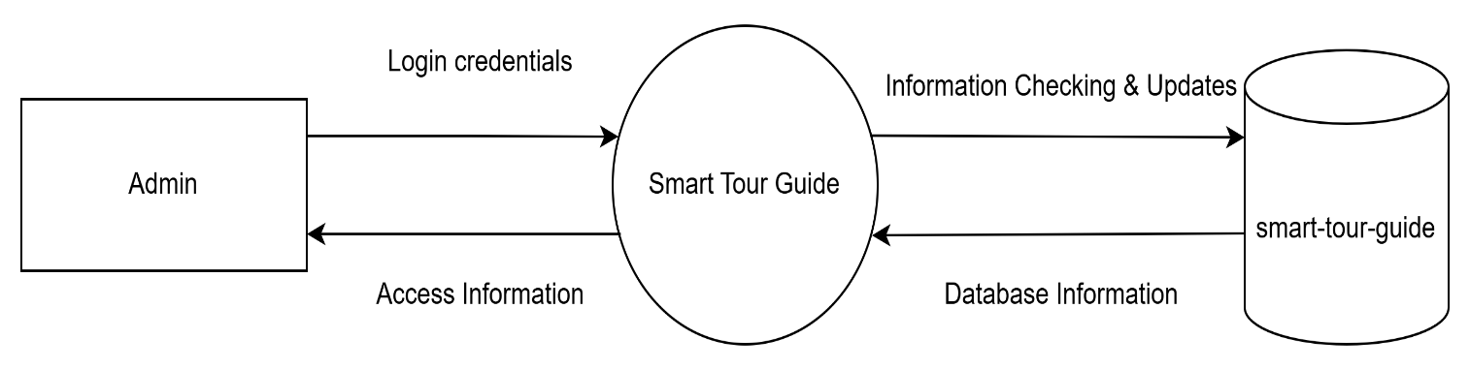

Figure 4.1: Level 0 Data Flow Diagram

Level 1.1 DFD

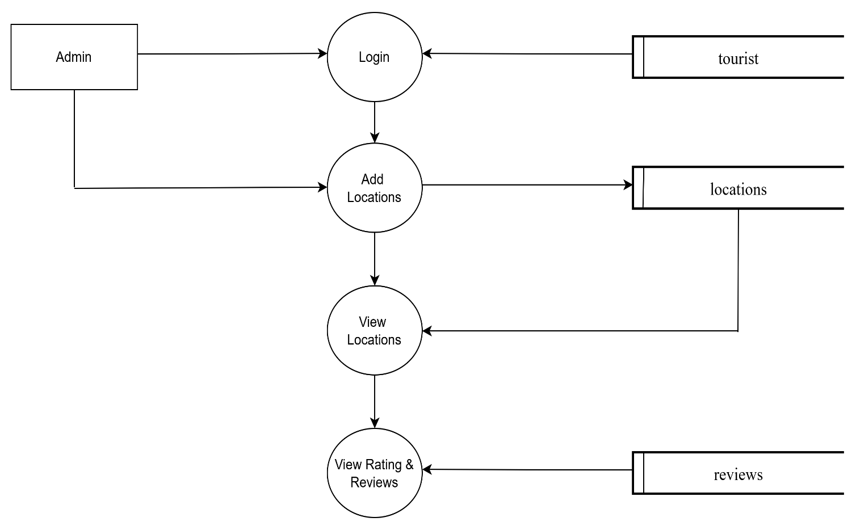

Figure 4.2: Level 1.1 Data Flow Diagram

Level 1.2 DFD

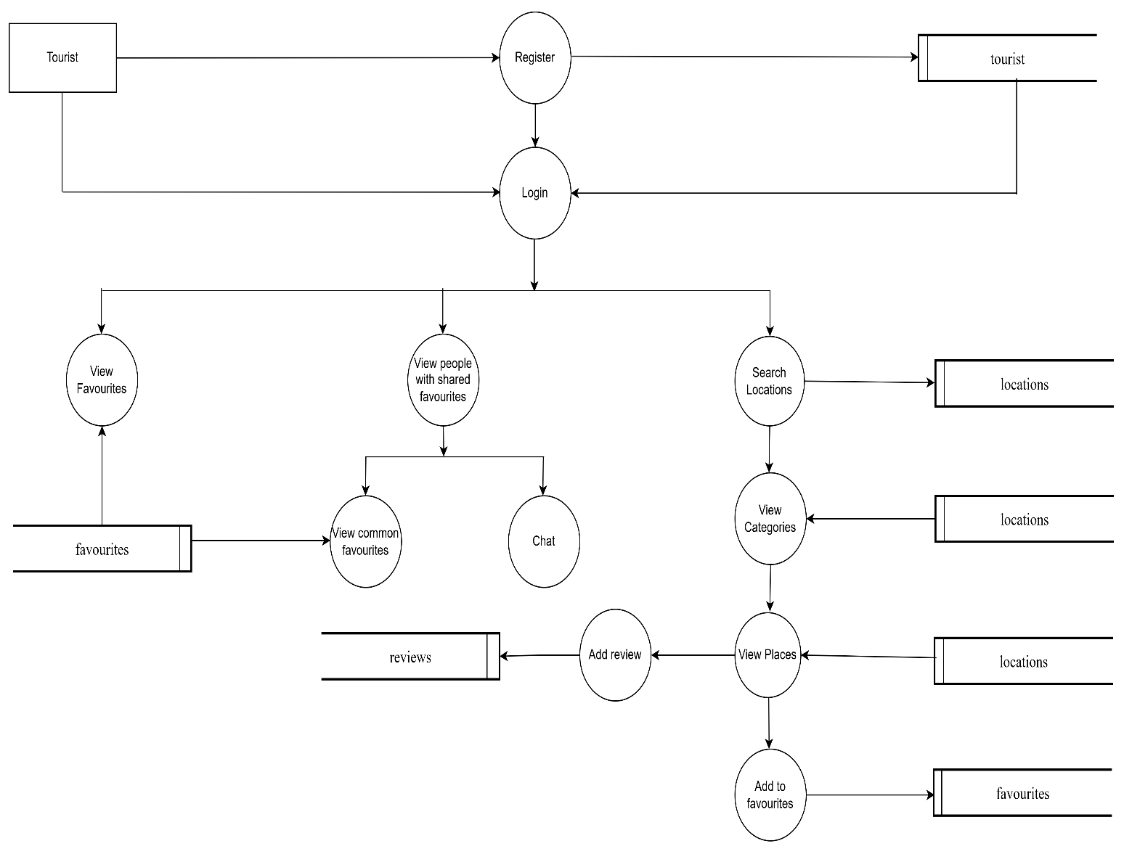

Figure 4.3: Level 1.2 Data Flow Diagram

## 4.4 Screenshots of User Interface

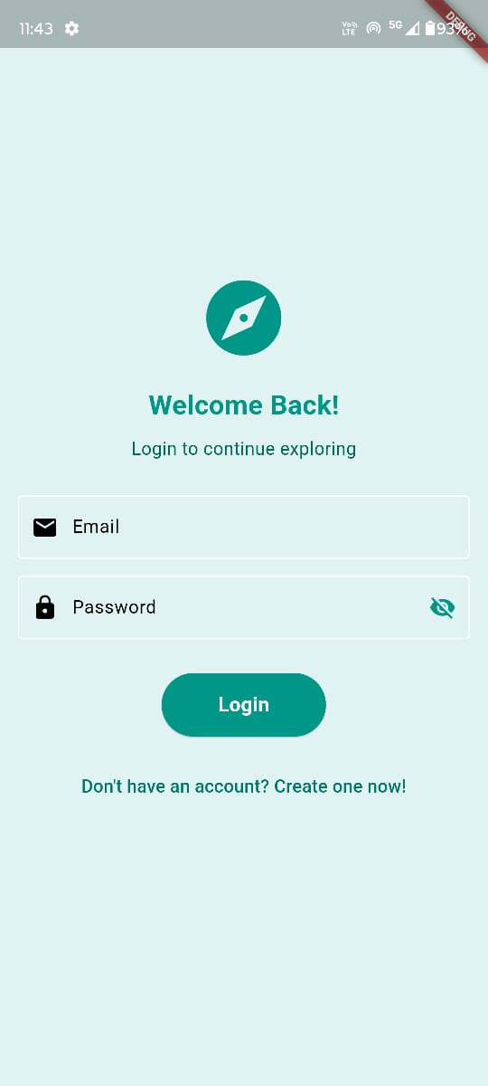

Figure 4.4.1: Login Screen

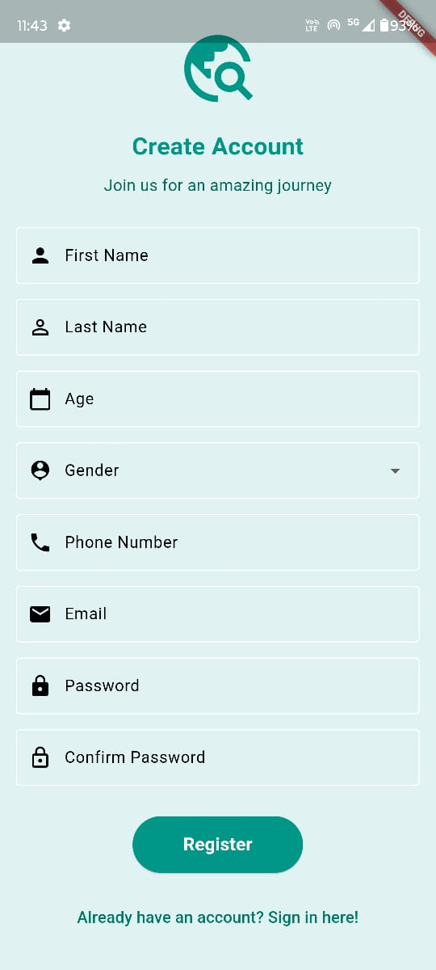

Figure 4.4.2: Register Page

 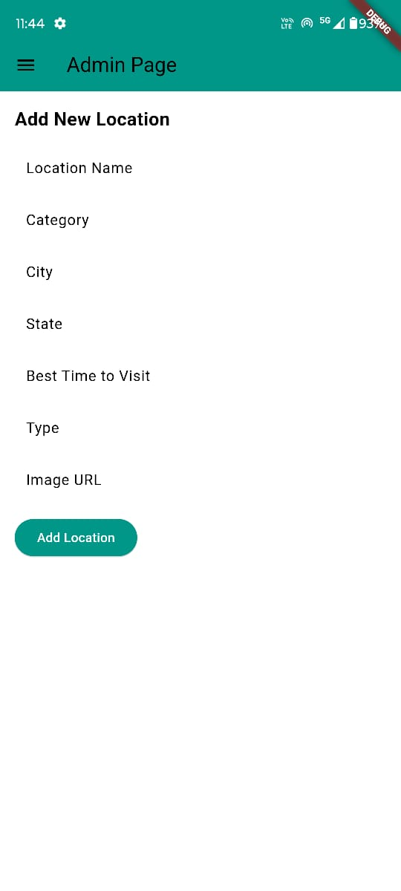

Figure 4.4.3: Admin Dashboard Page Figure 4.4.4: Admin Add Locations Page

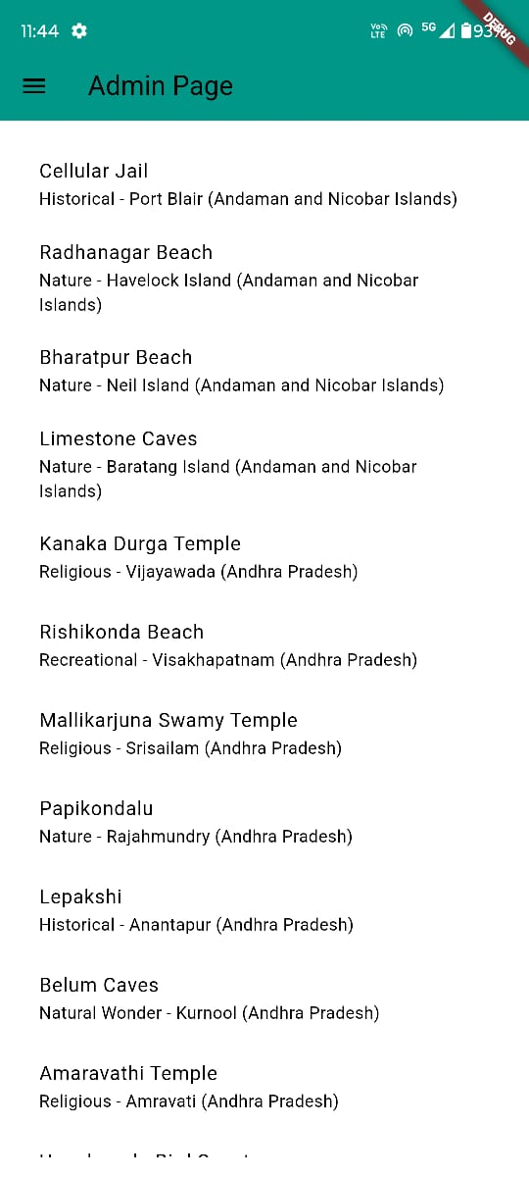 

Figure 4.4.5: Admin View Locations Page Figure 4.4.6: Admin View Reviews Page

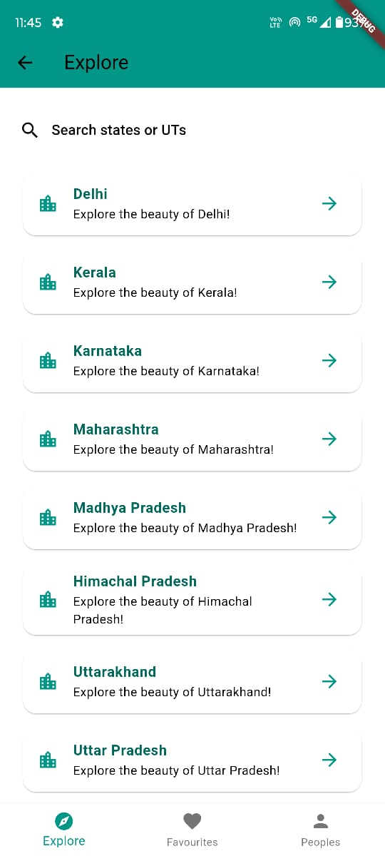 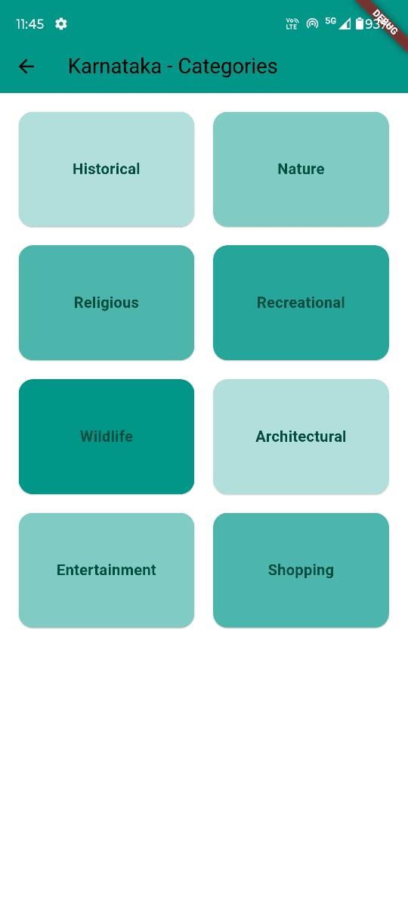

Figure 4.4.7: Explore Page Figure 4.4.8: Categories Page

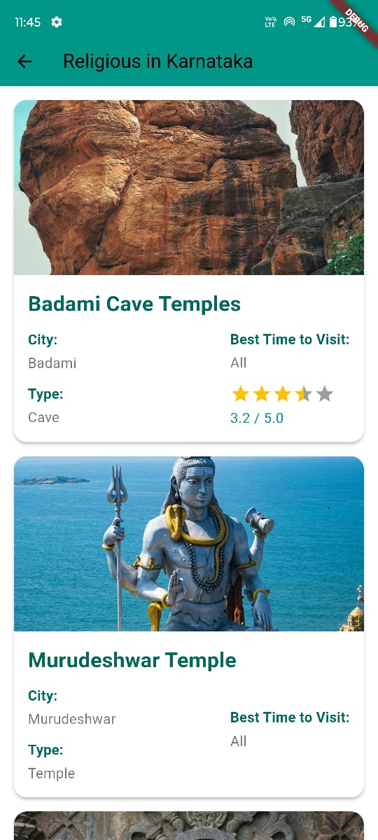 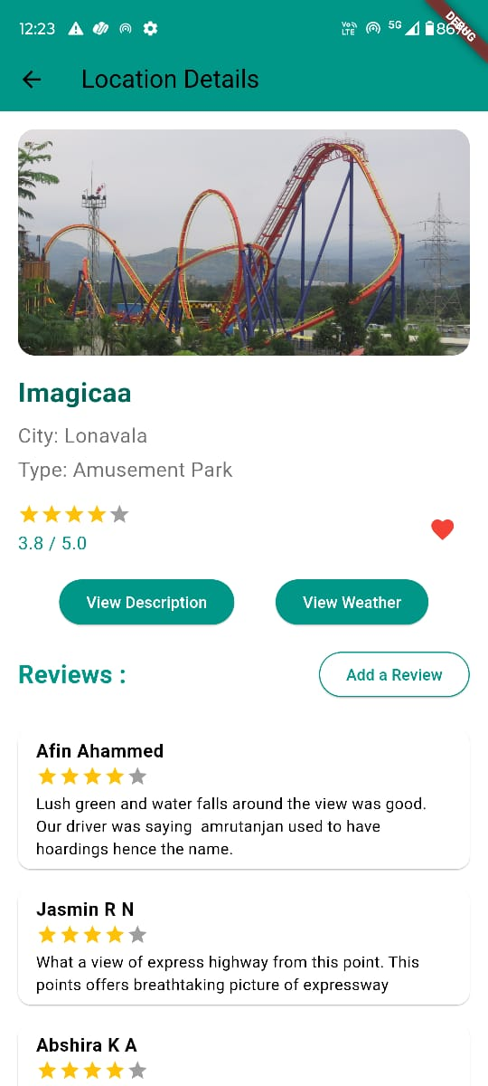

Figure 4.4.9: View Locations Page Figure 4.4.10: Locations Details Page

 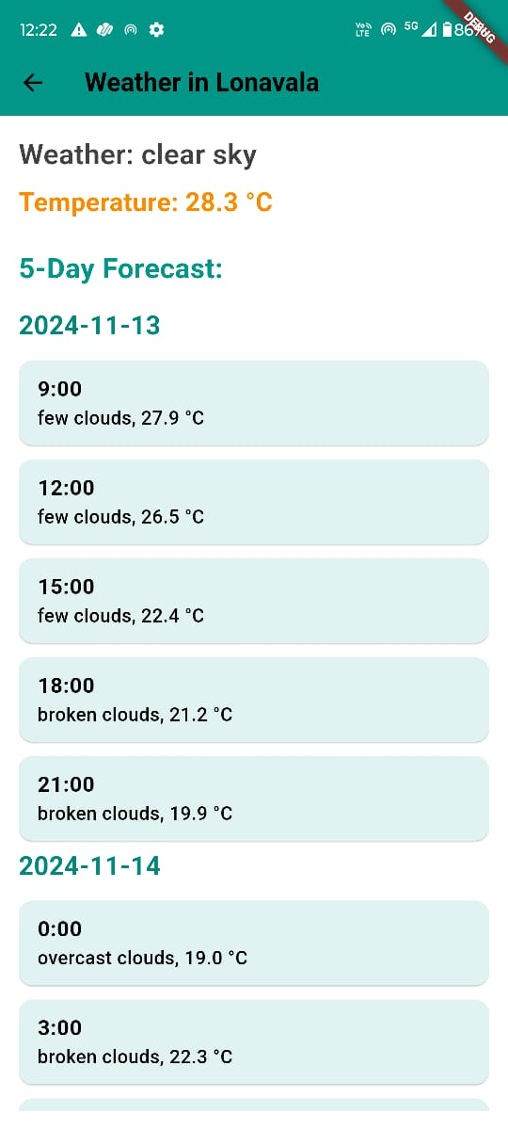

Figure 4.4.11: Descriptions Details Page Figure 4.4.12: Weather Details Page

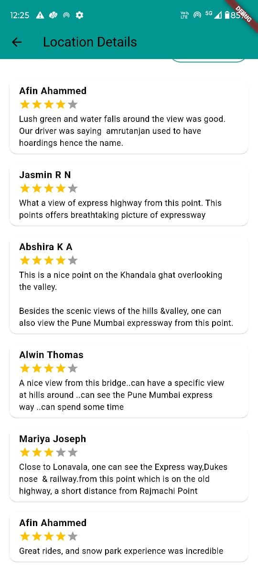 

Figure 4.4.13: Reviews Page Figure 4.4.14: Add Review Page

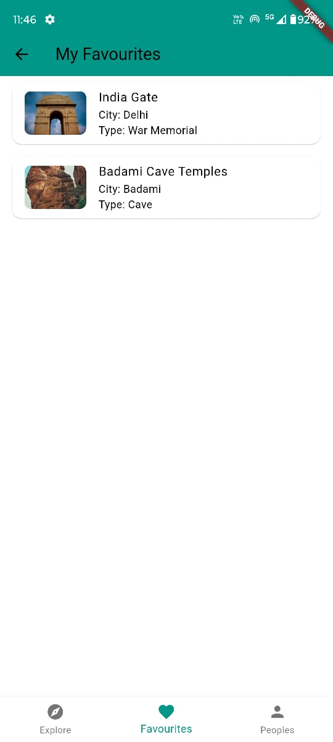 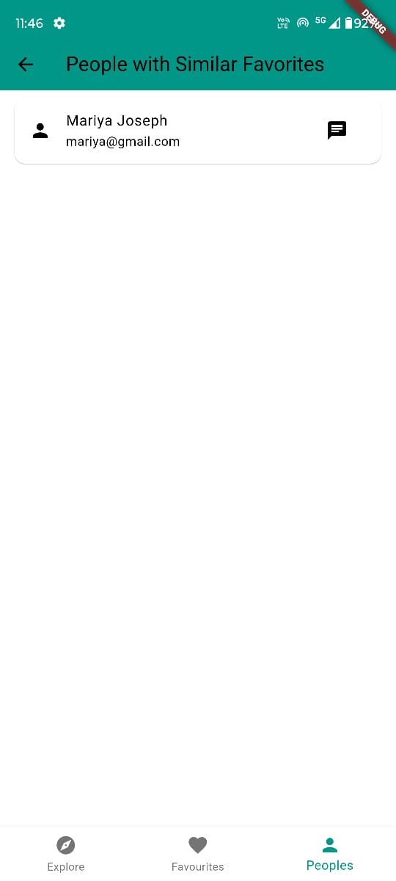

Figure 4.4.15: Favourites Page Figure 4.4.16: Similar Favourites Page

 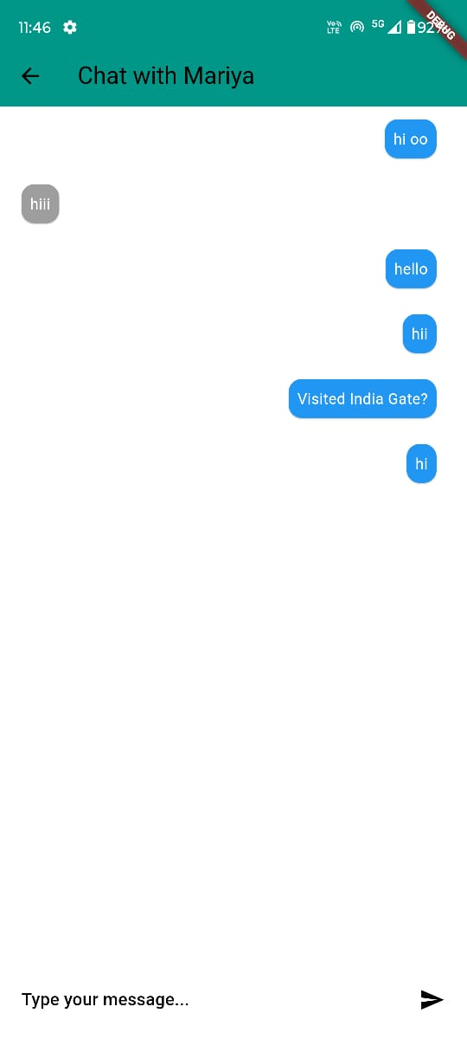

Figure 4.4.17: Shared Favourite Locations Page Figure 4.4.18: Chats Page

# Chapter 6

# Coding

## 5.1 Introduction

The coding is the process of transforming the design of a system into a computer language format. This coding phase of software development is concerned with software translating design specification into the source code. It is necessary to write source code & internal documentation so that conformance of the code to its specification can be easily verified.

Coding is done by the coder or programmers who are independent people rather than the designer. The goal is not to reduce the effort and cost of the coding phase, but to cut to the cost of a later stage. The cost of testing and maintenance can be significantly reduced with efficient coding.

## 5.2 Flutter

## Flutter, a cross-platform UI toolkit developed by Google, is the foundation of the hostel finder platform's front-end. With Flutter’s widget-based architecture, the platform offers a visually appealing and consistent user interface across Android and iOS devices. Flutter’s features, such as hot reload and customizable widgets, allow for rapid development and make the app responsive and user-friendly. The platform’s front-end follows a component-based structure, promoting modularity and reusability in the codebase.

## 5.3 Dart

Dart, the programming language used for Flutter, is employed throughout the platform’s development. Known for its efficiency and readability, Dart is well-suited for both UI logic and data processing tasks within the app. Its asynchronous programming support is particularly beneficial in handling real-time data fetching from Firebase, ensuring smooth and uninterrupted user interactions.

5.4 Firebase Firestore

Firebase Firestore acts as the backend database, providing a scalable NoSQL solution that integrates seamlessly with Flutter. Firestore’s real-time capabilities enable the platform to provide instant updates on hostel availability, ratings, and filtering results. The database structure, including collections for users, hostel listings, and reviews, is defined within Firestore and interacts with the app through Dart code. Firestore’s security rules and Firebase Authentication ensure data privacy and secure access for all users.

5.5 Firebase Authentication

Firebase Authentication is utilized to manage secure user logins, particularly using phone-based verification. This service simplifies the login process, enhancing both user experience and security. By integrating Firebase Authentication, the platform ensures that only authorized users have access, and its seamless connection with Firestore enables real-time personalization and data security across the platform.

# Chapter 7

# Testing and Implementation

## 7.1 Introduction

System testing is carried out in a planned manner according to the system test plan document. The system test plan identifies all testing-related activities that must be performed, specifies the schedule of testing, and allocates resources. It also lists all the test cases and the expected outputs for each test case. It ensures that the system works accurately and efficiently, before live operation commences. It helps in the noting and correction of errors.

## 7.2 Testing Methods

### 7.2.1 Unit Testing

Unit testing focuses on verification efforts made on the smallest unit of software design, a module. The modules are tested separately and this testing is carried out during the programming stage itself. The project can be divided into modules: Contract management, Task scheduling, Data management, Reporting and Feedback. Each of these modules contain multiple forms, which have been individually tested. The module interface is tested to ensure that information properly flows in and out of the program unit under test. It is ensured that each module works satisfactorily with regards to the output expected from it.

### 7.2.2 Integration Testing

Integration testing is used to take the unit tested modules and build a program structure. All the modules are combined and then tested as a whole. Data can be lost across interfaces and one module may have an adverse effect on others. Moreover, sub functions when combined may not produce the desired major functions. All these make integration testing necessary. Here, error correction is difficult because their isolation from the entire program becomes complicated.

### 7.2.3 Alpha Testing

Alpha testing takes place at the developer's side by the internal teams, before release to the external customers. Developers observe the working of the application and note problems. Generally, this testing is performed without the involvement of the development teams. It is done when development is about to complete. Minor design changes can still be made as a result of alpha testing. The focus of this testing is to simulate real users by using blackbox and whitebox techniques and the aim is to carry out the tasks that a typical user might perform, diagnose any errors that arise and rectify them.

### 7.2.4 Beta Testing

Beta testing of a product is performed by the real users of the software application in a real environment and can be considered as a form of external user acceptance testing. Beta version of the software is released to a limited number of end-users of the product to obtain feedback on the product quality. It reduces the risk of product failure and provides increased quality of the end product through customer validation. It is the final test before shipping a product to the customers. Direct feedback from customers is a major advantage of this testing in addition to helping to test the product in a real-time environment. It creates goodwill with the customers and increases customer satisfaction.

Since this project has been developed using an iterative model, it has been monitored by the client, Eagle Environmental service and pest control establishment, periodically to notify the desired changes to be made. This served as a customer validation and thereby helped in creating a better solution to the clients.

## 7.3 Test Cases

A test case in software engineering is a set of conditions or variables under which a tester will determine whether an application or software system is working correctly or not. The test cases in our project context are:

I) Sign In Page

|  |  |  |  |
| --- | --- | --- | --- |
| **Input** | **Expected Result** | **Actual result** | **Remarks** |
| Invalid username and password | Unsuccessful login | Unsuccessful login | Pass |
| Valid username, invalid password | Unsuccessful login | Unsuccessful login | Pass |
| Invalid username, valid password | Unsuccessful login | Unsuccessful login | Pass |
| Valid username and password | Successful login | Successful login | Pass |

II) Create tourist account

|  |  |  |  |
| --- | --- | --- | --- |
| **Input** | **Expected Result** | **Actual result** | **Remarks** |
| Blank entry | Unsuccessful creation | Unsuccessful creation | Pass |
| Empty username | Unsuccessful creation | Unsuccessful creation | Pass |
| Empty password | Unsuccessful creation | Unsuccessful creation | Pass |

III) Create admin account

|  |  |  |  |
| --- | --- | --- | --- |
| **Input** | **Expected Result** | **Actual result** | **Remarks** |
| Blank entry | Unsuccessful creation | Unsuccessful creation | Pass |
| Empty username | Unsuccessful creation | Unsuccessful creation | Pass |
| Empty password | Unsuccessful creation | Unsuccessful creation | Pass |

# Chapter 7

# Results and Discussion

This chapter provides an evaluation of the Smart Tour Guide platform, highlighting its advantages and limitations based on the implementation and user feedback.

## 7.1 Advantages and Limitations

### 7.1.1 Advantages

* User-Defined Filters:

The platform's filtering options allow tourists to customize searches by city and activity type, such as adventure, historical, family-friendly, and spiritual categories, enhancing the relevancy of search results and providing a tailored experience.

* Enhanced Social Connectivity:

The travel partner matching feature fosters connections among like-minded travelers by allowing users to create profiles, find companions, and communicate, adding a social dimension to the travel experience.

* Comprehensive Attraction Information:

The platform provides detailed descriptions for each attraction, along with map integrations and weather data, helping users make informed decisions and improving the overall planning experience.

* Engaging Review and Favourites System:

With features like ratings, reviews, and a favorites list, the platform enhances user engagement, allowing tourists to document experiences, save preferred locations, and contribute valuable feedback for future users..

* Modern Technological Stack:

The use of Flutter, Firebase, and APIs for maps, weather, and images ensures a responsive, scalable, and reliable platform, aligning with modern standards in mobile app development.

### 7.1.2 Limitations

* Learning Curve for New Users:

Some tourists may face a learning curve when initially navigating the platform’s features, especially if they are unfamiliar with the interactive map and filter-based search functions.

* Dependency on External APIs:

The platform's reliance on external APIs (for maps, weather, and images) means it is subject to the availability, pricing, and reliability of these services, which may impact app functionality.

* Internet Dependency:

Since key features rely on real-time data (like weather and maps), the platform requires a stable internet connection, which may be a limitation in remote travel destinations with limited connectivity.

# Chapter 8

# Conclusion and Future Scope

This chapter serves as the culmination of the Smart Tour Guide platform's development, summarizing key outcomes, contributions, and outlining potential future enhancements.

## 8.1 Conclusion

The Smart Tour Guide platform represents a significant advancement in personalized tourism, catering to the needs of modern travelers seeking tailored and interactive experiences. Built using technologies such as Flutter, Firebase, and integrated APIs for maps, weather, and city images, the platform offers a comprehensive and user-friendly guide for exploring various destinations. The app’s architecture, featuring real-time updates, a sophisticated filtering system, and an engaging review mechanism, provides users with a unique blend of flexibility and control over their travel planning process.

Key advantages of the Smart Tour Guide platform include personalized recommendations, seamless user interaction, and community-driven feedback, all of which align with the project’s objectives to enhance the tourism experience. By leveraging a dynamic and scalable tech stack, the platform is well-prepared to adapt to evolving user expectations and technological advancements in the tourism industry.

## 8.2 Future Scope

The Smart Tour Guide platform is positioned for continuous improvement and expansion, with potential enhancements including:

* Machine Learning Integration:

Incorporating machine learning algorithms to provide more accurate and personalized travel recommendations based on user preferences, behavior, and review data.

* Enhanced Security Features:

Strengthening security measures with multi-factor authentication and improved data encryption to protect user privacy and secure sensitive information.

* Advanced Social and Travel Partner Features:

Expanding social features, such as travel partner matching and real-time chat, to foster better connections between users and encourage collaborative travel experiences.

* Integration with Additional APIs:

Exploring integration with external APIs for enriched travel content, including cultural insights, restaurant recommendations, and real-time event updates at destinations.

* Mobile Offline Mode:

Developing an offline mode for key features, such as saved destinations and previously loaded information, to enhance accessibility for users traveling in areas with limited internet connectivity.

* In-App Analytics and User Feedback Tools:

Implementing analytics to track user behaviour and engagement, along with feedback tools to gather insights for ongoing feature enhancement and usability improvements.

* User Training and Onboarding Programs:

Introducing onboarding programs and tutorials for first-time users to improve familiarity with the platform's features and maximize its usability.

The Smart Tour Guide platform's journey does not conclude with its initial release; rather, it sets a solid foundation for continual innovation and refinement. Ongoing collaboration between developers, administrators, travel enthusiasts, and industry experts will play an essential role in shaping the platform’s evolution, ensuring it remains an effective, user-focused tool for enhancing travel experiences.

# Bibliography

## Websites

1. <https://firebase.google.com/docs>
2. <https://docs.flutter.dev/>
3. <https://pub.dev/>
4. <https://github.com/>
5. <https://undraw.co/>
6. <https://fonts.google.com/>

## References

[1] Beginning App Development with Flutter: Create Cross-Platform Mobile Apps 1st ed. Edition by Rap Payne (Author)

[2] Design Patterns: Elements of Reusable Object-Oriented Software 1st Edition, Richard Helm, Ralph Johnson, John Vlissides, Grady Booch

[3] Clean Code: A Handbook of Agile Software Craftsmanship 1st Edition, Robert C. Martin

[4] Beginning Flutter: A Hands On Guide to App Development by Marco L Napoli.