MANUSCRIPT SUBMISSION TUTORIAL

------------------------------------

This tutorial will guide you through the steps required to submit your manuscript.

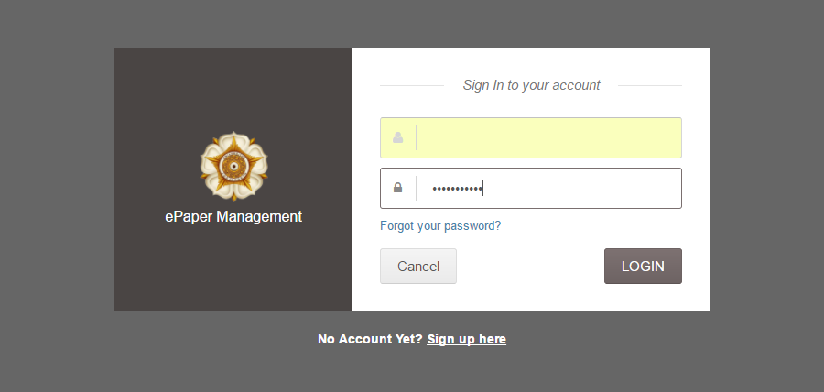

1. Sign in to your account
2. The window will appear as follows:

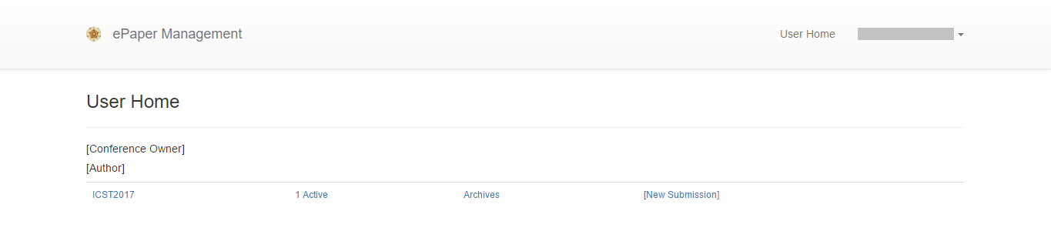

1. Click your name in the top-right corner and then select My Paper Submission

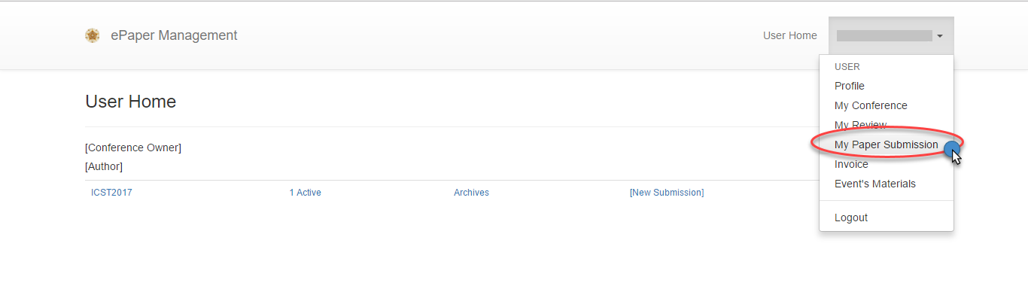

1. 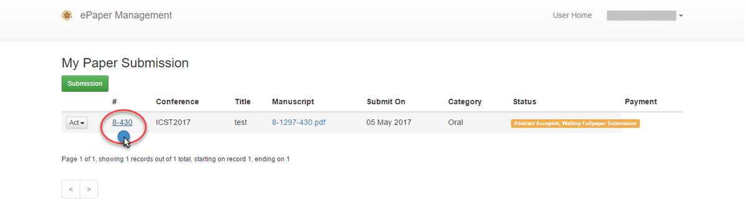In the My Paper Submission page, click the ID number of your abstract
2. 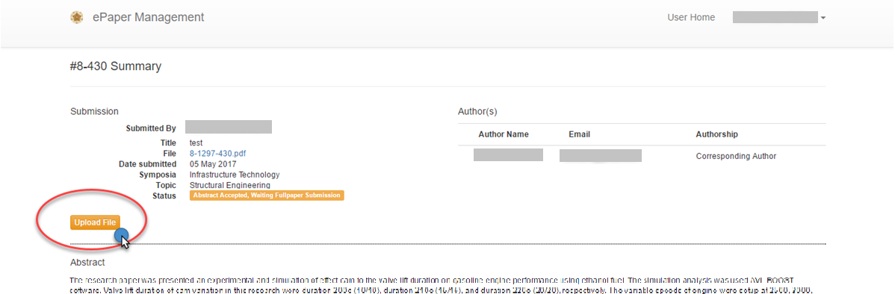Click Upload File button
3. 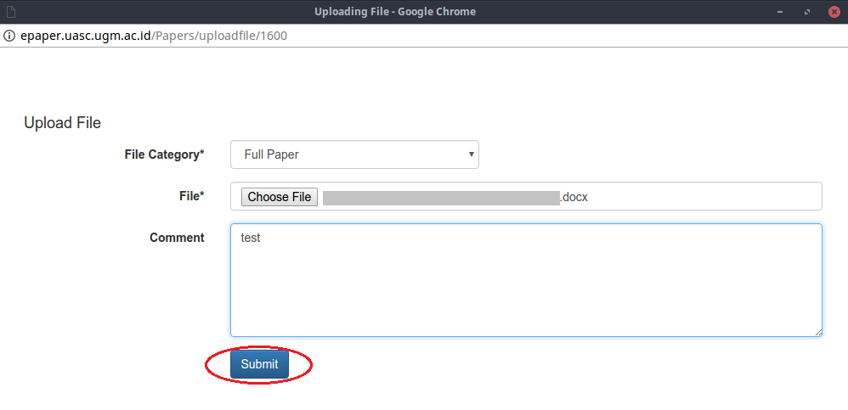Under File Category, choose Full paper and then click Choose File to add your manuscript
4. 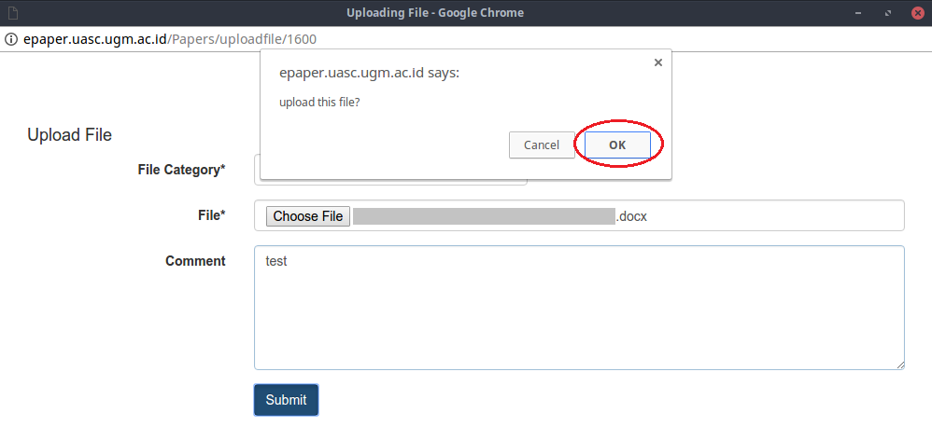Click Submit to submit your full paper. A notification dialogue will appear, click OK to confirm your submission
5. Your manuscript has been submitted

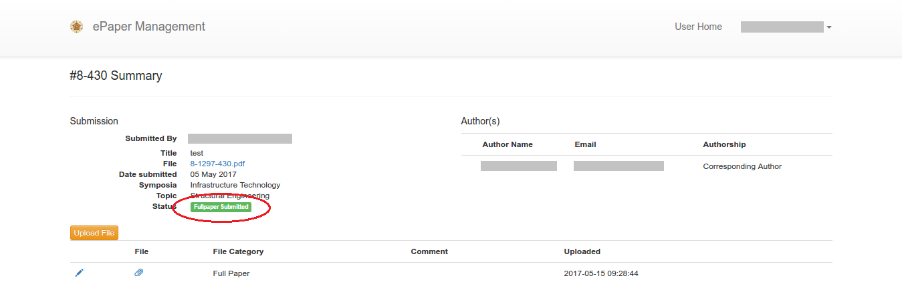

If you still require further assistance, please feel free to [contact us](mailto:icst@ugm.ac.id).