**INDEX**

Dashboard

School performance ranking

Top performing schools of a week

Fee collection this month

Fee management

Unpaid fees

New admissions

Student profile

New recommendations

* Content to cover today

Detailed content view

Content tracker

Relevant content data of class and section

* School performance

Average performance of all schools

Average performance of your school

* Content completion
* School chat
* Calendar

Holidays

Functions

Academic events

Add / Erase new events

School calendar (monthly, weekly, daily)

Top students

List of top students

Attendance

The list of students along with their attendance details day wise.

Attendance statistics

* Number of periods absent
* Number of periods late
* Attendance details of various classes

Class content Management

Sections associated with a particular class

Content supposed to be taught on a particular day

Performance

Track performance of the students

performance charts of each subject of the respective classes

* **Search bar**

Performance of a particular student

More

* Test audit

Upload answer sheets

* Student profile
* Fee management
* Help

Alllearn

User manual

Getting started

Open the following URL:

* The above URL redirects you to the Homepage of the Shivalik Public School Home page.
* The first page that opens up is the dashboard:

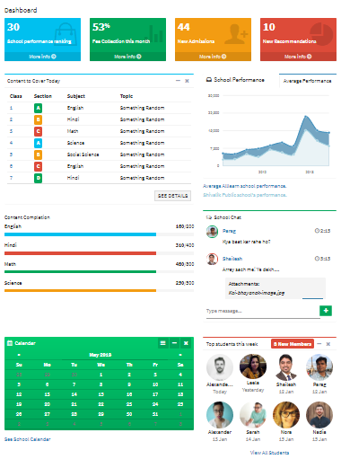

Once opened, The Home screen of the Shivalik Website is divided into functional parts as listed below.

* Dashboard
* Attendance
* Content
* Performance
* Test

† Dashboard

Dashboard is divided in to four different rows.

The first row of the dashboard lists the following functions:

* School performance ranking
* Fee collection this month
* New admissions
* New recommendations

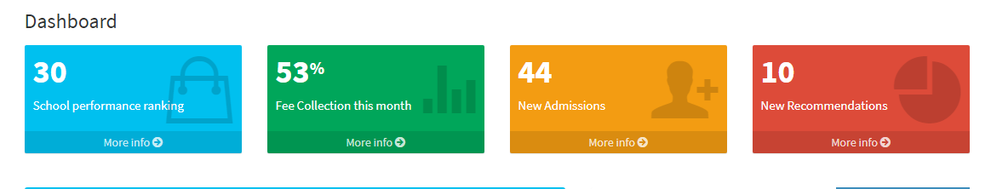

* School performance Ranking

Once you click on more info in school performance option you will be to see the ranking of the top ten schools of that week by their location.

**Click** → **more info**

↓

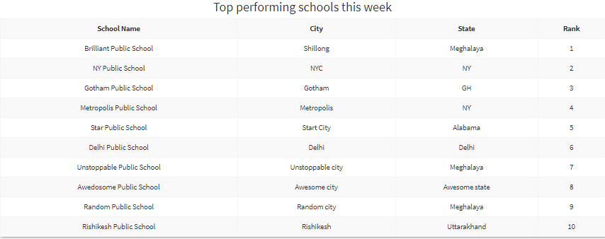

* Fee collection this month

This box shows the percentage of students who’d paid their fees. The more details button at the bottom of the box redirects to the fee management page where the list of all unpaid fee details is mentioned.

**Click** → **more info**

↓

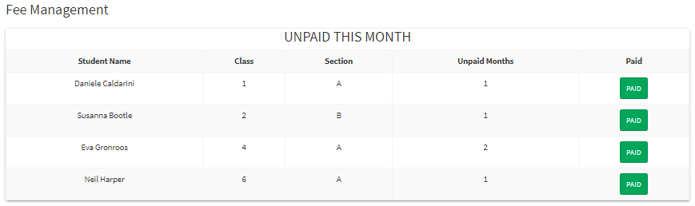

* New Admissions

This box shows the numbers of students who took new admission the more details button at the bottom of the box redirects you the page where we can use filters if we want to find some students by their last names or first names or we can find the students by their date of admission.

**Click** → **more info**

↓

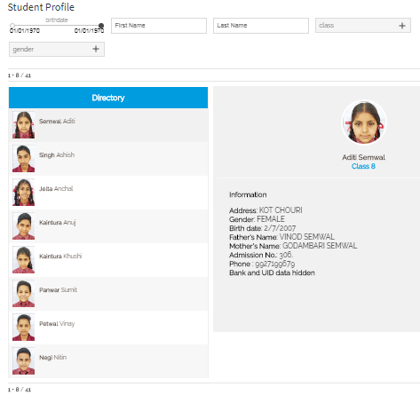

* New recommendations

This box shows the list of recommendations based on the performance data analysis of the school. This can be seen at class, section or student level if required.

**Click** → **more info**

↓

The second row of the dashboard has two panels

* Content to cover today
* School performance
* Content to cover Today

This box shows the subjects Teachers has to cover. There are four columns in it. First shows the class, second shows the sections of a class, third shows the subjects and the fourth column shows the topic that has to cover.

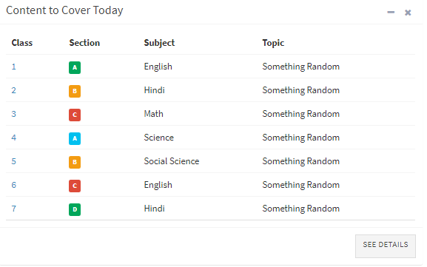

**Click** → **see details. Click on the Class and section to load the relevant content data**

↓

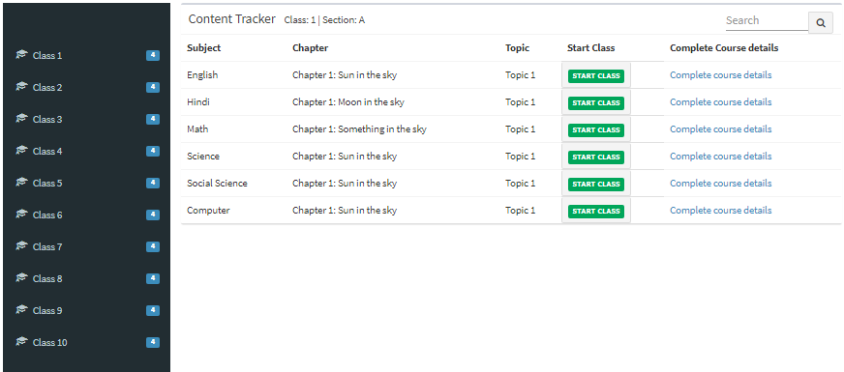

* School performance

This box shows the yearly performance of the school with the help of a graph.

The y axis contains the average percentages and the x axis contains the timeline

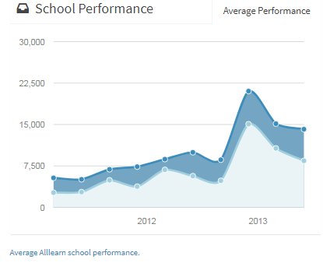



* Average performance of all schools

 Average performance of your school

The third row of the dashboard has two panels.

* Content completion
* School chat

* **Content completion**

This box shows the content that has been covered by the teachers of a particular subject.

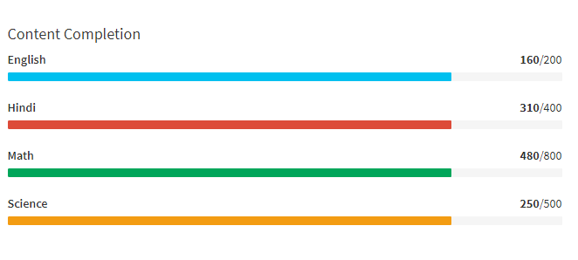

* **School chat**

This can be used to talk with other teachers of schools in order to get the information about the school and the students.

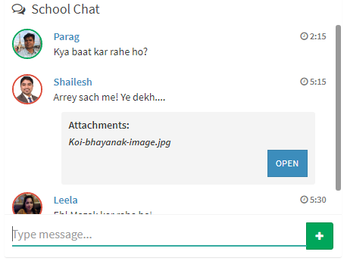

The fourth column of the dashboard has two panels.

* Calendar
* Top students this week
* Calendar
* This box shows the events of the school like holidays , functions, and Academic sessions. You can easily add any new event and clear events and also see the calendar of the schools.

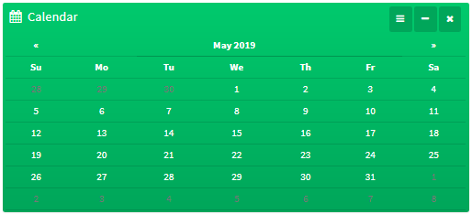

* If you want to see the school calendar then simply follow the steps:-

**Click** →  **see school calendar**

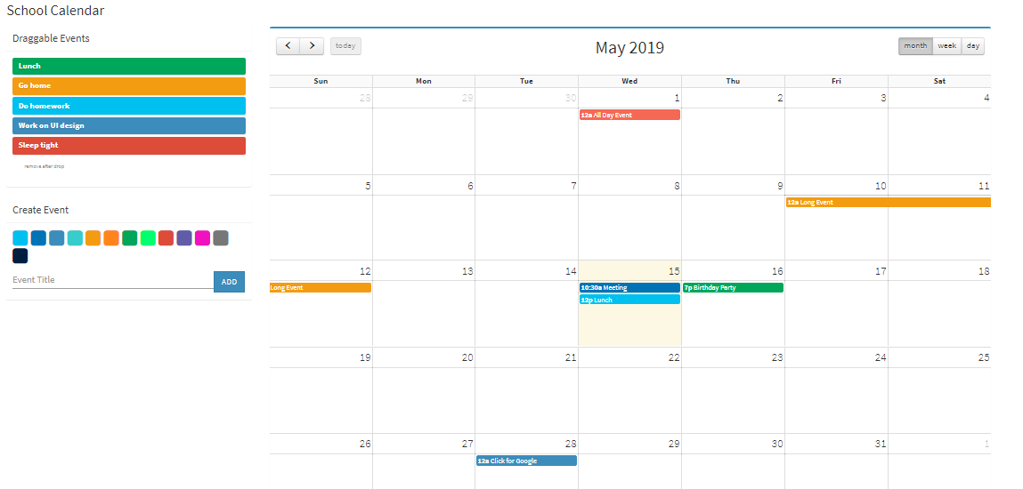

**To see the weekly and daily calendar**

**Click** →  **see school calendar** → **week**

**Click** →  **see school calendar** → **day**

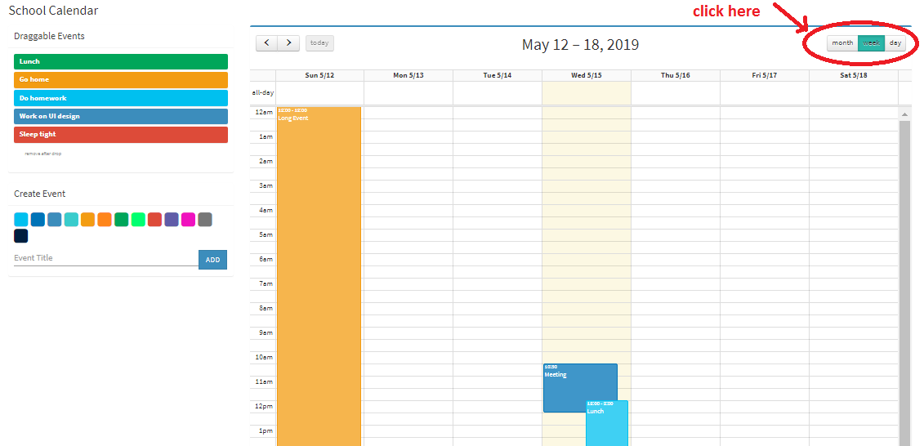

* Top students this week

In this box you can easily see the top ranked students of a school in a week.

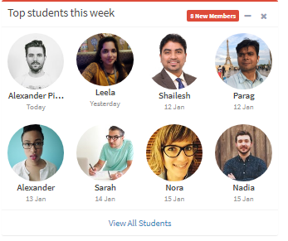

**To see the list of all students**

**Click** →  **view all students**

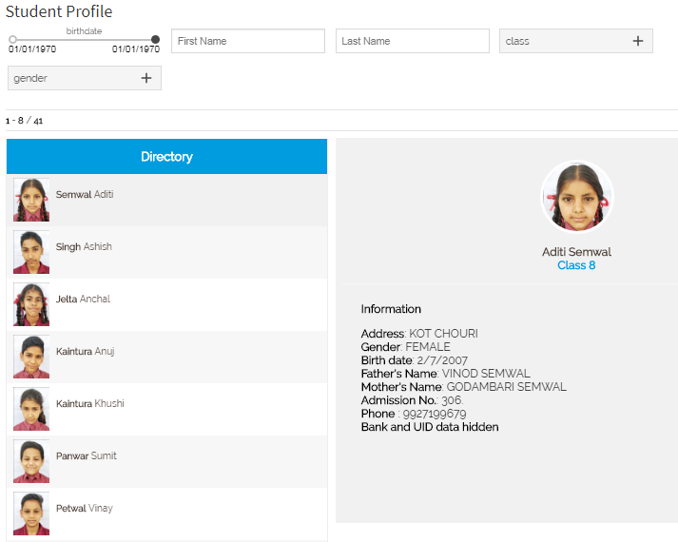

* Attendance:

When you click on the attendance the following screen appears:

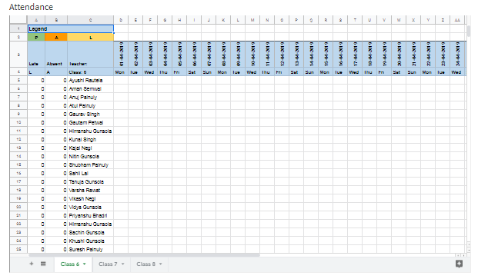

* In the Attendance you can access the list of students along with their attendance details day wise.
* It also provides the detailed attendance statistics like number of periods absent and number of periods late for each individual student along with the list.
* You can access the attendance details of various classes by selecting the class on the bottom

# Class Content Management:

* When you click on the Class Content Management the following screen appears:
* When you click on particular class the sections associated with it load up. Then when you click on one of the sections then the content that’s supposed to be taught on that day will be loaded on the right pane

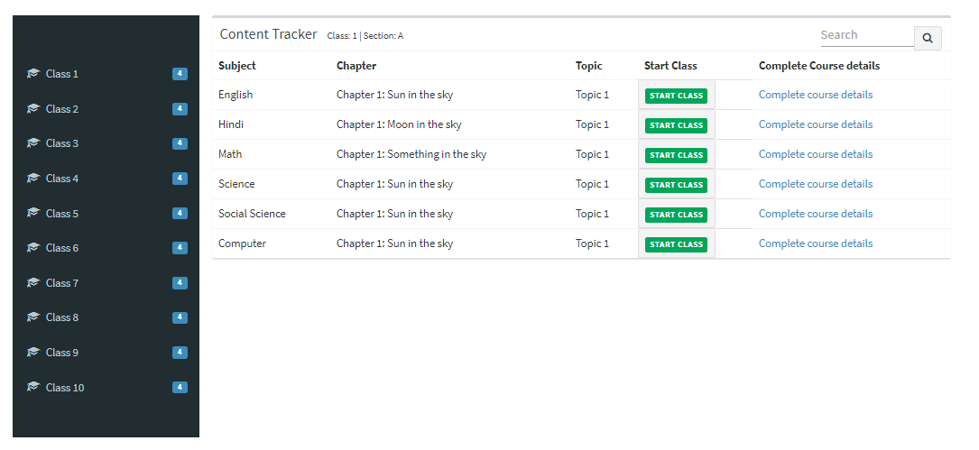

* When you click on the start class you will be redirected to the content delivery page

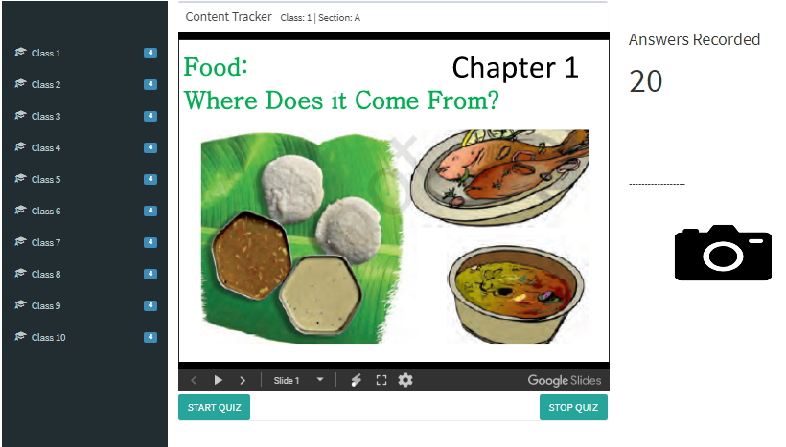

* Performance:
* When you click on the Performance the following screen appears:
* In this Performance Management, we can track the performance of students as a whole as well as individually (Using the search bar).

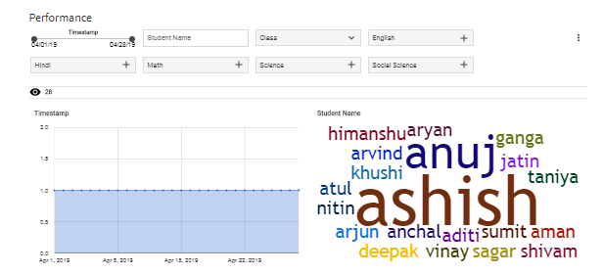

* When you scroll down, you can see the performance charts of each subject of the respective classes as follows:

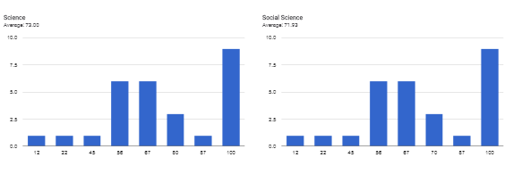 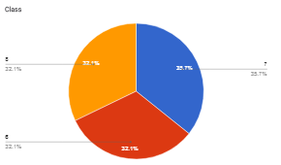

## Search bar:

* To view the performance of a particular student, you can just type the student name in the search bar as follows.

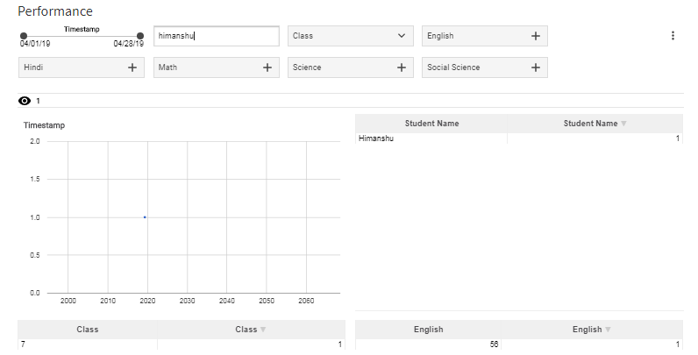

# More:

When you click on the ‘More’ option you will find 4 options as shown:

1. Test Audit
2. Student Profile
3. Fee management
4. Help

* When you click on Test Auditing, you will be redirected to the following screen
* In order to upload answer sheets just click on the option Fill out Form and you will be redirected to a page in which you can enter all of your credentials and upload the respective answer sheets

