Dummy Public School

# Class 5 - Class Feedback - Jul 06, 2020

## Subject : English

### Total Marks : 120

1. What thing is cold, sweet, creamy and wonderful to eat?

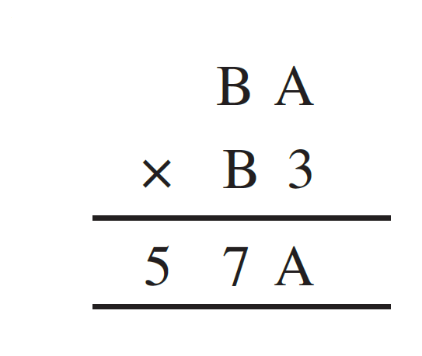

A. Pasta

B. Cold coffee

C. Juice

D. Ice- cream

1. Name the different flavours of ice-cream the Icecream Man had in his cart.



A. undefined

B. undefined

C. undefined

D. undefined

1. Which of the following is not an indoor activity?



A. undefined

B. undefined

C. undefined

D. undefined

1. Who do you think your shadow looks like?



A. like my mother

B. like my father

C. like me

D. like my uncle

1. What time of the day do you think it is when your shadow is the tallest?



A. afternoon

B. morning

C. evening

D. night