Eklavya Trust

# Class 1 - Weekly Test - 2020-05-07

## Subject : English

### Total Marks : 20

1. What did the big wolf say to the pigs?

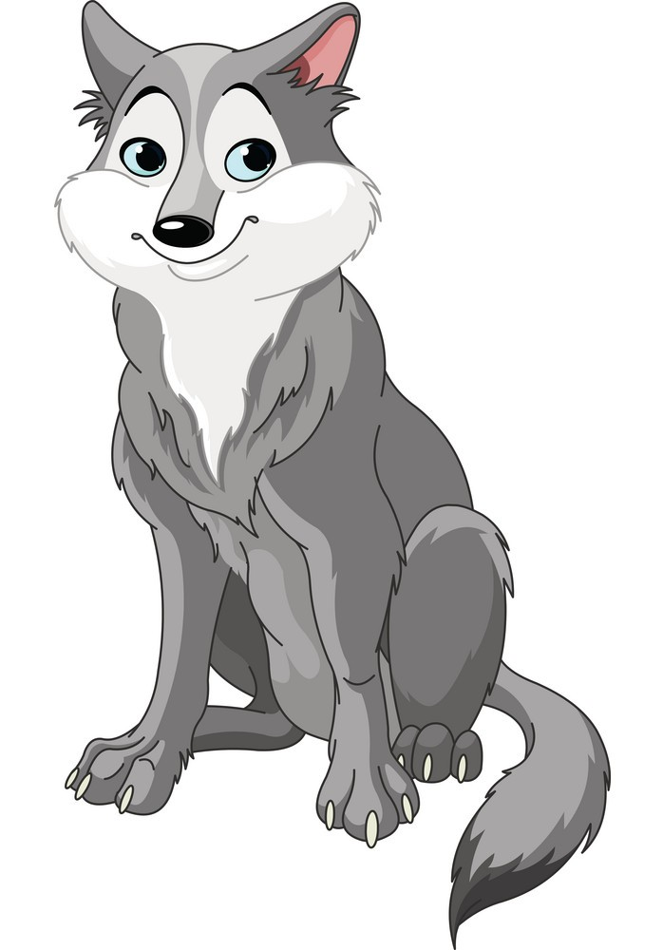

A. I will eat you small pigs.

B. I will eat your food.

C. I will huff and puff and I will blow your house down

D. Let's come to my home.

1. Was the wolf good or bad?

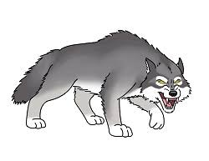

A. Good

B. Bad

C.

D.