Eklavya Trust

# Class 1 - Weekly Test - 2020-05-07

## Subject : English

### Total Marks : 50

1. What did the big wolf say to the pigs?

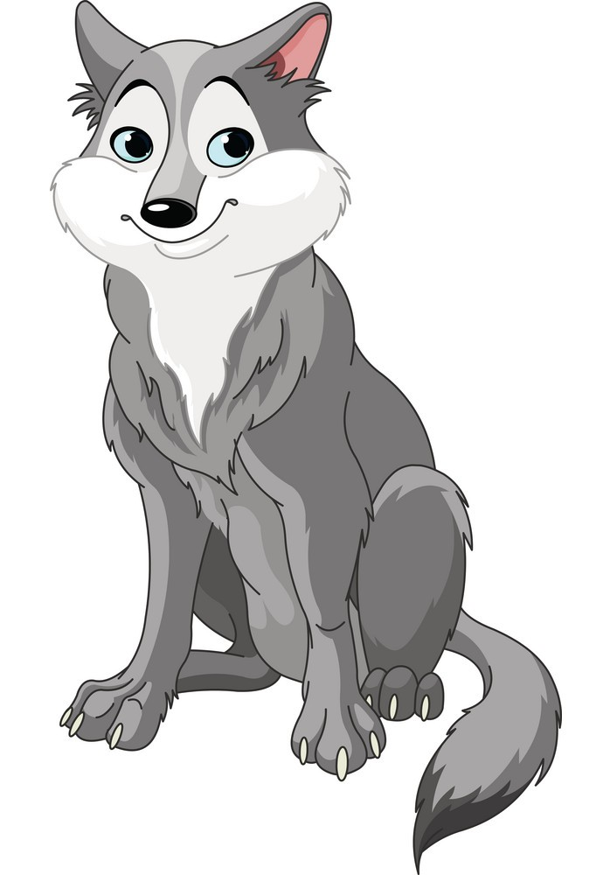

A. I will eat you small pigs.

B. I will eat your food.

C. I will huff and puff and I will blow your house down

D. Let's come to my home.

1. Was the wolf good or bad?

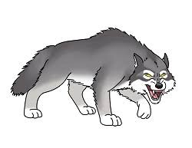

A. Good

B. Bad

C.

D.

1. Why did the wolf not blow the house of bricks?



A. It was too big

C. It was very small

D. It was an underground house

B. It was very strong.

1. Identify pig in the given picture.

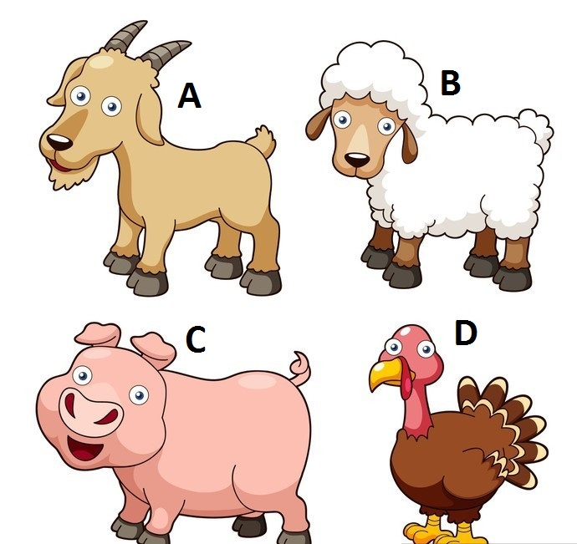

B. B

D. D

C. C

A. A

1. Who lived in the house of sticks?



A. Sonu

C. Gonu

D. Wolf

B. Monu